Name: Aatiqa Rehmani
Student Number: 2522836
Module Code And Title: LCHS4003 Introduction to Health and Social Care
Lecturer’s Name: Bernice Ejiogu
Assignment Title: Component 1

Task 1: Poster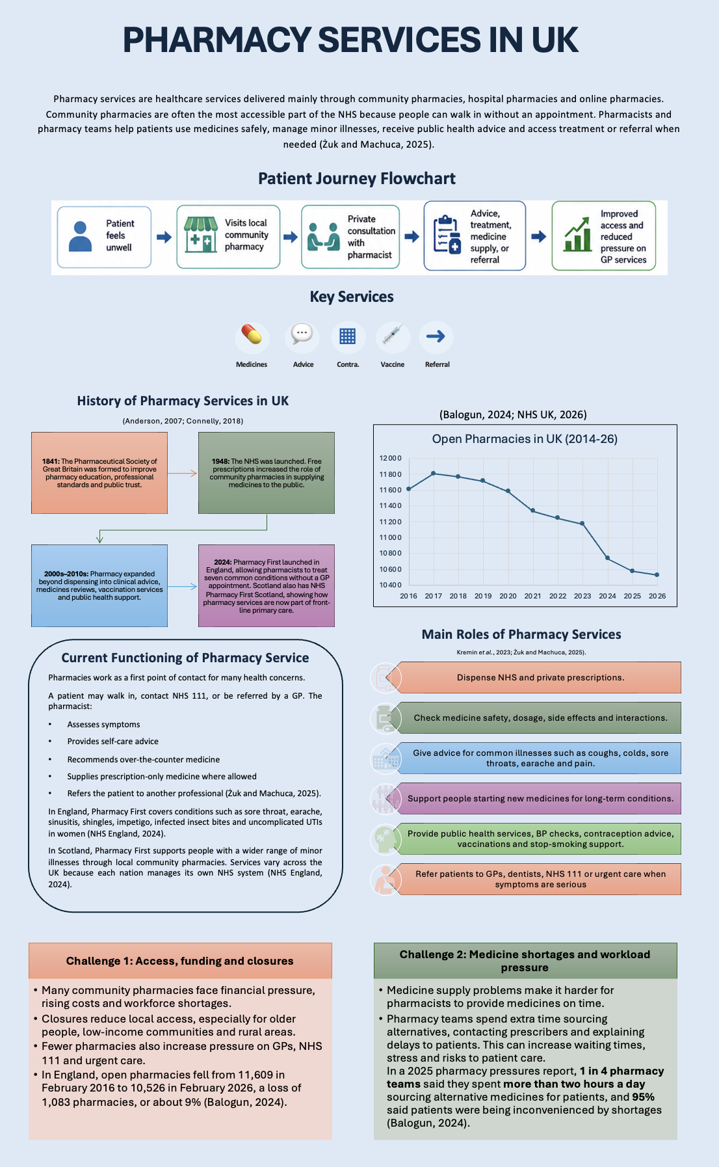
Task 2: Essay
Community Mental Health Services

Community mental health programs have been selected for analysis in this essay due to the fact that they highlight the shift within healthcare systems from an institutionally-controlled model of delivery towards a more community-supporting approach. Such programs cater for people suffering from mental health problems including major depression, bipolar disorder, schizophrenia, personality disorders, and anxiety problems (Malone et al., 2007). The objective of such programs is not merely therapeutic; they are aimed at facilitating safe, relationship, and community involvement.
Traditionally, mental healthcare services in Britain consisted of asylums and psychiatric hospitals. These facilities initially existed as shelters for people with various forms of illness, but soon enough most of them became crowded, restrictive and isolated environments (Turner et al., 2015). Post-World War II saw the formation of the NHS in 1948, which included mental healthcare under the umbrella of state provision. One important legislation was the 1959 Mental Health Act, which promoted more informal types of treatment (Gov UK, 1959). The 1962 Hospital Plan then supported the closure or reduction of large psychiatric hospitals and the development of care closer to home. Later, the NHS and Community Care Act 1990 and the Care Programme Approach in 1991 strengthened the idea that people with long-term mental health needs should have coordinated support in the community. By the late 1990s and 2000s, policy increasingly focused on multidisciplinary teams, risk management, recovery and service-user rights (Hall, 2022).
Today, community mental health services usually work through multidisciplinary teams. These may include psychiatrists, mental health nurses, psychologists, occupational therapists, social workers, support workers and voluntary-sector organisations. Services provide assessment, care planning, medication review, talking therapies, crisis support, safeguarding, relapse prevention and links to housing, employment and social care (Roth et al., 2021). NHS England’s recent Community Mental Health Framework promotes more integrated, place-based care, with closer links between GPs, specialist mental health teams and local community support (NHS England, 2019).
However, the current service has both strengths and weaknesses. Its main strength is that care can be delivered near the person’s home, making support more humane and less disruptive than hospital admission. Community care can also recognise social causes of distress, such as poverty, loneliness, trauma and housing problems. This makes it more holistic than a purely medical model (Williams et al., 2015). Despite all of this, services are facing challenges. Community mental health services are in demand, criteria for accessing help can be stringent, and many clients delay seeking treatment. Fragmentation of care, re-assessment, and lack of communication between services within the NHS, social care, and voluntary sectors have been observed among certain clients. Inequalities in services also exist as people living in deprived areas and some minorities face worse treatment (Turner et al., 2015).
Thus, the importance of community mental health services is extremely important. If they operate effectively, they will enhance the quality of life by enabling individuals to live independently, control their symptoms, gain confidence, and maintain social connections with family, education, employment, and the community. They are able to prevent isolation, emergencies, and promote recovery within the individual’s surroundings. To the carers and families, effective community interventions may alleviate stress as well as providing assurance that assistance is on hand before an emergency arises (Roth et al., 2021; Thornicroft, Deb and Henderson, 2016).
In conclusion, community mental health services evolved out of the decline of institution based care services and rise in community-based and right-oriented services. These services are currently important but are sometimes inconsistent and difficult to access. The potential importance of such services in future will be determined by adequate funding, provision of sufficient manpower, and user participation in decision making.

References
Anderson, S. (2007) ‘Community pharmacy and public health in Great Britain, 1936 to 2006: how a phoenix rose from the ashes’, Journal of Epidemiology & Community Health, 61(10), pp. 844–848. Available at: https://doi.org/10.1136/jech.2006.055442.
Balogun, B. (2024) Community pharmacy in England, House of Commons Library. Available at: https://commonslibrary.parliament.uk/research-briefings/cbp-9854/ (Accessed: 11 June 2026).
Connelly, D. (2018) NHS70: major moments in pharmacy 1948–2018, The Pharmaceutical Journal. Available at: https://pharmaceutical-journal.com/article/infographics/nhs70-major-moments-in-pharmacy-1948-2018 (Accessed: 11 June 2026).
Gov UK (1959) Mental Health Act, 1959. Available at: https://www.legislation.gov.uk/ukpga/1959/72/pdfs/ukpga_19590072_en.pdf.
Hall, J. (2022) ‘The development of supported mental health accommodation and community psychiatric nursing in Oxfordshire’, History of Psychiatry, 34(1), pp. 34–47. Available at: https://doi.org/10.1177/0957154x221136697.
Kremin, Y. et al. (2023) ‘Detailing the Ten Main Professional Roles of a Pharmacist to Provide the Scope of Professional Functions’, Scientia Pharmaceutica, 91(1), p. 5. Available at: https://doi.org/10.3390/scipharm91010005.
Malone, D. et al. (2007) ‘Community mental health teams (CMHTs) for people with severe mental illnesses and disordered personality’, Cochrane Database of Systematic Reviews, 3(3). Available at: https://doi.org/10.1002/14651858.cd000270.pub2.
NHS England (2019) NHS England» The community mental health framework for adults and older adults, England.nhs.uk. Available at: https://www.england.nhs.uk/publication/the-community-mental-health-framework-for-adults-and-older-adults/ (Accessed: 11 June 2026).
NHS England (2024) Pharmacy First, www.england.nhs.uk. Available at: https://www.england.nhs.uk/primary-care/pharmacy/pharmacy-services/pharmacy-first/ (Accessed: 11 June 2026).
NHS UK (2026) Pharmacy Openings and Closures - Open Data Portal, Nhsbsa.net. Available at: https://opendata.nhsbsa.net/dataset/pharmacy-openings-and-closures (Accessed: 11 June 2026).
Roth, C. et al. (2021) ‘Experiences of healthcare staff providing community-based mental healthcare as a multidisciplinary community mental health team in Central and Eastern Europe findings from the RECOVER-E project: an observational intervention study’, BMC Psychiatry, 21(525). Available at: https://doi.org/10.1186/s12888-021-03542-2.
Thornicroft, G., Deb, T. and Henderson, C. (2016) ‘Community mental health care worldwide: current status and further developments’, World Psychiatry, 15(3), pp. 276–286. Available at: https://doi.org/10.1002/wps.20349.
Turner, J. et al. (2015) ‘The History of Mental Health Services in Modern England: Practitioner Memories and the Direction of Future Research’, Medical History, 59(4), pp. 599–624. Available at: https://doi.org/10.1017/mdh.2015.48.
Williams, E. et al. (2015) ‘Mental health consumers’ perceptions of quality of life and mental health care’, Nursing & Health Sciences, 17(3), pp. 299–306. Available at: https://doi.org/10.1111/nhs.12189.
Żuk, A. and Machuca, M. (2025) ‘Pharmaceutical Care Services in Community Pharmacies: An Umbrella Review of Global Evidence with Insights from Polish and Spanish Practices’, Integrated Pharmacy Research and Practice, 14, pp. 113–136. Available at: https://doi.org/10.2147/iprp.s529641.

