  Component One: Student Journal (learning log) 750 words +/- 10%  Contribution to Overall Module Assessment: 25% | Student No: | 2239415
 | Module Title: | Hotel Placement - Operating Hotel Facilities
 | Module Code: | BMIH4006
 | Lecturer: | SCOTT JAMES
Component 1:
Description: I was recruited in the housekeeping department of Hampton by Hilton London Luton Airport. Within the housekeeping department of the hotel, I undertook various responsibilities and tasks, including cleaning and maintaining hotel rooms, cleaning public areas and setting of rooms for events and cleaning after conferences and parties. I was also responsible for washing, drying and folding the linens and towels and changing the linens as and when required.
Andrade et al. (2021) stated that housekeeping duties contribute to overall guest experience because it denotes safety, comfort and uplifts the reputation of the organisation. For instance, when linen, towels, bathroom, and the room is clean, it reflects a well-maintained environment, creating an atmosphere of safety for the health of guests. It also makes the guest feel valued and well cared (Alcalde-González et al. 2021).
I was extremely concerned about the individual needs and requirements of my guest. As a result, when I made a highly professional, cheerful, and prompt attention to needs and requirements of guests such as offering them complimentary chocolates according to their preferences and taking care of their health requirements like offering orthopaedic pillows, or using fragrance that guests like, it has reflected my commitment towards offering them excellent service.
Feelings: Sadhale (2021) highlighted that housekeeping teaches important life lessons and skills, such as efficiency, responsibility, and pride in keeping the environment orderly, organised and clean. However, through this placement experience, I felt extremely overwhelmed with the number of tasks that I was given in a particular day. Time was a major issue since I constantly focused on meeting customers' needs and requirements of each and every guest. However, there was very little time for me to perform these tasks that satisfied the guests. My way of working was quite different from other employees working within the department. It was extremely frustrating since I was not getting along with my teammates. Working within a fast-paced environment is both thrilling and challenging (Haugen and Preil, 2020). When I completed the task while ensuring that all needs and requirements of the guest have been fulfilled completely, I felt extremely satisfied with my work. However, on top of this, collaborating with my teammates was extremely challenging since our views were not matching.
Evaluation: The most important strength that I felt I possessed are my personality traits and ethical qualities. Most of the guests gave me feedback that I was extremely pleasant to talk to. My problem-solving skills are also excellent since I focused on critical thinking and active listening. I spoke to the guest for their feedback and kept an open mind to offer them solutions for their problems.
However, there are certain skills and capabilities that I need to acquire if I want to become successful within the hospitality industry. These are communication skills and time management, skills and capabilities. Attending each and every detail that helps meet customer preferences took a lot of time for me to complete the tasks. I could not delegate unimportant but urgent tasks to my teammates. My communication skill is also weak because when my team members were giving me feedback on improving time management skills, I did not give them much attention.
Analysis: from my placement, I realise that the housekeeping department plays a very important role in the satisfaction of guests because we as housekeepers have a direct contact with the guest and are responsible for ensuring their comfort and safety. Operational tasks such as cleaning is crucial as after the outbreak of the COVID-19 pandemic, the guests feel safe and secure (Mullins and Dossor, 2013). When they see that a particular property is well cleaned and it is maintaining cleanliness standards which are according to COVID-19 norms issued by the government (Rawal et al. 2020). Hence, it leads to hotel success.
Conclusion: Whiting and Symon (2020) highlighted that recruitment in the housekeeping department makes an individual efficient in terms of maintaining health and safety guidelines, and executing a standardised, housekeeping plan. A very important lesson that I learnt is that housekeepers have to handle toxic chemicals and work on slippery surfaces. Hence, we must properly train ourselves to keep us and other colleagues safe. It is also important to complete tasks within time and hence, organisation skills are very important (Ng, 2021). Gaining organisational skills can help me work much more efficiently in a team setting collaborating with other team members to achieve common goals of the department.
Action plan: for enhancing communication and time, management, skills and capabilities, I will be using the Eisenhower time management technique so that I can understand those activities that our urgent and important and carry them out immediately while those tasks which are urgent but not important can be delegated (Dmytryshyn and Goran, 2022). to improve my communication skills and capabilities, I will have to improve my emotional intelligence skills so that I can understand the reactions made by other individuals before further reacting on their feedback.

Component Two: Health and Safety Guide
Potential risks, industry best practices and regulations of housekeeping safety.
The housekeeping staff can face a lot of issues. These issues are as follows:
- Slips and trip: Bad housekeeping can cause a lot of accidents associated with slip and trip. To reduce the risk of tripping, it is always advised to keep walkways, unobstructed, clear and dry. If the walkway is wet, then safety signs must be kept to inform individuals who are walking from the walkways. It is important to keep wires away from equipment and avoid any cables lying on the floor to the vent tripping hazard.
- Fire hazard: Poor housekeeping can also increase the risk of fire taking place within the property. This is mainly because flammable substances and materials are stored incorrectly and there is also lack of training among the housekeeping staff to use these materials correctly. Both these incidents can pose a major fire hazard within the property (Shapoval et al. 2022).
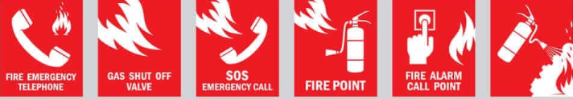
- Chemical exposure: The housekeeping staff has to use a lot of cleaning products which have harsh chemicals, which can be hazardous to health and safety of the staff members, causing skin and eye irritation, breathing problems, infection, burns, reaction to skin and respiratory issues.
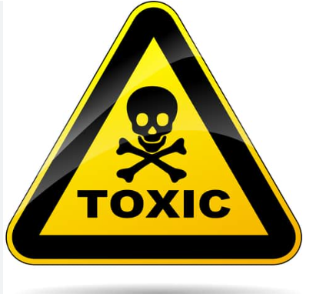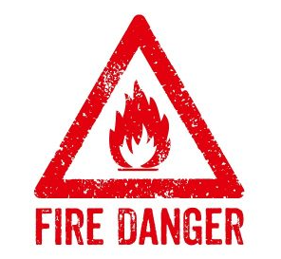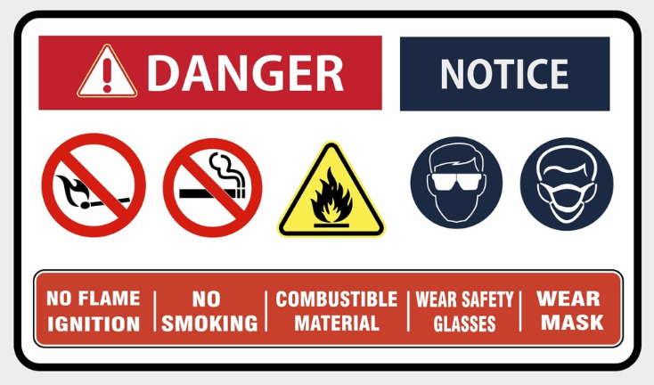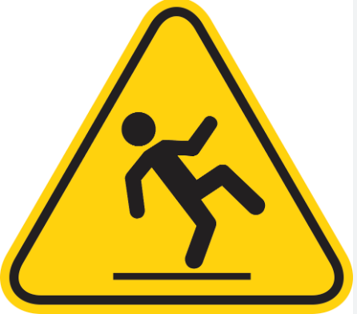
To prevent housekeeping staff members from encountering any of these risks, industry best practices and regulations have been developed to promote health and safety. These regulations and best practises are as follows:
- The employees should always ensure that any spill that is taking place within the property has been cleaned up immediately.
- In case the area is wet, there are warning signs kept on walkways, and in the aisle ensuring that guests and other staff members have clear communication of obstructions.
- An important best practice is to train the employees to inspect and use personal protective equipment and tools to keep themselves safe from any kind of chemical exposure. Training regarding fire hazard also has to be given to team members (Vincoli, 2024).
- The housekeeping staff should also practise hand and personal hygiene protocols, such as regular hand washing, using alcohol-based hand sanitisers and soaps (Quick, 2020).
- Controlling dust, avoiding clutter and prevention of objects falling are other important practices that are undertaken within the housekeeping department to prevent accidents.
Precautions
To prevent accidents and injuries from taking place within the workplace, there are certain precautions that have been taken in Hampton by Hilton London Luton Airport. These precautions are as follows:
- First, avoiding clutter and cleaning up spills immediately should be a common practice in the organisation. Any items such as decorative pieces, books, ladders, and showpieces are stored properly and kept in a place where there is no risk of falling down. There is a clear path with no obstruction. All spills that take place should be cleaned up immediately. The housekeeping staff also must focus on keeping the stairway free from any accident. To avoid fall, it is important to check that the handrail is running through the entire length of the staircase (Attia et al 2022).
- In the hotel, rugs are often used and it becomes extremely risky for staff members and customers to fall after tripping on the rugs. The rugs can also slide beneath the feet and they throw the customers off balance causing them to trip and fall. The housekeeping staff must ensure that all the rugs are put to place and non-skid pads are used. Double sided carpet tape should also be used to ensure slip resistance (Sadhale, 2021).
- All emergency items must be kept in a hand's reach (Raghubalan and Raghubalan, 2016). The hotel must be stocked with emergency items, such as first aid kits, batteries, flashlights and fire extinguishers. The staff members must be properly trained to use the fire extinguisher and use stairs in case of outbreak of a fire. The lift must be stopped from being used in case of a fire hazard.
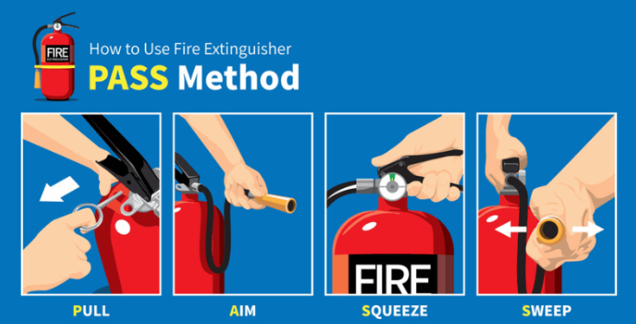
- After cleaning, the staff members must properly dispose of the waste and wash their hands before touching anything else. This ensures proper hand and personal hygiene.
Procedures
The organisation must also develop a step-by-step procedure for room cleaning. This will help the staff members get a proper guide.
- The staff members must first change bedlinen, bedspreads, and ensure that table, bed head, side tables, and bathroom counter is free from any dust or spills. All surface area must be cleaned with a disinfectant that is approved by the health and safety department of the organisation complying with COVID-19 pandemic cleaning standards (Bridger, 2021).
- In the bathroom, the sink, toilet and bathtub must be scrubbed every day and bathroom linen should be changed according to the needs and preferences of the customers.
- Finally, once the floor is dry, the staff members have to vacuum the floor and new supplies should be replenished. Old supplies should be collected safely in the waste bin
- In the entire process, the staff members must use personal protective equipment, such as masks, safety eyewear and gloves.
Equipment
The following tools and equipment must be used when cleaning the room.
- Bathroom toilet brush
- Broom and dustpan
- Vacuum cleaners
- Mop
- Protective eyewear and gloves
- Scrubber and sponge
- Cleaning agents
- Dustpan and waste bin
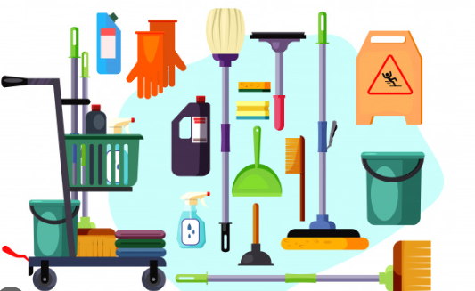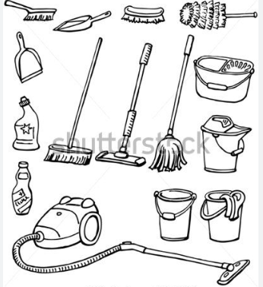
Hazard Mitigation
To mitigate hazard on health and safety of staff members, they should not only be trained to use the chemicals properly but the green and eco-friendly cleaning agents must be used which is free from any toxic chemicals. For instance, instead of using harsh chemicals, natural Non-toxic cleaning agents can be used. To prevent biological hazards such as exposure to infectious pathogens from the bathroom waste, mask and gloves must be worn at all times.

Component 3: Presentation
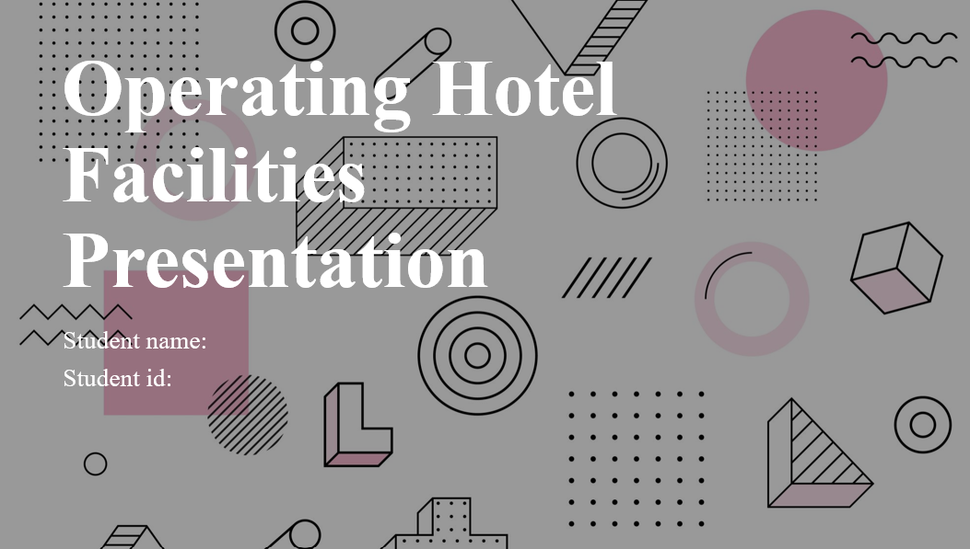
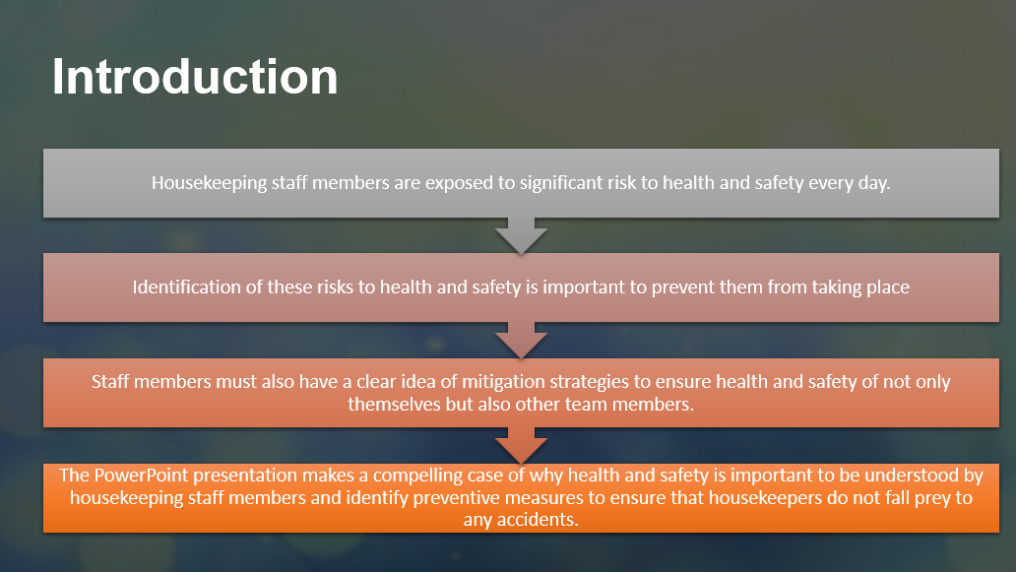
The housekeeping department within a hotel is often considered to be an important department because it is responsible for ensuring organisation and environmental cleanliness. However, it is more than that. Housekeepers are exposed to a number of risks of health and safety every day.

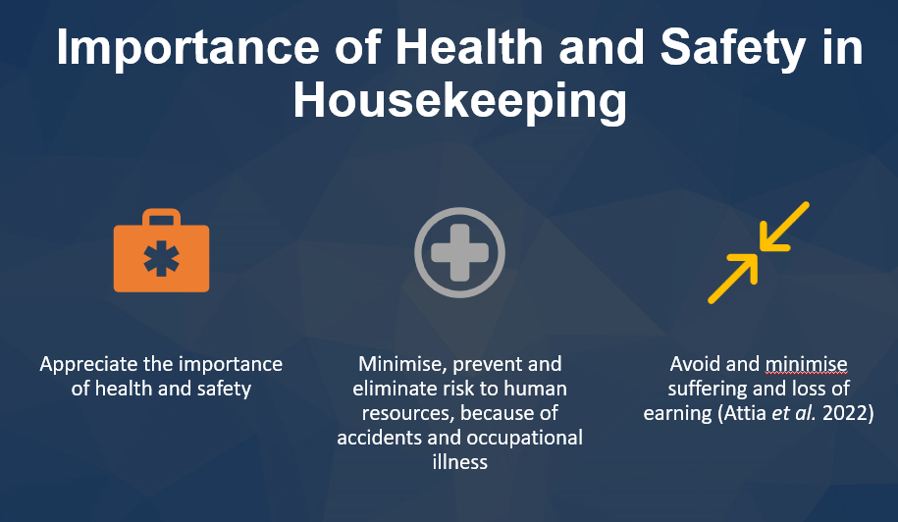
Health and safety to human resources is very crucial to ensure that any risk to health and safety is minimised, prevented and eliminated. Any form of industrial accident is a blow to organisational reputation. Understanding, health and safety can prevent this from taking place.
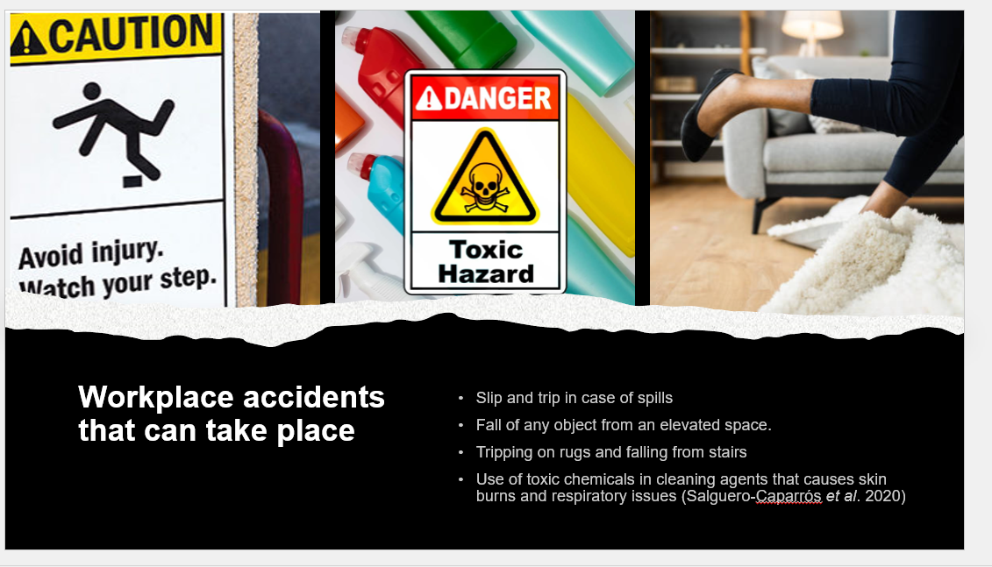
There are various types of workplace accidents that can take place within hotels. Slips and trips and falling down on wet surfaces is a very common accident. Apart from this, falling from stairs and falling of any object from elevated space also can cause significant injury to human beings. Skin or respiratory reaction to toxic chemicals can be extremely hazardous for the health and safety of employees.
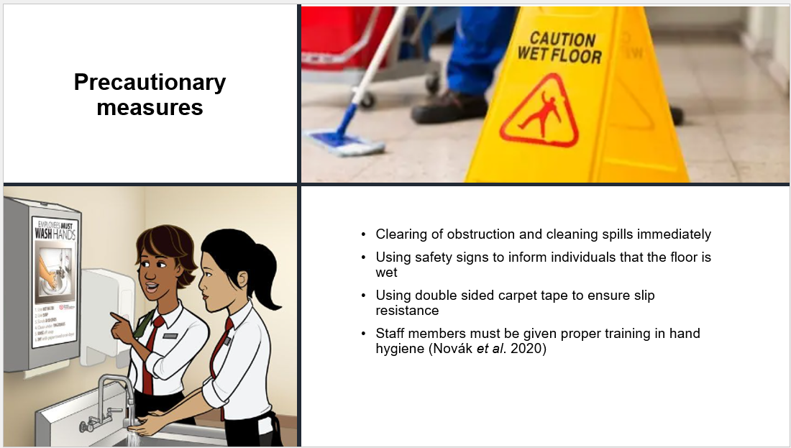
The staff members must be given proper training in hand hygiene, disposal of waste and use of safety kits and protective personal equipment. Online training sessions can be carried out to ensure that whenever staff members are using hazardous chemicals to clean the surface, they must use proper equipment, such as gloves and Mask to prevent toxic chemicals from touching their skin or being inhaled through the respiratory tract.

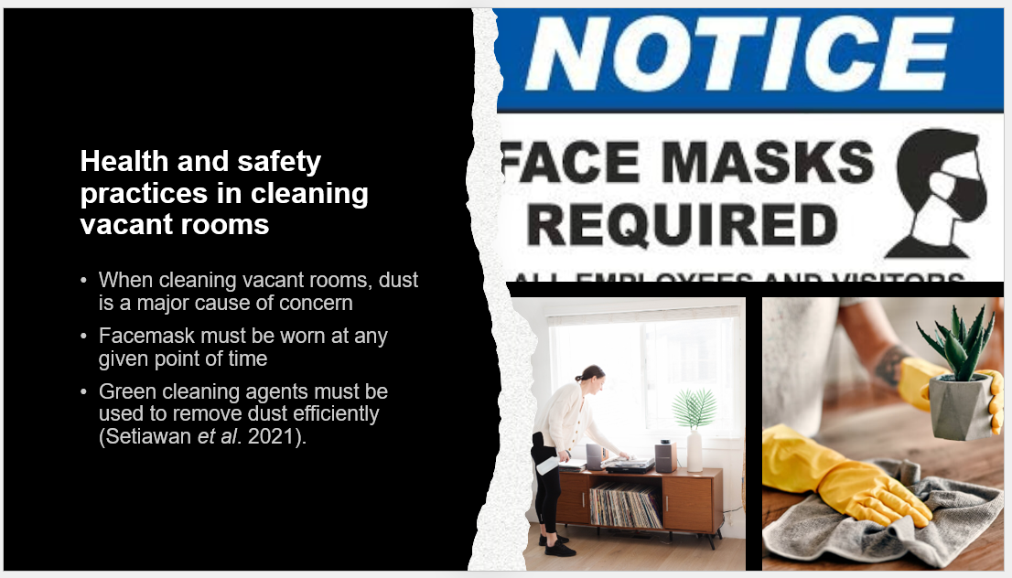
When cleaning vacant rooms, dust is a very common cause of concern for the housekeeping staff. As a result, face masks must be always worn to reduce any sort of respiratory problem.
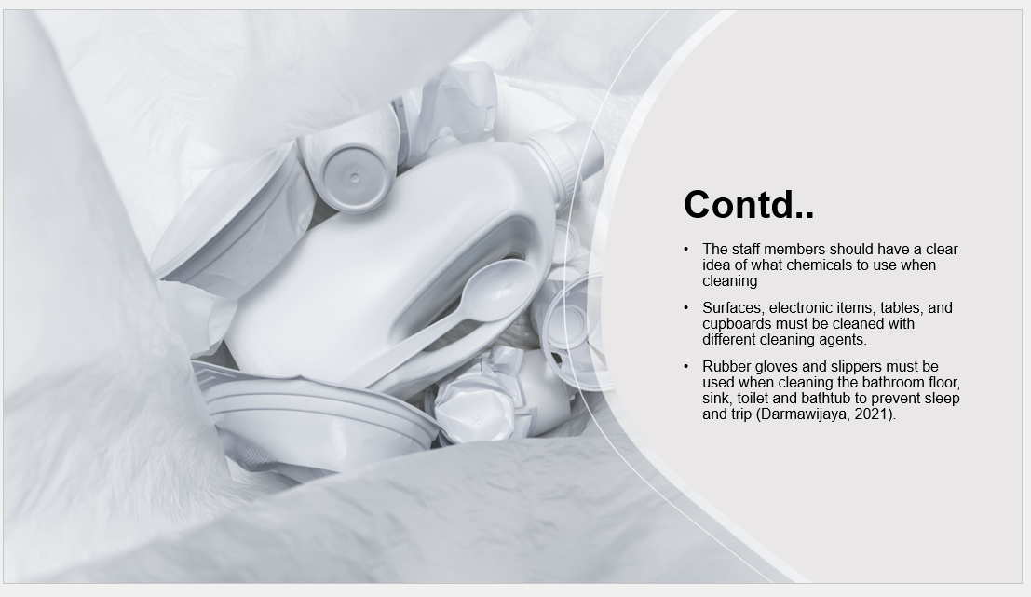
Different cleaning agents must be used to clean surfaces, electronic items and cables as it will not only be helpful in cleaning the dust properly, but also ensure that none of the electronics are Exposed to chemical agents that can impact their efficacy.

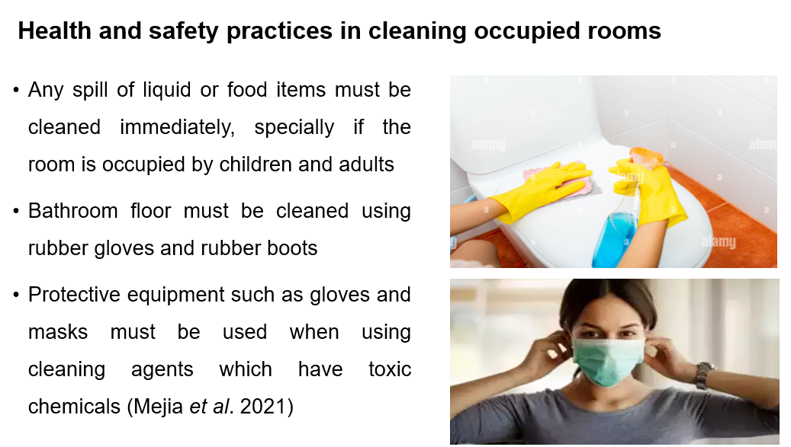
After entering the room, the staff members show the first look for any spill on the tables, floor, or bathroom floor. Water running on the bathroom floor must be cleaned immediately to avoid slip and trip.
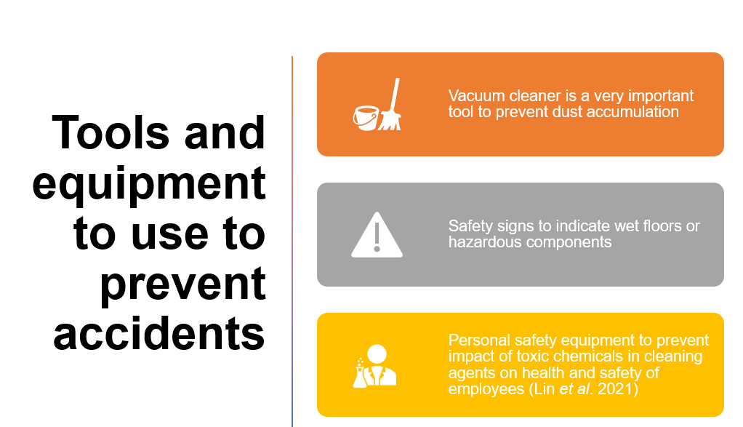
There are various equipment and tools that can be used not only to prevent accidents but also ensure that the daily activities of the housekeeping staff is conducted in the most efficient manner. This equipment includes vacuum cleaner, personal protection kits, Mop, vacuum cleaners, broom, dust pan, scrubber, waste bin and protective gloves.
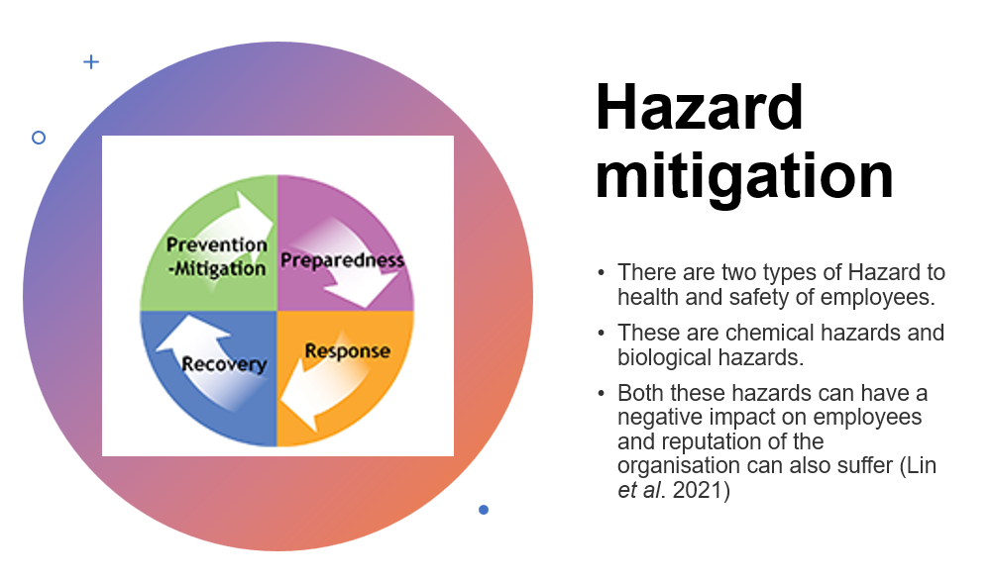
Chemical hazard refers to toxic use of chemicals that impacts the health of employees. Biological hazards refer to pathogens and infectious diseases that can impact health and safety of employees especially when they are cleaning the bathroom and dealing with waste disposal.
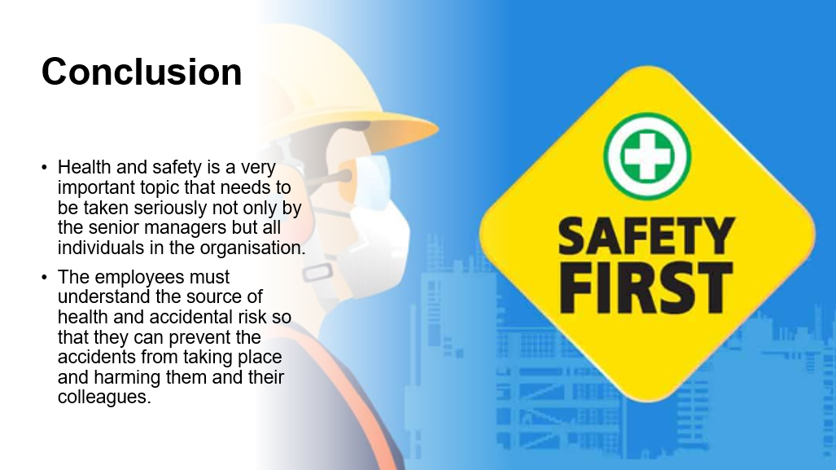
The employees should have a clear understanding of what can impact them and their colleagues so that a healthy working environment is established where employees are feeling safe and secure to work. Identification of risks and developing preventive measures is crucial for preventing any sort of accident.
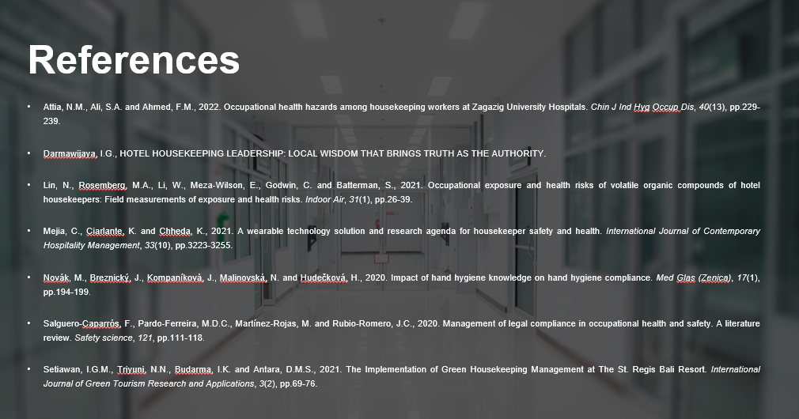
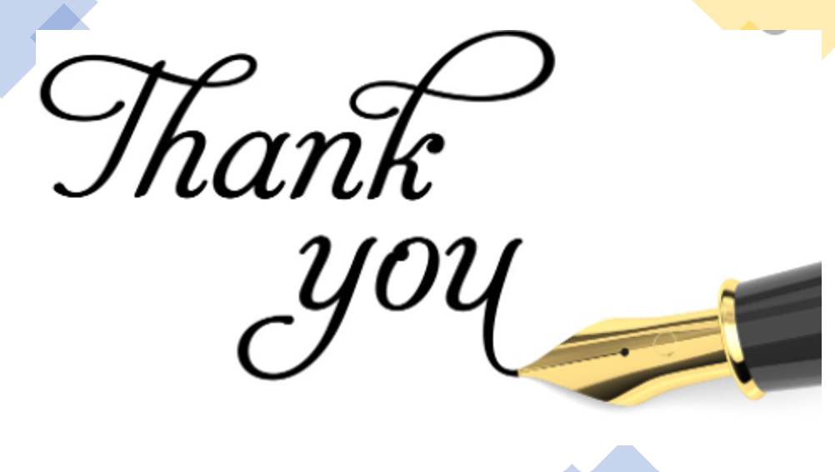

Reference List
Component 1
Alcalde-González, V., Mozo, A.G. and Bustos, A.V., 2021. No clean rooms, no hotel business: Subversion tactics in Las Kellys’ struggle for dignity in hotel housekeeping. Annals of Tourism Research, 91, p.103315.
Andrade, M.S., Miller, D. and Westover, J.H., 2021. Job satisfaction factors for housekeepers in the hotel industry: a global comparative analysis. International Hospitality Review, 35(1), pp.90-108.
Dmytryshyn, M. and Goran, T., 2022. Proposal of an effective time management system. Management: Journal of Contemporary Management Issues, 27(2), pp.283-298.
Haugen, Ø.R. and Preil, J., 2020. We can't help feeding the monster: the social handling of uncertainty in an environment of high-risk and fast-paced change. Organisational and Social Dynamics, 20(1), pp.79-100.
Mullins, L. and Dossor, P. 2013. Hospitality management and organisational behaviour. Pearson Education.
Ng, A.M.L., 2021. Housekeeping Skills Training for Independent Living Among Malaysian Adolescents with Special Needs: A Case Study. Journal of Special Needs Education, 11, pp.30-50.
Rawal, Y.S., Pal, S., Bagchi, P. and Dani, R., 2020. Hygiene and safety: A review of the hotel industry in the era of COVID-19 pandemic. Bioscience Biotechnology Research Communications, 13(10), pp.79-83.
Sadhale, M., 2021. The Changing Role of Housekeeping Department in Hotels Post COVID-19 Pandemic. Eureka Publications.
Whiting, R. and Symon, G., 2020. Digi-housekeeping: the invisible work of flexibility. Work, employment and society, 34(6), pp.1079-1096.

Component 2
Attia, N.M., Ali, S.A. and Ahmed, F.M., 2022. Occupational health hazards among housekeeping workers at Zagazig University Hospitals. Chin J Ind Hyg Occup Dis, 40(13), pp.229-239.
Bridger, E., 2022. Employee engagement: A practical introduction (Vol. 24). Kogan Page Publishers.
Raghubalan, G. and Raghubalan, S. 2016. Hotel Housekeeping - Operations and Management. 3rd ed. India: Oxford University Press.
Sadhale, M., 2021. The Changing Role of Housekeeping Department in Hotels Post COVID-19 Pandemic. Eureka Publications.
Shapoval, V., Sönmez, S., Hsieh, Y.C. and Apostolopoulos, Y., 2022. Occupational health and safety of immigrant hotel housekeepers. Workplace Health & Safety, 70(12), pp.566-573.
Quick, L. 2020. Managing Events. Real Challenges, Real Outcomes. London: SAGE Publications Ltd.
Vincoli, J.W., 2024. Basic guide to system safety. John Wiley & Sons.
Component 3
Attia, N.M., Ali, S.A. and Ahmed, F.M., 2022. Occupational health hazards among housekeeping workers at Zagazig University Hospitals. Chin J Ind Hyg Occup Dis, 40(13), pp.229-239.
Darmawijaya, I.G., HOTEL HOUSEKEEPING LEADERSHIP: LOCAL WISDOM THAT BRINGS TRUTH AS THE AUTHORITY.
Lin, N., Rosemberg, M.A., Li, W., Meza‐Wilson, E., Godwin, C. and Batterman, S., 2021. Occupational exposure and health risks of volatile organic compounds of hotel housekeepers: Field measurements of exposure and health risks. Indoor Air, 31(1), pp.26-39.
Mejia, C., Ciarlante, K. and Chheda, K., 2021. A wearable technology solution and research agenda for housekeeper safety and health. International Journal of Contemporary Hospitality Management, 33(10), pp.3223-3255.
Novák, M., Breznický, J., Kompaníková, J., Malinovská, N. and Hudečková, H., 2020. Impact of hand hygiene knowledge on hand hygiene compliance. Med Glas (Zenica), 17(1), pp.194-199.
Salguero-Caparrós, F., Pardo-Ferreira, M.D.C., Martínez-Rojas, M. and Rubio-Romero, J.C., 2020. Management of legal compliance in occupational health and safety. A literature review. Safety science, 121, pp.111-118.
Setiawan, I.G.M., Triyuni, N.N., Budarma, I.K. and Antara, D.M.S., 2021. The Implementation of Green Housekeeping Management at The St. Regis Bali Resort. International Journal of Green Tourism Research and Applications, 3(2), pp.69-76.

