Title:
E-portfolio
Student Name:
Liselothe Kandinda
Student Number:
2314130
Module Code: BMHP5015

Contents Page

Unit 1: Brand you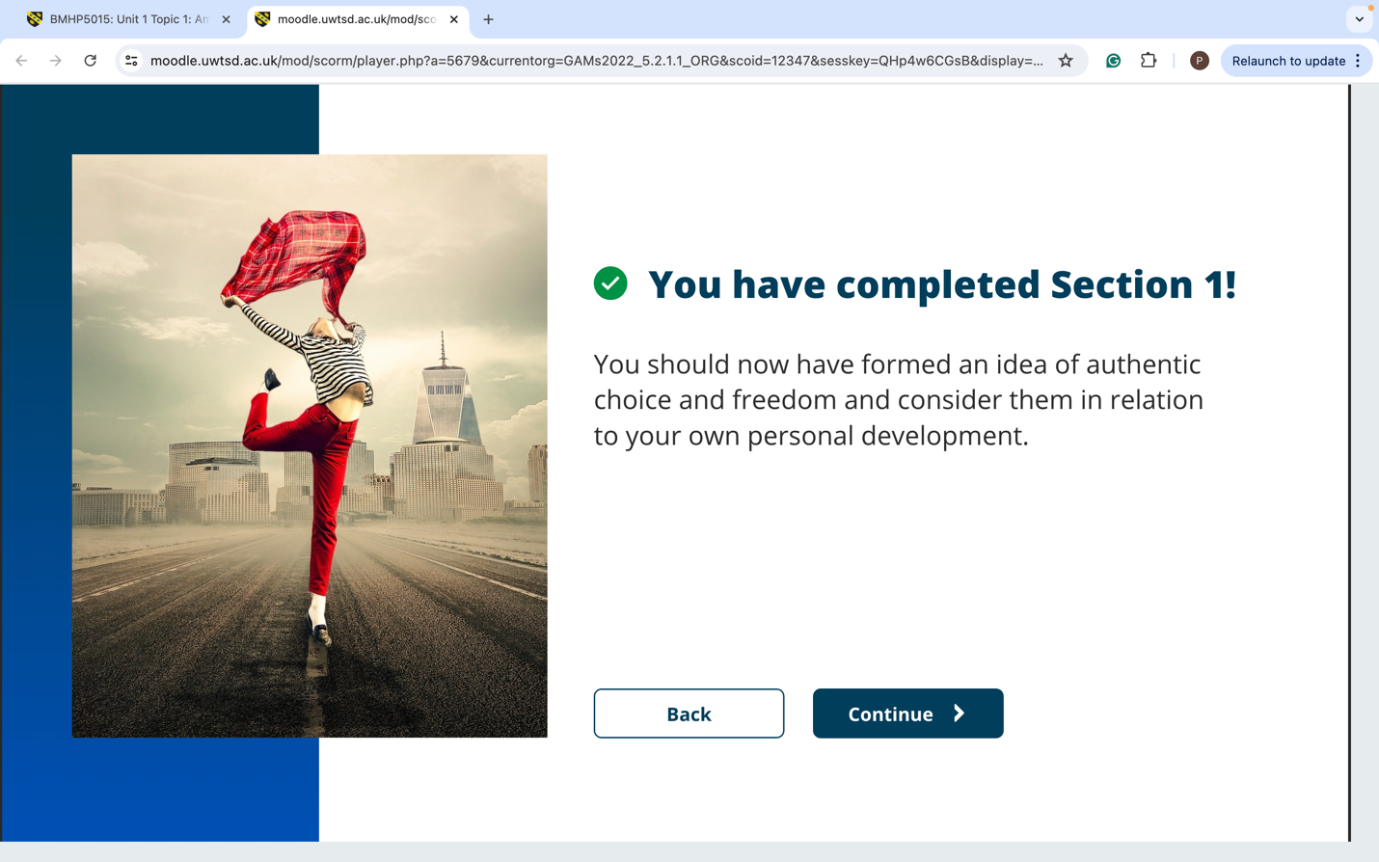




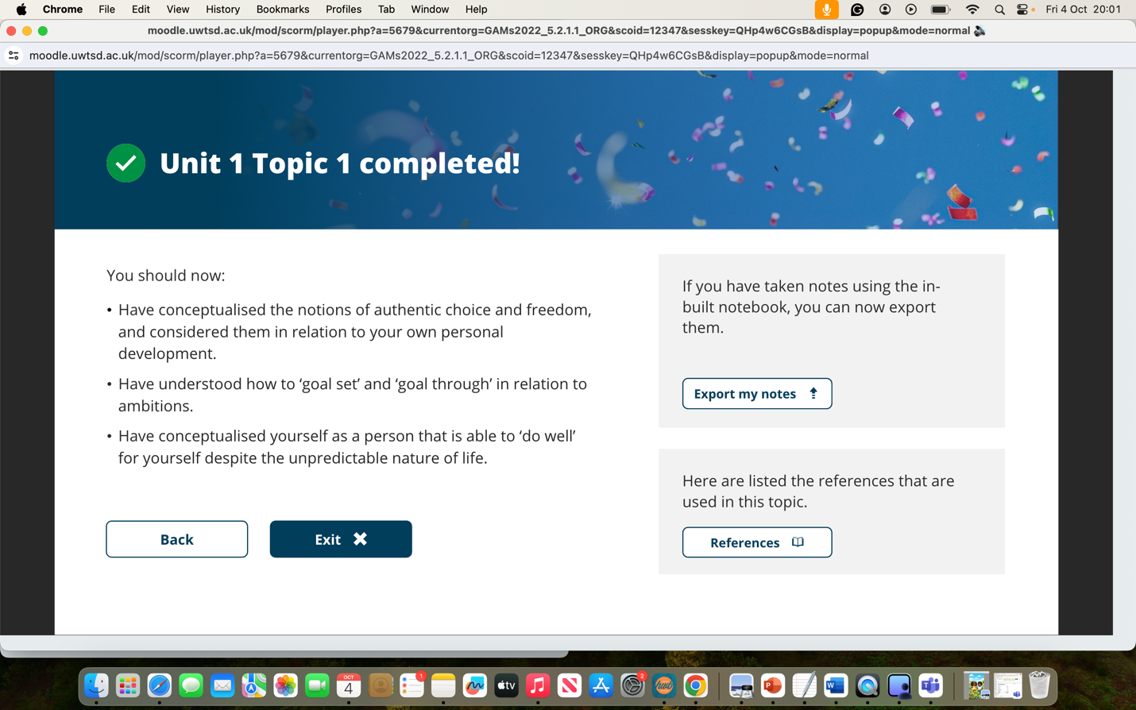

Forum post Unit 1
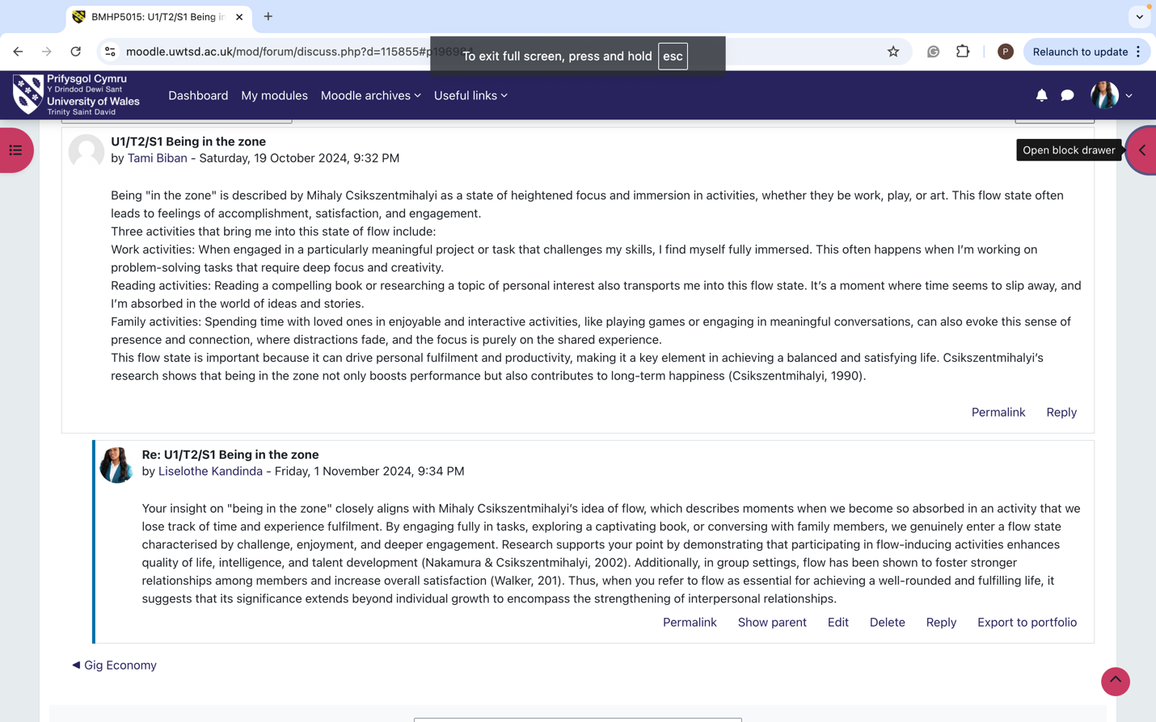
Unit 2:


Unit 3 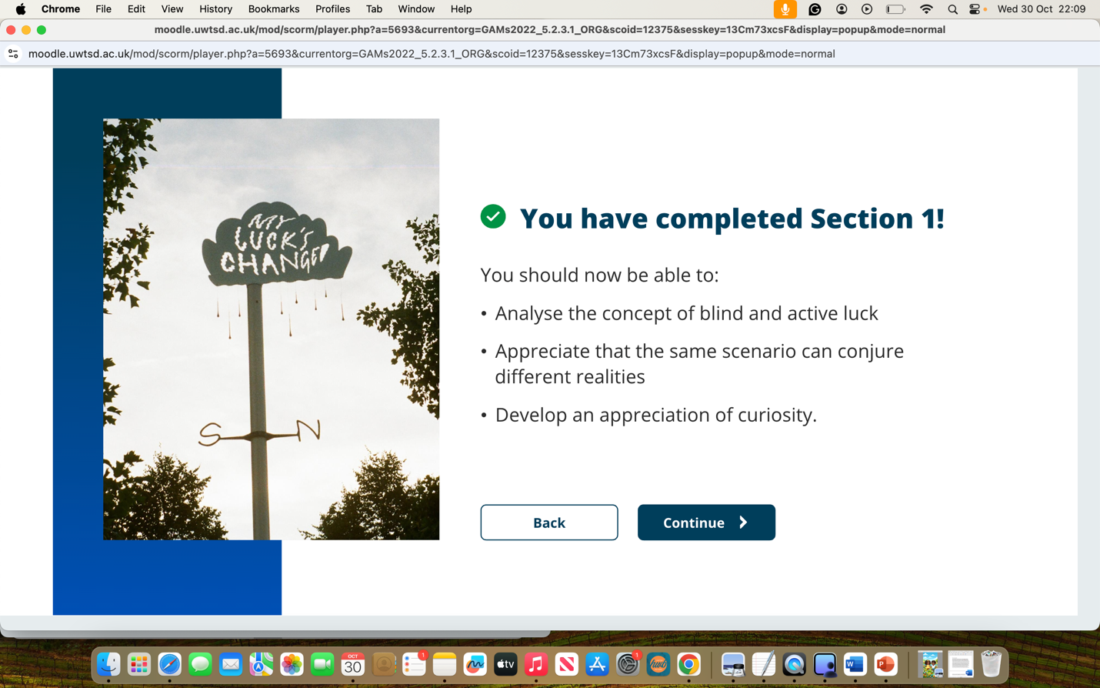
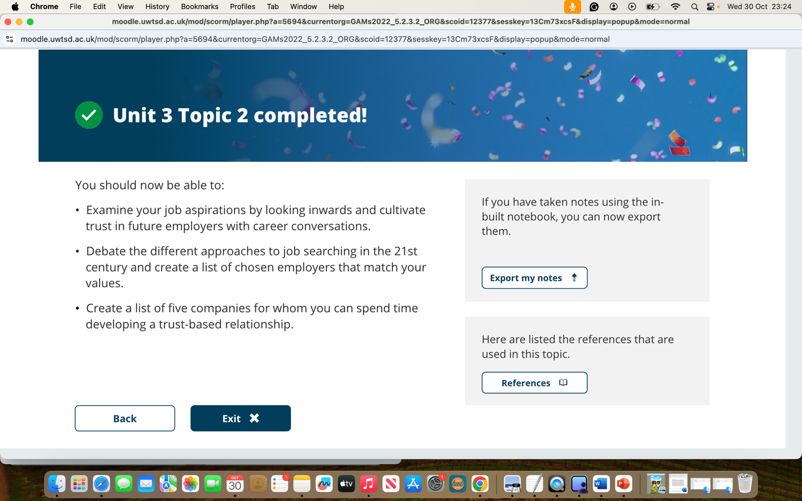
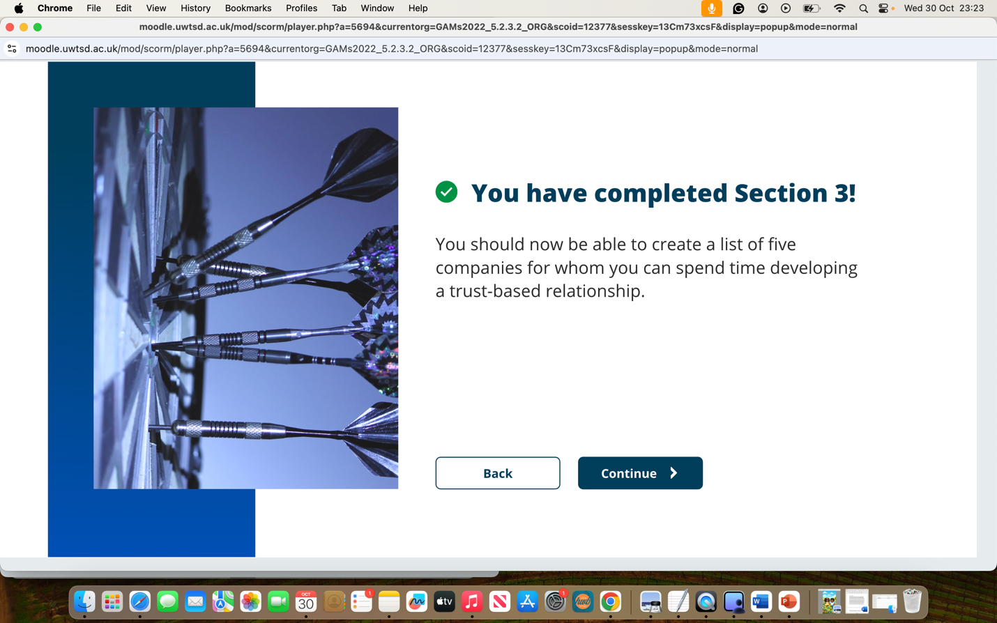
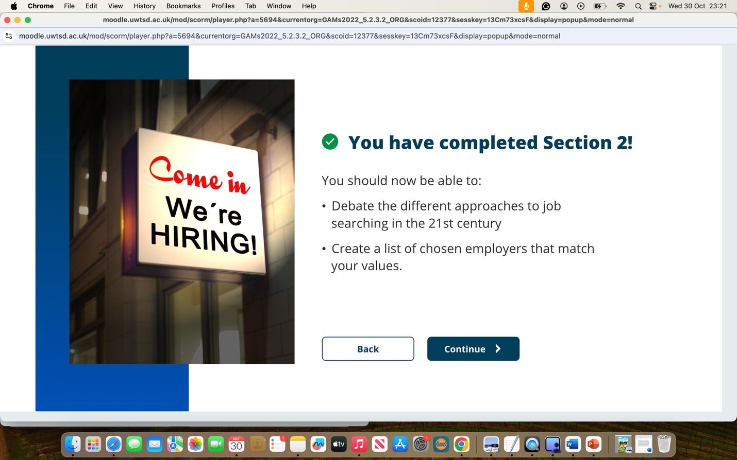

Unit 4 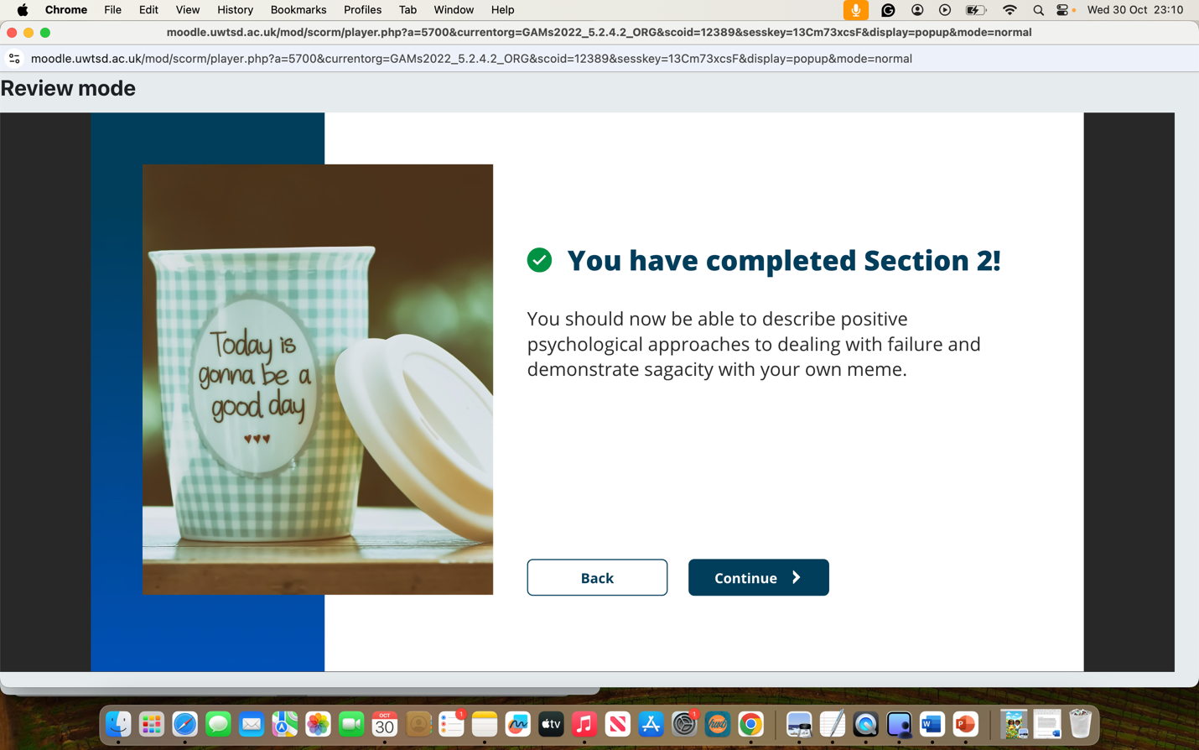


Unit 1: Forum Post
Topic 1: Ambition is Critical
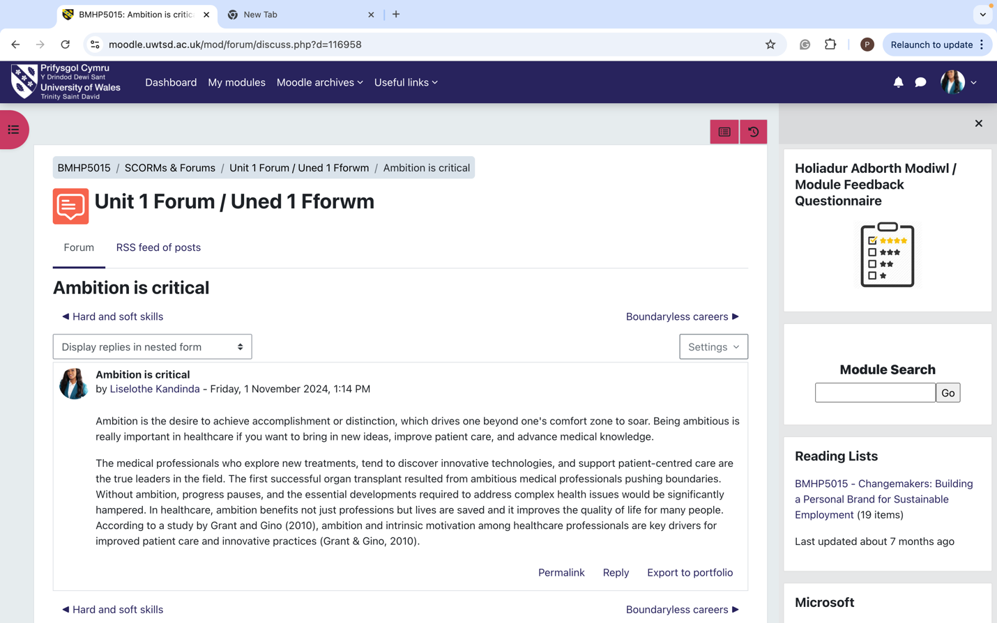

Topic 2: What drives you
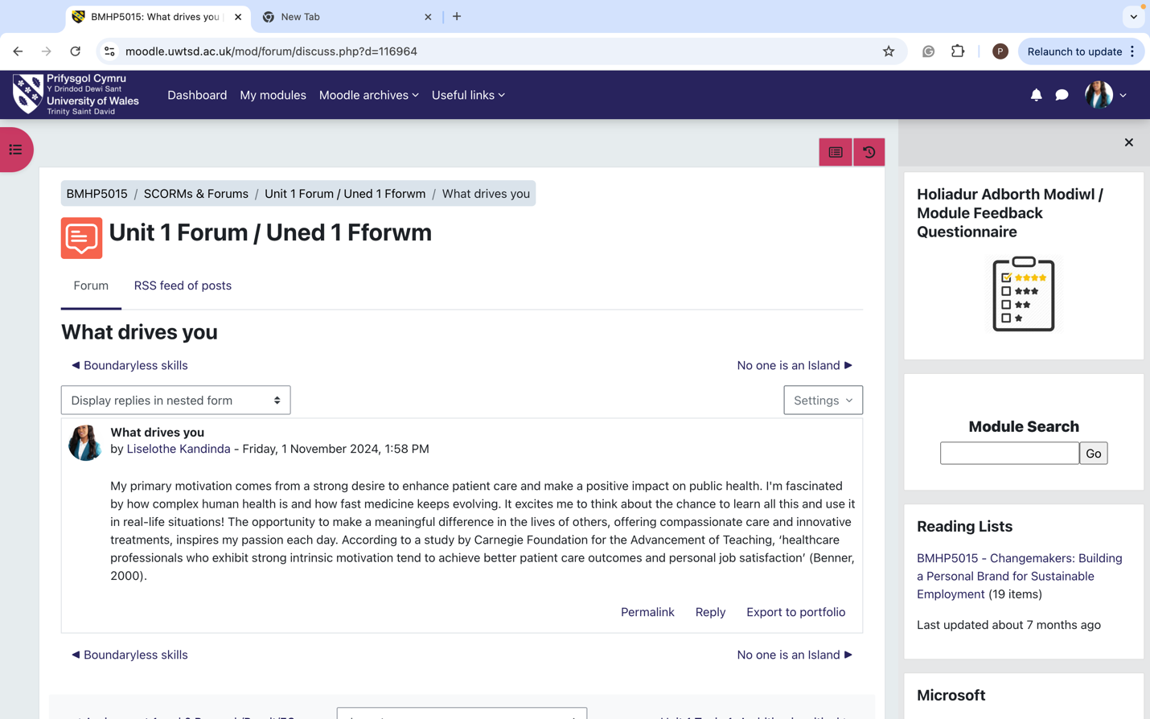

Topic 3: Boundaryless Careers
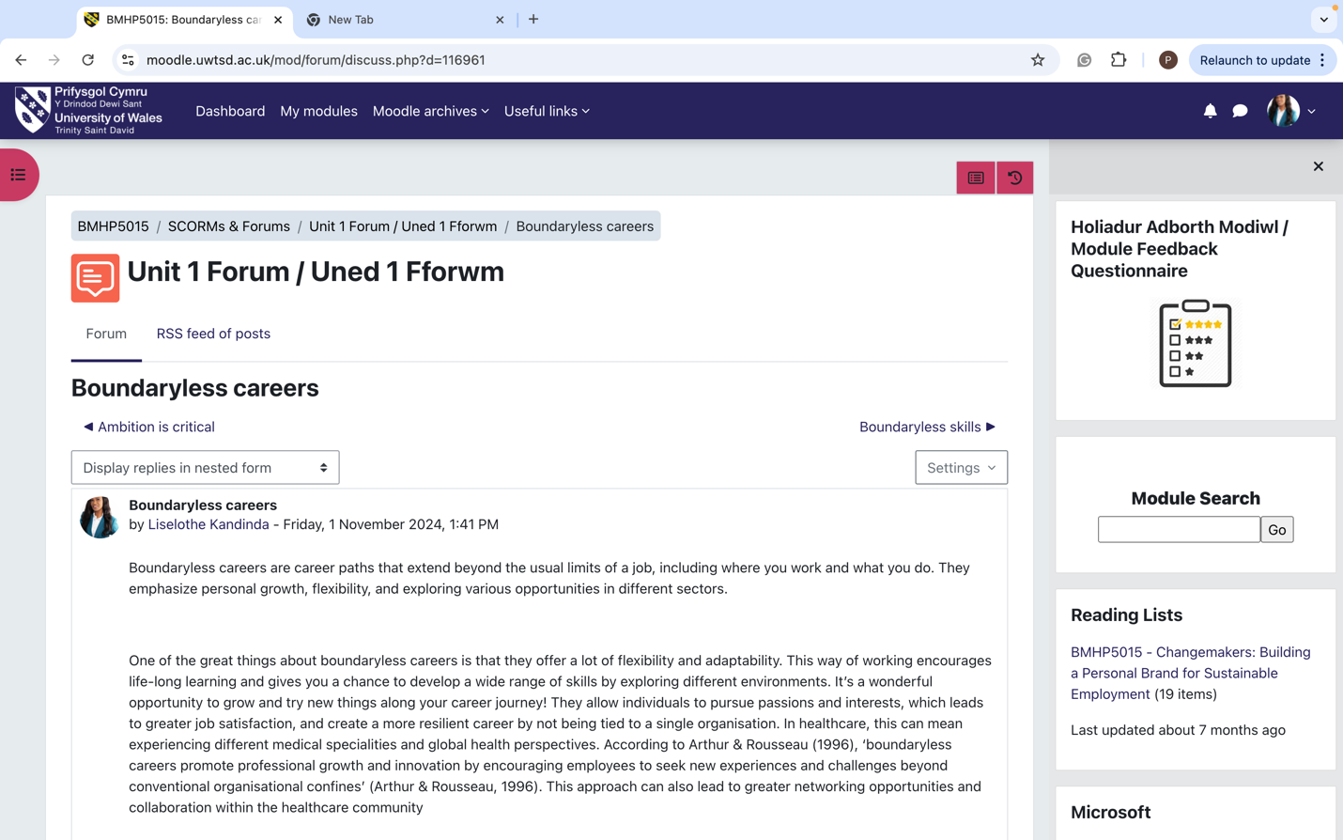

Forum posts: Gig Economy

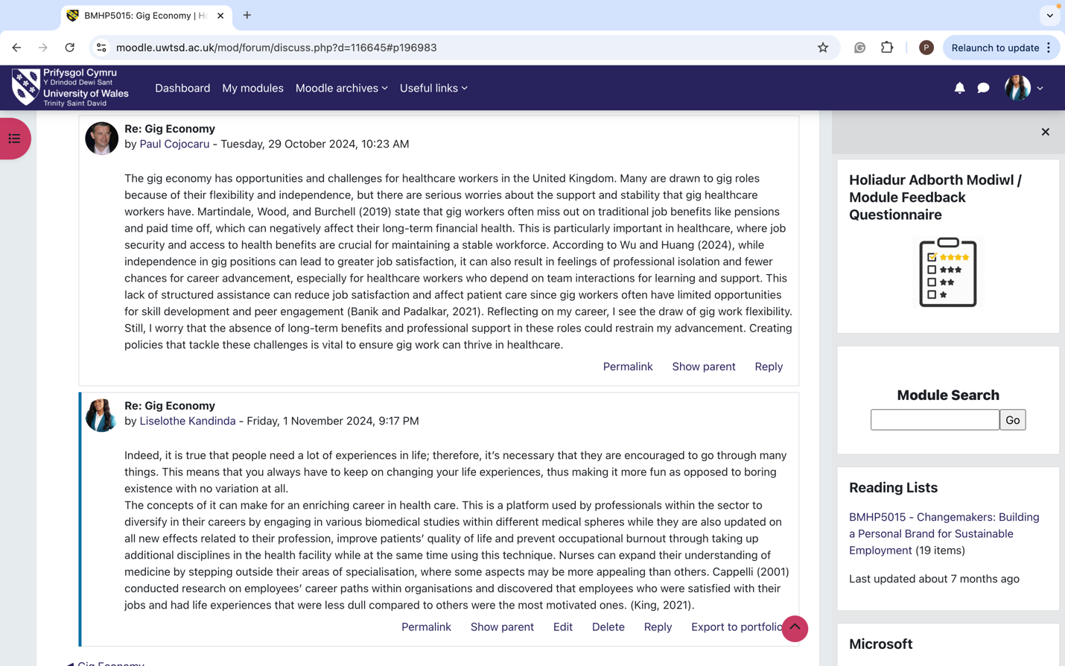
Topic 4 : Boundaryless Skills 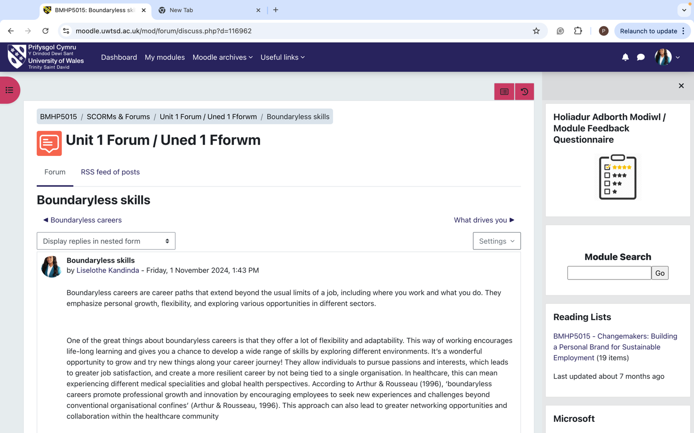

Unit 2:
Topic 1: No one is an Island
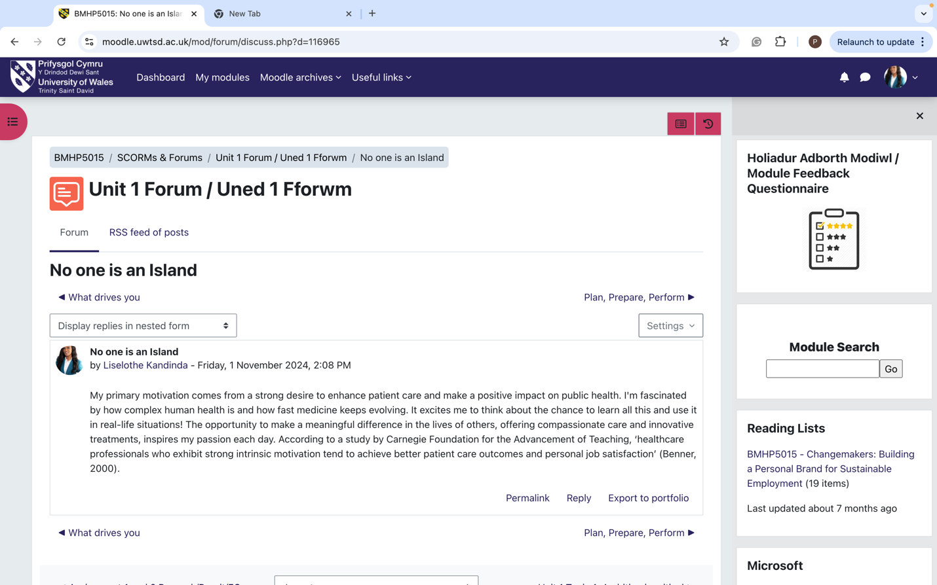
Forum posts Unit 2

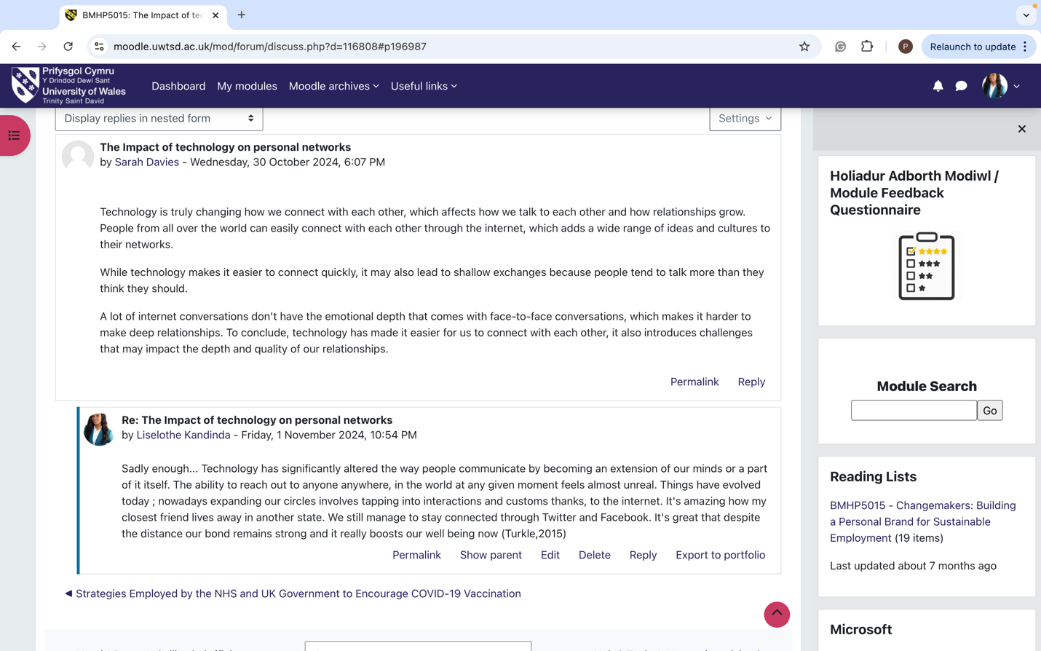
Topic 1:Gig Economy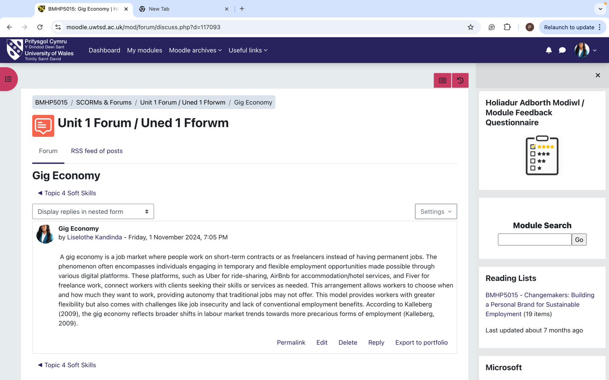
Unit 3:
Forum post:
Discovering my dream job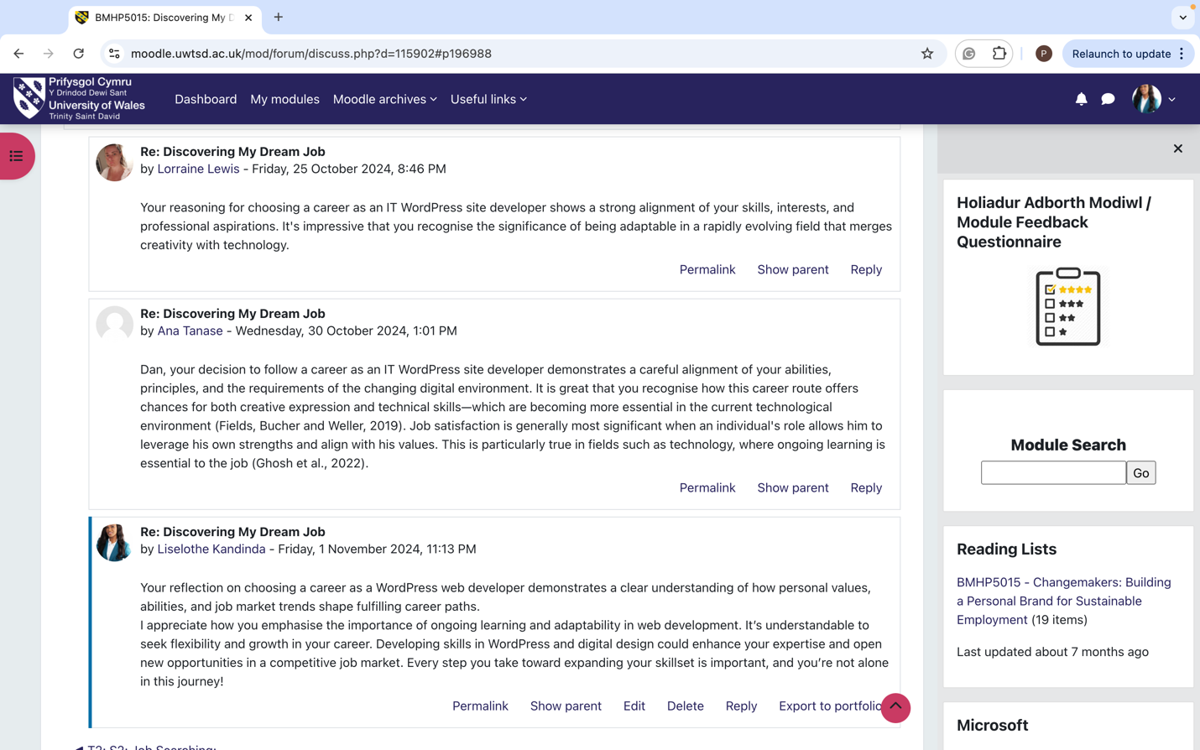

Unit 4:
Topic 3: Plan, Prepare and Perform
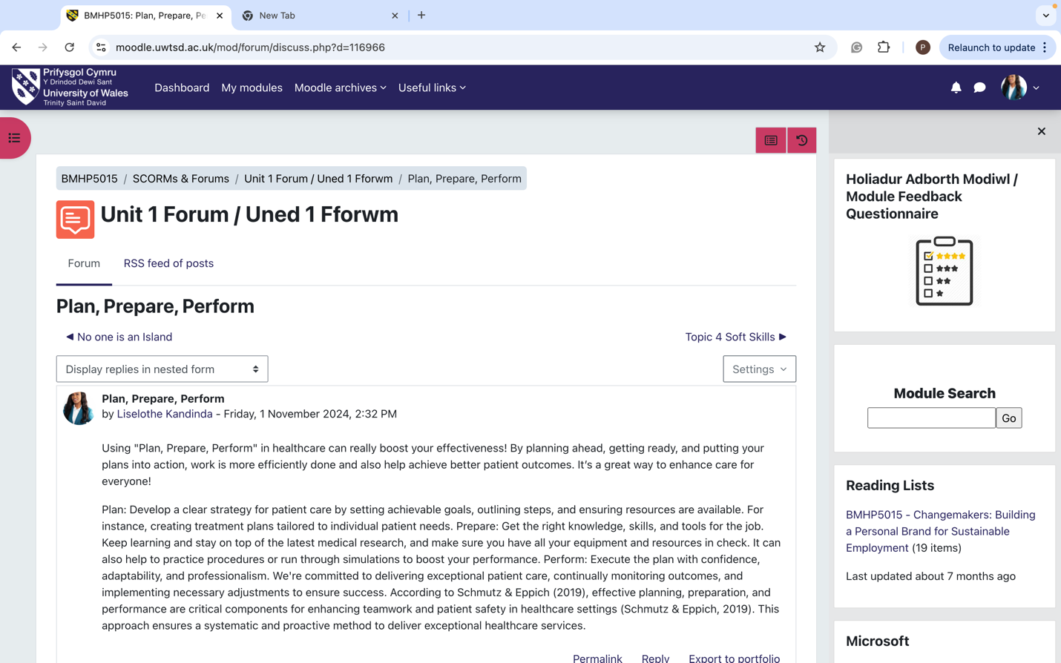

Personal Development Plan:
 | SKILL | CURRENT  ABILITY | TARGET  ABILITY | DEVELOPMENT  OPPORTUNITY | CRITERIA TO JUDGE SUCCESS | TIME FRAME | EVIDENCE
1st PRIORITY | Time management | Teachable | Flexibility in challenging situations | Continuous Training and Education | Follow up checks Monthly | 3-6 Months | Yield result
2nd PRIORITY | Attention to detail | Continuos Education and training | Resilience | Continuous Training and Education | Follow up checks Monthly | 3-6 Months | Self test
3rd PRIORITY | Adaptability | Effective communicatio | Compassion | Continuous Training and Education | Follow up checks Monthly | 3-6 Months | Self test

Reference List:

Arthur, M. B., & Rousseau, D. M. (1996). The Boundaryless Career: A New Employment Principle for a New Organizational Era. Oxford University Press.
Benner, P. (2000). From Novice to Expert: Excellence and Power in Clinical Nursing Practice. Prentice Hall.
C. F., & Snowden, D. J. (2003). The new dynamics of strategy: Sense-making in a complex and complicated world. IBM Systems Journal, 42(3), 462–483.
Cappelli, P. (2001). Why Do Employers Pay for College? Journal of Econometrics, 121(1-2), 213-241.
Castells, M. (2000). The Rise of the Network Society: The Information Age: Economy, Society, and Culture. Wiley-Blackwell.
Csikszentmihalyi, M. (1990). Flow: The Psychology of Optimal Experience. Harper & Row.
Grant, A. M., & Gino, F. (2010). A little thanks goes a long way: Explaining why gratitude expressions motivate prosocial behavior. Journal of Personality and Social Psychology, 98(6), 946-955.
Kalleberg, A. L. (2009). Precarious work, insecure workers: Employment relations in transition. American Sociological Review, 74(1), 1-22.
King, R. (2021). "Locum Doctors and the NHS: Financial Incentives and Flexibility in a Gig Economy." British Medical Journal, 372
King, R. (2021). "Locum Doctors and the NHS: Financial Incentives and Flexibility in a Gig Economy." British Medical Journal, 372
Nakamura, J., & Csikszentmihalyi, M. (2002). The concept of flow. In C. R. Snyder & S. J. Lopez (Eds.), Handbook of positive psychology (pp. 89-105). Oxford University Press.
Robles, M. M. (2012). Executive perceptions of the top 10 soft skills needed in today’s workplace. Business Communication Quarterly, 75(4), 453-465.
Salas, E., Sims, D. E., & Burke, C. S. (2005). Is there a "big five" in teamwork? Small Group Research, 36(5), 555-599.
Schmutz, J. B., & Eppich, W. J. (2019). Promoting learning and patient care through shared reflection: A conceptual framework for team reflexivity in health care. Academic Medicine.
Turkle, S. (2015). Reclaiming conversation: The power of talk in a digital age. Penguin Press.
Urtz, C. F., & Snowden, D. J. (2003). The new dynamics of strategy: Sense-making in a complex and complicated world. IBM Systems Journal, 42(3), 462–483.
Walker, C. J. (2010). Experiencing flow: Is doing it together better than doing it alone? The Journal of Positive Psychology, 5(1), 3-11.
Wiseman, R. (2003). The Luck Factor: The Sci

