Module name: Academic Skills in the digital era
Module code: BMSW4013
Assessment 1: E – Portfolio
Student name: Aimee Zupkova
Student number: 2512683
Lecturer: Scott James
Deadline: Friday 21st November 23:59

Contents
Component 1: Research and planning……. Page 3
Source exploration………………………………Page 3
Key challenges for students…………………. Page 3
Key opportunity for students………………… page 4
Planning your report …………………………… Page 4
Timeline to complete component 2 ………. Page 4
Component 2: answering the question…… Page 5
Introduction………………………………………... Page 5
Opportunities digital tools provide…………. Page 5
Challenges students face ……………………. Page 5
How students can adapt………….…………... Page 6
Conclusion………………………………………… Page 6
Component 3: Reflective presentation……Page7
Slide 1 (overview)…………………………………Page8
Slide 2(research)…………………………………Page9
Slide 3(planning and writing) ………………. Page10
Slide 4(challenges)…………………………………Page11
Slide 5(successes…………………………………page12
Reference list …………………………………page 13

Ai acknowledgement
I confirm that I have not presented any Ai Generated Materials as my own work. I confirm that that I have resources to prove that I have not used ai generated work.
Component 1 – research and planning
I have chosen the article ‘Education management innovation: Challenges and opportunities in the digital era’ which was written by Dudlang Mulyana, published in 2023. The main point of this article is about how digital tools are constantly changing and having to overcome challenges and take advantage of new opportunities. Students who have digital skills and the ability to adapt to the newest technology will be offered much better opportunities in the digital world (Budiman, 2017)
I have chosen this source because it is only 2 years old, so it is quite up to date with the digital tools, we have access to now, and it is an extremely easy source to understand. Google does not have anything about this being an unreliable source. From the article I can see that this will help me answer the question.
I know this source will help me answer the question as the author has used clear and concise language. The source also has noticeably clear titles which will help me find the right information for this assignment. I think the source will help me solve the question as it talks about e learning, how the curriculum has changed during the digital eras and the effectiveness.

Key challenge for students
One big challenge student face within the digital aspect that the digital learning materials may not be interesting enough for students to take interest in it and keep being engaged.
For example, If I have been set work online, but the materials are boring, I am less motivated to get the work done as my attention span goes fast. However, if the work is more entertaining and more interactive, I take more interest in getting it done and I do not put off doing the work as much.

This challenge is important because if students are not engaged the quality of work is going to be extremely poor and they dont fully understand the work. This means that their overall performance in lessons will be negatively affected.

Key opportunities for student
An opportunity for students is the online collaborations. Online collaborations is a way of connecting teachers a student together, this opens the door for teachers and students to work virtually together on projects. (Mulyana D, 2023)
An example of this is when I was in college and I was doing assignments me and my group made a shared word document and we would all write different sections on the same document. Our teacher was also added into it she would give us feedback on the document. This opportunity is an incredibly good aspect of the digital word as this lets student's teachers connect outside of school if they need more help with assignments

Planning your report
For component 2 my focus will be on the challenges and opportunities as they are both as important as each other. From my perspective the source is very balanced, and it helps me show how both the challenges and opportunities are as important as each other. The plan for this paper is to include talking about, internet access, Vr and game-based learning. This will not be the only things I will be talking about.
The report will follow this structure
Introduction -> opportunity (Artificial intelligence)-> Challenge (Educational Content) -> how to adapt -> Conclusion

Task | Deadline
Finish research | 30th October
Draft first section | 6th November
Complete first section | 12th November
Final editing | 20th November

Component 2 – Answering the question
Introduction
Digital tools are constantly changing, whether its new apps or updates for laptops, tablets, and mobile phones. This may bring lots of new challenges for students but also new opportunities. It is essential that students know about the tools and what the downsides to them are. This is because if students do not know the challenges and opportunities with the digital tools are they can struggle a lot whilst trying to use them which may set them back whilst trying to complete assignments etc. This report will be about both the challenges and opportunities students face with different digital tools and how students can adapt to succeed.

Opportunities digital tools provide
Online learning has become a more modern learning approach that utilises technology like computers and internet which provides a lot more flexible learning material (Hadis & Muna,2015) One of the most modern digital tools that has been about recently is adaptive learning applying to artificial Intelligence and it has opened the door to a more personalised learning approach(Mulyana D, 2023). Artificial intelligence (ai) can provide learning materials for students which is more personalised to them and their specific needs. If it is used properly this will help the student overcome their personal challenges with the subject and become more confident in it. This shows that digital platforms for education brings many benefits like increasing learning accessibility and flexibility (Khusnal & Suharyadi, 2021)
Another opportunity for students is the online collaboration and joint projects. Online collaboration/joint projects is a feature you can use on most Microsoft platforms which lets students and their teacher be in the same doc. This lets students edit the doc and do their work together. I would use this very often throughout college as it was the easiest way to do group projects and get it all done at a reasonable time seeing what others in the group has completed as-well. This encourages the adaption of many interactive learning tools and online platforms that will help the quality of learning (Putro et al, 2023)

Challenges students face
One key challenges student face with is that the work students are set online can be too plain. This could discourage them from getting their assignments done efficiently. Boring materials are often particularly challenging for students to deal with as the motivation usually wears off when they have no interest in the material. This would help as online learning would become more interactive which would increase the effectiveness and involvement by students (Mulyani, 2013)
Another challenge for students about the digital aspect of education is internet access. Internet access is one of the main parts of education, yet most people have problems with it. These problems could be that they live in rural areas, and their service could be on and off. It could also be that may not be able to afford having wifi. Either way this is a significant factor which affects students overall as they could be severely behind. Technical breakdowns during the online sessions are one of the most common roadblocks which also disrupts and discourages students (Rana R, 2025)

How students can adapt
For students to succeed they must learn how to use technology wisely, here are three ways they can adapt
- Improve note taking – Apps like one note, notion, or Evernote. They could use mind mapping or drawing apps to organise thoughts visually.
- Balance screen time – Students must take regular breaks whilst doing assignments and do some offline hobbies
- Learn basic tech problem solving – students should understand simple problems so they can solve them easily. As the time changes all the time students should learn skills to keep up with all the new challenges they may face (Jamun, 2018)
By following these steps students will improve academically whilst using digital technologies

Conclusion
Overall, Students face challenges like assignments being too plain which could set them back from their peers, however they also have opportunities such as Ai. Which will let them have their own personal learning experiences at a faster pace. For students to adapt efficiently students must be improving note taking, balancing their time and learn how to fix any basic bugs. Having these skills students will adapt to using digital skills way more and it will help them out eventually. The education system will eventually need to include technology learning skills which will be relevant to the the needs of the job markets (Alimudin et al,2023)

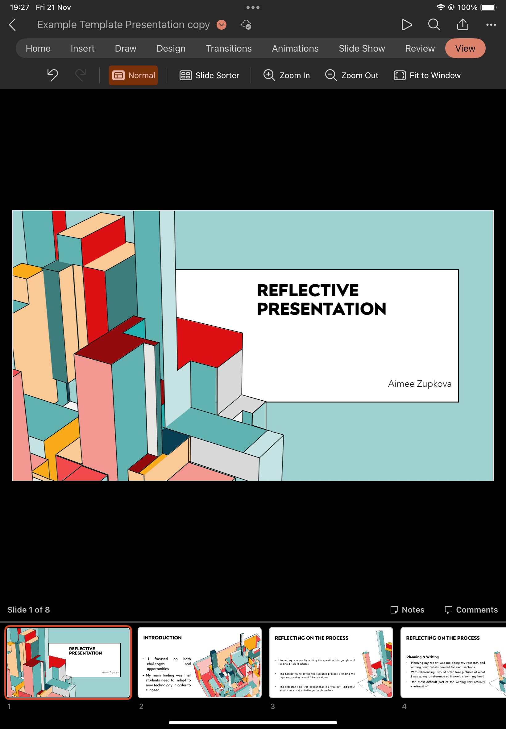

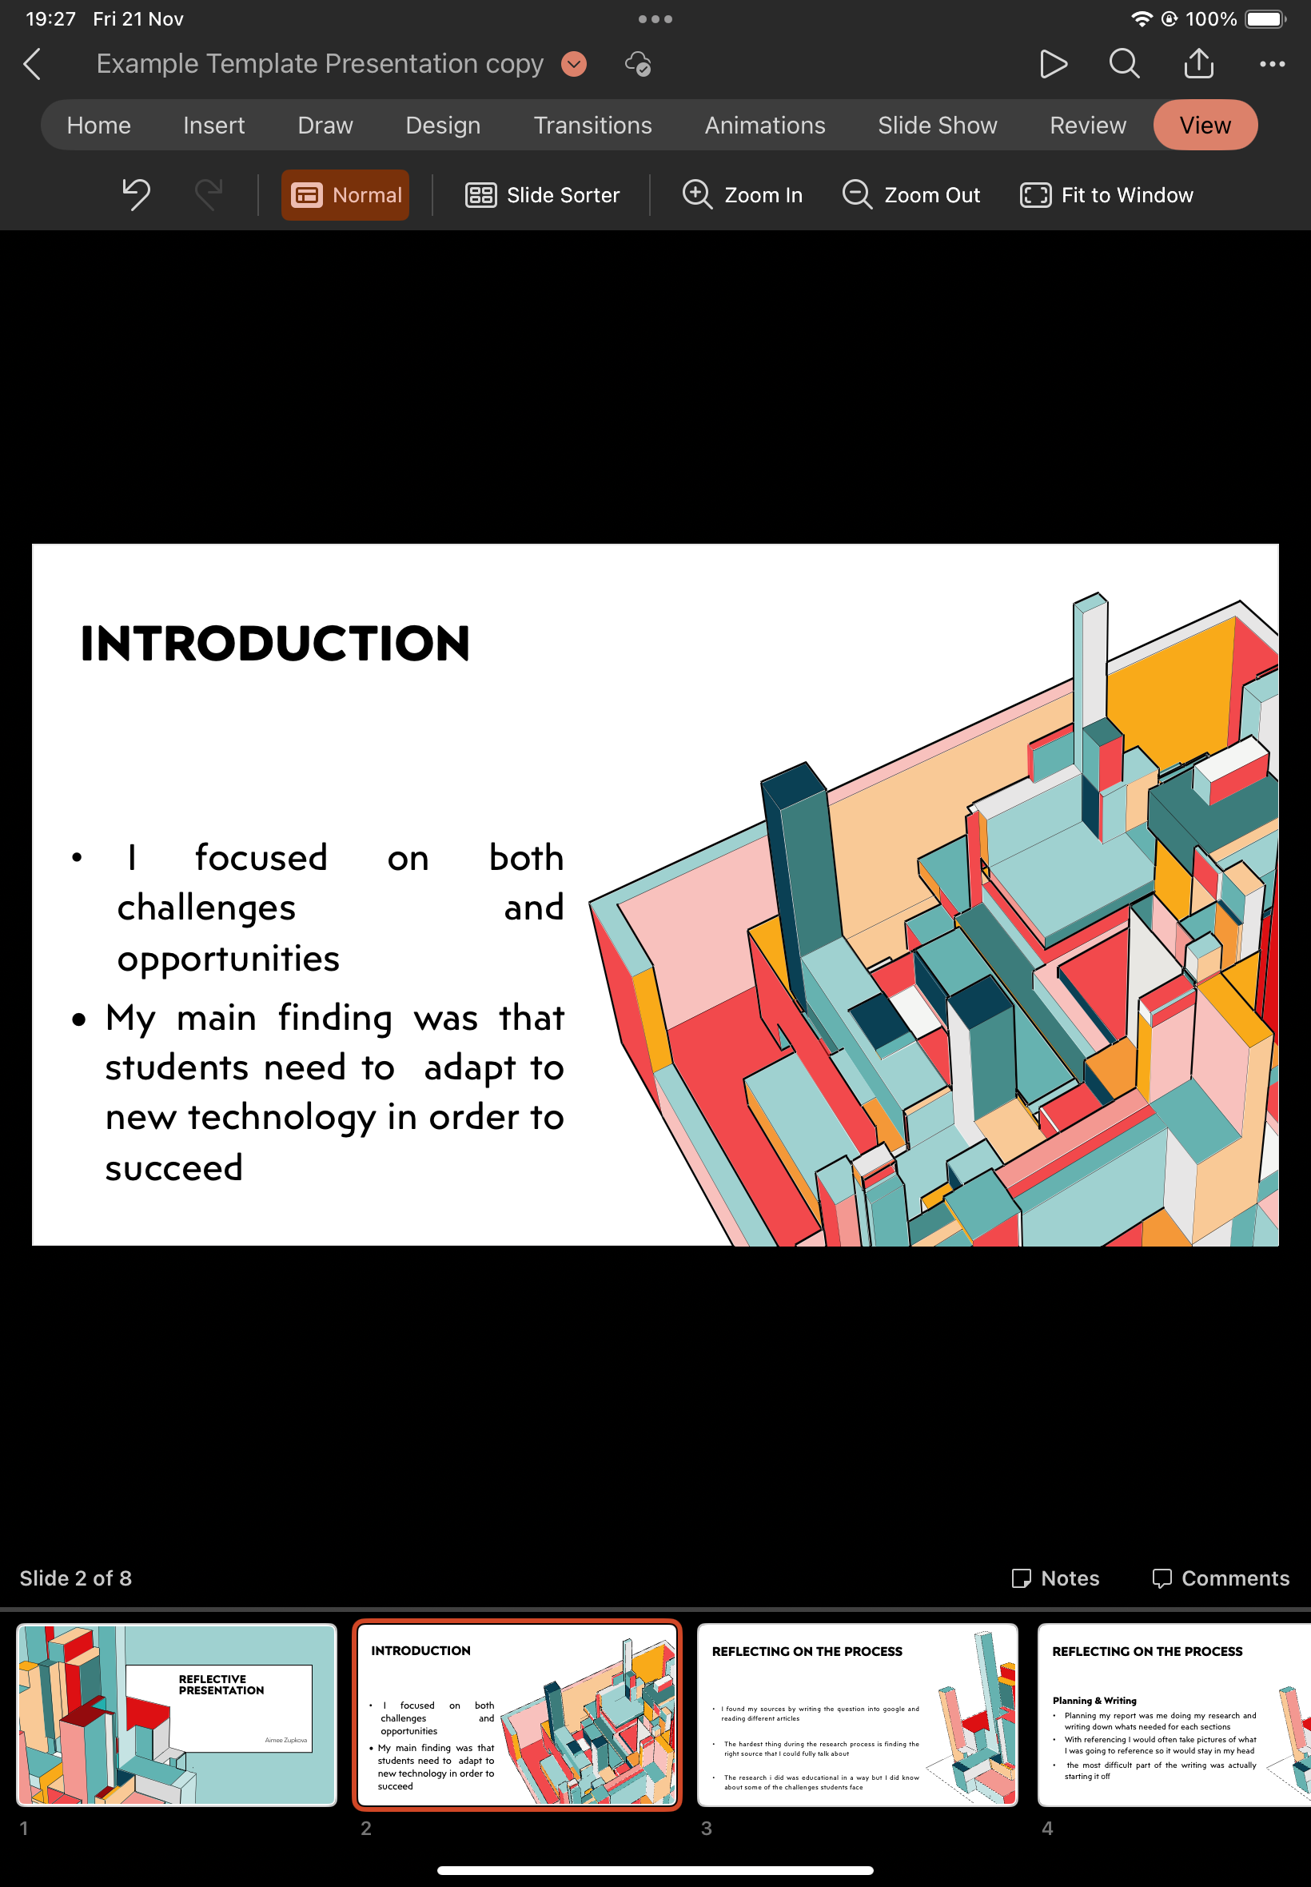
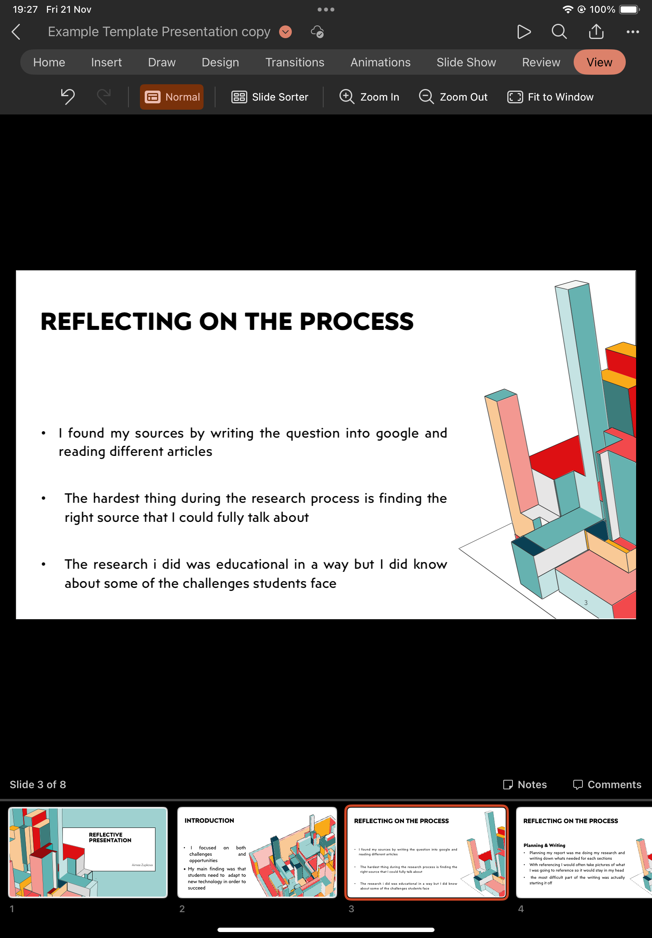

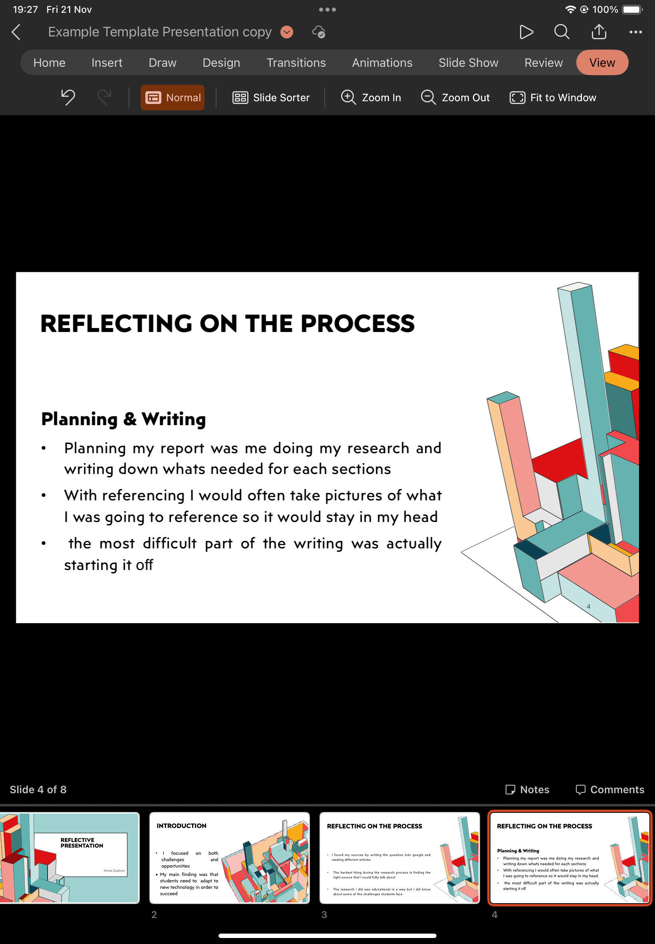

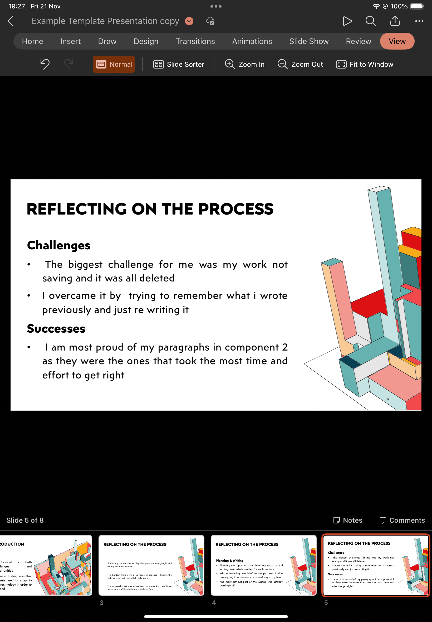

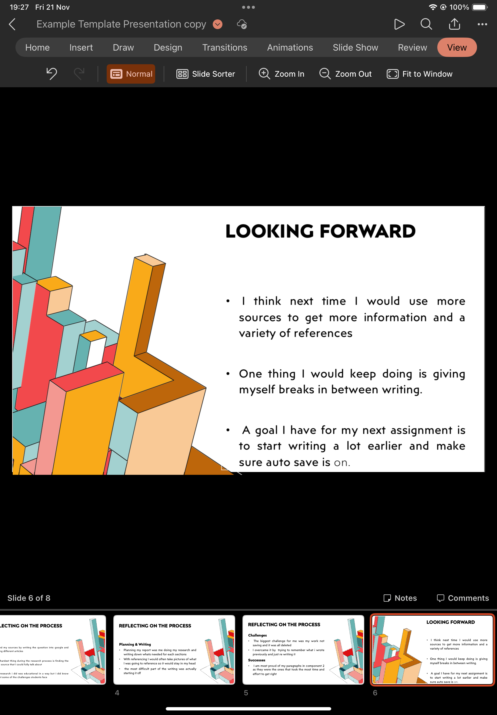
Reference list
Budiman, A (2017) ‘Behaviourism in foreign Language teaching methodology’ semanticscholar.org
https://www.semanticscholar.org/paper/Behaviorism-and-Foreign-Language-Teaching-Budiman/a317db8949a9524f8fe523a6a848dc1d3d5a6459
Mulyana D (2023) ‘educational management innovation: Challenges and opportunities in the digital era’ Sean institute https://ejournal.seaninstitute.or.id/index.php/InfoSains/article/view/4082/3281
Khusnal, N, Suharyadi, A (2021) ‘Strategi Dosen Dalam Manajemen E-Learning Guna Meningkatkan Hasil Belajar Mahasiswa di Perguruan Tinggi.Kelola’ ejournal.uksw.edu 8(1)
https://ejournal.uksw.edu/kelola/article/view/4357
Mulyani, M, & Jepson, P (2023) ‘Redd+ and forest governance in Indonesia: A multistakeholder study of Perceived challenges and opportunities’ The journal of Environment & Development
https://journals.sagepub.com/doi/10.1177/1070496513494203
Rana, R (2025) ‘7 major Challenges of online education faced by students today’ 21kschool
https://www.21kschool.com/id/blog/challenges-of-online-education/
Muhammad Alimudin and Indriati Sumarni (2025) “ANALISIS SUMBER DAN PENGGUNAAN MODAL KERJA PADA PT BANK MANDIRI (PERSERO) TBK PERIODE TAHUN 2021-2023”, 8(1)
https://jurnal.stiatabalong.ac.id/index.php/JAPB/article/view/1182

Appendices
Appendix 1: CRAAP Test
Currency: The article I chose to write about was an up to date one as it was written in 2023. This is important because students need to use up to date information.
Relevance: The article has correct and relevant information which is what students look for in an article.
Authority: The author of this article is Dudang Mulyana, he works for the department of education technology, and he is a researcher.
Accuracy: The article has made everything clear and easy to find.
Purpose: The purpose of the journal is for students and educators to have more information on their opportunities and challenges and how to properly adapt.

