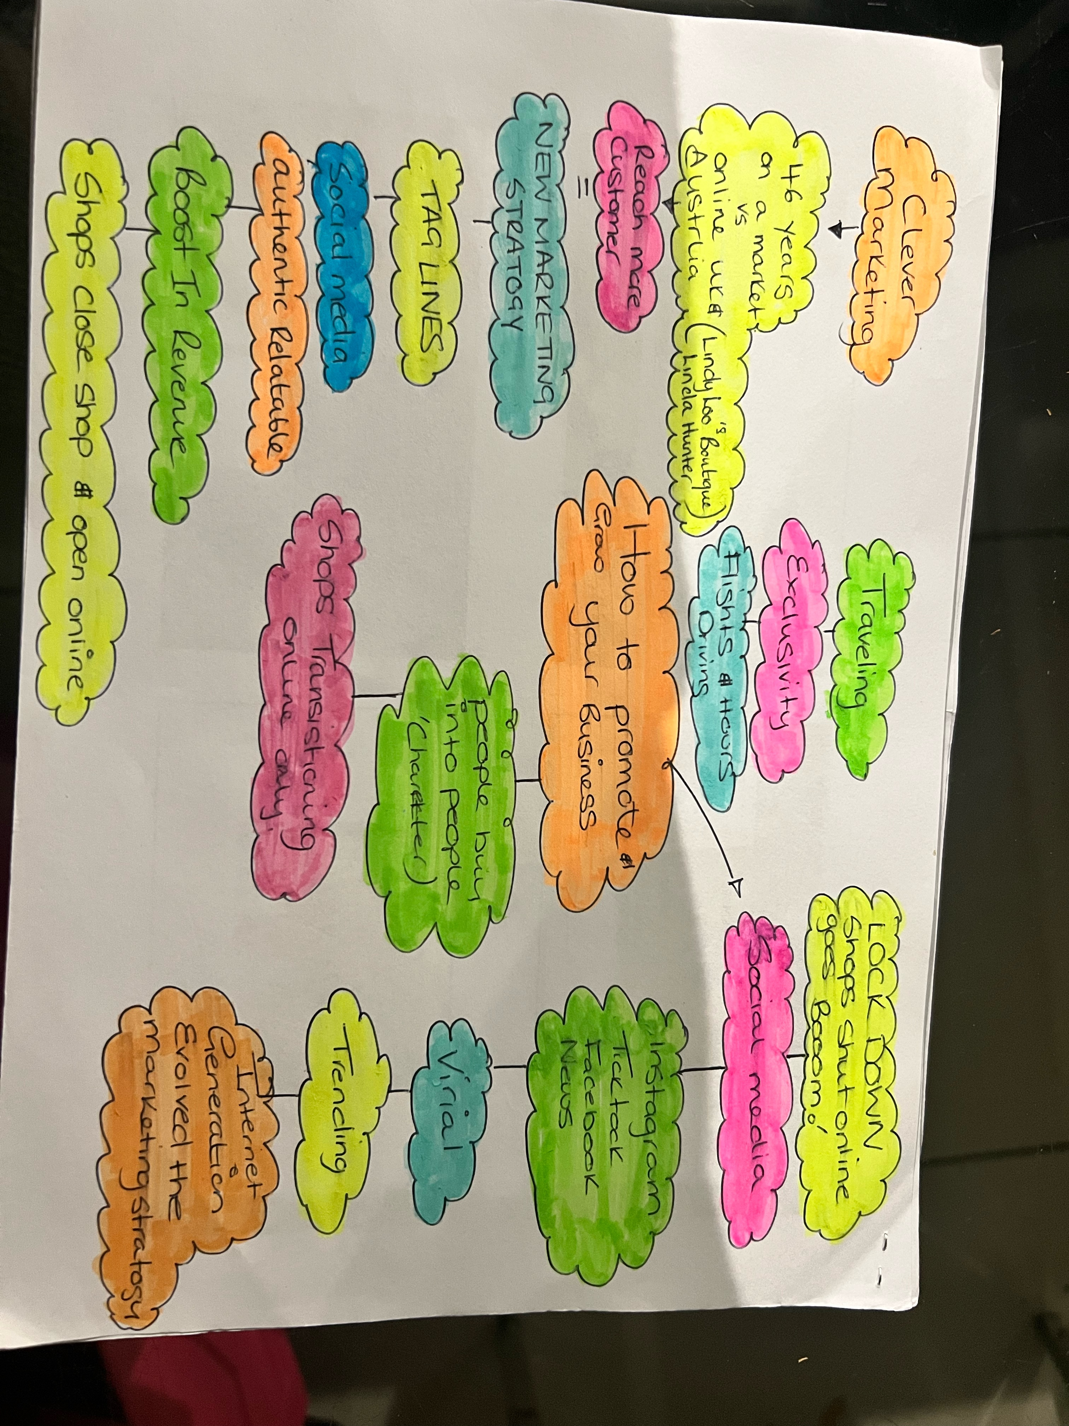


Assessment 1 – Reading Task Template
PART 1: Upload your photo of your A3 in-class notes here:


PART 2:
- Answer every question below in 1-3 full sentences.
- Use your own words. Do not use generative AI to answer these questions.
- Include a specific detail from the text when asked.
REMINDER
- The main idea is the overall message of the whole text.
- A key point helps to explain the main idea.
- A specific detail or example from the text shows that the key point is true.

- What is the main idea of the whole text? The purpose of the text is to highlight the evolution with the new marketing strategy.Promoting your business through social media . Customers are making videos which is trending worldwide so the target market has has tenfold. Binley Mega Chippy went viral when the customer posted the jacket potato stall besieged with customers (Ben Newman)couldn’t believe how much social media boosted his business and how far his customers were traveling .

- What is one key point that supports the main idea, and which specific example from the text shows this? In the text it states 1.5 million UK businesses use TikTok figures was shared by social media platforms. 200million businesses internationally are using Instagram to gain customers.Lindy Loo’s Boutique was selling on a market stall for 46 years has now closed the stall now selling online which now has a bigger target market and ships across the uk & Australia with more opportunities to be worldwide.

- What is a different key point that supports the main idea, and which specific example from the text shows this? People buy into people so social media breaks the barrier of unknown sellers now you can see who your buying from and awareness is at the heart of it.Marketing expert from Laindon (Faye Martin) has researched this people know what the do and don’t want.Catchy tag lines authentic and relatable (Nothing beats a Jet2 Holiday ) has gone viral it’s and trending with its voice over its a internet meme.

- Which part of the text do you think is most important, and why? I would say there are a few parts like where it highlights growth within the new marketing strategy 1.5 million UK businesses operate through TikTok , 200million businesses worldwide use Instagram.Lindy Loo’s Boutique is now online only after 46 years of trading on markets stalls and has now expanding sales throughout the uk and Australia.

Reflection:
- What did you find difficult in this task (including in-class components), and why was it difficult? I feel there is a lot of business jargon so I’m willing to lean but found it challenging and could of done with a introduction to business jargon . For example mind map which I was confused as I call it a spider diagram or brainstorm , so a little time needed for me to adjust.

- What helped you with this difficulty, and how did it help you? I asked the tutor to explain to me one on one in layman terms which then I clearly understood what I was doing .when I raised the question as it refers to the same thing it was explained in the professional world it is mind map as a pose to spider diagram or mind map .I have now downloaded a app which helps me to speak with more clarity and grammar which should also start to reflect within my work and answers in class.

