Managing Digital Identities
Personal digital identity management
James Dexter (1907923)
Tutor: Anthony Burns

Personal Digital Identity Management

Introduction

This essay will be about how digital identities are projected, discussing how a polished professional uses different platform, also how personal use of digital identity is being used. There will be many topics that will be discussed such as the platforms in which one would use to try and project the identity that they wish for people to perceive of them. Comparing and contrasting how each have managed digital identities.

The polished professional used will be Paul Rodriguez a professional skateboarder who is incredibly famous in the skateboarding company.

Digital identity

When it comes to describing digital identity, many factors come into play and this is because digital identity is made up from multiple things.

Digital identity is formed when pieces of data are collected in digital form that once pulled together would then lead to a particular person, brand and businesses. Data attributes give away information, this information can be usernames or web pages to less obvious things such as likes or searches that have been made (LifeLock).

Creating a digital identity is something that can be done without someone’s own knowledge after using the internet facilities available. Over time more information is collected, and this can come in forms on social media such as likes, shares, comments, pictures, but also names, email, passport number or even the mobile phone used (Trulioo). People are able to use this to their advantage in terms of branding and advertising or even personal gains.

The internet and social media websites have allowed many digital identities to be created for people to inform themselves but not everyone will always be true in what they are trying to project. There are legal systems that can help protect digital identities from impactful issues.

Digital Platforms

The internet being created has manged to allow technologies and people to come together. All different types of individuals ranging from customers to groups of like-minded people. Digital platforms allow data to create value in various amount of ways which can mean new products and services (Accenture). These products and services tend to be tailored to the information which is collected.

Social media has a big influence on the way that one digital identity can be projected. Social media is as an online tool that users are able to interact with in real time. These interactions can be anything from sharing a post to sending a message all done with a digital device. Social media is designed to share information quickly and efficiently. Business and personal accounts can be made on social medias to help promote or provide services for their intended a business if done in the correct way because of the amount of user’s social medias hold today making it harder to become more established.

Social media is pretty much anything you can interact with online being blogs, posts and even music is classed as a social media. The main social media that people are familiar with today would be names such as Facebook, Instagram and twitter. These social medias have helped many companies stay afloat with advertising and custom.

Facebook
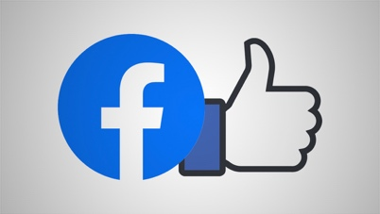
Figure 1
Facebook is one of the most popular social media in today’s digital world and has a staggering number of users. Facebook is a social media where all sorts of content can be uploaded. Content can come in many forms such as pictures, posts, videos, live videos and even be able to instant message others. the information being shared does have different methods to target audiences by making posts public or private (Nations).

Facebook has the options of giving information in a bio for the page or person, this can help information being typed in lead to a certain page through suggestions allowing more of an audience. This is great for business as there are so many users that can become potential consumers of their products or services and even for the image they represent.

Twitter

Twitter is another social media that is one of the most used social medias due to the ease of the exchange of information and images. Twitter only allows up to 140 characters with the ability to attach links to websites and resources. Having a follow option enables posts to pop up from certain brands or individuals meaning you can stay in the loop with what’s going on in the world (economic and social research council).
Figure 2

Being able to follow certain people or groups will always help with creating an audience because if the content is relatable and has meaning people will more likely keep interest. This can help with sales of certain products or services and promotions.

Instagram
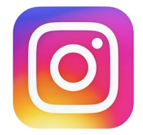
Figure 3
Insta gram is a social media started in 2010 that people upload picture and video content to that can have captions, create hashtags, follows people/pages, upload temporary stories and tag other accounts. The app comes with preloaded filters that can transform any imagine (Tillman).

With the ability to do all this stuff it stands as one of the best apps for uploading content to. with followers, likes and comments can always help the image of a brand or person because the more they get the more successful they will appear to be. This app is known for many reasons for digital identity because anything can be put onto the app such as lifestyle influencers, a favourite singer, favourite types of dogs. Instagram has content for everyone.

Paul Rodriguez


Figure 4
Paul Rodriguez is a professional skateboarder that was born in 1984 who began in the sport when he was around 11 years old and quickly became successful in skateboarding obtaining a sponsorship at only 16. He was then promoted to a professional status by Girl skateboards company in 2002.


During his career as a skateboarder he has also starred in some independent films such as Street Dreams, a great skateboarding movie for its time which also starred other renowned professional skateboarders. Videos games such as EA Skate, Skate 2 and some Tony Hawk games have featured Paul (Transworld), again showing how famous within the industry he has been.

Paul has been a big person for the skateboarding scene because of the tricks he can do in multiple stances making it hard to contend with. Having such a great skill set has allowed Paul to win numerous medals in various contests across the globe at all levels of the sport competing against the best in the business.
Figure 5
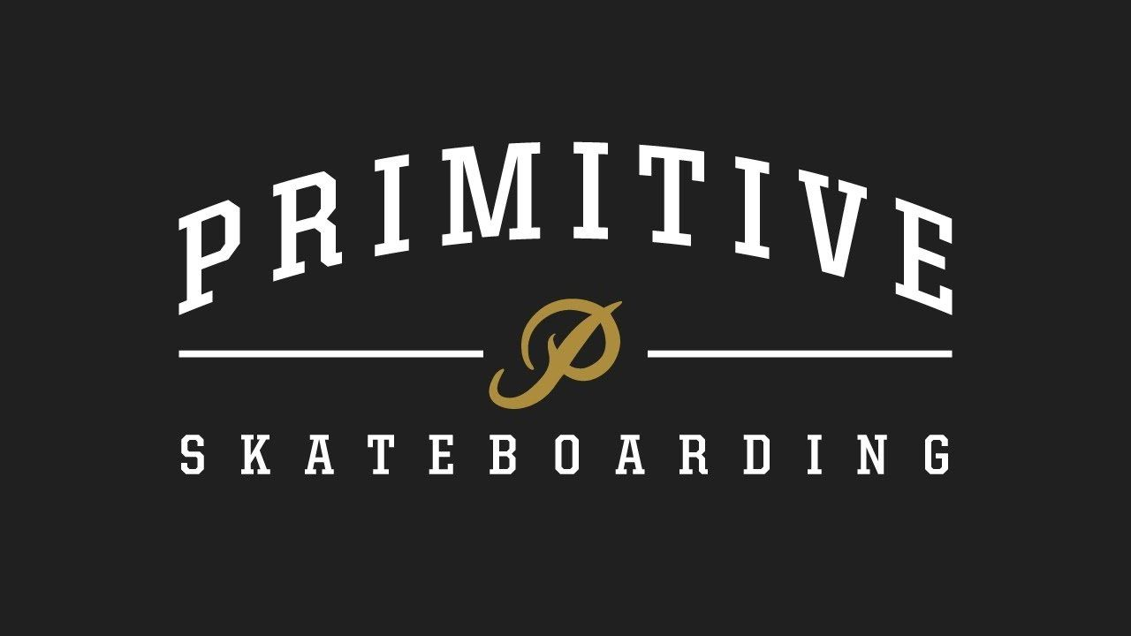
Figure 6
Paul pushed himself further within the sport when he decided to leave a well-known brand Plan B skateboards to become a founder of his own company called Primitive. The company was set up during 2008 in Los Angeles that would produce skateboards, streetwear and also sneakers. Primitive was able to find its way onto the skateboarding market and also wholesale traders (Hypebeast). This business is custom and now found globally.

Paul uses social media on the internet to promote his brand and project his digital identity. Being a professional athlete will always have some weight when it comes to creating a brand but will not help the business if it is not projected correctly.

In an interview with Boardsport Source Paul was asked a question to how they are using social media to target their audience. Mentioned is that the marketing teams do a lot of logistics for running campaigns on social medias to find out the best aesthetics to represent Primitive. Paul employs a legendary photographer as his head of marketing also. Paul wants to represent the brand as a 100% authentic and the way the branding is done should help reflect it. With the brand he tries to make sure as much feeling and thought go into what is posted or shared for their audience, he says making the brand deeply connected to social media for making a name for itself withing the sport and outside (Boardsport Source).
Figure 7

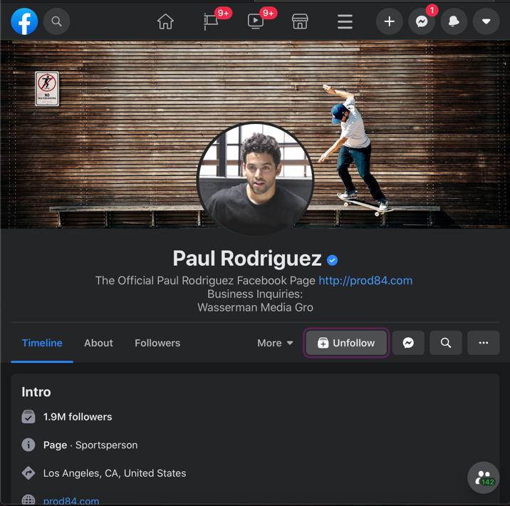
Looking throughout Paul Rodriguez’ social medias and website there is always a sense of professionalism in what is being shown on screen and the quality of content being produced and this is what he could be aiming towards for his digital identity but also a down to earth person. With the pictures provided users can really see the quality of what he puts out. Professional photographers have the best techniques and shots to engage an audience making them more pleasurable to look at, especially with the lighting when it comes to skateboarding or even someone with a good eye for photography.

The ability that Paul and his team have to make an impact on his digital identity that is projected is amazing, the work and posts can show for how well his brand comes across. The information being displayed and the products that are on offer also impact as with technology it can be shown off in many ways. in some Instagram posts there will be videos of Paul skateboarding or his friends, this is a great way to project a digital identity because it will bring the person to life on the internet so users will feel more emotion or connection to them instead of guessing what they would be like.

From the content shown in many places and the information out there, anyone can get a sense that skateboarding is his life, not a chore but more of a lifestyle and hobby as he loves the sport and wants to create a part of skateboarding for himself and others to enjoy.
Figure 8
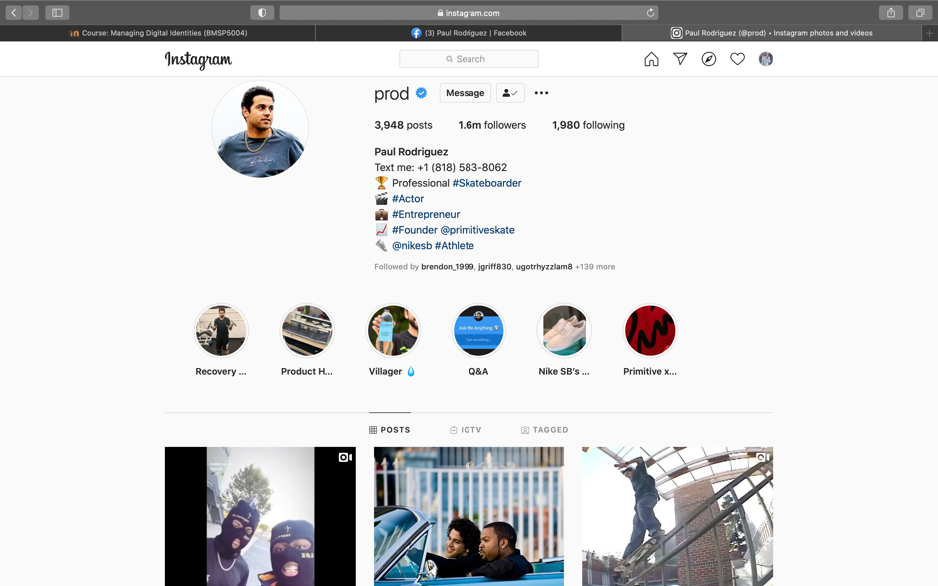
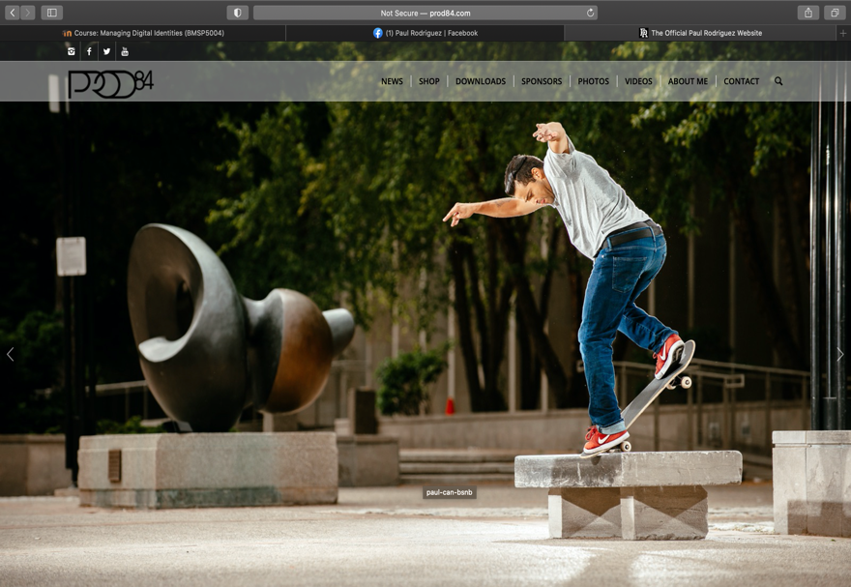
Figure 9

Personal Digital Identity

Social Media is a tool that James utalises in order to help project his digital identity using a few of the most popular social medias that available through his smart devices. James seems to project himself as a person with many interests especially the sport of skateboarding. his digital identity helps create a friendly atmosphere for interactions with content posted. Interests are made very clear as soon as someone visits the pages set up with projecting his identity.
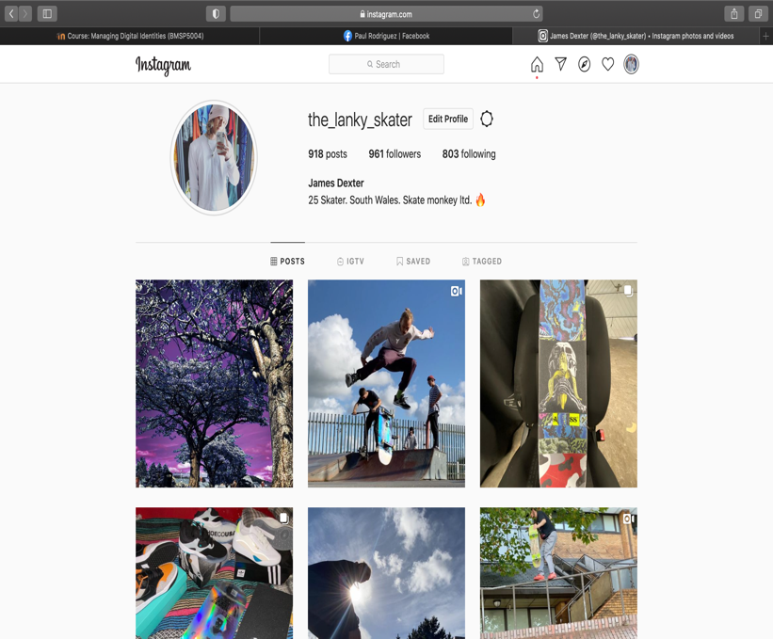
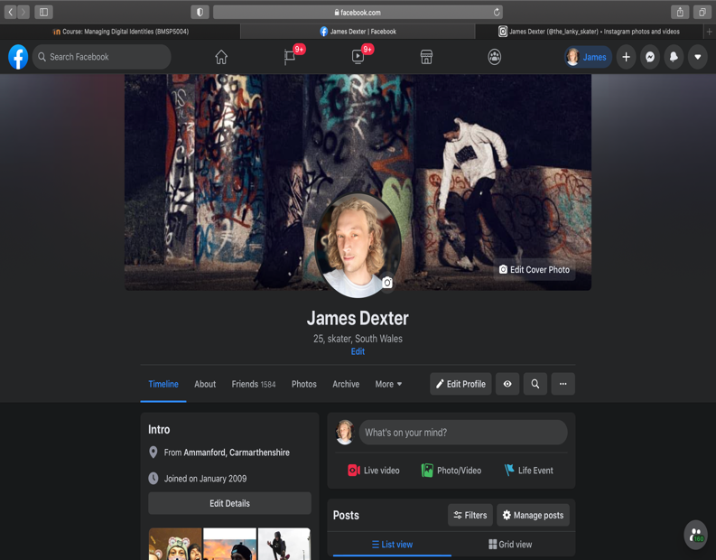
Figure 10
Figure 11
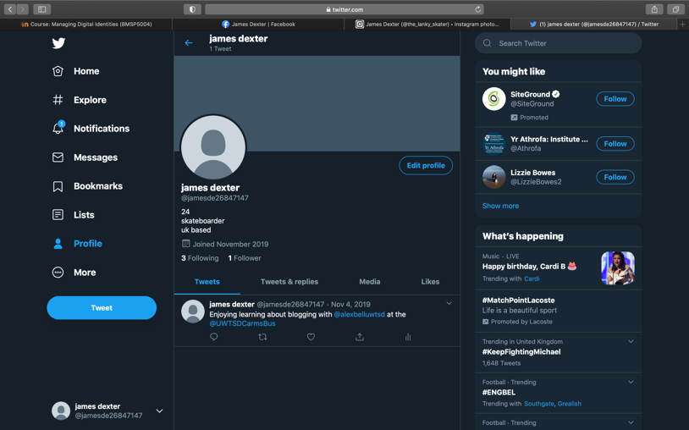
Figure 12

Through social media many followers and following are happening on Instagram and this is due to many years being on the app, all types of content are displayed on his Instagram meaning there are more content for a wide range of audience members to be reached.

Facebook is another place where James publishes content, this isn’t always personal interests as Facebook is full of all random content and easily shared amongst everyone one his friends list or followers, having so many friends on Facebook allows his content to be shared to more people than expected. He doesn’t seem to use Facebook in a professional manor as. Such as the content shared can be seem as jokes as well as relatable things.

Although a twitter account has been set up by James, he clearly doesn’t utilise this social media as no content or information has been shared in a very long time and only is following 3 people from his University course last academic year.

Comparison

During the essay information about both persons is available and what the utilise to create a personal digital identity.

They both use the popular site Facebook, having an account on this platform is great because there are so many people to target as an audience that interests can be shared at an instant. Paul tends to post content to his page that is relatable to himself and what goes on within his life and personal business, whereas James seems to share mems and some relatable content. This is good for Pauls identity because he remains to come across as professional although James would come across more of a comedic person. Both profile pictures used can be seen as high quality showing off the person in the picture, with these people are more likely to visit or interact with the profile or user.

Instagram is another online site that both James and Paul utilise by posting onto their page. Paul is very well known within the Skateboarding community and because of this has many followers, the content Paul puts out are all related to his identity and what he is known for, skateboarding and founding his company Primitive. This work incredibly well for Paul as there are so many people following and supporting him helping create a stronger digital identity. James does post relatable stuff to what he is interested, not having as many followers does impact his identity as he seems to have to try harder with what is posted to keep his followers engaged as his isn’t a well-known individual within social medias or life for his interests.

Paul does not have a Twitter account meaning that he is not utilising this type of social media, this could be for some personal or professional reasons but although he has no account still remains a public figure in skateboarding. James does have a Twitter account but what not set up for his normal content posting. James and Paul could utilise this by following people and pages to enable them to share content on another platform with millions of users.

References

LifeLock, what’s your digital identity?, LifeLock, 27 April 2018, https://www.lifelock.com/learn-identity-theft-resources-whats-your-digital-identity.html

Trulioo, Identity insights, data attributes as the new digital identity, 3/5/2018, https://www.trulioo.com/blog/data-attributes-identity

Accenture, G20 young Entrepreneurs alliance, five ways to win with digital platforms, 2016, https://www.accenture.com/us-en/_acnmedia/pdf-29/accenture-five-ways-to-win-with-digital-platforms-full-report.pdf

Hudson, the balance small business, what is social media?, M Hudson 23/6/2020, https://www.thebalancesmb.com/what-is-social-media-2890301

Figure 1, Newcastle studio, How Facebook’s new logo design affects broadcasters, M hill 04/11/2019, https://www.newscaststudio.com/2019/05/01/new-facebook-logo/

Lifewire, What is Facebook?, D Nations, 19/12/2019, https://www.lifewire.com/what-is-facebook-3486391

Figure 2, Flaticon, Twitter free icon, 2020, https://www.flaticon.com/free-icon/twitter_124021

https://esrc.ukri.org/research/impact-toolkit/social-media/twitter/what-is-twitter/
Economic and social research council, what is Twitter and why should you use it?, 2020,

Figure 3, Shutterstock, Instagram logo images, 2020, https://www.shutterstock.com/search/instagram+logo

Figure 4, Sidewalk magazine, the Paul Rodriguez interview, Coote, visited 2020, https://sidewalkmag.com/longform/paul-rodriguez-interview-part-2

Figure 5, Degrip, street dreams, M Ardelean 06/9/2009, http://blog.defgrip.net/tag/street-dreams/

Transworld skateboarding, Paul Rodriguez, 2020, https://skateboarding.transworld.net/tag/paul-rodriguez/

Figure 6, Logodix, Primitive Skateboarding Logo, Logodix 2020, https://logodix.com/primitive-skateboarding

Hype beast, Primitive, Hypebeast 2020, https://hypebeast.com/tags/primitive

Boardsport Source, we dig into Paul Rodriguez’s Primitive Brand operations In Europe, Boarsdsport Source 2020, http://www.boardsportsource.com/2019/07/19/we-dig-into-paul-rodriguezs-primitive-brand-operations-in-europe/

Pocket-lint, what is Instagram and how does it work? Plus 29 top tips and tricks, M Tillman, 3/12/2019, https://www.pocket-lint.com/apps/news/instagram/133957-how-instagram-works-plus-tips-and-tricks

Figure 7, facebook, Paul Rodriguez, 2020 https://www.facebook.com/prod84

Figure 8, Instagram, Paul rodriguez, 2020, https://www.instagram.com/prod/

Figure 9, PROD84, home page, PROD 84, http://prod84.com/?fbclid=IwAR3qjH6pJqsMh-DLg33S9hlfMrAhuVnM6T2JYag6zHfb65N5gYdBO8kZ9LQ

Figure 10, Instagram, The_Lanky_Skater, 2020, https://www.instagram.com/the_lanky_skater/

Figure 11, Facebook, James Dexter, 2020, https://www.instagram.com/the_lanky_skater/

Figure 12, Twitter, James Dexter, 2020, https://twitter.com/jamesde26847147

