  Component One:  What are the key skills required when working in the housekeeping team? 750 words (+/- 10%)  Contribution to Overall Module Assessment: 25% | Student No: | 2207385
 | Module Title: | Operating hotel facilities
 | Module Code: | BIHM4006
 | Lecturer:
  : Lola Villard, Chris Wilkin, Lisa Bassler ,Muhammad Cassamo ,Lisa Knight
Operating Hotel Facilities:
Student Journal (Learning Log )
What are the key skills required when working in the housekeeping team?
Student ID: 2207385
Student Name: Nicoleta Rusu
The Module Title: Operating Hotel Facilities BMIH4006
Lecturer: Lola Villard, Chris Wilkin, Lisa Bassler ,Muhammad Cassamo ,Lisa Knight
To be a good member of a housekeeping team, in my opinion, we need to focus and to be able to offer key skills like :
- organization
- time management
- self discipline
- thoroughness
- trustworthiness
- careful listening
- interpersonal communication
- physical flexibility and strength
- sweeping and mopping
- dusting
- trash management
- changing bedding
- laundry
- equipment know-how

The main important skill ,in my opinion, is organization . Being organized is helping us to keep the track of our main activities and is helping us to be fast and easy to manage when we are splitting our big task into smaller tasks. As well, as a housekeeper, we need to double check our carts, we need to make sure that our rooms are clean and tidy and are achiving the level that our customers are requiring.
A housekeeper needs to do multiple tasks at wonce. For example , housekeeping member are required to clean multiple rooms and spaces at wonce in a specific time. To achieve that, a housekeeper needs to make an action plan which will lead them to success. They need make sure that they are doing their best , not to be 100% perfect.
Housekeeping can involve some pretty tedious, unpleasant tasks. As a housekeeper, you’ll have to persevere day after day, performing each duty to the best of your ability. You likely won’t be supervised 24/7, so you’ll have to go out and do your best even when no one’s watching. Try to keep your devices on silent , eat healty and make sure that you are every day energized. Jones (2007)
Thoroughness helps you stand out when you’re on the job. As a housekeeper you will be in different places and because of that you need to make sure that you are doing you job nice and well, that you are checking everything twice and make sure that all you activities are taken to the end.
Trustworthiness can be a big factor if you’re working at a hotel or motel. Make sure that all the information that are you receiving are keept private and the customers expensive items are remaining untouched . Being trustfull is representing not just yourself and also the company.
A lot of information can get thrown at you when you’re a housekeeper. Make sure that you are paying attention to your supervisors and as well to your clients needs. A good listener will deal even with their most difficult tasks.
Housekeepers have to play well with others. Depending on the scope or size of your job, you might be working with other housekeepers. Do your best to be friendly, polite, and accommodating to everyone around you, especially if you work at a business. Interpersonal skills are important for any housekeeping job, even if you only work for a single household. Blackman(2005)
Housekeeping can involve a lot of heavy lifting. As a housekeeper you will always be in need to deal with moving furniture, carring heavy thinghs or doing activities that are difficult to deal. Keep yourself in a good shape.

Cleaning floors is the bread and butter of housekeeping. Those activities are required by your daily task or by customers. Make sure that you are following the wet signs when you are mopping open spaces like reception, bathrooms , etc.

You’ll need to keep every surface looking spick-and-span. As a housekeeper, you’ll need to clean off any dust from each and every surface and piece of furniture. You might even be asked to do some polishing once you’re done cleaning it off.
Taking out the trash is a less glamorous but necessary part of housekeeping. As a housekeeper, you’ll need to dump smaller waste baskets into a large garbage bag or can. From there, you’ll need to take out the trash—this might mean bringing it out to the client’s curb or driving it to a larger disposal site.
As a housekeeper, you’ll be in charge of someone’s living space. Housekeepers are having the duty to make beds, to make sure thet laundry is putted correctly and all the bed areas are checked properly .
Housekeepers are in charge of washing a client’s clothes and bedding. With this in mind, you’ll need to know the ins and outs of basic laundry care before applying for this type of job. Study the laundry essentials, like sorting garments, reading fabric care symbols, and choosing the best settings on a washer and dryer. Jones (2007)
From my work experience , being a housekeeper is not an easy job. Being perseverant in your job by dealing well with your tasks will give you the key to success .

Reference list :
- Walker, J. R., Miller, J. E. (2009). Supervision in the Hospitality Industry: Leading Human Resources. United Kingdom: Wiley.
- Blackman, H. (2005). Travel and Tourism. United Kingdom: Pearson Education.
- International Journal of Human Development and Sustainability Vol.4, No.1. (2011). United States: Universal Publishers.
- Executive Housekeeping Today. (2007). United States: National Executive Housekeepers Association.
- Jones, T. J. A. (2007). Professional Management of Housekeeping Operations. United Kingdom: Wiley.
- Tucker, G., Scoviak, M., Schneider, M. (1998). The Professional Housekeeper. United Kingdom: Wiley.
- White, L., Van Der Wagen, L. (2018). Hospitality Management. Australia: Cengage Learning Australia.

Word Count | 776

Component Two:
Contribution to Overall Module Assessment: 25%
In this scenario – You have just been promoted to team leader for a floor within the hotel. A guest complains that on their arrival, their room had not been properly cleaned. Create an action plan and answer the following questions.

Problem | Why did it happen? | What are you going to do? | How will you prevent this from happening in the future? | What measures would you introduce to improve team effectiveness?
Unhappy customer | The housekeeping team didn`t paid to much attention on details and cleaning properly the room | I will make sure that I will apologize and try to repair the mistake | I will check in detail every room after cleaning | I will regularly have group meetings with the staff to understand their needs and In this way if they will feel confident will work more effective
The customer will not return if we will not meet their expectations | The person responsible with checking the rooms didn`t check properly the room | Like an compensation I can give to the customer a free breakfast or a voucher | I will make sure that the staff is understanding their duties at work | The staff will follow the rules of cleaning properly on every shift
Bad review | Because of the situation ,the customer can leave a bad review that can affect our future customers | I will give to the customer a different room | I will make sure,as a team leader , that our customers are receiving what they are expecting | I will improve the cleaning equipment to make sure that will be more effective ,and, as well, to be more effective as well for the staff
If the customer is not receiving what is expecting we will lose our credibility | To many rooms to be cleaned and not enough staff | Sometimes ,as a team leader , we are coming to help in different departments to make sure that everything is running as they should | I will make sure that the staff is receiving enough rooms to be able to clean them properly | I will make sure that during the busiest seasons I have enough staff to be able to work effective
The customer can become very angry and can act violent sometimes | The customer didn`t receive what they was expecting | Apologize and remain calm and make sure that you are dealing with the situation corectly | Before the arrival of the future guest I will double check in details every room and after I will assign the rooms | Giving to the staff the right instructions will make them understand properly the duties for the specific day

Component Three:
Contribution to Overall Module Assessment: 50%
Your task is to create and prepare a presentation following the detailed scenario provided below.

As the floor housekeeping manager and given the recent guest complaints you need to put together a basic training presentation for your colleagues within the housekeeping team to get the best out of them, ensure that brand standard is being achieved and that Health and Safety procedures are also being followed.

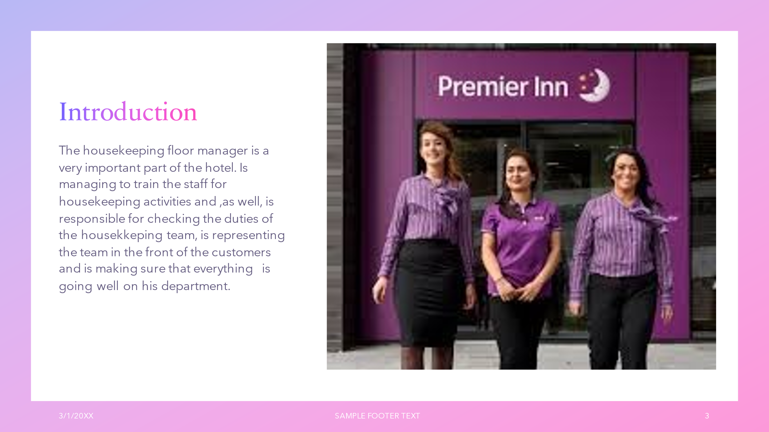
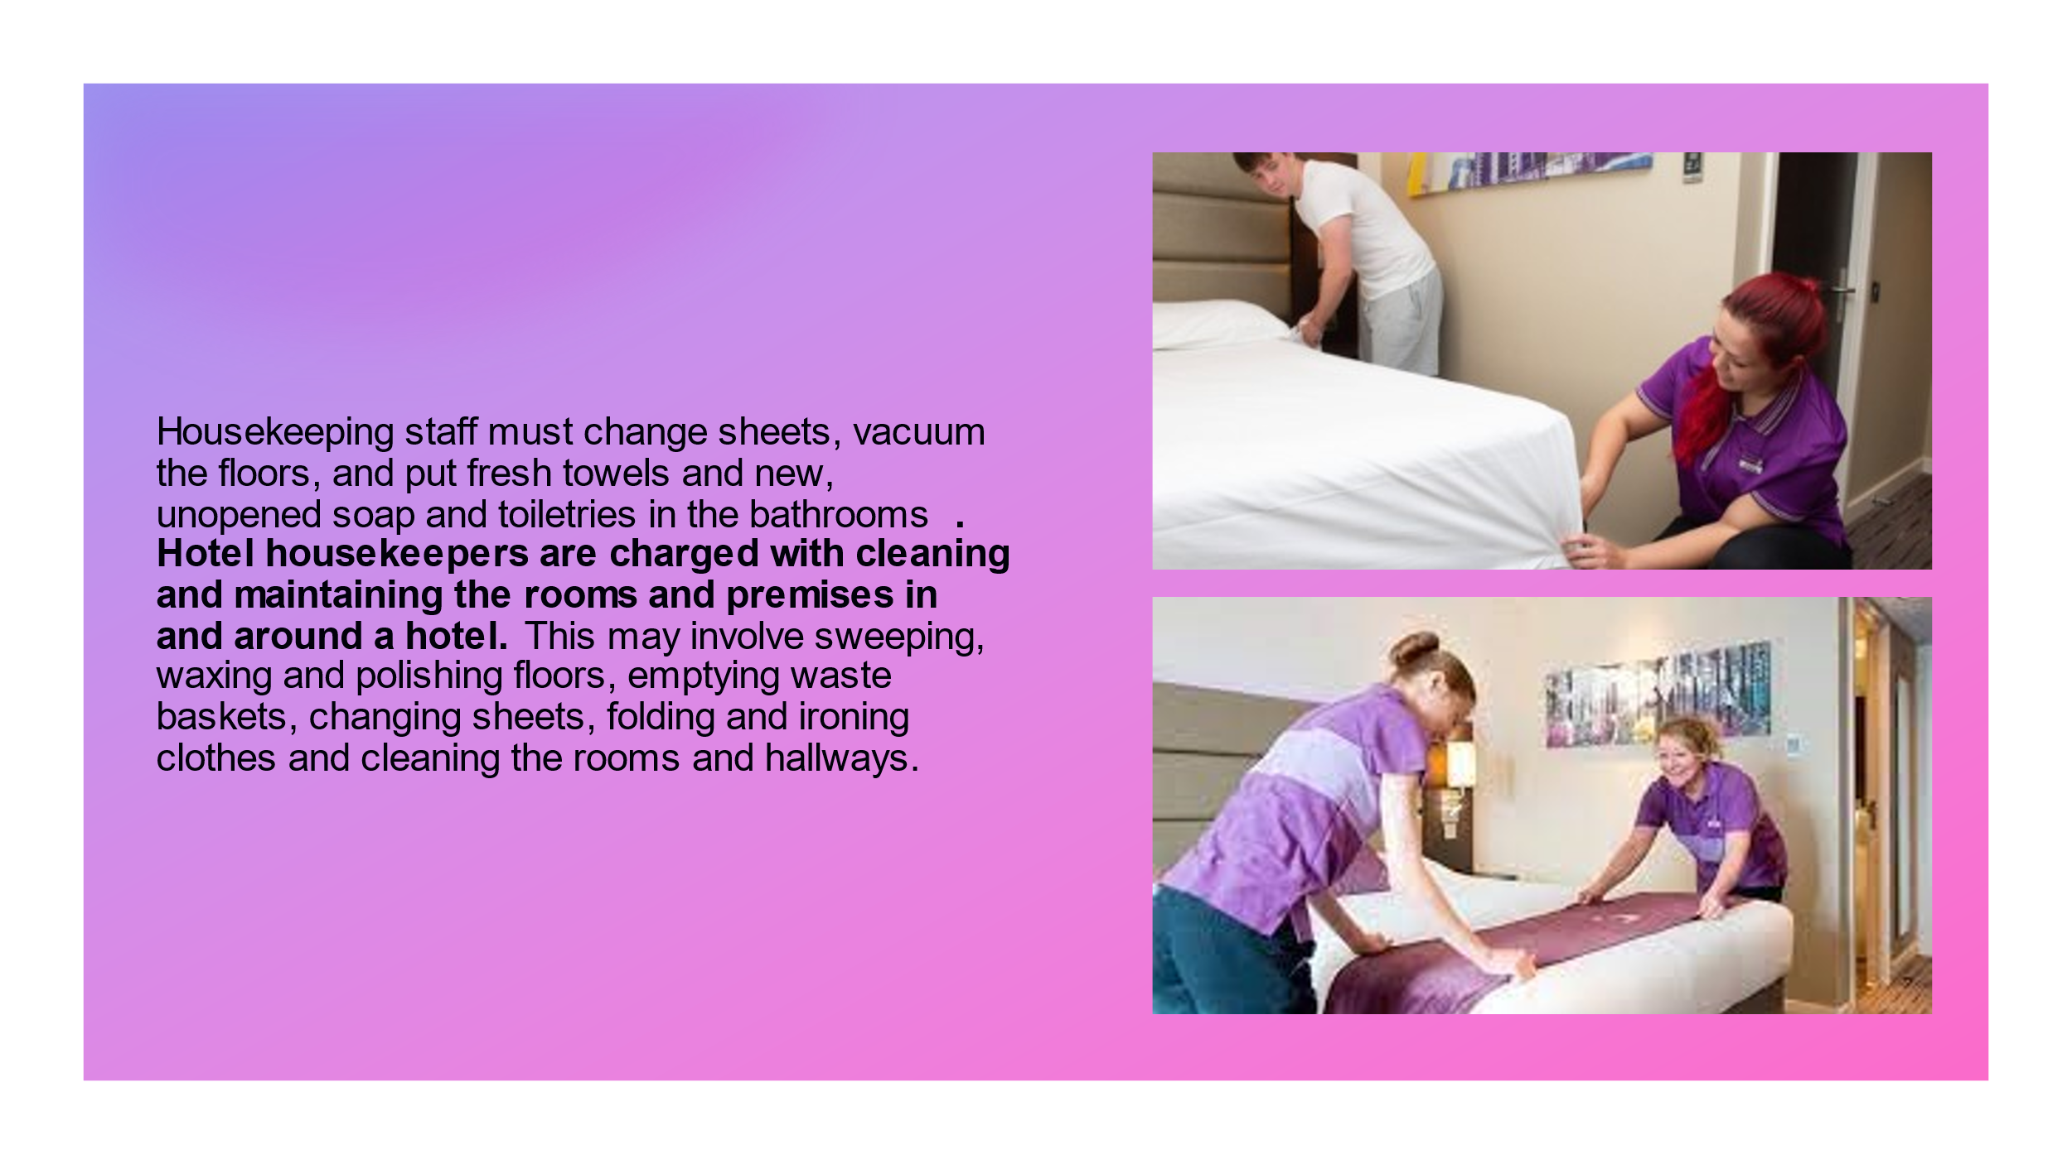
Training Notes: As a housekeeper you need to pay attention to every small detail and to make sure that everything is made following the current regulations and up to the high standards.
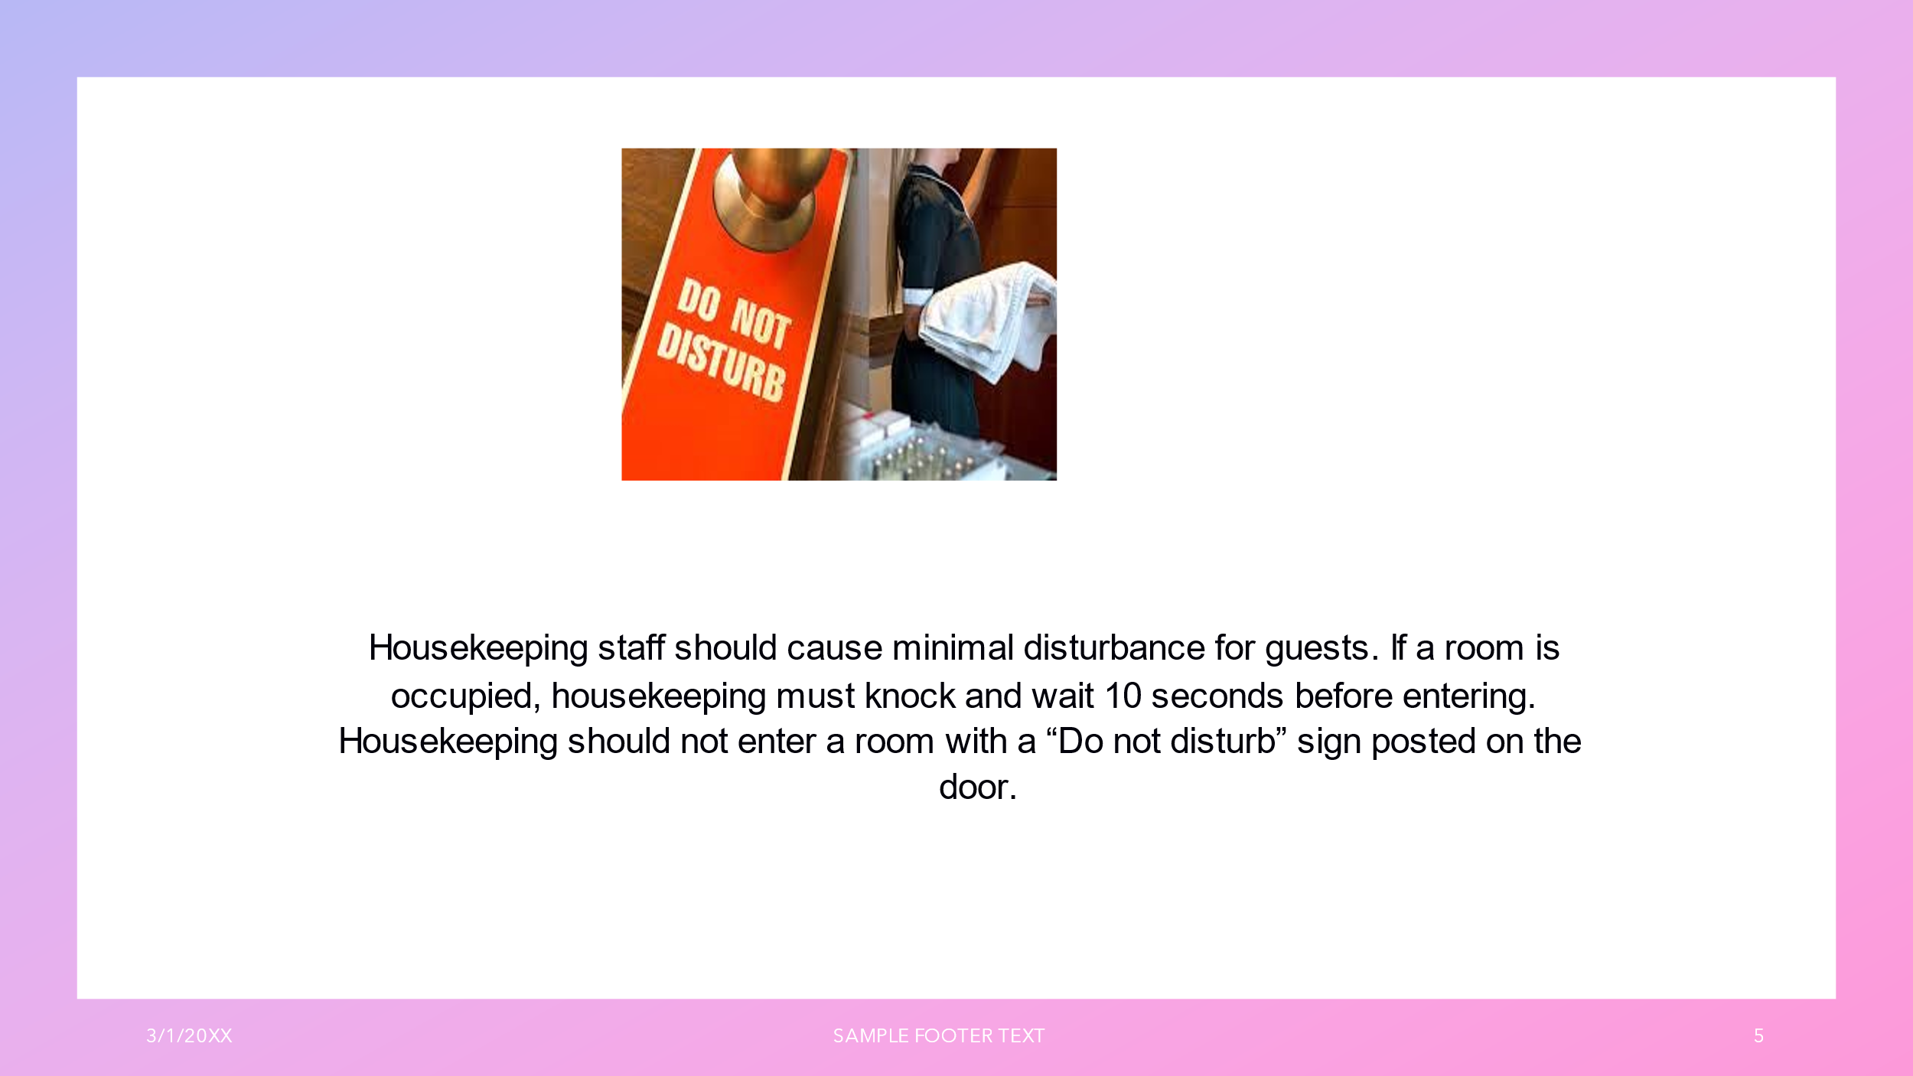

Training Notes: While you are making your own duties make sure that you are not disturbing the other guests. Respecting the privacy signs will not cause you any further incidents.
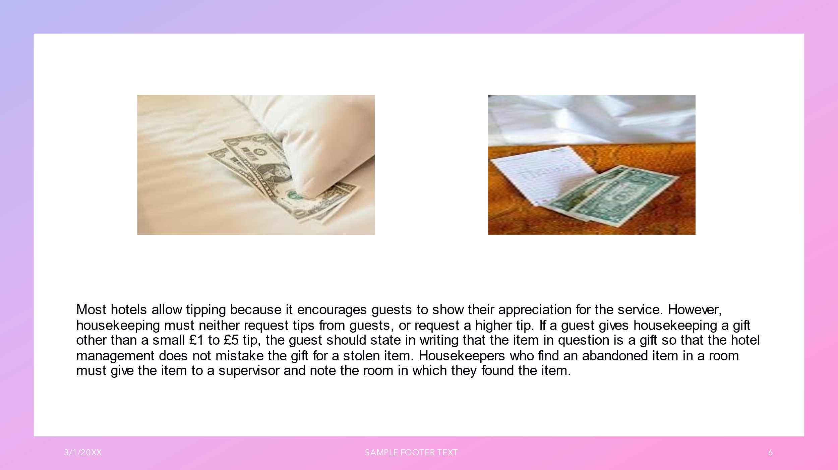

Training Notes: Don`t touch or take an item that is not yours. Send every lost object to the front office team to be putted on the lost objects . Make sure that you are proving to be a trustfull member of the staff.
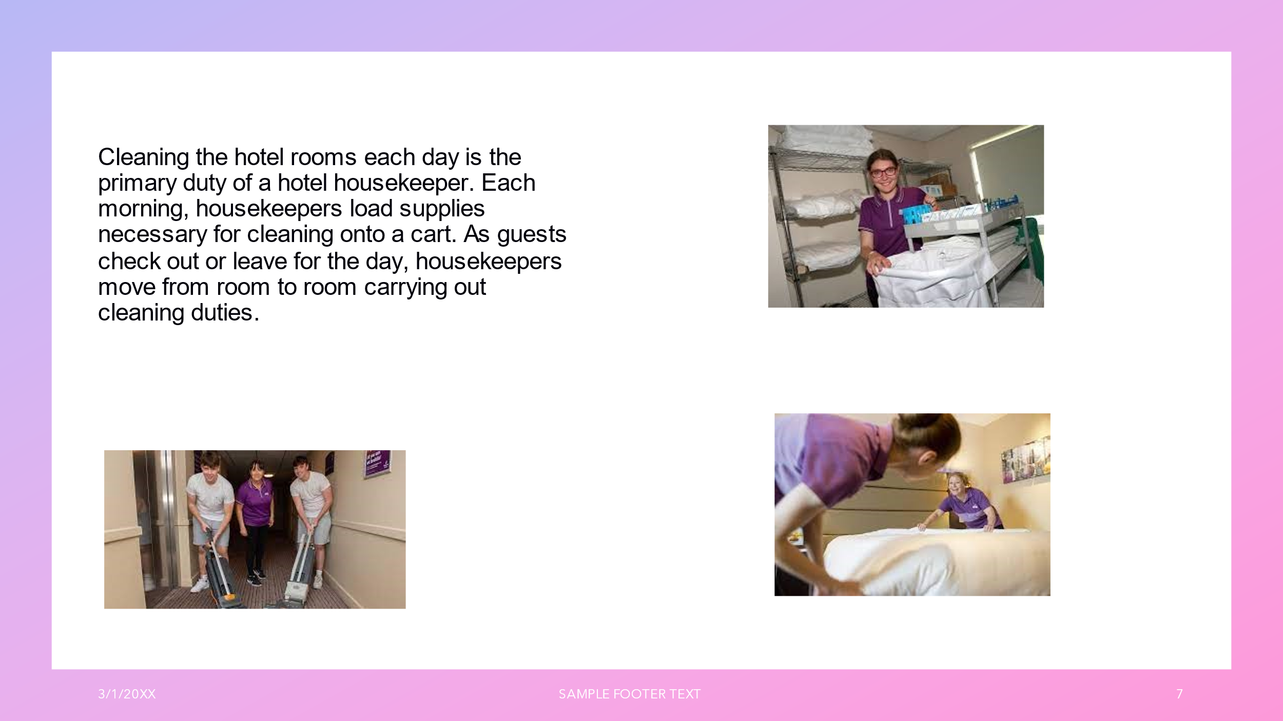

Training Notes: Make sure that you are respecting the Health and Safety procedures while are you starting your every day duties. Use the right ways to move your trolley.
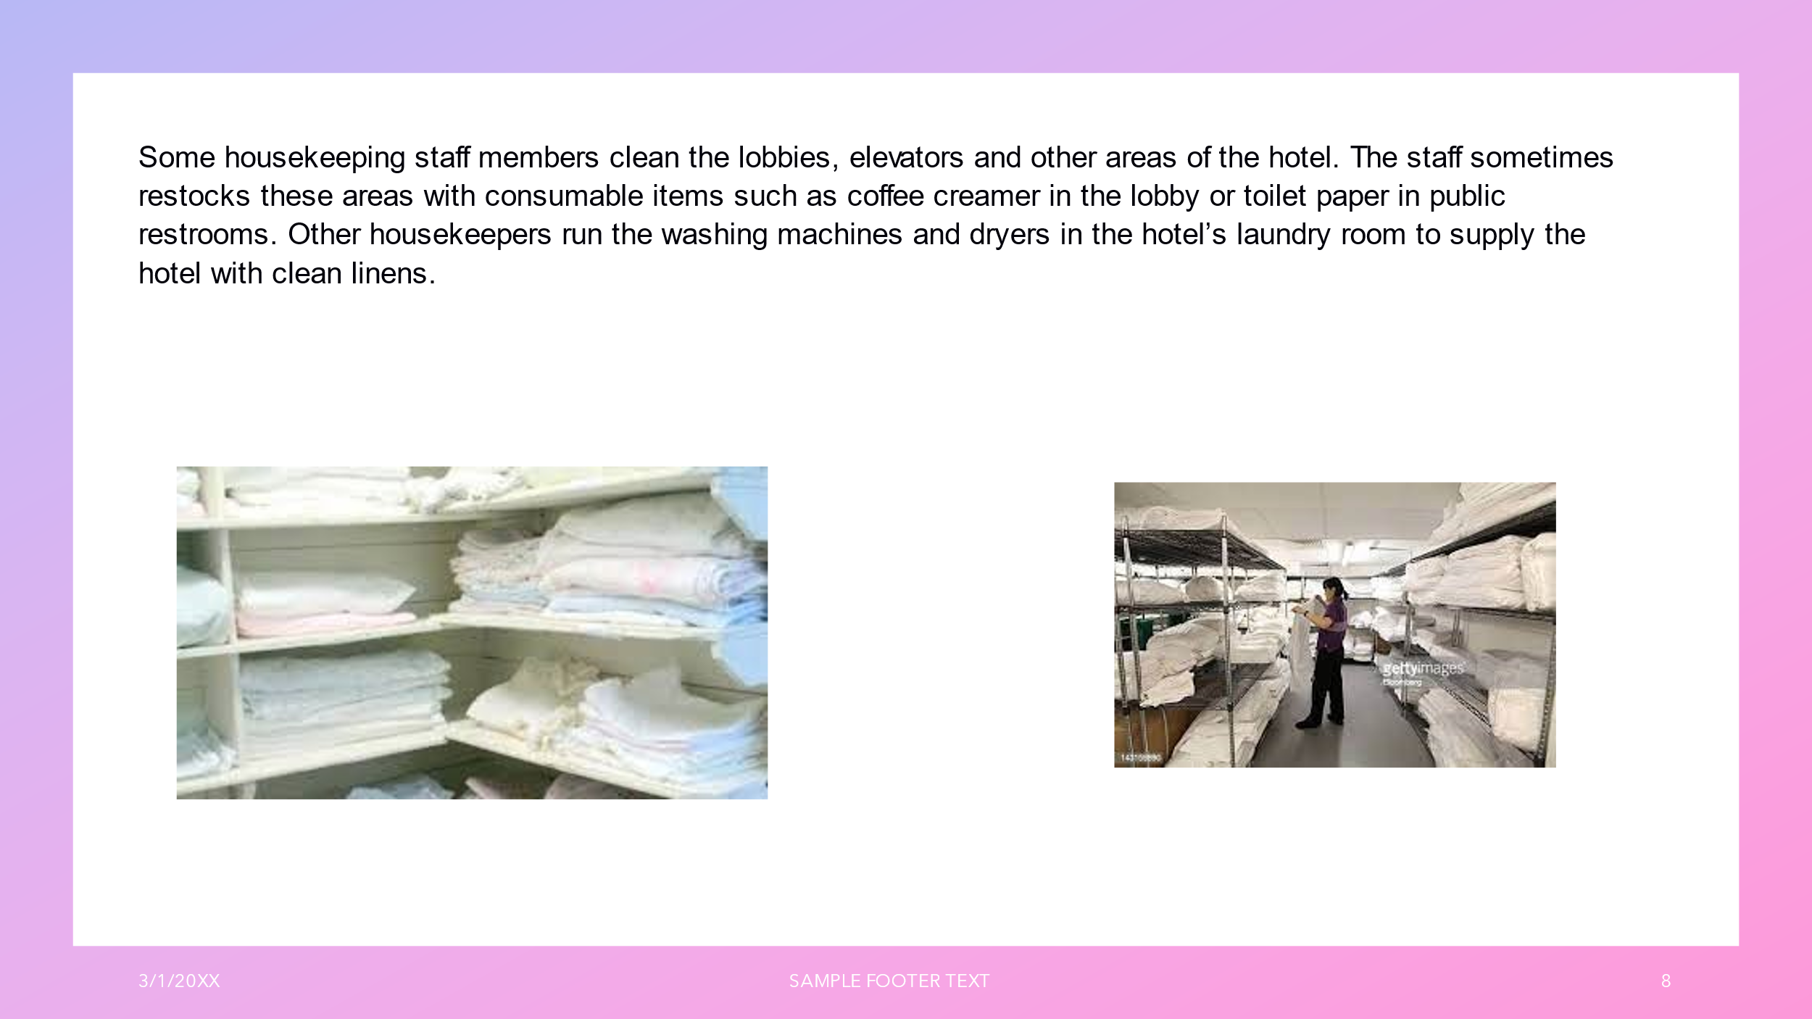

Training Notes: Use the equipment correctly and make sure that you are respecting your training provided. While loading the restocks use proper equipment to carry them and , on need, lift everything respecting the right procedures.

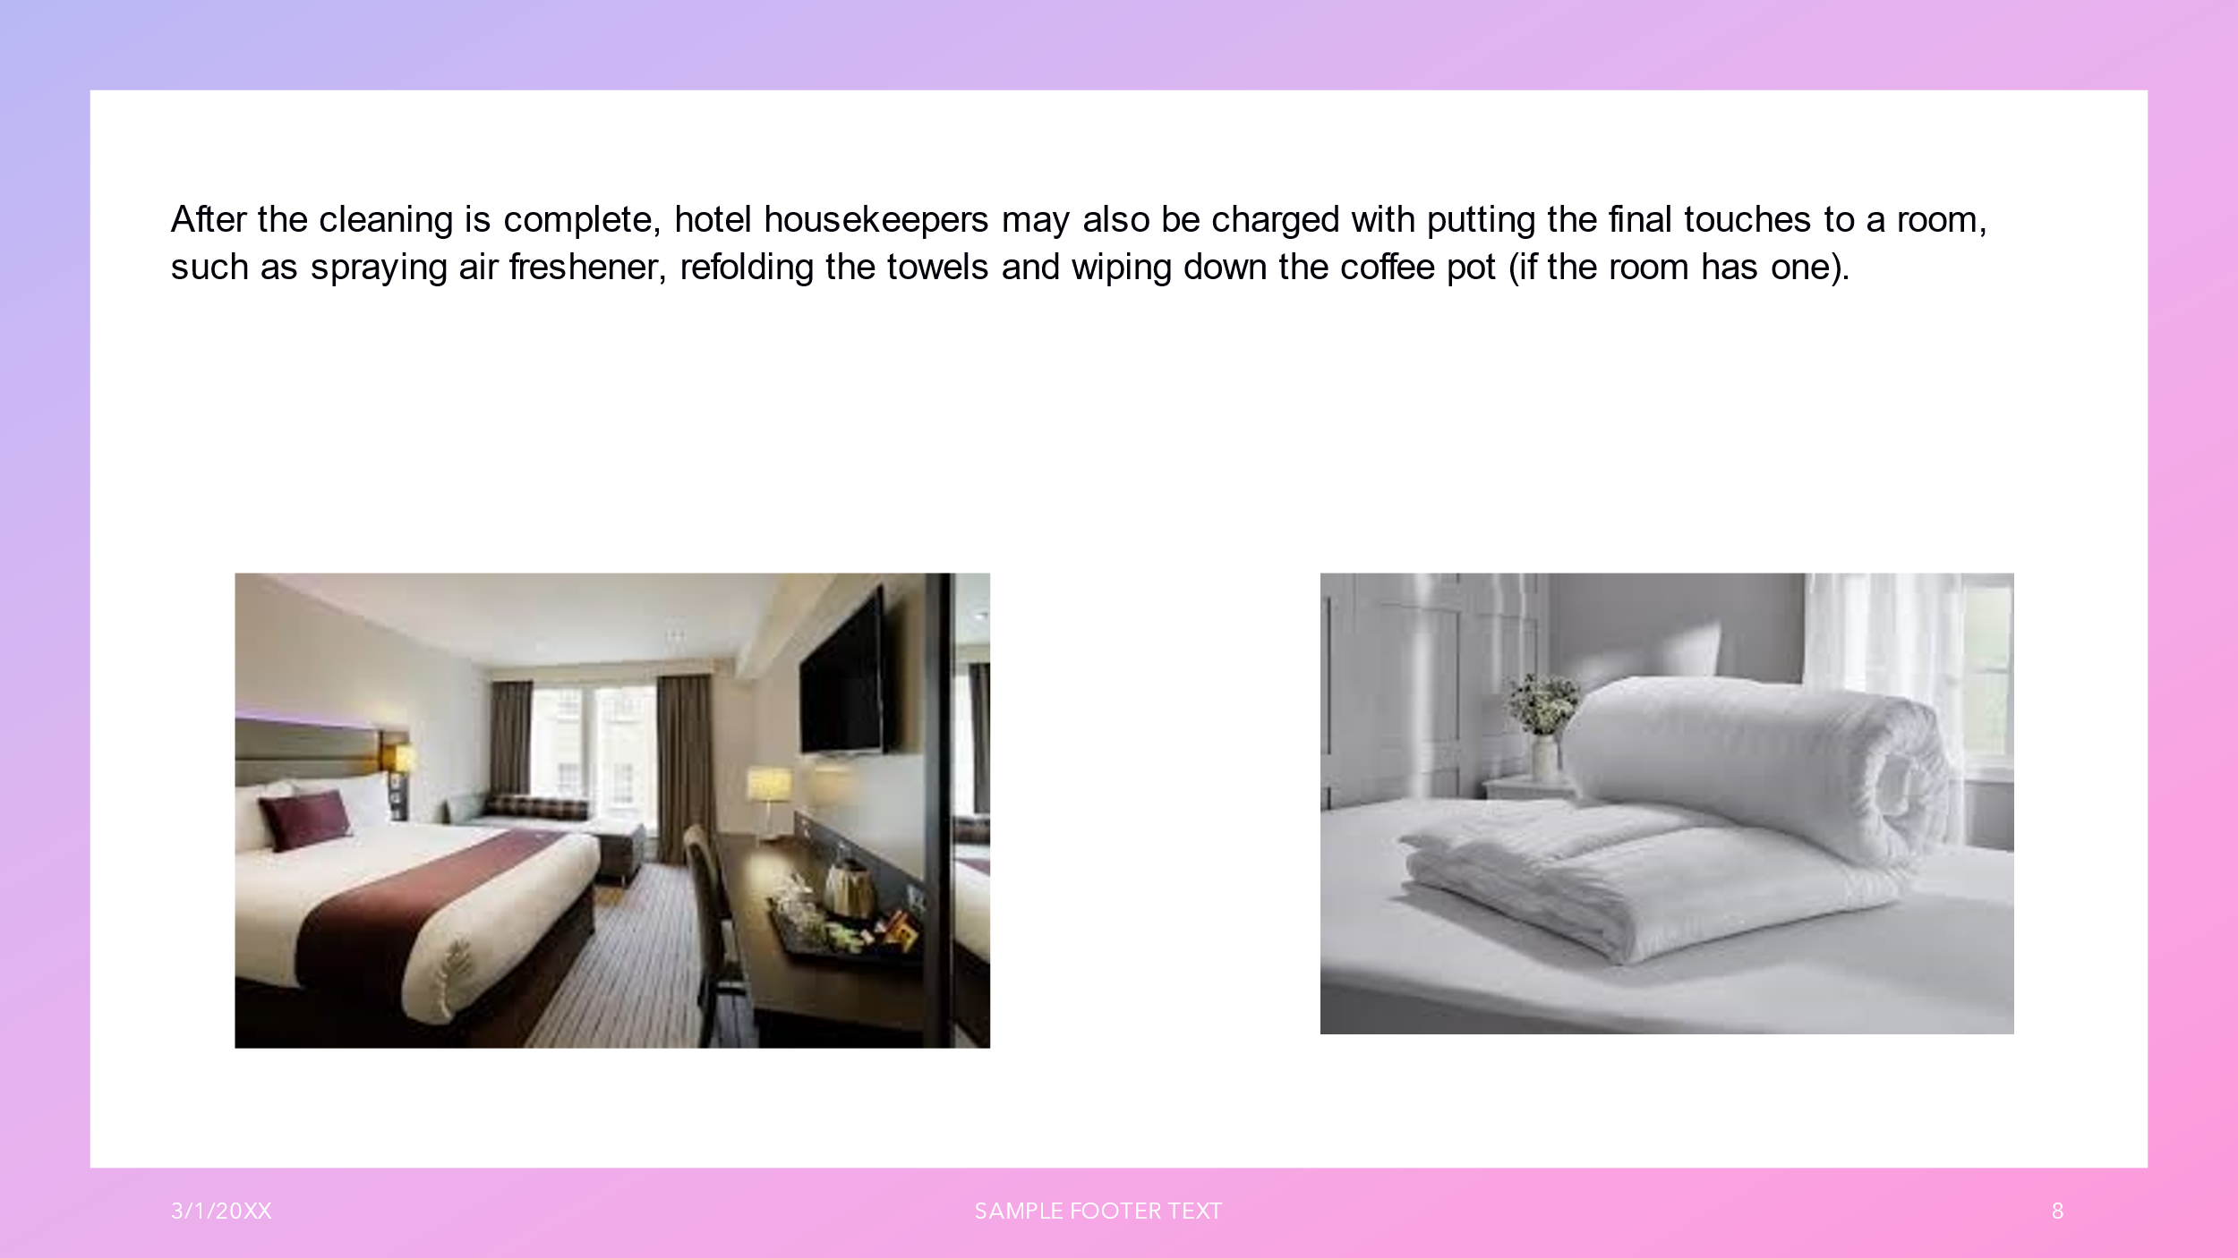

Training Notes: Double check every details to make sure that the room is respecting the standards.
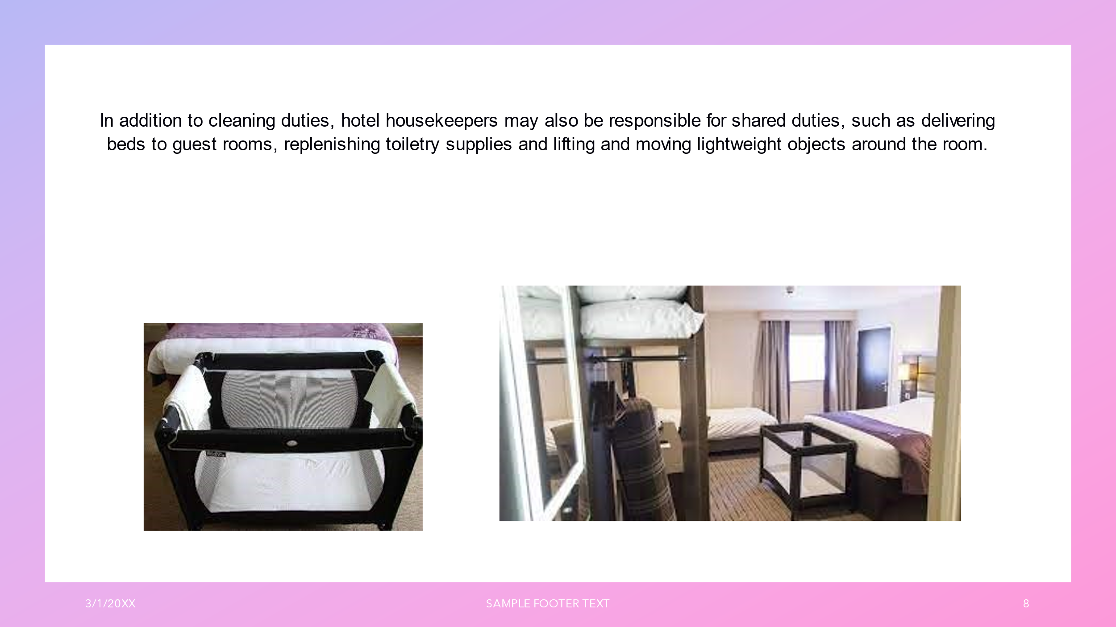

Training Notes: Make sure that your life style is keeping you in a good shape at work every day. Use the right metods while are you lifting or moving lightweight objects.
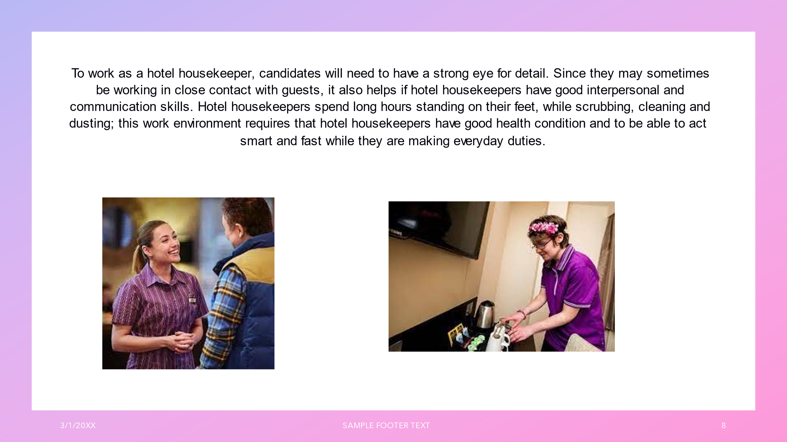

Training Notes: Be respectfull , come at work clean and tidy , because you are represing a very important part of the business .
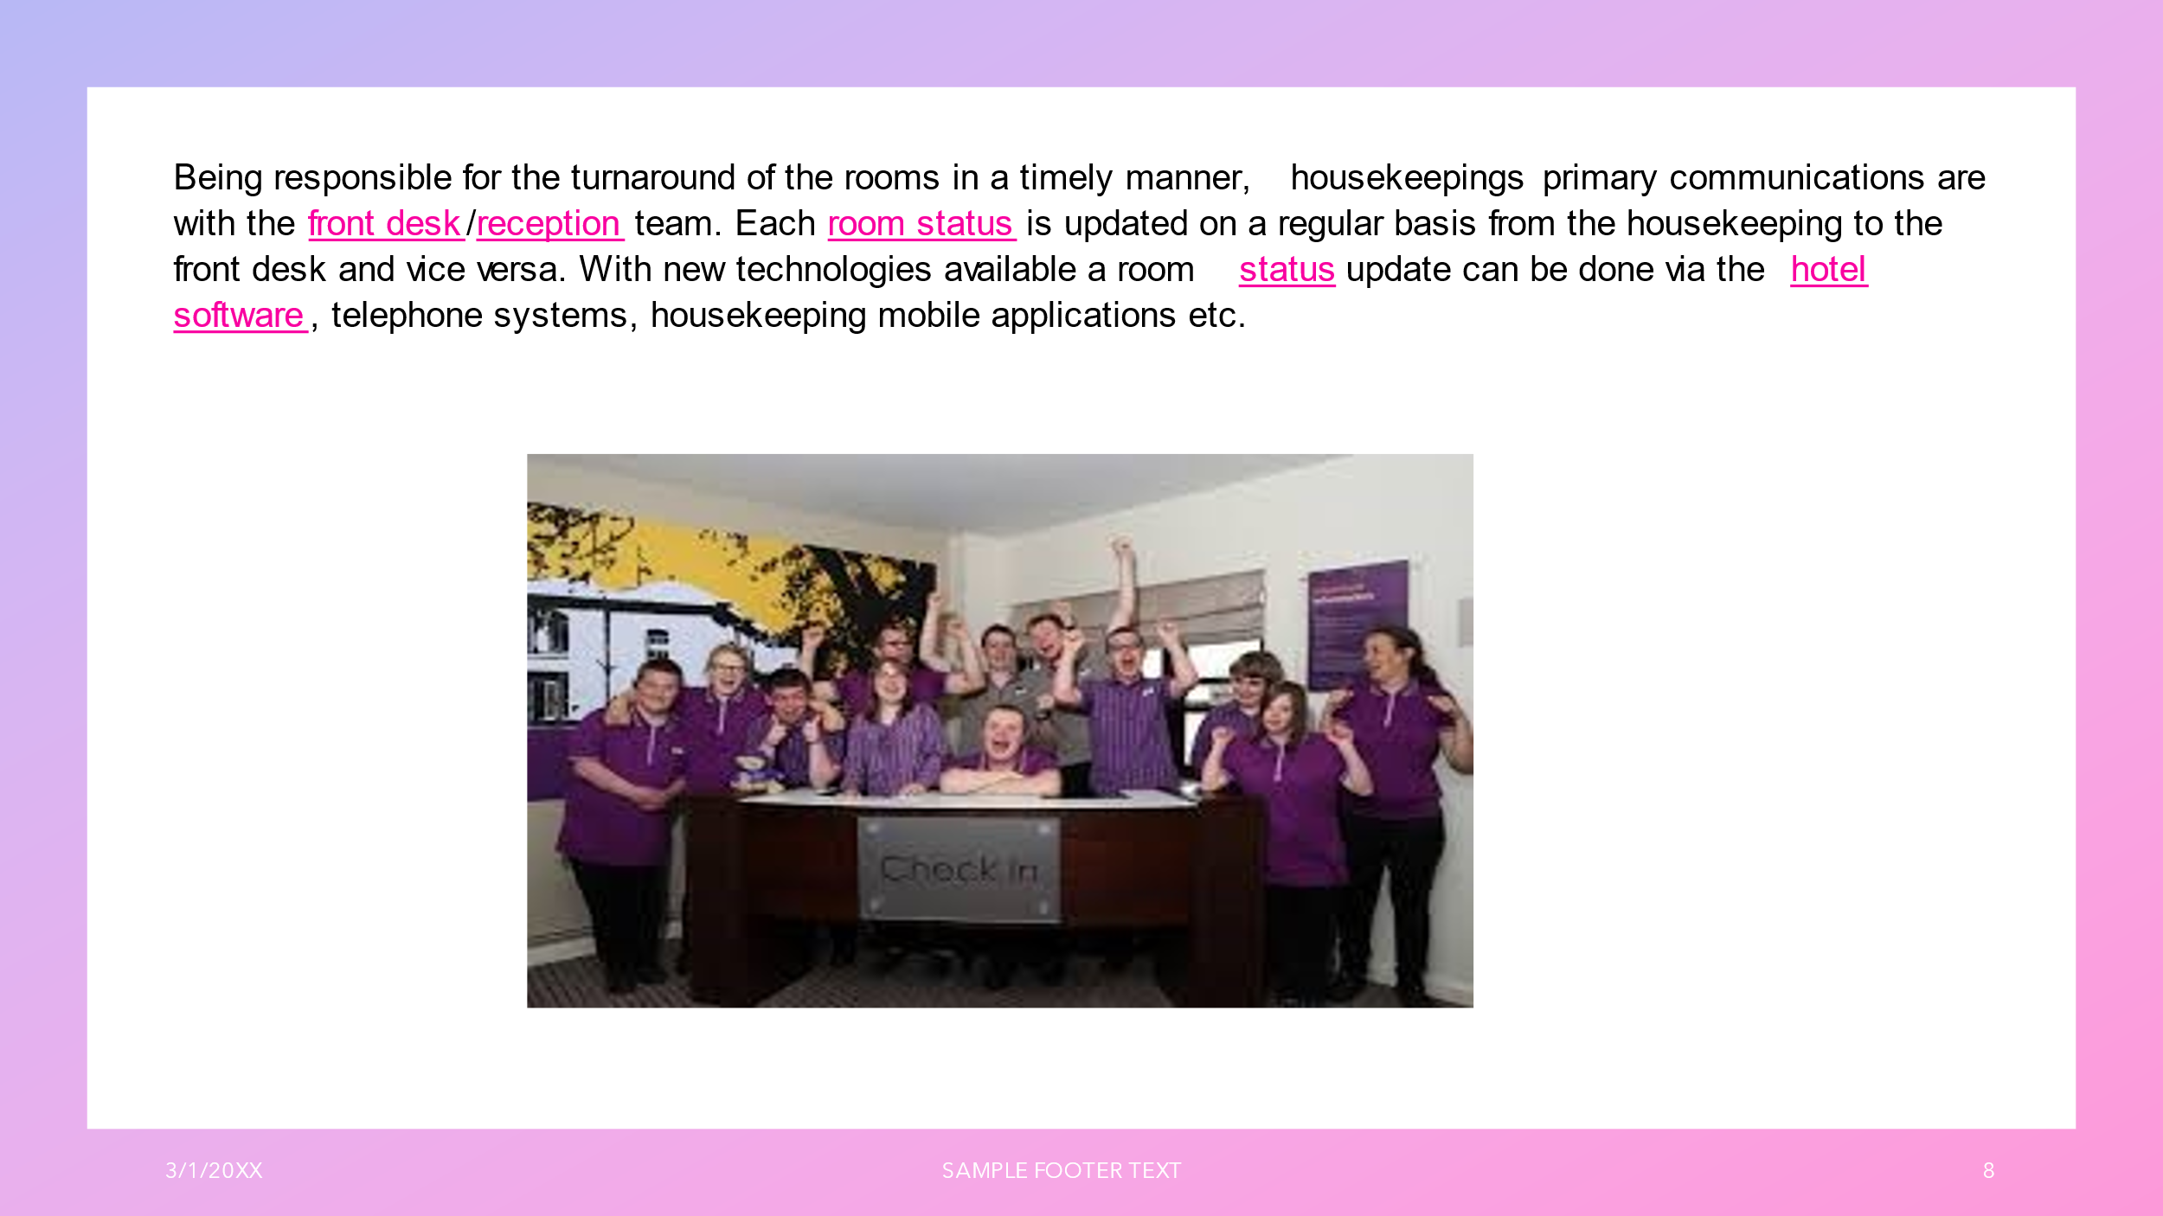

Training Notes: Make sure that you are communicating with the other departments to be able to give and receive the correct informations.
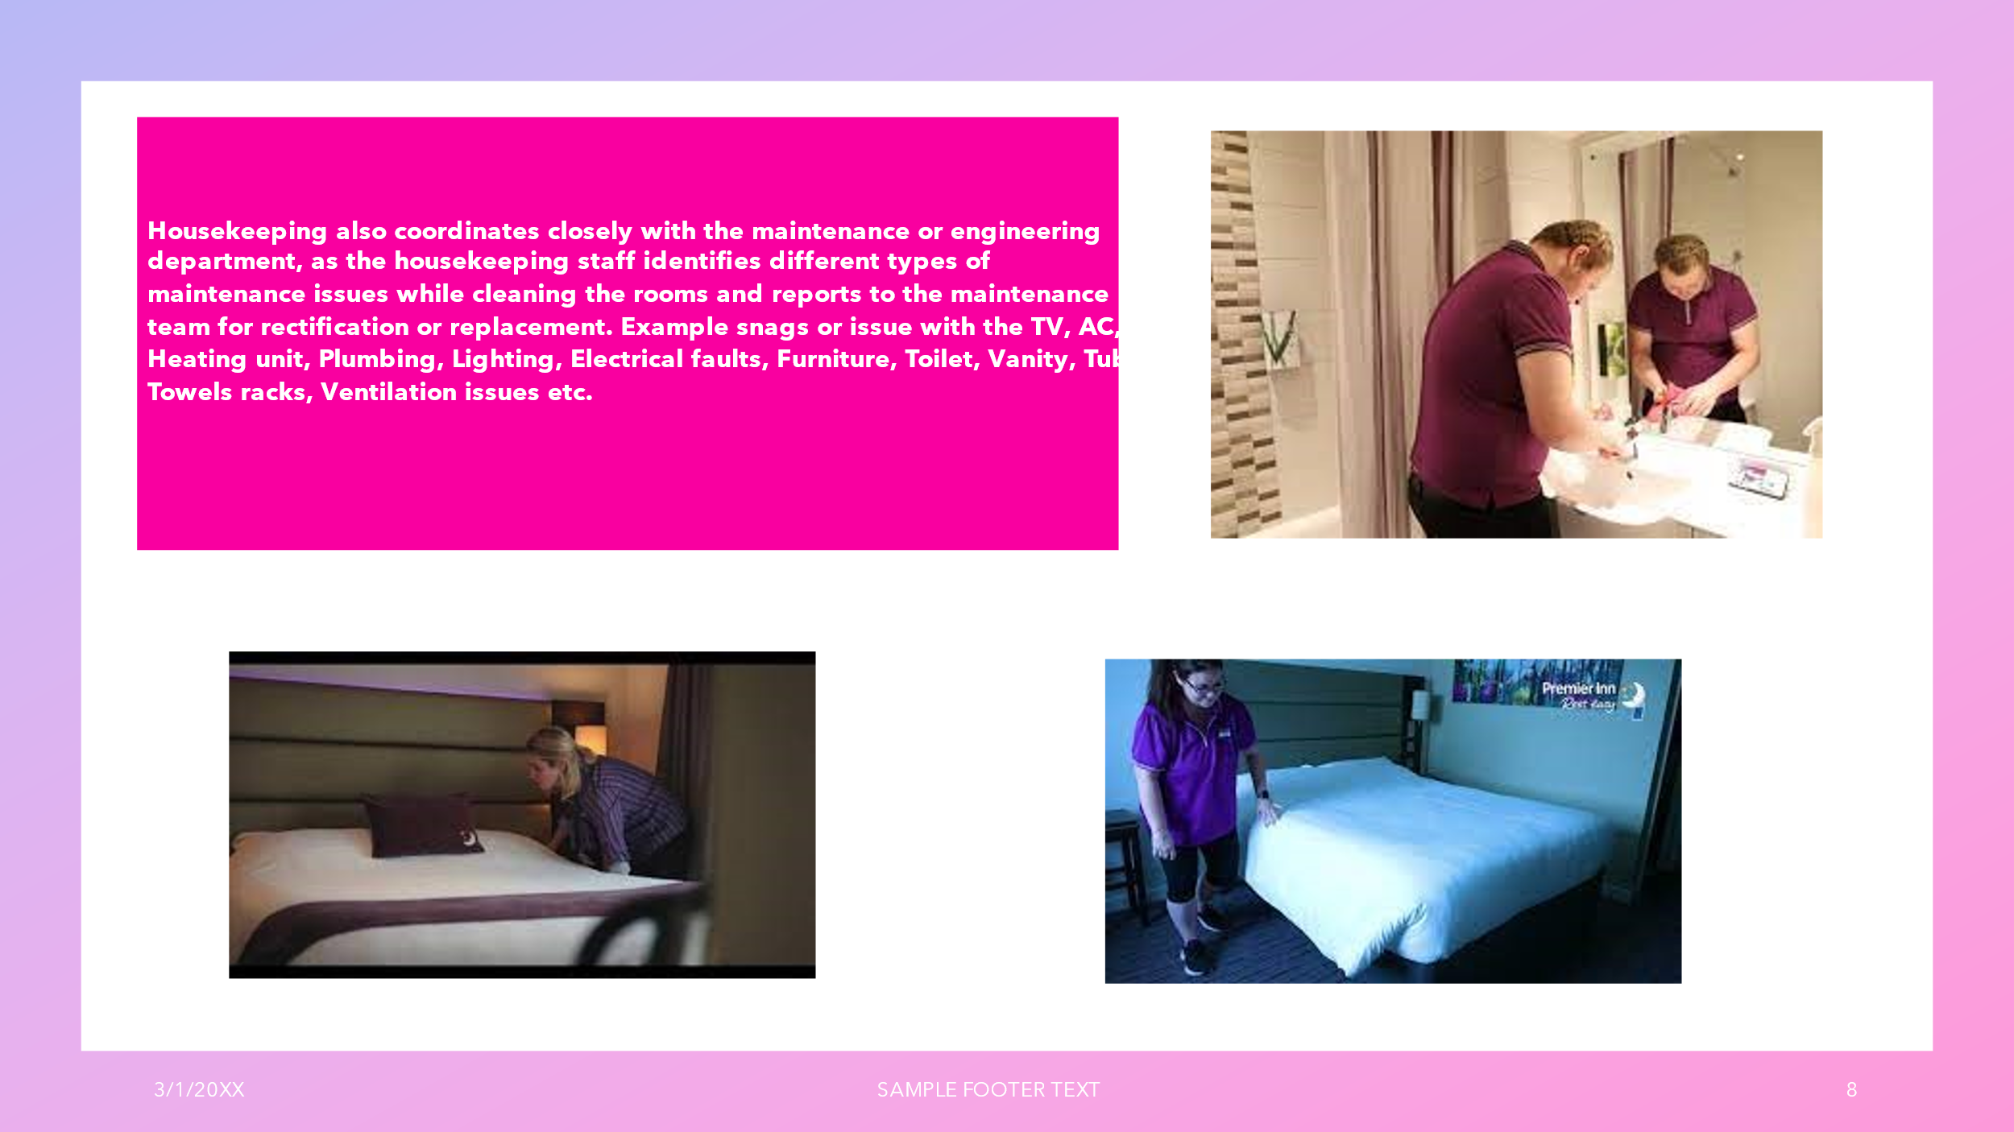
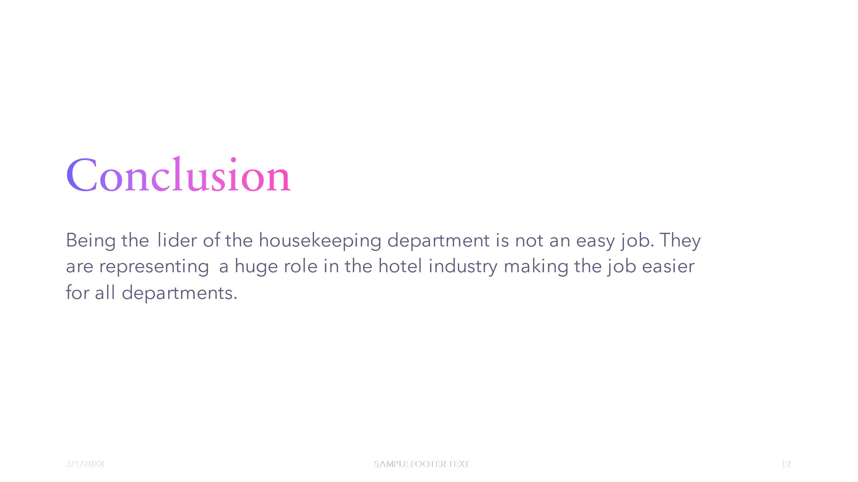
Training Notes: Report every incident to your supervisor to be able to be fixed before the room is given to another customer. Like that, in future , we will avoid the complaints.

References

- Raghubalan, G., Raghubalan, S. (2015). Hotel Housekeeping: Operations and Management. India: Oxford University Press.
- Jones, T. J. A. (2007). Professional Management of Housekeeping Operations. United Kingdom: Wiley.
- Hotel Housekeeping Operations. (2020). (n.p.): Orangebooks Publication.
- HOTEL HOUSEKEEPING: The Key Elements Of Housekeeping And Operations Techniques. (n.d.). (n.p.): NestFame Creations Pvt Ltd..
- Housekeeping (Theory and Practice). (n.d.). India: S. Chand Publishing.
- Casado, M. A., Livio, M. (2000). Housekeeping Management. United Kingdom: Wiley.

