Climate Change and Activism
The Green Adventure
Break Down Concept of Original Ad
Ad idea: contrasting between kids behind screens and empty lifeless gardens to happy children in nature and gardens full of wildlife. Also, a poetry reading of a Welsh poet about stopping and taking the time to enjoy nature.
Opening Hook: what we do in the next ten years will profoundly affect the next thousand, or a child’s question “what happens when all the bees disappear?”
Intriguing Detail: lack of biodiversity, health and wellbeing issues affected due to lack of nature
call to action: Remember nature, connection, rewild gardens, kid engagement with nature, benefits of nature

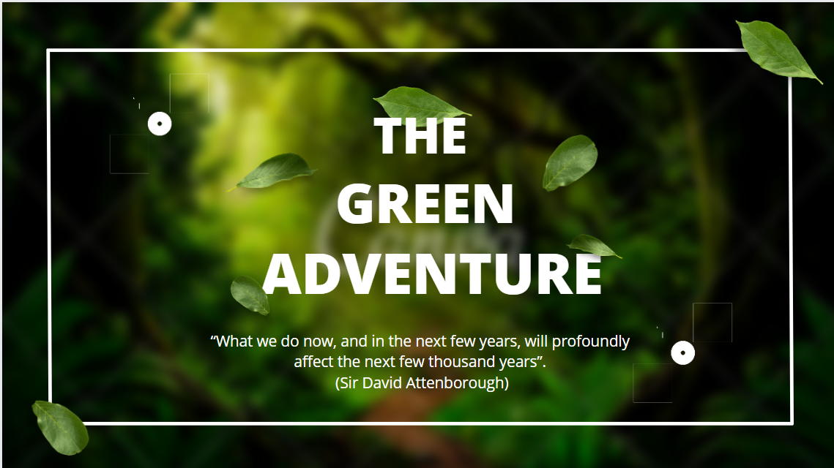 | 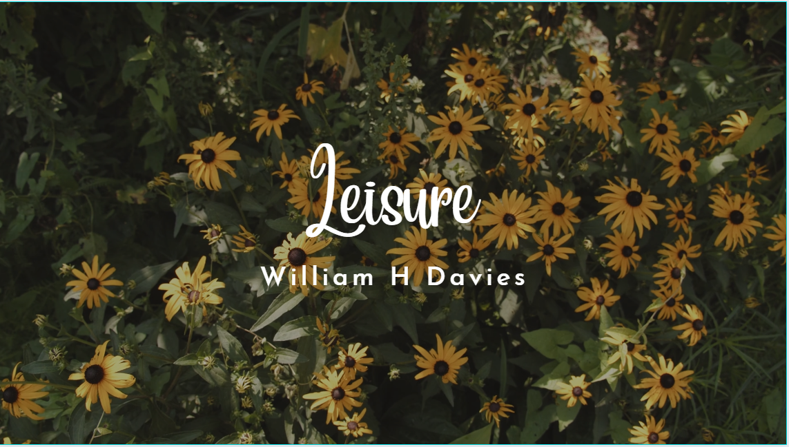 | 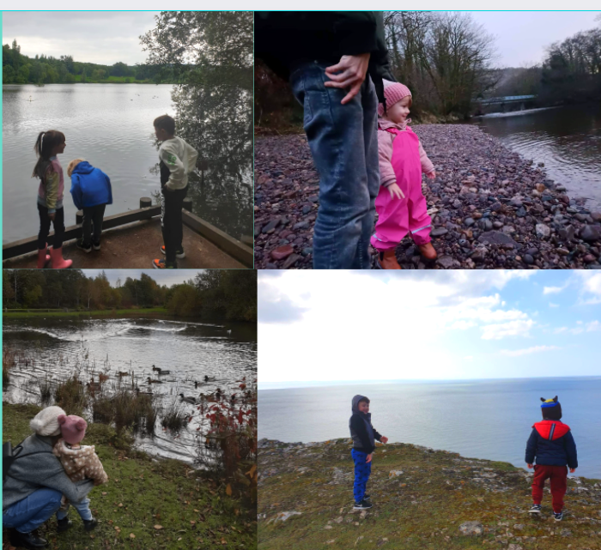 | 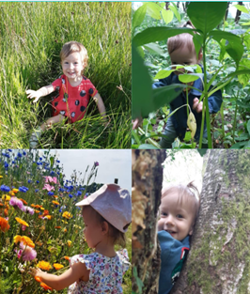
Title Slide: bright green colours to invoke the nature theme of the ad.  Then the quote from Sir David Attenborough as the hook for the ad about the impacts of the things we do now on the coming future. Since as he is considered a protector of the environment and a very respected figure due to his work, I thought it apt to quote such a well-known figure as part of the ad, to aid in recognition. | Title Slide: Poem introduction  I have chosen William H Davies poem called Leisure to be the backing sound for the ad while in the shots will be the facts written for clarification.  The poem's simplicity of nature-based leisure demonstrates how simple things may have a profound impact on a person’s mind and body and its core theme is the importance of being close to nature | Poem line: What is this life, if full of care we have no time to stand and stare  I chose images that had the children looking out into water, into its vastness to convey how much is unknown about the environment that surrounds us, linking it to the first line of the poem  Fact: kids today spend less than 4hours in nature, and the UK has lost half of its biodiversity  These are the two driving factors for my ad campaign hence why their mentioned first | Poem Line: No time to stand beneath the boughs and stare as long as sheep or cows  To relate to the line of the poem I chose images of children in flower meadows and fields  Facts: almost 90% of households have gardens  In this I wanted to cover how much green spaces we have just outside are back door and by making small changes we can have a big impact by using this resource that most households have.

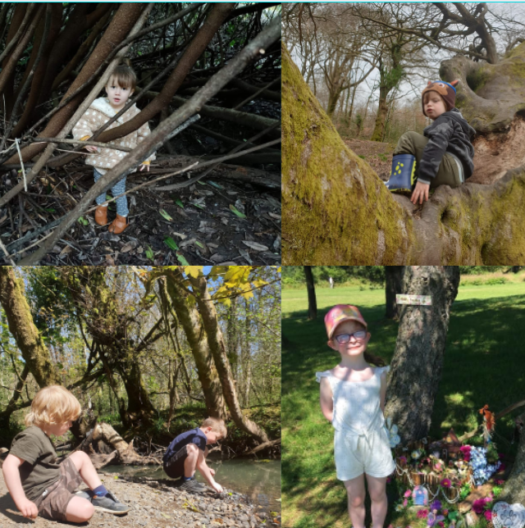 | 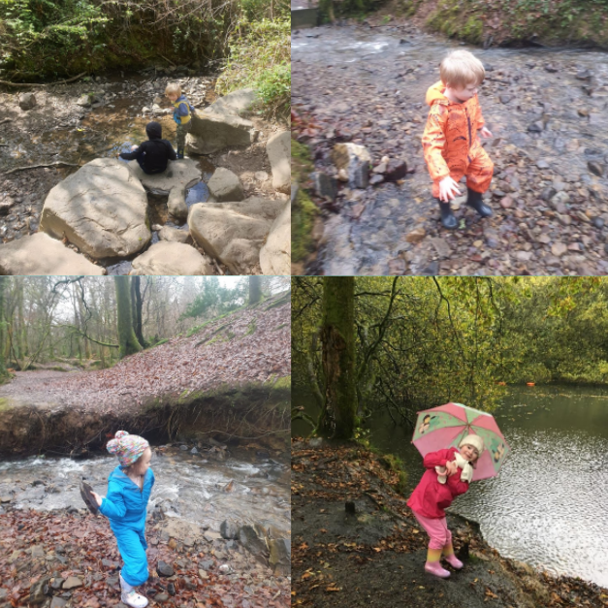 |  | 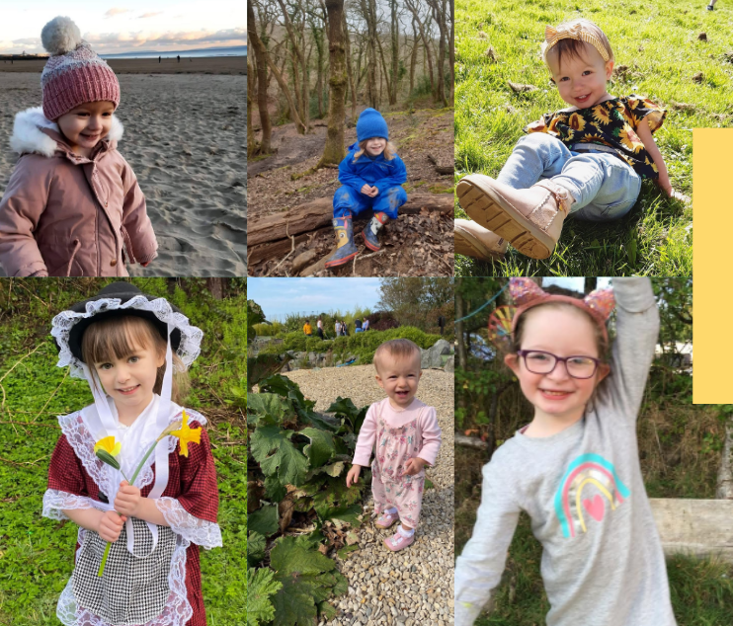
Poem Line: No time to see when woods we pass, where squirrels hide their nuts in grass  Again, relating to the poem I’m trying to establish a link between poem and picture with reference to facts. So in this I chose images of the children in trees.  Here I wanted to mention about rewilding gardens, insert a link to a website to arts and crafts and other activities for kids that would help create their rewilded gardens. | Poem Line: No time to see in broad daylight, streams full of stars, like skies at night  Streams link to poem  In this I wanted to link the benefits of kids by being in nature listed by Harvard Medical Blog (6 reasons children need to play outside - Harvard Health, 2022)  The 6 main benefits as listed below in accordance with their research  1. Sunshine.  2. Exercise.  3. Executive function.  4. Taking risks.  5. Socialization.  6. Appreciation of nature  All of which are of such a high importance to the growth and development of a | Poem Line: No time to turn at beauty's glance, and watch her feet, and how they dance  This slide I have a video of my friends child jumping in puddles  Facts: 88% of teachers say that children are happier after playing outdoors.  This I wanted to use the videos of kids playing outdoors without the interaction of adults but left to their own devices kids with their natural curiosity for nature. | Poem Line:No time to wait till her mouth can enrich that smile her eyes began  This slide I added pictures of kids smiling again to enhance the positivity of the feelings these kids are enjoying themselves outdoors

The Main Idea
The green adventure was my take on inspiring a green movement on building alternatives to standard gardening practices while also highlighting the benefits of such a movement to the younger generation and furthermore the future of biodiversity in the UK.
The key issues this ad campaign is trying to target is the lack of biodiversity and children’s lack of awareness of their natural surroundings. The focus is that by reintroducing children into nature by supporting the wild gardening movement. This not only greatly benefits the children but also by giving the children an appreciation and understanding of their natural surroundings gives them the tools to support and care for the natural environment that we have been losing creating this “indoor generation.”
Although my idea of rewilding gardens and the benefits of that reach people of all age groups. I decided to specifically target the younger generations as they are the ones who need to be more encouraged to connect with nature as they are the ones to which we will be handing over the care of this natural environment to in the future. I also wanted to make this ad campaign fun and appealing so as not to enhance negativity with the current issues our climate faces but highlighting the good positive things we can be doing to be effective.
The reasons why these are important issues is because on the whole the UK has lost almost half of its biodiversity (UK Biodiversity Loss Nearly at 50%, At Risk of “Ecological Meltdown” | Earth.Org - Past | Present | Future, 2022) , the wildlife that used to be common in our gardens is disappearing and without our intervention to help support these natural ecosystems then we will continue to lose those natural green spaces and the species that inhabit them.
I wanted to make my ad campaign, an easy and accessible idea for everyone. So, I started with peoples back gardens as according to the (Garden resource for wildlife, 2022) “About 87% of households in the UK have gardens, so there are getting on for 23 million gardens.” If we were to rewild these we would be able to create so many different habitats for all the wildlife as well as the green spaces becoming a classroom for people to learn about their environment, they’re also getting a beautiful garden low maintenance without high costs.

The Research
According to National Trust data, youngsters spend just over four hours per week playing outside. This contrasts with their parents' 8.2 hours when they were children. Furthermore, according to UK government research, 10% of respondents have not spent at least a year in a natural area such as a park, forest, or beach. It found that in the current day, general interaction with outside rural environments is low, and that it is strongly reliant on both the parents' attitudes toward outdoor exercise and their socioeconomic standing. (Children spend half the time playing outside in comparison to their parents, 2022)
Looking over this data, It was shocking looking at the lack of time spent by young kids today outdoors. There are a lot of factors that can be attributed to why, but that is why the implementation of forest schools in primary schools is becoming a key part of young peoples learning and education. Forest schools are regular classes that are centred on activity-based learning, supporting the children’s natural exploration, encouraging risk taking, independent learning and all while ensuring the children are enjoying themselves.
Another main source of research used was Richard Louv’s book last Child of the Woods, in this he describes children’s lack of exposure to their natural environment as “nature deficit disorder.” Louv attributes being in nature to being a fundamental part of self-growth for a child. Louv claims that today's youngsters are more alienated from the environment then earlier generations, weaving together appealing narratives and scientific data. A variety of issues keep kids inside the house, including a lack of open space, fear of injury, and, of course, electronic forms of entertainment. Louv links this natural deficiency to a slew of new phenomena, ranging from childhood obesity and depression to a lack of creativity and poor academic performance. This book was key in understanding the social changes that is faced by this current generation in a lack of
One of my inspirations for the ad was a video with similar concepts highlighting the indoor generation and the disconnection between children in this modern era and nature. I especially loved the videos of the children enjoying themselves in nature in contrast with the urbanised future they face. Talking about the Ancestral routes, holistic ways, finding connections with nature and encouraging kids to know the outdoors.
Spreading the Word
I would hire a marketing team to organise different social media types which would boost online presence, and keep writing/posting daily posts, photos and images about the project itself and ways people can join in. Then hosting challenges and giveaways for post engagements and sharing amongst followers. I would even start making tiktoks with small ways in which we can make this campaign a reality. Also, another way would be in contacting local schools and showing them this and encouraging rewilding of there school gardens with lessons that teach them how to be able to do the same thing at home.

Bibliography

https://www.childinthecity.org/2018/01/15/children-spend-half-the-time-playing-outside-in-comparison-to-their-parents/?gdpr=accept
Child in the City. 2022. Children spend half the time playing outside in comparison to their parents. [online] Available at: <https://www.childinthecity.org/2018/01/15/children-spend-half-the-time-playing-outside-in-comparison-to-their-parents/?gdpr=accept> [Accessed 8 April 2022].

https://www.youtube.com/watch?v=0Yv8gcFaJL0
Youtube.com. 2022. [online] Available at: <https://www.youtube.com/watch?v=0Yv8gcFaJL0> [Accessed 3 April 2022].

https://earth.org/uk-biodiversity-loss/
Earth.Org - Past | Present | Future. 2022. UK Biodiversity Loss At 50%, At Risk of “Ecological Meltdown” | Earth.Org - Past | Present | Future. [online] Available at: <https://earth.org/uk-biodiversity-loss/> [Accessed 1 April 2022].
http://www.wlgf.org/garden_resource.html#:~:text=About%2087%25%20of%20households%20in,on%20for%2023%20million%20gardens.
Wlgf.org. 2022. Garden resource for wildlife. [online] Available at: <http://www.wlgf.org/garden_resource.html#:~:text=About%2087%25%20of%20households%20in,on%20for%2023%20million%20gardens.> [Accessed 5 April 2022].
https://www.health.harvard.edu/blog/6-reasons-children-need-to-play-outside-2018052213880
Harvard Health. 2022. 6 reasons children need to play outside - Harvard Health. [online] Available at: <https://www.health.harvard.edu/blog/6-reasons-children-need-to-play-outside-2018052213880> [Accessed 24 March 2022].

