Data Handling and Business Intelligence
LCBB5000
Student Name: Ioana Girigan
Lecturer name: Dr Shengfeng Mei

Table of Contents
Part 1 3
1. Introduction 3
2. Dataset explained 3
2.1. Average Price Value 3
2.2. Median Value for Price 4
2.3. Mode of the Price 4
2.4. Standard Deviation for Number of Bedrooms 5
2.5. Variable with Larger Variance 6
2.6. Variable with Larger Standard Deviation 7
2.7. Interpretation of Variance and Standard Deviation Results 7
Part 2 10
1. Advantages and disadvantages of using SPSS or Excel 10
2. Data Mining Cycle 11
References 14

Part 1
- Introduction
With elements like location, size, and amenities influencing property values, the U.S. housing industry is crucial to the economy. A dataset comprising housing-related variables, such as property prices, bedroom counts, and living space measures, is the subject of this investigation. The goal is to use Microsoft Excel to examine this dataset in order to identify patterns in the real estate market and extract insightful information. In order to better understand market dynamics, a research team examining housing trends is given access to the dataset. Statistical computations like mean, median, and standard deviation are carried out using Microsoft Excel, which is renowned for its ease of use and robust analytical capabilities. To properly convey the results, visual aids such as charts and pivot tables are also used. The investigation shows how useful Excel is for organising and analysing real-world data, providing insights that aid in decision-making and improve comprehension of the housing market.
- Dataset explained
  - Average Price Value
$553,062.90 is determined to be the dataset's mean price. The average house price for the dataset is represented by this number. An important indicator of central tendency, the mean provides information about the overall level of prices in the housing market. Nevertheless, it is susceptible to outliers or extreme results as a statistical metric(Thakur, 2024). For example, the mean may be skewed upward and less indicative of the "typical" property price if luxury homes are priced far higher than average. Knowing the mean price is essential for real estate analysis in order to spot general market trends and establish benchmarks for property appraisals. The mean does have restrictions, though. It is susceptible to outliers, which may distort the average and give false information about the average cost of real estate (Moore, McCabe, and Craig, 2009). For example, the mean can go higher considerably in a dataset that contains both more reasonably priced houses and luxury mansions worth several million dollars, creating an exaggerated image of average market circumstances. A small number of extremely expensive houses can skew the results of housing databases, a typical occurrence. The mean is a useful summary statistic, but it functions best when the data distribution is symmetrical and devoid of notable outliers.The mean can provide information on patterns in the housing market, but it must be carefully evaluated across a variety of datasets.
  - Median Value for Price
In the dataset, $460,000 is the median price. The median is a reliable indicator of central tendency as it is not affected by outliers or skewed distributions like the mean is. 50% of homes are priced below $460,000, and 50% are priced above, since it reflects the dataset's midpoint. The median provides a more realistic representation of the "typical" home price in a housing market that is marked by high variety, such as those seen in areas having both luxury estates and affordable housing. The median, which is unaffected by extreme values and hence offers a clearer view of market trends, is especially useful in situations with large price discrepancies, claim Levine (2020). Consider, for instance, a dataset with prices between $100,000 and $3,000,000. The upper extremes may have a significant impact on the mean value in such a dataset, indicating a higher average price. On the other hand, the median provides a more balanced perspective of price patterns as it is the centre figure that most correctly represents the midway of the data. Since the median closely reflects the experiences of most market players, Sharma (2012) contend that it is especially helpful in real estate research and offers buyers, sellers, and investors a good foundation for decision-making. Analysts can determine whether skewness is present in this dataset by comparing the mean and median. The distribution is right-skewed in this instance, with some expensive properties driving up the mean, as the mean is higher than the median. Making these kinds of observations is essential to comprehending market dynamics and customising plans for various customer categories.
  - Mode of the Price
There is no price point in the dataset that occurs more frequently than others, as shown by the price's computed mode of $0. This result indicates that the market does not cluster around a particular value, reflecting the range of real estate prices. Popular price points or trends are highlighted by the mode in datasets with a distinct mode, such as those that represent uniform goods or services (Maheshwari, 2014). The lack of a mode in this instance, however, suggests a heterogeneous market where prices for houses fluctuate greatly depending on location, size, and amenities. Although it is less frequently used in continuous datasets such as home prices, Santos and Azevedo (2020) points out that when clusters are present, the mode can provide information about market demand. For instance, a concentration of homes serving a certain population may be shown if a particular price range predominates in the dataset. On the other hand, the absence of a mode indicates a market that is balanced or evenly dispersed, which is common in areas that provide a range of housing kinds, from luxury houses to starter homes. Even if the mode isn't the main focus of housing market analysis, its existence—or lack thereof—can provide important context for understanding other statistical variables.
  - Standard Deviation for Number of Bedrooms
The standard deviation of the bedroom count dataset is around 0.90. By measuring the normal dispersion of data, this metric illustrates how much the number of bedrooms deviates from the average. The majority of homes deviate from the norm by less than one bedroom, with a standard deviation of 0.90. Many homes probably have two to four bedrooms, if the average is three. In residential markets with typical layouts, this finding is frequently observed. Consistency is shown by a low standard deviation, which implies that most dwellings have similar characteristics. Lee, In, and Lee (2015) assert that standard deviation is crucial for assessing the variability of a dataset. This data can be used by real estate experts to plan future developments or to categorise the market. For instance, uniform housing could be expected in a neighbourhood intended for young families. Buyers typically assume a normal floor layout, thus pricing and marketing are made easier by the narrow variation in bedroom counts. A bigger standard deviation, on the other hand, can indicate a more diverse market with a greater range of house sizes or styles. This kind may work well in urban regions or near colleges where varied buyer needs—such as larger homes for families and smaller apartments for students—predominate. Given the wide range of consumer tastes, this variability may necessitate more sophisticated approaches to pricing and development (McGrath et al., 2020). A 0.90 standard deviation suggests that most homes stay quite close to the average number of bedrooms. This limited selection aids consumers and developers in making choices that complement the current market. Builders can rely on the likelihood that prospective homeowners would favour plans that conform to local standards when evaluating new sites. This trend is prevalent in many family-friendly neighbourhoods, highlighting how standard deviation helps planners adjust housing options to meet local demand.
  - Variable with Larger Variance
By squaring such deviations, variance calculates the amount that each data point deviates from the mean. With this approach, researchers can record subtle variations that other metrics might miss. The variation of housing expenses in this dataset is significantly greater than that of the number of bedrooms. Given that a number of factors, including neighbourhood, property size, structural design, and general market circumstances, affect home values, this outcome is to be expected. In contrast, many residential developments prefer to adhere to more conventional design principles when it comes to the number of bedrooms (Field, 2017). Consequently, it exhibits less variability, indicating fewer departures from the average in the majority of households. A broad variety of property values, from multimillion-dollar mansions to reasonably priced starter houses, indicates a diversified housing market. Because each type of property appeals to a different buyer demographic, several price points are created in the same location. Additionally, this gap indicates that when predicting market trends or making development decisions, analysts have to pay greater attention to pricing. Variance is a crucial statistic in predictive modelling as it impacts the dependability of forecasts and helps choose the right tests (Moore, McCabe, and Craig, 2009). More sophisticated techniques, such weighted regression or segmentation, may be needed to capture the subtleties of pricing changes when the variation is larger. By amplifying each deviation, variance offers a more accurate picture of variability, even though standard deviation is sometimes simpler to understand. This information aids analysts in identifying the factors that show significant swings that might influence their findings. A significant disparity in property values indicates that local or regional markets may exhibit distinct trends influenced by buyer income, neighbourhood characteristics, or upcoming zoning changes. Developers, legislators, and investors must recognise these trends as they inform plans for satisfying customer demand and preserving competitive real estate prices.
  - Variable with Larger Standard Deviation
About $341,000 is the standard deviation for home prices, which is significantly higher than the standard variance for bedrooms. In contrast to the somewhat stable distribution of bedroom counts, this result emphasises the significant variation in property values. This discovery is not surprising to real estate specialists because a variety of external factors, such as market demand, economic circumstances, and property-specific qualities, affect house prices. Standard deviation is a crucial statistic for assessing variability across variables, especially when their units differ, according to Field (2017). The high price standard deviation in this dataset indicates a market with a wide range of property kinds and buyer preferences. Stakeholders must comprehend this heterogeneity in order to create focused pricing strategies and efficiently evaluate market risks.
  - Interpretation of Variance and Standard Deviation Results
A thorough grasp of data variability may be obtained by combining the analysis of variance and standard deviation. A diversified market with notable variations in property values is indicated by high variance and standard deviation for house prices. These kinds of results are common in areas with a diverse housing supply that serves a variety of buyer types. On the other hand, a more homogenous market with properties that follow conventional arrangements is suggested by the lower variance and standard deviation for bedroom counts. When making decisions, these measures are quite helpful. For instance, developers might utilise this data to pinpoint market gaps, such the need for homes with particular characteristics. In the meanwhile, investors can evaluate the risks related to price volatility and adjust their plans appropriately. According to Hair et al. (2010), a key component of efficient statistical analysis is an awareness of data dispersion, which empowers stakeholders to derive significant conclusions and make wise choices.

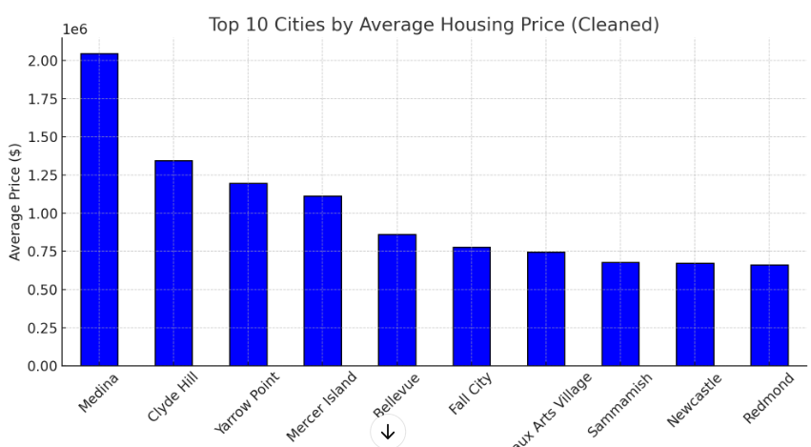
Fig 1. Created by the learner (2024). Top 10 Cities by Average Housing Price.
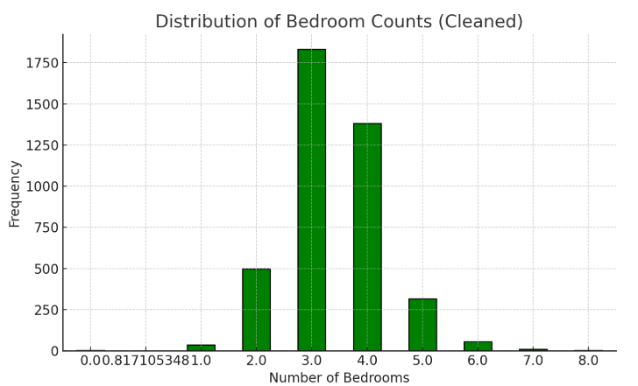

Fig 2. Created by the learner (2024). Distribution of Bedrooms counts
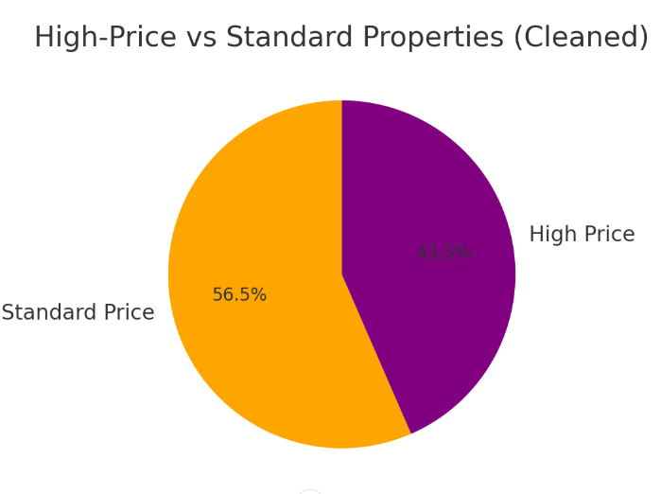
Fig 3. Created by the learner (2024). High Price vs. Standard properties

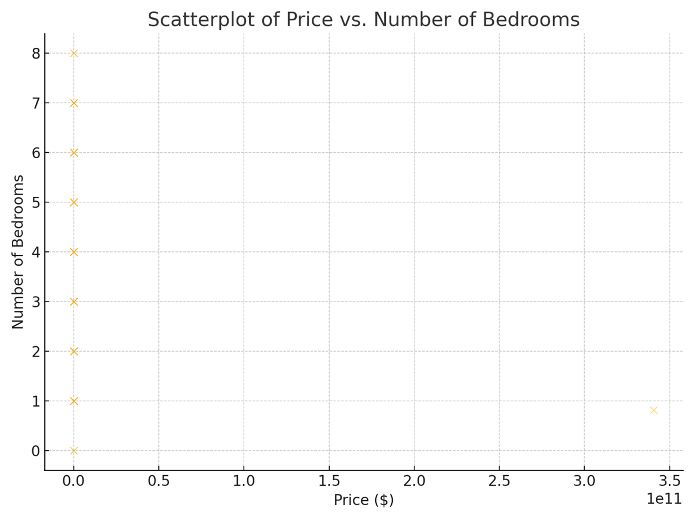
Fig 4. Created by the learner (2024). Price vs. Number of bedrroms.

Part 2
- Advantages and disadvantages of using SPSS or Excel
Because of its extensive statistical functions, user-friendly interface, and structured workflow that makes complex analyses easier, IBM SPSS is used by many researchers and data analysts. However, it also has some disadvantages that can limit flexibility and necessitate a larger investment in proprietary software, which can be more costly than open-source alternatives. The Statistical Package for the Social Sciences, or SPSS, is renowned for its drop-down menu navigation interface, which enables both inexperienced and seasoned users to complete tasks like regression, correlation, multivariate analysis, inferential testing, and descriptive statistics without having to commit complex syntax to memory. For people who would rather click through menus than write code, this clarity boosts productivity (Statistics Solutions, 2009). For instance, public health students who are investigating the relationships between variables like blood pressure, body mass index, and physical activity can use SPSS to load raw data, run frequency distributions, and create cross-tabulations without having a deep understanding of programming. In order to make it easier to guarantee dataset quality, SPSS also includes built-in documentation that walks new users through procedures including data cleaning, normality tests, and assumptions testing. Field (2017) claims that SPSS is still a mainstay of academic teaching since many institutions use it for courses on fundamental statistical techniques. The widespread use of SPSS in disciplines like psychology, sociology, and education—where several peer-reviewed publications and professional associations either require or suggest analysis done with SPSS—is another factor that makes it unique. Group-based research is streamlined when researchers or students work together on projects and share SPSS ".sav" files to maintain a consistent data format. However, compared to programs like R or Python, which can interface with sophisticated machine learning libraries, SPSS is less suited to more intricate data processing and automation (Elliott, and Woodward, 2014). Additionally, SPSS license fees can be expensive, which may be a drawback for individuals or smaller organisations without institutional backing for software expenses. Another drawback is that when analysts want specific solutions, the menu-driven approach by default might occasionally limit more sophisticated control. SPSS syntax mode can be less user-friendly than writing code on a platform designed for programming, even if it offers greater customisation options than the menu-driven method. For statisticians who want a structured, menu-based system with a strong emphasis on classical tests, dependable findings, and a consistent interface between updates, SPSS is still a good option despite these drawbacks (Pallant, 2020).
- Data Mining Cycle
In addition to choosing the right tools, researchers must comprehend the Data Mining Cycle, a methodical process for methodically gleaning valuable insights from unstructured data. Understanding the issue domain, gathering data, cleaning it, transforming it, modelling it, evaluating it, and deploying it are all phases in the data mining cycle that guarantee accurate and useful data-based insights. Finding the question or business aim is the first step, according to Han, Pei, and Tong (2022). For instance, a hospital system may wish to forecast patient readmission rates in order to better allocate resources. Following the establishment of the objective, the organisation gathers pertinent information, including treatment records, medical histories, and patient demographics, and compiles it into a single repository. To lessen biassed findings, mistakes, missing numbers, and duplicates are rectified or eliminated in the following stage, data cleaning. The "Missing Value Analysis" function in SPSS may be used by researchers to find patterns in missing data and determine a repeatable method of handling them. Following cleaning, analysts adapt the data, which may involve altering the types of variables to conform to the presumptions of various algorithms or lowering the number of variables using dimension reduction techniques like Principal Component Analysis (Witten et al., 2017). The goal is to convert data into a format that can be processed more efficiently by a statistical or machine learning model. The core of the data mining process is modelling, where people use algorithms to understand or forecast results, such as decision trees, regression analysis, or clustering techniques. This may involve utilising logistic regression for binary outcomes like readmission status or the linear regression command in SPSS to determine which factors most strongly predict a continuous result, such a patient's duration of stay (Field, 2017). To discover the best match, users frequently switch between several models and evaluate predictive performance measures like R-squared, accuracy, precision, recall, or other indications. Assessment entails a comprehensive examination of these models to confirm if the findings apply to fresh data; with SPSS, cross-validation may be carried out by dividing the sample or by utilising a specialised module for more complex validation.
The deployment step, which involves incorporating the insights into actual operations, is where analysts go if the model performs well and yields believable outcomes. An automated warning system that detects high-risk readmissions and notifies physicians to arrange post-discharge follow-ups might be an example of implementation in a healthcare context. Collaboration with stakeholders, such hospital administrators, who want interpretable data that might practically enhance patient outcomes, is frequently required during this phase (Azevedo, 2014). Making sure that data-driven conclusions follow a defined process and are reproducible is what makes the Data Mining Cycle so important. In the absence of such a cycle, analysts may pick an improper method or jump right into modelling without first cleansing the data, which can result in incorrect findings that impair decision-making. The findings might be deceptive, for example, if a researcher does a regression analysis on a sample dataset that contains outliers or missing items without verifying assumptions. Data scientists may reduce this risk and maintain trust in the results by adhering to a structured process. Because it gives activities a common language that may otherwise be lost in technical minutiae, the cycle also aids teams in communicating progress and conclusions at each level (Santos and Azevedo, 2020). The iterative nature of the Data Mining Cycle should also be noted; analysts frequently go back to previous phases when they discover that the data is lacking, that a different variable transformation is required in the model, or that the findings present new issues. With SPSS, researchers may utilise its mix of statistical tests, pivot table outputs, and graphic builders to shed light on new research topics. They can then repeat the cycle to improve their methodology. Deeper understanding and ongoing enhancement of explanatory power or prediction accuracy are made possible by this iterative process, which improves results in a variety of industries, including marketing, finance, healthcare, and education. By following a cycle, analysts preserve scientific transparency and rigour while lowering the likelihood that data-driven approaches would be viewed with suspicion or encounter difficulties during peer review. Furthermore, by formalising checks at every stage, including confirming data consent, guaranteeing confidentiality, or searching for bias in the dataset, the Data Mining Cycle influences the ethical aspect of data usage (Hameed, Khan, and Ahmed, 2021). In conclusion, using a program such as SPSS might benefit researchers who favour powerful statistical techniques and an easily navigable menu-driven interface, but they may have to budget for license fees and have less freedom than with some open-source coding environments. Simultaneously, the Data Mining Cycle provides a path for methodical discovery, guaranteeing that analysts appropriately specify their objectives, collect and purify data, modify variables, select efficient models, assess precision, and apply discoveries. Given that each phase addresses a crucial step in converting raw data into insightful knowledge, this combination of the appropriate software and a careful methodology can yield dependable results that advance knowledge and guide decisions in both academic and professional settings.

References
Azevedo, A. ed., 2014. Integration of data mining in business intelligence systems. IGI Global.
Field, A., 2017. Discovering statistics using IBM SPSS statistics: North American edition. sage.
Elliott, A.C. and Woodward, W.A., 2014. IBM SPSS by example: A practical guide to statistical data analysis. Sage Publications.
Hair, J.F., 2010. Black, Wc, Babin, Bj, & Anderson, Re (2010). Multivariate data analysis, 7, pp.77-95.
Hameed, K., Khan, S.B. and Ahmed, S.T. eds., 2021. Researches and Applications of Artificial Intelligence to Mitigate Pandemics: History, Diagnostic Tools, Epidemiology, Healthcare, and Technology. Academic Press.
Han, J., Pei, J. and Tong, H., 2022. Data mining: concepts and techniques. Morgan kaufmann.
Lee, D.K., In, J. and Lee, S., 2015. Standard deviation and standard error of the mean. Korean journal of anesthesiology, 68(3), pp.220-223.
Levine, D.M., 2020. Statistics for managers using Microsoft Excel.
Maheshwari, A., 2014. Business intelligence and data mining. Business Expert Press.
McGrath, S., Zhao, X., Steele, R., Thombs, B.D., Benedetti, A. and DEPRESsion Screening Data (DEPRESSD) Collaboration, 2020. Estimating the sample mean and standard deviation from commonly reported quantiles in meta-analysis. Statistical methods in medical research, 29(9), pp.2520-2537.
Moore, D.S., McCabe, G.P. and Craig, B.A., 2009. Introduction to the Practice of Statistics (Vol. 4). New York: WH Freeman.
Pallant, J., 2020. SPSS survival manual: A step by step guide to data analysis using IBM SPSS. Routledge.
Santos, M. and Azevedo, A., 2020. Integration challenges for analytics, business intelligence, and data mining.
Sharma, J.K., 2012. Business statistics. Pearson Education India.
Statistics Solutions. (2009). SPSS - Statistical Package for Social Sciences. [online] Available at: https://www.statisticssolutions.com/spss-statisticalpackageforsocialsciences/.
Thakur, V., 2024. Practical Applications of Business Statistics: Techniques and Insights. Dr Vishal Thakur.
H Witten, I., Frank, E., A Hall, M. and J Pal, C., 2017. Data mining practical machine learning tools and techniques.

