How is humanity’s shift towards decentralisation in the post-human era reflected in works of art

Abstract:
This project examines the work of two decentralised artists, Anika Yi and Mary Mattingly, exploring how the shift towards decentralisation in the post-human era is reflected in their artworks. The paper will analyse theoretical perspectives from philosophers such as Rose Braidotti, anthropologists and other scholars. Subsequently, the paper will examine four artworks by Anika Yi and Mary Mattingly: *Dewdrop Continuum, Biologizing the Machine (tentacular trouble), *Swale* and Pull. The analysis will focus on how these four artworks embody decentralisation. Drawing on Rose Braidotti’s view that the essence of life is Zoe, this paper argues that the mode of existence of the subject is nomadic, distributed and relational within a decentralised world (Rose Braidotti, 2013). This philosophical concept is embodied in all four artworks. In Swale, Mary Mattingly transforms a barge into a floating food forest, roaming the waterways of New York; in Pull, she interprets everyday objects as the burdens of life, roaming the city’s streets; in the artwork Dewdrop Continuum*, Anika Yi bio-engineers machines into breathing lungs, roaming the exhibition space in the form of Zoe; and in the artwork *Biologizing the Machine (tentacular trouble), Anika Yi recodes machines into wombs, with simulated moths roaming within them. This text explores how humanity survives in a decentralised world through a nomadic existence, transforming from a ruler into a participant.

Keywords: nomadic subjectivity, posthumanism, vitalist materialism, contemporary art

1. Introduction
1.1 Research Background
Jacques Derrida (1966) argued that Western society has always been searching for a centre; from the Middle Ages, people adhered to theocentrism, with God at the centre—a highly centralised system in which all interpretative authority pointed to God as the sole source. Centuries later, during the Renaissance, the status of the human being was emphasised; Leonardo da Vinci (1490), one of the three great masters of the Renaissance, created the Vitruvian Man, in which the human form, fitting within a circle and a square, connects heaven and earth, establishing that man is the measure of all things. Two hundred years later, the dualism proposed by the philosopher Descartes (1641) became a pivotal moment in the Enlightenment. Through a series of propositions, such as ‘I think, therefore I am’, he sought to establish a rational, centralised society. Meanwhile, William Shakespeare’s (1602) play Hamlet was published, giving rise to the notion that ‘there are a thousand Hamlets in a thousand people’s eyes’, At this juncture, humanity was endowed with the power to generate self-awareness, and the individual came to be regarded as the centre. Three hundred years later, the French philosopher Jacques Derrida (1966) delivered his famous lecture *Structure, Sign, and Play in the Discourse of the Human Sciences, in which he first introduced the concept of deconstruction. Jacques Derrida argued that no system possesses a centre, as the centre itself is constituted by signs and is constrained by the fluidity of language; any attempt to establish a centre is, in essence, a coercive intervention of power, and such intervention is logically and inherently inconsistent. This lecture has since been hailed as the embryonic stage of post-humanism.

From the theologian St Anselm (1077), who proposed that God is the starting point of thought—without God, all rational thought is mere empty talk—the centre of the Middle Ages was God; whereas Descartes (1641), with his ‘I think, therefore I am’, placed humanity at the centre, arguing that it is precisely because humans think that their existence can be proven; otherwise, not even the existence of God could be demonstrated. Furthermore, only humans possess consciousness; humans are the sole truth, and the world is centred on humanity. Both of these perspectives affirmed that the world possesses a centre; however, Jacques Derrida argued that the centre does not exist, leading me to conclude that no system is centred. Ihab Hassan (1977), in Prometheus as Performer, employed the term ‘posthumanism’, heralding the end of the era of anthropocentrism. Through deconstruction, Ihab Hassan dismantled the theoretical framework established by Descartes (1641), which placed the human being at the centre. In summary, posthumanism represents a pivotal phase in historical development, with decentralisation at its core.

1.2 Research Questions and Research Subjects
The research question of this paper is how the shift towards decentralisation in the post-human era is reflected in works of art. I will use
four works by Anika Yi and Mary Mattingly to demonstrate how contemporary art achieves the decentralisation of the subject by breaking down the boundaries between the human and the non-human. The subjects of this study are the artists Anika Yi and Mary Mattingly. This paper will focus on analysing how the artists embody decentralisation in the four artworks: Dewdrop Continuum, Biologizing the Machine (tentacular trouble), *Swale* and Pull. A comprehensive analysis will be conducted from the perspectives of the works’ appearance, function, materials and environment.

1.3 Structure of the Thesis
This paper is divided into five sections and aims to explore how the shift towards decentralisation in the post-human era is reflected in works of art. Firstly, the paper focuses on four artworks by Anika Yi and Mary Mattingly: Dewdrop Continuum, Biologizing the Machine (tentacular trouble), Swale and Pull. Secondly, the paper will analyse the relationship between Rose Braidotti’s theory of nomadic subjectivity and decentralisation. Subsequently, it will examine the relationship between the artworks of Anika Yi and Mary Mattingly and decentralisation. Finally, the paper will provide a systematic summary, focusing on the similarities and differences between Anika Yi and Mary Mattingly.

2. Theoretical Framework
2.1 What is posthumanism?
Posthumanism is not a rejection of humanity, but rather a radical reconfiguration of the world since the Renaissance and the Enlightenment. Humanism has transformed human society from a centralised to a decentralised world; from a carbon-based existence to the current fusion of silicon and carbon, the bio-mechanisation of machines has found strong theoretical support in posthumanism. This is akin to the ‘Cyborg Manifesto’ proposed by Donna Haraway (1985), a theory that blurs the boundaries between biology and machinery. This established her as a pioneering figure in posthumanism. In the years that followed, Rosi Braidotti (2013) argued that the traditional concept of humanity has long been centred on white men, excluding women and people of colour, and that humanity should instead establish a form of equality across all species. N. Katherine Hayles (1999) explored the dematerialisation of information, downplaying the importance of the body and positing that humans are merely machines for processing information. Peter Sloterdijk (1999), from a genetic perspective, posits that the essence of human civilisation is a process of design, and that humans can modify their own genetic code through genetic engineering. Karen Barad (2003), drawing on quantum mechanics, argues that humans do not exist in isolation; when humans interact with their surroundings, the environment and the individual together constitute a unified whole.

In summary, the influence of posthumanism on contemporary art is evident in the fact that artists no longer focus solely on humanity itself, but have turned their attention to exploring the entanglement between the human and the non-human. This is evident in Untilled, where Pierre Huyghe (2012) placed a headless human sculpture in an abandoned garden, its head replaced by a beehive. This emphasises the parasitism of humans by non-human organisms and the constant transformation of the sculpture as the bees live within it, illustrating the symbiosis between humans and non-humans within this system. In short, as post-humanism has evolved over time, an increasing number of perspectives have emerged, all centred on the core concept of decentralisation—a tone established as far back as Donna Haraway’s era. In the present day, more and more artists are discovering this symbiotic relationship and gradually incorporating it into their work; by integrating the latest technologies, they have spawned numerous new creative directions. Artist Anika Yi collaborates across disciplines with scientists, utilising the sense of smell to facilitate communication; she refers to this as the ‘biopolitics of the senses’.

2.2 The Link Between Nomadic Subjectivity Theory and Decentralisation
As the world evolves from centralisation towards decentralisation, where should humanity go from here? In this chapter, we will introduce the theory of nomadic subjectivity. By examining how others have analysed the artworks of Mary Mattingly and Anika Yi, we aim to demonstrate the connection between post-humanist decentralisation and the theory of nomadic subjectivity. Furthermore, this chapter will explore how the theory of nomadic subjectivity shapes my own perspective on these issues. The relationship between nomadic subjectivity and decentralisation in the artworks of these two artists is that their works provide a platform for validating the theory of nomadic subjectivity. Mary Mattingly, by introducing a barge, has constructed a ‘food forest’ floating on the water, which drifts along the river in a nomadic manner, lacking a central point. Viewers engage in a profound interaction with the food forest, with plants, people and the barge forming a symbiotic system.

In the works of Mary Mattingly and Anika Yi, the audience observes how macro- and micro-systems present art in different ways, yet at their core, both are articulating the concept of decentralisation. So, in this process of decentralisation, in what manner do objects exist? This is what the remainder of this chapter will briefly outline. Rose Braidott, the pioneer of nomadic subjectivity theory, posits that “The posthuman subject is not a singular, localised, individual entity, but rather a nomadic, distributed, and relational one.” (Rose Braidott, 2013, p. 49). This perspective succinctly summarises the form in which a decentralised society exists, providing a solid theoretical foundation for the artistic practice of Mary Mattingly and Anika Yi. T.J. Demos (2016) suggests that in the artwork *Pull*, Mary Mattingly expresses a form of physical entanglement; the sphere she pulls symbolises humanity’s inability to escape these artificial constructs, embodying a ‘Biopolitics of Survival’. In Anika Yi’s artworks, Caroline A. Jones (2016) refers to the ‘Sensorium’. Caroline A. Jones notes that Anika Yi creates a ‘Politics of Symbiosis’ by placing microorganisms, odours and machines within a single unified whole; within this relationship, the concept of anthropocentrism is rendered untenable, and it aligns closely with the three concepts of nomadic, distributed and relational, as highlighted in the artworks *The Postnatal Egg* (2023) and *Living and Dying In The Bacteriacene* (2019). We have never truly been independent; the former combines kelp, artificial moths, to form an organ capable of nurturing life, whilst the latter combines algae, resin and water to create a bioreactor, embodying this cross-species connection. There is no concept of a centre; individuals are interconnected, for at both the microscopic and macroscopic scales, this cross-species connection constitutes a nomadic journey of the subject. Individuals that were previously unconnected are assembled together by Anika Yi, Furthermore, the intricate interactions between these entities reveal that there is no clear centre, nor is there a single inner voice or self that controls everything; ultimately, all entities are interconnected. In *The Postnatal Egg (2023), Anika Yi proposes an eternal egg capable of undergoing various cycles of generation, wherein one work within the series gives rise to subsequent works and subsequent series, and so on. This creative impulse drives the gestation and birth of artworks beyond the limits of physical reproduction; it is a postnatal, post-birth form of fertility.

2.3 The Influence of Nomadic Theoretical Approaches on Contemporary Artworks
This section will explore how the theory of nomadic subjectivity shapes our approach to understanding issues. Drawing on Rose Braidott’s (2013) theory of nomadic subjectivity, Braidott argues that a decentralised world is not characterised by singular, localised, individual entities, but rather by nomadic, distributed, and relational qualities—in other words, a symbiotic world. We can find answers to this in the artworks of Mary Mattingly and Anika Yi. Many things are interconnected. In the artwork *You Can Call Me F* (2015), the artist Anika Yi extracted bacteria from the vaginas of 100 female artists and cultured them in large agar dishes, allowing these bacteria to grow within the exhibition space and emit a scent. Precisely because this scent is intrusive, every visitor entering the gallery is compelled to establish a connection with these 100 female artists; the carbon dioxide exhaled by the audience interacts with that emitted by the vaginal bacteria. This essentially embodies the ‘relational’ concept mentioned by Rose Braidott (2013). In summary, the theory of nomadic subjectivity instructs the author to view issues through the lens of interconnectedness.

The preceding text not only explains the connection between the theory of nomadic subjectivity and the artworks of Anika Yi and Mary Mattingly, but also elucidates the link between these two theoretical frameworks and the decentralisation of humanity in the post-human era. If the theories of coding and decoding and nomadic subjectivity have laid a solid theoretical foundation for this text and provided a logical fulcrum, then the four works—Dewdrop Continuum, Biologizing the Machine (tentacular trouble), Swale, and Pull transform abstract philosophical concepts into tangible artworks through entanglements in the physical world and cross-species fusions. The following section will discuss the artworks of Anika Yi and Mary Mattingly, with a particular focus on how the shift towards human decentralisation is manifested in the artworks Dewdrop Continuum, Biologizing the Machine (tentacular trouble), Swale, and Pull.

Artists Anika Yi and Mary Mattingly are both highly distinctive post-humanist artists; the central tenet of both artists’ work is decentralisation. As can be seen in Mary Mattingly’s works Pull and Swale, she embodies a form of spatial nomadism, whilst Anika Yi’s Dewdrop Continuum and Biologizing the Machine (tentacular trouble) demonstrate the fusion of different species; yet both align with the theory of nomadic subjectivity.

3. The Relationship Between Mary Mattingly’s Artwork and Decentralisation

3.1 pull

In her artwork Pull, Mary Mattingly bundles her everyday belongings into a huge, heavy ball and drags it laboriously through the city streets. She illustrates how, under modern consumerism, people are obsessed with consumption, acquiring vast quantities of goods and becoming deeply entangled with them. Mary Mattingly deconstructs the logic of modern consumerism. In a capitalist society, an individual’s possessions are coded as a reflection of their social status; however, by bundling the consumer goods people have purchased into a single sphere and laboriously dragging this heavy mass whilst appearing to be in distress, she presents these objects as the oppressive weight of existence. The public need not necessarily comply entirely with the rules established by society since time immemorial; they may voice opposing views, and this is the shadow of de-centring humanity. Through her laborious pulling, Mary Mattingly demonstrates that property—or, one might say, human interests—is not controlled by the human subject; rather, humans are enslaved by these interests. This makes humanity realise that it is no longer the sovereign subject capable of ruling the world, but has gradually become part of a centralised space. Rose Braidott argues that the nomadic subject should be a subject in a state of continuous generation and flux, capable of continuous fluidity in terms of identity. (Rose Braidott, 2013) As Mary Mattingly drags heavy objects through a centralised space, the subject labours; the isolated self collapses under the weight of matter, forming a structural deadlock between the subject and the sphere of objects. As long as the subject continues to inhabit this space, escape remains impossible; yet one may adopt a different identity, joining as a participant. This shift from domination to entanglement is precisely the transformation of identity advocated by Rose Braidott. If ‘pull’ represents the subject’s self-rescue from a centralised space towards a decentralised identity, then ‘Swale’ signifies the subject’s liberation from material servitude. As a nomadic, open space, it relies on close collaboration between species, weaving them into a trans-species, symbiotic nomadic network—a survival strategy for humanity in the post-human era.
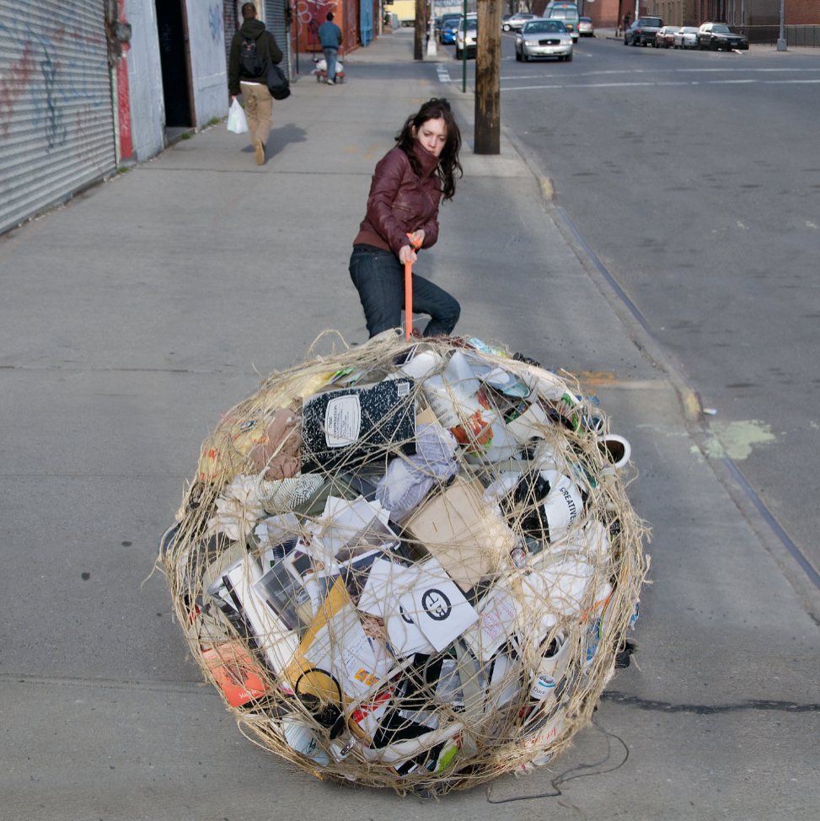
Figure1. Pull, 2013

3.2 Swale

Swale challenges the traditional, anthropocentric social order by creating floating food forests in public waters; recipients are left to interpret the artist’s work for themselves under a set of confrontational instructions. To illustrate, a luxury goods salesperson might tell you that a particular handbag is made from rare leather and is a limited edition, available in only a few stores across the region. By emphasising the bag’s scarcity, the salesperson forces the message that the bag must be purchased immediately into the conversation; this message is then interpreted differently in the consumer’s mind. Some consumers feel compelled to buy immediately because of the item’s scarcity, whilst others decode the salesperson’s message in a counter-narrative manner, insisting they are not buying for that reason. Urban bureaucratic systems have coded agricultural cultivation on public land as an illegal act. Mary Mattingly utilised the land ownership derived from these systems, exploiting the gap between maritime and land laws to move food forests onto barges. What was originally an illegal act restricted to land was transformed into a shared resource, accelerating humanity’s attempts at decentralisation. According to Rose Braidott’s theory, the subject of the posthuman era is not a singular entity, but exists in a decentralised, nomadic form. (Rose Braidott, 2013) Swale not only aligns closely with nomadism on a physical level, freeing itself from the constraints of land, but also tours the waters of New York. Swale not only shatters the binary of centre and periphery but also delivers a powerful rebuttal to Descartes’s doctrine of isolated individualism. Precisely because of the barge’s unique nature, humans, machinery and plants coexist within a single ecosystem. This cross-species connection is inextricably linked to human decentralisation. Rose Braidott has proposed a concept whereby there exists a force between species capable of transcending individual boundaries, binding countless individuals together. Rose Braidott terms this force ‘zoe’, a vital life force. (Rose Braidott, 2013) In the Swale project, humans coexist with other beings; when humans begin to interact with plants that do not belong to them, a connection is formed between humans and plants. Human subjectivity is diluted within zoe; at this point, the subject is no longer an isolated individual, but rather a node dedicated to maintaining the entire system. Subjects continuously connect with one another, generating one another, and continue to roam.
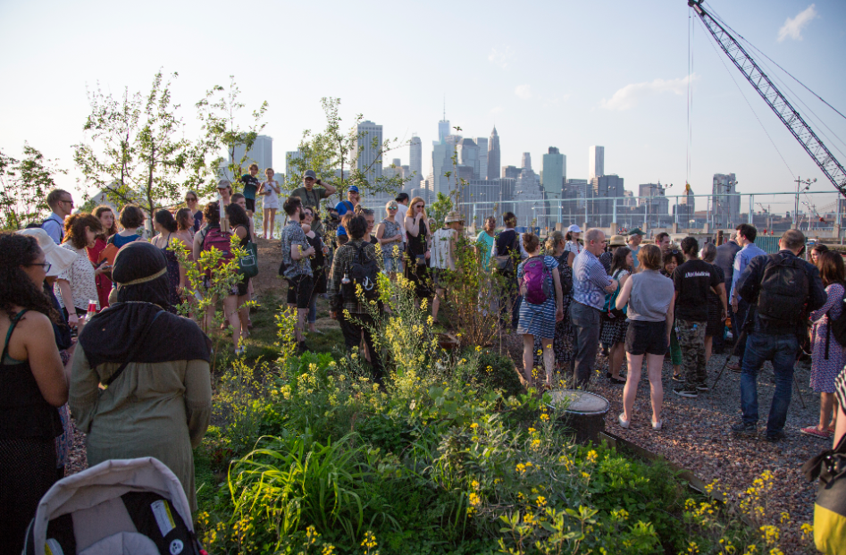
Figure2. Swale, 2016

4 The Relationship Between Anika Yi’s Artwork and Decentralisation

4.1 Dewdrop Continuum
Anika Yi’s work challenges the boundaries between the living and the non-living. By blurring the lines between different subjects and hybridising various media, her art seeks to forge a unique connection between different species. In the artwork *Dewdrop Continuum*, Anika Yi expresses this decentralisation through a unique perspective. Using PMMA optical fibre, silicone, LED lights and a microprocessor, *Dewdrop Continuum* simulates a translucent mechanical lung. Within traditional centralised frameworks, humans occupy a dominant position, and breathing—a characteristic unique to living beings—serves as a key distinction between the living and the non-living. Thus, when Anika Yi endows the machine with this biological trait, respiration ceases to be the exclusive preserve of living beings; instead, it becomes a biological characteristic shared by both machine and organism, thereby realising the ‘biologisation’ of machinery. Furthermore, as viewers observe the rhythmic oscillation of the mechanical lung, it implies that biological signals can be transmitted via electronic signals—a transformation that undermines the centrality of the biological subject in the human environment. Dewdrop Continuum is not merely a visual display of biological rhythmic oscillation; at a deeper level, it represents a nomadism of subjectivity. Rose Braidott argues that the decentralised subject of the posthuman era is not singular, but rather a nomadic state that transcends boundaries, a continuous evolution tending towards diverse forms of subjectivity. (Rose Braidott, 2013) In Dewdrop Continuum, we can observe a transformation of the subject within the post-human process of decentralisation: the subject shifts from a biological entity composed of blood, neurons and cells to a lung structure made of PMMA optical fibre, which, through the conversion of electronic signals, becomes electronic pulses. These electronic pulses roam throughout the exhibition space, thereby indirectly challenging Descartes’ notion that the subject must reside within an independent individual. When viewers find themselves within the exhibition space, they merge and collide with the life signals emitted by the mechanical lungs—that is, the stream of electronic pulses—placing them within an entirely new, decentralised space. This bears a close relation to the concept of ‘zoe’ proposed by Rose Braidott. Zoe is a decentralised network; the subject of zoe is in a state of constant nomadism, merging with different subjects to produce diverse states. In Dewdrop Continuum, zoe functions as a vital force, with vital forces from different organisms becoming entangled with one another. The electronic pulses emitted by the microprocessors on Dewdrop Continuum are received by the visitors, light signals flow and intertwine between the human retina and the microprocessors of Dewdrop Continuum. This aligns with Rose Braidott’s (2013) assertion that ‘the posthuman subject is not a singular, localised, individual entity, but rather a nomadic, distributed, and relational one’, thereby constituting a decentralised information network. The vitality unique to carbon-based lifeforms is detached from its physical form, flowing between optical fibres, liberating the subject from the biological body and transforming it into an intelligible electronic signal, thereby further dissolving the blurred boundaries between the biological and the mechanical. In the process of decentralisation, the core of Dewdrop Continuum seeks life within itself, expressing it through the breathing of mechanical lungs.

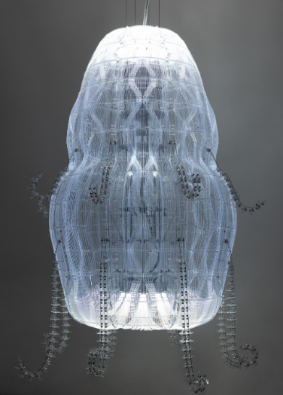
Figure3. Dewdrop Continuum, 2023

4.2 Biologizing the Machine (tentacular trouble)
Biologizing the Machine (tentacular trouble), meanwhile, connects multiple species through a decentralised symbiotic network by means of collaboration between different materials. In Biologizing the Machine (tentacular trouble), artist Anika Yi uses a massive piece of translucent kelp to envelop acrylic, mechanical water pumps and biomimetic moths, creating an appearance strikingly reminiscent of a womb nurturing life. Artist Anika Yi has endowed machines with the reproductive capacity unique to living organisms, a crucial step in the process of mechanisation. Now that machines possess the ability to reproduce offspring just like living beings, humanity’s control over the world will be further eroded. From a young age, Anika Yi has been deeply committed to the expression of scent. To put into practice the ‘biopolitics of the senses’ she has long emphasised—a concept that runs through many of her artworks—she uses the sense of smell to interact with visitors. The artwork *Biologizing the Machine (tentacular trouble)* employs seaweed as the machine’s exterior; it not only carries a rich marine scent but also bears a resemblance to the scent of biological reproduction. Anika Yi emphasises an olfactory intrusion as a means of establishing deep communication with the viewer, hoping that the sensory reactions triggered by smell will lead to physical contact through touch. This creative philosophy represents a departure from traditional, centralised approaches to art-making. Anika Yi also deconstructs the dichotomy between nature and the artificial. Within the traditional anthropocentric cognitive framework, humans habitually categorise objects into two distinct spheres. Since Descartes (1641) posited that the rational soul and the physical body are two entirely separate entities, this has indirectly led to a series of opposing dichotomies, such as the artificial versus the natural, and the mechanical versus the biological. Through this dichotomy of nature and the artificial, Anika Yi transforms kelp—a natural product—into the skin of a machine, thereby blurring the boundaries between the mechanical and the biological. Through the concept of the ‘biopolitics of the senses’, Anika Yi recodes the relationship between nature and the artificial, not only fusing them on a physical level to establish a bridge of communication between organic life forms and machines, but also providing a safe haven for the biologisation of machines—cloaked in a biological guise—that facilitates greater integration. As Rose Braidott points out, the subject of the post-human era is not a single entity, but a nomadic, decentralised network of entities that are inextricably intertwined. (Rose Braidott, 2013) The materials used in *Biologizing the Machine (tentacular trouble)* include seaweed, acrylic, LED lights, artificial moths, water and water pumps. These constantly fluttering bionic moths serve as a medium linking artificial intelligence and mechanical lifeforms; this also reflects Anika Yi’s future contemplation on how to establish new channels of communication between artificial intelligence (AI) entities and organic lifeforms. By using algorithms to simulate the flight trajectories of biological moths, these bionic moths are not only able to fly safely within the mechanical lifeforms, but the simulated moths, water and water pumps also collectively form a decentralised symbiotic entity. A total of six such symbioses are positioned along the window ledge, each influencing the others. Anika Yi reveals a decentralised world where the artificial and the natural coexist. Whenever a person enters this space, they are not the controller of the system, but rather share the same habitat with the mechanical lifeforms and mechanical moths; this is a prime example of post-humanist collaboration between the artificial and the natural.
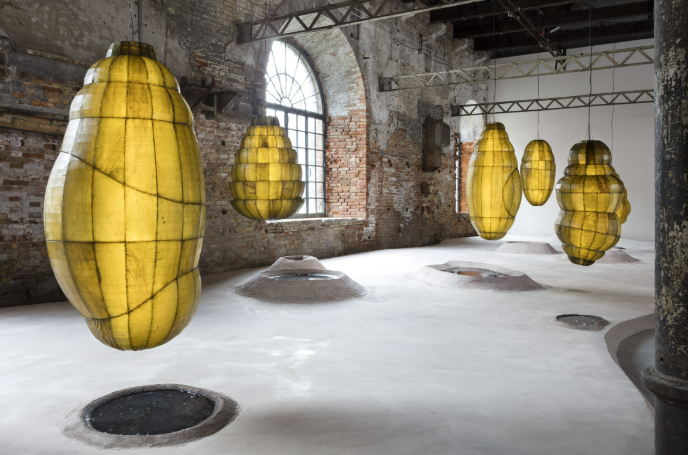
Figure4. Biologizing the Machine (tentacular trouble), 2019

5. Conclusions
Through an analysis of the artworks by Anika Yi and Mary Mattingly, I perceive the collapse of an anthropocentric society in *pull*; in *Swale*, I see how the subject enters the space of a post-human society; in *Dewdrop Continuum*, I observe communication between the living and the non-living; and in *Biologizing the Machine (tentacular trouble)*, I witness the fusion of different individuals amidst the biologisation of machines. In summary, within this series of artworks, compared to the anthropocentric perspective of the Renaissance, I perceive a decentralised world where machines and living organisms coexist and develop in synergy. Humans, as a single node within the world, set aside their own interests to merge with the world; they do not exist in isolation, for human actions influence other forms of life, whilst simultaneously being influenced by them. Consequently, from a posthuman perspective, these works not only shed the conceptual burdens of the human framework but also transcend anthropocentrism, situating themselves within a decentralised world where humans and non-humans intertwine.

reference
Alaimo, S. (2010) Bodily Natures: Science, Environment, and the Material Self. Bloomington: Indiana University Press.
Anselm, St. (1998) Proslogion: with the replies of Gaunilo and Anselm. Translated by T. Williams. Indianapolis: Hackett Publishing Company. (Original work published c. 1077-1078).
Barthes, R. (1977) 'The death of the author', in Image, music, text. Translated by S. Heath. London: Fontana, pp. 142–148.
Beauvoir, S. de. (2010) The Second Sex. Translated by C. Borde and S. Malovany-Chevallier. London: Vintage. (Original work published 1949).
Bennett, J. (2010) Vibrant Matter: A Political Ecology of Things. Durham: Duke University Press.
Braidotti, R. (1994) Nomadic subjects: embodiment and sexual difference in contemporary feminist theory. New York: Columbia University Press.
Braidotti, R. (2011) Nomadic Theory: The Portable Rosi Braidotti. New York: Columbia University Press.
Braidotti, R. (2013) The Posthuman. Cambridge: Polity Press.
Brinson, K. (2017) Anicka Yi: Life Is Cheap. [Exhibition catalogue]. New York: Solomon R. Guggenheim Museum.
Capurro, E. (2024) 'Becoming-with in Anicka Yi’s Artistic Practice', Open Cultural Studies, 8(1), p. 20240022.
Demos, T.J. (2016) Against the Anthropocene: Visual Culture and Environment Today. Berlin: Sternberg Press.
Derrida, J. (1978) 'Structure, sign and play in the discourse of the human sciences', in Writing and difference. Translated by A. Bass. London: Routledge, pp. 278–294.
Descartes, R. (1996) Meditations on first philosophy. Translated by J. Cottingham. Revised edn. Cambridge: Cambridge University Press. (Original work published 1641).
Descartes, R. (2006) A discourse on the method of correctly conducting one's reason and seeking truth in the sciences. Translated by I. Maclean. Oxford: Oxford University Press. (Original work published 1637).
Eco, U. (1989) The open work. Translated by A. Cancogni. Cambridge, MA: Harvard University Press. (Original work published 1962).
Gadamer, H.G. (2004) Truth and method. 2nd rev. edn. Translated by J. Weinsheimer and D.G. Marshall. London: Continuum. (Original work published 1960).
Galt, R. (2021) 'Metabolic Encounters: Anika Yi’s Aerobes at Tate Modern', Screen Culture, 15(4), pp. 22–29.
Hall, S. (1973) Encoding and decoding in the television discourse. Birmingham: University of Birmingham.
Hall, S. (1980) 'Encoding/decoding', in Hall, S., Hobson, D., Lowe, A. and Willis, P. (eds.) Culture, media, language: working papers in cultural studies, 1972-79. London: Hutchinson, pp. 128–138.
Hall, S. (ed.) (1997) Representation: cultural representations and signifying practices. London: SAGE.
Haraway, D.J. (1991) Simians, Cyborgs, and Women: The Reinvention of Nature. New York: Routledge.
Haraway, D.J. (2016) Staying with the Trouble: Making Kin in the Chthulucene. Durham: Duke University Press.
Hassan, I. (1977) 'Prometheus as performer: toward a posthumanist culture?', The Georgia Review, 31(4), pp. 830–850.
Hayles, N. K. (1999) How We Became Posthuman: Virtual Bodies in Cybernetics, Literature, and Informatics. Chicago: University of Chicago Press.
Innocent III, Pope (1978) On the misery of the human condition (De miseria humanae conditionis). Edited by D.R. Howard. Translated by M.M. Dietz. Indianapolis: Bobbs-Merrill. (Original work published c. 1195).
Jones, C.A. (2016) 'The Sensorium: Anika Yi and the Politics of Olfaction', in The Sensorium: Notes on the Posthuman Condition. Cambridge, MA: MIT Press, pp. 89–112.
Jones, C.A. (2021) 'Anicka Yi’s Sensorium', Artforum, October. Available at: https://www.artforum.com (Accessed: 23 April 2026).
Lee, P.M. (2015) 'Anika Yi: The Kitchen', Artforum International, 54(1), pp. 312–315.
Leonardo, da Vinci (c. 1490) The Vitruvian Man [Pen and ink on paper]. Gallerie dell'Accademia, Venice.
Mattingly, M. (2013) Pull. [Performance and Installation]. New York City. Available at: www.marymattingly.com/html/MATTINGLYPULL.html (Accessed: 23 April 2026).
Mattingly, M. (2016) Swale. [Floating Food Forest/Public Art Project]. New York City. Available at: www.swaleny.org (Accessed: 23 April 2026).
Saltz, J. (2009) 'The Waterpod Project', New York Magazine, 14 July. Available at: https://nymag.com (Accessed: 23 April 2026).
Shakespeare, W. (2016) Hamlet. Edited by A. Thompson and N. Taylor. Revised edn. London: Arden Shakespeare. (Original work published c.1601).
Steinberg, J. (2014) 'The Art of Survival: Mary Mattingly’s Nomadic Structures', Journal of Contemporary Art, 12(3), pp. 45–58.
Tate Modern (2021) Hyundai Commission: Anicka Yi: In Love with the World. [Exhibition Guide]. London: Tate Publishing.
Wolfe, C. (2010) What is Posthumanism? Minneapolis: University of Minnesota Press.
Yi, A. (2013) Dewdrop Continuum. [Installation]. Gladstone Gallery. Available at: www.gladstonegallery.com (Accessed: 23 April 2026).
Yi, A. (2015) 7,070,430K of Digital Spit. [Exhibition]. Basel: Kunsthalle Basel.
Yi, A. (2019a) Biologizing the Machine (tentacular trouble). [Installation]. Venice Biennale, Italy.
Yi, A. (2019b) 'Biopolitics of the Senses', in Rugoff, R. (ed.) May You Live in Interesting Times: 58th International Art Exhibition of La Biennale di Venezia. [Exhibition Catalogue]. London: Hayward Publishing.
Yi, A. and Knast, K. (2015) Anika Yi: 6,000 Years. New York: The Kitchen.

