
Rachael Parry 2219708 ECEY4001 Human Development Transitions:

A Guide to Early Years Practitioners

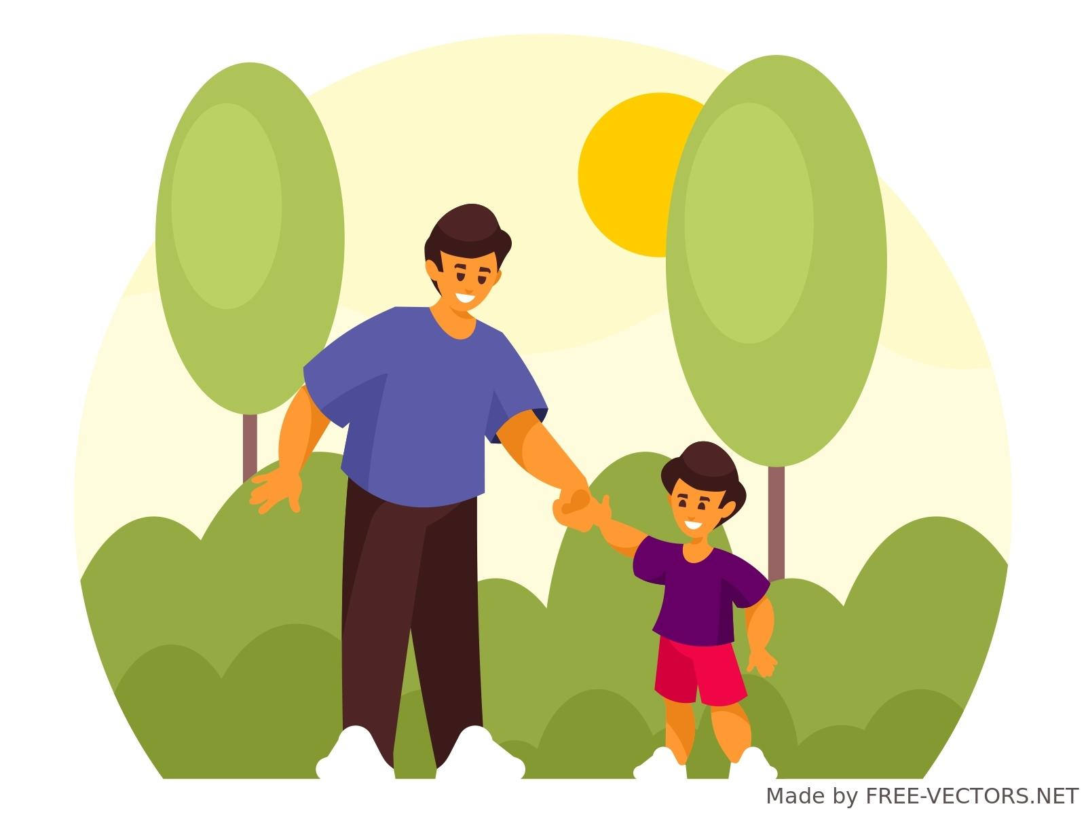

Contents

Introduction

What is a transition?

The needs of a child

The role of the adult

Partnerships

Interventions

Proposed outcomes

Reference list

Introduction
This handbook has been designed as a practical, usable guide, with the purpose of providing information and support about transitions in the early years. The transition a young child makes from home to their early years setting is a significant time of change for the whole family.

The objective is to enable Early Years Practitioners to understand their key role in working with and supporting children and their families through a smooth, gradual transition process.
The information contained focuses on all aspects of children making the transition from home to their first preschool early years setting.

What is a transition?
A transition is a process of change a person may have to experience from one significant stage to another.
Allington (2012) explains how Children experience many types of transitions in their early years.
Physical developmental changes, for example, the progression from crawling to walking. Environmental changes such as a new sibling, moving house or parental separation. Care and education transitions like moving from home to childminder to preschool. Children can experience more than one transition at a time. Transitions can be described as vertical and horizontal .
Vertical transitions are the key changes from one state to another, moving upwards, for example the move from childminder to nursery or nursery to reception.
Horizontal transitions are less significant than vertical transitions. These are routine movements children make in their everyday lives like going to school or moving from one care setting to another.
Dunlop and Fabian (2002) insist that children’s experiences in early years will have a critical effect on their future educational, personal and social development.It is the responsibility of the early years practitioner to ensure the quality of care for the child particularly as they make their transitions through their early years.
Transition is not a single event, it is not the child's first day at preschool but more a period or even a passage of transition. Transition from home to preschool would begin from the first point of contact, the initial introduction of a home visit for example . The period would not end until the child is considered a fully established member of a new setting. The early years practitioner involved plays a vital role in communicating with all involved to ensure a smooth transition Vogler (2008) emphasises the importance of this,stating that transitions are recognised to be key to young children's experiences and well-being.

Bronfenbrenner identified that smooth transitions from home to nursery will make future transitions more successful according to O’Connor (2006) How successful a child's first transitional experience is, is thought to influence future transitions and how these may be handled. These early transitions are believed to affect the child's ability to cope with change in their future. A smooth gradual transition is proven to have a more positive outcome promoting confidence in the ability to cope with the period of transition. The early years practitioner must allow time recognising that all children and their needs are different

Brocker (2008) explains that Bronfenbrenner describes transition as children in a social world , with changing environment affecting the children's roles and identity.Bronfenbrenner’s ecological systems theory suggests that each setting or environment a child experiences is described as a microsystem, examples include Home, childminder and nursery. Each of these play a role in the child's development. Bronfenbrenner argues that it is the links between the microsystems, which he calls the mesosystem, that are the most important contribution to a child’s well-being. The more links experienced the better the child's outcomes will be. With this in mind Brocker (2008) suggests home visits and ‘all about me’ forms as a way of gaining information, communicating with families to ensure the smooth transition. 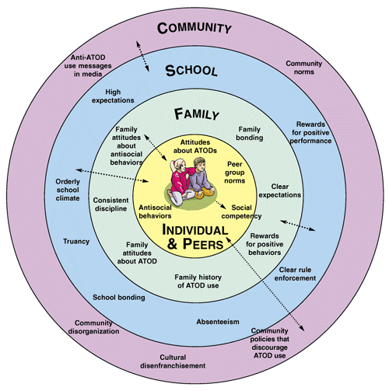Bronfenbrenner's ecological systems theory
(simply psychology)

The needs of a child

Maslow's hierarchy of needs is a theory made up of a five tier model of human needs. Maslow placed these needs in order, believing that one needed to be acquired before the next could happen. Children will be less successful learners if their basic needs are not met;
Psychological needs - the child needs the basics of food, water, rest, exercise and fresh air these will all be provided at an early years setting.
Safety needs - all children need to feel safe and secure both physically and emotionally. A clear routine and access to assessed risk taking will encourage this.
Belongingness and love - a child needs to feel like they belong, are connected and included. Excellent adult role models and peer friendships will promote this.
Esteem needs - feelings of achievement, being recognised as a special individual, a positive inclusive environment promoting an inclusive cultured presence will inspire this.
Self actualisation - achieving one's full potential. The child has all of their needs met enabling them to be a confident, competent leader.
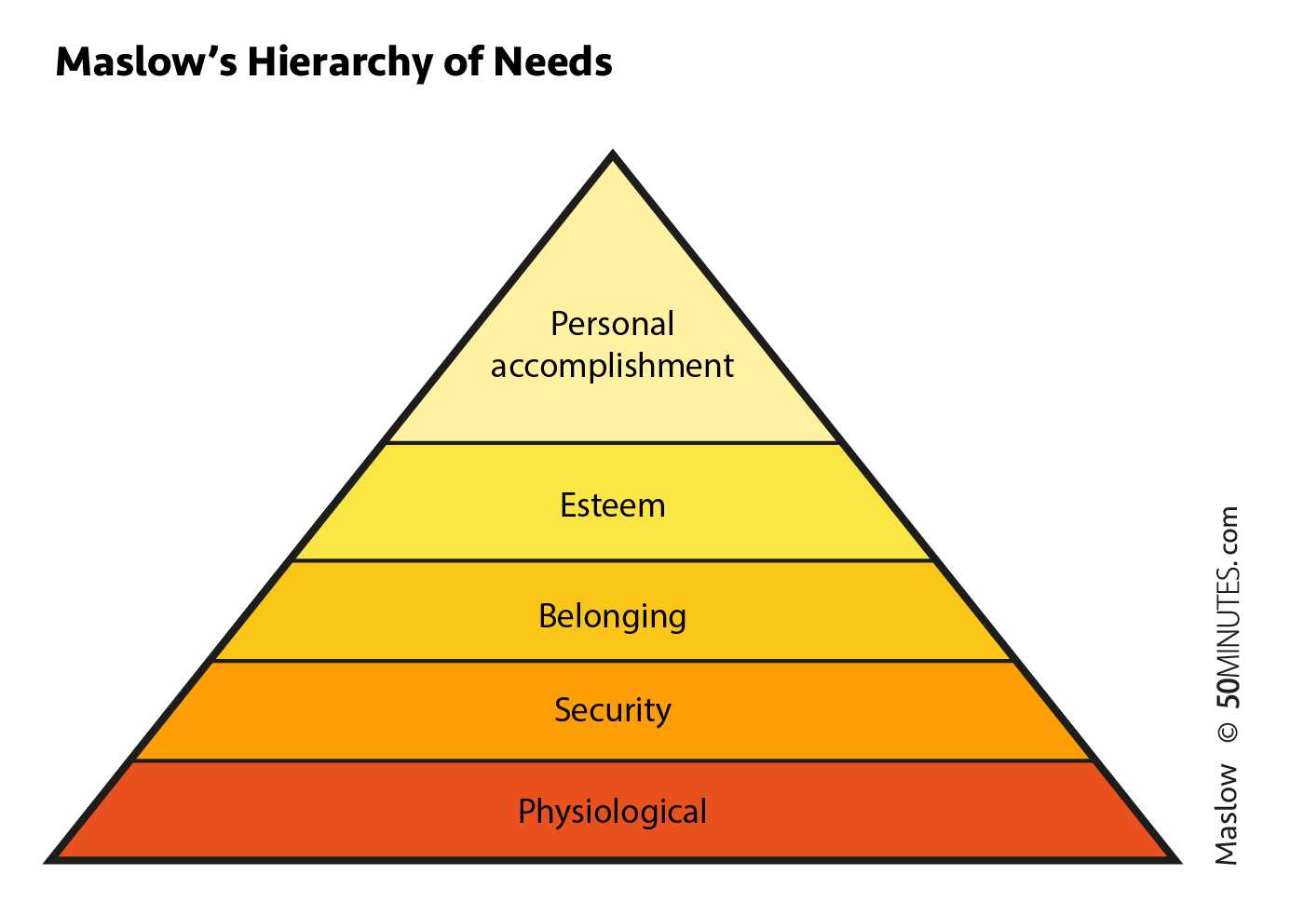(50minutes.com 2015)
Interventions
Maslow stated that each individual has a variety of needs, however some needs are more vital than others. If a child's basic needs are not met, they will not be able to focus on their learning as their energy will be focussed more on trying to meet their immediate needs.
The children's individual needs must be understood and appropriate Interventions should be made to meet these needs. For example a child may be attending the setting hungry, their concentration may be limited or their mood, thus impacting negatively on their learning. Another example may be, a child feeling unsafe at the setting, they may not be able to communicate their feelings, which may then lead to their behaviour becoming disruptive. The understanding practitioner should recognise that this is not chosen behaviour, they should be curious to discover what need may not be being met and ensure that an intervention is made to ensure that the needs of these children are met. The hungry child could be provided with breakfast on arrival at the setting. The child feeling unsafe could be given a little more time to settle, be nurtured and offered strategies to promote belonging such bringing familiar items from home into the setting. Once these basic needs are met the children are then open to fulfil further needs.

Role of adults

All children need a stable and secure relationship with at least one caregiver for healthy development to occur (Bowlby 1997) A good relationship allows for children's needs to be met as the caregiver will know and understand the child's cues to be able to respond promptly and appropriately to their needs.
Bowlby’s Attachment theory proposes that the quality of care provided to the child, leads to secure or insecure attachment. The security of this bond is determined by the ability of the parent or primary carer to sensitively and appropriately respond to the child's bids for attention. It is the adult's role to be aware of the importance of making connections, meeting needs and ensuring the child feels valued and important in their own right. How a child experiences theses phases of attachment development is thought to influence self worth
The quality of early years experiences affects development. Attachment relationships play an important role in supporting children's development to their full potential and influence their future wellbeing. It is therefore critical that early years practitioners understand the importance of building relationships and appreciate how this will impact the children's future wellbeing.
Nutbrown (1996) states that a respectful practitioner Includes all children, valuing and respecting the child’s individuality, their language, culture, background, ability and needs.
It is a fundamental role of the early years practitioner to ensure that children know and understand their rights. Children's rights must be encouraged, promoted and enabled in accordance with the United Nation convention on the rights of a child known as the UNCRC. The UNCRC is a statement of children's rights compiled by Unicef to empower all children to have a voice and a say in decisions that affect them. Article 19 insists that all children must be protected from violence, abuse and neglect. The government must do all they can to ensure children are protected from bad treatment.
And Article 28 states that every child, without exception, has the right to education.

UNCRC underpins the Welsh government's National minimum standards. The national minimum standards are a collection of minimum standards child care provision must adhere to, designed to ensure that care and provision is fit for purpose and meets the needs of people using care services.

The curriculum for funded non-maintained nursery settings is part of the curriculum for Wales; it identifies that it is essential that early years practitioners are skillful, observant and interested; these key principles enable holistic and meaningful learning. Welsh government say
that early years practitioners should model a joyful approach to learning, encouraging and supporting children's natural curiosity.

Cognitive development is described by Brodies (2018) as the development of intelligence, the development of a child's thought process, to include problem solving, reasoning, perception and memory. Cognitive development comes from all areas of learning.

Vygotsky and Piaget are two leading theorists in relation to cognitive development who both agree that children actively construct knowledge however;
Vygotsky's sociocultural theory of development states that children learn through relationships and social interaction with family and members of the community, that children learn about what is relevant to their own society. Vygotsky maintains that language is a primary tool ,central to cognitive development, children will benefit through adults Scaffolding them through their learning. Alternatively Piaget maintains that learning takes place in stages. He studied how children learn through doing things and not through listening. Children have their own way of learning, through play and exploration using action and senses to learn about their surrounding environment (Linden 2012)
Barnes M., and Cummings E. (1994) explains that according to Piaget's theory of cognitive development children go through a series of stages of intellectual growth. Piaget introduced the term schema. A schema is described by Louis (2003) as a natural pattern of repeated behaviour from which children explore ideas and thoughts through play. Louis (2003) believes that schemas are central to a child's learning and development, additionally maintaining that schemas are biological, children are born with the ability and inclination to use them.
The childcare, play and early years workforce plan emphasises that the role of the early years practitioner is vital in helping provide children with the best start in life (Welsh Government 2017) The early years practitioner should promote an inclusive Each unique family must be welcomed and listened to.

Environment
Home should be a familiar safe, secure environment for most children and for a lot of children the familiarity and routine of homelife may be all that they know. Dunlop and Fabian (2007) believe that the experience of moving to the unknown, new environment, with new people and culture, new surroundings, rules, routine and expectations can be challenging for young children.The Offer a welcoming warm , nurturing environment with appropriate activities to include, stimulate and promote the children's natural curiosity. Each unique family must be welcomed and listened to. A welcoming atmosphere in the setting should be evident from the first initial contact.
Early years practice is not limited to education, practitioners have the responsibility to provide a safe stimulating, nurturing environment should be provided with health and safety policies and procedures in place and adhered to. Equipment must be fit for purpose, appropriate for the age and stage of the child's development. Risk assessments are essential to ensure the environment is safe.

It is widely accepted that high quality early years education and care supports positive developmental outcomes for children. Bowlby 2007) highlights the importance of child development with practitioners ensuring that they feel safe and secure.
Be inclusive
The early practitioner should offer the children the opportunity and time to understand each other's beliefs and come from secure and stable relationships (Barnes and cummings 1994) Equal opportunities are promoted, all children and families are valued and welcome.

Bowlby(1969) proposed that children are pre programmed from birth to develop an attachment to their primary attachment figure, typically the mother figure Bowlby suggested that there are four stages of attachment development that the child will encounter in their first three years

O,connor (2013) explains that children experience a number of transitions during their first five years of life. The first major transition is that from home to an early years setting. Changes can have a serious impact on young children. Stress, separation and insecure attachments can affect the child’s emotional and intellectual development.These changes can trigger feelings of apprehension and abandonment. The child may feel anxious, scared and overwhelmed. This time and experience should be handled sensitively, the child needs a sense of belonging and a feeling of secure attachment when adjusting to change. The child and also the family may feel anxious and emotional. To ensure continuity for children , their movement through the system and transition from one setting to another should be seen as a journey. The Welsh government developed the national curriculum to allow for more consistency between different phases in early education ,recognising the need for continuity at a fundamental time of the children's development.

Partnership and communication

Tickell (2011) maintains that communication plays a vital role in a child's development. It is crucial that there is strong and effective communication and partnership between early years practitioners and families. Building and maintaining positive relationships with children, families, colleagues, communities, professionals and organisations. The Welsh government (2011) states that strong connections with a child’s home and community, gives a sense of belonging. Hornby (2011) claims that parental participation has long been recognised as a positive factor in childhood education. Other professionals that may work with the early years setting may include health visitors, social workers and police and school staff.
Gasper (2010) Multi agency working and professional cooperation is the most efficient and effective way of providing support for young children, their families and communities. It is useful to appreciate different professional perspectives.
A two way, honest, respectful, inclusive, effective relationship between home and early years setting is of great benefit in keeping communication open therefore encouraging the child to meet their full potential (non maintained curriculum welsh gov)

Children who receive support from practitioners and families working in respectful partnerships benefit the most as this partnership ensures a good understanding of the child’s needs, leading to appropriate support for the child and the family. Parents have a rich knowledge of their children’s personalities, interests, likes and dislikes. (birth to 5 matters 2021)

The early years practitioner should Listen to children, including the use of observations and sources of information from parents. Be alert of signs of a troubled transition. Trodd (2012) believes that the early years practitioner should be respectful of a child’s sense of self and emotional well-being. By creating links and partnerships between parents, families, communities and umbrella organisations linked to the child's world it is ensuring that the child feels suitable to the environment, secure and recognised. The child should feel confident and able to participate feeling that they belong, are loved and respected. This is the desired outcome of a successful smooth transition.
Communication is key and Listening attentively involves listening to what parents say but also recognising non-verbal messages and actions communicated by parents, as they can be even more powerful than words, particularly where English may not be the home language. Parents may wish to share information.

Excellent two way open communication between home and school, Communication with all agencies

A good successful transition. Positive outcomes
Children meeting milestones
Developing happiness, social,confidence and content.
Children demonstrate that they are settled, they play independently and become less dependent on early years staff, they should develop relationships with their peers and other staff. Showing that they are comfortable in and have a good understanding of the environment. Responsive, confident, happy, secure and able to explore their surroundings independently.

Communication
Effective communication to include the child, staff, families and community and multi agency professionals.
Parents - maintain open and honest communication
Henry (1996) parents know their child better than anyone and this is a valuable resource to practitioners
It is vital that practitioners understand their role of facilitating and supporting transitions,causing minimal disruption to child development. the early years practitioner must be aware of the skills and knowledge
Dowling (2004) children feel safe with people and surroundings that they are familiar
With.
Children can communicate their needs and wishes from birth through actions, gestures, sounds and cues.as children get older their communication skills may grow with the development of speech and understanding.
Good communication is an integral element in professional practice. Communication involves listening, questioning and understanding. Communication between the child and the practitioner enables the adult to identify and respond appropriately to the child's needs. It allows for information to be shared, for feelings and views to be understood. Negative or challenging behaviour may be the child trying to communicate their frustrations , lack of understanding or fear of the new environment. (flying start)There may be any number of reasons why a child may not be able to communicate through speech, it is important that the child's needs are always met by promoting, encouraging and enabling the childs ‘voice’.

INTERVENTIONS
Wall explains that Observations are extremely beneficial as part of the recording, monitoring and planning system at an early years setting as it enables the understanding of a child’s competence levels. It informs future planning and assessments can be carried out enabling children to receive help, support and encouragement helping children to reach their full potential. Children who are experiencing difficulties can be identified through observations, records can be taken and appropriate intervention strategies can be put in place.
Practical ideas, strategies or methods to promote the smooth transition.
Home visits - allow children to see that the family trusts the practitioners enough to allow them into their home.this is the beginning of building close relationships with the family as a whole. Allowing time for conversation a chance to discover a little about the family and childs background, likes and dislikes. It allows for the child to be seen in the environment that best encourages them to feel happy, comfortable, confident and safe. To capture the child's true personality. Interventions such as the following could be put in place:
Welcome pack
Meet the staff and new environment
Ongoing affective communication
One page profile or all about me form - an overview/ snapshot of the child on paper compiled by the family. This will help the child carers to learn what's important to the child and the family. What does the child like or dislike? A chance to share information.

Proposed outcomes
Many early years curriculum have the same desired outcome; the focus to meet children's needs with the aspiration of children all achieving their full potential. Reaching the top of Maslow's hierarchy of needs triangle, obtaining self actualisation. These confident, competent, resilient, independent learners are going on to be confident, competent, resilient, independent adults.

The Foundation phase framework The Welsh government (2017) has developed more consistency and continuity between all of the phases in early education so that learning builds on knowledge previously acquired. This will encourage a most seamless experience of change for the children at this key stage of child development.

The Early years Wales framework states that the role of an early years practitioner is to ensure that the children in their care; are safe and feel safe, are resilient, capable and coping. All children should be learning and developing and no child should live in or be disadvantaged by poverty.(welsh government )

Curriculum for Wales (Welsh Government 2017) has been developed with the main aim being to promote holistic well-being. High expectations are set for all with the aspiration that all children will be;
Ambitious, capable learners, healthy and confident , enterprising and creative, ethically informed citizens.

The Reggio emilia approach is an educational philosophy built on the child's natural potential to grow and to learn and develop relations with others. Hall et al (2014) explains that the emphasis of the approach is on parental and community involvement which builds a sense of social responsibility towards all children and their families. The early years setting recognises the need to involve parents and carers as well as teachers, working with the whole family as well as the environment through the child's education. Whilst rich stimulating physical environments also enhance children's creativity.

Te Whariki concept of belonging promotes emotional and social wellbeing. Children learn from engaging in meaningful interactions. Whariki means woven mat this is a metaphor used to envisage the four principles of the curriculum - empowerment, holistic development, families and communities and relationships being interwoven with the five curricular stands, well-being, belonging, contribution, communication and exploration. The outcome is envisioned that children will grow to be competent and confident learners and communicators, healthy in mind, body and spirit , secure in their sense of belonging and in knowledge making valued contributions to society.

Rachael Parry 2219708 Human Development Reference list

Allingham S. (2012) Transitions in the early years:A practical guide to supporting children between early years settings and into key stage one. London:Practical pre-school books

Barnes, M. and Cummings E. (1994) Caregiver stability and toddlers attachment - Related behaviour towards caregivers in daycare - infant behaviour and development

Birth to 5 matters (2021) Parents as partners:available at https://birthto5matters.org.uk (accessed 3rd December 2022)

Bowlby J. (1997) attachment and loss:Attachment London:pimlico

Brodie K. (2008)The Holistic care and development of child development from birth to three: An essential guide for students and practitioners. Oxon: Routledge

Brooker L (2008) Supporting transitions in the early years Berkshire:Open university press

Dunlop A. and Fabian H. (2002) Transitions in the Early Years: debating continuity and progression for young children in early education.London:Routledge

Gasper, M. (2010) Multi Agency Working in the Early Years: Challenges and Opportunities. London: Sage.

Hall K. et al (2014) Loris Malaguzzi and the Reggio Emilia experience. London: Bloomsbury academic

Hayes N., O’Toole L., and Halpenny M. (2017) Introducing Bronfenbrenner:A guide for practitioners and students in early years education Oxon: Taylor and Francis group

Hornby, G. (2011) Parental involvement in Childhood Education: Building Effective school-family partnerships. London: Springer.

Hostettler J. Scharer (2018) How educators define their role: building professional relationships with children and parents during transition” a case study. European early years childhood education research journal 26.2 246-257 http://doi.org/10.1080/1350293x.2018.144204

Louis S. (2013) Schemas in young children: again! again!London:Bloomsbury publications

Linden J. (2010) Understanding child development (2nd edition) London:Hodder education

New Zealand government. Te Whariki: early childhood curriculum (2017) Wellington: Ministry of education, New Zealand

.Rachael Parry 2219708 Human Development Reference list

Nutbrown C. (1996) Respectful educators-capable learners: children’s rights and early education. London:paul chapmanpublicatoins/Sage

O’connor A, (2006) All about ………transitions. Nursery world, 1st june 2006
Piaget J. (1969) The mechanisms of perception. london:Routledge

Reggio emilia approach https://www.reggiochildren.it/en/reggio-emilia-approach/ (accessed 2nd December 2022)

Simply psychology. Bronfenbenners ecological systems theory https://www.simplypsychology.org/Bronfenbrenner.html (accessed 3rd december 20220)

Tickell. (2011) The Early Years Foundations for Life, Health and Learning. An Independent Report on the Early Years Foundation Stage to Her Majesty's Government. London: Department for Education

Trodd L. (2012) Transitions in the early years:working with children and families. London: Sage

UNICEF United nations convention on the rights of the child

Vogler et al. (2008) Early childhood translational research:A review of concepts, theory and practice

Wall, K. (2006) Special Needs and Early Years: A Practitioner's Guide. 2nd ed. London: Paul Chapman Publishing.

Welsh assembly government (2005) Framework for children's learning for 3 - 7 year olds in Wales. Cardiff: Welsh assembly government

Welsh Government (2021) A Curriculum for Funded Non-maintained Nursery Settings. Cardiff: Welsh Government.

Welsh Government (2017) Flying start transition guide. Cardiff:Welsh government

Welsh Government (2015) Foundation phase framework in Wales. Cardiff:Welsh Government

Welsh Government (2021) Introduction to curriculum for Wales guidance. Cardiff: Welsh Government

Welsh Government (2012) Learning and teaching pedagogy. ISBN:9780750445498

Welsh Government(2012) National minimum standards for regulated childcare Cardiff: WElsh Government

Yu-Chia Huang (2021) Comparison and contrast of Piaget and Vygotskys theories https//atlantis-press.com

50 minutes.com (2015) Maslow's hierarchy of needs: understanding the true foundation of human motivation

