Marketing plan written for

Madrid Merriott Auditorium Hotel and Conference Center

Student Name: Madalin Popescu
Student ID number: 2207349

Marketing Essentials BMIH4005

Lecturer: Ruth Taylor Davis

Introduction
The marketing plan for Madrid Merriott Auditorium Hotel and Conference Center has been created to attract new customers in the current climate by introducing new ideas to provide a new direction for the business.
Evaluating fundamental theories, analysing the 5’C’s, which are our company customers, competitors, collaborators, and climate, along with Pestle and Swot Analysis will conduct the research. The plan concludes with Objectives, Strategies, and actions that will help the main target of this report, which is gaining new customers.

Situation Analysis
Strengths Weaknesses
International hotel brand Communication channels
Relation to customers Location for new aerodrome
Location

Opportunities Threats
New idea of sales Weather
Lifting Covid restrictions Fuel prices
Customers wishes/new trends Location for heliport

Company =>

Customers

Segmentation of our customers helps the team address to our main category of visitors which is business customers. As the hotel was created to offer facilities for customers who need meeting halls, even if we have a fitness centre, we must add an extra service to help with relaxation, create unforgettable memories, and give customers quality time and gaining new customers. The main target is understanding who your customers are and why they are coming to your property. (Hotelbeds,2020). We address especially to Gen Z of customers because they are more probably to buy our new service.

Competitors

The main competitor for our hotel is represented by IHG – InterContinental Hotels Group. (Hitesh Bhasin, 2018) In Madrid, they are represented by InterContinental Madrid, which is a very expensive hotel, positioning itself in the luxury category of hotels.

Collaborators

As a part of Marriott Bonvoy, the hotel Madrid Merriott Auditorium Hotel and Conference Center has all the support that can be offered. Adding helicopter rides to our services, we will have a new collaborator because, for the moment, it is not affordable to buy helicopters but to rent them at a smaller price. For this, it is going to help us, MADRID HELIPAD/Helicopter Charter Service, with the best option -AgustaWestland AW 109. A twin-engine helicopter, six seats multi, purpose luxury helicopter built by AgustaWestland. (Helicopter Charter,2022)

Climate

P | E | S | T | L | E
Political | Economic | Social | Technological | Environmental | Legal

Using a pestle chart will be easier to determine the environment in which our hotel offers its services. The political and legal parts of the analysis refer to laws and regulations that must be put into practice by hoteliers to function, especially now, after the Covid pandemic. Hotel Merriott in Madrid makes sure to follow all the regulations and laws. (Mariott Bonvoy,2022). Hoteliers worldwide are experiencing similar uncertainty regarding the difficulties that Covid-19 will provide to them. (Vera Herédia-Colaço,2021)
On the social and environmental aspects, the hotel minimizes the ecological footprint by using renewable energy and reducing waste and carbon emissions, making sure that the statement fits our customers' needs and new trends. In the technological and economic areas, our hotel adapted to nowadays challenges regarding inflation and uses technology to implement the savings methods by having a sustainability certification. Six hundred fifty hotels will pursue LEED certification or equivalent by 2025. (Mariott International, 2022).

Objectives
This report aims to generate new customers for Madrid Merriott Auditorium Hotel and Conference Center by introducing the concept of Helicopter Sky Rides. Providing a relaxing experience will enhance the customers who are at the hotel but not only and promoting this new experience can make it easier to attract more customers by promising unforgivable moments and experiences.

Strategy
Madrid Marriott Auditorium Hotel & Conference Center differentiates from the rest of the hotels by the type of building and the segment of customers that chooses. Being designed with 56 panelled and no-column meeting rooms, galleries for conventions, and an impressive Auditorium using the new concept of Madrid Buffet is addressing especially business customers. The new strategy will rely on the Gen Z customers. Although the present generation is Millennial, the future belongs to Gen Z. Millennials are more aware and informed about their primary needs and wants than the older generation. (A. Ramgade and A. Kumar,2021). Having a target differentiate and reinforce new concepts that can bring the hotel big profits over a long period, the lifestyle and interests could merge, making our customers enjoy the unforgivable moments. All the information is delivered on the official website, making sure that the new service along with the hotel statement are visible and clear. Promoting the service on social media and on tv will make our new service more visible for potentially new customers.

Tactics=>Marketing mix

Product
The Madrid Merriott Auditorium Hotel and Conference Center now offers a Fitness Center, Indoor and Outdoor Pools, and meeting spaces. Adding this extra service will add value to our hotel, raising the prestige for which the hotel is already known. This new service will be an innovation regarding transport for the hotel industry. Madrid would be the first hotel to offer such an impressive experience.

Place (Distribution)
The primary information about the hotel location is on the official hotel website. However, it is also presented on our booking sites partners who provide helpful information about how to get to the location by diverse methods of transport. It is discussed that we soon build as close as possible from the hotel the mini helipad in order to offer our customers a smooth and fast transfer from the hotel to the helicopter.
Price
Regarding the pricing subject, based on the searches made until now, the primary provider who offers helicopter rides is in Barcelona, and their price is around 113£ for two people, which is very expensive. As our helicopter has six spaces for customers, we can offer 30 minutes rides for the first six months at the discounted price of 100£ per full flight and after the first six months to quickly increase the price until reaching around 180-200£ per full flight. If the number of customers is less than 6, the price will be fixed, which will be 60£/ seat.
Promotion
The hotel will communicate the new service mainly on the official website. Advertising is our main target, and it will be used by the number one star in Madrid, Enrique Iglesias, who has already agreed to sign a six-month contract. These adverts will be presented as a luxury tv commercial and a huge outside banner presented on the left side wall of the building, making it as visible as possible but with not much information, starting curiosity in our customers and making them visit our property soon after the big opening.

Action
Gannt chart of marketing activities

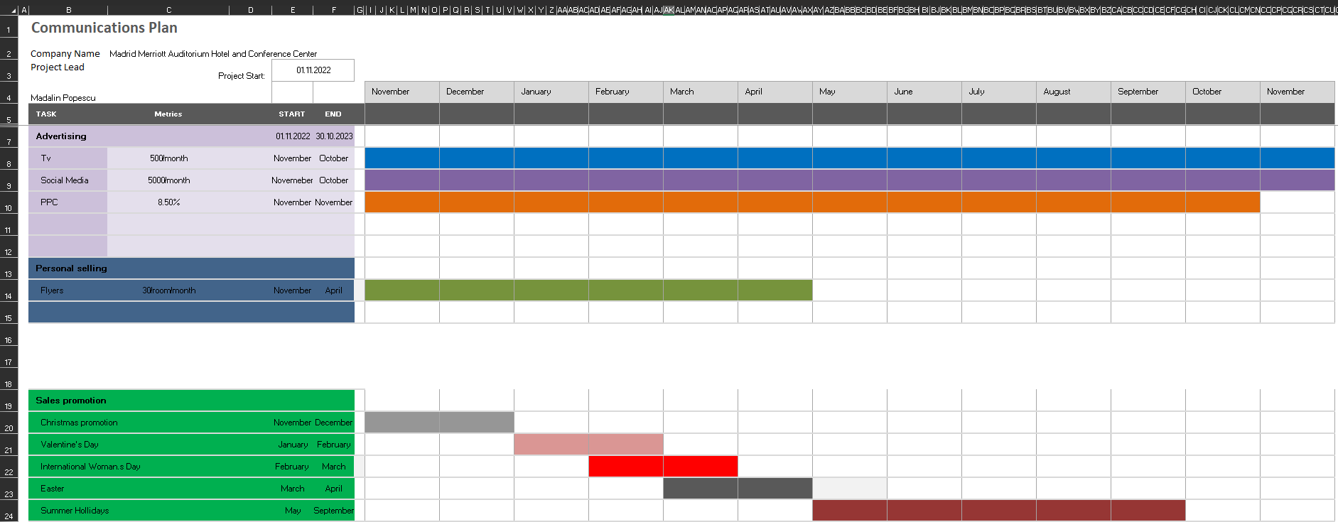

Control
As USP is a key element of marketing, is has been decided to go forward with the following statement: “Flying may not be all plain sailing, but the fun of it is worth the price.” (Amelia Earhart).
The benefits from adding this new service to our customers is related to the superlative sensations offered in the benefit of our customers increasing hotel profits and gaining many reviews on the main websites. Is expected to add over 35% more bookings especially that the Festive season is soon, and the light displays around Madrid will offer a sensational view from the sky.

Conclusion
In conclusion, the marketing plan for Madrid Merriott Auditorium Hotel and Conference Center is meant to generate new customers by adding extra service for the use of customers, which is Helicopter rides across Madrid. By adequately promoting the new experiences that the hotel will provide, along with the reviews on the main websites from the previous customers, we hope to archive better percentages on sales and new curious and adventurous customers. The promises are already made and checking the progress of the newly implemented ideas will be followed as closely as possible.

PowerPoint Presentation Slides
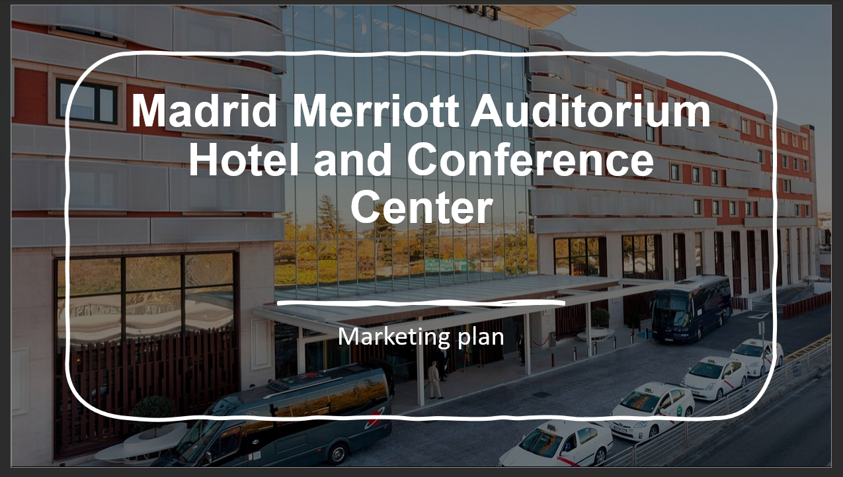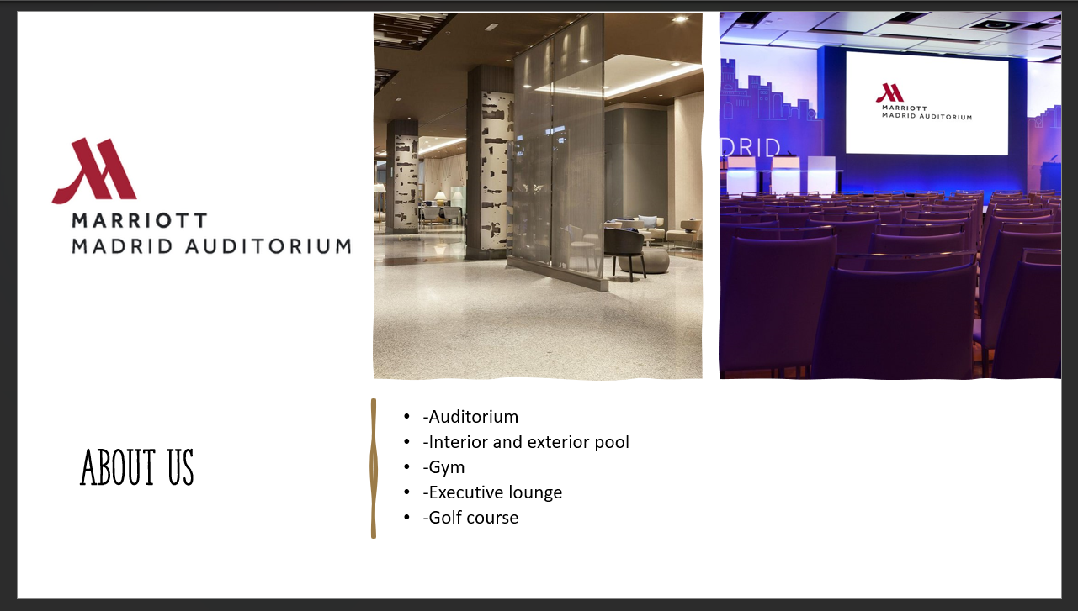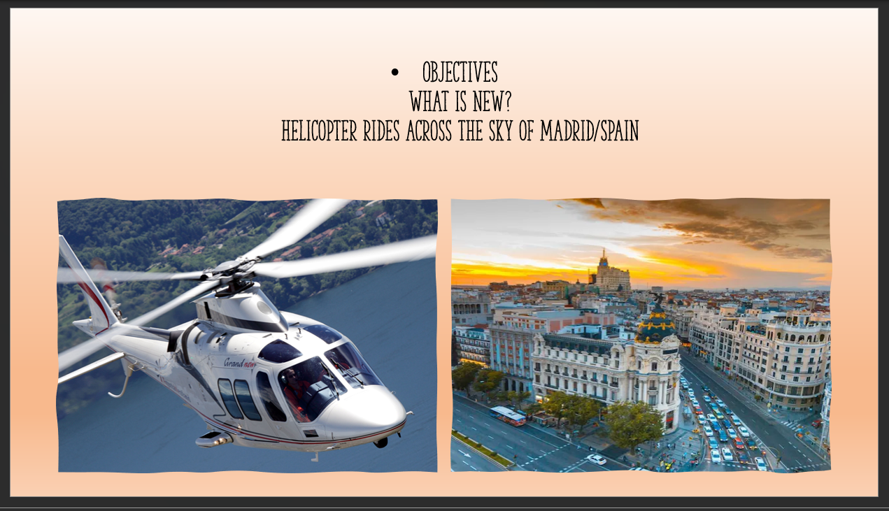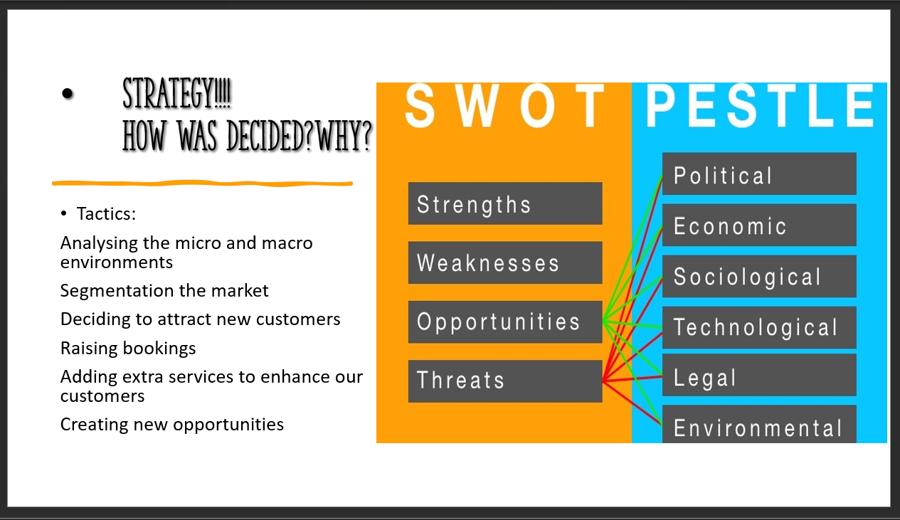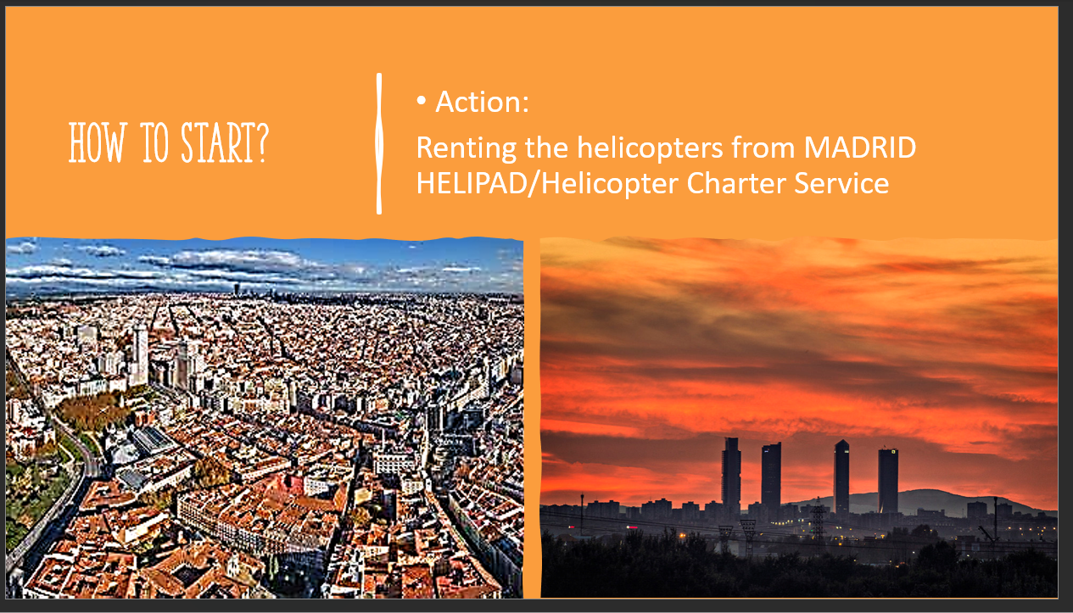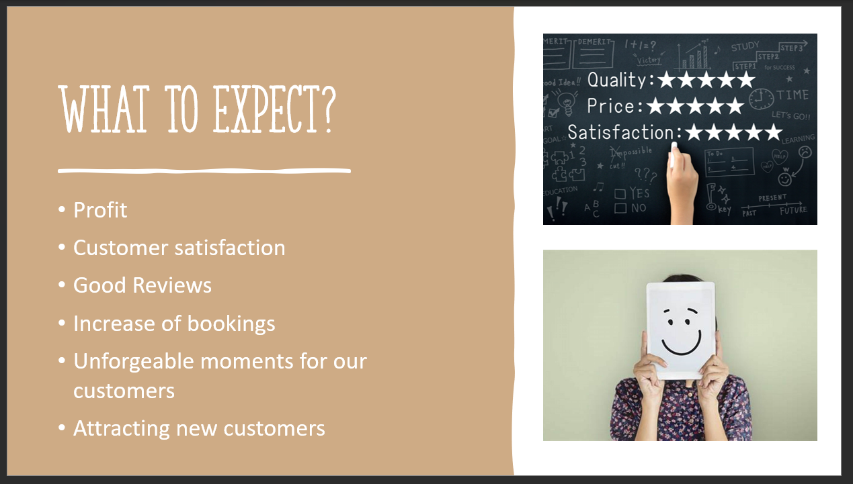

Reference list
Airpano (2022) Bird's eye view of Madrid #2 (ID:1332).[picture]. Available at: Photogallery | Madrid | Virtual Travels, 360&deg; Aerial Panoramas, 360° Virtual Tours Around the World, Photos of the Most Interesting Places on the Earth (airpano.com). (Accessed on:11.2022)
HelicopterCharter (no date) MADRID HELIPAD Helicopter Charter Service. Available at: 🚁 Helicopter Charter Madrid. Get 2020 Helicopter Rent Price Madrid Met Center Helipad 🚩 (helicopterscharter.com).(Accessed on:11.2022)
Helicopter Charter (2020) AgustaWestland AW 109 [picture] .Available at: 🚁 Helicopter Charter Madrid. Get 2020 Helicopter Rent Price Barajas Helipad 🚩 (helicopterscharter.com). (Accessed on:12.2022)
Hitesh Bhasin (2018) Top Marriott Competitors. Available at: Top 10 Marriott Competitors - Marriott Competitor analysis (marketing91.com). (Accessed on.11.2022)
Hotelbeds (2020) Hotel market segmentation: how to target your most profitable guests. Available at: Hotel market segmentation: how to target your most profitable guests (hotelbeds.com).( Accessed on.11.2022)
HT(2021) How to Effectively Conduct a PESTLE & SWOT Analysis.[Picture]. Available at: How to Effectively Conduct a PESTLE & SWOT Analysis - Himalayan Tribune. (Accessed on.12.2022)
IHG (2022) A COSMOPOLITAN RETREAT EMBRACING THE RENAISSANCE OF VIBRANT MADRID. Available at: Luxury 5-Star Hotel: InterContinental Hotel Madrid (ihg.com). (Accessed on.11.2022)
Marriott Bonvoy(2022) Travel With Confidence During COVID-19. Available at: Marriott Cleanliness Council | Marriott Bonvoy.(Accessed on 11.2022)
Marriott (2022) Madrid Marriott Auditorium Hotel & Conference Center. Available at: What to Expect in the Age of COVID-19 | Madrid Marriott Auditorium Hotel & Conference Center. (Accessed on: 11.2022)
Marriott(2022) Sustain responsible operations. Available at: Sustain Responsible Operations | Marriott International Serve360.(Accessed on:11.2022)
Neelie Verlinden (no date), Organizational Values: Definition, Purpose & Lots of Examples, Available at: What Are Organizational Values? Definition, Purpose & Examples - AIHR. (Accessed on.12.2022)
Ramgade and A. Kumar(2021) ‘Vidyabharati International Interdisciplinary Research Journal’ CHANGING TRENDS OF HOSPITALITY INDUSTRY: EMERGENCE OF MILLENNIALS AND GEN Z AS FUTURE CUSTOMERS AND THEIR INFLUENCE ON THE HOSPITALITY INDUSTRY’.( ISSN 2319-4979).Available at: 12.pdf (dypvp.edu.in). (Accessed on:11.2022)
TECNOHOTEL (2019) Madrid Marriott Auditorium also says goodbye to plastic. [picture]. Available at: Madrid Marriott Auditorium also says goodbye to plastic - TecnoHotel (tecnohotelnews.com).(Accessed on:11.2022)
TripAdvisor (2022) Madrid Marriott Auditorium Hotel & Conference Center. Available at: MADRID MARRIOTT AUDITORIUM HOTEL & CONFERENCE CENTER $89 ($̶1̶1̶3̶) - Updated 2022 Prices & Reviews - Spain (tripadvisor.com).(Accessed on:12.2022)
Vera Herédia-Colaço (2021) International Journal of Hospitality Management, Hosting in turbulent times: Hoteliers’ perceptions and strategies to recover from the Covid-19 pandemic. Available at: Hosting in turbulent times: Hoteliers’ perceptions and strategies to recover from the Covid-19 pandemic - ScienceDirect.(Accessed on:11.2022)
Viator(no date) 360º Barcelona: Old Town Walking, Helicopter Flight & Sailing Small Group Tour. Available at: 360º Barcelona: Old Town Walking, Helicopter Flight & Sailing 2023 (viator.com) . (Accessed on:11.2022)
3rdshiftdesk (2022) Focused and Cost-Effective.[picture]. Available at: Service Features - 3rdShiftDesk.(Accessed on: 11.2022)

