

Student Name: Md Ahmed Al Zayed
Student ID: 2516697

Module Name: Financial Management
Module Code: LCMB7002

Lecturer’s Name: Shengfeng Mei Patrick Yeboah
Work Count: 5144

Term 1

Contents
Introduction 4
Task 1 5
Introduction to the Analysis of the Financial Performance and Statement 5
Profitability and Efficiency Ratio Analysis 5
Liquidity, Gearing and Cash Flow Position 6
The risk of corporate failure and overall financial evaluation 7
Task 2 9
Cash Operating Cycle Tests 9
Impact of Liquidity Inefficiencies on Working Capital 9
Liquidity Enhancement Plans Working Capital Reforms 10
Rapidly, Short-term and Long-term Financing 10
Task 3 12
Introduction to Strategic Financial Restructuring 12
Financial Restructuring Options 12
Shareholder Value Influence, Operational Flexibility and Debt Structure 13
Ethical and International Issues 14
Task 4 16
Investment Project Assessment 16
Comparative Analysis of Method Conflicts 16
Financial Foundation Recommendation 17
Non-Financial Risk 17
Optimal combination of project and Capital Rationing 18
Final Recommendation 18
Conclusion 20
References 21
Appendices 23

Introduction
This report contains a financial analysis of the performance of Tesla Inc. as Chief Financial Officer of the company in the 5-year period of 2020-2024. It will be analyzed using comprehensive financial statements and ratio analysis, including profitability, liquidity, efficiency, gearing, and cash flow. The results show a high revenue growth rate, whereby the sales grew in 2020, 31,536 million dollars, to 97,690 million dollars, in 2024, and a high liquidity status revealed in the current ratio of about 2.0. Nevertheless, the decreasing profitability, especially the decrease of the net profit margin down to approximately 7 percent in 2024, indicates the formation of the operational pressure. This report thus analyzes financial performance, efficiency of working capital, restructuring strategy, and investment decisions to facilitate the sustainable growth.

Task 1

Introduction to the Analysis of the Financial Performance and Statement
As the Chief Financial Officer at Tesla Inc., a systematic evaluation of financial performance of the company within the last five years provides a clear basis on strategic decision-making. It is analyzed using income statement, balance sheet and cash flow statement of the company and ratio calculations have already been done in Excel. This is to come up with meaningful financial trends, financial strengths and emerging risks, which may affect long-term sustainability (Guryanova et al., 2020).
In 2020-2024, Tesla experienced a rapid increase in revenues, followed by a stabilisation year. Since the year 2020, revenue has increased significantly (approximately 31,536 million dollars) to 2024 (approximately 97,690 million dollars), and this is more than three times higher. This is a pointer of a high rate of market penetration, expansion in the production capacity and expansion in the global demand of electric vehicles. However in this expansion of revenues warning signs of strain are shown in the subsequent years in terms of profitability.
Another significant increase was the total assets which were around 52,148 million dollars in 2020 and 122,070 million dollars in 2024. This implies that there was extensive investment in production plants, technology and global growth. At the same time, the total equity increased to 73,680 million dollars in comparison with 22,225 million dollars, i.e. the increased strength of capital and reduced reliance on external debt.

Profitability and Efficiency Ratio Analysis
The profitability ratios will provide a clue on how efficient Tesla is in turning its revenue into profitability. The gross profit margin also increased to approximately 26 per cent in 2022 compared to approximately 21 per cent in 2020, which reflects increased cost efficiency and economies of scale. The margin however dropped a little more in the later years to about 18 per cent in 2023 and was quite steady in 2024. This indicates a rise in the cost of production or pricing pressure in the electric vehicle market.
The operating profit margin can be said the same thing (Mahdi and Khaddafi, 2020). It increased dramatically by about 6 per cent in 2020 to nearly 17 per cent in 2022, which is a sign of efficiency in operations in the expansion phase. It has however, plummeted sharply to about 9 per cent in 2023 and about 8 in 2024. This reduction shows that over the years, the operating costs, like research and development and administrative expense have increased at a higher rate as compared to the growth in revenue.
Net profit margin is also indicative of this. This is a high level of profitability as it rose to more than 15 percent in 2023 compared to its 2 per cent in 2020. It has, however, decreased tremendously to approximately 7 per cent in 2024. This decline is a major problem, because it indicates that Tesla is going through margin squeeze despite the high degree of revenue.
Its peak Return on Assets is 15 per cent in 2022 and 2023, and then the values drop to approximately 6 per cent in 2024. This means that the rising asset base of the company is not used as effectively as it was previously. Similarly, Return on Equity has also increased significantly to an average of over 23 percent in 2023 and has seen a drop to about 10 per cent in 2024. This drop highlights lower returns to shareholders and can influence investor confidence.
This is also reinforced by efficiency ratios. Its total asset turnover increased to nearly 1.0 in 2022 against approximately 0.60 in 2020, indicating successful use of assets to get revenue. However, it declined to about 0.80 in 2024 which signified underutilization of assets or slower growth of revenues than growth of its assets.

Liquidity, Gearing and Cash Flow Position
The liquidity ratios ascertain the ability of Tesla to settle its short-term debts. The current ratio had been decreasing to less than 1.5 in the past years to approximately 2.0 in 2024 (Wildan Army Abdillah, 2025). It is a good liquidity position and current assets are sufficient to cover short-term liabilities. The quick ratio also shows the same growth and proves that in spite of the fact that the inventory has been removed, the company has an extensive liquidity buffer.
Even though high liquidity is generally desirable, excessively high liquidity may be an indicator of underutilization of factors of production. Tesla is holding a huge amount of cash and short-term investments that may not be achieving optimum returns. This means that there must be better cash management or reinvestment strategies.
The company also has good working capital management, with its cash conversion cycle is negative. This means that Tesla receives the cash and remits suppliers. The negative cycle is fuelled by the high payable days in comparison to the inventory and receivable days (Wildan Army Abdillah, 2025). This indicates a good bargaining power with suppliers and good operational cash flow control. It is a large competitive advantage.
The gearing ratios show a gradual decline in financial leverage (Wildan Army Abdillah, 2025). The debt-to-equity ratio continued to decrease throughout the period and this showed reduced reliance on debt financing. Similarly, the debt ratio increased to over 50 per cent in 2020 and 40 per cent in 2024. This means increased financial security and decreased financial risk.
Interest coverage ratio is satisfactory, which would mean that Tesla can comfortably meet its interests. This would reduce the risk of financial distress and improve creditworthiness.
Cash flow analysis also helps in improving the stability of the company. Cash flow of operations has been positive in the period, implying that core operations are cash-generating. However, it is noted that there have been a substantial reduction within the past few years compared to the peak period. In the meantime, the level of capital expenditure has increased manifold, with the present investment in growth and technology being in place.
The operating cash flow to total debt ratio is high, implying that Tesla will be able to cover its debt interest. This is among the financial management strengths.

The risk of corporate failure and overall financial evaluation
Altman Z Score is a useful instrument in quantifying the risk of financial distress (Kenton, 2024). Based on the calculated data, Tesla scored above 3 in 2024 in terms of Z Score, which implies that the company is safe. This means that the possibility of corporate failure in short term is very low.
This conclusion can be proved by all the factors of the Z-score. The current liabilities to current assets ratio is positive, indicating that there is good short-term financial health. There is a high proxy of retained earnings in the form of the total equity relative to assets, which shows previous profitability and financial strength. The ratio of EBIT to total assets is positive, but smaller than it was the previous years, which implies that the operations were less efficient. The equity-to-liabilities ratio is high with good capital structure (Kenton, 2024). Finally, the sales to total assets ratio, makes us believe the company is still making significant revenue considering its assets.
And despite this strong overall position, there are a number of problems which are emerging and cannot be ignored. The most severe issue is the acute decline in profitability in 2024. As long as this tendency is not halted, it may ultimately endanger the cash flows, reduce returns and cause financial strain.
Furthermore, the efficiency ratios may be decreasing, which might be a sign that Tesla is over-investing in assets without the corresponding growth in revenues. With this, it has the risk of decreased returns in the long term unless it is managed well.
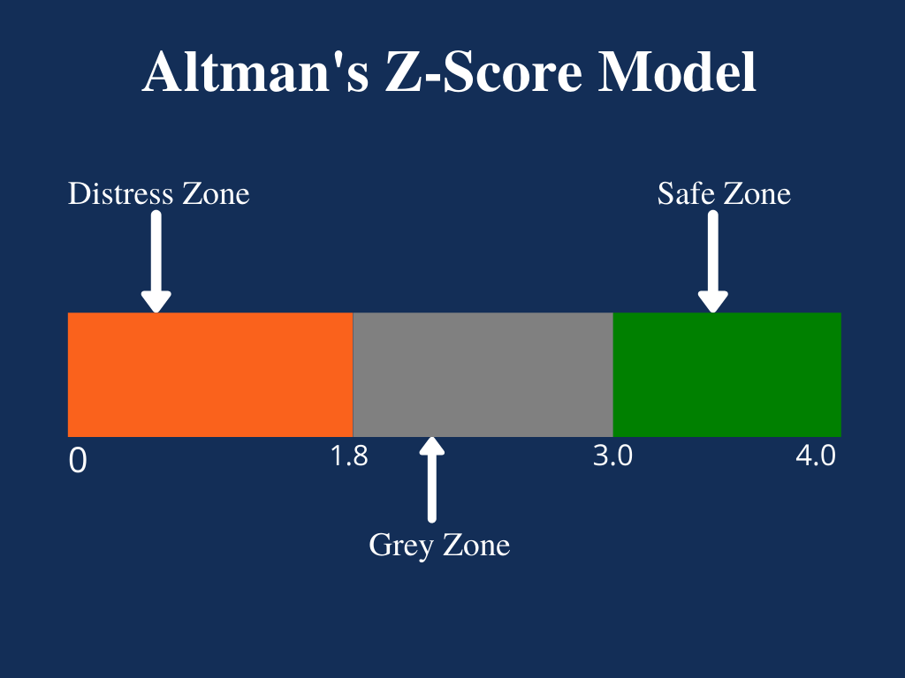
Figure: Altman’s Z-Score Model
Source: (Kenton, 2024)

Task 2

Cash Operating Cycle Tests
The cash operating cycle is a clear pointer to where Tesla Inc. is effective in managing its short-term assets and liabilities. Based on the computations in Excel, the working capital position of Tesla is characterised by a constant negative cash conversion cycle (CCC) during the five years of the period between 2020 and 2024 (Währisch, 2019).
The inventory days increased significantly over the years, reaching over 80 in 2023, and then bounching back to 70 in 2024. This trend indicates that Tesla has been holding more inventory over the years that may be linked to more production, a shift in demand, or inefficiency in supply chain management. Even though the slight increase in 2024 is a positive sign of corrective measures, the stock management is a big issue.
The days outstanding have been very low and stable with an average of 20-25 days over the last five years. This demonstrates good credit control policies and efficient collection procedures, in such a way that cash inflows via the customers are realised within a short period of time. This performance could be associated with the business model of Tesla, in which a significant portion of the sales is related to upfront or short-term payments.
Payable days on the other hand are much higher with the range being at about 95-110 days. This implies that Tesla has a longer time to pay its suppliers than it has to convert inventory to sales and collect receivables. This implies that the CCC is negative with the values approximating between minus 10 to minus 20 days in the period (Währisch, 2019).

Impact of Liquidity Inefficiencies on Working Capital
Despite a negative CCC, suggesting that Tesla has a high efficiency of working capital, there are inefficiencies in the background that can affect the liquidity over the long-term (Wildan Army Abdillah, 2025). The increase in inventory days is a pointer to potential stock build-up that ties up capital and reduces the flexibility of operations. The 2020-2023 period increased by approximately 60 days to over 80 days, referring to the fact that a larger portion of money is not invested in stock.
This trend can lead to liquidity pressure unless it is managed with much care, particularly when the profitability is on a negative trend. According to the financial health analysis outcomes, the net profit margin of Tesla dropped significantly falling to over 15 percent in 2023 and approximately 7 per cent in 2024. The available cash can be reduced along with a rise in reliance on external financing as a result of a decline in profitability and an increase in inventory levels.
In addition, the payable days would be high too, which would provide some liquidity in the short run but excessive dependence on supplier credit would be a source of some risks. Suppliers might become more demanding in the terms of credit, which in turn may increase Tesla cash flows abruptly, as an attempt to react to the situation in the market or perceived financial weakness. This dependence on long payables can therefore put the business into jeopardy of operation and financial defeat.

Liquidity Enhancement Plans Working Capital Reforms
Various strategic reforms may be implemented to improve liquidity and improve efficiency of working capital. Inventory management should come first. Tesla can also adopt new approaches of demand forecasting and optimise the production timing to achieve a shorter inventory holding period. The desired reduction in inventory days, approximated to be 70 days, to less than 60 days would release capital held up and would raise the cash flow.
Second, Tesla is advised to keep on good receivables management practices but to also improve on the same. Although the current level of receivable days is low, the introduction of digital payment systems and the popularisation of early payments can reduce the time to receive even more, which can positively affect the liquidity situation.
Third, strategies of supplier payments should be balanced very well. As good credit conditions are good, Tesla should not indulge in delays that may strain its suppliers. To retain the liquidity benefits, it can be helpful to negotiate systematised payment contracts as well as to offer strategic alliances to ensure that the supplier will not reject the offer in the long term.

Rapidly, Short-term and Long-term Financing
The working capital should be managed properly according to proper financing strategies. Short-term and long-term financing are available with their own strengths and weaknesses that Tesla can avail.
The short-term financing options are regarded as bank overdrafts, trade credit and short-term loans. They are those sources that can easily access funds and can be utilized in addressing a short-term liquidity crisis. One such instance is that the overdrafts allow flexible borrowing, depending on the current cash needs, and trade credit allows business continuity without the need to pay in cash. However, such short-term financing would be at a premium rate of interest and would most likely be subject to refinancing risks particularly when the market is volatile.
The long-term sources of financing include equity financing, long term debt as well as corporate bonds. These are more reliable and predictable sources and therefore are suitable in case of long term investments and structural enhancements. The declining debt ratio of Tesla that has dropped to around 40 per cent, indicates that it can continue to grow in the long run debt as the need beats. Equity financing is capable of reducing financial risk, although it may have the effect of diluting the ownership of the existing shareholders (Desta, 2025).
In comparison of the two, short-term financing is more flexible and risky since it is more temporary as compared to long-term financing which is more stable and may be more expensive and flexible. The balanced approach is, therefore, needed.
In Tesla, the financial position shows that the reliance on short-term financing could be diminished due to a high internal cash generation and negative CCC. Instead, long-term financing should be planned to finance expansion and technological development with a reasonable amount of short-term financing so that operations can be flexible.

Task 3

Introduction to Strategic Financial Restructuring
Being the Chief Financial Officer of Tesla Inc., the financial health analysis reveals that the company remains in a stable financial situation, yet there are certain new structural issues which should be resolved with a strategic approach. The worst is the radical decline in profitability, where net profit margin is expected to decline to approximately 7 per cent in 2024 compared to approximately 15 per cent in 2023. In the meantime, its asset increase has also been continuing, the total assets being over 122,000 million dollars; resulting in its declining efficiency, illustrated by the negative growth of asset turnover to approximately 0.80.
As a result, a holistic financial restructuring strategy is necessary to restore profitability, increase asset utilisation and long-term growth. The restructuring plan must balance between the financial stability, shareholder value, operational flexibility and risks and ethical responsibility within the global sphere.

Financial Restructuring Options
One of the key restructuring alternatives is divestiture of non-core or underperforming assets. The rapid increase in the Tesla's assets has resulted in a decline in efficiency as indicated by the declining return on assets between about 15 per cent in 2022 to about 6 per cent in 2024. This means that not all the investments are likely to pay off. By selling of underperforming business units or surplus assets, Tesla can reduce its asset base and raise its efficiency ratios, enabling the company to utilize the liberated capital in more productive manner. It would have a direct positive impact on assets turnover and return on assets.
Another strategic alternative is targeted mergers/ strategic alliances (Stefanelli, 2025). Tesla does not have to make large acquisitions; it can be in the form of a partnership with technology firms, battery manufacturers or local distributors. Such alliances can also lead to a reduction in the cost of operation, improved supply chain and international expansion without making heavy investments. The strategy is particularly relevant bearing in mind that the company is experiencing an increasing cost pressure that has already resulted in a decline of operating margin between approximately 17 percent in 2022 and less than 8 per cent in 2024.
A third option is equity restructuring or selective equity injection. According to the balance sheet, Tesla has a good growth in equity, which has seen the total equity grow to about 73,680 million dollars in 2024, with the debt ratio standing at approximately 40 per cent. This provides the possibility to raise additional equity where required. Equity financing, however, ought to be taken with precautions since it has a tendency to dilute the ownership of the existing shareholders. Instead, retained earnings are supposed to be invested in the company initially, with only selective equity issues being applied as an expansion strategy.
Moreover, debt restructuring can also be considered with the objective of optimising the capital structure. Having a high interest coverage ratio and a declining leverage, Tesla can afford to issue an average level of long-term debt. This will allow Tesla to finance the growth at a lower cost compared to equity, and still have a balanced capital structure.
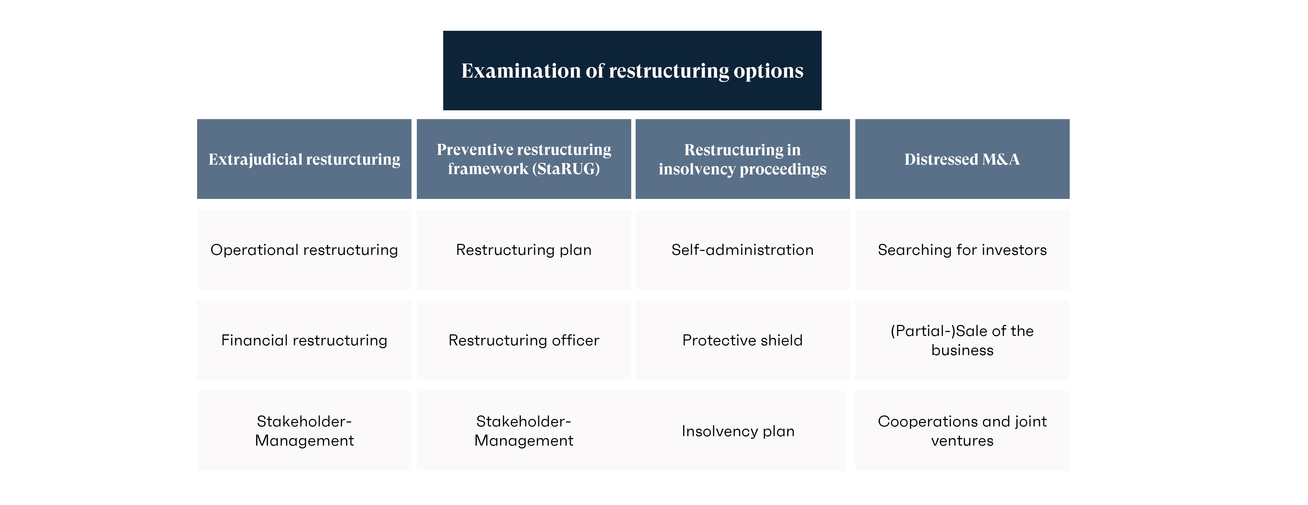
Figure: Restructuring Options
Source: Author’s creation

Shareholder Value Influence, Operational Flexibility and Debt Structure
The consequences of the suggested restructuring plans on the shareholder value are immense. Disposing of non-performing properties would add to the bottom line profitability and efficiency and hence better ROE. The recent decrease in the ROE of over 23 per cent in 2023 to around 10 per cent in 2024 might be addressed by allocating capital more efficiently and reducing inefficient investments for example. High shareholder wealth would be due to high profitability.
Strategic partnerships and mergers can also be used to increase shareholder value by reducing the cost and enhancing competitiveness in the market. Through this resource and capability sharing, Tesla will be in a position to achieve economies of scale without massive capital investments, saving cash flows and increasing profitability.
Regarding debt structure, moderate long-term debt will also be introduced, which will increase the financial leverage and it might increase shareholder returns. The Tesla debt ratio is reduced to about 40 per cent, meaning a conservative capital structure, now. Whereas this will reduce risk to finance, it may also reduce possible returns. The balance between an increase in leverage (to multiply returns without excess financial risk) can be achieved as long as the cash flows are steady.
The other aspect that is worth considering is the flexibility of operations. The flexibility may be increased with the help of divestiture and partnerships, which will allow Tesla to focus on the core competencies, i.e., producing electric vehicles and energy solutions. In the meantime, the company will be able to respond quickly to the changes in the market due to a high degree of liquidity, which is also seen in the current ratio of approximately 2.0.
However, excessive use of debt or aggressive restructuring may lead to reduced flexibility due to increased fixed financial obligations (Savvopoulou, 2023). Therefore, it is necessary to strike a balance between restructuring of finances to ensure that it enhances the agility of operations rather than restraining it.

Ethical and International Issues
Tesla as a global company, will need to consider international financial risks in its restructuring strategy. One of the factors is currency risk. Tesla operates in multiple markets and the exchange rates may affect both revenue and expenses. To provide an example, where the foreign currencies are devalued against the US dollar, the international revenue would be less when it is reported under the reporting currency. In order to reduce this risk, Tesla should consider hedging strategies, such as forward contracts and diversification into currencies.
There is an inflation risk to consider. The inflation can cause an increase in the cost of production, particularly on the raw materials and labour, and this may cause a squeezing of the margins. These cost pressures can manifest themselves at least in part by the decline in the operating margin (from nearly 17 per cent in 2022 to under 8 per cent in 2024. To minimise the consequences of inflation, Tesla must, therefore, establish cost control systems and pricing strategies.
Within the framework of taxation, Tesla has the ability to optimise its international taxation through the international tax laws and subsidies on sustainable energy projects. However, the violent means of tax evasion may be morally dubious and may damage the reputation of a business. Tax planning ought to be undertaken in both realms of law and ethics (Boiler, 2023).
Corporate social responsibility is another significant aspects of financial restructuring. As one of the major industry players in electric vehicles, Tesla has a part to play in ensuring environmental sustainability and ethical business practices. The decision of divestiture should not only consider the financial returns but also must be environmental and socially oriented. One such thing is reducing the operations that are carbon-intensive and investing in clean energy solutions where brand value and long-term sustainability will be increased.
Furthermore, there should be fair labour practices and ethical supply chain management. As Tesla relies on foreign suppliers, it should ensure that the materials are ethically sourced such as lithium to create batteries. This will bring the financial strategy in line with the broader societal expectations and increase the confidence of the stakeholders.
Overall, the proposed reorganisation plan is a comprehensive blueprint of the improvement of the financial stability of Tesla, the improvement of the operational performance, and further expansion in the international sphere.

Task 4

Investment Project Assessment
As the Chief Financial Officer of Tesla Inc., the three given investment projects are considered using the assistance of five the most significant approaches: Payback Period, Accounting rate of Return (ARR), Net Present Value (NPV), Profitability Index (PI) and Internal rate of Return (IRR). The project will be subject to 50 million pounds investment on all projects, and a discount rate of 10 per cent will be applied.
The results of the analysis performed using Excel indicate that there are clear variations in the financial attractiveness of the projects. The cash flows are not distributed equally in the five-year period in project A; hence, the payback period in project A is relatively long and thus, the payback period is about 4.6 years. The NPV of it is positive but the relative value of NPV is low compared to other projects which implies that there is little value creation. The ARR is not substantial as well, which suggests decreased average profitability (APM, 2019).
Project B on the other hand, provides predictable and regular annual cash flows of 11 million pounds. This implies that it will recover its investment in the shortest time of 4.5 years and this is the shortest of all three projects. It possesses a middle ARR and a positive but not the highest NPV. The IRR is stable and is higher than the required rate of return, indicating financial feasibility. The key benefit of Project B is that it is predictable and the risk profile is lower.
Project C shows a very different trend with the cash inflows being low during the first few years, but the inflows are high in the third and fourth years. This makes the payback period to be relatively longer about 3.7 years, than project A and project B due to the huge inflows during the middle period. Project C is the project which has the largest NPV among the three and as a result, it generates the highest shareholder value. It also boasts of the best ARR and IRR, which has a higher profitability and a higher potential for returns (APM, 2019).
Overall, despite the fact that Project B is doing well when assessed using the payback method due to its consistent cash flows, Project C would do better compared to all the other projects using most of the investment appraisal methods, particularly, NPV, IRR and ARR.

Comparative Analysis of Method Conflicts
The analysis shows that there is an overall contradiction between the appraisal methods. Using the Payback Period method, Project B will be the most attractive because it recovers the initial investment more quickly. However, this method fails to consider the cash flows beyond the payback period, and it does not consider the time value of money.

On the other hand, the NPV, which is supposed to be the most correct method, indicates evidently that Project C is superior. Project C has far greater discounted cash inflows and thus the best NPV of the three options (APM, 2019). This means that it contributes the most shareholder wealth.
The IRR results also support project C as it provides the highest internal rate of return, which is much higher than the 10 per cent discount. Similarly, Project C has the highest Profitability Index, which indicates that it is effective in generating value per unit of investment.
By this, despite the advantage of Project B in payback period, general financial analysis would strongly indicate that Project C is the most preferred investment.

Financial Foundation Recommendation
The final decision on the investment must also consider the performance of Tesla over the past five years. There is a decline in profitability in the company as it has been established in the financial health analysis. The net profit margin has declined significantly, and now stands at approximately 7 per cent as of 2024, compared to over 15 per cent as of 2023, but the operating margin has declined to less than 8 percent compared to approximately 17 per cent. This indicates increased cost pressure and reduced efficiency.
In the meantime, Tesla is highly liquid and has a current ratio of approximately 2.0 and a negative cash conversion cycle, which is good internal cash generation. This means that the company has the financial capability of investing in new projects, but one must look at the projects that will most probably bring a high payoff in the long term.
In this case, project C is the most suitable. Its maximisation of shareholder value, which is important, is directly linked to its NPV being high in the aftermath of the recent decline in profitability. In addition, the project will make the high IRR earn returns that are significantly above the cost of capital, which will help in improving the overall financial performance.
Project B has more stability, but low NPV implies that the project does not contribute to the long-term value creation to this degree. Given that Tesla must be more profitable and efficient, it is more strategically appropriate to select a project with a higher payback such as Project C.

Non-Financial Risk
Non-financial aspects should also be considered in addition to financial indicators (Kaiser, 2016). Project B with its stable cash flows is less susceptible to market changes and less operational risk. This makes it suitable during fluctuating economic conditions.
However, the risk associated with project C is higher as it has an inconsistent cash flow pattern. Successful implementation and a favourable environment in the market precondition the big inflows later. These future cash flows may be affected by such factors as political risk, changes in regulations, and supply chain disruption.
Also to be considered is market demand and customer loyalty. Tesla is a business in a highly competitive electric vehicle market, and brand strength and innovation is the most important. The projects involving technological development and product differentiation have an increased likelihood of enhancing customer loyalty and competitiveness in the long-run. These strategic investments may be associated with project C, which is more profitable and which may be more oriented towards the objectives of Tesla's growth.
Tesla is well-positioned in terms of liquidity and the company is not very indebted, a buffer against the uncertainties, although at a greater risk. In this respect, the company is able to take a higher-risk high-return project.

Optimal combination of project and Capital Rationing
The company has a capital constraint because the maximum investment that it can undertake is 100 million pounds. Tesla would also be able to select two or three of the projects since each project would require a cost of 50 million pounds.
Project B and Project C have the best combination based on the NPV results. Project C is the one with the highest NPV, and Project B is the one with the constant cash flow and lower risk. They pool and make a balanced investment portfolio that gives maximum returns and maintains the financial situation stable.
The combination of NPV of Projects B and C is the largest among any other combination, and therefore, the most value increasing. As an alternative, the selection of Projects A and B or Projects A and C would result in a smaller cumulative NPV, which means that the capital is not allocated efficiently.
Besides, the risk associated with the asymmetric cash flows of Project C can be offset with the help of Project B, which is particularly important in the current financial conditions of Tesla.

Final Recommendation
Based on the general analysis, Project C must be the first to be encouraged as it has the best NPV, IRR and ARR. By applying capital rationing constraints, the optimal solution would be to select Project B and Project C, as this would maximise shareholder value without excessively raising the risk profile.
This action will be in line with the Tesla's financial health, which is characterised by a large liquidity level and decreasing profitability. Investing in projects that would result in high returns and retaining a certain level of stability will help Tesla enhance performance in the long term, become more efficient, and competitive in the global electric vehicle market.

Conclusion
To sum up, Tesla Inc. is financially stable, as it has high liquidity, negative cash conversion cycle, and low risk of corporate failure suggesting a Z score that is above 3. The analysis, however, shows that profitability and efficiency are evidently declining, with operating margins decreasing to less than 8 percent and a return on equity of approximately 10 percent in 2024. Restructuring of finances strategically through asset optimisation and balanced capital structure adjustments is thus needed. By investment decision, the most value-generating decision is Project C, whereas the combination of Project B and C gives the best decision based on the capital constraint. Comprehensively, the key factors to maintaining long-term competitiveness and shareholder value are disciplined financial management and strategic investment.

References
APM (2019). What is investment appraisal and project funding? | APM. [online] www.apm.org.uk. Available at: https://www.apm.org.uk/resources/what-is-project-management/what-is-investment-appraisal-and-project-funding/.
Boiler, B. (2023). Issues for enhancing the ethics of Professional Accountants in Business and in Public Practice when performing tax planning for an organization or employer. [online] Available at: https://www.ethicsboard.org/sites/default/files/2023-05/Issuing%20for%20enhancing%20Ethic.pdf.
Desta, M. (2025). Equity financing 101: How companies raise capital through equity. Academy of Accounting and Financial Studies Journal, [online] 29(1), pp.1–3. Available at: https://www.abacademies.org/articles/equity-financing-101-how-companies-raise-capital-through-equity.pdf.
Guryanova, L., Bolotova, O., Gvozdytskyi, V. and Olena, S. (2020). Long-term financial sustainability: An evaluation methodology with threats considerations. RIVISTA DI STUDI SULLA SOSTENIBILITA’, (1), pp.47–69. doi:https://doi.org/10.3280/riss2020-001004.
Kaiser, T. (2016). Managing non-financial risks: A new focus area for executive and non-executive board members. Journal of Risk Management in Financial Institutions, 9(1), p.53. doi:https://doi.org/10.69554/yvxk8143.
Kenton, W. (2024). Altman Z-Score. [online] Investopedia. Available at: https://www.investopedia.com/terms/a/altman.asp.
Mahdi, M. and Khaddafi, M. (2020). The Influence of Gross Profit Margin, Operating Profit Margin and Net Profit Margin on the Stock Price of Consumer Good Industry in the Indonesia Stock Exchange on 2012-2014. International Journal of Business, Economics, and Social Development, [online] 1(3), pp.153–163. doi:https://doi.org/10.46336/ijbesd.v1i3.53.
Savvopoulou, E.I. (2023). The Global Debt Restructuring Architecture Debate and a Proposal for an Environmental Sovereign Debt Restructuring Mechanism (E-SDRM). SSRN Electronic Journal. [online] doi:https://doi.org/10.2139/ssrn.4456853.
Stefanelli, G. (2025). Strategic alliances vs mergers: choosing the right path. [online] Data Studios ‧Exafin. Available at: https://www.datastudios.org/post/strategic-alliances-vs-mergers-choosing-the-right-path.
Währisch, M. (2019). Der Cash-Conversion-Cycle. Controlling, 31(4), pp.22–28. doi:https://doi.org/10.15358/0935-0381-2019-4-22.
Wildan Army Abdillah (2025). Analysis of the Effect of Liquidity Ratios and Solvency Ratios on Hedging Decisions. Journal of Economicate Studies, 9(1), pp.39–45. doi:https://doi.org/10.32506/joes.v9i1.651.

Appendices
Appendix A
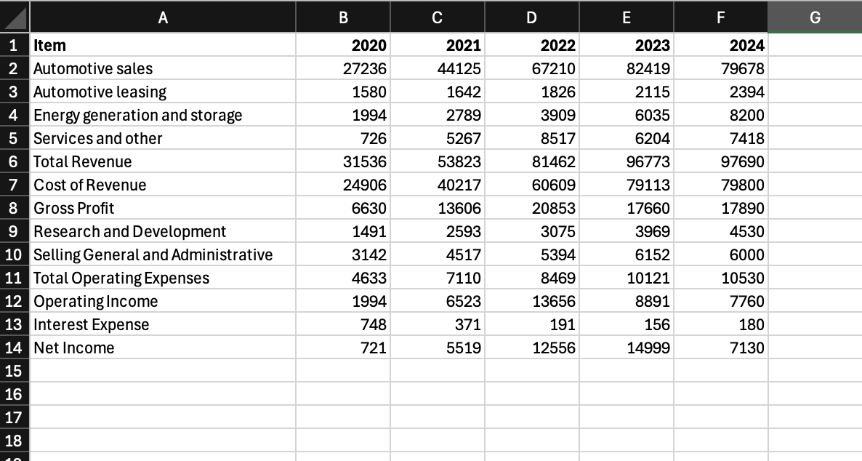
Appendix B
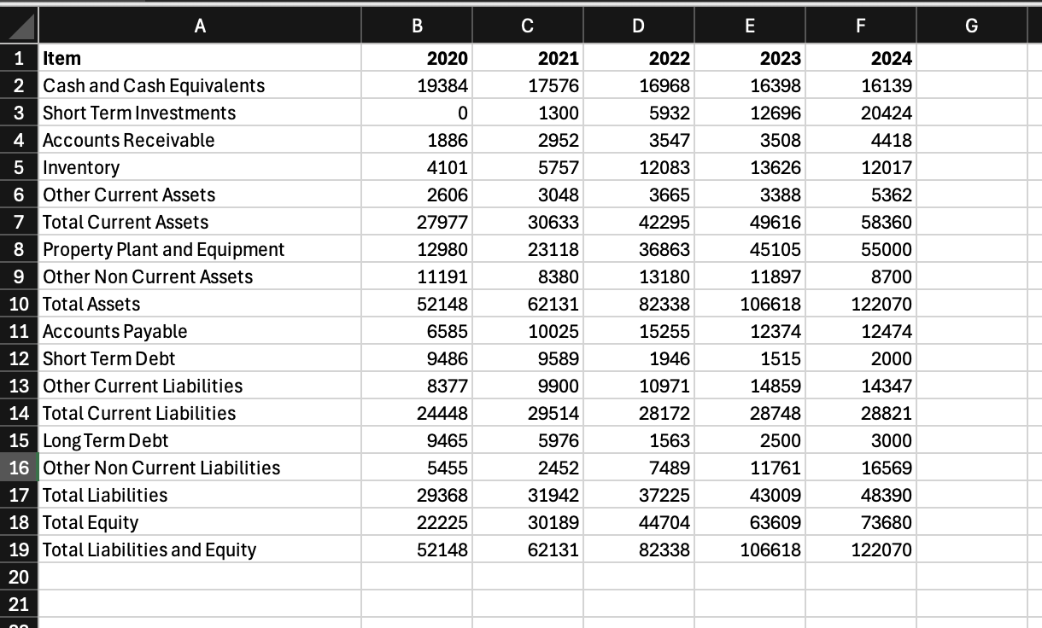
Appendix C
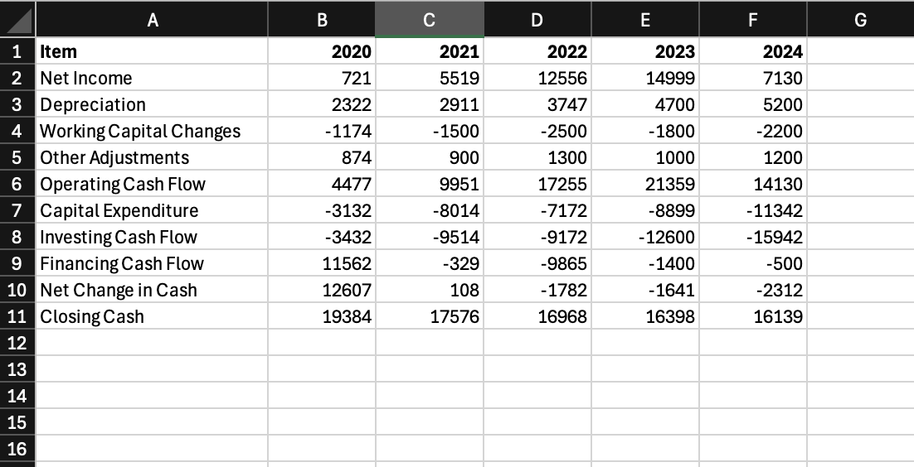
Appendix D
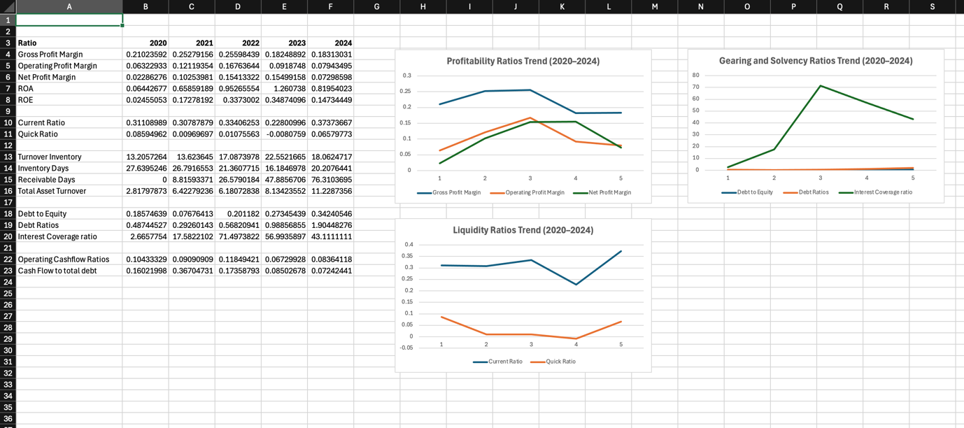
Appendix E
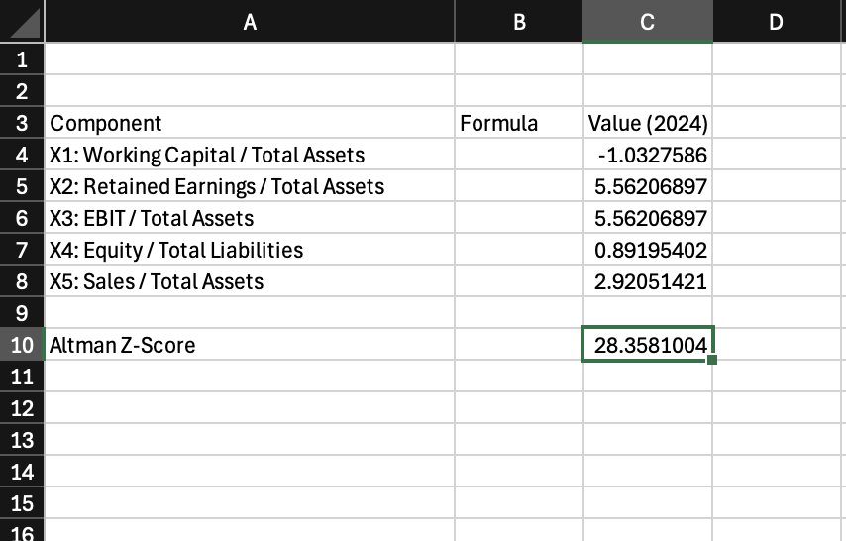
Appendix F
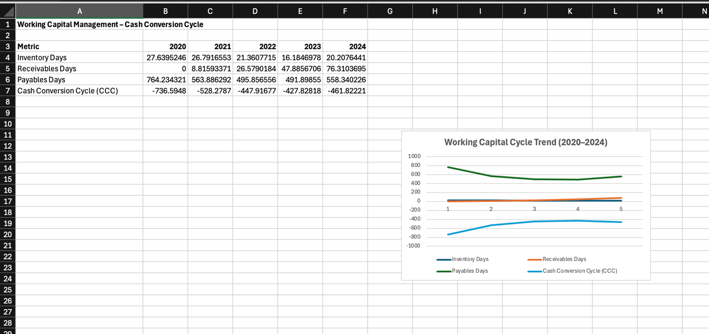
Appendix G


