University of Wales
Trinity Saint David

Banking Financial Management and Financial Markets (LCMB7012 OCT 19 REWORK)

Assessment 1 – “RBS”

By Stanislav Baychev (Student ID: 1813732)
Lecturer: Isaiah Oino
Submission date: 10/01/2020

Contents
1. Introduction 3
2. Critical Ratios Review 5
Capital adequacy ratio 5
The liquidity coverage ratio 6
Asset quality ratio 7
3. Risks the bank faces and strategies of mitigating the risks 8
Interest rate risk 9
Liquidity Risk 13
Foreign Exchange Risk 15
Credit Risk 16
4. Efficient Market Hypothesis 18
The relevance of the efficient market hypothesis to modern banking 19
5. Role of regulators 22
6. Conclusion 24
7. Reference list: 25

Introduction
The Royal Bank of Scotland is one of the oldest financial institutions in the United Kingdom. It was founded in Edinburgh in 1727. During the years RBS became one of the biggest banks in Scotland. This is because of past mergers and acquisitions with and between hundreds of past banks. These banks were all different – operating on a huge or small scale, in big cities or small towns, traditional or commercial. They successfully served the banking needs of the growing population with growing needs all over the United Kingdom and even beyond. All these institutions had influenced today`s RBS in one way or another. Some of the bank`s brands were created before the Royal Bank of Scotland even existed. Some were even established by Britain's first bankers, the first goldsmiths in London. These are Child & Co, which origins can be traced back to the 1640s and which can be considered probably the oldest banking institution still trading in the United Kingdom; Coutts, established in 1692 and quite popular in the 19th century; and Drummonds, founded around 1712.
Another big part of the Royal Bank of Scotland Group plc is NatWest. This branch was introduced in 1970 and although it may sound like a new bank, actually it sits on top of 300 years of banking done by more than 200 different financial institutions. They were all suiting the needs of banking of diverse communities across England and Wales. One example is the first bank in England to operate outside of London - Nottingham Smiths Bank. It was formed in the 1650s and is now a branch of NatWest. NatWest has other brands that can tell their own stories. Such an example is Lombard, which was established in Rotherham in 1861 and first served as a railway wagon leasing company. In 1809 an army pay agency was created by the name of Holt's. They started to introduce banking services for army officers and managed to develop into a bank later.
Another well-known part of the Royal Bank of Scotland is Ulster Bank. It was established in 1836 in Belfast. At first, it was run by and for the needs of the population of Belfast and Ulster, but soon after that, it continued to grow throughout Ireland.
Isle of Man Bank was another local bank to become part of the Royal Bank of Scotland. The Isle of Man’s Companies Act was introduced in 1865, and Isle of Man Bank was the first company to be formed under the Act. It plays an important role as a factor of trust on the island ever since then. (RBS`s “Our history”, 2019)
Moving forward to modern times, the way of people doing banking and legislation were changing and in 1985 the Royal Bank of Scotland was merged with Williams & Glyn's Bank to create a nationwide high street bank, probably the first one to operate on such scale. Also in 1985, the Royal Bank of Scotland launched Direct Line, a new motor insurance company. The move was regarded as a huge success as it turns out to be profitable. This was in its major part thanks to the successful marketing campaign, which made the brand very well recognized in Britain thanks to a red telephone running on wheels, featured in their everyday adverts for years.
In the early 1990s, the bank underwent a major reorganization on its core corporate structure, which was the same other banks were doing at the time. The Royal Bank of Scotland decided to shift from its core business of retail banking and start building an investment portfolio for future growth. In 1993 RBS acquired Adam & Company, a private bank based in Edinburgh. Because of the growing customer needs a telephone banking service was launched in 1994. Again, for the same reasons in 1997 the Royal Bank of Scotland launched the first fully developed internet banking system in the United Kingdom.
In 2000 RBS the acquisition of National Westminster Bank was announced. This £21bn deal, the largest takeover in the history of British banking at that time, was a major transformational event. The bank faced new challenges it was unfamiliar with as it started to penetrate emerging international markets. Digitalization was accelerating globalization, shifting the power balance towards multinational companies and worldwide economies. In 2007, the Royal Bank of Scotland became part of a consortium that acquired a Dutch bank called ABN AMRO. In the same year, a financial crisis hit the United Stated markets and worsening economic conditions that followed worldwide weakened many financial institutions, making the crisis global. By that time some of the RBS`s strategic decisions turn out to be wrong. This made the situation even worse. The Royal Bank of Scotland became highly vulnerable. The government decided to rescue it with a £45.5bn capital injection in 2008, making it partly state-owned. RBS has worked to rebuild customer trust and shareholder value since then. (RBS`s "Heritage archive", 2019)
The Royal Bank of Scotland is in the prosses of appointing the new Chief Executive Officer, as in April 2019 the current CEO`s Ross McEwan gave his resignation. He managed to restructure the bank in a way that turned the state-owned bank to profitability. There are several candidates to lead the company: Alison Rose, head of the bank's commercial and private banking business, and also internal favorite; the head-hunter Spencer Stewart; Mark Bailie, in charge of the new RBS digital bank Bo; Les Matheson, head of personal banking; and Simon McNamara, chief administrative officer. If appointed, Alison Rose will be the first woman to become CEO of RBS (RBS, 2019).

Critical Ratios Review
There are different measures of performance. The performance of a bank can be measured in terms of profitability, liquidity, capital adequacy, solvency, etc. In this section, we are going to analyze capital adequacy, the liquidity level and the asset quality of the Royal Bank of Scotland to critically evaluate its performance from different angles. The calculation and valuation are as follows:

Capital adequacy ratio
According to Wang, Y. (2018) capital adequacy ratio (CAR) is also known as capital to risk-adjusted assets ratio. CAR measures the amount of capital a bank can retain in comparison to its risk. It is very crucial to the shareholders because it measures the soundness of a bank. It can be calculated based on tier 1 and tier 2 capital over the risk-weighted assets. The calculation is as follows:
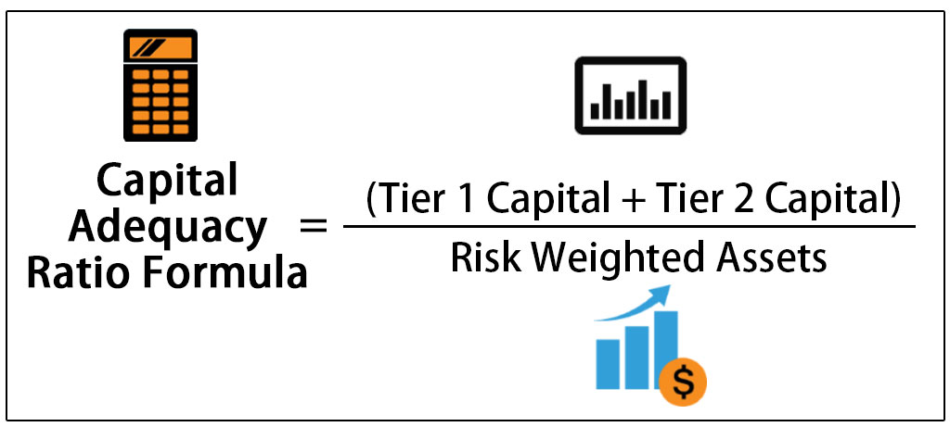
Tab. 1 Capital adequacy ratios of Royal Bank of Scotland (2014-2018) and Barclays (2018):
Royal Bank of Scotland | 2014 | 2015 | 2016 | 2017 | 2018 | Barclays 2018
T1 capital in bn | 39.9 | 37.6 | 30.6 | 39.554 | 36.223 | 53
T2 capital in bn | n/a | 10.9 | 12.9 | 8.377 | 7.951 | 6.6
RW assets in bn | n/a | 242.6 | 228.2 | 200.923 | 188.691 | 311.9
Capital adequacy ratio | n/a | 0.2 | 0.19 | 0.239 | 0.234 | 0.19
Capital adequacy ratio in % | n/a | 19.99 | 19.06 | 23.86 | 21.41 | 19.1

Figure: Capital adequacy ratio comparison (RBS, 2019)
Source: Author’s calculations and Annual Financial Reports of Royal Bank of Scotland and Barclays
Evaluation
Under Basel III, a bank's tier 1 and tier 2 capital must be a minimum of 8% of its risk-weighted holdings. The minimum capital adequacy ratio, also including the capital conservation buffer, is 10.5%. However, RBS and Barclays have a very higher level of CAR ratio than the required level of CAR. Though a higher level of CAR refers to a higher level of solvency, it comes from the sacrifice of profitability. So, it might be better for RBS to maintain the required level of CAR and invest the excess fund to increase profitability.

The liquidity coverage ratio
According to Arnold, G. (2012) the liquidity coverage ratio refers to the provision of highly illiquid assets held by financial institutions to meet the short term obligations. It is sometimes calculated based on highly liquid assets. The liquidity coverage ratio is calculated based on the reserve of highly liquid assets over the expected withdrawals in different expected scenarios. Thus the calculation of LCR of RBS is as follows:
Tab. 2 Liquidity ratios of Royal Bank of Scotland (2014-2018) and Barclays (2018):
Royal Bank of Scotland | 2014 | 2015 | 2016 | 2017 | 2018 | Barclays 2018
Liquidity cover ratio in % | 4.2* | 136 | 123 | 152 | 158 | 169
Minimum LCR required in % | n/a | n/a | 70 | 80 | 90 | 90
*Based on end-point CRR Tier 1 capital and revised 2014 Basel III leverage ratio framework. (RBS, 2019)

Figure: Liquidity coverage ratio comparison
Source: Author’s calculations and Annual Financial Reports of Royal Bank of Scotland and Barclays
Evaluation
According to Basel III, the minimum liquidity coverage requirement is 90%. However, RBS has a very higher level of liquid assets. We know that the higher the liquidity, the lower the profitability. There is a big trade-off between these two factors. However, RBS maintaining a very higher level of liquidity. It refers to that RBS is inefficiently managing its liquid position. It might focus on finding more investment sources to invest its excess liquid fund.

Asset quality ratio
The asset quality ratio sometimes refers to the loan quality ratio that is related to the left-hand side of the bank balance sheet. Banks are concerned about asset quality because good quality assets/loan/investment offers a higher level of return. However, lower quality investment/assets often lean to the failure/NPL of banks. Asset quality can be calculated by adding net advances, net investment, and money at call over total assets. Thus the calculation of assets quality of RBS is as follows:
Tab. 3 Asset quality ratios of Royal Bank of Scotland (2014-2018):
(Amount in billion GBP)
Particulars |  | 2014 | 2015 | 2016 | 2017
Earning assets | Net advances | 65.2 | 60.7 | 63.3 | 61.2 | 60.6
Earning assets | Net investment | 9 | 8.5 | 9.1 | 7.2 | 8.1
Earning assets | Money at call | 2.8 | 2.1 | 2.5 | 2.4 | 2.3
Total earning assets |  | 77 | 71.3 | 74.9 | 70.8 | 71
Total assets |  | 99 | 93 | 94.2 | 93.1 | 94.4
Asset quality ratio |  | 78% | 77% | 80% | 76% | 75%
Source: Author’s calculations and Annual Financial Reports of Royal Bank of Scotland and Barclays
Figure: Asset quality ratio
Evaluation
We have already found that RBS has a very higher level of liquid assets. Among the highly liquid assets on an average 8% investment in short term investment generates some interest income. However, they have more than 20% reserve in the central bank. So, consideration of that RBS has very good asset quality ratios as it is ranged between almost 75-80%. However, asset quality is decreasing over the years.

Risks the bank faces and strategies of mitigating the risks
The term "risk" can be defined as an unplanned event with financial consequences, which leads to bank losses or liquidity issues. The bank can`t predict its future performance because of the uncertainty. Risk is the state where there is a high possibility of negative results to happen. Risk is the uncertainty what the results could be, especially if they are unwanted and/or negative, signs of future hardship and financial loss. Very often the words "risk" and "uncertainty" are used as interchangeable in financial jargon, which is far from the truth as the two terms describe various possibilities for results. The term "uncertainty" describes the situation where all possibilities from a particular bank action are known. The term ”risk” must be used for cases where the probability of deviations exists, or this is the amount of uncertainty. (Ernst & Young, 2012)
The risk will always exist because of the nature of the bank business - the banks have little or no control over Bank of England interest rates, currency exchange rates, how markets react to certain planned or unplanned events, issues with debt collection, etc. Risk can be operational in trivial cases such as computer or internet failure, employee misconduct or industrial action, theft and robbery and any forced-major events like fire, flood, riots, lightning strikes, etc. Risk can be systematic – when it affects the entire market, or unsystematic, where it affects a specific industry, company, or bank. From all of the above, four types of risks can be defined as important for this study – credit risk, operational risk, liquidity risk, and market risk (Piesse, 2017).

Interest rate risk
According to Piesse, (2017) interest rate risk arises in a financial institution when the maturity of the assets mismatches with that of liabilities in the balance sheet. In most of the cases, the maturity of the assets (loans & advances) is greater than that of liabilities. This is because the bank takes short term deposits (liabilities) from the depositors and extends comparatively longer-term loans and advances (assets) to the borrowers. If this is the situation, then when the interest rate rises the financial institution loses. It is receiving the same low-interest rates, as specified for a fixed period and rate, from their borrowers but has to pay higher rates to the depositors. Otherwise, the depositors will withdraw their money from the FI and deposit it with the other FI resulting in a fund shortage for it. Although there may be some situations, when the bank may gain from interest rate movements, we will not go for considering those situations as our main focus is only on those situations in which the FIs "loses" due to those interest rate movements. So in summary two types of interest rate risk are:
Refinancing Risk:
When the maturity of assets is greater than the maturity of liabilities, then if there is a possibility that the market interest rate will rise, the bank will not be able to reprice its assets as much as the liabilities get repriced as assets' interest rate is fixed over a longer period of time. And this risk of future losses is known as refinancing risk (Arnold, 2012). So, from the following scenario we can identify when this sort of risk will arise:
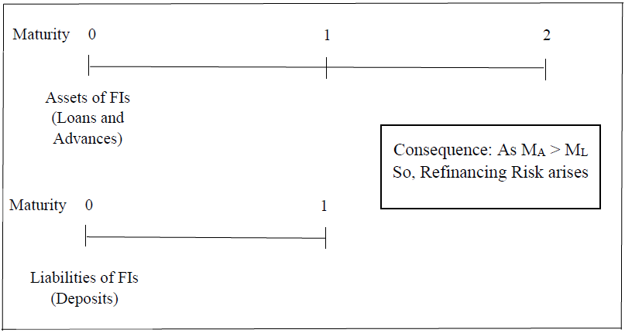
Figure: Refinancing Risk (Arnold, 2012)

Reinvestment Risk
According to Piesse, (2017) when the maturity of assets is less than the maturity of liabilities, then if there is a possibility that the market interest rate will decrease, the FIs will not be able to reprice their liabilities as much as the assets get repriced as liabilities' interest rate is fixed over a longer period of time. And this risk of future losses is known as reinvestment risk. So, from the following scenario we can identify when this sort of risk will arise:
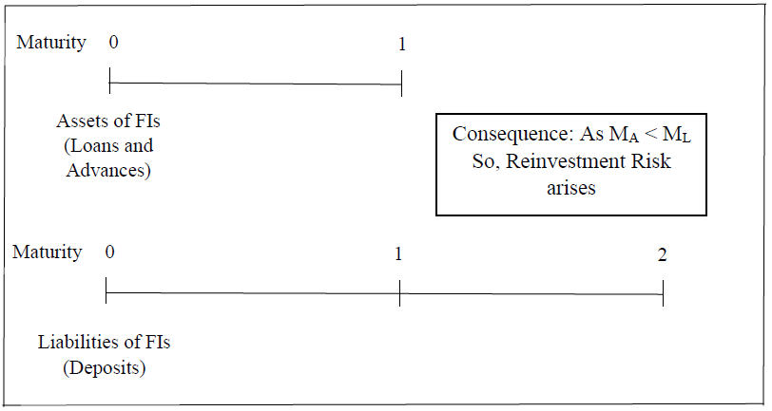
Figure: Reinvestment Risk (Arnold, 2012)
The summary can be made under these three situations like the following:
Relative Maturity | Interest Rate Scenarios | Effects
MA = ML | Increases | No Interest Rate Risk
MA = ML | Decreases | No Interest Rate Risk
MA > ML | Increases | Interest Rate Risk: Refinancing Risk
MA < ML | Decreases | Interest Rate Risk: Reinvestment Risk
Table: Interest Rate Risk Scenarios (Tasca, 2016)
When the maturity of the asset is higher than that of liabilities, a decrease in the interest rate is profitable for the financial institution. In this case, it is receiving the same high-interest rates, as specified for a fixed period and rate, from their borrowers but is paying low rates to the depositors. And when the maturity of assets is lower than that of liabilities, an increase in the interest rate is profitable for the financial institution. In this case, it is receiving lower interest rates, as specified for a fixed period and rate, from their borrowers but has to pay higher rates to the depositors (Tasca, 2016).

Interest Rate Risk Measures and Management
There are three specific models for measuring the interest rate risk exposure of a financial institution. These are:
1. Repricing Model
2. Duration Model
3. Maturity Model
As the maturity model is not currently used that much due to its some limitations (maturity is not the best estimation of the pure lock-in period), we will describe the other two approaches for calculating interest rate risk exposure for The RBS.
Repricing Model
According to Wang, Y. (2018), the repricing gap is identified to show how this gap is related to the effect of the interest rate changes on the net interest income (NII) of the FI. In the following section, we can see the impact of GAP (GAP over a given time frame) on the relation between changes in interest rates and changes in Net Interest Income (Assuming equal changes in interest rates for RSAs and RSLs):
Row | CGAP | Change in interest Rates | Change in Interest Income |  | Change in Interest Expense | Change in NII
1 | > 0 | up | Up | > | up | up
2 | > 0 | down | Down | > | down | down
3 | < 0 | up | Up | < | up | up
4 | < 0 | down | Down | < | down | down
Table: Impact of Changes in Interest Rates on Net Interest Income (NII)
But if the changes in interest rates for RSAs and RSLs are not same, then the following situation will arise:
The change in NII (Net Interest Income) in amount can be calculated by using the following formula:
Δ𝑁𝐼𝐼𝑖 = (𝐺𝐴𝑃𝑖) Δ𝑅𝑖
Here, the Repricing Gap is measured and then Cumulative GAP (CGAP) is calculated by taking the summation of the Repricing GAP up to that maturity bucket. Then we can measure the impact of changes in interest rates at different levels ( 1%, -1%, 2%, -2%) on the Net Interest Income (NII).
Duration Model
In the previous section, we have seen the application of the Repricing model for both RBS. But in that model, there are some limitations. These are: Repricing model is book value-based model, run-offs adjustment is not made, Intra cash flows are not considered, and off-balance sheet items are not also considered (Tasca, 2016). For these reasons, a superior model is used for interest rate risk management and that model is the Duration Model. In this model:
First of all, the Duration of Assets is calculated.
Then the duration of liabilities is calculated.
Then leverage adjusted Duration GAP is to be identified.
Finally, we will use the following formula to calculate the impact of Duration Gap on the FI’s equity.

Δ𝐸= − [𝐷𝐴−𝐷𝐿𝐾] × 𝐴 × Δ𝑅/(1+𝑅)
𝐻𝑒𝑟𝑒,
Δ𝐸 = 𝐶ℎ𝑎𝑛𝑔𝑒𝑠 𝑖𝑛 𝑒𝑞𝑢𝑖𝑡𝑦 𝑣𝑎𝑙𝑢𝑒
[𝐷𝐴−𝐷𝐿𝐾] = 𝐿𝑒𝑣𝑒𝑟𝑎𝑔𝑒 𝐴𝑑𝑗𝑢𝑠𝑡𝑒𝑑 𝐷𝑢𝑟𝑎𝑡𝑖𝑜𝑛 𝐺𝐴𝑃 𝑤ℎ𝑒𝑟𝑒
𝐷𝐴 = 𝐷𝑢𝑟𝑎𝑡𝑖𝑜𝑛 𝑜𝑓 𝐴𝑠𝑠𝑒𝑡𝑠
𝐷𝐿 = 𝐷𝑢𝑟𝑎𝑡𝑖𝑜𝑛 𝑜𝑓 𝐿𝑖𝑎𝑏𝑖𝑙𝑖𝑡𝑖𝑒𝑠
𝐾 = 𝐿𝑒𝑣𝑒𝑟𝑎𝑔𝑒 𝑅𝑎𝑡𝑖𝑜 (𝐿/𝐴)
Δ𝑅/ (1+𝑅) = 𝐼𝑛𝑡𝑒𝑟𝑒𝑠𝑡 𝑅𝑎𝑡𝑒 𝑆ℎ𝑜𝑐𝑘
Immunization against Interest Rate Risk
RBS can immunize their interest rate risk by matching the rate-sensitive assets with their rate-sensitive liabilities under the repricing gap model or they can match the leverage adjusted duration of liabilities to the duration of assets. But usually, the FIs do not completely immunize their positions to gain from their position based on expected interest rate movements (Arnold, 2012).

Liquidity Risk
According to Arnold, G. (2012) liquidity risk is the risk that a company or bank may be unable to meet short term financial demands.
Measuring Liquidity Risk
There are various ways to measure liquidity risk exposure of a financial institution. Here the following three ways are used to measure liquidity risk of the financial institutions. These are:
- Peer Group Ratio Comparison
- Liquidity Index
- Financing Gap and Financing Requirement
Peer Group Ratio Comparison
According to Wang, Y. (2018) peer group ratio comparison is one of the methods used to measure a financial institution’s liquidity exposure. Here, mainly three ratios are used. The ratio of the financial institution is compared to that of the overall industry.
Loan to Deposit Ratio: The ratio measures what percentage of deposit is provided as loans to individual and industrial sectors. The formula is total loans divided by total deposits of the FIs (Tasca, 2016).
Borrowed Fund to Total Asset Ratio: It shows the proportion of total assets that have been collected from borrowing funds or purchased funds rather than from deposits. Higher ration indicates less liquidity as the funds are borrowed to manage liquidity problems. It is calculated by the total borrowed funds divided by total assets multiplied by 100.
Loan Commitment to Total Asset Ratio: The ratio shows the future loan commitments of a financial institution as a percentage of its total asset. The higher commitment indicates that the financial institution has to face liquidity problems in the future if the committed loans are to be a grant.
Liquidity Index
The liquidity index is calculated using a fire-sale disposal price and a normal market price. The greater difference between fire-sale price and normal market price indicates greater liquidity risk. The index will always lie between 0 and 1 (Arnold, 2012). This index can also be compared to peer group indices to measure the liquidity position of the financial institution.
Property and Assets | Amount | Weight, Wi | % recovery if fire sale occurs | Fire sale recovery | Wi*(Pi/Pi*)
Cash | 12,301,086,194 | 5.53% | 100% | 12,301,086,194 | 0.0553
Balance in other banks and FIs | 3,176,565,149 | 1.43% | 99.99% | 3,176,247,492.49 | 0.0143
Money at call | 1,580,000,000 | 0.71% | 95% | 1,501,000,000.00 | 0.0067
Investments | 17,388,395,082 | 12.31% | 90% | 14,649,555,573.8 | 0.1108
Loans and Advances | 66,145,119,129 | 74.69% | 75% | 54,608,839,346 | 0.5602
Fixed assets | 3,128,176,263 | 1.41% | 50% | 1,564,088,131.50 | 0.0070
Other assets | 8,725,556,033 | 3.92% | 50% | 4,362,778,016.50 | 0.0196
Total Assets | 94,234,897,850 | 100% |  | 83,163,594,755 | 0.8840
Here, the liquidity index is 0.8840 or 88.40%. It indicates that from the fire sale of the asset 88.40% of the actual market value can be recovered. As there is a greater discount from the market value for loans, fixed assets, and other assets, the liquidity index is higher. So, the bank is in lower liquidity risk in 2018.

Foreign Exchange Risk
Foreign Exchange Risk is related to the change in earnings due to a change in exchange rates in the market. In light of the Foreign Exchange Risk Management Guidelines of the Central Bank, an institution has to develop its Foreign Exchange Risk Management Manual, which is approved by the Board of Directors of the institution. As risk management tools, they need to have Board approved dealers’ dealing limits; counterparty limits, and well-defined internal approval procedures. Besides, the internal Audit Division of an institution needs to conduct several independent inspections, every year, on foreign exchange business activities and reports to the senior management accordingly. Moreover, gives an institution the Net Open Position (NOP) limit, based on its total capital, and some other qualitative judgment. To minimize foreign exchange risk, and to fulfill regulatory requirement an institution needs to maintain the NOP limit very meticulously.
The net exposure of the bank to foreign currencies can be calculated by using the following formula:
Net Exposure _{i} = (FX Assets _{i} – FX Liabilities _{i}) + (FX Bought _{i} – FX Sold _{i})
The exchange rate of the currencies that RBS holds can give rise to a loss or gain to the bank. In particular, a fall in the exchange rate will cause a loss to the bank whereas a rise in the exchange rate will give rise to a gain to the bank. However, the bank does not know how the exchange rate will move in the future that is why it needs to take an appropriate step to eliminate the exposure of loss. In this case, the bank can take two different measures to protect itself from the loss due to adverse movement in foreign exchange rates. The measure is as follows:
- On Balance Sheet Hedging
- Off-Balance Sheet Hedging
On Balance Sheet Hedging: To eliminate the foreign exchange risk, RBS can make changes in the composition of the balance items that are related to foreign currencies. More specifically, the bank needs to finance its foreign currency lending by withholding funds in those respective currencies. In this case, the adverse movement in the foreign exchange rate will equally affect the FX asset and FX liability position which is necessary to reduce the exposure of losses that may arise due to adverse changes in foreign exchange rates (Tasca, 2016).
Off-Balance Sheet Hedging: In this case, to eliminate the foreign exchange risk, RBS can enter into forwarding contracts to fix the foreign exchange today that will be applied in the future period. So, we can say that the forward contracts can eliminate the exposure of adverse foreign exchange by fixing rate today. So, the adverse movement in the foreign exchange rate in the future period will not affect the FX asset and FX liability position of the bank, as the exchange rates have been determined already. This is how the bank can reduce the exposure of losses that may arise due to adverse changes in foreign exchange rates.

Credit Risk
According to Wang, Y. (2018) credit risk is the risk of non-repayment of principal and interest. It also includes a violation of any terms and conditions or rules and procedures. The default related to any document also causes credit risk. The credit quality of the borrower may deteriorate due to his investment in risky assets like junk bonds that provide high returns and also involves high risk. It creates problems for the lender as the probability of repayment of the loan by the borrower reduces. When the lender provides a loan to a large number of borrowers, their lender selection procedure becomes weaker.
Types of Loans Provided by RBS
The characteristics of loans provided by the financial institutions vary with the type of loans. Based on the characteristics, loans can be divided into three types.


Types of Loans
Commercial and Industrial Loans
Real Estate Loans
Individual Loans

Figure: Types of Loans provided by RBS
Commercial and Industrial Loan: Commercial and industrial loans are made to borrowers who need loans to run their business activities or start a new business. These loans are provided for short term as less than one year and long term as 8 years or more. Short term loans with a maturity of less than one year are used to finance the firm’s working capital needs and long term loans are used to finance credit needs that extend beyond one year. There are various types of commercial loans.
Real Estate Loan: Real estate loans are provided for house-building purposes. These loans are mortgage loans or home equity loans. Mortgage loans can be of a fixed rate or adjustable rate. An adjustable-rate, interest rates adjust with movement in the underlying market interest rate.
Individual Loan: Individual loans are provided to consumers on a personal basis. These loans are provided for various consumption purposes such as the purchase of automobiles. These loans are provided in different ways that are comfortable to the borrower. A credit card is such a type of loan. The borrower must satisfy the credit quality required by the bank issuing the loan (Wang, 2018).
Default Risk Models
Qualitative Models: These models are used if quantitative information is not available. The financial institutions have to collect information from the private sector if such information is not found from the private sector.
This information includes borrower specific information and market-specific information. Borrower specific information is specifically related to the individual borrower’s Reputation, Leverage, Volatility of Earnings and Collateral, etc. And in the case of market information, we need to evaluate the business cycle conditions and the level of Interest Rates. These are discussed below:
Borrower Specific Information | Market Specific Information
Reputation: The reputation of the borrower includes the borrowing-lending history of the credit applicant. The applicant's attractiveness is enhanced with his reputation for prompt and timely repayment of the loan. | The Business Cycle: The position of the economy in the business cycle phase is enormously important to a financial institution in assessing the probability of borrower default. During the recession, the producers of consumer durables may do worse than non-durable goods producers. Thus the probability of default in such sector increases with the fluctuation in the business cycle.
Leverage: The capital structure or the ratio of debt to equity affects the probability of default as a large amount of debt in the capital structure results in more fixed payments. So, higher risk premium should be charged on such loans.
The volatility of Earnings: High volatile earnings stream increases the probability of default as the borrower may fail to meet the fixed interest and principal payment. | The Level of Interest Rates: Higher interest rates give an indication of restrictive monetary policy by the central bank. Thus, financial institutions should consider the rate of interest charged on the loans. The interest rate charged should reflect the market interest rate. Higher rates encourage the borrowers to take the high risk or excessive risk that increases the probability of default by the borrower.
Collateral: Collateral provided by the borrower also affects default risk. If the value of the collateral is higher and has liquidity, the risk of default may be reduced as the amounts can be recovered from the asset used as collateral.
Table: Qualitative Credit Risk Evaluation Criteria
Quantitative Models
There are different types of quantitative models to measure credit risk. Two types of models are credit scoring models and term structure-based models.
Credit Scoring Models: These models are quantitative models that use observed borrower characteristics either to calculate a score representing the applicant’s probability of default or to sort borrowers into different default risk classes.
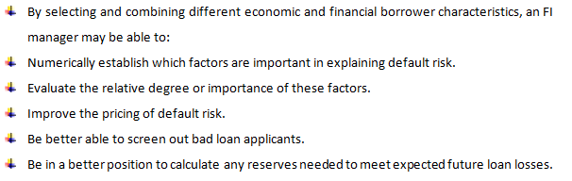

Off-Balance Sheet risk (OBS)
Off-balance sheet (OBS) item is a term for assets or liabilities that do not appear on a company's balance sheet. Although not recorded on the balance sheet, they are still assets and liabilities of the company. Off-balance sheet items are typically those not owned by or are a direct obligation of the company. For example, when loans are securitized and sold off as investments, the secured debt is often kept off the bank's books. An operating lease is one of the most common off-balance items.
The global financial crisis from 2007 highlighted the urgent need for improvements in risk regulating procedures. The Royal Bank of Scotland started to implement three lines of defense imposed by the regulators: credit restructure and new segmentation; introducing new models for credit risk management and credit evaluation; and internal modelings, like stress tests and periodic examinations of minimum capital required. Another method used for mitigating the risks is diversification – a negative correlation between Asset 1 and Asset 2 tiers.

Efficient Market Hypothesis
According to the Efficient Market Hypothesis, any information regarding the given bank on the public company has an immediate effect on the market value of its shares. The Efficient Market Hypothesis suggests that financial markets are information-efficient. (Kirman, Alan, 2009)
The efficient market hypothesis refers to financial economics that states that the market price of a particular asset incorporates all the available information. It also discovered that all the market information is adjusted in price. So the excess return provided by the market is the risk-adjusted return. So risk becomes the central issue of inefficient market hypothesis. , Depending on the nature of information adjustment to the market price, the market can be categorized into three forms namely week form of efficiency, the semi-strong form of efficiency, and the strong form of efficiency.
Nobel laureate Fama Has conducted an empirical test on these three forms of efficiencies in 1970 and won the Nobel prize in 2013. These three forms of efficiencies are described below:
Weak form of efficiency
According to Meric, I. and Meric, G. (2018) the weak form of market efficiency assumes that all the past and present information are reflected in the current price. So the analysis of past information or technical analysis becomes irrelevant in a market that has a weak form of efficiency.
Semi strong form of efficiency
Semi strong form of efficiency assumes that the market is efficient enough to adjust all the available information very quickly. Security price quickly adjusts newly available information. As a result, fundamental analysis and technical analysis becomes irrelevant in a market that holds a semi-strong form of efficiency. However, investors may earn an abnormal return with the help of private information (Meric, 2018).
The strong form of efficiency
The strong form of efficient market assumes that all the public and private information are adjusted in the share price. So, it becomes irrelevant to collect private information as it has no impact on the market price of the stock. Insider information has no impact on the profit-making function of the investors and profit exceeding normal return is not possible.

The relevance of the efficient market hypothesis to modern banking
Overview of stock market performance of RBS’s stocks
Being a multinational and listed bank, stocks of RBS are traded all over the world. So, it becomes quite relevant for RBS and banking industry to study stock market behavior and make decisions accordingly.
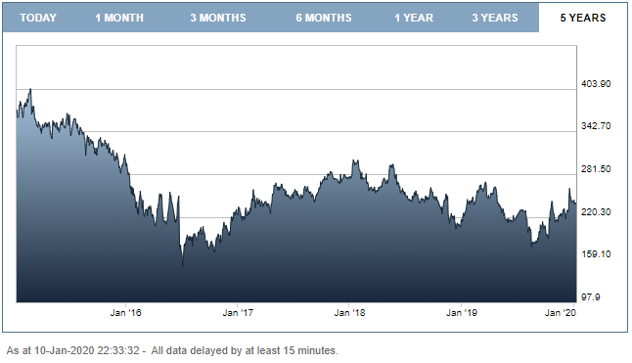
Figure: Overview of stock market performance of RBS's stocks in the last five years (RBS, 2019)
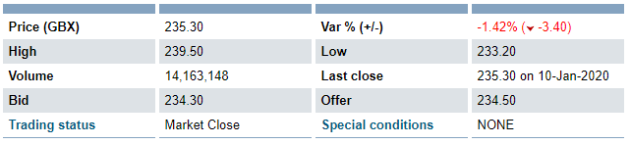
Table: Market price update of RBS (RBS, 2019)
Summary of the efficient market hypothesis is the different level of information adjustment ability to the market price of stocks. Investors get dividends and capital gains By investing in stock markets. The core objective of the managers of banks and financial institutions is to maximize the wealth of the investors. Maximization of the share price sometimes refers to the wealth maximization objective of the shareholders. In the investment profession, it is assumed that investors are rational and they prefer the higher return for a given level of risk or a given level of return for the minimum amount of risk.
The banking industry is considered as the heart of the economy. All the performing industries in an economy is directly related to the performance of the banking industry. We all know the global financial crisis of 2007-2008. It is simply occurred based on the overuse of mortgage-backed security and certificates of deposits. These are baking industry products. However, the failure of one bank has lead to the massive failure of the global economy.
Besides, the Asian currency crisis also provides us a signal of studying market behavior and efficiency of the market. A negative signal can easily change the whole picture of the banking industry.
There are differences between traditional finance and behavioral finance. Behavioral finance assumes that human behavior is biased instead of rational. There are cognitive and emotional biases that lead to the failure of market movement. So, a sensitive industry like the banking industry must need to be very careful about the negative information. Unexpected negative information can lead to a drastic fall in share price and economy simultaneously (Meric, 2018).
The banking industry nowadays is globalized. As a result, the price movement of the market is crucial for the managers of financial institutions. It is relevant to the modern banking industry as a stock market is operationally efficient. Information regarding share price and volume of trading of past transactions is available widely. There is price continuity in the market and the market offers accurate, relevant, and material information to investors. So, the expected future positive movement of cash flows and earning might have a potential impact on increasing the share prices. So, it becomes relevant to the bankers to know the performance factors that might positively lead to the share.
It is expected that the price movement will occur based on the arrival of new information. It is also assumed that the arrival of new information is random and independent. If the new information is anticipated by some of the investors then they can on abnormal return. So, RBS needs to ensure that the arrival of new information is random and might not occur much impact on the price movement.
There are some random noise exists in the market along with some anomalies. So, it becomes critical for bankers to reduce the impact of these anomalies and random noise by offering accurate, timely, and relevant information to the investors (Arnold, 2012).
It is also relevant for the banks and financial institutions to focus on the EHM to ensure the payment for investment research is not profitable, no irrelevant bargains in the stock market, investors might randomly select the stocks as prices are correctly adjusted to the information, elimination of manipulation, and elimination of timing issues.
Finally, it is most relevant to the banking industry due to the higher level of financial crisis possibility and severity in the banking industry.

Role of regulators
Three independent institutions regulate the British banking system – the Bank of England, the Financial Conduct Authority (FCA), and the Prudential Regulation Authority (PRA). Their common goals are maintaining financial stability and support for economic growth. To achieve the above the banking sector and the capital markets must stay strong and play their role as financial mediators. The role of regulators include improving the banks financial health by clearing the income statements from unpaid credit; relieving the regulations preventing future development of better integration between capital markets; resolving the issues with the current regulations and improving corporate management in some of the banks; mitigating the risks specific to foreign exchange credit exposure; and eliminating the disbalance on the real estate markets, which is moved by the rise of mortgages. (Ernst & Young, 2012).
The banking industry is the heart of the world economy. System failure or financial crises like 2007-2008 can further bring huge damage to the global economy. So is stability in the economic system and the banking industry is the prime concern of the regulator. Regulators might focus on curative as well as a preventive action to avoid an unwilling system failure in the banking industry. Thus Regulators must need to design accurate, reliable, and trustworthy regulation systems to avoid the crisis. proper empowerment, control, and monitoring are the key sections required to avoid system failure. Thus regulators may strictly focus on the following issues to avoid unexpected crisis (Meric, 2018)
Need to extend regulatory oversight to the shadow banking system. Here shadow banking systems refer to private equity and hedge funds. These are often unregulated and create a crisis. Currently, these special forms of funds are very much alive. so regulator needs to design a strict framework to control these unregulated sections.
Regulators should also reduce or eliminate the excessive use of off-balance sheet items. Currently, there is an increasing trend of investing in our balance sheet items. however, some of the banks do not have sufficient capital to protect the bank solvency and even the liquidity if the crisis occurs.
Regulators should also implement different precautionary principles. Currently, the use of highly risky instruments like collateralized debt obligations and credit default swaps are increasing. These are sometimes called Innovative financial products that had already lead to a financial crisis before. Though it is difficult to eliminate these financial products from product inventory of the banks, regulators should implement strict control over these instruments (Piesse, 2017).
Regulators should further move virtually all financial security transactions onto exchanges. These are mainly over the counter instruments.
Regulation of online security systems and ensure different layers of safety to avoid cyber attacks.
Need to transform financial firm incentive structures that include excessive risk-taking because they often received enormous compensation in the boom however fail to return in the downturn.
Regulators should also restrict the growth of debt through countercyclical capital requirements or reserve provisioning (Tasca, 2016).
Thus global regulators have already implemented some global plans to prevent financial crises. These are as follows:
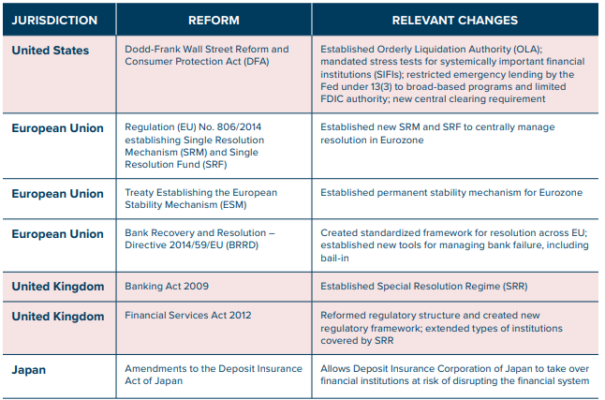
Table: Actions taken by the global regulators to prevent the financial crisis (RBS, 2019)
However, proper monitoring and controlling might be the key factors that can prevent further financial crises. The willingness of financial institutions is also crucial here.

Conclusion
Even though there are heavy regulations in the banking sector in the United Kingdom, a system of rules for effective management decisions should be implemented. This must be done so the banks can take the right decision regarding the risk they should take. Several parts of the process of management can be improved. The first thing to be defined is the bank risk profile like whether the bank is more commercial or investment orientated and its geographical placement. The second thing to be done is risk profile management for all types of services and geographical regions. Another task is building a new information system that can monitor various financial indicators. And the last component is the implementation of the above systems to eliminate any unwanted and unprofitable risk the royal bank of Scotland can take otherwise.

Reference list:
Arnold, G. (2012). Corporate financial management. Harlow, England: Pearson.
Bankofengland.co.uk (2020). Home. [online] Bankofengland.co.uk. Available at: https://www.bankofengland.co.uk/ [Accessed 10 Jan. 2020].
Barclays`s “Annual Report” 2018 https://home.barclays/content/dam/home-barclays/documents/investor-relations/reports-and-events/annual-reports/2018/2018-barclays-plc-annual-report.pdf [Accessed: 16th August 2019]
Basel 3 (2020). [online] Uk.practicallaw.thomsonreuters.com. Available at: https://uk.practicallaw.thomsonreuters.com/7-504-1959?transitionType=Default&contextData=(sc.Default)&firstPage=true&bhcp=1 [Accessed 10 Jan. 2020].
Ernst & Young, 2012. Banking risk management survey.
Finder-WUSTL, C. (2020). How we can prevent another financial crisis - Futurity. [online] Futurity. Available at: https://www.futurity.org/financial-crises-regulation-insolvency-1712122/ [Accessed 10 Jan. 2020].
Kirman, Alan, 2009. Economic theory and crisis. Voxeu
Kinsella, R. (2016). New issues in financial services. Oxford: Blackwell Basil.
macrotrends.net (2020). Royal Bank Scotland - Stock Price History | RBS. [online] Macrotrends.net. Available at: https://www.macrotrends.net/stocks/charts/RBS/royal-bank-scotland/stock-price-history [Accessed 10 Jan. 2020].
Meric, I. and Meric, G. (2018). Global financial markets at the turn of the century. Amsterdam: Pergamon.
Norman, P. (2018). The risk controllers. Chichester: John Wiley.
Piesse, J., Peasnell, K. and Ward, C. (2017). British financial markets and institutions. London: Prentice-Hall.
Rbs.co.uk (2020). Royal Bank of Scotland Online – Bank Accounts, Mortgages, Loans, and Savings. [online] Personal.rbs.co.uk. Available at: https://personal.rbs.co.uk/personal.html [Accessed 10 Jan. 2020].
RBS`s “Our history”, 2019 https://www.rbs.com/rbs/about/our-history.html [Accessed: 15th August 2019]
RBS`s “Heritage archive”, 2019 http://heritagearchives.rbs.com/ [Accessed: 16th August 2019]
RBS`s “Annual Report” 2018 https://investors.rbs.com/~/media/Files/R/RBS-IR/results-center/annual-report-2018.pdf [Accessed: 16th August 2019]
RBS`s “Pillar III Report” 2014 https://investors.rbs.com/~/media/Files/R/RBS-IR/2014-reports/pillar-3-report-2014-v2.pdf [Accessed: 16th August 2019]
RBS`s “Annual report” 2016 https://investors.rbs.com/~/media/Files/R/RBS-IR/annual-report-2016/capital-risk-management-2016.pdf [Accessed: 16th August 2019]
Schwert, G. (2011). Stock Volatility during the Recent Financial Crisis. European Financial Management, 17(5), pp.789-805.
Tasca, P., Aste, T., Pelizzon, L. and Perony, N. (2016). Banking Beyond Banks and Money.
Wang, Y. (2018). Financial Governance in East Asia.

