The Historical legacy and Culture opportunity’s for Swansea

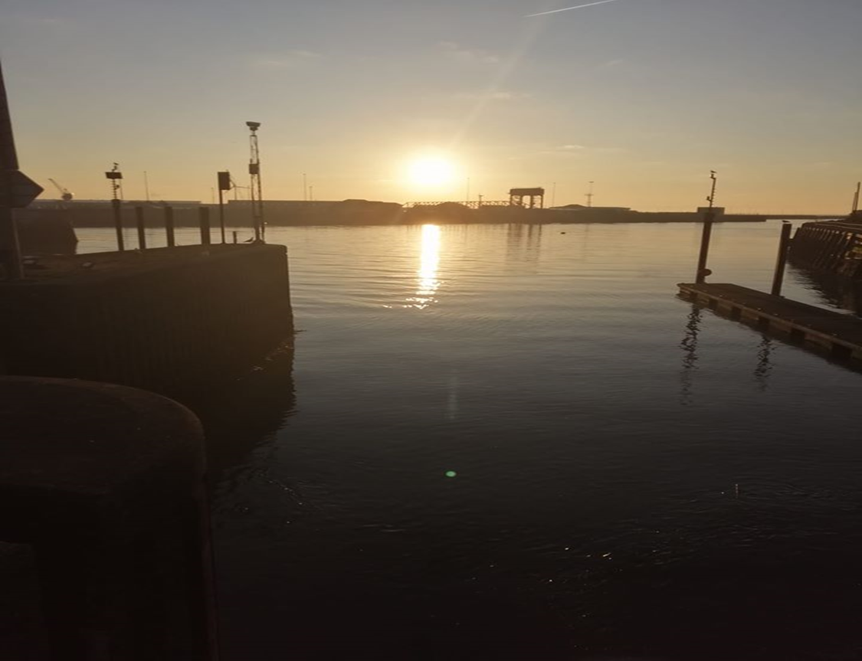
Credit to Author, Swansea Waterfront, SA1, 2019.
By Marie West (1702919)

Table of Contents
Introduction 3
Strengths, Weaknesses and Threats of Swansea ……………………………………………………………………3
Castle Square: Strengths 5
Castle Square: Weaknesses 5
Castle Square: Threats…………………………………………………………………………………………………5
Singleton Park: Strengths………………………………………………………………………………………..5
Singleton Park: Weaknesses………………………………………………………………………………..5
Singleton Park: Threats………………………………………………………………………………….5
Opportunity’s for Swansea 5
Converting Castle Square Back into Castle Gardens 6
Make the Square Green with Flora 6
Access to Singleton Park……………………………………………………………………………………………7
Conclusion………………………………………………………………………………………………………………………………..8
Reference…………………………………………………………………………………………………………………………………8
Web Links for More Reading…………………………………………………………………………………………………10

Introduction
The population in the United Kingdom (UK) continues to grow with large numbers moving or living in cities. At the present time the population for the UK is 67,781,900 (Worldometer, 2020). There are an estimated 66 (UKCITIES, 2020) cities in the UK with an estimated 83.4% of the UK population living within these cities (Trading Economics, 2018).
With population continuing to grow the city centres need to be more economic. However, on 500 different high streets in the UK in the first 6 months of 2019 over 2,868 stores closed, this worked out as roughly 16 stores a day; opening stores in 2019 with 1,634 stores opening (pwc, 2019). With 2,868 stores closing 1,634 stores opened.
The main city that will be examined for this report is Swansea City, South-Wales, which is the second largest city in Wales (Swansea’s Assessment of Local Well-being, 2017). The population of this city is 246,500 (Swansea Council, 2019), much of the population is aged 25 to 64 (119,800) which is working age (Swansea’s Assessment of Local Well-being, 2017). As previously stated, city centres are dealing with a lot of shop closures, Swansea is not exempt from this phenomenon; most of the shops in Swansea centre is mainly charity shops or pawn shops. There are many reasons that could have led to this decline and closure of shops in high streets and city centres; one being the increase of online shopping and the use of space.
In the whole of the UK online shopping accounted for 16.5% in 2017 (Sabanoglu, 2020). People are shopping online more due to the convenience, longer working hours or lack of shops in the areas which makes it easier to shop online.
There is a lot of call centres in Swansea but most of the population work in civil service. The DVLA, UK Statistics Authority, Intellectual Property Office and Companies House and HMRC headquarters can all be found in Swansea, Cardiff and Newport (Ifan and Sion, 2019).
Each city is unique and will thrive if it embraces and enhances its strengths. However, Swansea does not seem to be thriving.
“The City Centre is currently not meeting its potential. The CC suffers from: a small resident population; a limited number of jobs; poor quality office accommodation which delivers low rents; low footfall; a limited retail offer with significant vacant floorspace; and the lack of major attractions to make it a destination. The catchment perceives the CC as tired, dated and declining with an average offer, coupled with a complex traffic system, congestion and poor/expensive car parking. The ambition of the catchment remains strong for an, integrated and coherent CC capable of supporting city region status and delivering a 24-hour economy.” (City and County of Swansea, 2015: p.5.)
With this information this report will be looking at the historical legacy and cultural strengths, weakness, opportunity’s and threats of Swansea. The opportunity’s will also be in accordance with any laws, legislation and strategy that are applicable.
Strengths, Weaknesses and Threats of Swansea
Swansea is rich with history and culture however when the author was speaking to local people who were born here or have lived here for a number of years; it was found that some the of people might have known the history of the area but not some of the historic buildings around the area.
There are many strengths that Swansea has when it comes to the culture and history of the area, here is some of the big part of its history:
- The town of Swansea was first founded in the 12th Century. Normans conquered the area and built a wooden castle (Lambert, n.d.)
- In the 18th and 19th Century was the peak of industry in Swansea. Gold mining, iron pre, coal, lead, bricks steel etc. Were all mined or made in Swansea and exported out to other countries (Museum Wales, 2019).
- In the 1980’s coal mining had disappeared from Swansea which led to a larger number of unemployment. (Museum Wales, 2019)
There is much more history to Swansea but the mining and exportation of materials are the most know; remnants of these time periods can still be found and talked about at present. The history has also given Wales and Swansea a lot of its culture. For example, mining was hard on the workers and mining family’s this meant that the community would come together to help one another, and this rare behaviour can still be seen in full force.
Some of the other strengths are laws, strategy’s and act put in place to improve the area. The Tall building strategy is in place to make sure that the seafront does not become crowded by buildings that have more than 4 stories (Swansea Council, 2016). Well-being of Future Generations (Wales) Act has outlined 7 different goals that will bring a better future to the next generation; this act has taken consideration for just Wales itself, which includes embracing and having a thriving culture and welsh language (Gruffydd, 2019). These are just one of many documents put in place by City and County of Swansea to improve Swansea.
However, this history and culture does not mean that it is being used to its full potential (City and County of Swansea, 2015). Swansea needs to become more sustainable to be able too provided for the local population. There are weakness and threats that could put Swansea in danger of being unable to sustain its self.
Some of the area’s weaknesses are transport and business. The road layout system can be very difficult to manoeuvre which means that public transport can be late, not stop close enough to the location you are trying to get to or get stuck in traffic. As previously stated, most of the shops and business in the area are charity shops or Pawn shops. There is not a variation of different cloths shops and a larger number of people work in civil service job (Ifan and Sion, 2019) as a lot of government building have been placed in Swansea and other parts of Wales.
Even though there are a few museums in Swansea historic locations do not seem to be as well looked after or represented; Castle Square for example. The history is important, and it does not appear to be maintained or encourage as it could be.
The main areas that will be discussed by the author are Castle Square and access to Singleton Park.
Castle Square: Strengths
- Is in the middle of the city centre.
- A large open space.
- A lot of seating area.
- Most buildings are no higher than 4 stories meaning that it isn’t in the shadows.
- Close to food restaurants.
Castle Square: Weaknesses
- Lacking in colour as its mainly made of stone.
- Lacking in variation of vegetation.
- A larger tall building just behind the castle.
- Nothing to amuse children.
Castle Square: Threats
- Closure of shops nearby as local people do not want to sit in Castle Square for long periods of time.
- The history of the area is being lost and could further be lost with no information as to why there is a Castle in the square.
Singleton Park: Strengths
- Historical land.
- A large location with plenty of vegetation.
- Free to entre.
- Is a designated Green Space by City and Council of Swansea which means it is maintained and looked after.
Singleton Park: Weaknesses
- Location, it can be a challenge to for people to walk there and little parking is available for private cars.
- The signage is not clear on where to park or the entrance so visitors will leave. An example of this is the author was going to visit over the summer and could not figure out what car park was the right one to park in so after half an hour she just gave up and left.
Singleton Park: Threats
- Because of location and signage visitors could stop visiting which could lead too the council using parts of the land for other uses, for example to build houses on or car parks.
Opportunity’s for Swansea
To be able to identify opportunity’s the author thought it best to do some research of the area; she read the history of Swansea, visited the Water Front museums, went on local tours, talked to and listened to local people. Strategy’s, laws, legislation were read, guest speakers, input for lectures and watching documentaries were all gathered to be able to identify opportunity’s that could improve Swansea.
Moving the BT Tower:
Castle Square was once an area that was covered in grass and trees, it was known as Castle Gardens. However, because of anti-social behaviour the council decided in the 1990’s to develop Castle Gardens in the Castle Square (Dalling, 2018). There is a great opportunity to bring back some of the culture and history to area by turning Castle Square back into Castle Gardens.
This could be done by moving the BT tower to a ‘Welcome Zone’ in accordance with the Tall Building Strategy 2016. The building could be demolished and/or relocated to an area further back which is a welcome zone (pictured below). Furniture from offices in the building can be reused and placed into the new building, which would be more environmentally friendly.
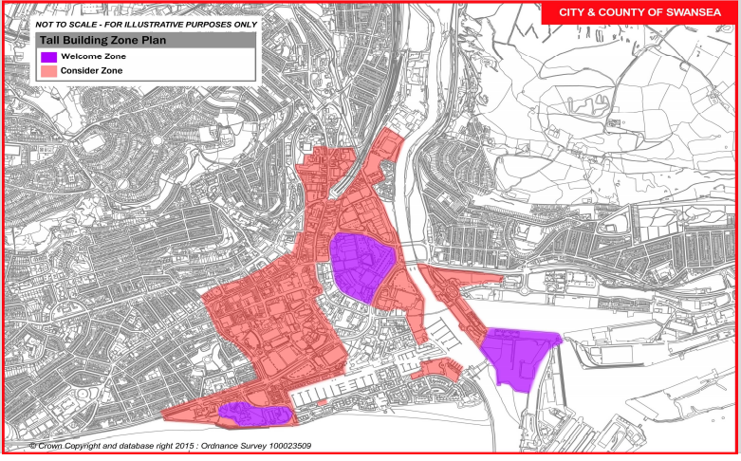
(Swansea Council, 2016. Tall Building Strategy Welcome and Considered zones)
by moving the BT building it will allow the Castle to stand out. It would also free space that an information centre can be placed where stories from for elderly that lived through the blitz in World War Two are told through written descriptions; this area was hit for three nights in a row in 1941 (Dalling, 2019).
Case Study: Depending on how the building is going to be moved will depend on the method used. In this situation a whole moved will be best and because of the new and current location; demolishing and rebuild will need to be carried out. The rebuild would be one of the cheapest options. In 2004 St Kilda Kiosk, Australia was burnt down by arson and due to the building’s history, it was rebuilt after the old building plans were found (Peterson, 2005)
Make Castle Square Green with Flora:
The square was once covered in trees and grass. This area was used by shoppers to rest and for their children to play in while their guardians were shopping. This could be done by adding grass, trees and shrubs, the water fountaining can stay as it will provide wildlife with water.
Making the area green again will bring more locals into the centre and visiting shops. It will bring more biodiversity into the Centre as there would be places for the animals to build their hides and a consistent source of water. The flora can help with mental health of local people; a study in 2017 looked at how art and horticulture therapy could help with depression, anxiety and stress. The study showed that stress was significantly impacted positively by horticulture therapy (Vujcic et al., 2017).
Case Study: The National Parks Board is an organisation that is dedicated to greening up Singapore and turning it into a City in Nature. The Greening Strategy for Singapore is a larger scale goal then converting Castle Square into Castle Gardens, but this organisation has done it.
“At the start of Singapore’s greening journey, the aim was to green up the island as quickly as possible for the purpose of providing shade and access to green spaces for all. The greening strategy then evolved to provide colour through the planting of flowering trees and shrubs. Parks were linked up by the Park Connector Network and developments were encouraged to incorporate skyrise greenery to help improve the living environment. In more recent years, NParks has adopted biophilic design in restoring habitats and has been engaging the community in our efforts to sustain our greening efforts. This is where we are today – a biophilic City in a Garden where greenery pervades our urban landscape.” (National Parks, 2020: p.1.)
Access to Singleton Park:
Singleton park has history links to the copper mining industry in Wales. The area was brought by John Vivian for his son, in 1847 (Swansea Council, 2019). It has historical value and according to the Tall Building Strategy is a desegregated green space. To make it easier for people to visit Singleton Park and Mumbles a tram system could be put back in place as there was once tram serves in Swansea; a tram system would make it easier for tourists to visit different areas without the need to change and get lost. By bring a tram system back it would also bring more jobs into the area as the trams tracks would need to be laid, trams would need conductors and drivers; they would also need a maintenance yard. Swansea had the first passenger tram, they were first horse and carts; this was started in 1807 (Rhys, 2014).
First the tram service would need to start small to make sure that it could work. The best position for a tram station to be laid would be behind the Swansea City and County Council building on an empty patch of grass near the sea front. If it was laid here, then there are pathways that are already wide enough to fit pedestrian and tram tracks on; a barrier would need to be placed to divide the two paths. The end of the line could be near Verdi’s in Mumbles. (See photo below for the tracks of the trams).
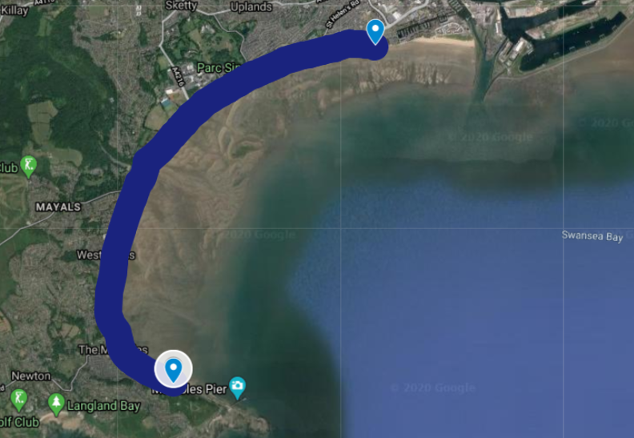
(Were Tram Tracks could be placed. Blue line is Tracks; the light blue pins are tram Station. Made by author)
Case study: The Metrolink is in Greater Manchester, UK and is a tram service. This tram services in some form have been running since 1880s. Trams went from horse pulled carts to electric by the 20th Century. In 1949 trams stopped and buses took over until 1992 when the trams were put back in action (Cox and Thompson, 2013). This has been successful as new lines are opening (Transport for Greater Manchester, 2020).
Conclusion
In conclusion all these opportunities are possible but can be costly and take a long time to put into action. Examining each case study and scale of changes the author has reconsidered some of the opportunities.
The moving of the BT building will be around £2milllion to move the building (estimated on similar buildings that have been moved) and take at least 2-3 years to do. However, this is not the main reason that the author changed her mind on moving it; while searching online for information on the BT building she came across a Facebook page that was set up by locals who considered the BT building to be a historic land mark; with this information it is more sustainable to leave the building where it is.
The Singapore case study is a large scale operation that first started in 1967 to present (HistorySG, 2015) that has cost millions of Great British Pounds; the greening of Swansea city centre is a small operation which would be estimated in the thousands and take a maximum of a year. As previously stated, this would be good for the area as it would help with mental health and bring the possibility of more jobs.
The tram system would also prove to be beneficial to the area as it would bring more jobs and help members of the public to get locations that can be difficult to get to if they do not drive. The case study of the tram system in Greater Manchester has proven to be successful. This tram system could also help with the traffic on the Swansea roads as less cars would not be on the road. The Metrolink in Manchester added 15 new stops which were along 9 miles to the airport, this cost £400milion (Pidd, 2014); but again, this is a large-scale operation. We are just looking at one or two tram lines for the moment, so it would be less then £400million but possible near too.
Reference
2015. Swansea City Centre: Strategic Framework Review. [PDF] Swansea: City and County of Swansea, p.5. Available at: <http://www.swanseacitycentre.com/wp-content/uploads/2012/10/SCC-SFR-Cabinet-final14.01.15-web-format2.pdf> [Accessed 18 March 2020].
2016. Swansea Tall Buildings Strategy. [PDF] Swansea: Swansea Council, pp.13 and 18. Available at: <http://file:///C:/Users/Student/Downloads/Tall_Buildings_Strategy.pdf> [Accessed 18 March 2020].
2017. Swansea's Assessment of Local Well-Being 2017. [PDF] Swansea, p.2. Available at: <http://file:///C:/Users/Student/Downloads/Annex_1_A_demographic_profile_of_Swansea.pdf> [Accessed 16 March 2020].
Cox, C. and Thompson, D., 2013. The Way We Were: The birth of tram travel. Manchester Evening News, [online] p.1. Available at: <https://www.manchestereveningnews.co.uk/news/nostalgia/way-were-birth-tram-travel-6276741> [Accessed 20 March 2020].
Dalling, R., 2018. The Familiar landmarks that have vanished from Swansea in the name of progress. Wales Online, [online] p.1. Available at: <https://www.walesonline.co.uk/news/wales-news/familiar-landmarks-vanished-swansea-name-15147310> [Accessed 18 March 2020].
Dalling, R., 2019. How Swansea's Castle Square went from beautiful greenery to derided concrete crater. Wales Online, [online] p.1. Available at: <https://www.walesonline.co.uk/news/wales-news/castle-square-swansea-history-past-17427107> [Accessed 18 March 2020].
Gruffydd, P., 2019. Decisions for Future Generations: Introduction to The Well-Being of Future Generations Act.
HistorySG. 2015. "Garden City" Vision Is Introduced. [online] Available at: <http://eresources.nlb.gov.sg/history/events/a7fac49f-9c96-4030-8709-ce160c58d15c> [Accessed 20 March 2020].
Ifan, G. and Sion, C., 2019. The Public Sector in Wales. [PDF] Cardiff: Wales Fiscal Analysis Cardiff University, p.40. Available at: <https://www.cardiff.ac.uk/__data/assets/pdf_file/0019/1517041/public_sector_june_final2.pdf> [Accessed 16 March 2020].
Lambert, T., n.d. A Brief History of Swansea, Wales. [online] Local Histories. Available at: <http://www.localhistories.org/swansea.html> [Accessed 18 March 2020].
Museum Wales. 2019. Coal Mining. [online] Available at: <https://museum.wales/curatorial/industry/coal-mining/> [Accessed 21 March 2020].
Museum Wales. 2019. Industry. [online] Available at: <https://museum.wales/curatorial/industry/heavy-industries/> [Accessed 21 March 2020].
National Parks. 2020. Nparks To Work with The Community to Transform Singapore Into A City in Nature. [online] Available at: <https://www.nparks.gov.sg/news/2020/3/nparks-to-work-with-the-community-to-transform-singapore-into-a-city-in-nature> [Accessed 20 March 2020].
Peterson, R., 2005. A Place of Sensuous Resort: Buildings of St Kilda And Their People. [PDF] St Kilda Historical Society Inc., p.8. Available at: <http://skhs.org.au/SKHSbuildings/pdf%20files/1.pdf> [Accessed 20 March 2020].
Pidd, H., 2014. Manchester Metrolink Line Opens More than a Year Ahead of Schedule. The Guardian, [online] p.1. Available at: <https://www.theguardian.com/uk-news/2014/nov/02/manchester-metrolink-line-opens-ahead-schedule> [Accessed 24 March 2020].
pwc. 2019. Store Closures Hit Record Levels as Restructuring Drive Largest Net Decline in Testing Retail Climate. [online] Available at: <https://www.pwc.co.uk/press-room/press-releases/store-closures-hit-record-levels.html> [Accessed 16 March 2020].
Rhys, S., 2014. 27 fantastic pictures of trams and a Welsh street scene you'll scarcely believe used to exist. Wales Online, [online] p.1. Available at: <https://www.walesonline.co.uk/lifestyle/nostalgia/27-fantastic-pictures-trams-welsh-7780511> [Accessed 20 March 2020].
Sabanoglu, T., 2020. E-Commerce in The United Kingdom (UK) - Statistics & Facts. [online] statista. Available at: <https://www.statista.com/topics/2333/e-commerce-in-the-united-kingdom/> [Accessed 16 March 2020].
Swansea Council. 2019. Statistics on Population and Households-Official Population Estimates, Recent Trends, Small Area Data, Density, Population Characteristics, Household Estimates, Population and Household Projections, Swansea Demographic Profile. [online] Available at: <https://www.swansea.gov.uk/population> [Accessed 16 March 2020].
Swansea Council. 2019. Singleton Park: A Must Visit for Families of All Ages. Singleton Park Has Acres of Simple, Unadorned Green Space. [online] Available at: <https://www.swansea.gov.uk/singletonpark> [Accessed 18 March 2020].
Trading Economics. 2018. United Kingdom- Urban Population (% Of Total). [online] Available at: <https://tradingeconomics.com/united-kingdom/urban-population-percent-of-total-wb-data.html> [Accessed 16 March 2020].
Transport for Greater Manchester. 2020. The Future of Rapid Transit. [online] Available at: <https://tfgm.com/future-travel/tram> [Accessed 20 March 2020].
UKCITIES. 2020. Welcome to UK Cities. [online] Available at: <http://www.ukcities.co.uk/> [Accessed 16 March 2020].
Vujcic, M., Tomicevic-Dubljevic, J., Grbic, M., Lecic-Tosevski, D., Vukovic, O. and Toskovic, O., 2017. Nature based solution for improving mental health and well-being in urban areas. Environmental Research, [online] 158, p.385. Available at: <https://www.sciencedirect.com/science/article/abs/pii/S0013935117312161> [Accessed 18 March 2020].
Worldometer. 2020. U.K. Population (LIVE). [online] Available at: <https://www.worldometers.info/world-population/uk-population/> [Accessed 16 March 2020].
Web Links for More Reading:
https://www.facebook.com/pages/BT-Tower-Swansea/118929478192590 https://www.citylab.com/design/2013/10/how-original-london-bridge-ended-arizona/7200/
https://www.emporis.com/buildings/184624/bt-tower-swansea-united-kingdom

