
BA International Hotel Management
Module Name and Code: Marketing Essentials (BMIH4005)
Assignment Title: Marketing Plan- Hilton East Midland Airport Hotel

Student Name: Abul Fozol Oliullah
Student ID: 2226836
Word Count: 1278
Lecturer Name: Scott James

Table of Contents
Introduction 3
Situation Analysis 4
Objectives 5
Strategy 6
Tactics 7
Action 9
Control 10
Conclusion 11
References 12
Appendices 14
SWOT Analysis 14
PESTLE Analysis 14
Presentation 15

Introduction
This marketing plan analyses the global potential of the Hilton East Midlands Airport Hotel as well as the challenges that lie ahead. The SOSTAC model, the 4Ps, and Ansoff's matrix are all incorporated into the strategy for stakeholders who are interested in strengthening the hotel's position in the market. These methodologies make it possible to conduct in-depth analyses and devise strategic plans for placing the hotel within the competitive hospitality sector. The hotel's continuing success in an ever-evolving industry is driven by efficient marketing, which is in turn driven by holistic insights and specialised strategies.

Situation Analysis
Examining the Hilton East-Midland Airport Hotel using the 5 'C's provides a solid situational analysis for strategic marketing solutions.
Company: Starting with the Company, a complete SWOT analysis shows strengths like a strong brand and a prime location and weaknesses like operational inefficiencies. Travel trends and competition are also noted as external opportunities and dangers (Reidhead, 2020). This micro-level analysis underpins strategic decisions, helping the hotel capitalise on its strengths and manage weaknesses.
Customers: In customer focus, segmentation and targeting are key. The hotel may segment and target online behaviour, preferences, and demographics using Similar Web data. Defined customer profiles help comprehend various demands and expectations (Chang, Ku and Chen, 2019). This helps personalise marketing to specific customer categories.
Competitors: Perceptual positioning maps and Bowman's strategy clocks aid competitor analysis. The hotels distinctive value propositions and market gaps can be identified by mapping the competition landscape (Çeti̇n, Ultav and Uz, 2019). By studying competitors' techniques, the Hilton East-Midland Airport Hotel may improve its own and stand out.
Collaborators: B2B partnerships, franchises, and relationships are key collaborators. By knowing about these agreements, the hotel can maximise synergies, market reach, and client experience (Ma, 2021). Strengthening collaboration can strengthen the business model.
Climate: Climate study using PESTLE yields macro-level insights. This method shows how political, economic, social, technological, legal, and environmental aspects affect the hotel business (Zeng, 2021). The larger perspective helps proactive adaptation to changing market situations, regulatory landscapes, and emerging trends.
Marketing Mix: Product offerings, price strategies, distribution routes, and promotional activities should be aligned with previous assessments for a cohesive plan. The hotel's value proposition, pricing, distribution methods, and promotional activities can be improved with strategic changes (Kotler, 2019).

Objectives
Specific | Measurable | Achievable | Relevant | Time-Bound
Targeted customer acquisition and retention strategies can improve market share and fortify the hotel's position as a leader in the industry. | Track a 15% increase in market share using KPIs during the upcoming fiscal year. | This 15% growth target can be attained by customer-centricity, strategic marketing, and operational enhancements | To align with the hotel's strategy, marketing should prioritise customer satisfaction and sustainable growth. | To give time for the implementation, review, and adjustment of the marketing strategy, and reach the market share growth during the upcoming fiscal year.
Table 1: SMART

Strategy
The Hilton East-Midland Airport Hotel will strategically adjust its value proposition to strengthen its market position as a direct result of the difficulties that have been identified. To strengthen its brand reputation and concentrate on expanding its customer base, the hotel plans to make strategic use of Ansoff's matrix. It is necessary to reach new segments to diversify its client base (Ku et al., 2019). The value proposition consists of showcasing positive customer experiences, highlighting distinctive characteristics, and addressing unfavourable opinions. This approach calls for significant adjustments to the marketing mix. The process involves precise product positioning, value-based pricing, the optimisation of distribution channel operations, and focused promotional strategy implementation (Cateora, 2022). This all-encompassing strategy aims to revamp the hotel's image, broaden its market reach, and bolster its competitive position in the ever-changing hospitality industry.

Tactics
As part of the RACE initiative, the Hilton East-Midland Airport Hotel will put into place several approaches to address the issues presented by situational analysis. The hotel's communication strategy is based on the four pillars of Reach, Act, Convert, and Engage (Wei, 2022).
The hotel's online visibility will increase thanks to strategic digital marketing campaigns that focus on SEO and paid advertising respectively (Linxi, 2021). Across all available platforms, engaging material will be targeted towards a variety of customer subsets.
During the Act phase, the hotel will make improvements to both its website and the booking processes to encourage quick action (Kim et al., 2023). To accomplish this, it is necessary to have interfaces that are easy to use, clear calls-to-action, and exclusive bargains to encourage speedy bookings.
Client interest can be converted into bookings through the use of conversion strategies. The data provided by guests will be used by the hotel to customise its promotions and offerings (Bell, 2023). Conversion rates can be increased with the use of dynamic pricing and limited-time offers.
Methods of engaging customers emphasize the formation of relationships. The hotel will provide a prompt response to any reviews or conversations on social media (Brandler, 2023). Repeat business and participation can be encouraged through the use of loyalty programmes and unique bonuses.
The results of the hotel's social media, emails, and searches on SimilarWeb will be evaluated (Similarweb, 2023). The content and targeting will be redesigned to address engagement metrics such as low rates of interaction on social media and unread emails.
On its social media accounts, the hotel will post graphics, interactive updates, and testimonials from satisfied guests. Personalization will be applied to email marketing to avoid sending generic messages (Igbinedion, 2023). The data from SimilarWeb will be used to inform adjustments depending on the strategies employed by competitors and the trends observed in the market.
Using A/B testing, the hotel will be able to evaluate a variety of communication channels to determine which ones perform the best (Murray, 2023). The monitoring and analysis of KPIs will provide input for ongoing modifications, which will guarantee the adaptability and responsiveness of communication strategies.

Action
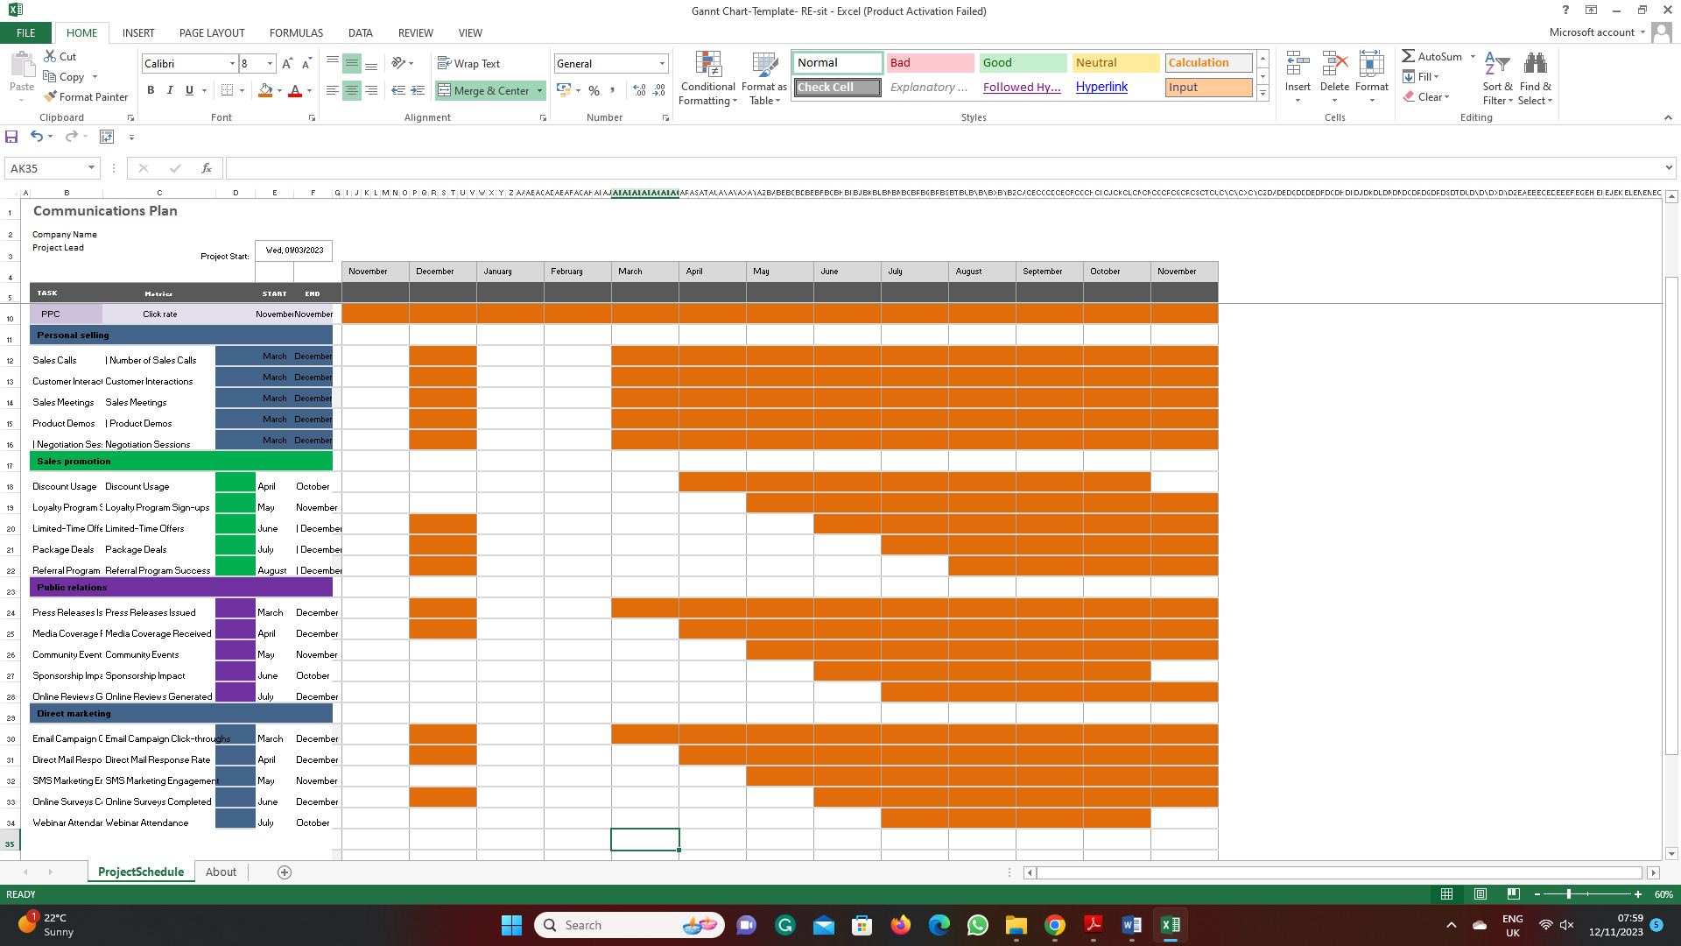
Figure 1: Action
Source: Author
The timeline for the various marketing channels is informed by the data obtained from market research, competition analysis, and performance analytics. These decisions on the behaviour of our customers, the peak engagement periods of our campaigns, and the results of previous campaigns (Cateora, 2022). Using data from SimilarWeb, the schedule corresponds to periods of high online activity. The insights provided by a Gantt chart provide a clear schedule for coordinating and carrying out timely channel executions. The plan for the Hilton East-Midland Airport Hotel can be optimised with the use of this analytical method by strategically timing and aligning marketing channels with project milestones.

Control
Acquisition of new customers, improvement in customer mood, and increased profits will all be used to evaluate success. Key performance indicators (KPIs) include customer acquisition rates, online sentiment analysis, and profit margins. The success of a marketing plan can be measured using these metrics. The objectives are to broaden the customer base, improve the image of the brand, and boost profits (Kotler, 2019). Tracking and enhancing these key performance indicators (KPIs) is essential to achieving success when it comes to the marketing plan for the Hilton East-Midland Airport Hotel.

Conclusion
Concerns regarding competitive dynamics, volatile market conditions, and consumers' perceptions of the brand need to be addressed in the marketing plan. It is advised that a transformation in the strategic value proposition, digital platforms as a means of reach, and targeted promotions be implemented. Collaboration, the enhancement of the marketing mix, and the modification of communication strategies based on analysis are all very significant. The success of the plan is dependent on careful monitoring, responsiveness to shifting market conditions, and satisfied customers. By taking these steps, the Hilton East-Midland Airport Hotel will be better equipped to maintain steady growth and maintain its competitive edge in the dynamic hospitality industry.

References
Bell, L. (2023). Best and worst UK hotel chains. [online] Which? Available at: https://www.which.co.uk/reviews/uk-hotel-chains/article/best-and-worst-uk-hotel-chains-aaVVF4u1jZpe [Accessed 11 Nov. 2023].
Brandler, H. (2023). Hilton unveils autumn menus with carbon labelling across UK hotels. [online] Business Traveller. Available at: https://www.businesstraveller.com/business-travel/2023/10/11/hilton-unveils-autumn-menus-with-carbon-labelling-across-uk-hotels/ [Accessed 12 Nov. 2023].
Cateora, P.R. (2022). International Marketing. New York: Mcgrawhill Education.
Çeti̇nH.A., Ultav, Z.T. and Uz, F. (2019). Reflections of the İstanbul Hilton Hotel on Mid-century Hotel Buildings in Turkey. Art-Sanat Dergisi, [online] (12), pp.57–88. Available at: https://dergipark.org.tr/en/pub/iuarts/issue/47471/598494.
Chang, Y.-C., Ku, C.-H. and Chen, C.-H. (2019). Social media analytics: Extracting and visualizing Hilton hotel ratings and reviews from TripAdvisor. International Journal of Information Management, 48, pp.263–279. doi:https://doi.org/10.1016/j.ijinfomgt.2017.11.001.
Igbinedion, D. (2023). These 10 Best Hilton Hotels In London For An Extraordinary Stay. [online] TheTravel. Available at: https://www.thetravel.com/hilton-london-hotels/ [Accessed 10 Nov. 2023].
Kim, C., Kang, H.J., Chung, K. and Choi, K. (2023). COVID-19 and Hotel Productivity Changes: An Empirical Analysis Using Malmquist Productivity Index. Service Science, 13(4), pp.243–257. doi:https://doi.org/10.1287/serv.2021.0283.
Kotler, P. (2019). Principles of marketing. 17th ed. Hoboken: Pearson Higher Education.
Ku, C.H., Chang, Y.C., Wang, Y., Chen, C.H. and Hsiao, S.H. (2019). Artificial Intelligence and Visual Analytics: A Deep-Learning Approach to Analyze Hotel Reviews & Responses. 52nd Annual Hawaii International Conference on System Sciences (HICSS). [online] Available at: https://eprints.ncl.ac.uk/251076.
Linxi, X. (2021). The Digital Transformation Strategy of Hilton During COVID-19. [online] www.atlantis-press.com. doi:https://doi.org/10.2991/aebmr.k.210917.050.
Ma, R. (2021). Human resource management in multinational companies from the perspective of Hilton Hotels. E3S Web of Conferences, [online] 235, p.02058. doi:https://doi.org/10.1051/e3sconf/202123502058.
Murray, J. (2023). Hilton extends menu carbon labelling to UK hotels. [online] www.businessgreen.com. Available at: https://www.businessgreen.com/news/4133278/hilton-extends-menu-carbon-labelling-uk-hotels [Accessed 8 Nov. 2023].
Reidhead, C. (2020). Impact of Organizational Culture on Employee Satisfaction: A Case of Hilton Hotel, United Kingdom. [online] papers.ssrn.com. Available at: https://papers.ssrn.com/sol3/papers.cfm?abstract_id=3563546.
Similarweb. (2023). hilton.com Traffic Analytics & Market Share | Similarweb. [online] Available at: https://www.similarweb.com/website/hilton.com/#overview [Accessed 9 Nov. 2023].
Wei, D. (2022). The Ratio Analysis for the Impact of COVID-19 Pandemic on the Hotel Industry: Evidence from Hilton. [online] Available at: https://www.clausiuspress.com/conferences/LNEMSS/WTED%202022/Y0903.pdf [Accessed 11 Nov. 2023].
Zeng, L. (2021). Analysis of Hilton Worldwide Hotel Group’s Transnational Operation Strategy. Academic Journal of Business & Management, [online] 3(11). doi:https://doi.org/10.25236/AJBM.2021.031104.

Appendices

SWOT Analysis
SWOT Analysis
Strengths | Reputable brand, Prime location, Established B2B relationships, and Quality amenities (Zeng, 2021).
Weaknesses | Potential operational inefficiencies, Limited room for expansion, Dependence on specific market segments, Seasonal demand fluctuations
Opportunities | Emerging travel trends, Technological advancements, Strategic partnerships, Market diversification
Threats | Intensifying competition, Economic downturns, Regulatory changes, Shifting consumer preferences (Wei, 2022).
Table 2: SWOT Analysis

PESTLE Analysis
PESTLE Analysis
Political | Government regulations, Tax policies, and Political stability (Reidhead, 2020).
Economic | Economic stability, Currency exchange rates, Inflation rates
Social | Demographic trends, Cultural influences
Technological | Technology integration, Innovations in hospitality
Legal | Regulatory compliance, Employment laws (Ma, 2021).
Environmental | Sustainability practices, Environmental impact
Table 3: PESTLE Analysis

Presentation
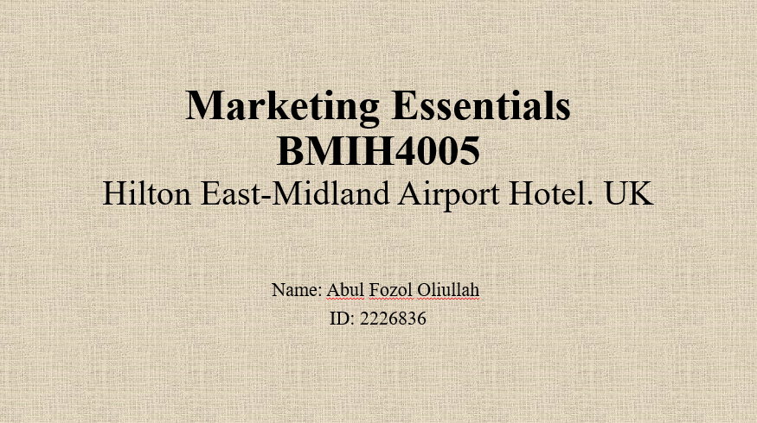
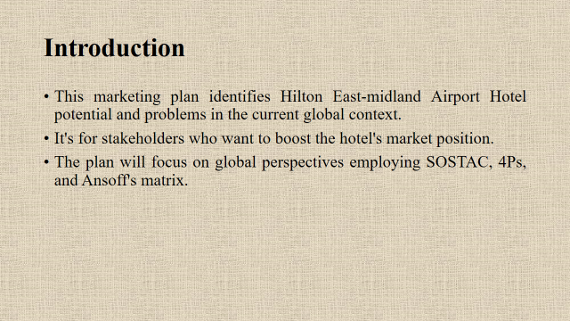
This marketing plan analyses the present global environment to determine the opportunities and challenges facing the Hilton East-Midland Airport Hotel. It is for the hotel's stakeholders who desire to improve the hotel's position in the market. The plan will place an emphasis on international viewpoints by making use of SOSTAC, the 4Ps, and Ansoff's grid.
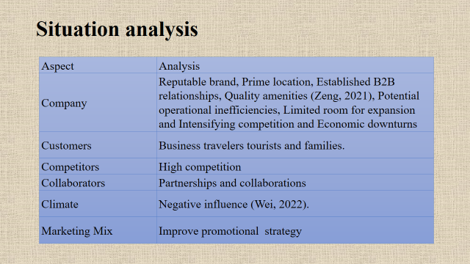
This extensive situational analysis underpins targeted and effective marketing. The Hilton East-midland Airport Hotel can strategically position itself in the dynamic hospitality industry by leveraging internal strengths, understanding customer nuances, navigating the competitive landscape, optimizing collaborations, and adapting to the broader market context (Wei, 2022).
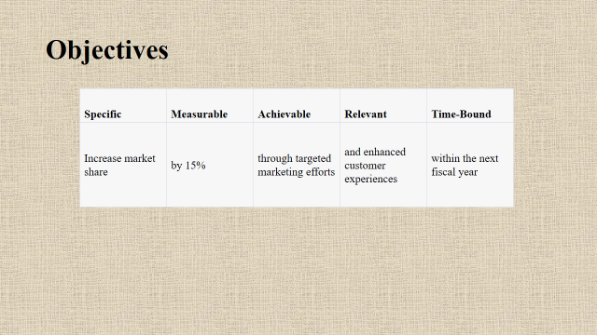
In the following table, the SMART marketing goal of the Hilton East-Midland Airport Hotel is broken down into components that are specific, attainable, relevant, and time-bound (Reidhead, 2020).
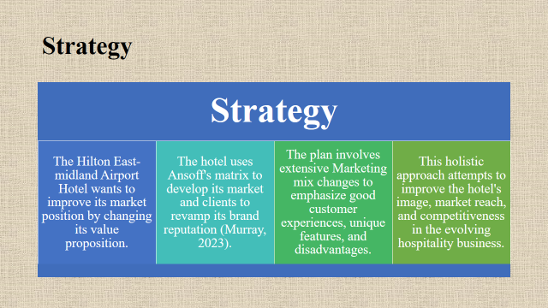
By altering its value proposition, the Hilton East-midland Airport Hotel hopes to strengthen its position in the market. The hotel revamps its brand reputation by utilizing Ansoff's matrix to develop its market and clientele. The strategy calls for significant adjustments to the marketing mix in order to highlight advantages, special features, and positive client experiences (Murray, 2023). This all-encompassing strategy aims to enhance the hotel's reputation, reach, and competitiveness in the dynamic hospitality industry.
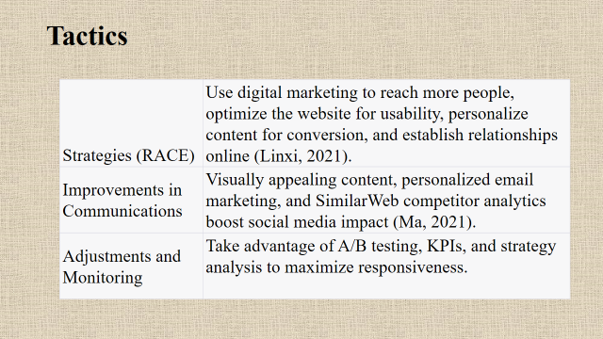
Employ digital marketing to expand your audience, improve the usability of your website, provide individualized content to increase conversions, and build online relationships (Ma, 2021). Enhance social media impact with aesthetically appealing content, customized email marketing, and SimilarWeb competitor statistics. To maximize responsiveness, make use of strategy analysis, KPIs, and A/B testing.
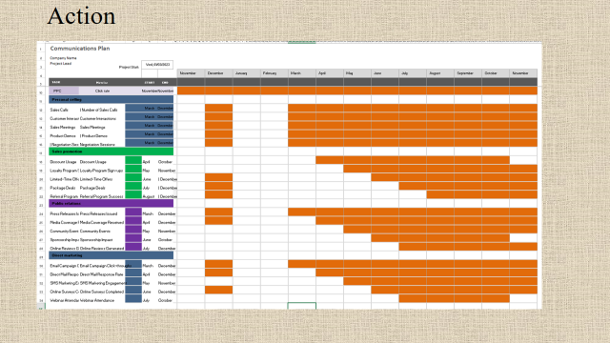
Gantt chart provides details about the communication plan.
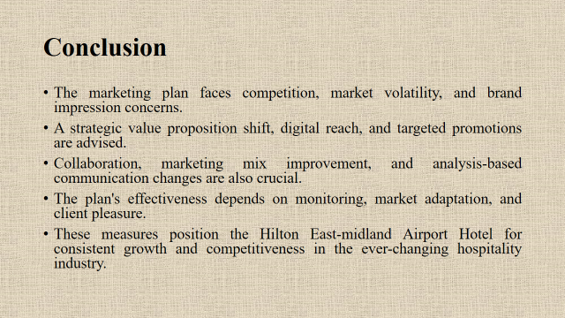
The marketing plan faces competitive dynamics, market volatility, and brand perception issues. A strategic value proposition shift, digital channels for reach, and targeted promotions are suggested. Collaborating, improving the marketing mix, and adjusting communication methods based on analysis are also important. Monitoring, adaptability to market changes, and customer satisfaction are key to the plan's success. These measures prepare the Hilton East-midland Airport Hotel for stable growth and competitiveness in the ever-changing hospitality business.


