Principles of OME assignment
Lucius Galloway

Introduction Pg 2
Secondary Explosive Properties- TNT Pg 2 - 3
Primary Explosive Properties- Lead Azide Pg 3 - 4
Detonation Transition Between Pg 4 - 5
Effects of confinement Pg 5
Possible Detonation Conditions Pg 5 - 6

Introduction
Firstly, this assignment will cover the properties of Lead Azide and TNT, such as ignition sources and energy released, as well as how the two explosives interact. Specifically, how a detonation transitions between the two and the conditions required to get them to do so.
Whilst there are many compounds that include TNT and many ways by which it can be manufactured, I will be specifically be using theoretical data for “Ideal” TNT for general properties and for critical diameter and density will be using data referring to pure TNT produced using pressing.
I was unable to find critical density or diameter values for Lead Azide (x) directly as density remains fairly constant and it is able to detonate even with extremely low diameters.

Secondary Explosive Properties
TNT (trinitrotoluene) was first discovered in 1863, and whilst it was initially used as a yellow dye by its inventor, Julius Wilbrand, upon discovery of its explosive properties and the beginning of manufacture in mass, it began to be used extensively, especially in munitions in both world wars where its high explosive yield, low sensitivity and the ability to cast it into shells made it a vital part of both sides war efforts., replacing Lyddite (Picric Acid), before itself being replaced, today most secondary explosives are RDX (Hexogen) based. (Krehl, 2009)
The key properties of TNT are:
Its theoretical maximum density (TMD) is 1.654 g/cm^3, and as getting the best effect for weight and volume is key to maximise the damage to a target and the range at which the target can be hit It compares relatively favourably with Picric Acid, with a similar density of 1.767 g/cm^3, whilst RDX is notable denser at 1.818 g/cm^3. Whilst increasing density of TNT typically increases velocity of detonation, TNT becomes less effective and less sensitive as it approaches TMD however it is still able to detonate, meaning it cannot be effectively dead pressed. (Koch, 2021) (Mohammed Almuntaga Ahmed, 2020)
Its critical density is about 0.22 g/cm^3 (the lowest density of TNT that is still capable of successful detonation), which is important for ensuring that TNT used will have the desired effect, ensuring there is no wastage and reducing the risks of faulty or ineffective ordinance, munitions and explosives. (Koch, 2021) (Alfred m.Anzalone, 1955) (Price, 1981)
The heat of products of detonation is -4.653 kJ/g. This is the amount of heat energy released by a successful detonation and is a significant factor in the velocity of detonation as well as the thermal damage and risks of chain reaction to other explosives. RDX, is significantly higher at -5.783 kJ/g, and Picric Acid is slightly lower at 4.542 kJ/g. Whilst TNT has a higher heat of products of detonation than Picric Acid by weight, its lower density means that it is less effective by volume, while RDX is notably better in both regards, being more effective by weight and volume. (Koch, 2021) (Mohammed Almuntaga Ahmed, 2020)
A critical diameter of 13mm at 1.62g/cm^3 density. (the lowest diameter of a sphere of TNT that can still undergo successful detonation) this is a very important piece of data, especially as it acts as a limiting factor for the minimum size of a shell or explosive device using TNT. (Koch, 2021)
The Standard initiating conditions for TNT are 15J by Impact and 360N by Friction, this is one of the most beneficial properties of TNT over previous explosives, its much lower susceptibility to impact ignition, Picric acid (Lyddite) is 7J and 355N, and while the small increase In needed friction isn’t a notable improvement, TNT being twice as difficult to detonate via impact made it a much safer material to use, resulting in less accidents and reducing the precautions needed that would slow down or make production more expensive in early 20th century war economies. RDX, which is widely in use today, instead has initiation conditions of 7.5j and 120N, significantly worse than TNT in both regards, which Is partially why RDX based explosives are more common than pure RDX, whereas with TNT pure TNT was seen as the better choice when possible. (Koch, 2021)
A melting point of 80.8 degrees Celsius, this low melting point makes casting an easy, quick and cheap way to fill shell casings, a major advantage for mass production. (Koch, 2021)
The velocity of detonation is 7290 m/s at 1.65 g/cm^3 and is one of the most important performance characteristics for an explosive, with a direct correlation to the shock wave and the resultant damage and lethality. Picric Acid is slightly higher at 7680 m/s at 1.76 g/cm^-3, again showing how the pure power was not the deciding factor for the swap from Lyddite to TNT. RDX on the other hand has a notably higher velocity of detonation at 8428 m/s at 1.70 g/cm^-3. (Koch, 2021)
In summary TNT was a very commonly used explosive for a reason, it could be safely and cheaply produced and used in large quantities, due to high friction and impact forces for detonation, whilst having comparable effectiveness with other explosives of its time, though as the use of more complex mixes of different explosives to take advantage of the properties of each has become more common, other explosives like RDX became the dominant base, due to its higher power. (Koch, 2021)
Primary Explosive Properties
Lead azide is a primary explosive, primary explosives are more powerful than secondary explosives like TNT, but are much more sensitive and thus require significantly more care to manufacture, transport and operate. (Koch, 2021)
Lead azide was first invented in 1891and began early production by 1907 and by the end of ww1 many countries had began to consider transitioning to using lead azide in detonators, however its lead based nature made it difficult to manufacture or handle, leading to the development of diluted forms of lead azide such as by phlegmatizing it with Dextrin to improve handling safety, though this is less dense. (Koch, 2021) (Trotsuk AV, 2011)
Despite many attempts and much research leads azide is still used widely, with efforts to produce affordable and safe alternatives a continuous process, though silver azide’s use as an alternative has increased. (Koch, 2021)
The key properties of Lead Azide are:
The theoretical max density of Lead Azide is 4.716 g/cm^3 and most lead azide is produced with densities between 4.68 and 4.716 g/cm^3. Silver Azide for comparison has a density of 5.1 g/cm^3. (Koch, 2021)
Getting reliable values for the critical density of Lead Azide is very difficult, as it can detonate even with very small amounts, however the lowest value I could find evidence for was a computer model calculation that went as low as 1.5 g/cm^3 and predicted a detonation, notably both Silver and Lead azide cannot be dead-pressed. (Koch, 2021) (Trotsuk AV, 2011)
The heat of products of detonation is -1.638 kJ/g. this relatively high value is a key part of lead azide’s usefulness as a primary explosive as it can thus consistently act as an ignition source for even less sensitive secondary explosives. (Koch, 2021)
Getting reliable values for the critical diameter of Lead Azide is very difficult, as it can detonate even with very small amounts, however some evidence suggests successful detonation can occur with as little as 2mm diameter. (Koch, 2021)
The initiation conditions for Lead Azide are similarly difficult due to the low values involved, however Is around 0.5-4j and 0.3-0.5N, numbers that when compared to TNT demonstrate an exceptionally higher sensitivity. Notably Silver azide has similar impact sensitivity as lead azide at about 1-4j and similarly low friction sensitivity. (Koch, 2021)
The velocity of detonation however is 3880 m/s at 2 g/cm^3 and can reach up to about 6000 m/s, very powerful but notably weaker than TNT and such a range of values helps allow for charges to be as low as they can while still initiating the larger secondary charges. Silver azide is very similar, with 3830 m/s at 2 g/cm^3. (Koch, 2021)
Considering these it becomes apparent that both lead azide and silver azide have very similar properties, yet ultimately we use lead azide more despite its relative toxicity, this is because of the use of Tetracene as a way to further sensitise primary explosives, which it can do for lead azide, but is not compatible with silver azide. (Koch, 2021)

Detonation Transition Between
For a detonation to successfully transition from the primary explosive to the secondary explosive the primary explosive must firstly be able to detonate itself, secondly the secondary explosive must also have met its critical values to itself detonate, thirdly the primary explosive must meet at least one of the initiation conditions of the secondary explosive.
The primary way by which a subsequent detonation on an explosive train occurs is via impact, as the shockwave from the primary explosive moves through the secondary explosive, forcing the crystals together and creating hot spots and a subsequent detonation. (Trotsuk AV, 2011) (Alfred m.Anzalone, 1955)
For this example, Lead azide is initiated by burning oil at a minimum of 350 degrees C detonating a minimum of 0.7g of lead azide, which in turn detonates adjacent TNT with a diameter of a minimum of 13mm when unconfined. (Koch, 2021)
Effects of confinement
The detonation of an explosive produces a reaction front, were the velocity of detonation occurs, there is a direct causal link between the rate velocity of detonation and the pressure of the resultant shockwave with the same explosive, given that the shockwave is typically the primary cause of damage produced by an explosive and that a high velocity must be reached for the transition from deflagration to detonation to occur, velocity of detonation is one of the most important properties of an explosive. (Koch, 2021)
As an explosive detonates, the shockwave moves out in all directions, however when it meets resistance, either from self-confinement by interference by the detonation of adjacent explosive material, or external confinement by a casing or shell, some of the shockwave is reflected and gas cannot as easily escape, this reflection and the constructive interference with he original shock wave along the reaction zone increase the velocity of detonation. (Koch, 2021) (Krehl, 2009)
Because of this confinement is a powerful tool, used in nearly all explosives as a way to maximise the effectiveness and minimise the material and space needed. (Koch, 2021)

Possible Detonation Conditions
The densities and diameters that can allow for a successful detonation ultimately require a velocity greater than the speed of sound through TNT. Below is a graph of the densities and diameters that can achieve detonation for a confined sample of TNT.
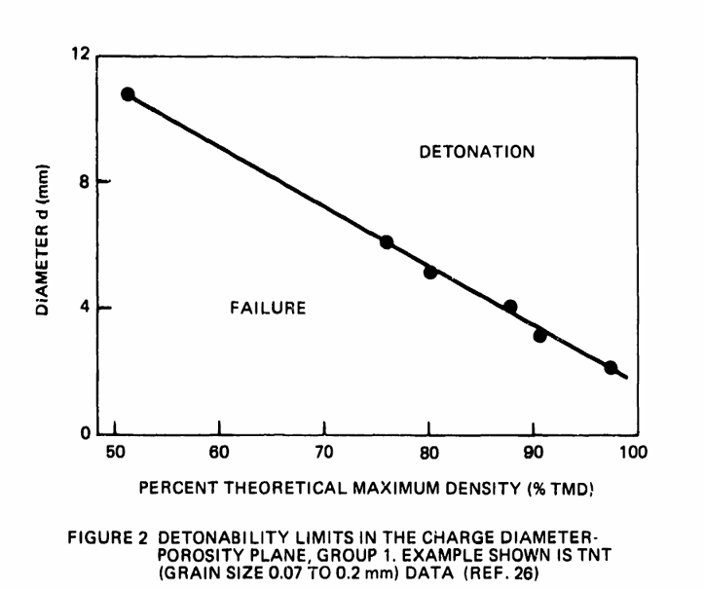

Here we can see the relationship between diameter and fraction theoretical maximum density, notably the critical diameter is significantly lower, due to the confined nature of these charges, demonstrating a clear benefit. (Price, 1981)
And below this a variety of values for successful detonation for unconfined TNT produced with different methods.
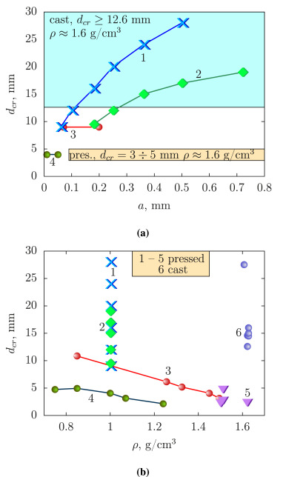
This consist of (b) the densities and diameters of successful detonations for cast tnt and tnt pressed to either a set density (1 and 2) or tnt with different structure (3 and 4) or for high density TNT (5). (Mohammed Almuntaga Ahmed, 2020)
A on the other hand shows the length of charge needed for different densities and critical diameters.
The detonation, dependant on whether confined or not and the density of the charge, can occur at speeds between 6740 and 7380, though I was unable to find a table of data or graph to show the relationship between them directly.

