2020

The Importance of Employee Engagement in a Company
university trinity saint david london

human resources management (lcmb7000)

student: ionela madalina saiz - 1605699
lecturer: dr. Gladius kulothungan

Table of Contents
Introduction 2
Best Business Practices to Increase Employee Engagement 3
Management Practices for Adding Business Value 5
Theoretical underpinnings 8
Conclusion 12
References 13

Introduction
Proactive employee engagement can play a significant role in terms of increasing and organisational services effectiveness in the current competitive market to a large extent. However, the present report will pay attention to critically evaluate the prospects of increasing employee engagement within a Vietnam based hats and caps manufacturing company namely Hanoi Hat. In this concern, the report will shed light on contemporary reward practices in terms of enlarging employee engagement aspects in the company. Moreover, the report will also include the process of pursuing reward practices by the general manager in order to add a fair business value. Apparently, a theoretical consideration will also be provided in this context with reference to the circumstances.

Best Business Practices to Increase Employee Engagement
Employee engagement is considered as the intensity of the duration when the employees feel more dedicated and passionate regarding their jobs and commitments towards the organisation by providing immense effort in their work. It is also considered as an emotional connection between the employees towards their organisation which tends to affect their level of behaviour and efforts in the activities related to the work (Singh et al., 2016). It is mainly considered as an approach for developing the environment of the workplace in which employees care about their own work which can easily engage them. Employee engagement is very important in the Hanoi Hat Company as it goes beyond games activities and events. The process of engaging the employees drives their performance. The engaged employees stay busy with the overall company by understanding the main goal and the way of achieving it. Along with this, it is also helpful for making better decisions (Jha and Kumar, 2016). Therefore, some of the contemporary reward practices for the Hanoi Hat Company that could be introduced into the business with the aim of increasing employee engagement are as follows:
Employee productivity - productive employees provide more rather than taking. Therefore, the manager of this particular organisation understands the objectives of the business in a proper way by participating in the affairs of the organisation with hard work and appropriate contribution for the best outcome of the business (Kang and Sung, 2017). In order to get more productivity, it is needed for the organisation to provide a healthy workplace to the employees with proper cultural management and appropriate satisfaction as per the employees. This helps to develop the passion of the employees regarding their work and it provides more productivity. However, better productivity can also help to satisfy the demands of the customer and helps to gain more profit for the Hanoi Hat Company.
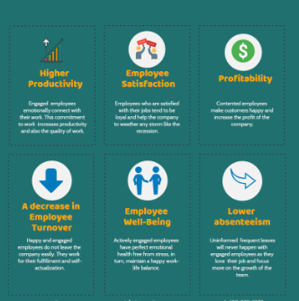
Figure 1: Other contemporary rewards for increasing employee engagement
(source: Popli and Rizvi, 2016)
Improving the condition of the workplace - In order to improve the condition of the workplace for the engagement of the employees, it is needed for team management to improve the ambience of the workplace, teamwork management, internal communication with proper respect to the members and a healthy relationship among each other. Therefore, all these aspects help to drive engagement and productivity in the Hanoi Hat Company if it is maintained. In the case of improving the condition of the workplace, it is needed for the management to arrange a platform for better communication by maintaining a better culture in the workplace (Albrecht et al., 2018). Apart from this, it is also needed for the organisation to arrange some activities and practices for the employees which can help to maintain a better relationship among the members of the company. On the other hand, the practice of using better risk management tools can also improve the condition of the workplace by alerting before the occurrence of any kind of issue.
Establishing a better future vision - The employers look to provide the employees with better meaning regarding the work which can develop a transparent vision for future work. However, 77% of the employees accepted that it was important to maintain the job engagement and satisfaction for understanding the mission and the vision of the company according to the survey in the Society for Human Resource Management’s annual Employee Job Satisfaction and Engagement survey. The employees mainly get motivated and inspired when the leader communicates about the vision properly in a clear way (Popli and Rizvi, 2016). In the Hanoi Hat Company, it is needed to maintain the practice of HR by the experts for deploying the onboarding software for communicating regarding the vision to the employees.
Employee motivation - the motivation of the employees is considered as the most essential aspect of engagement. Therefore, motivated employees perform in a better way and provide more productivity for the Hanoi Hat Company. The employees who are motivated become more committed to the objectives and goals of the company. This can help the Hanoi Hat Company to raise its productivity by allowing the company to achieve its output in higher-level (Osborne and Hammoud, 2017). This practice can be very effective for this Hat Company. However, the motivation of the employees can easily be developed with positive communications in the working area by rewarding them for this thing. It is also needed for the manager of this company to look after whether the employees are getting demotivated for any reasons
Understanding the attitude of the employees - the workplace mainly consists of diversifying the set of minds which helps to complete the task of the employees. Therefore, it is the responsibility of the manager to have a better knowledge regarding the aspects and delegating the works to the employees on the basis of their core interest and strength. It is also required for the managers to make the environment flexible so that the employees can work independently in their own way (Stoyanova and Iliev, 2017). However, this activity can be practised in the Hanoi Hat Company which helps in changing the behaviour and the attitude of the employees which can provide better employee engagement and productivity to the organisation.

Management Practices to Add Business Value
The General manager is right about her idea that appointing a specialist HR will mitigate the present issues faced by Hanoi Hat. The traditional human resource policy of this company was paying a higher level of wages to the employees (Kaur and Singla, 2019). However, these policies had limited applications due to its lack of dynamite and flexibility. In this context, the General manager can point out to her lion managers that a specialist HR will be able to understand the exact kind of reward mechanisms that will motivate the employees while ensuring higher profits for the company (Besieux et al., 2018). Along with this, the General Manager can also detail the following importance of reward mechanisms to her line managers:
Increase in productivity
The reward mechanism is said to increase the productivity of the employees. A recent study has shown that factors such as stress, lack of dignity, poor working relationships, unhappiness can reduce the productivity of the employees (Eisenberger et al., 2016). The General Manager can point out that over 21% of the employees are demotivated in the workplace and this hampers their productivity. On the other hand, reward mechanisms motivate employees to enhance their skill sets and to enter into a healthy competition with other employees. The General manager can also detail that employees like to be rewarded and appreciated. It has been found that approximately 69% of the employees are wanting to give their best in the workplace if they are properly appreciated (Barik and Kochar, 2017). Thus, having an appropriate employee engagement system is a necessity for Hanoi Hat if it wants to enhance the productivity of the employees.
Motivates employees
The General Manager can brief the line managers regarding the present situation of Hanoi Hat. The motivation level of the employees has reduced to a great extent due to the recent changes in their organizational operation. Beforehand, the employees used to earn higher incentive on a piece-rate system as they were producing similar kinds of products. However, recent contracts with international companies have resulted in lesser production and lesser wages (Antony, 2018). Thus, the General manager needs to point out that the employees are resisting change which is ultimately having a negative impact on their motivation. Along with this, she can also show recent studies which have shown a direct relationship between employee rewarding systems and employee motivation which then leads to more productivity and lower employee turnover. Effective rewarding systems provide guidance to the employees to track their own performance and to improve the same (Mohda et al., 2016). Thus, having a reward system will definitely be the ultimate solution to increase employee motivation and easier employee management in Hanoi Hat.
Enhances teamwork and cooperation
The General manager needs to showcase the results of numerous surveys and studies that have suggested that teamwork and cooperation is necessary for the success of the organization. A recent survey has shown that over 71% of the executives think that employee engagement is necessary for the overall development of the organization (Osborne and Hammoud, 2017). In this respect, motivating the employees through an effective rewarding system will lead to enhanced teamwork and cooperation. Numerous studies have shown that employee motivation creates a certain kind of shared mentality among the employees whereby they can get access to shared knowledge and experience to drive their personal and professional growth. Moreover, the General Manager should also detail that a reward mechanism is often time backed by a performance measurement and management system. This system tracks the employee performance, the level of conflict, level of cooperation and many other things to ascertain the rewards to be given to these employees (Weerasooriya and Alwis, 2017). Thus, the General manager can aptly point out that the reward system is also necessary for Hanoi Hat to improve team spirit, team cooperation and to reduce conflict within the organization.
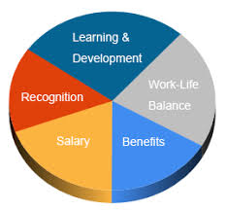
Figure 2: Reward Mechanism for Employees
(Source: Chandani et al., 2016)
Attracting top talents
Hanoi Hat is expanding its business by entering into contracts with other international companies. However, in order to maintain its competitive advantage and to increase customer base, this company needs to attract more talented employees. In this context, the General manager of this company can showcase the importance of the reward system in attracting talented employees (Chandani et al., 2016). She can highlight that having a transparent and fair employee rewarding system will increase employee satisfaction which will get reflected in the productivity of the employees. This factor alone will influence other employees to join this company. Moreover, having an effective rewarding system will also reduce employee turnover in the company (Wamweru and Makokha, 2018). Thus, it will not only enable the company to retain its existing talents, it will also help it to attract the best talents in the world.
Long term effectiveness
Employee motivation and employee productivity is directly related to long term effectiveness of the organisation. The General Manager of Hanoi Hat should identify that having a reward mechanism will influence the employees to have a positive long-term outlook towards the future. It will give them the confidence and assurance to improve their skill sets and to provide their best in the workplace (Akingbola and van den Berg, 2019). Moreover, the General manager can also explain to the line managers that the reward system is necessary to create a healthy and productive working environment. This factor alone will improve the overall brand image of Hanoi Hat in front of its clients and other stakeholders.

Theoretical underpinnings
Theory of employee engagement
This theory was invented by William Kahn. According to the theoretical consideration, employee engagement is defined as the ability of employees in terms of harnessing their full self at work (Kwon and Park, 2019). In this context three physiological conditions can be identified which are defined below-
- Meaningfulness
- Safety
- Availability
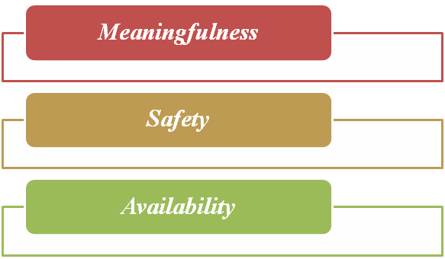
Figure 3: Employee engagement theory
(Source: Rothmann, 2017)
Meaningfulness
Hanoi Hat has been serving in the Vietnam market with a simple structure and sophisticated human resource management system where the administration office was responsible in order to deal with the issues with recruitment, dismissal and pay. Moreover, the employees were paid on a piece-rate basis along with developing their internal skills for producing indefinite numbers of basic models (case context). Due to this reason, good wages were earned by their employees. In this context, the meaningfulness of the organisational operations very selected to be satisfied as the employees and cutters paid full attention to engage themselves by harnessing their full self at work.
Safety
The second condition reflects on the safety prospects (Pukkeeree et al., 2020). In the case of Hanoi Hat, the organisational employees were notified to stay in a safe workplace atmosphere where the recruitment related issues, dismissal and others were dealt with by the administration office. Apart from that the personal problems were also dealt with by the line manager of the employees. As a result of this, it can be stated tHat the company had initiated to provide a safe atmosphere for their employees based on which they might be able to bring their full self to the work by avoiding the negative consequences.
Availability
The third condition reflects on the concept of availability in which the employees feel mentally and physically able to harness their full self (Rothmann, 2017). In this concern Hanoi Hat is notified to be contracted by an international sportswear company for producing short runs of special models for specific events such as the South East Asian games. As a result of this, the company had initiated to enlarge its financial feasibility as this contract was highly profitable for the company. In this concern, the cutters also developed their skills of producing each order. Moreover, training was provided to the employees in terms of cutting down the production rate. Due to this reason, the employees were earning less. This factor leads to considerable dissatisfaction among the employees despite having comparable opportunities from the external labour market. In this context, the employee satisfaction and engagement aspects are noted to be down falling which might be upgraded by providing specific reward practices.

The two-factor theory of Frederick Herzberg
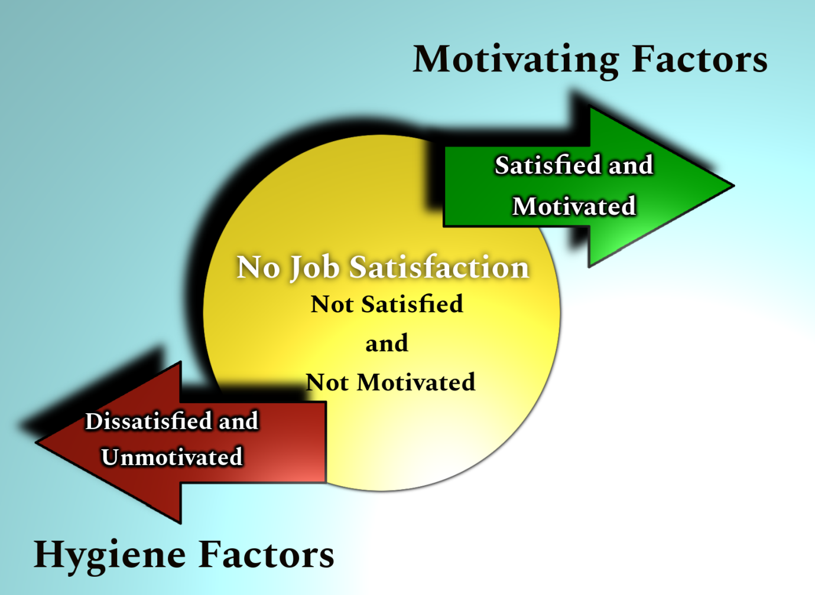
Figure 4: Two-factor theory
(Source: Alshmemri et al., 2017)
According to the theoretical concern, a couple of factors should be preferred in order to increase employee motivation and engagement towards organisational operations including hygiene factors and motivating factors. That theory defines high hygiene and high motivation aspects to an organisational employee in order to increase their engagement towards the company operations (Sanjeev and Surya, 2016). In the case of Hanoi Hat, the company was notified to provide a decent workplace environment by securing relational operational issues and other personal problems with the engagement of the administration office and employees line manager (case study). From this viewpoint a high hygiene workplace environment can be noted.
On the other hand, the requirement of training for developing different skills for producing each order designed differently results in a reduced production rate for Hanoi Hat (case study). This factor also conceptualized less earning for the employees which acted against their motivation and led to considerable dissatisfaction. In this context low motivation was seen among the employees of Hanoi Hat. Hence the company is recommended to apply reward practices in order to achieve both high hygiene and high motivation in their employees.

Conclusion
Based on the overall report it can be notified that Hanoi Hat should pay attention to conceptualize increasing employee motivation and teamwork in order to increase their production rate. Moreover, they can also choose the option of contemporary reward practices in order to enlarge proactive employee engagement aspects within their operations. Apparently, the company was also noted to provide a hygiene workplace environment by considering the responsibility of handling issues by the administrators and line manager of the employees. With this factor, Hanoi Hat management will have to focus on mitigating considerable dissatisfaction among the employees due to earning less for requiring training behind each order as contracted by the international sportswear company. Two different theoretical considerations are also provided in this report according to which the employee engagement aspects can be enlarged by the company along with increasing the employee motivation level. as a result of this long-term effect might be achieved by the company in the current market.

References
Akhtar, A., Nawaz, M.K., Mahmood, Z. and Shahid, M.S., 2016. Impact of high performance work practices on employees' performance in Pakistan: Mediating role of employee engagement. Pakistan Journal of Commerce and Social Sciences (PJCSS), 10(3), pp.708-724.
Akingbola, K. and van den Berg, H.A., 2019. Antecedents, consequences, and context of employee engagement in nonprofit organizations. Review of Public Personnel Administration, 39(1), pp.46-74.
Albrecht, S., Breidahl, E. and Marty, A., 2018. Organizational resources, organizational engagement climate, and employee engagement. Career Development International.
Alshmmari, M., Shahwan-Akl, L. and Maude, P., 2017. Herzberg’s two-factor theory. Life Science Journal, 14(5), pp.12-16.
Antony, M.R., 2018. Paradigm shift in employee engagement–A critical analysis on the drivers of employee engagement. International Journal of Information, Business and Management, 10(2), pp.32-46.
Barik, S. and Kochar, A., 2017. Antecedents and consequences of employee engagement: A literature review. International Journal of Latest Technology in Engineering, Management & Applied Science, 6(4), pp.33-38.
Besieux, T., Baillien, E., Verbeke, A.L. and Euwema, M.C., 2018. What goes around comes around: The mediation of corporate social responsibility in the relationship between transformational leadership and employee engagement. Economic and Industrial Democracy, 39(2), pp.249-271.
Chandani, A., Mehta, M., Mall, A. and Khokhar, V., 2016. Employee engagement: A review paper on factors affecting employee engagement. Indian Journal of Science and Technology, 9(15), pp.1-7.
Eisenberger, R., Malone, G.P. and Presson, W.D., 2016. Optimizing perceived organizational support to enhance employee engagement. Society for Human Resource Management and Society for Industrial and Organizational Psychology, 2, p.22.
Jha, B. and Kumar, A., 2016. Employee engagement: A strategic tool to enhance performance. DAWN: Journal for Contemporary Research in Management, 3(2), pp.21-29.
Kang, M. and Sung, M., 2017. How symmetrical employee communication leads to employee engagement and positive employee communication behaviors. Journal of Communication Management.
Kaur, R. and Singla, D., 2019. INTERDEPENDENCE OF PERFORMANCE MANAGEMENT SYSTEM AND EMPLOYEE ENGAGEMENT. PIMT, p.96.
Kwon, K. and Park, J., 2019. The life cycle of employee engagement theory in HRD research. Advances in Developing Human Resources, 21(3), pp.352-370.
Madhani, P.M., 2020. Effective Rewards and Recognition Strategy: Enhancing Employee Engagement, Customer Retention and Company Performance. The Journal of Total Rewards, 29(2), pp.39-48.
Menguc, B., Auh, S., Yeniaras, V. and Katsikeas, C.S., 2017. The role of climate: implications for service employee engagement and customer service performance. Journal of the Academy of Marketing Science, 45(3), pp.428-451.
Mohda, I.H., Shaha, M.M. and Zailana, N.S., 2016, September. How work environment affects the employee engagement in a telecommunication company. In 3rd International Conference on Business and Economics, 21-23 September.
Osborne, S. and Hammoud, M.S., 2017. Effective employee engagement in the workplace. International Journal of Applied Management and Technology, 16(1), p.4.
Osborne, S. and Hammoud, M.S., 2017. Effective employee engagement in the workplace. International Journal of Applied Management and Technology, 16(1), p.4.
Popli, S. and Rizvi, I.A., 2016. Drivers of employee engagement: The role of leadership style. Global Business Review, 17(4), pp.965-979.
Pukkeeree, P., Na-Nan, K. and Wongsuwan, N., 2020. Effect of attainment value and positive thinking as moderators of employee engagement and innovative work behaviour. Journal of Open Innovation: Technology, Market, and Complexity, 6(3), p.69.
Rothmann, S., 2017. Employee engagement. The Wiley Blackwell handbook of the psychology of positivity and strengths-based approaches at work, pp.317-341.
Sanjeev, M.A. and Surya, A.V., 2016. Two factor theory of motivation and satisfaction: An empirical verification. Annals of Data Science, 3(2), pp.155-173.
Singh, S.K., Burgess, T.F., Heap, J. and Al Mehrzi, N., 2016. Competing through employee engagement: a proposed framework. International Journal of Productivity and Performance Management.
Stoyanova, T. and Iliev, I., 2017. Employee engagement factor for organizational excellence. International Journal of Business and Economic Sciences Applied Research (IJBESAR), 10(1), pp.23-29.
Vuong, B. and Sid, S., 2020. The impact of human resource management practices on employee engagement and moderating role of gender and marital status: An evidence from the Vietnamese banking industry. Management Science Letters, 10(7), pp.1633-1648.
Wamweru, T.J. and Makokha, S., 2018. Relationship between total reward management systems and employee engagement: a case study of Bamburi cement limited, Kenya. Journal of Human Resource and Leadership, 3(1), pp.29-51.
Weerasooriyan, N.W.M.R. and Alwis, A.C.D., 2017. Impact of employee engagement on lean manufacturing: An empirical study in Sri Lanka. FIIB Business Review, 6(2), pp.33-42.

