Floriculture in Biophilic Design

Research Methods & Communication
M7X02233

Zara James
P150964

Image List
Figure list
Figure 1 - King, C., 2018. Jungle Of Love. [image] Available at: <https://www.hearthomemag.co.uk/blog/jungle-of-love-extract-from-wonder-plants-2> [Accessed 11 January 2021].

Figure 2 - King, C., 2019. [image] Available at: <https://deardesigner.co.uk/6-ways-to-introduce-summer-into-the-bedroom/> [Accessed 11 January 2021].

Figure 3 - Oliver Heath. 2020. DIY SOS – Biophilic Design Case Study - Oliver Heath. [online] Available at: <https://www.oliverheath.com/portfolio-item/diy-sos-biophilic-design-case-study/> [Accessed 20 December 2020].

Figure 4 - Toa.st. 2020. In The Studio With Artist Lucy Augé. [online] Available at: <https://www.toa.st/magazine/in-the-studio-with-artist-lucy-aug.htm> [Accessed 11 January 2021].

Figure 5 –Orangebox.com. 2020. Welcome To Orangebox. [online] Available at: <https://www.orangebox.com/products/woods> [Accessed 11 January 2021].

Figure 6 - LinkedIN. 2020. Orangebox. [online] Available at: <https://www.linkedin.com/company/orangebox/> [Accessed 11 January 2021].

Floriculture is ‘the cultivation of flowers or flowering plants, especially for ornamental purposes.’ (Dictionary.com, 2020) My love for painting and designing with florals has come from my creative upbringing. Both my parents in their own ways have influenced me and the way I design. My Dad is a very creative person and has always pushed me to work hard. Since I was old enough, I have been working at my family run Garden Centre, this is where my love for florals and botanicals started and still continues to grow. My Mum has also played a huge part in inspiring me through her interior design business and shop. I can sit and look for hours through fabric books and swatches and nagging for cut offs, to stick into sketchbooks. She creates beautiful environments in other people’s homes and mine. Whilst writing this report, I have realised just how much my parents have inspired me and also annoyingly how much I am like them both. I want to create inviting and homely spaces like my Mum does by using the imagery of plants that my Dad has grown and taught me about. I want to discover how biophilia in our homes can change and help our mental health. This year we have spent more time at home, and I feel more than ever we need peace and happiness in our homes.

‘The word ‘biophilia’ literally means ‘love of life’ (Coulthard and Bratby, n.d.) In Sally Coulthard’s book Biophilia: You & Nature & Home, she talks about the benefits of biophilic designs and why nature is good for us. ‘Modern Society, where most people live in densely populated, urban surroundings, is separating us increasingly from any meaningful contact with nature… The answer is that we have discovered that there is a direct link between nature and wellbeing.’ (Coulthard and Bratby, n.d.) Oliver Heath has the same opinion ‘Oliver firmly believes that biophilic design has the ability to change lives. 'It can shift our emotions and our physical and emotional states.’’ (Oliver Heath on the plants that will bring maximum health & wellbeing benefits, 2020) This idea of bringing the outdoors in is becoming very popular as an interior design trend. Below are some examples of how house plants and botanical inspired patterns are becoming very popular. My plan for my creative venture is to design wallpapers and fabrics for interiors that will have the benefits that Heath talks about in the home. I want my designs to make the bedroom feel relaxing and serene and the office a productive and happy space. With everything going on in the world at the moment, I want to focus on designing for homes. The pandemic has changed our lives in many ways, but the biggest being how much time we spend at home. Our work lives and even our social lives have all been at home and we need our homes to adapt to these changes. We are all yearning for simplicity, people and the outdoors.

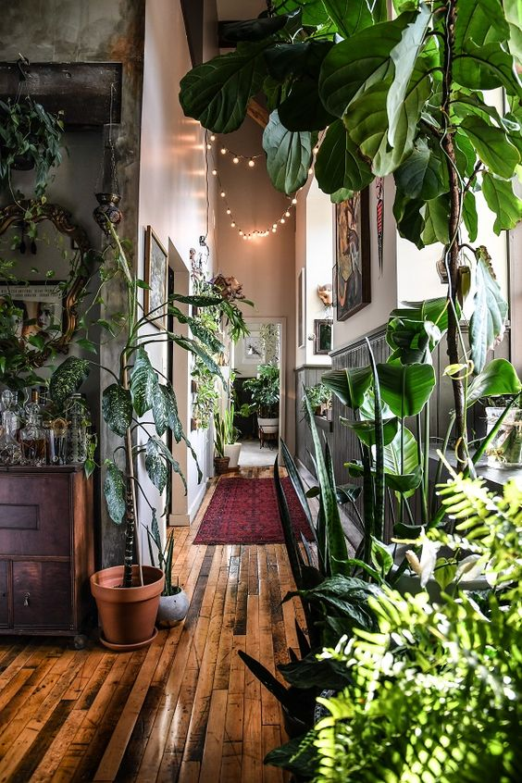
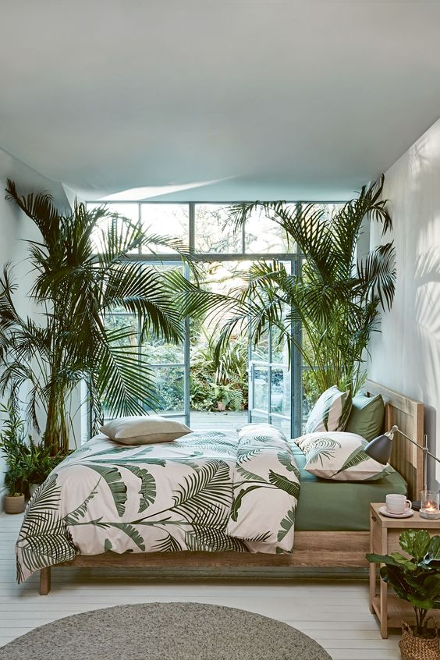
Figure 1. (King, 2018) Figure 2. (King, 2019)

Why does nature have these effects on us? Humans have interacted with nature throughout history whilst gaining basic physical and emotional needs from the environment, which are important to their survival wellness and well-being. Plants literally filter the air that we breath and bringing these into our home can improve the air quality making us healthier people. ‘One famous NASA experiment, published in 1989, found that indoor plants can scrub the air of cancer-causing volatile organic compounds like formaldehyde and benzene.’ (You Asked: Can Indoor Plants Really Purify the Air?, 2018)

Nature would provide security from predators and bad weather and produce the food and water they needed to survive. (Orians & Heerwagen, 1992). We have always relied on nature and its resources. As humans we are designed to be around it, and therefore the positive effects that nature gives us are imbedded deep within our DNA.

Bringing live plants into the home is good for us as they literally filter the air that we breathe. But how can a floral wallpaper or a fake plant have similar effects on us as well? Coulthard states that faking it doesn’t always work. But I disagree. I think that a floral or botanical wallpaper, patterned cushion or even a patterned dish can have the same well-being and calming effects that real plants can have. Oliver Heath did a case study in partnership with DIY SOS for the Finley family. The idea was to help the mother of the house, become more comfortable and happier they did this by using biophilic design in her home. ‘Floral patterned wallpaper was used – flowers are an evolutionary indicator of fruit and nutrition – and the unique Urban Retreat carpet floor tiles by Interface add to the input of natural images and textures.’ (DIY SOS – Biophilic Design case study - Oliver Heath, 2020)
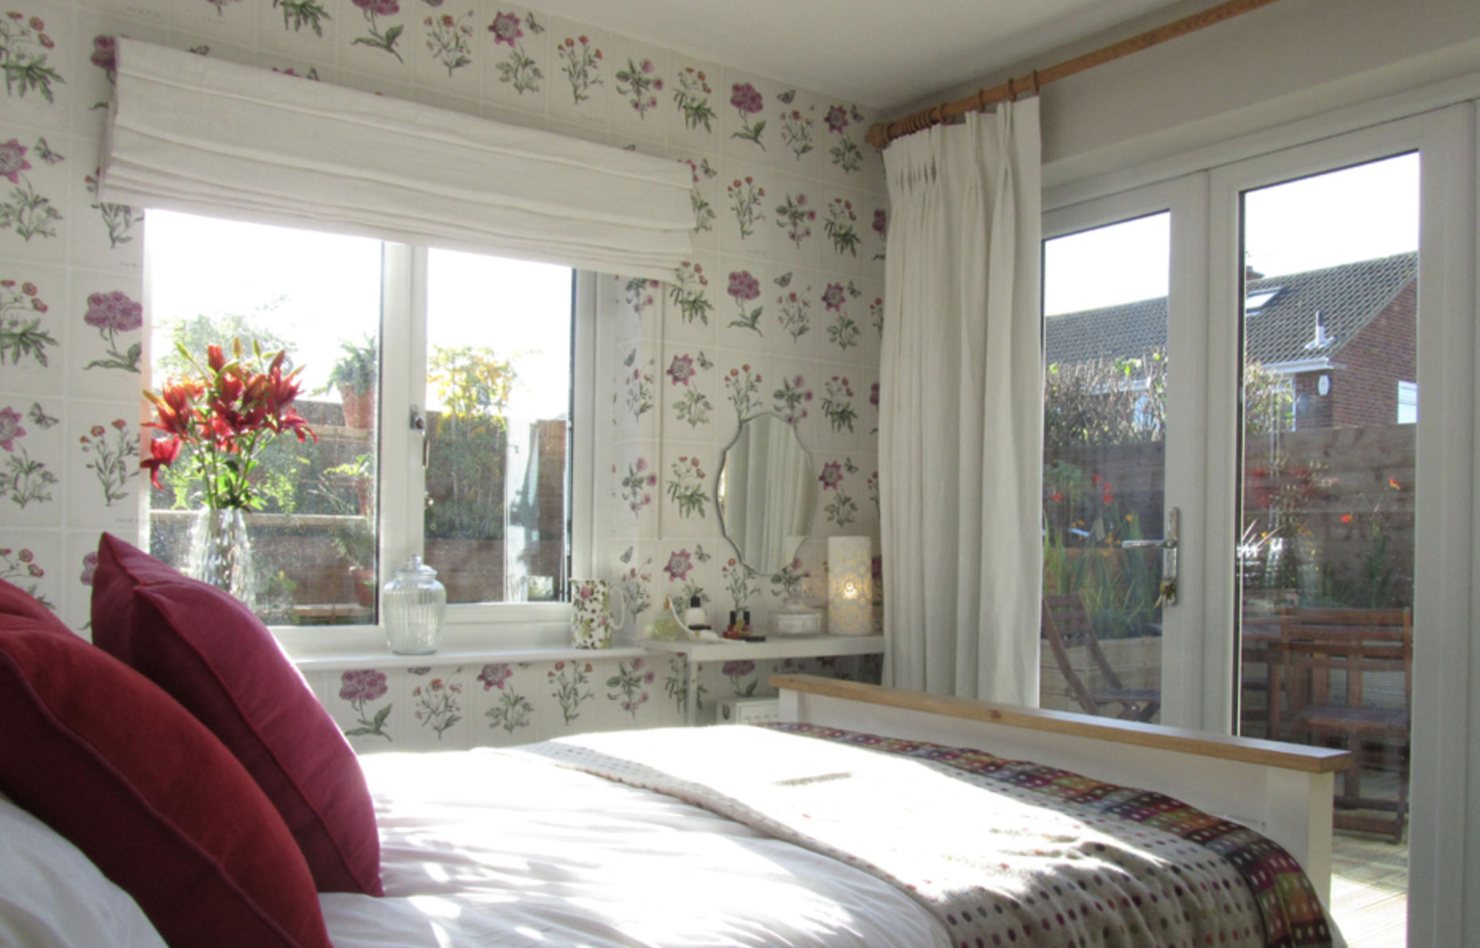

Figure 3. (DIY SOS – Biophilic Design case study - Oliver Heath, 2020)

This idea of ‘indirect connection’ to nature as Heath puts it in the video on his website, is how we ‘mimic or evoke a sense of nature.’ (Oliver Heath, 2019) By having these floral images on our walls or even on our notebooks it can mimic the effects that real plants have on us. An article in the Journal of environmental Phycology called ‘Viewing a flower image provides automatic recovery effects after psychological stress’ states that ‘Viewing a flower image reduced negative emotion, blood pressure and cortisol release’(Mochizuki-Kawai, Matsuda and Mochizuki, 2020) This might suggest that an image of a flower has the same effects as biophilic design. Having floral wallpapers and even just botanical motifs around your home can make it a more relaxing environment for you to live in.

A study by Jeannette Haviland-Jones Ph.D. of Rutgers found that flowers have an immediate impact on happiness. People have cultivated flowers for more than 5000 years, but there is no known incentive for this. Flowers have immediate and long-term effects on emotional responses, mood, social habits and even memory. It is believed that cultivated flowers are rewarding because they have evolved to induce positive emotions in humans quickly, much like other plants have developed in a wide range of species to cause varying behavioural responses leading to the dispersal or proliferation of the plants. Haviland-Jones suggested that flowers can have a positive effect upon moods, can decrease anxiety, and make spaces more welcoming. She conducted 3 studies, The one that I found the most interesting was Study 1 – Immediate Smiles and Long-Term Mood Change. She tested woman from all ages and ethnicity’s and presented them with a bouquet of flowers. She then conducted ‘Mood Interviews’ where she questioned them on their moods throughout the time of having the bouquet. A few points I found especially interesting where that they were very positive when they first received the bouquet. They were also twice as likely to place the bouquet in a social space in their home, for example the lounge or the hallway. And that more than often changed their social behaviours, eg being more inclined to invite people in or just be more pleasant in those rooms. (Haviland-Jones, 2005) I agree with Haviland-Jones’ theory of flowers making us happier. I know personally I love florals and the gift of a floral bouquet especially make me happy. The fact that they put the bouquet then into a more social room where more people would see it or maybe they would see it more often, takes me back to the biophilic design and how having these in our homes can help
our mental health and make us generally happier people.

I am constantly inspired by nature, as are plenty of textile and surface pattern designers. William Morris is one of the most famous surface designers ever, his work is heavily inspired by nature. Much like myself, Morris grew up around up around plants and in gardens. (Bringing the garden indoors: how nature inspired William Morris, 2020) I am especially drawn to florals, I love the colours and shapes. For me having something that has that painted quality or an artistic quality to it I am also more drawn to. In this article by Hannah Fester it states how art in our homes can have similar effects to biophilic design. ‘‘Can art really affect mood?’, you might ask. Studies have proven that, yes, art can have a direct affect on one’s mood, and when choosing the right art this effect can be happiness.’ (Fester, 2019) She then goes on to mention how our subconscious focuses on the beauty of the piece in front of us which has proven to reduce stress. My question is, is this down to personal taste? I think so, we all have our own ideal of beauty, and things we like and dislike, but if this piece of art is of a beautiful forest of trees and florals, your mind is designed to be relaxed when looking at these natural shapes and images.

A personal story that a resonate with is that of Lucy Auge. I found Lucy through Instagram and have been obsessed with her illustrations and paintings ever since. In an interview with Toast she states ‘The reason that I paint flowers, is that I’m so drawn to nature… Lucy began to grow vegetables, and became “somewhat obsessive” in her love of flower shows’ (In the Studio with Artist Lucy Augé, 2020) During this interview with toast she says that it all started with an injury which left her ‘having more in common with her 80 year old neighbours’… “I knew that I needed a focus, and it was my father who found it. Encouraging me to come into the garden.” (In the Studio with Artist Lucy Augé, 2020) The garden healed her and also inspired her new obsession of plants. She went on to set up her first exhibition called ‘500 flowers’ where she covered all the walls with the paintings and drawings of flowers. I feel that I have become ‘somewhat obsessive’ over not just flowers and plants but drawings, paintings, postcards and even stickers of plants. Anything I can find that has those natural shapes and the natural colours I find I am really drawn to. Lucy Auge’s work has given her the positive effects that biophilic design and artwork in the home states to give. My work is different to Auge’s but I want to show the same drive that she has, and create and paint as many florals as I possibly can. Whilst also learning about the plants I am drawing. I want to learn what plants can calm you what can energise you, and use these to my advantage when designing for the home.

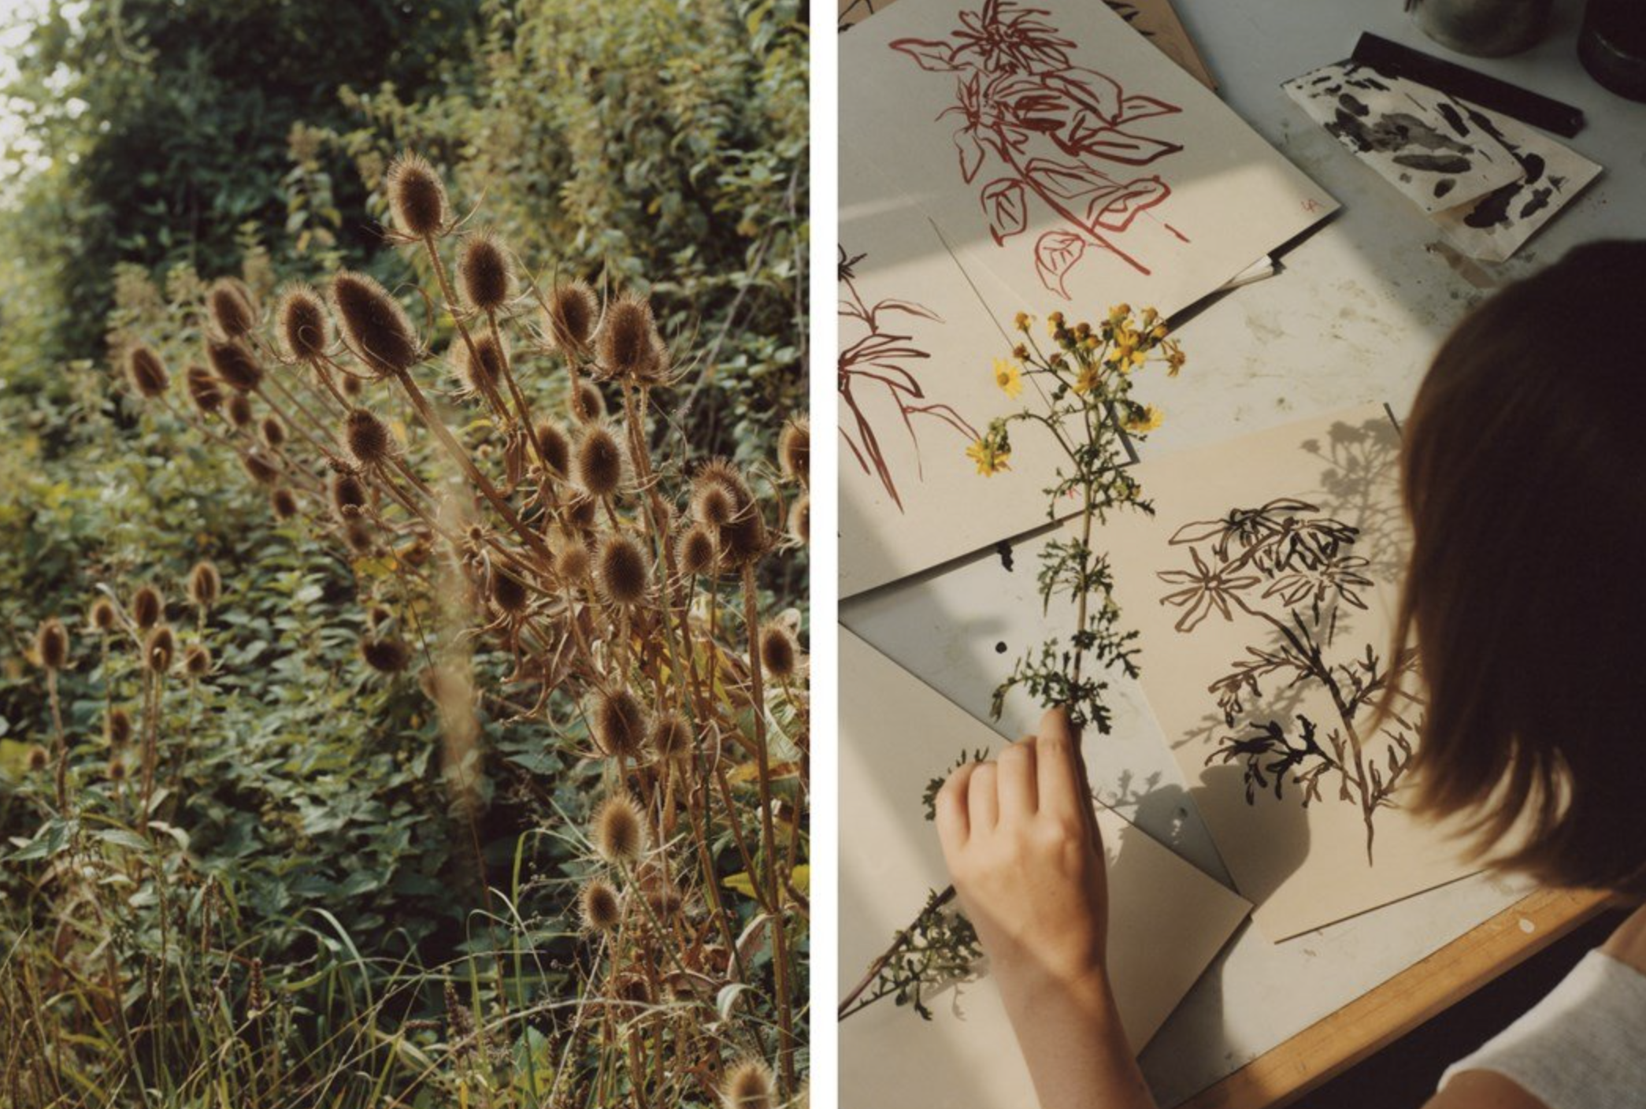

Figure 4 (In the Studio with Artist Lucy Augé, 2020)

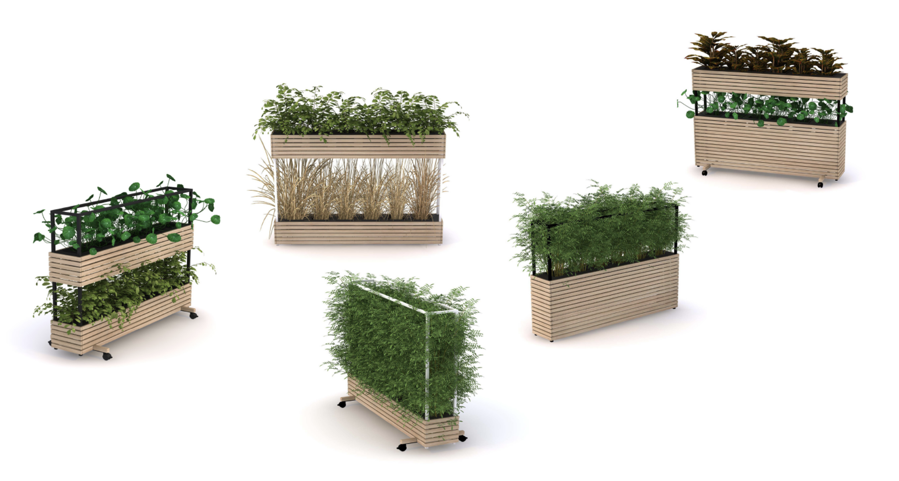
In the year we have all been working from home, where there are plenty of distractions, ‘home offices’ have become a necessity. Big commercial offices often use biophilic design to create more productive and peaceful spaces. One that especially comes to mind is the Orange Box offices in Cardiff. I visited the Orange Box offices in 2019 as part of live project with them. Their offices are truly bringing the outdoors in, by having plants almost everywhere you look. Obviously, them being the professionals when it comes to office design and promoting productivity in the workplace, botanical design is essential for them. ‘Research tells us that the more plants you have, the more beneficial they become… We also know that spending time in more natural environments makes us better at doing our jobs and increases our feeling of vitality, boosting energy levels and making us feel more animated.’ (Welcome to Orangebox, n.d.) They have created a mobile planter that can be moved around the office as needed. They can house real or fake plants and even have a watering system so no one needs to look after them too often. So not only can biophilic design calm and relax us it can also boost our energy and productivity. The same can be applied to your home office.
Figure 5. (Welcome to Orangebox, 2020)

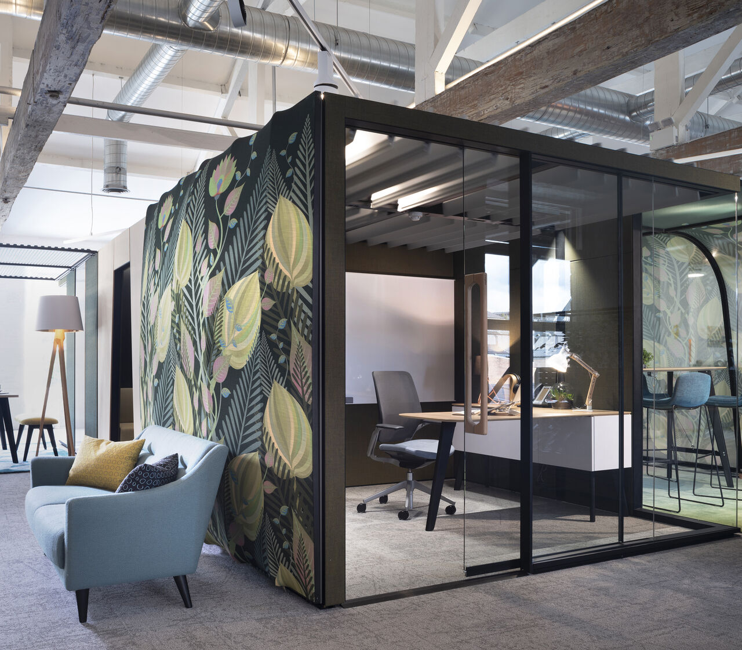
Figure 6 . (OrangeBox, 2020)

‘If you can, get outside. If you can’t, bring nature in. Spending time in green spaces can benefit both your mental and physical wellbeing. If you can’t go outside, you can try to still get these positive effects by spending time with the windows open to let in fresh air, arranging space to sit and see a nice view (if possible) and get some natural sunlight, or get out into the garden if you can.’ (Guidance for the public on the mental health and wellbeing aspects of coronavirus (COVID-19), 2020)

This information from the government website about mental health and wellbeing during the Corona Virus pandemic literally states ‘bring nature in.’ This is perfect for people living in built up cities, who at normal times don’t get to see greenery daily, but even if you live in the middle of the country side, I think it is beneficial to have some nature in your home too, especially with us spending so much time at home at the moment . ‘Because so many of us spend so much time indoors, there's an urgency to bring the outdoors into our spaces in order to boost wellbeing’ (Johanson, 2020) This quote is from a BBC Worklife article posted in the October of the pandemic.

‘Morgan, the remote worker in Washington, DC, had never heard of biophilic design before she intentionally staged her home office with plants, linen furniture and ample natural light. She says it simply made her feel good, and also helps to project a soothing image to colleagues on daily video calls. “I want the energy to show through on the camera that I am in a controlled, calm space where I can be productive but also rest and have some serenity,” she says. Each work day starts by letting in natural light, saying hello to the plants (“they’re all named”) and placing a “productivity blend” of spearmint and lemongrass in an essential oil diffuser.’ (Johanson, 2020)

In my opinion, biophilic design has such an important role in how we live our lives at home, especially in recent times. If it’s simply a bouquet of flowers from the supermarket or you turn your home into a miniature jungle, the benefits can be really positive to your mental wellbeing. Our homes are our safe spaces, and they are where we spend, and have spent a lot of time recently, they need to create the energy we want to feel throughout our day.
To conclude, for my creative venture I would like to create a collection of interior patterns and designs that not only look attractive and stylish but benefit the inhabitants well-being. These floral and botanical designs will give the same effects as biophilic design through ‘indirect connection’ to nature as Oliver Heath suggests. My designs will ‘mimic or evoke a sense of nature.’ (Oliver Heath, 2019) and therefore portray similar effects. I want to become obsessed with drawing plants, like Lucy Auge. Painting things from real life, things from the garden, things gathered on walks, anything that makes me happy. My collection will be made up of chapters, so there is a collection for each room or mood. Eg a bright and productive space for an at home office, and a calm and warm toned space for the bedroom. The purpose of our homes have slightly changed in recent times and I hope that my designs can help it transition into the spaces that we need. My plan is that each room will have it is own collection and theme, some may cross over as you might also want to feel relaxed and serene in your lounge, but I want there to be a clear difference in the designs themselves. I will be designing for the atmosphere or the ambience of the room as well as keeping on trend. When designing a space you want it to be inviting, I like to think of myself as a floriculturist, and an interior designer I cultivate and design the florals and botanicals in the home for ornamental and decoration purposes. By adding these designs and idea’s into our homes we can hope to make them happier and more relaxing spaces to spend time in.
Bibliography

Coulthard, S. and Bratby, H., n.d. Biophilia: You Nature Home. Kyle Books, Octopus Publishing Group Ltd, p.11.

Fester, H., 2019. How Paintings And Art In The Home Can Make You Happy. [online] Home Improvement Pages. Available at: <https://hipages.com.au/article/how_paintings_and_art_in_the_home_can_make_you_hap#:~:text=Our%20home%20is%20our%20sanctuary,subconsciously%20investing%20in%20your%20happiness.> [Accessed 28 December 2020].

GOV.UK. 2020. Guidance For The Public On The Mental Health And Wellbeing Aspects Of Coronavirus (COVID-19). [online] Available at: <https://www.gov.uk/government/publications/covid-19-guidance-for-the-public-on-mental-health-and-wellbeing/guidance-for-the-public-on-the-mental-health-and-wellbeing-aspects-of-coronavirus-covid-19> [Accessed 11 January 2021].

Haviland-Jones, J., 2005. An Environmental Approach To Positive Emotion: Flowers. [article PFD] New Brunswick: Evolutionary Psychology, pp.104-132. Available at: <https://journals.sagepub.com/doi/pdf/10.1177/147470490500300109> [Accessed 3 January 2021].

House Beautiful. 2021. Oliver Heath On The Plants That Will Bring Bring Maximum Health & Wellbeing Benefits. [online] Available at: <https://www.housebeautiful.com/uk/decorate/a33633525/oliver-heath-biophilia-plants/> [Accessed 20 December 2020].

Johanson, M., 2020. How ‘Biophilic’ Design Can Create A Better Workspace. [online] Bbc.com. Available at: <https://www.bbc.com/worklife/article/20200929-how-biophilic-design-can-create-a-better-workspace> [Accessed 6 January 2021].

Mochizuki-Kawai, H., Matsuda, I. and Mochizuki, S., 2020. Viewing A Flower Image Provides Automatic Recovery Effects After Psychological Stress. [ebook] Tsukub: Journal of Environmental Psychology. Available at: <https://reader.elsevier.com/reader/sd/pii/S0272494419304001?token=FBC5432B87B7AE8020DFE40D984A5867B81A70BBBBDBED25566069FB287D8E7333A898A0FC2D2C37E626D73EB8157799> [Accessed 2 January 2021].

National Trust. 2020. Bringing The Garden Indoors: How Nature Inspired William Morris. [online] Available at: <https://www.nationaltrust.org.uk/features/bringing-the-garden-indoors-how-nature-inspired-william-morris> [Accessed 11 January 2021].

Oliver Heath. 2020. DIY SOS – Biophilic Design Case Study - Oliver Heath. [online] Available at: <https://www.oliverheath.com/portfolio-item/diy-sos-biophilic-design-case-study/> [Accessed 20 December 2020].

Orangebox.com. n.d. Welcome To Orangebox. [online] Available at: <https://www.orangebox.com/products/woods> [Accessed 29 December 2020].

Orians, G.H., & Heerwagen, J.H. (1992). Evolved responses to landscapes. In Barkow, J.H., Cosmides, L, & Tooby, J., (Eds.), The adapted mind: Evolutionary psychology and the generation of culture (pp. 555-579). New York, NY: Oxford University Press, Inc.

Time. 2018. You Asked: Can Indoor Plants Really Purify The Air?. [online] Available at: <https://time.com/5105027/indoor-plants-air-quality/#:~:text=Through%20photosynthesis%2C%20they%20convert%20the,compounds%20like%20formaldehyde%20and%20benzene.> [Accessed 11 January 2021].

Toa.st. 2020. In The Studio With Artist Lucy Augé. [online] Available at: <https://www.toa.st/magazine/in-the-studio-with-artist-lucy-aug.htm> [Accessed 22 December 2020].
www.dictionary.com. 2021. Definition Of Floriculture | Dictionary.Com. [online] Available at: <https://www.dictionary.com/browse/floriculture> [Accessed 28 December 2020].

