Research Activity

You are a student with a passion for the outdoors and outdoor adventure activities. You feel that outdoor activities can improve people’s health. Being outdoors makes you feel good but do others feel the same? Is there any evidence that that there are health improvements from engaging in outdoor activities? After giving this much thought you are interested in finding out if your instinct is right.
You are ready to engage in inquiry and research.
So were do you start, well you start by writing out the question you want to find an answer to, so that is the starting point.
So you get started, you write the question down in about ten different ways and finally after a gulp of air and a scratch to the head you decide this is how you feel the question is best stated.
Here is the question you have arrived at.

How do you think outdoor activities can be used as a focus for improving people’s general health and wellbeing?

- What type of research paradigm best describes this question?
Qualitative
- Where will you search for information to address this question? (List all)
I will use articles around this subject which can be found on google scholar, the online Library, I will use Questionnaires to get people’s opinions.
- How easy / difficult is it to find sources to help answer the question?
It is generally quite easy to find sources using google scholar as well as the online library, it is also simple to hand out Questionnaire’s.
- What did you do to make the process less difficult?
Break down health and wellbeing into smaller categories to get a more direct answer by breaking down well-being into Mental and physical health.
- How did you arrange the materials you found? Did you have a system (folders etc)
I used folders so I can have folders for mental health and physical health serpartley.

- Pick five search results.
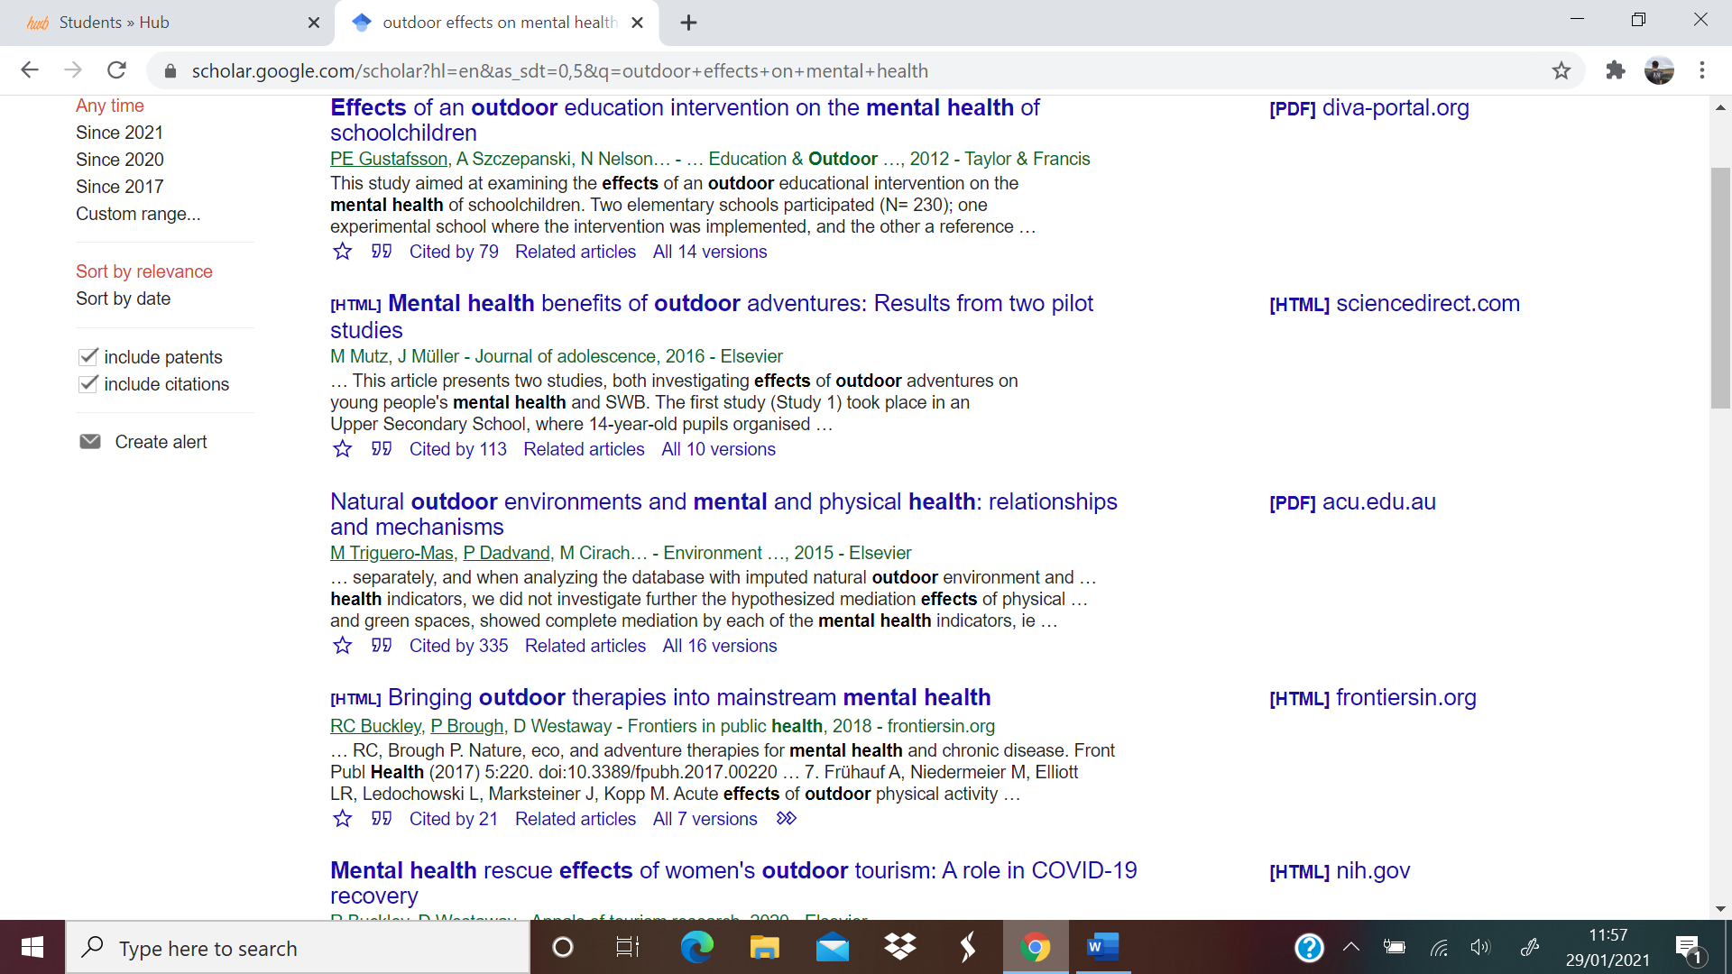

The next stage is the literature review process.
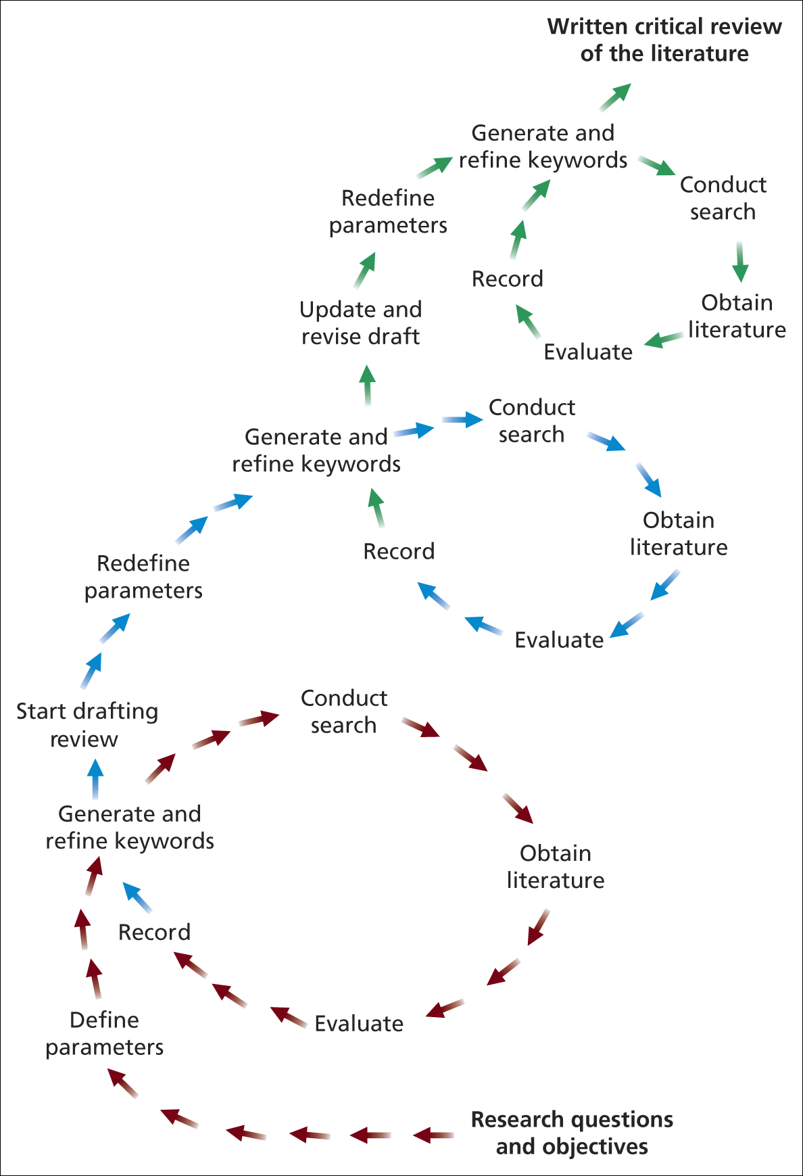
Figure 1 The literature review process Saunders et al., 2009

- The process suggests you need to evaluate those search results, but how do you do that?
Check the date, location, relevance, peer reviewed.
- How would you evaluate those five search results? Are there any guidelines / checklists you would follow to decide what you are looking for in those papers?
I would look at the abstract, title and make sure the article is relevant as well if the journals articles have been peer reviewed.
- Now you have your evaluation checklist ready then read the three research sources and report on your checklist.
All the research sources met the criteria, the first one was written in 2012, this is written 8 years ago so this would still be revenant. The second one was written in 2016 and this is very recent.

- Make a summary of what are the key findings from the papers. Report these.
From the Papers I found that there is a positive link to outdoor activities and the relationship to improving people’s health and well-being. Both physical and mental health go hand in hand, and both improved through outdoor activities by stimulating the brain and being engaged physically.
- Did the sources provide useful findings and what are these findings?
People from a more economic background have more benefits being outdoors as they may spend more time in doors then children who are from a less economic background.
- Did the sources you found indicate a need for further research?
The sources indicate that people with more money can reap more benefits being outdoor than people with less money. I would research this topic more next time.

