Innovative Service Plan

"Tech-Connect"

Academic Report

Ricardo Alexandre

2025546

Developing Innovation and Creativity for Business Advantage

  - BMSW6102

  - Lecturer: Dr Abdullah Ijaz

  - July 10, 2023

Table of Contents
Introduction 3
1. Innovative Service/Product Idea 3
2. E-commerce Implementation 7
3. Marketing 11
Brief Conclusion 15
References: 16

Table of Figures and Table
Figure 1. Sources: Website page (Looka, 2023). 3
Figure 2: Innovation and entrepreneurship 4
Figure 3: Source: Innovation and entrepreneurship. (Bessant, & Tidd, 2015). 4
Figure 4. Sources: Website page (Looka, 2023). 6
Figure 5. Source: The Stragile Conscious Vision. Based by Schultz, (Chapter 3, 2004). 7
Figure 6. Source: Porter Value Chain Template, based by Khoo and MacDonald, (2011). 9
Figure 7. Source: The 4Ps of marketing by Bhatt and Emdad (2001) 11
Figure 8. Website page (Looka, 2023). 12
Figure 9. Sources: Website page (Looka, 2023). 12

Table 1. Source: Forecast Cost by Checkatrade (2023) 8

Introduction
In my research project, I am emphasising the importance of strategic innovation in businesses like mine. I understand the significance of meeting evolving customer needs and driving overall firm performance. That's why my primary goal is to develop an innovative service called Tech-Connect that offers remote tech support and assistance directly to our customers. To ensure a seamless user experience and effective customer engagement, I am tailoring our eCommerce website.
I will have a user’s friendly interface, intuitive navigation, and an appealing design. Key features will include secure payment processing, real time chat support, and a knowledge base section with troubleshooting guides and frequently asked questions.
To set Tech-Connect apart from our competitors, I am making sure that our website is fully mobile-responsive. This way, our users can access our services seamlessly from their mobile devices. By offering Tech-Connect through our eCommerce website, I aim to address the growing demand for reliable and efficient tech support. I believe this will help us establish a strong presence in the market and cater to the ever-evolving needs of our valued customers.


Figure 1. Sources: Website page (Looka, 2023).

Innovative Service/Product Idea

In my project, I have developed a simplified model of Harris (1998) the innovation process to guide the development and implementation of Tech-Connect, my innovative service plan. A key attribute of entrepreneurship is innovation, according to Drucker (1985).

Idea Generation
The first step in the innovation process is generating ideas. The creative process according to Levinson (1997). I have actively sought out opportunities and identified the emerging customer need for reliable and efficient tech support services. This need has served as the foundation for developing the concept of Tech-Connect.

Figure 2: Innovation and entrepreneurship
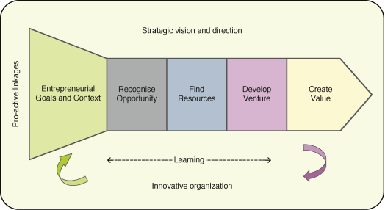

Figure 3: Source: Innovation and entrepreneurship. (Bessant, & Tidd, 2015).
Entrepreneurial Goal and context
I was screening and evaluating ideas is crucial for their feasibility and potential success. In implementing Tech-Connect, market demand, competition and resources were carefully considered. This process confirmed that Tech-Connect meets customer needs and is profitable and viable.
Recognise Opportunity
After selecting the idea, my concept of TechConnect is developed, outlining key features, benefits, and value proposition. Market research, customer insights and refinement ensure the service meets target customers' needs and preferences.
Find Resource
To validate our concept and gather feedback, prototypes were created and tested. Feedback was sought from potential customers, ensuring service design met expectations and resolved technical issues effectively.
Develop
The concept is refined and validated, enabling Tech-Connect implementation. Infrastructure development includes eCommerce website, secure payment processing, and customer support systems. Strategic partnerships with retailers and technology providers enhance reach and accessibility.
Create Value
Launch Tech-Connect and monitor performance and customer feedback to assess satisfaction, identify areas for improvement and adjust. This ensures the service remains innovative, relevant and effective in meeting customer needs.

This simplified model of the innovation process has guided the development of Tech-Connect, from idea generation to implementation and continuous improvement. We are following this process of Tidd and Bessant (2020). I am confident that I have laid a strong foundation for the success of TechConnect as an innovative service in the tech support industry.

As the founder of Tech-Connect, my innovative service plan revolves around providing exceptional tech support services to individuals and businesses. Tech-Connect is an online venture dedicated to connecting customers with reliable and efficient solutions. Our approach focuses on personalised service and delivering timely solutions to address emerging customer needs.

Tech-Connect provides remote tech support services for devices and software issues. Their skilled technicians provide personalised solutions, understanding customers' specific needs. I am utilising an eCommerce website, we offer a central hub for accessing information, submitting inquiries and scheduling remote assistance. The user-friendly interface ensures a seamless customer experience and easy communication.

Figure 4. Sources: Website page (Looka, 2023).
Tech-Connect offers personalised service and exceptional customer experiences, addressing the growing digital landscape's reliance on technology. They provide tailored solutions, remote assistance, and convenient solutions, ensuring quick resolutions and minimising downtime, providing peace of mind for customers.

Tech-Connect does well in tech support with personalised approach, remote assistance and customer satisfaction, but I am prioritising expertise, convenience and customer-centric solutions. Their efficient service delivery and transparent communication build trust and loyalty. Comprehensive strategy developed to sustain innovative business proposition and maintain competitive advantage:
- Continuous Improvement:
Stay updated with technological advancements and invest in technician training for cutting-edge solutions and expertise.
- Exceptional Customer Service:
Providing exceptional customer service is crucial for sustainability; Tech-Connect will actively seek feedback, address concerns and improve overall experience.
- Strategic Partnerships:
Collaborating with technology manufacturers and software providers enhances service offerings, market position and exclusive resources, but we will be improving market position and market position.
- Marketing and Branding:
A robust marketing strategy involving targeted advertising, content creation and social media engagement will effectively reach customers, build brand awareness, highlight value proposition and nurture customer relationships.

- Long-Term Vision:
We will develop a clear roadmap for expansion and diversification, exploring opportunities to offer additional services or enter new market segments. This approach ensures our long-term sustainability and adaptability to evolving customer needs.

Figure: The Stragile Conscious Vision
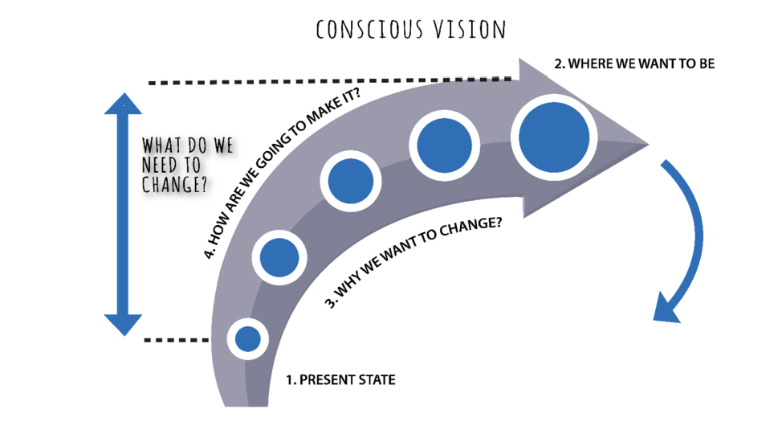
Figure 5. Source: The Stragile Conscious Vision. Based by Schultz, (Chapter 3, 2004).
It appears that Tech-Connect is an innovative service proposition that aims to provide exceptional remote tech support services. Through personalised solutions, convenience, and customer satisfaction, we are well-positioned to meet emerging customer needs in the tech support industry. That implementing sustainable strategies, continuously improving our offerings and nurturing customer relationships, we are confident in our ability to maintain our competitive advantage and thrive in the long run.

E-commerce Implementation
I chose Shopify for my website, as it offers a user-friendly interface, customisable templates, secure payment processing, and inventory management. With a monthly fee of £19, I can build a high-powered online store, ensuring a seamless and professional shopping experience for my customers.
The content on the Tech-Connect website will be designed to inform and engage visitors. It will include detailed descriptions of our tech support services, showcasing the range of assistance we offer. Additionally, I will incorporate informative blog articles, troubleshooting guides, and frequently asked questions to provide valuable resources to customers. High-quality images and videos will accompany the content to enhance the overall user experience.
In terms of financing based on checkatrade (2023), I have estimated the Forecast costs involved in setting up and running the e-commerce website (Table 1). This includes expenses related to website development, hosting, domain registration, and initial marketing efforts.
I plan to secure funding through a combination of personal savings, loans, or potential investors who recognise the potential of Tech-Connect as an innovative service.
Table 1. Source: Forecast Cost by Checkatrade (2023)
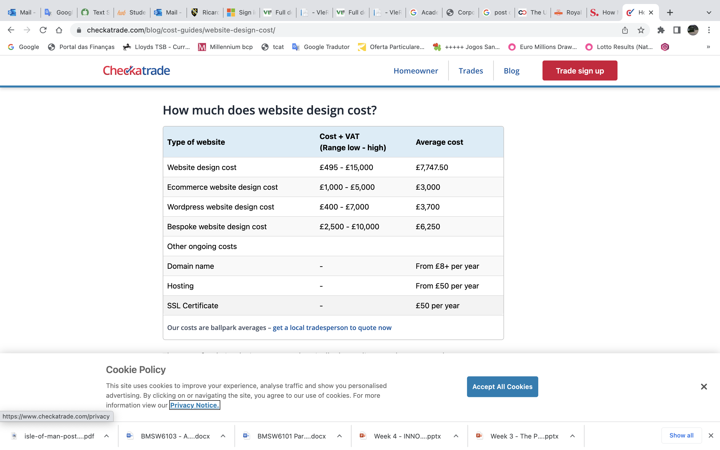
To ensure, I will efficient e-commerce operations, equipment and supplies are essential, including internet connectivity, computers for order management, software applications for inventory tracking, packaging materials, and shipping supplies.
Tech-Connect will provide customers with multiple payment options for innovative services, including major credit cards like Visa, Mastercard, and American Express. Secure payment gateways like PayPal will be integrated for added convenience and security. Compliance with PCI-DSS is ensured for customer payment information protection.
The Shopify platform enables easy content creation and customisation using WordPress, PHP, Python, and Java without coding knowledge. Spotify offers pre-designed templates for visually appealing pages. Copyrighted materials, including text and images, will be used with proper permissions and licenses. Initially, the business will handle website management and customer inquiries, but as it grows, additional staff may be hired for order processing, customer support, and marketing activities.
This analysis revealed that, Tech-Connect e-commerce platform will be built using Shopify, enabling a seamless and secure online shopping experience. The website will offer informative content, payment options, and a well-designed interface, prioritising customer payment security through PCI-DSS compliance. Tech-Connect will be equipped for efficient online order handling.
Tech-Connect value chain analysis is essential for understanding key operations and customer value creation based Khoo and MacDonald (2011), (figure 6). I was analysing each stage by critical thinking hold the view that DeBono, (1985)., the company can identify internal strengths, weaknesses, opportunities for improvement, and potential innovation areas. This helps Tech-Connect identify internal strengths, weaknesses, and areas for improvement.

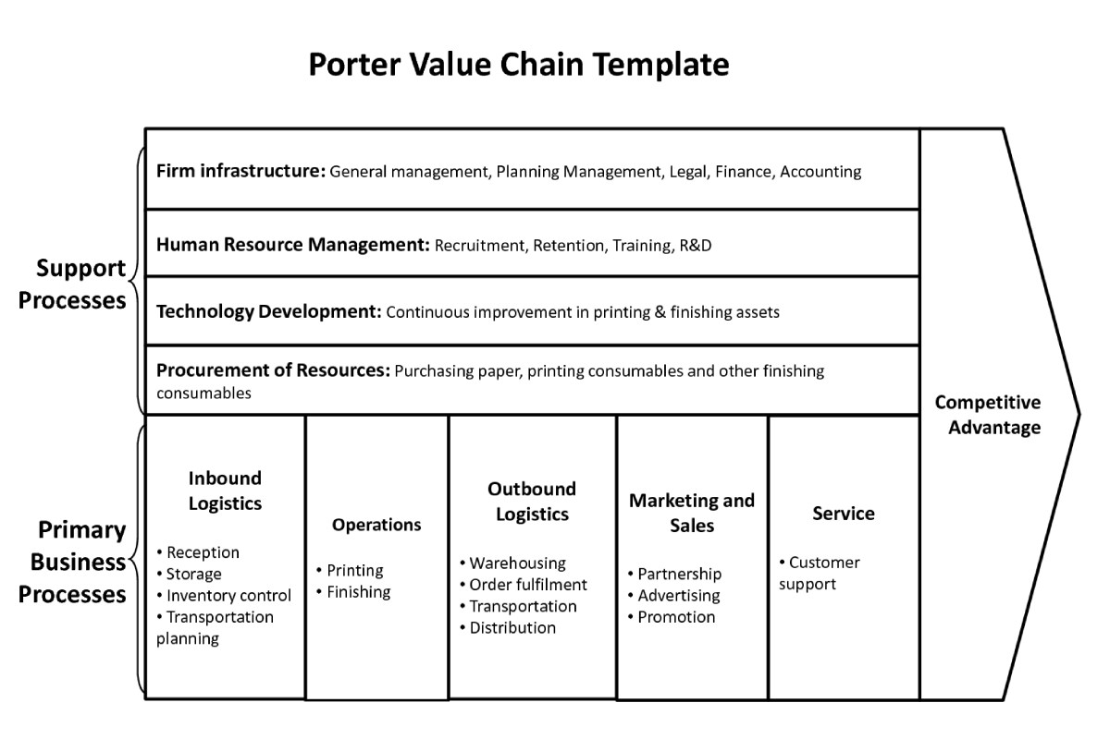

Figure 6. Source: Porter Value Chain Template, based by Khoo and MacDonald, (2011).
Inbound Logistics
We will examine how we manage our incoming materials, resources and technology required for product development (Figure 6). This includes evaluating our sourcing processes for components, software, hardware and assessing the efficiency of their integration into our development process.
Operations
We will explore into our product development process, including design, prototyping, testing, and production stages. By assessing the effectiveness and efficiency of these operations, we can ensure that our ideas are translated into tangible products with optimal efficiency.

Outbound Logistics
We will evaluate how we deliver our finished products to customers. This involves analysing our distribution channels, shipping methods and our ability to integrate customer feedback into the product improvement process.

Marketing and Sales
We will analyse our marketing and sales strategies for our new products. This includes understanding how we identify customer needs, promote our products and make sales. We will assess the effectiveness of our marketing campaigns and customer marketing efforts.

Service
We will consider our post-sale services and customer support. By examining how we handle customer inquiries, complaints, and technical issues, we can enhance customer satisfaction and build loyalty.
Procurement
We will assess our procurement process for acquiring the necessary resources for product development. This includes negotiating with suppliers, managing supplier relationships and securing favourable terms.
Technology and Innovation
We will examine our approach to technology adoption and innovation. This involves staying updated with the latest technological advancements and investing in research and development to remain competitive in the market.

Human Resources
We will evaluate the skills, expertise, and capabilities of our employees involved in new product development. Additionally, we will consider how we foster a culture of innovation and collaboration within our organisation.
Infrastructure
We will assess the physical and technological infrastructure that supports our new product development process. This includes evaluating our facilities, equipment and software tools used throughout the development cycle.

Firm's Culture
This essay has been organised in the following way, we will explore our organisational culture and its impact on fostering creativity, risk taking, and continuous improvement. A culture that encourages innovation can significantly drive the success of our new products.

In their analysis of conducting by Normann & Ramirez, (1993) a thorough value chain analysis, Tech-Connect can improve operations, identify improvement areas, and leverage innovation opportunities, resulting in a more efficient and effective product development process, ultimately leading to market success.

Marketing

In my project, I have developed a comprehensive marketing strategy for promoting my innovative service, TechConnect. The 4Ps framework of marketing (Product, Price, Place, and Promotion). I have guided the development of this strategy:
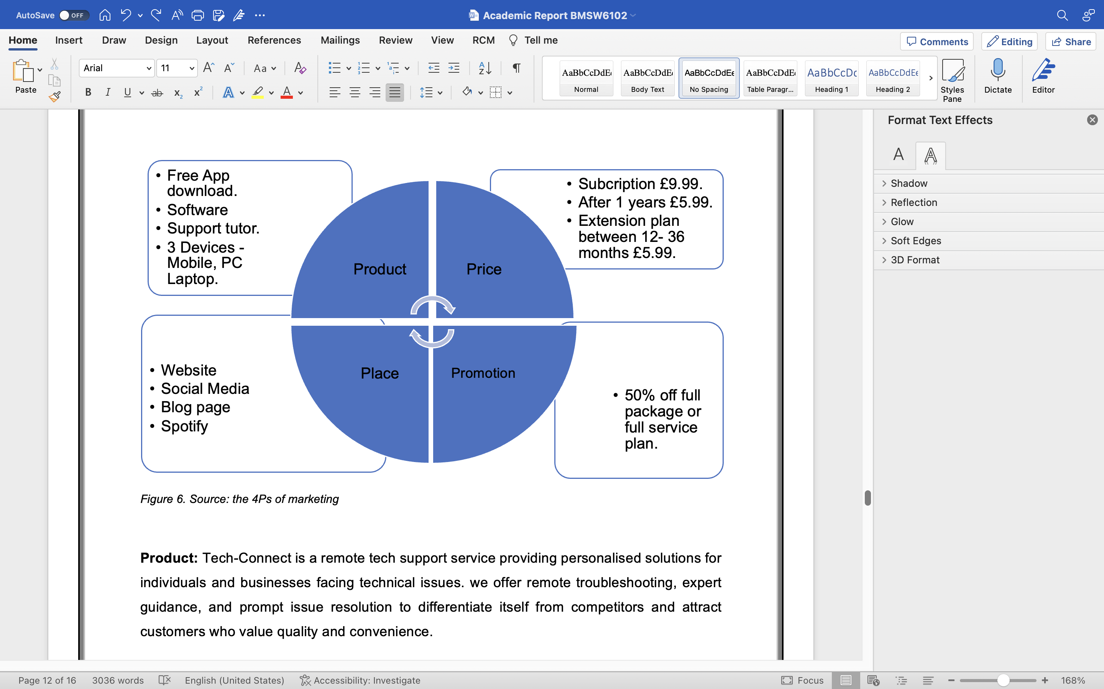
Figure 7. Source: The 4Ps of marketing by Bhatt and Emdad (2001)
Product: Tech-Connect is a remote tech support service providing personalised solutions for individuals and businesses facing technical issues. According to Goi (2011); Muala & Qurneh (2012). We offer remote troubleshooting, expert guidance and force issue resolution to differentiate itself from competitors and attract customers who value quality and convenience.

Price: TechConnect's pricing strategy will be competitive, considering production costs, market demand and perceived value. As expressed by Virvilaite et al. (2009). Emphasising expertise and convenience, we will be a helpful investment for efficient tech support.

Place: Tech-Connect will be offered through an eCommerce website, providing easy access from home or office. The strategy partnering with retailers or technology providers for localised support.
Promotion: To effectively promote Tech-Connect, I will adopt a multi-channel approach that leverages various marketing techniques and platforms.

The key strategies I will employ include:

Social media
I will utilise popular platforms such as Facebook and Instagram to create brand awareness, engage with potential customers, and share valuable content related to tech support. This we will involve regular posting, responding to inquiries and running targeted add campaigns.

Figure 8. Website page (Looka, 2023).
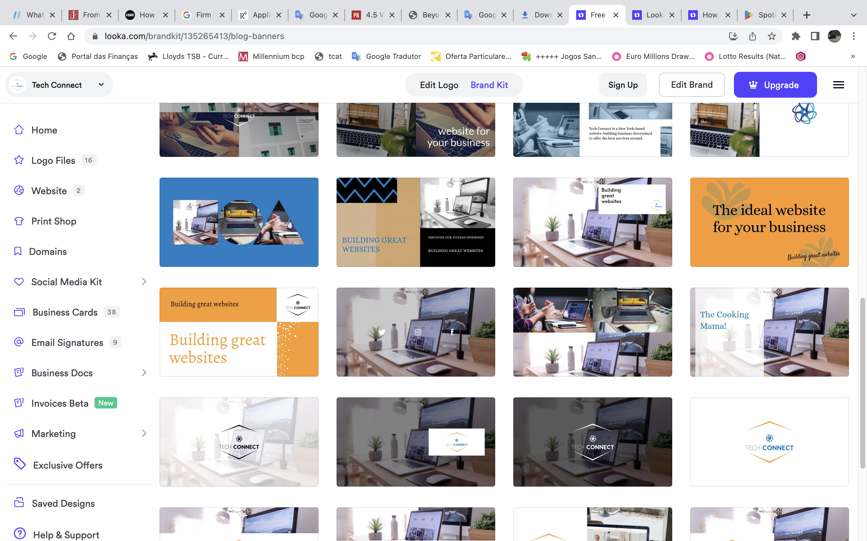
Figure 9. Sources: Website page (Looka, 2023).
Paid search engines
I will make use of search engine advertising, such as Google Ads, to increase visibility and attract customers actively searching for tech support services. This we will involve optimising keywords, creating compelling ad copy and monitoring campaign performance.

Customer journey
Understanding the customer journey is crucial in designing effective marketing campaigns. I will map out the customer's experience from discovering the need for tech support to finding Tech-Connect as the solution. This will allow me to identify touchpoints and create targeted messaging that resonates with customers at each stage of their journey.

Physical and online marketing techniques
Depending on the target market and customer preferences, I will consider other marketing techniques such as direct mail, email marketing, and content marketing. These methods can help reach customers who may prefer traditional channels or have specific information needs.

Pre-launch promotion
Prior to the official launch of Tech-Connect, I will create anticipation and buzz through pre-launch promotion. This can involve teaser campaigns, sneak peeks and exclusive offers to build excitement and generate early interest among potential customers.

Implement marketing strategies to raise Tech-Connect awareness, reach target customers effectively, and position the service as reliable tech support. Utilise social media, paid search engines and targeted techniques for a strong brand presence.
As leader crucial to understand the concepts of ecosystems, co-opetition, co-creation and the changing work culture to drive innovation and product development. Here's how these concepts can be applied to Tech-Connect:

Ecosystems
Tech-Connect operates in a broader network with customers, suppliers, partners, competitors, and others. Based on my research Clarysse et al., (2014). I am understanding and leveraging our business ecosystem, we can form comprehensive strategies and collaborations that create value for everyone involved. This broader perspective allows us to identify opportunities and synergies that can lead to innovation and growth.

Co-Opetition
Tech-Connect can benefit from collaboration with competitors by fostering innovation and creating new products and services. By embracing a mindset of co-opetition and exploring strategic partnerships, Tech-Connect can leverage industry strengths for success.

Co-Creation
I understand the importance of involving stakeholders, particularly customers, in the product development and innovation process. By adopting co-creation strategies, we can actively engage our customers and other stakeholders in the design and development of our products and services. This approach not only leads to better solutions that meet their needs but also fosters a sense of ownership and connection to our brand.
New Work Culture
I recognise that the work culture is evolving rapidly, driven by digital-native generations and changing attitudes. Embracing the new work culture characterised by agility, flexibility, collaboration and flat hierarchies is essential for fostering innovation and problem-solving in Tech-Connect. Barile et al., (2020) Holds the view that creating an environment that encourages creativity, open communication, and collaboration, we can unlock the full potential of our team and drive our business forward.
E-Business and E-Commerce
Tech-Connect, CEO of an e-commerce business, recognises the significance of e-business concepts, focusing on online buying and selling, enhancing transactions, customer support and overall business operations.
E-Business Models
E-commerce models include seller-controlled, buyer-controlled and neutral marketplaces, tailored to business goals and target audience, generating value for customers and partners.
We can thrive in the digital age, impacting the ecosystem, fostering innovation and adapting to changing work culture, driving growth and competitive advantage in the e-commerce market. The Growth Matrix, based by Schultz (2004) describes a methodology for measuring growth.

Figure 5: Growth matrix for product markets.

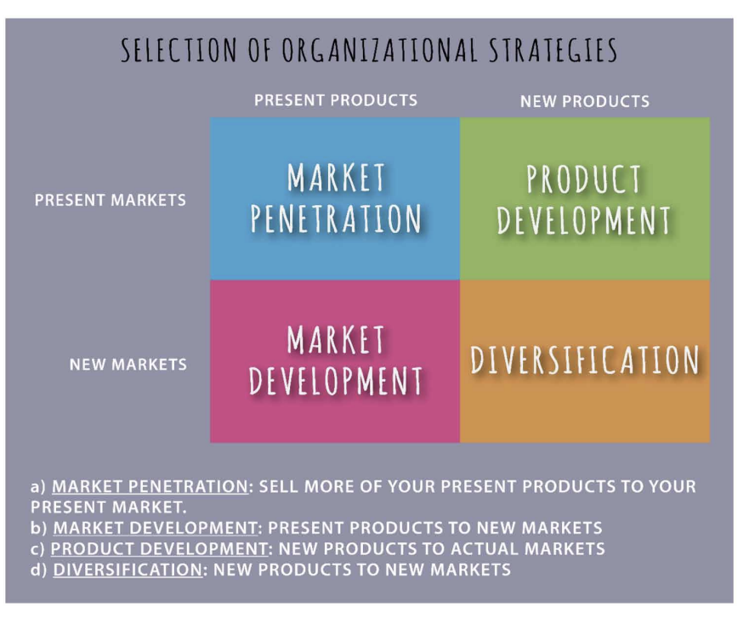
Figure 5. Source: Adaptation from: Schultz, 2004. The product market growth matrix.

Brief Conclusion
As CEO leads a team of professionals providing remote tech support services, focusing on personalised solutions, convenience, and customer satisfaction. Utilising Shopify's e-commerce platform, my focus on efficient inventory management, secure payment processing, and prompt resource delivery. Following the 4Ps framework, our prioritise product differentiation, competitive pricing, strong online presence and effective promotional strategies. Our user-friendly website serves as a central hub, with strategic partnerships with retailers and technology providers. We also collaborate with influencers and bloggers to expand their reach and engage with a broader audience.

Our brand was launching an eCommerce website with enhanced features like secure payment processing, real-time chat support and a knowledge base. The fully mobile-responsive platform caters to on-the-go needs, ensuring reliable and efficient tech support.
Ours team primary objective is to meet customer needs and solidify its position as a trusted industry leader.

References:
- Al-Hakim, L. ed., 2016. Handbook of research on driving competitive advantage through sustainable, lean, and disruptive innovation. IGI Global.

- Barile, S., Grimaldi, M., Loia, F. and Sirianni, C.A., (2020). Technology, value co-creation and innovation in service ecosystems: Toward sustainable co-innovation. Sustainability, 12(7), p.2759.

- Bessant, J. and Tidd, J. (2015). Innovation and entrepreneurship. 3rd ed. John Wiley & Sons Ltd.

- Bhatt, G.D. and Emdad, A.F., (2001). An analysis of the virtual value chain in electronic commerce. Logistics Information Management, 14(1/2), pp.78-85.

- Clarysse, B., Wright, M., Bruneel, J. and Mahajan, A., (2014). Creating value in ecosystems: Crossing the chasm between knowledge and business ecosystems. Research policy, 43(7), pp.1164-1176.

- Checkatrade , 2023. Website design cost guide Copyright Checkatrade. Using this information in an article or blog? Please add a link back to https://www.checkatrade.com/blog/cost-guides/website-design-cost/. [Online]
Available at: https://www.checkatrade.com/blog/cost-guides/website-design-cost/
[Accessed 06 07 2023].

- DeBono, E. (1985). Six hats thinking. Six Thinking Hats. (Boston, MA: Little, Brown and Co.).

- Drucker P.F. (1985) Innovation and Entrepreneurship, London: Pan Books Ltd.

- Eyob, & Tetteh, E. (2012). Customer-oriented global supply chains concepts for effective management. IGI Global. https://doi.org/10.4018/978-1-4666-0246-5or.

- Goi, C.L., (2009). A review of marketing mix: 4Ps or more. International journal of marketing studies, 1(1), pp.2-15.

- Harris, R., 1998. Introduction to creative thinking. Innovation and Goal–free Living–Stephen Shapiro. Innovation. com/innovationorcle. htn.

- Kazadi, K., Lievens, A. and Mahr, D., (2016). Stakeholder co-creation during the innovation process: Identifying capabilities for knowledge creation among multiple stakeholders. Journal of business research, 69(2), pp.525-540.

- Khoo, M. and MacDonald, C., (2011). An organizational model for digital library evaluation. In Research and Advanced Technology for Digital Libraries: International Conference on Theory and Practice of Digital Libraries, TPDL 2011, Berlin, Germany, September 26-28, 2011. Proceedings 1 (pp. 329-340). Springer Berlin Heidelberg.

- Levinson, M.H., (1997). Creativity: Flow and the Psychology of Discovery and Invention. ETC.: A Review of General Semantics, 54(2), pp.254-256.

- Looka, 2023. Looka. [Online]
Available at: https://looka.com/brandkit/135265413
[Accessed 4 July 2023].

- Normann, R. and Ramirez, R., (1993). From value chain to value constellation: Designing interactive strategy. Harvard business review, 71(4), pp.65-77.

- Schultz, R.L., (2004). A note on the product-market growth matrix. University of Iowa, November.

- Pizana, J.E.P., Valdes, S.O. and Hernandez, L.M.B. eds., (2018). Applications of Conscious Innovation in Organizations. IGI Global.

- Tidd, J. and Bessant, J.R., (2020). Managing innovation: integrating technological, market and organizational change. John Wiley & So.

