Application of Computer Aided Engineering Processes
univeristy of wales trinity saint david, motorsport engineering

Structural Design & Fluid Analysis

Harry Williams (2004975)
[Year]
Contents
Introduction 1.0 1
Aims and objectives 1.1 1
Methodology 2.0 2
Validation 3. 3
Cantilever beam 3.1. 3
Bi Metallic strip 3.2 5
Investigated areas 4.0 6
Computer aided engineering (CAE) 4.1 6
Total deformation 4.2 7
Equivalent stress 4.3 7
Temperature 4.4 7
Kinematic simulation 5.0 7
Initial study aluminium 5.1 7
Static structural results 5.1.1 8
Material 2 forged aluminium 5.2 10
Material 3 high carbon steel 5.3 11
Material 4 low carbon steel-heat treated 5.4 12
Results discussion 6.0 13
Conclusion 7.0 13
References 8.0 13
Appendix 9.0 16

Introduction 1.0
Over the past few decades, computer-aided engineering technologies have notably become more significant within the engineering profession. These systems have several restrictions but can aid the design and testing phases of component creation. In this assignment I will be demonstrating my knowledge on the CAE process, its constraints, and the practical application of the aforementioned technologies. This will mimic the testing in a computer model of a real-world system. I will be demonstrating a component assembly whilst analysing the systems kinematics under true operating systems. During the evaluation aspect of this assignment, I will be assessing the static structural integrity of a single component in the assembly process. In order to improve structural performance, I will also be evaluating the component, considering both structural loadings.

Aims and objectives 1.1
- To assess and validate the software that will be used for the study.
- Complete an analytical study validation within anysis to verify the use of the software.
- Complete a validation on mesh sizes within anysis
- To conduct a kinematic analysis of the piston assembly within anysis using real world conditions.
- To investigate and analyse total deformation, equivalent stress and temperature of a piston
- Carry out an investigation to improve the design of the piston and how other materials affect the piston

Methodology 2.0
To carry out the validation study and the study on the piston assembly, the software anysis was used. Anysis is a form of CAE and is widely used within industry

Figure 1, Anysis workbench

Looking at the image above, this is how the study for the piston was carried out, by using anysis 19.2 engineering data was filled out as displayed below, and various material properties was inputted to represent a real-life material
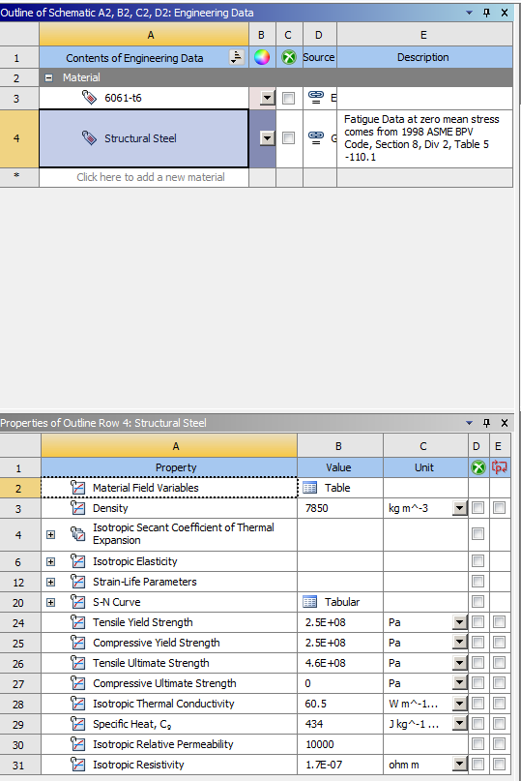
Figure 2 engineering data image
From inputting this data, a rigid dynamic study could be carried out. Within the rigid dynamic section all of the revolute connections were made for the components allowing the components to only move in the direction I wanted them too. All connections (joints used was a revolute joint, majority of them was between each component however two of these was used at component to ground in order to make the assembly not move in rotation with other components. This section was the largest section to setup as it was the section where the joint probe was taken from which allowed us to import motion loads into the static structural study.

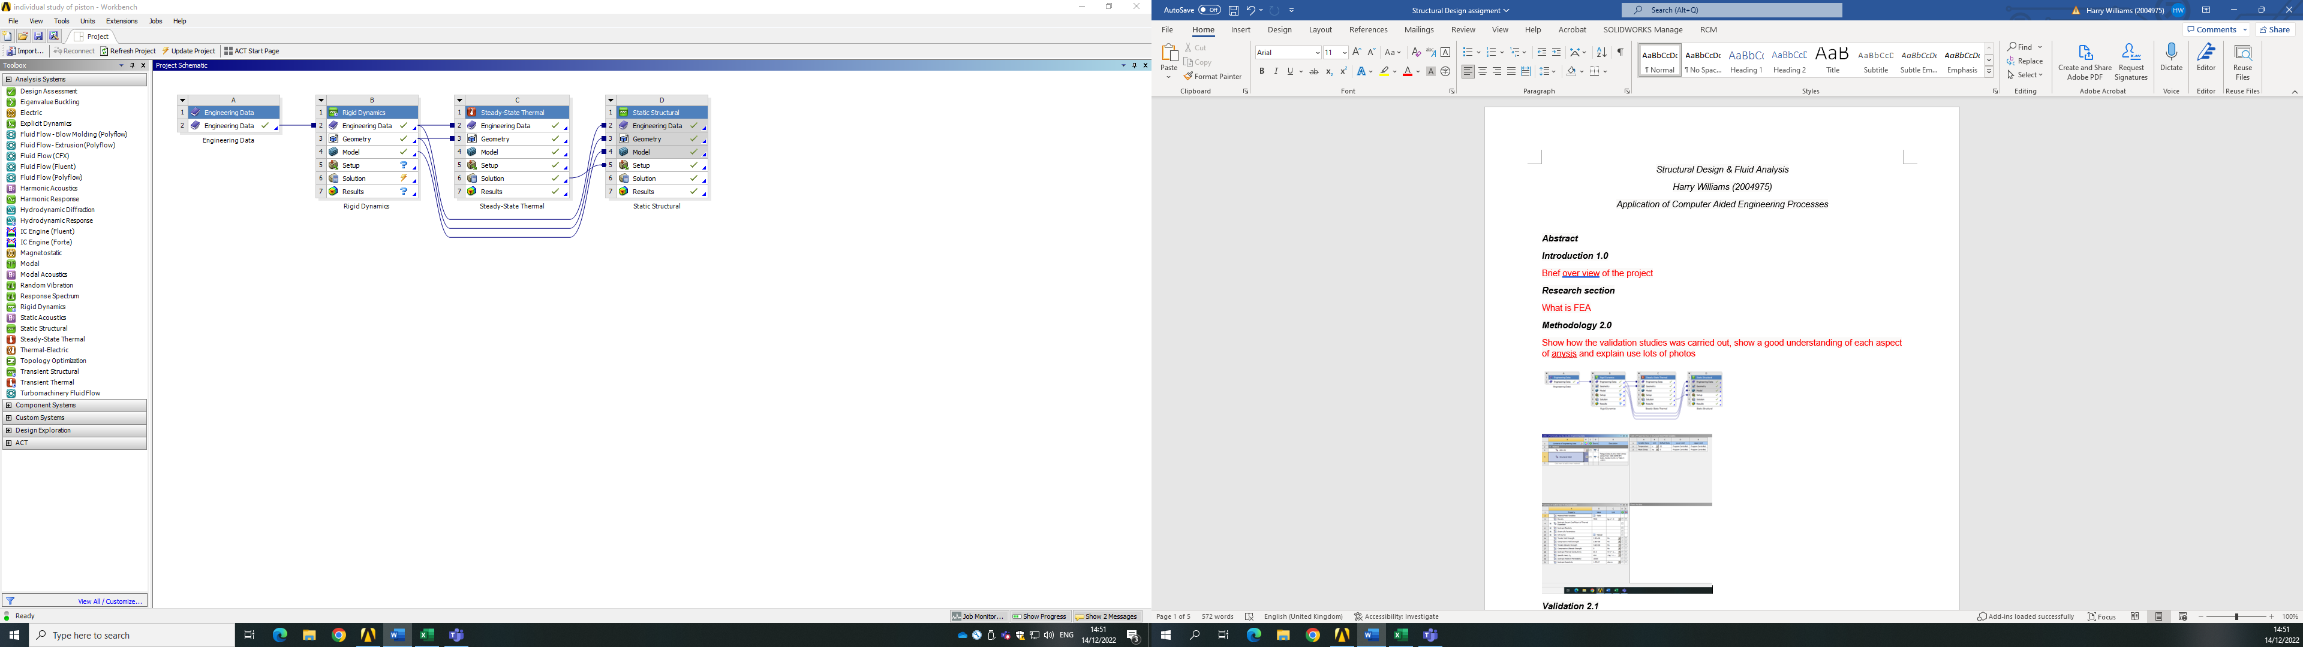
Figure 3 Rigid dynamics study
After the rigid dynamic study was completed, although on figure 1 the steady state thermal study comes next I had to set up the static structural study first to create the links between the sub systems, whilst doing this the motion loads taken from the rigid dynamic study could be imported into the static structural, however this study could not be solved as the software was not ready to be solved just yet
Figure 4 static structural study
Before carrying out the static structural study a steady state thermal had to be conducted. linking the subsystems of geometry and engineering data from the rigid dynamic study to the thermal study this carried across all the necessary data to solve the thermal study and what we were solving was temperature as discussed below. Within this section convections were created, convections were used to put the in-heat transfer boundaries on different parts of the piston head, this allowed us to have a indepth analysis of the heat transfer.
Figure 5 steady state thermal study
Now that the steady state thermal study was conducted and solved, the subsection “solution” from the thermal study can now be linked to the subsection “setup” of the static structural study, this will give the static structural all the results taken from the thermal study. Once this is done a pressure (1.05E07 PA) was then applied in the static structural study, and the solutions of total deformation and equivalent stress was applied, this is what the solver will be calculating. Once all of these was setup and ready to go the static structural study was ready to be solved and on the static structural study all three results could be seen and compared (thermal study, total deformation and equivalent stress).

Validation 3.
“Validity. In a general sense, validity is the extent to which a test, model, measurement, simulation, or other reproduction provides an accurate representation of its real equivalent.” (Manfred D. Roehrle) this is vital for this project as the aim of the project is to represent real world conditions accurately, for that I need to know my simulation is a real life representative and is accurate. “For a good measurement system, the accuracy error should be within 5% and precision error should within 10%” (Sigma magic analysis software) having a lower margin of error shows that the simulation as stated above is a good measurement system if it is within a 5 percent margin or error, for this project I will be aiming for a margin of error of 3 percent to make the simulation even more an accurate anything below that will be accepted

Cantilever beam 3.1.
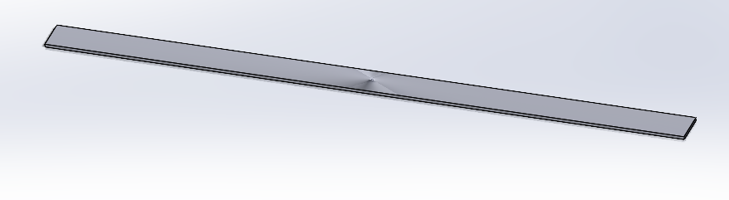
Figure 6 Cantilever beam (solid works)
the analytical solution for the bending moment when the beam is under pressure can be shown as,
$$=-\frac{q{\left(L-X\right)}^{2}}{2}$$
Equation 1
The variables used for the case study validation are displayed below these values will be used to validate my cantilever beam to attempt to recreate the results and be within a suitable percentage of error
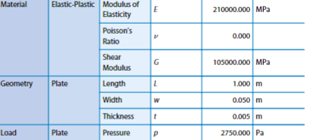
Figure 7 validation material properties
The results from the initial study which will be replicated in the validation study are
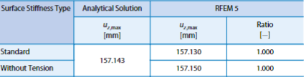
Figure 8 validation study, calculated values

Mesh(mm) | Deformation(mm) | Case study deformation(mm) | Error of percentage(%)
2.5 | 157.15 | 157.143 | 0.00445
2 | 157.15 | 157.143 | 0.00445
1.5 | 157.15 | 157.143 | 0.00445
1 | 157.15 | 157.143 | 0.00445
Table 1 cantilever beam simulation results
It can be seen from carrying out different studies with different mesh sizes on the cantilever beam (2.5mm,2mm,1.5mm,1mm) that the total deformation results received were all the same (157.15mm). The desired result of 157.143m deformation was not achieved however the percentage of error between the two sets of results was 0.00445% which is within a 1% margin of error. From this it can be said that the study was a success and that the total deformation study is operational and validated.
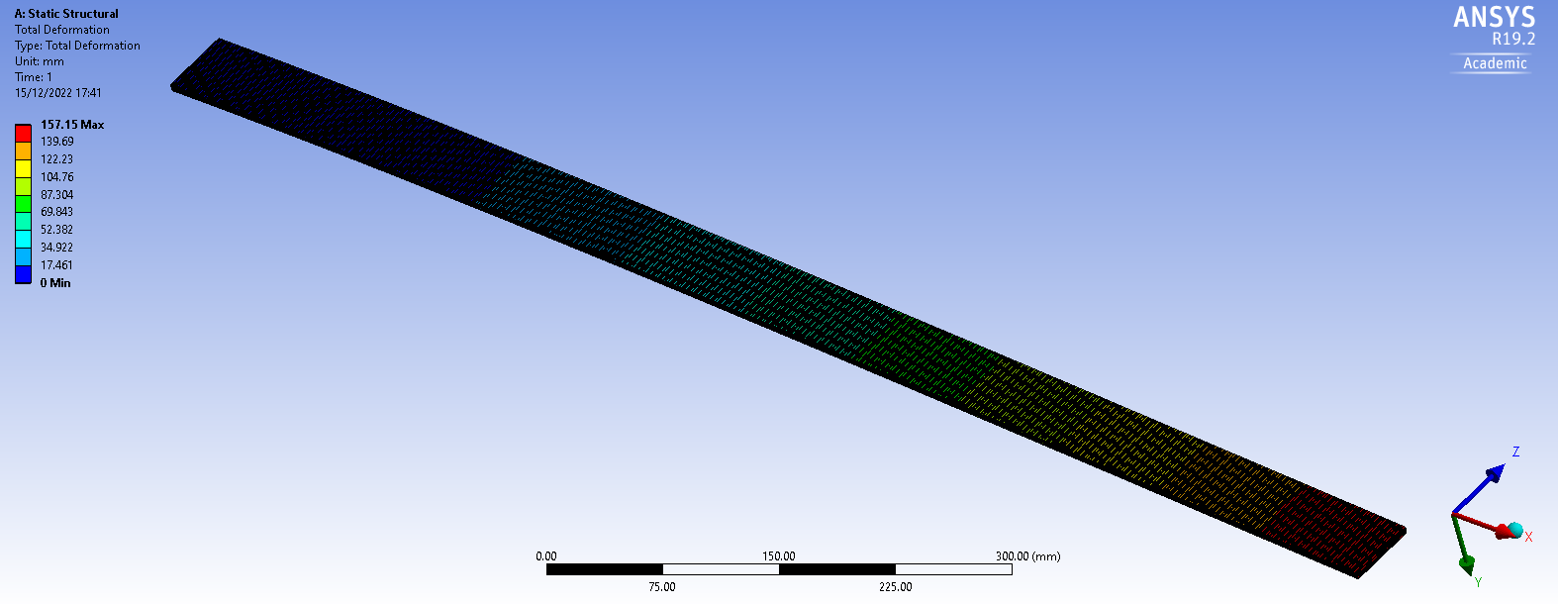
Figure 9 cantilever beam anysis

Bi Metallic strip 3.2
A bimetallic strip is made up of two independent sections one made from invar and the other copper. The left-hand side of the strip is fixed, and the right-hand side is free. To validate this study the deflection on the righthand side of the strip which is free will be investigated.
Analytical solutions
The analytical solution to calculate equivalent stress is as follows
$$k1=4+6\frac{tc}{tj}+4(\frac{tc}{tj})^{2}+\frac{Ec}{Ej}(\frac{tc}{tj})^{3}+\frac{Ejtj}{Ectc}$$
Equation 2
The maximum deflection is then calculated as followed,
$$Uzmax=\frac{6\left(Aj-Ac\right)\left(Tj+Tc\right)Tc}{Ts^{2}K1}\frac{L^{2}}{2}$$
Equation 3
The materials (Invar and copper), geometry of the strip and the load applied to the free end are.
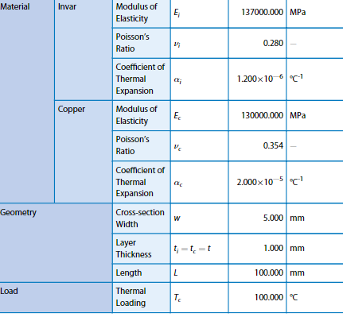
Figure 10 validation study material properties
The results from the initial study which will be replicated in the validation study are
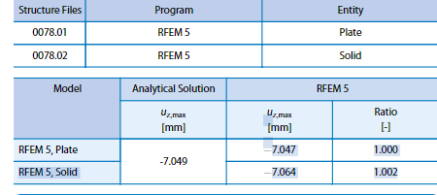
Figure 11 validation study calculated results
Mesh(mm) | Deformation(mm) | Case study deformation(mm) | Error of percentage(%)
0.2 | 7.121 | 7.049 | 1.0214
0.1 | 7.1203 | 7.049 | 1.0114
0.15 | 7.1206 | 7.049 | 1.0157
0.25 | 7.1213 | 7.049 | 1.0256
Table 2 Bi-Metallic strip simulation results
Evaluating the results produced from anysis for the total deformation study for the Bi-metallic strip the mesh sizing does make an impact on how accurate the results are when comparing results to the desired result of 7.049mm. Using the 0.1mm mesh on the Bi-metallic strip produced the total deformation at 7.1203 and that is with a margin of error of 1.0114. this is the lowest margin of error between the mesh study however using a mesh this small can cause some problems on anysis due to the mesh being so small it may take longer for the software to simulate the model and produce results
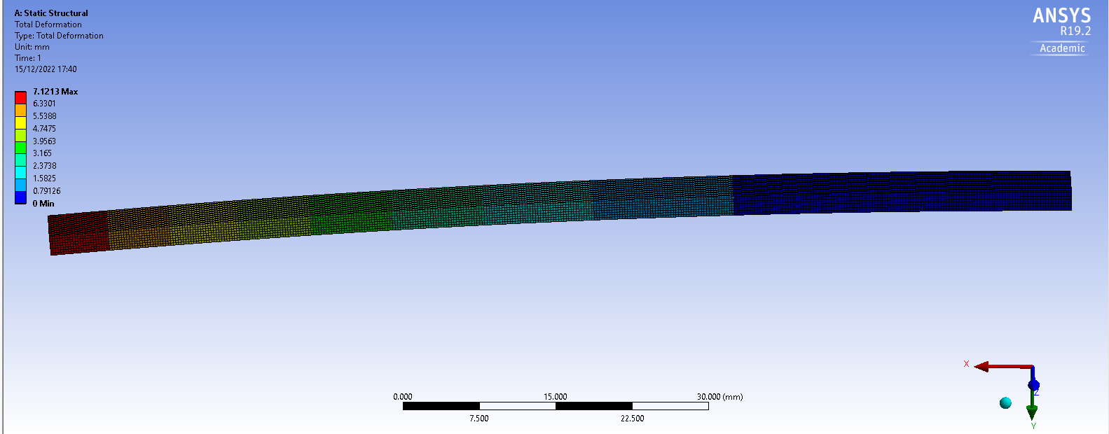
Figure 12 Bi-Metallic strip (anysis)

Investigated areas 4.0

Computer aided engineering (CAE) 4.1
CAE has a massive impact on the engineering industry, it allows engineers to perform testing on new designs and old designs all from their office and get accurate results which saves companies huge amounts of money when it comes to the design process. “The benefits of CAE include reduced product development cost and time, with improved product quality and durability. Design decisions can be made based on their impact on performance. Designs can be evaluated and refined using computer simulations rather than physical prototype testing, saving money and time” (SIEMANS). CAE is vitally important within the industry as it allows engineers to test, develop, design and alter their design models without having to make physical models and saves time and money making the engineering design process more sustainable and effective for this study FEA was used (finite element analysis), FEA allows you to simulate real world conditions and study how your design is affected by those “Finite Element Analysis (FEA) is a computer-aided engineering (CAE) tool used to analyse how a design reacts under real-world conditions. Useful in structural, vibration, and thermal analysis, FEA has been widely implemented by automotive companies” (Finite element analysis (FEN))

Total deformation 4.2
“Deformation of the piston shape Change of the piston shape is caused mainly by thermal expansion of material and is very large for the aluminium alloy from which the piston was made. However, a deformation of the piston hubs occurs due to vertical force being a result of pressure action on the piston crown” (Wladyslaw Mitianiec, Oct 2018) this is a concern when developing a piston that is going to withstand masses of stress and pressure being applied to it every second as if the piston deforms in anyway, it will affect the engines performance and effectiveness

Equivalent stress 4.3
“Damage mechanisms have different origins and are mainly wear, temperature, and fatigue related. But more than wear and fatigue, damage of the piston is mainly due to stress development, namely- Thermal stress, Mechanical stress.” (June 2015, Dilip Kumar Sonar) as stated, the piston is going to undergo thermal and mechanical stress when in the combustion chamber, this is area of concern when designing or looking to improve a piston as the piston needs to be able to withstand both stresses and not break or crack or take any form of deformation.
When using equivalent stress on anysis it represents “Equivalent stress is widely used to represent a material's status for ductile material. Engineers use this simple scalar value to determine if the material has yield or failed.” (solid mechanics I-understanding physics, anysis)

Temperature 4.4
If the piston temperature gets too hot it will have a negative effect in performance of the engine due to “The metal expands when it gets warmer, and when it gets too warm it expands to the point where it doesn't fit in the cylinder anymore,” (10) therefor the material used for the piston needs to have a high thermal conductivity and not expand under certain pressures. When piston temperatures are high the air surrounding the piston is less dense which results in a loss of power, therefore a cooler piston will result in denser air which will increase the engines output and effectiveness and make the piston material less likely to expand.

Kinematic simulation 5.0
The kinematic simulation was conducted using 4 different types of materials to try and improve the design of the piston, the first was aluminium, second forged aluminium and the last two materials used for the study was high and low carbon steel, however they are not commonly used in pistons so the study was carried out to see if they could be used and what affect they would have on the piston design. “Kinematics is a simulation showing where all of the parts in an assembly are in time as it goes through a cycle. This technology is useful for simulating steady-state motion (with no accelerations) as well as in evaluating motions for interference purposes. Reaction forces on the associated parts are also critical.” (Kinematics, PES performance)

Initial study aluminium 5.1
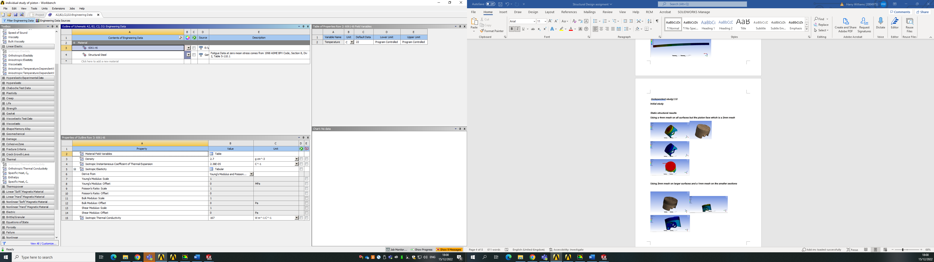
Figure 13 Initial material properties

Static structural results 5.1.1
Using a 4mm mesh on all surfaces but the piston face which is a 2mm mesh
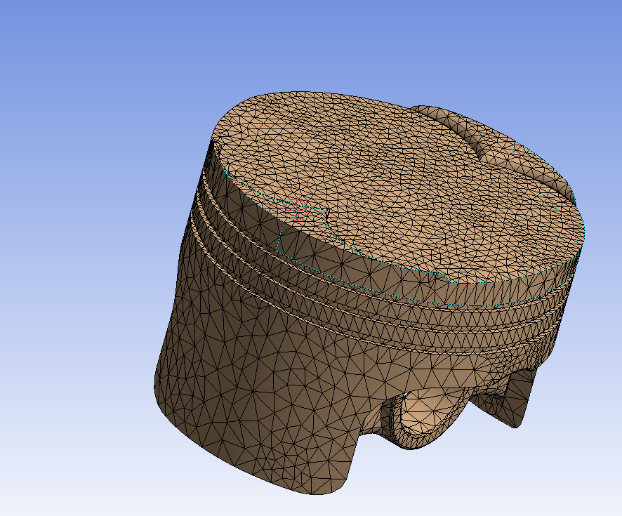
Figure 14 Initial mesh
the image displayed above shows the mesh used on the piston, which is 4mm on the larger surfaces, and then a 2mm mesh on the smaller surfaces.
The initial study using the material 6061 T6 aluminium produced results of.
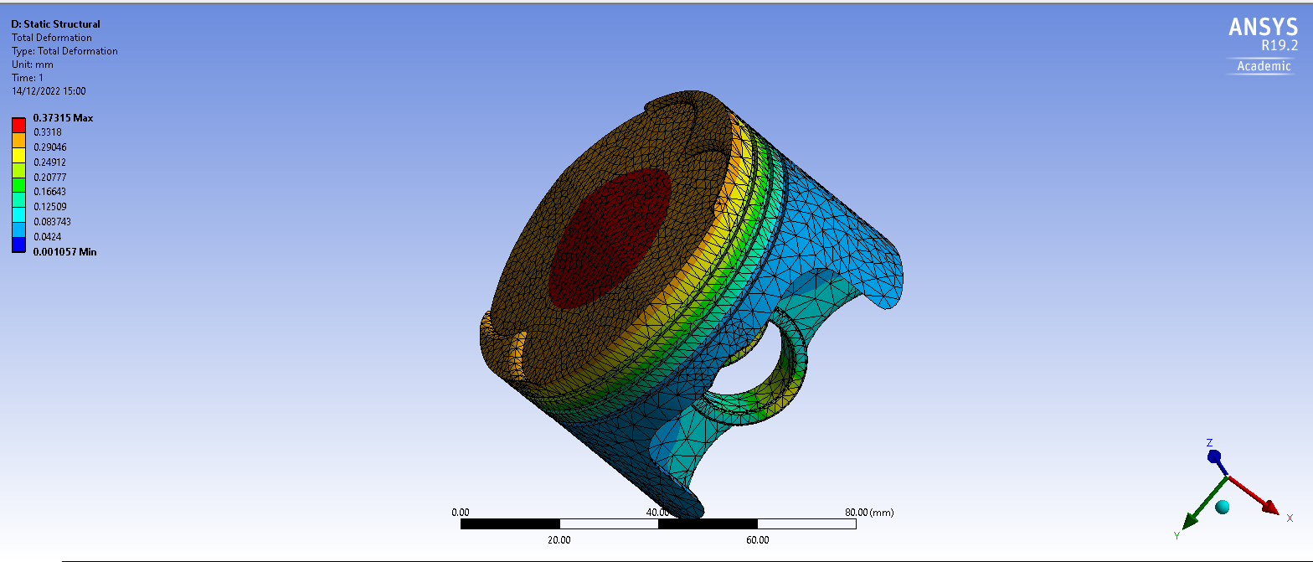
Figure 15 total deformation initial study
When investigating the total deformation, the material produced the max figure of 0.37315mm, where the max can be found on the piston face.

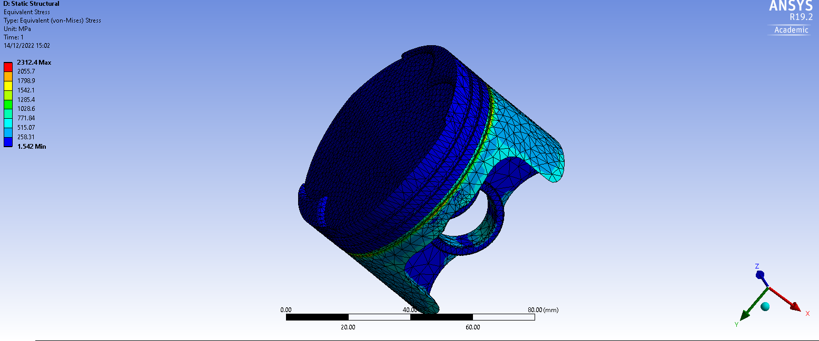
Figure 16 total stress initial study
When analysing the total stress of the piston the max value produced was 2312.4mm

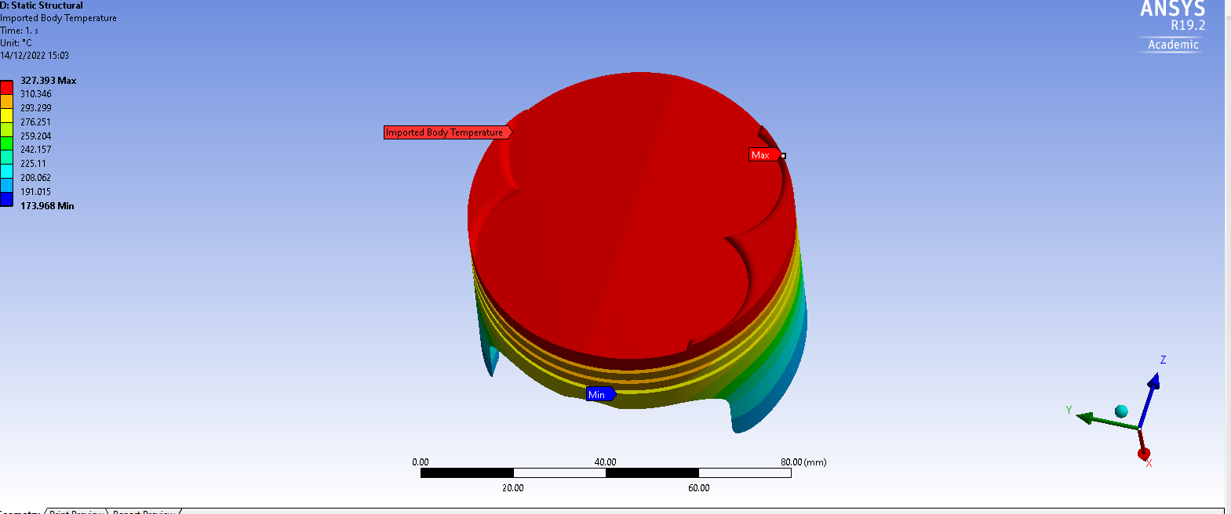
Figure 17 temperature initial study
The max temperature for the piston face when using the material was 327.93

Using 2mm mesh on larger surfaces and a 1mm mesh on the smaller sections
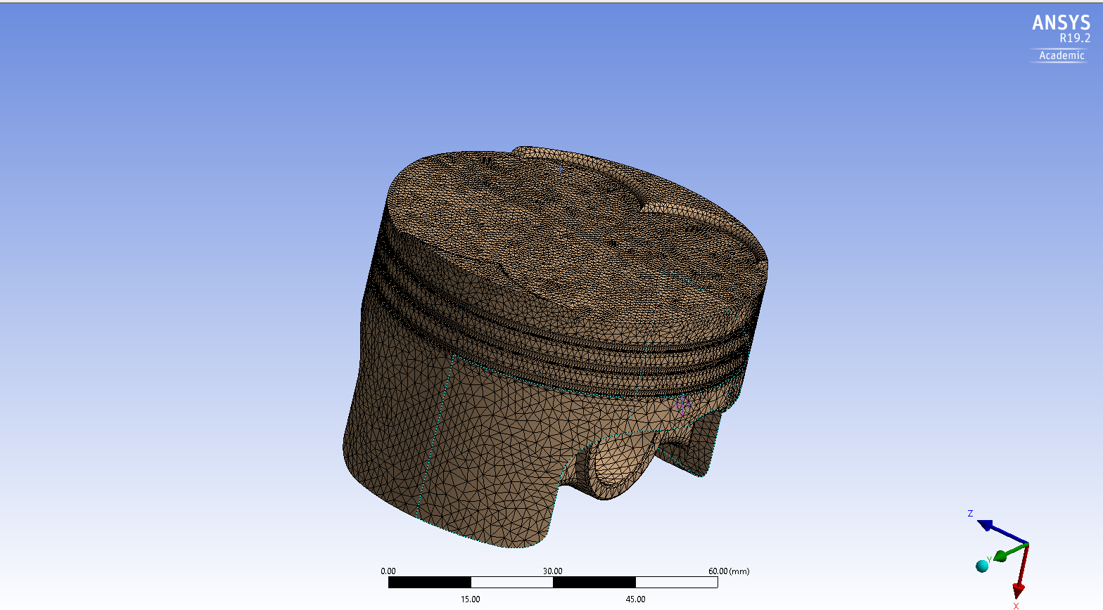
Figure 18 initial material, updated mesh
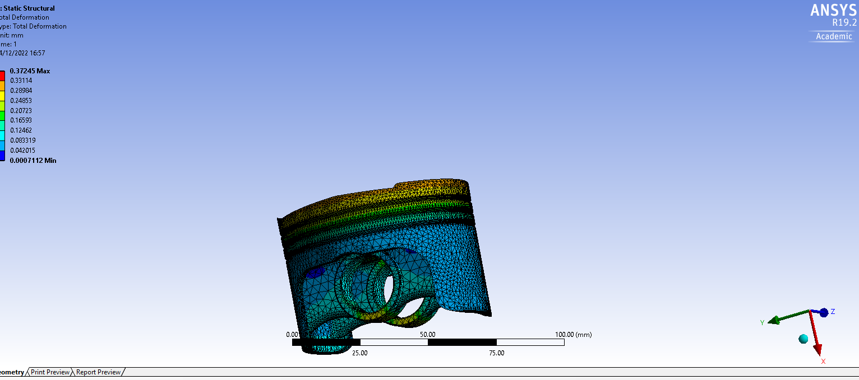
Figure 19 total deformation new mesh
Total deformation 0.373245
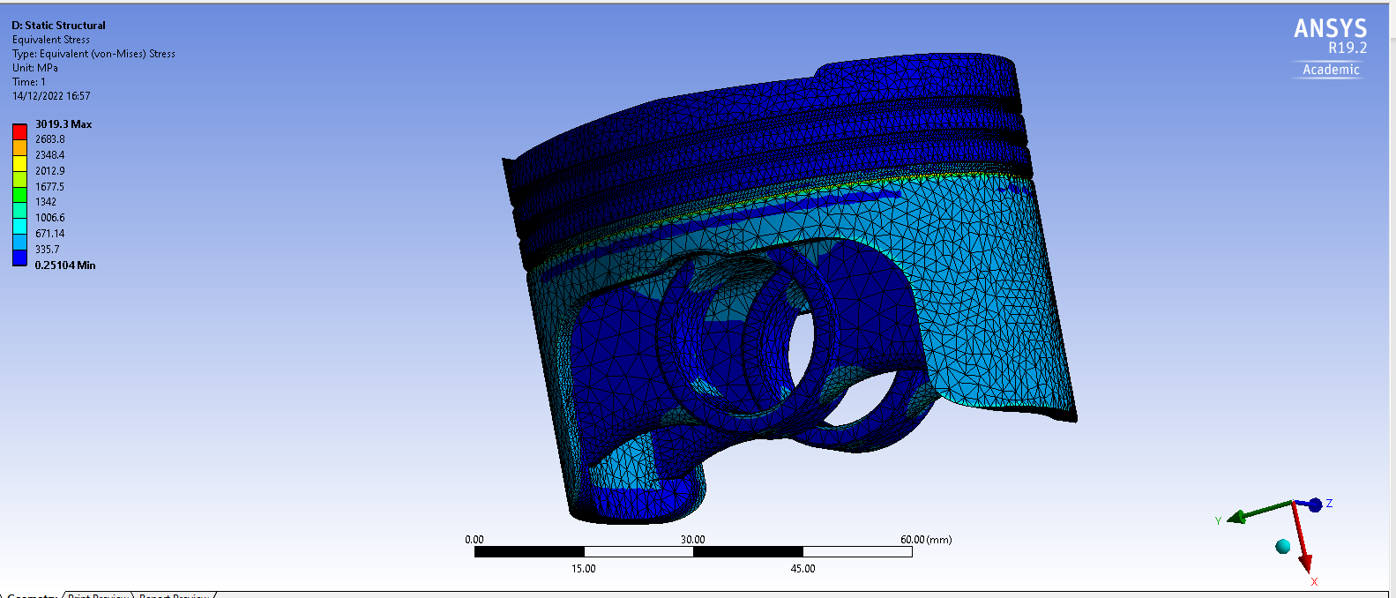
Figure 20 total stress, updated mesh
Total stress 3019.3
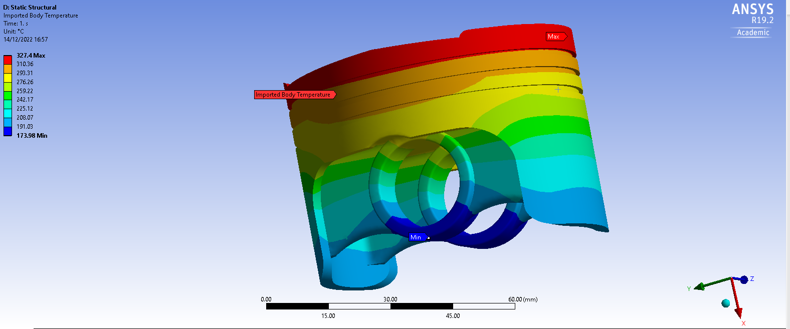
Figure 21 total temperature, updated mesh
Total temperature 327.4
It can be seen that when the mesh was changed from using a 4mm on the main body and a 2mm mesh on the smaller surfaces to a 2mm mesh in the main body and a 1mm mesh on smaller surfaces the results did change. Looking at total deformation the results changes by a 0.0254589% increase, the total stress changed by 30.57% increase and the temperature study results saw a change of = 0.16162% decrease. The investigated area that saw the most change was the total stress study.

Material 2 forged aluminium 5.2
To look to further improve the design of the piston I carried out an investigation of the piston using different materials to investigate how different material properties would affect the total deformation, equivalent stress and temperature of the piston when a pressure is applied to the piston face simulating combustion within the combustion chamber.
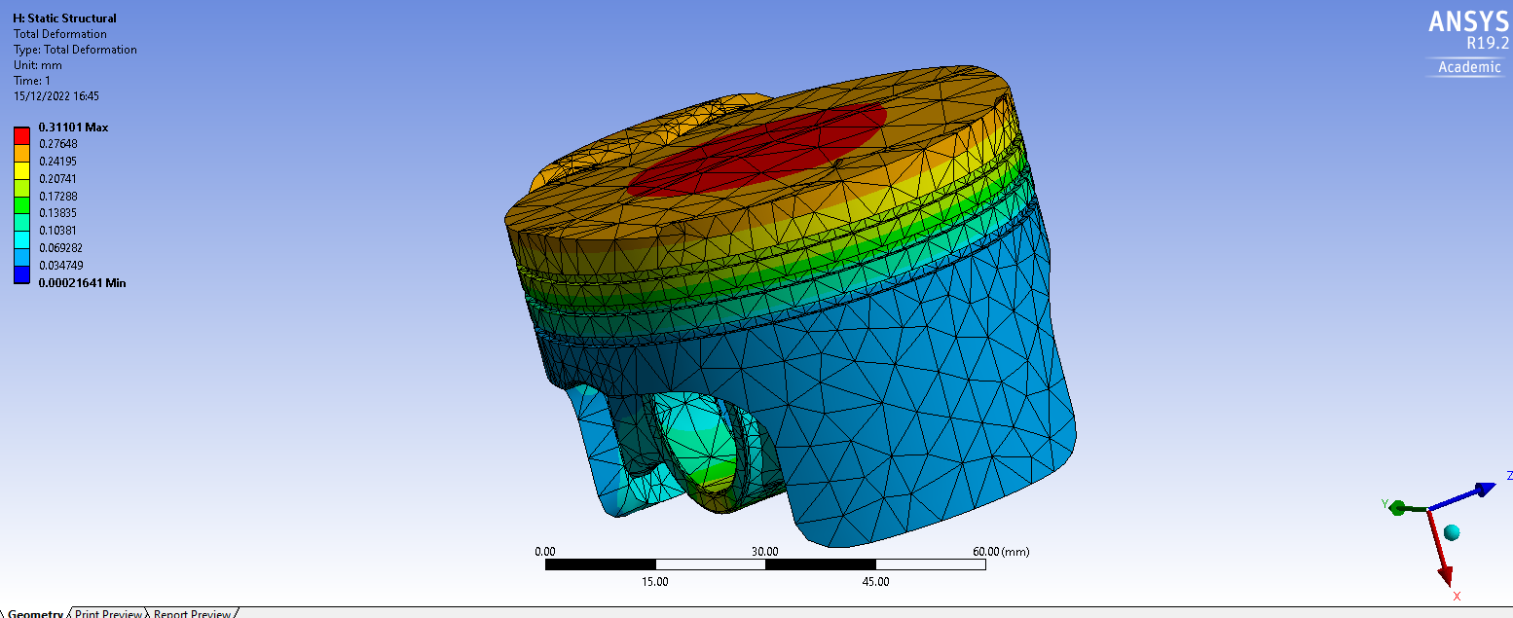
Figure 22 forged aluminium, total deformation
When using forged aluminium, the total deformation for the piston face was 0.31101
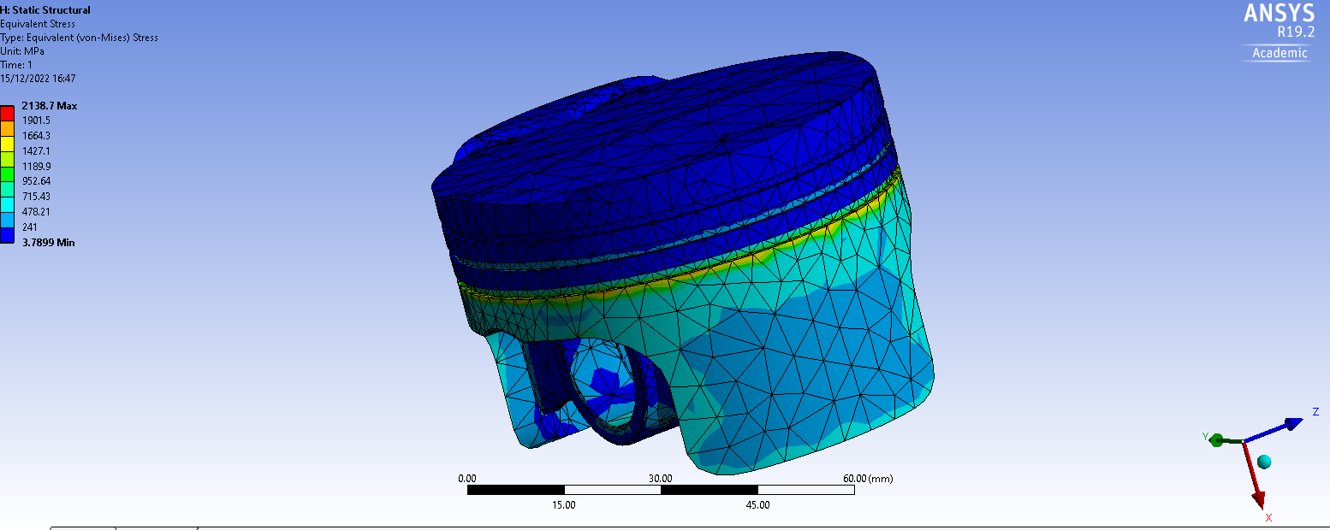
Figure 23 forged aluminium, equivalent stress
The mas equivalent stress was simulated to be 2138.7
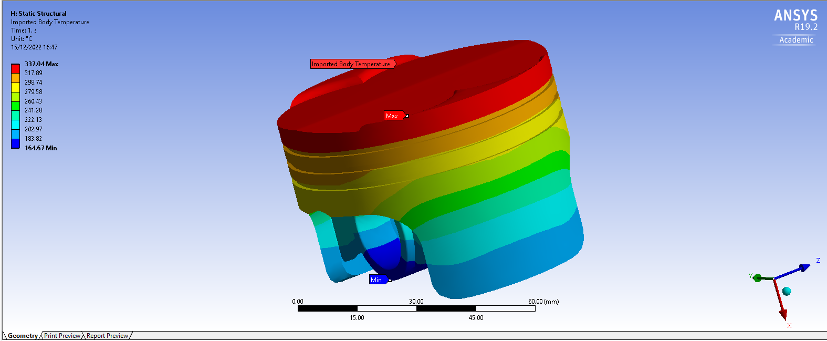
Figure 24 forged aluminium, temperature study
The max temperature the piston face produced was 337.04
Forged aluminium is a suitable material to use when designing a piston due to its mechanical properties, forging a material makes that material more reliable and it can be done for a very reasonable price, it increases the strength of the material which is suitable for a piston due to all the forces it will withstand. ““Unless you are rebuilding an engine with little to no budget you're going to upgrade to aluminium forged pistons. Besides being stronger than cast pistons, the lighter aluminium cuts parasitic power loss. That translates into more power at the wheels.” (Oct 8, 2008) it is a very commonly used material to upgrade your pistons to if you are looking to upgrade your engines internals on a budget this is due to the manufacturing costs of the material.
“Forging is the manufacturing process of hammering, pressing or rolling metal into shape. This is either delivered from a hammer, press or die. It is essentially the art of heating and working hot metal to design or shape that is fit for a specific purpose or use.” (Somers 1866) the process of forging a material improves its strength significantly, it makes a more reliable product and also the material can withstand heat better than before.
“Aluminium pistons transfer heat to the cylinder wall rapidly, running cooler and heating the incoming fuel-air mixture less than an iron piston.” (December 1st, 2021) when a piston material exports the heat to the cylinder wall more efficiently this is good as when the heat is mainly on the cylinder wall it can be cooled down more quickly due to the cooling systems on the engine which allows for a more effective piston design
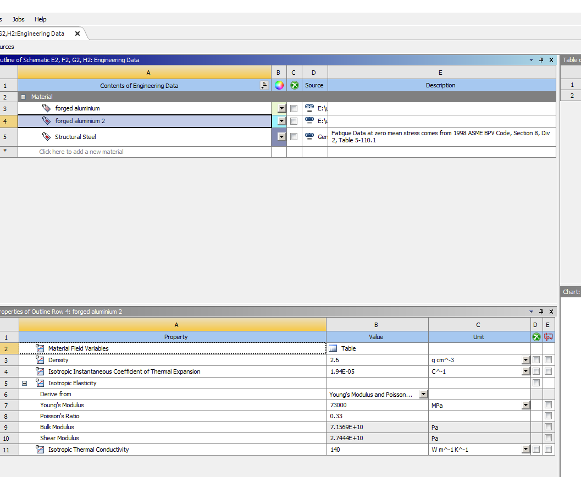
Figure 25 forged aluminium, material properties

Material 3 high carbon steel 5.3
For this material study the material chosen was high carbon steel….
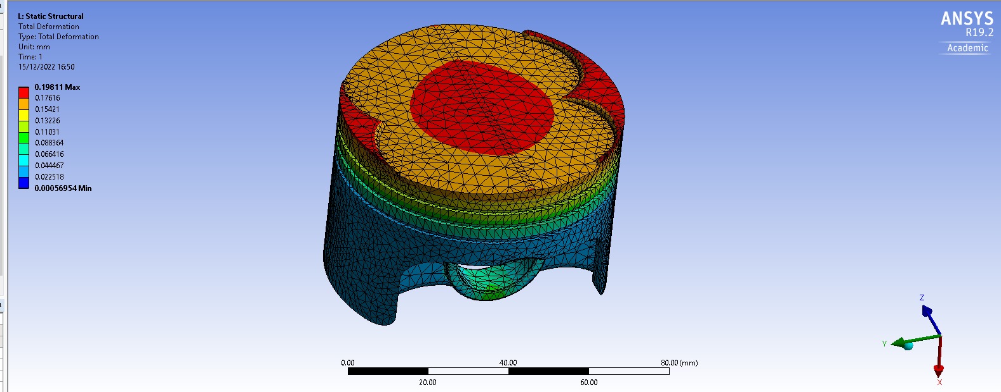
Figure 26 High carbon steel, total deformation
The total deformation on the piston when using high carbon steel was 0.19811
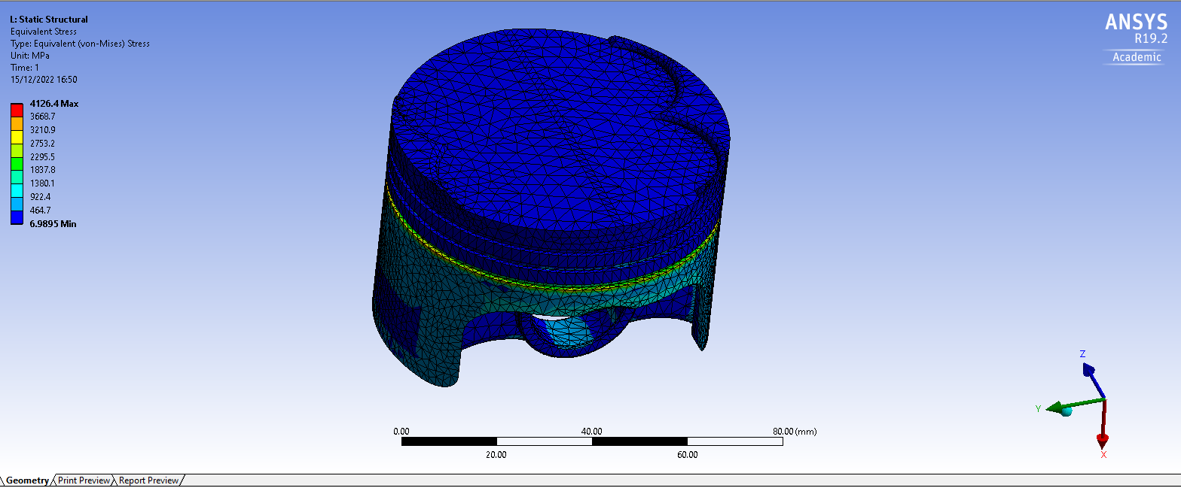
Figure 27 High carbon steel, equivalent stress
The total stress simulated was 2138.7
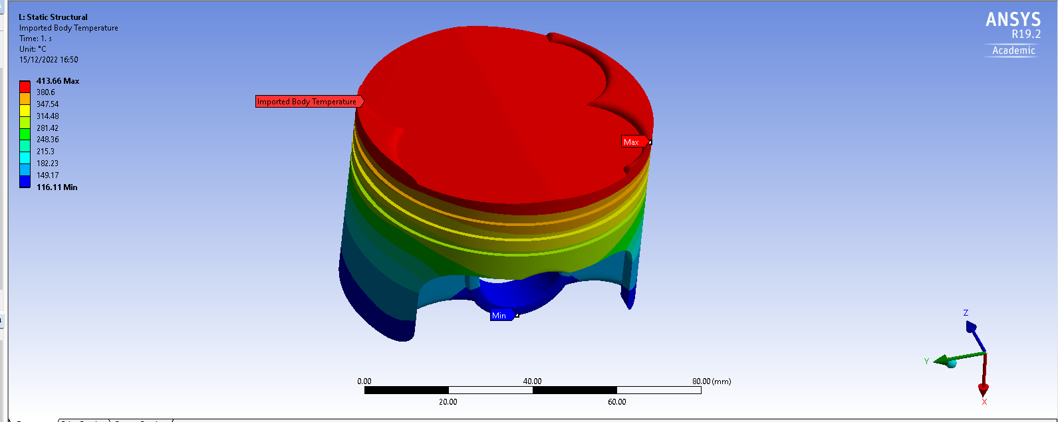
Figure 28 High carbon steel, temperature study
The max temperature simulated on the piston face was 413.66
High carbon steel is not a common material to be used for piston manufacturing, and is commonly found used in “cutting tools that retain their sharp edge, and masonry nails that can be driven into concrete blocks or bricks without bending” (Reliance foundry) however it can be used when manufacturing piston rings that is due to the material being very malleable and able to handle high temperatures, however there are down falls to high carbon steel, “High carbon steels are very hard, which makes them good at resisting abrasion and retaining shape. They can withstand significant force before deforming. Unfortunately, hard metals are also brittle: when placed under extreme tensile stress, high carbon steels are more likely to crack than bend” January 6, 2020) if this material was to be used for piston development the piston would be able to withstand the forces being applied to it however when placed in a engine with higher pressures the stress could crack the piston face.
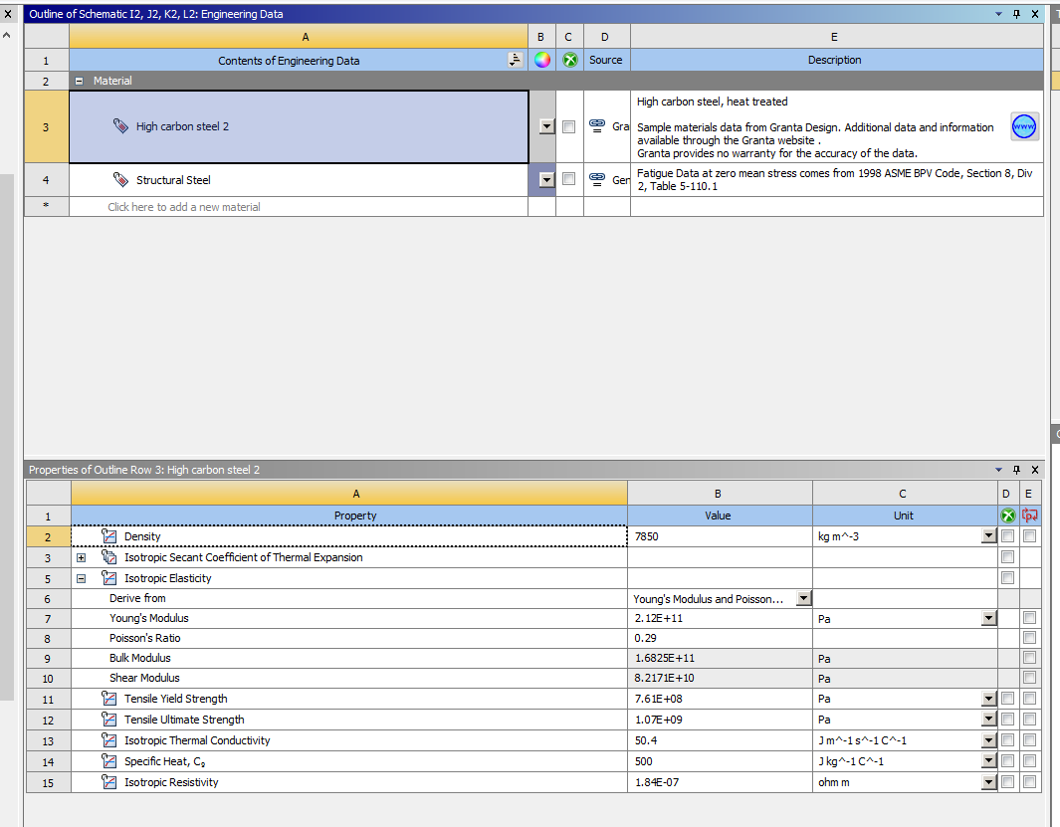
Figure 29 High carbon steel, material properties

Material 4 low carbon steel-heat treated 5.4
Following on from using high carbon steel I wanted to see the affected of using low carbon steel which has been heat treated to see the comparison between the two similar materials
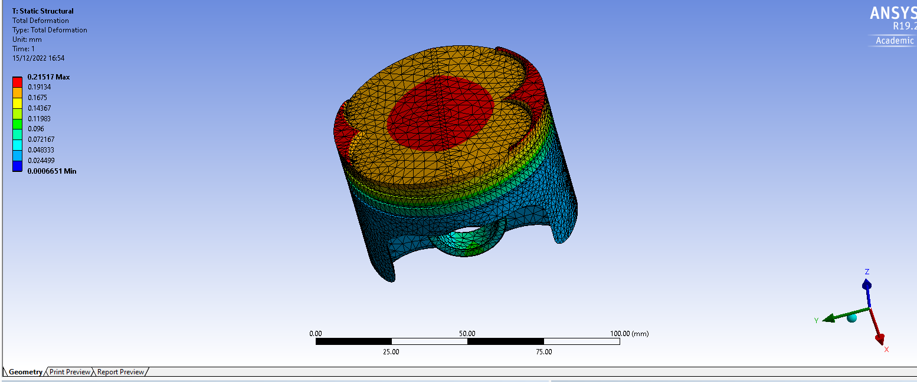
Figure 30 low carbon steel, total deformation
The total deformation for the piston when using low carbon steel was 0.21517
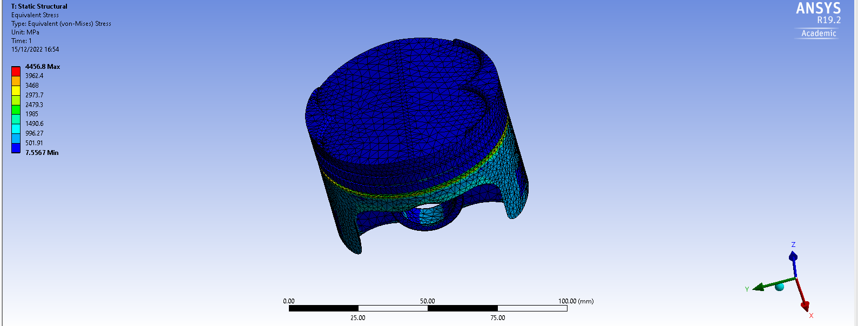
Figure 31 low carbon steel, equivalent stress
The total equivalent stress produced was 4456.8
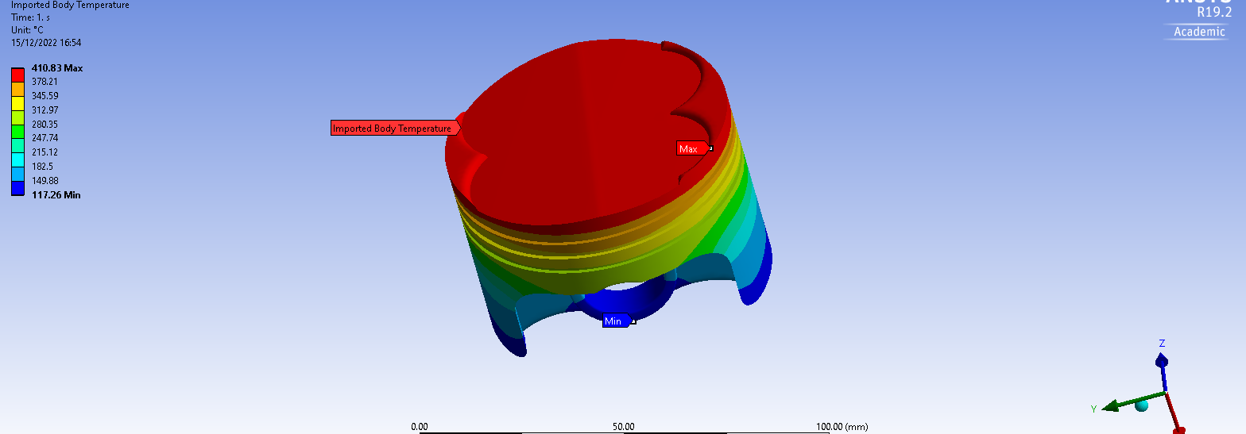
Figure 32 low carbon steel, temperature study

The piston face produced the max temperature of 410.83
Low carbon steel in industry is used for a variety of uses unlike high carbon steel. It can be commonly found in “Low carbon steels are often used in automobile body components, structural shapes (I-beams, channel and angle iron), pipes, construction and bridge components, and food cans.” (Mat match) however low carbon steel can be found used in pistons due to its properties “Pistons are made from either a low carbon steels or aluminium alloys. The piston is subjected to high heat, inertia, vibration, and friction. Carbon steels minimize the effects of differential thermal expansion between the piston and cylinder walls.”
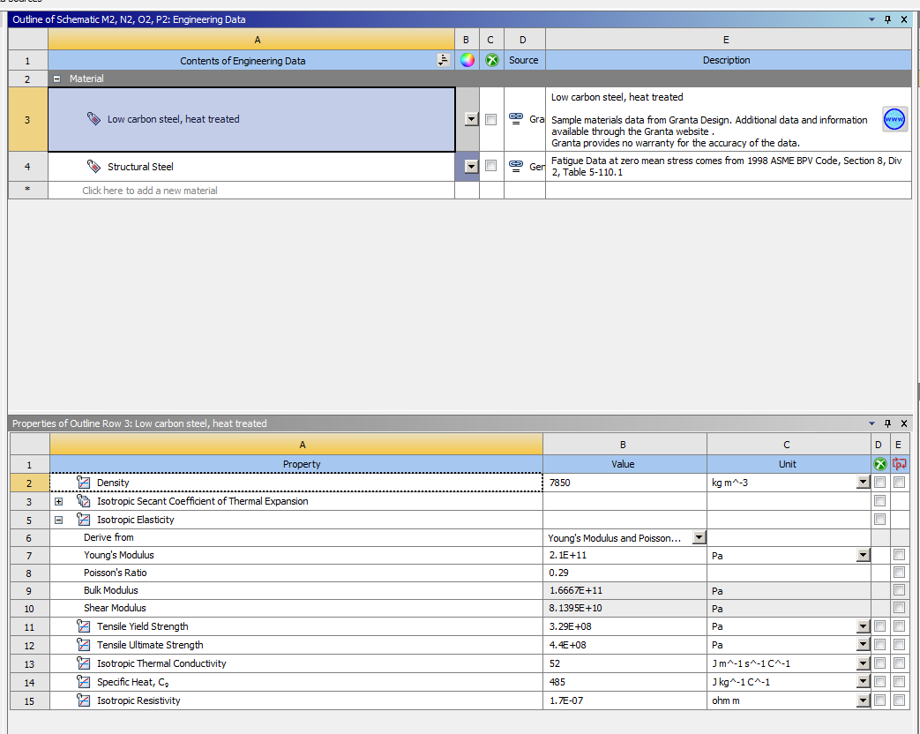
Figure 33 low carbon steel, material properties

Results discussion 6.0
material | Total deformation | equivalent stress | temperature
aluminium | 0.37245 | 3019.3 | 327.4
forged aluminium | 0.31101 | 2138.7 | 337.04
high carbon steel | 0.19811 | 4126.4 | 413.66
low carbon steel | 0.21517 | 4456.8 | 410.83
Table 3 all material results
Analysing the table above, it can be seen that when investigating the total deformation for all four materials that high carbon steel has the lowest amount of deformation, this means when the piston is undergoing combustion the material deforms the least and stays in its original condition the most out of all four materials tested.
When investigating the equivalent stresses on the piston and how much it affects the piston when in combustion, forged aluminium is the more suitable material to be used as it deals with the stresses acting upon the material the best with a value of 2138.7mm
Looking at how each material was affected by temperature the original material aluminium was best suited to this with a simulated value of 327.4c. by having a lower temperature when the engine is in operation the piston can be more effective and produce more power efficiently as stated above higher temperatures within the combustion chamber means less dense air which results in less power, so out of all four materials aluminium 6061 T6 has the lowest temperature and is the most effective in this area.
However, when looking at all of the results combined is can be seen that forged aluminium scored the best overall, although it only finished first in one category it was the most consistent in all areas being investigated, when analysing temperature, it placed second out of all materials with an equivalent stress of 337.04mm, and for total deformation it finished 3rd overall with a value of 0.37245mm

Conclusion 7.0
To summarise this project. The validation of the Anysis software using the cantilever beam and the bi-metallic strip was both a successful study as all results was within the margin of error stated a succeeded this with all results being lower than a 1.03% of error. When looking to improve the piston design by studying how different material properties would act the design was improved by using the forged aluminium it surpassed the original material in two out of the three areas being investigated and also was the overall best performing material.

References 8.0
Accessed on:4/12/2022
Available at: https://www.frontiersin.org/articles/10.3389/fpsyg.2020.00605/full#:~:text=meet%20this%20challenge.-,Validity,phenomenon%20it%20claims%20to%20measure. (A Framework for the Testing and Validation of Simulated Environments in Experimentation and Training, Manfred D. Roehrle)
Accessed on:4/12/2022
Available at: https://www.sigmamagic.com/blogs/is-my-measured-data-acceptable/#:~:text=For%20a%20good%20measurement%20system,precision%20error%20should%20within%2010%25. (Is my measured data acceptable?, Sigma magic analysis software)
Accessed on:
Available at: https://www.motortrend.com/how-to/hrdp-0810w-mahle-piston-alloy-comparison/#:~:text=Unless%20you%20rebuilding%20an%20engine,more%20power%20at%20the%20wheels. (Which Aluminum Forged Piston Is Right For Your Engine?, Courtesy Of Mahle Clevitephotographer, Oct 8, 2008)
Accessed on:4/12./2022
Available at: https://www.somersforge.com/what-is-forging/#:~:text=Forging%20is%20the%20manufacturing%20process,a%20specific%20purpose%20or%20use. (WHAT IS FORGING?, Somers 1866)
Accessed on:5/12/2022
Available at: https://www.reliance-foundry.com/blog/carbon-steel-versus-stainless-steel ( Carbon Steel vs Stainless Steel, Reliance foundry)
Accessed on:5/12/2022
Available at: https://matmatch.com/learn/material/carbon-steel ( Carbon Steel: Properties, Production, Examples and Applications, Mat match)
Accessed on: 6/12/2022
Available at: https://depts.washington.edu/matseed/mse_resources/Webpage/Engine/pistons.html (What's in an Engine & Why?, Pistons, 05/10/03)
Accessed on:7/12/2022
Available at: https://www.researchgate.net/figure/Contact-surfaces-of-piston-and-piston-pin-62-Deformation-of-the-piston-shape-Change-of_fig2_328237641#:~:text=Deformation%20of%20the%20piston%20shape,action%20on%20the%20piston%20crown. (Wladyslaw Mitianiec, Oct 2018)
Accessed on:7/12/2022
Available at: https://www.ijesi.org/papers/Vol(4)6/H046052061.pdf (Theoretical Analysis of Stress and Design of Piston Head using CATIA & ANSY, June 2015, Dilip Kumar Sonar)
Accessed on:10/12/2022
Available at: https://dieselnet.com/tech/combustion_piston-cool.php (Piston Cooling, Hannu Jääskeläinen)
Accessed on:10/12/2022
Available at: https://www.google.com/search?q=how+does+piston+temperature+affect+preformance&rlz=1C1CHBF_en-GBGB939GB940&sxsrf=ALiCzsZtDJ0O9XH6EnWekxX2UeAAqXGyeg%3A1671212438973&ei=lq2cY9KHO4jJgQax75eoBg&ved=0ahUKEwjSqpO-1_77AhWIZMAKHbH3BWUQ4dUDCA8&uact=5&oq=how+does+piston+temperature+affect+preformance&gs_lcp=Cgxnd3Mtd2l6LXNlcnAQAzIHCCEQoAEQCjoICAAQhgMQsAM6BAgjECc6CAghEBYQHhAdOgUIIRCgAUoECEEYAUoECEYYAFDWElifRmCfSWgEcAB4AIABWogBgRCSAQIyOJgBAKABAcgBBMABAQ&sclient=gws-wiz-serp (thermal effects of a diesel engine, sae international, Manfried, D.roehrie. 1978)
Accessed on:13/12/2022
Available at: https://www.cycleworld.com/story/blogs/ask-kevin/how-motorcycle-piston-temperature-affects-engine-power/ (pistons hot and cold, kelvin Cameron, cycle world, December 1st 2021)
Accessed on:13/12/2022
Available at: https://www.plm.automation.siemens.com/global/en/our-story/glossary/computer-aided-engineering-cae/13112 (computer aided engineers, SIEMANS)
Accessed on:13/12/2022
Available at: https://www.sae.org/learn/content/pd531241/#:~:text=Finite%20Element%20Analysis%20(FEA)%20is,widely%20implemented%20by%20automotive%20companies. (Finite element analysis (FEN), SAE international, quality- safety and maintenance finite element analysis)
Accessed on:15/12/2022
Available at: https://pes-performance.com/pes-performance-services/kinematics/#:~:text=Kinematics%20is%20a%20simulation%20showing%20where%20all%20of%20the%20parts,associated%20parts%20are%20also%20critical. (Kinematics, PES performance)
Accessed on:16/12/2022
Available at: https://courses.ansys.com/wp-content/uploads/2019/04/1.3.4-Equivalent_-Stress-_-rebranded.pdf (Equivalent stress, solid mechanics I-understanding physics, anysis)
Accessed on:16/12/2022
Avliable at: https://petropipesvalves.com/carbon-steel/#:~:text=High%20carbon%20steels%20are%20very,likely%20to%20crack%20than%20bend. (Carbon Steel
January 6, 2020)

Appendix 9.0
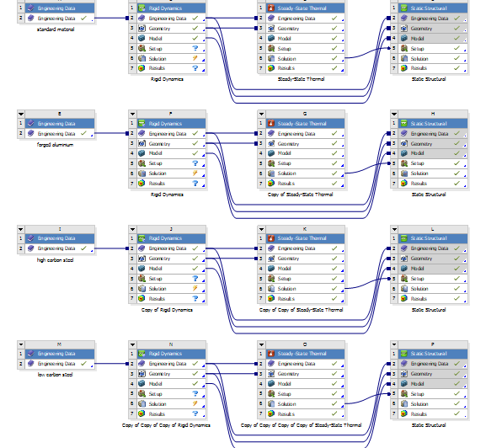
Figure 34 anysis workbench, all systems on one image
$$\frac{(V2-V1)}{V1}x100=pertange of error$$
Equation 4 equation for percentage of error

