UNIVERSITY OF WALES
TRINITY
SAINT DAVID
Emergent Leadership Skills in the Workplace
Dr. Eric Osei
This Photo by Unknown Author is licensed under CC BY
BMSW6101
Task 2: (Academic Report)
The NHS: The Many Challenges for Leadership
Peolita Douglas- 1911615

Contents Page
Introduction Page 3
Difference between leadership and management Page 4
Effective Leadership styles Page 6
Effective Leadership skills Page 8
Leadership styles in COVID-19 Era Page 9
Ethical Leadership Page 11
Conclusion Page 13
Bibliography Page 14

Introduction
In this report it is highlighted the new chief executive Amanda Pritchard (2021 of NHS England), has been assigned to re-establish the NHS Health system regarding the high increase of pressure that COVID-19 has created on a global scale.
As suggested by Lancet (2021), ‘The country has fallen behind in the coordination of care and in equity’. The changes that were put in place regarding the COVID-19 pandemic, was not supported by the union leaders, as they expressed the timing was wrong. The effects of COVID-19 have increased the NHS workload, however as there is already effects of health issues this has made the situation even more demanding.
Throughout this report there will be several topics discussed to identify the types of leadership and management that need to be applied within the NHS Healthcare system. Following on will be a breakdown analysis of effective leadership styles, effective leadership skills regarding what the new chief executive needs to address in her job responsibilities.
Furthermore, will be an account how Amanda Pritchard will manage the crisis of COIVD-19 within the NHS giving a breakdown of her leadership styles with explanation of leadership theories such as task-oriented leadership, transformational leadership, authoritarian leadership and bureaucratic leadership. Ethical leadership will also be mentioned ending with conclusion.

Difference between Leadership and Management
‘Leadership is a process whereby an individual influences a group of individuals to achieve a common goal’ (Northouse, 2007). This demonstrates leadership is about the leader setting goals and directing managers to accomplish these goals. Leaders’ tasks are to excel for the future whereas a manager’s responsibility is to process the task in the present working environment. Example of leadership is, in the NHS there would be a clinical service where the leadership is divided by head consultant, operational lead, and nursing lead this is known as ‘Triumvirate’.
‘Your role as a manager is to set direction for your team and coordinated resources to meet your organization’s goals’. (Harvard, 2017, page 7). This suggests managers are required to have the skills to produce the goals that is expected from their leader. The manager will divide the tasks amongst their teams, motivating them to complete the goals in the working environment, with many complex responsibilities. Managers are required to have the skill to produce these goals the manager needs to encourage their employees to process the day-to-day tasks to be completed. For instance, in the NHS department, the manager would be titled Unit Nurse Leader, their responsibility would be to make sure the subordinate staff would complete their day-to-day procedures within their appointed wards.
Leadership and management however the differences are few and far between here are some points why. ‘Leadership and management are often considered to have overlapping functions. While this can be true, these two terms have different meanings and should not be used interchangeably. Both imply a unique set of functions, characteristics, and skills that share similarities’ (Martic, 2020).
Leader’s aim is to create a followership gaining people to follow their lead whereas managers only request subordinates to do what they are required to do. Managers demand respect and exert their power over their subordinates; however, leaders use their power to encourage people through their vision and goals. With regards to goals being met leaders need to have a passionate attitude towards the vision, whereas managers create the process and plan to how the goals will be achieved. Leaders understand there will be trials to achieve their goals, they use that to their advantage to make a difference whereas managers try avoiding conflict at all costs, to prevent them from being distracted to complete the tasks.
Pritchard (2021) is viewed as a respected leader with optimism, however even if she does her best, the waiting list of NHS care will still rise which is unavoidable due to the pandemic. Pritchard will have to work harder to convince an already overstretched workforce, her aim is to reduce the number of patients needing care. There is a concern that the overall outcome has made the situation accelerate, this suggests that Pritchard need to apply the leadership where she meets the demands and needs of the patients and not distract herself from the needs the primary needs of the employees.

Effective Leadership Styles
The two styles that will be highlighted in this report will be task-oriented leadership and bureaucratic style leadership, this is highlighted through the NHS report to what is expected from the new chief executive.
Task oriented leadership is when the leader does not focus on the employees’ feelings but only to focus on completing the tasks within the workforce. For instance, Pritchard would be expected to focus on reducing the number of patients needing emergency care, however Pritchard would not take into consideration the enormous pressure that the subordinates may find themselves in.
Bureaucratic Style of Leadership is where the manager manages “by the book¨ Everything must be done according to procedure or policy’. (Saquib, Khan,2015, p90). Bureaucratic style of leadership is where the manager does everything according to procedure and policy, should the manager or leader not follow policy by the book they would refer to a next level above him or her. The leader would ensure that training and safety is always followed through the workforce, this is of paramount importance. This suggests should Pritchard feel any concerns of her leadership responsibilities, those issues would have to be addressed with the Health Secretary Sajid Javid.
The advantages of task-oriented leadership are there are step by step procedures for the managers to follow which maintain high standard for completion of the goals. This leadership makes it straightforward to complete results. The disadvantage of task-oriented leadership is there is lack of empathy for their employees, there is no time for team building, or employee feedback should they feel pressure in the working environment.
The advantage of bureaucratic leadership is there are clear terms to how the jobs should be completed. This leadership removes favouritism in the workplace, which enables all employees to be treated equally. The disadvantages of bureaucratic leadership are it does not focus on an individual’s personal growth, opinions, or beliefs. They do not collaborate as a team, rather only focus for the team of employees to complete goals.
Furthermore, it also states that Amanda must collaborate with other leaders from other health authorities that are on the same level of leadership. ‘Her key challenge will be eliciting the proper support from politicians’. (The Lancet, 2021, p559). This highlights that Pritchard is expected to focus on the political issues within the health system, rather than the individual needs of the NHS staff, this is an example of Bureaucratic leadership.

Effective Leadership Skills
It is evident in the case study that Pritchard comes across to be hardworking, believes in positive outcomes as she is optimistic, along with determination to overcome the challenges of the NHS during the pandemic. (Lancet, 2021) suggests the leader should strengthen the long tradition clinical research, to be proactive in dealing with the NHS, to be strong in a broad public sector. To encourage the welfare of the workforce.
The case study identifies Pritchard would have to stay determined in executing the tasks and keep control and focus in directing all members of the health department. This provides Pritchard influencing the staff leaders to provide the care needed making these quick changes with stable control. Amanda’s leadership skills can benefit the NHS in reducing the pressure of providing care for patients, as suggested by Lancet (2021), Amanda’s challenging work and optimism would encourage stability and trust from other heads of services within NHS that she can accomplish reaching these goals.

Leadership Styles in COVID-19 era
Overall, during the global pandemic regarding COVID-19, it was recognised that the government leaders along with the health secretary had to make quick changes in order to put in place emergency measures to reduce deaths amongst the population in Britain and patient care. It was high concern from managers of various hospital departments, along with numerous government officials noticing the increasing levels of hospital waiting lists, patients.
There was diverse number of leadership styles that were adapted and shown in the case study regarding COVID-19 and how Pritchard and the department had to lead their health service, the effective leadership skills that are evident in the case study are transformational leadership, authoritarian leadership, and bureaucratic leadership.
Transformational leadership style and authoritarian leadership were both portrayed in the way the leaders had to adapt and progress their leadership style during the high demand of COVID-19 to keep the health department under control. Yukl (2010) suggests that “Transformational leadership styles expressed moral values of followers in their efforts to raise their awareness about ethics and to assemble their resources and reform their foundations within the health department”. Transformational leadership shows a positive outcome for leaders in all departments of the health culture and government, this is because this leadership style enhanced leaders to motivate all departments while implementing latest changes to help reach their goals. For instance: the health department brought trainee nurses and doctors to support their services for COVID-19 patients before they were completely qualified. Retired doctors and nurses were asked to returned services which changed the policies to complete their objectives of reducing the waiting list for health care.
Another positive outcome is all leaders within the department were able to work on a bureaucratic leadership style also because they still had to show passion to provide the care for their patients along with changing their day-to-day process, and still be able to reach their objectives from Pritchard. Furthermore, Pritchard would still have to adapt authoritarian style of leadership because Pritchard would have to strong authority and control subordinates without any questions or regards to the pressure the health departments are working under, this is evident as a negative outcome towards employees feeling encouraged.

Ethical Leadership
Ethical leadership is about showing you have principals, demonstrating normatively and performing appropriate conduct through personal actions and when making decisions in both management and leadership. ‘Ethical leadership is leadership centered around appropriate conduct through respect for ethics and values, as well as the rights and dignity of others. Ethical leadership can provide value to businesses by inspiring employees to be motivated and live up to the company’s values’ (Indeed Career Guide, 2021). This quote supports the idea that ethical leadership is an important part of one’s leadership style when managing an organisation in showing integrity, respect to employee’s values.
Ethical leadership values include honesty, respect, community, integrity these highlight a standard in ways ethical leadership can prevent conflict an unfairness within the working environment. ‘Ethical leadership is concerned with treating followers fairly, setting an ethical example to others and actively, managing morality. This leadership style is especially desirable within the healthcare sector where the most vulnerable are being cared for’ (Impact, 2019). This quote supports the case study regarding the NHS because, the case study (Lancet, 2021) highlights that the NHS require leader who will help support the wellbeing of both staff and patients within health care system showing equality, taking their values, and respecting the community in all areas.
Ethical leadership also requires the leader within the organisation to make good decision making alongside respecting the employees’ values, someone who is able to show support, loyalty and set boundaries, this is requested within Pritchard’s work expectations during her leadership throughout the health departments.
According to Lancet (2021), It is suggested Pritchard needs to strengthen long tradition of clinical research within the health system. Her key challenge would be to obtain the full support from the politicians. Amanda would need to be fair minded and buoyant in her leadership when dealing with the pressures of the NHS healthcare during the COVID-19 pandemic.
Another direction highlighted from Lancet (2021), is Pritchard would have to make strong effective decisions regarding the fast-paced changes that needed to be met during the pressures of the workforce within the NHS health care system. This demonstrates the integrity and preparation of Pritchard as a leader.
Overall, should Pritchard apply all the leadership styles and effective leadership skills mentioned this could help Pritchard achieve reducing the patient care needed, also Pritchard would be able to motivate other heads of department to reach their full potential in progressing through this pandemic on through their day-to-day services.

Conclusion
In conclusion regarding leadership and management there is priority that Amanda Pritchard should focus on leadership first, leading the heads of service and managing the national health, which will enable Pritchard to stay focused on the goals. This enables for her leadership to encourage all departments and drive throughout the health care system with all leaders involved in making decisions.
Overall, in discussion to effective leadership, it has come to a result that bureaucratic leadership is the most effective leader style that Pritchard should apply throughout the COVID-19 era as this would help achieve the goals. Transformational skills encourage leaders to motivate their employees while working in an ever-evolving environment.
Ethical leadership demonstrates the importance to applied in both Amanda’s leadership and management skills due to showing her care of individuals wellbeing both to her subordinates and to how Pritchard communicates heads of departments.
However there is a disadvantaged while Pritchard is aiming to achieve these goals for the health department, the smaller risk is using task oriented leadership can cause conflict for the subordinates and general public who still may feel their services are not working quick enough, lives will still be lost which can enhance patient unsettlement, job dissatisfactory which was unavoidable during the COVID-19 era.

Bibliography
Pears, R. and Shields, G. (2016) Cite them right: the essential referencing guide. 10th rev. edn. Basingstoke: Palgrave
Articles
Guan, B, Wang, H (2018). The Positive Effect of Authoritarian Leadership on Employee Performance: The Moderating Role of Power Distance. Pychol, F FrontiersPsychology (Online) Available at: (https://www.frontiersin.org/articles/10.3389/fpsyg.2018.00357/full) (Accessed 28th March 2022)
Impact. (2019). What Are the Factors Affecting Ethical Leadership in the NHS? [online] Available at: https://www.workwithimpact.co.uk/news/what-are-the-factors-affecting-ethical-leadership-in-the-nhs/ [Accessed 1 Apr. 2022].
Books
Peter Guy Northouse (2007). Leadership: Theory and practice. Chapter 1, Page 3. 4th Edition. Thousand Oaks. Sage Publications, (Accessed 13th March 2022)
Harvard (2017). Harvard Business Review Manager’s handbook: the 17 skills leaders need to stand out. Chapter 1, Page 7, Boston, Massachusetts: Harvard Business Review Press. (Accessed 13th March 2022)
Blogs
Doyle, L. (2019). Leadership vs Management: What’s the difference? (Online) available at: https://www.northeastern.edu/bachelors-completion/news/leadership-vs-management/. (Accessed 12th March 2022)
Indeed, Career Guide. (2021) How to Improve Ethical Leadership Skills (With Examples) Indeed.com, September 2021. (Online) Available: https://www.indeed.com/career-advice/career-development/ethical- leadership#:~:text=Ethical%20leadership%20examples%201%20Set%20an%example.%20Ethical (Accessed 1st April 2022)
Martic, K, (2020). Leadership Vs Management: The 5 Main Differences. (online) blog.smarp.com available at: https://blog.smarp.com/leadership-vs-manegement (Accessed 22nd March 2022)
Martic, K. (2020). Leadership vs Management: The 5 Main Differences (online) https://www.blog.smarp.com/leadership-vs-management (Accessed 13th March 2022).
ResearchGate. (n.d). (PDF) Leadership Theories and Styles: A Literature Review. (online) Available at: https://www.researchgate.net/publication/293885908_Leadership_Theories_and _Styles_A_Literature_Review (Accessed 14th March 2022)
Journals
The Lancet. (2021). The NHS: the many challenges for leadership. The Lancet. 398 (10300), P 559. (Accessed 21st February 2022)
The Lancet. (2021). The NHS: the many challenges for leadership. The Lancet. 398 (10300), P 559. (Accessed 25th February 2022)
Saqib Khan, M., Khan, I., Qureshi, Q., Ismail, H., Rauf, H., Latif, A. and Tahir, M/ (2015), p87- p92 The Styles of Leadership: A Critical Review. (online) available at: https://www.ioste.org/Journals/index.php/PPAR/article/viewFile/20878/21131
(Accessed 14th March 2022)
Research gate (2020). Effect of Transformational and Transactional Leadership Style on Public Health Centre Performance. (Online) researchgate.net available at: EFFECT-OF-TRANSFORMATIONAL-AND-TRANSACTIONAL-LEADERSHIP-STYLE-ON-PUBLIC-HEALTH-CENTRE-PERFORMANCE.pdf (researchgate.net). Volume 2 February 2020 Edition, Issue 1, Page 305. (Accessed 25th March 2022)

Websites
Key Difference. (2015). Difference Between Leadership and Management (with examples and comparison chart). (online) https://keydifferences.com/difference-between-leadership-and-management.html# (Accessed 13th March 2022)
Lees, S. (2020). What is Bureaucratic Leadership? (online). Torch. Available: https://torch.io/blog/what-is-bureaucratic-leadership/#:~:text=What%20Are%20Pros%20and%20Cons%20of%20Bureaucratic (Accessed 14th March 2022)
BrainKart. (N.d.). McGregor’s X and Y Theory- Theories of Motivation (online) Available at: https://www.brainkart.com/article/McGregor-s-X-and-Y-Theory_37732/ (Accessed 14th March 2022)
Cleverism. (2017) Bureaucratic Leadership Guide: Definition, Qualities, Pros & Cons, Example. (online) Available: https://www.cleverism.com/bureaucratics-leadership-guide/#:~:text=THE%20QUALITIES%20OF20OF%20A%20BUREAUCRATIC%20LEADER%201%20Detail-oriented. (Accessed 18th March 2022)
Salary.com (2021). Head Nurse Job Description/ Salary.com (online) Availablee at: https://www.salary.com/research/job-description/benchmark/head-nurse-job-description (Accessed 18th March 2022)

Wordcount: 2306

UNIVERSITY OF WALES
TRINITY
SAINT DAVID
Emergent Leadership Skills in the Workplace
Dr. Eric Osei
This Photo by Unknown Author is licensed under CC BY
BMSW6101
Task 2:
Reflective Essay

Peolita Douglas- 1911615

Contents Page
Introduction Page 19
Feelings Page 20
Evaluation Page 22
Conclusion Page 23
Bibliography Page 24
Appendices Page 25

Introduction
Within this report I will share my evaluation of the modules taught throughout the course and explain what activities, discussions, and sessions I feel relevant to my learning in the future regarding emergent leadership skills in the workplace. My favourite sessions overall were the survey and learning about my own leadership style and identifying my leadership skills, this module helped me find out what my strengths were and where I can improve as a leader in the workplace.
It was interesting to at the start to see there was various ways one as an individual can become a strong and effective leader through the various types from democratic, to task oriented, people orientated, I found it interesting to learn that some leaders lead by their relationships towards the organisation they are leading while others where leading by the tasks they need to reach. It was good to see what can motivate a leader to lead.

Feelings
My first reaction I was very intrigued to discover there were various leadership styles around which enabled me to find out my type of leadership style is democratic. This was a positive outcome because I felt there was other leadership styles, I should incorporate alongside being a democratic leader, this is because I learned that you should change your style of leadership to meet the situation and accomplish your goals, depending what work environment I am in.
For instance, I have had experience running my own business where my leadership style as a democratic leader and people-oriented leader worked because I needed to have understood for my workers (see appendix 1). However, in the future I would adapt task-oriented leadership along with democratic leadership because as a task-oriented leader, when you need to meet goals it is not always the right approach with your team of workers, as you could be distracted and seen as soft and laid back which can cause lack of motivation where targets can be missed.
Regarding some of the tasks during this module, the presentation was not my favourite experience due to not liking public speaking, however I was still able to learn what the key objectives were when sharing about the two diverse types of leadership, which was people orientated and task orientated. This part of the module helped me reflect on the disadvantages and advantages of people orientated leadership and task orientated leadership.
At the start I thought this was module was remarkably interesting while at the same time I felt overwhelmed by the pressure of finding out the various differences, because it was hard to choose between what type of leadership style I preferred to be as some leadership styles had similar traits which was hard to separate when analysing myself as a leader.
However, this module help me discover I could be a people orientated leader and incorporate task orientated leadership also to enhance a better outcome when working professionally in the future.
I feel from the sessions within this module, it would have been beneficial to elaborate more on other leadership styles such as administrative, interpersonal and conceptual as I felt these types of leadership were not explained in depth, I feel this session should have had more in-depth discussion. However, when researching in my own time, I could identify where interpersonal leadership skill was like people orientated leadership and democratic leadership. I also discovered Conceptual leadership matched with traits from task-oriented leadership.
I would have liked to do more questionnaires which I feel helps us as individuals reflect on our strengths and work improvement in our leadership skills and styles. This would be beneficial all students could both discuss and share their work experiences highlighting the theories we have been taught.

Evaluation
Overall, during this module what worked well for me as a student was actively learning in class, whereas learning via online I found to be difficult at times, this is because I feel there would be better social interaction which helped me analyse my opinions better when sharing my views and feedback with other peers in class.
The case study was complex due to not understanding some of what was asked to identify, it was difficult with some elements of the case study, however once we were given the structure of the case study it became easy to identify.
During my own learning there was advantage in seeking various feedback from other companies who shared their thoughts on their leadership styles. For instance, learning this module enabled me to speak to other relatives/peers who worked within NHS (see appendix 2), social work and retail that shared what leadership styles they recognised in their work field which helped me because I was able to identify what the leadership styles were.
A disadvantage of my learning through this module was doing the presentation, I give better direction of voicing my opinion when writing in an assignment rather than speaking publicly. In future I feel the sessions could have added examples of public speaking presentations which would help me gain confidence in presentations.
I feel if we had more interaction activities during this module, showing different leadership styles through workshops, role play, one to one and group discussion this would have enabled me to grow a better understanding, also enabling me to learn equally with other peers, where it is an advantage to learn together as learning on your own via online can be isolating and you can doubt your own views.
When reading in my research regarding leadership styles and skills it was interesting to recognise various leadership theories interlinked with each other. This gave me clarity that I was on the right track when finding evidence to support my opinions in learning this module.

Conclusion
For action plan I hope to return to employment within the public sector as a manager and hope I can incorporate some of the leadership skills and leadership styles, to work effectively in the future.
If I could do things differently as explained above, I would do more workshops, questionnaires, practical sessions less online sessions and I would have group sessions where we can discuss our views together, this would benefit our learning as I feel social interaction can be an advantage when learning about leadership styles.

Bibliography
Books
Owen, J. (2020). LEADERSHIP SKILLS HANDBOOK: 101 Essential skills you need to be a leader. (Accessed 1st April 2022)
Blogs
Becker, B. (2020). The 7 Most Common Leadership Styles & How to Find Your Own. (online) Hubspot.com. Available at: https://blog.hubspot.com/marketing/leader-styles (Accessed 1st April 2022)
Articles
The Lancet (2021). The NHS: the many challenges for leadership. The Lancet 398 (10300), p.559. (Accessed 24th March 2022)
Lee, E. (2021). Leadership Styles. (online) CPD Online college. Available at: https://cpdonline.co.uk/knowledge-base/business/different-leadership-styles/. (Accessed 1st April 2022)
Videos
EPM (2019). Gibb’s Reflective Cycle Explained. YouTube. Available at: https://www.youtube.com/watch?v=gbczr0IRf4. (Accessed 1st April 2022)
Websites
St. Thomas University (2014). What is Task-Oriented Leadership? (online) St. Thomas University Online. Available at: https://online.stu.edu/articles/education/what-is-task-oriented-leadership.aspx. (Accessed 1st April 2022)
IMD (2021). The 5 Leadership Styles you can use & how to implement each. (online) IMD business school. Available at: https://www.imd.org/imd-reflections/reflection-page/leadership-styles/. (Accessed 1st April 2022)

Wordcount: 1097

Appendices
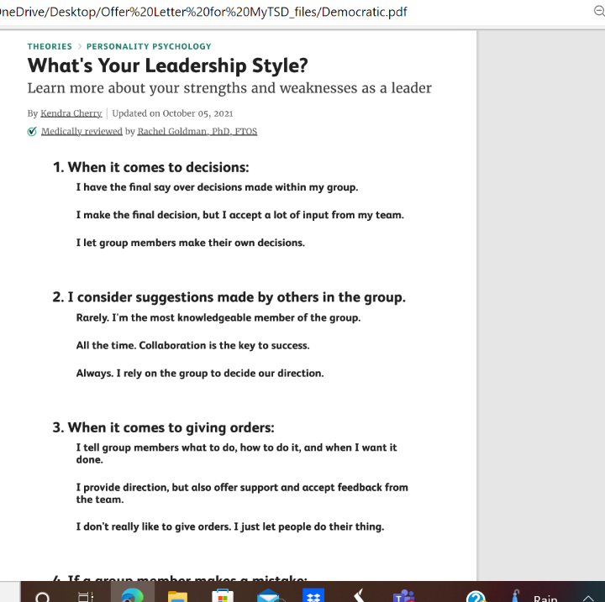
Appendix 1
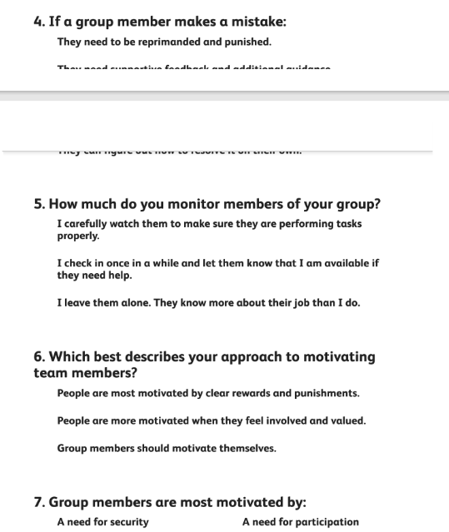

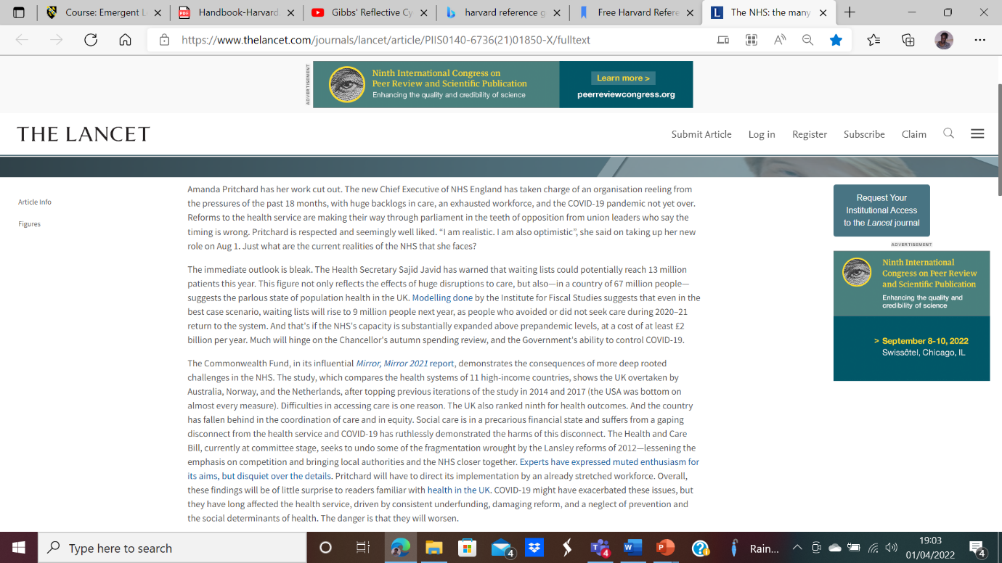
Appendix 2
THE NHS: The Many Challenges for Leadership / Editorial/Vol 398 Page 559 (www.lancet.com)

