Target 1 | Make further use of articles from journals to give your work more academic rigour.
Target 2 | Revise minor referencing errors in the reference list, i.e. referencing a journal article.
Target 3 | Proofread your work to ensure clarity of expression.
Target 4 | More detailed critical analysis.

Critically reflect on your pedagogical progress demonstrated through required elements of the Professional Learning Passport, identifying a specific area for professional development and justifying the next steps for improvement.

Link to Professional Learning Passport https://v3.pebblepad.co.uk/spa/#/public/kwhG4Zjrsr3hR83qznx768zRHW

Part 1
Reflection on Subject Knowledge Development

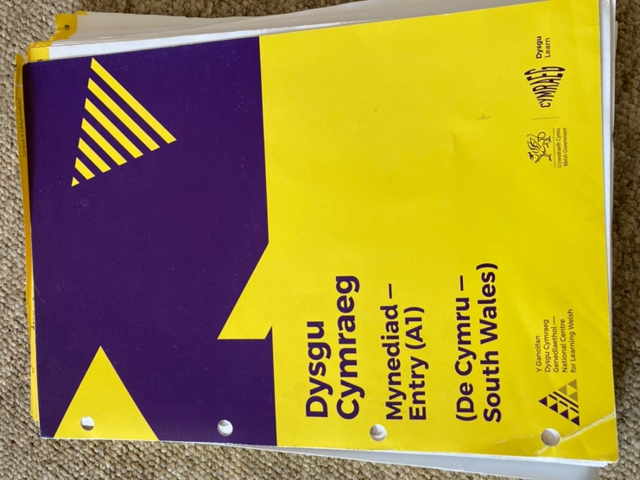
Welsh Language
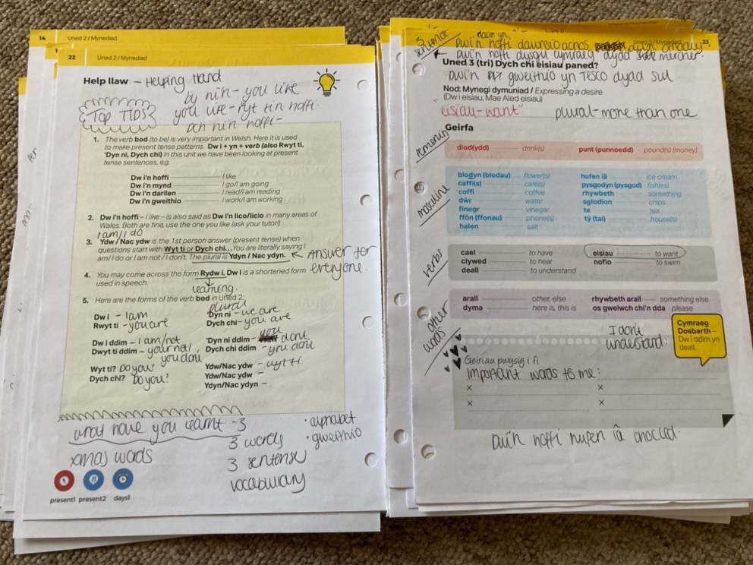
Dysgu Cymraeg Evening Course

My Welsh language skills and abilities have always been a priority of mine as a student-teacher. In reflection, I often feel like this will always be an area for my development as my confidence in using the language is not high. As a result, I enrolled on an evening Welsh class with Dysgu Cymraeg Level 2 at the start of September 2020, and this takes place over the virtual platform Zoom every Wednesday evening from 6 pm until 8 pm. I aim to improve my subject knowledge and development towards the Welsh language and to feel more confident using it in the school environment. Throughout the 2-hour session, we have covered many aspects of the Welsh Language through group work. Past evening classes have involved becoming familiar with the alphabet, repeating and drilling words, exploring new vocabulary, using short sentence patterns and understanding mutations.

Developing my subject knowledge and attending the evening class has positively impacted my confidence whilst using the language throughout my final Professional Teaching Experience (PTE). During my placement, I felt more able to read stories to the children alongside asking questions during certain activities to support and engage with their learning. My pronunciation of words has certainly progressed due to understanding the sounds of the Welsh alphabet.

Mathematics and Numeracy
YouTube Teaching Place Value Using Concrete Resources
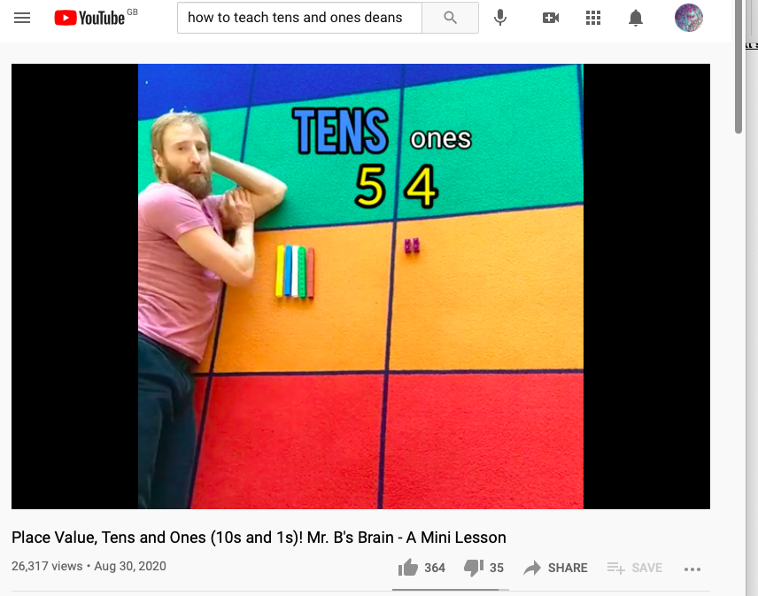

During this reflection, I will be discussing how I used YouTube to support my subject knowledge whilst teaching place value to children in a Year 1 class. Initially, I had planned one rotation of lessons for the week based on understanding the place value of numbers and, more specifically, tens and units. Through observation, I could see the children were not understanding the concept of the tens and units and the place values of different numbers and were finding it confusing to understand the value of each column. Therefore, I wanted to find a visual strategy to teach the children this mathematical skill.

Following the YouTube video, I started implementing the same strategy in the classroom using maths links blocks. I used these resources to show the children how many tens and ones are in a number by making stacks often and then having the ones left over. Once I modelled this several times, I encouraged the children to take control of their learning and practice the skill for themselves.

Through research, this YouTube video showed me the importance of using concrete resources, the importance of drilling mathematical skills whilst using fun, real-life and engaging teaching strategies. Using the online platform Youtube was a very effective strategy, and using YouTube to research different mathematical teaching strategies has helped me develop my maths subject knowledge.

Language Literacy and Communication
Ruth Miskin Read, Write, Ink Online Training

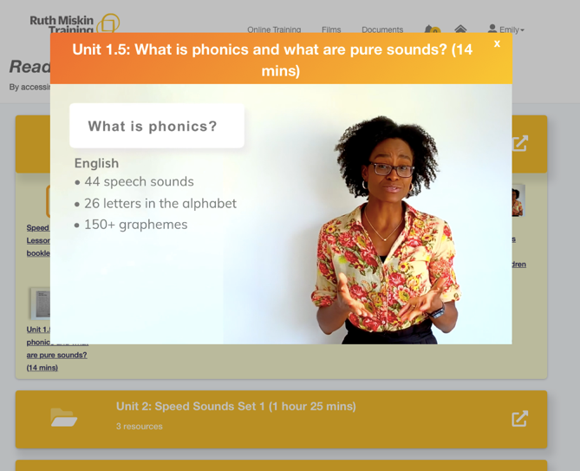
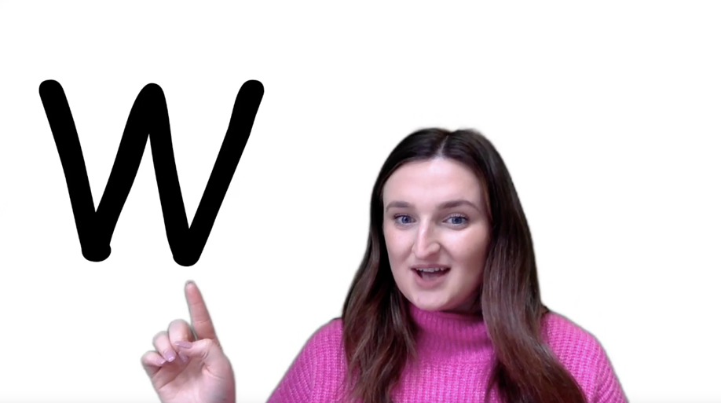

Throughout PTE 3, I taught my Year 1 class through online learning due to the COVID-19 lockdown, this experience was unique, and I learned and developed enormously as a student-teacher. During my second week of PTE in a Year 1 class, I had the opportunity to pre-record a set of phonics videos using the Read, Write, Ink (RWI) Framework. I had never taught phonics before, and therefore I completed Ruth Miskin’s RWI online training to develop my knowledge and understanding to ensure I was giving the pupils the best learning opportunity.

This was an extremely useful experience as it enabled me to understand the different sets of phonics, sounds, actions, and phrases used to support the children's development and understanding. In reflection, I did find some of the phonics sounds challenging to remember. Therefore, it was easy for me to access the training throughout my time on placement to remind myself how to pronounce the sound accurately before teaching it. This online training has helped me develop my subject knowledge of teaching phonics to children and will support me in my future teaching career.

Reflection on Planning for Progression

Professional Learning Template 1
Language Literacy and Communication AoLE – Instructional Writing

What did you do and why?

This experience took place in my final PTE 3 in a Year 1 class. During this experience, the aim of the lesson was for the children to write a set of instructions. This was going to take place over the next few weeks and was planned as a series of lessons (see appendix 1) for the lesson plans. As the weeks progressed, I will see how the children were advancing in their learning over time. This was extremely helpful for myself and the children as it enabled me to locate gaps in their learning to which I was then able to fill them with extra support and resources.
During the start of the learning experience, my class teacher gave the children a cold task: to write a list of instructions based on making an Easter egg hunt (see appendix 2). This was a challenge for the children as they needed to do this work independently with no support or help from the class teacher, myself or anyone else in the classroom. Due to the current COVID-19 lockdown, the children's independent learning has understandably decreased during the home learning phase. Therefore this makes any work a challenge for the majority of learners within the class.
Pie Corbett explains that the teaching and learning process that embraces cold and hot tasks is an effective teaching strategy that is extremely useful at the beginning of every unit or genre in literacy. The process involves the children have a go at doing the task. They then do all the unit of work with support from the teacher where the children are taught every skill they need. At the end of the unit, they do a Hot Task, where the children have a second go at doing the same piece of work. This process allows the teacher to build on what the child already knows to ensure they show a high level of progression in their work. There are great benefits for the child because they can also see the difference between what they could do before and afterwards. It is a way of celebrating great work and understanding the meaning of progression and improvement.
During the cold task, my class expectations were high; however, I knew their writing skills needed much support to build it back up to a high standard. After observing the children during the activity and looking at their cold task, I could locate learning gaps and this was identified through live marking (see appendix 3). As a result, I could see that many of the children had forgotten punctuation, spelling, capital letters, full stops, finger spaces, writing on the line, and therefore, this was what I was going to base their learning on for the first week of instructional writing.
The following weeks in the Literacy lessons were based on 4 different activities per lesson. These involved a teacher task, LSA task, independent learning task and a Time to Move (4 different independent cross-curricular activities). All of these activities were based on teaching the children how to write a set of instructions. This involved working for a class, following instructions themselves, giving instructions, ordering instructions, DCF, outdoor learning with the bee bots (coding instructions). The series of activities and lessons were created to ensure the children understood why we used instructions and what we need to include to make them effective and clear. After taking part in all of the activities, I could see great progression in the children's learning and their effort and resilience to learning.
By the end of the final week of writing instructions, the children had met all of their skills after completing their hot task on instructional writing, and I was extremely impressed with the work they had produced and at home much they had progressed (see appendix 4). All children included: ordering numbers concerning their sentences, punctuation - full stops, capital letters, finger spaces and imperative verbs. I wanted the children to see how much they have progressed; therefore, I chose a few books and showed them their cold task compared to their hot task. This was a way of celebrating the children's work to make sure the children could visually see how they must have progressed in their learning over the past few weeks.
What have you learned?

Throughout the different Literacy lessons, I have learned that the use of cold tasks and hot tasks is an effective way for the children and myself to see progression in learning. This was an effective teaching strategy that was used over 3-4 weeks, and I also think the children benefitted from this as they were able to compare and contrast their work and celebrate this. However, the cold task did start the children of a negative as some of them could not write a sentence or even understand what instruction was. Therefore, I think this was a downside to the strategy, but I explained to the children that this is only for me to see to help you with your learning. I did explain this to the children several times and that I wanted them to try their best to see what they could write without any help.
Although at times it was a challenge for the learners and me to ensure the children stayed positive and resilient, therefore being able to refer back to the cold task when they were finding their work challenging and showing them how far they have come extremely helpful and a positive way to reinforce their effort and resilience in learning. According to Duckworth (2016), to develop resilience and determination in our students, we first need to develop interest. Due to standardised national curriculums, this can be a challenge as it is not possible for all students to be genuinely interested in everything they study. Therefore, teachers should find ways to get them interested in the subject matter to ensure they are resilient learners who want to achieve the best.
Throughout the process, the children proved to me that they were ambitious and capable of the learning that I had set them, and I was so pleased to see how far they came once they had finished their hot tasks. The planning over the past few weeks met all of the intended outcomes as all the children could write a set of instructions and meet the literacy skill. This often looked different for MAT and LA children, but I could differentiate their learning, so they were set up for success and not failure.
What next?
As a result of this experience, I am certainly going to use the hot and cold tasks in my future practice as I feel like this is a great way for the children to see how they have shown progression over time. This boosts their confidence and their resilience to keep trying even when it does get challenging. I think this teaching strategy is a very natural and gradual way to ease the children into learning a writing skill as every week you can get them to add to their work, and then when it eventually it comes to the hot task, they can then refer back to the work they have done a put it all together.

Professional Learning Template 2

Health and Wellbeing AoLE – Throwing and Catching Physical Education

What did you do and why?
This experience was based in a Year 1 class. Each lesson was based on the Area of Learning and Experience (AoLE) Health and Well-being – through a series of Physical Education (PE) lessons (see appendix 5). Each lesson aimed to teach the children how to throw and catch, and as the weeks progressed, the children's skills would improve. I had never taught an indoor PE lesson before, so I was unsure of what was involved or what was expected of the children, and as a result, I asked for support from my class teacher and the lead teacher in my placement school for the AoLE Health and Well-being. By working with in-school colleagues, I plan and have a clear understanding of what was expected when teaching an indoor PE lesson. This enabled me to create a lesson that met the children's needs through an appropriate challenge to ensure they were making progress in their learning and making it engaging and enjoyable throughout.
Due to the current COVID-19 lockdown, the children have not been able to participate in the 'normal' PE lessons that were held either outside or in the hall. As I did not know the children and their abilities, planning for them was a challenge. Therefore, I had to plan using a wide range of skills and activities.
The first lesson aimed to allow the children to understand and observe how to sensibly, throw and catch a bean bag of a bib (see appendix 6). This was done through carefully modelling, where the children observed their peers and me through a physical example. Getting the children to learn from their peers during the introduction of this lesson was very useful and engaged the children even more as it was the children who were leading the learning. The children were able to take control of their learning and show their peers a WAGOLL (what a good one looks like) to learn from each other. Vygotsky (1962) suggested that learning occurs through the interactions students have with their peers, teachers, and other experts.

Consequently, teachers can create a learning environment that maximises the learner's ability to interact with each other through discussion, collaboration, modelling and feedback. This teaching technique contributed to 'managing the learning environment' as this got their attention to focus on myself and the person that was modelling. Throughout this modelling phase of the lesson, I would ask the child to 'show me how you catch a ball, what do we like about how child A throws the ball? How can we help child B improve their catching? Using open-ended questions was an effective and enthusiastic way to engage with the children.
Encouraging the children to practise their throwing and catching skills through working with a partner encouraged them to learn from their mistakes, and this was a crucial part of the first introduction lesson as it was important for them to ensure their confidence is high. Child Mind Institute explains 4 strategies that help increase children's confidence; make time for play, provide them with small jobs, give them your attention and often encourage (Greene, 2020).
Once the children understood the basic skills of throwing and catching during lesson 1, they were then able to put this skill to the test during lesson 2, which took place the following week.
Lesson 2 included a rotation of 4 different activities, which involved throwing and catching (see appendix 7). The implementation of the different activities encouraged the learners to become more independent and use the appropriate skills. Throughout the lesson, I used my 'horn' to control the learning environment; following this, I would ask several children who worked extremely hard to show the class their excellent learning. Throughout this celebration of their work, I explained to the children how pleased I was at how much they had progressed and improved compared to the first lesson. This was an effective approach and certainly boosted their confidence. By the end of lesson 2, through observation, it was clear the children were making great progress in learning as their throwing and catching skills were improving, and they were extremely independent.
What have you learned?
Throughout this experience, I have learned the importance of being creative and getting the children up and doing something straight away. Throughout the first lesson, I demonstrated how to throw and catch and a ball, and then I was getting children to come up to the front and model. These strategies were very useful. However, I felt like, towards the end of the introduction, the children were getting bored and just wanted to start the activity. Also, I underestimated how quickly the children would learn the throwing and catching skill. This became an issue during the first lesson as they had finished quicker than expected, and as a result, I had to ask my class mentor if she knew any interactive throwing and catching PE games to help fill the time. Following this experience, I became prepared with an extra game, and just in case, the lesson finished learning in the following lesson.
Learning from this experience, I was able to ask for support from in-school colleagues, and this was extremely helpful as the other teachers were able to share some of their good practice with me. I took these techniques, researched them, and then started to implement them through each PE lesson plan I taught. The research stated: make the learning meaningful, ensure the pupils make progress, increasing the time spent on the activity and ensure the appropriate resources and apparatus are ready to use. Through the implementation of these effective teaching strategies, it supported the learner’s progression evermore.
The use of the bike horn was a very effective strategy to get the children's attention to manage the learning environment, and I used this in every PE lesson afterwards.
What will you do next?

Following this experience, I will expand my subject knowledge and understanding of physical education and its importance for children and young people. I want to understand how I can become better teaching within this subject area, as I am aware of how this can impact childhood development. When children participate in physical activity, it can positively impact their physical, social, emotional, mental and fine and gross motor skills.

Reflection on planning for the Four Purposes

Ethically Informed Citizens

What did you do and why?
This experience was based on Christmas Around the World and took place during PTE2 in KS2. During this experience, it was essential for all children to understand and learn about different cultures, countries, beliefs, religions and food. I felt this topic involved several aspects of the four purposes as it enabled them to develop as ethically informed citizens. Learning about religion and learning from religion is important for all pupils, as religious education (RE) helps pupils understand themselves and others. RE promotes the spiritual, moral, social and cultural development of individuals and groups and communities (Qualifications and Curriculum Authority 2009).
This experience aims to give the children real-life experiences to understand this topic on a deeper level. Therefore, I organised a member of the local Mosque to visit and give an assembly to the whole of KS2, which involved year groups 3, 4, 5, and 6. Doing this involved many strong elements of the QTS standards as the children were learning about authentic real-life contexts and engaging with the widest school community. Inviting the visitor into the school enabled the children to learn from first-hand experiences and understand how Muslims celebrate, what they eat, what they do and why they do this (see appendix 8).
My role during this experience involved contacting the Mosque, organising times, places, the context of the session, and communicating with parents and careers before the visit. This involved discussing DBS checks before entering the school, previous school experiences, and whether it was suitable for him to attend. It was also essential for me to write a letter to all of the parents and careers of the children within KS2 to ensure they felt it was appropriate for their children to attend the session. I felt this was a completely new experience for me as I had never been able to organise my event for a school before.
During the assembly, the children had the opportunity to hear the visitor pray in Arabic. This was extremely different for many of the children to experience as they all live in the small rural community school, and therefore, they have possibly never experienced this. The children were also able to listen, engage with conversations, ask and answer questions, and understand how other cultures celebrate certain festivals within their religion.
Although this experience was extremely successful, I wish I had done some personal research on their religion beforehand, as I felt this could have enabled me to ask more questions to the man from the Mosque. Doing this would have given the children a better opportunity to learn about religion through effective questioning.
What have you learned?
I have learned several things from this particular experience that have supported my professional development concerning communicating and engaging with the wider community. This QTS target in itself is at the heart of the community school already. However, allowing the children and the teacher to develop this even further and my placement is extremely exciting once I have left. I have also learned how it is important to be professional and clear when organising visitors into the school, and it is essential to follow procedures concerning welcoming outside members into the school, which links to safeguarding and DBS checks.
This experience met all of the intended outcomes; however, next time could be improved by allowing the children to engage with certain activities, school trips, pictures, music and food. This would enhance the four purposes of the curriculum even further, which will then support the children becoming ethically informed citizens. As these extra experiences would be very useful, I have passed on phone numbers (with permission) to the school's headteacher, which allows her to continue building relationships with the wider community and could involve out of school trips and experiences.
Throughout the experience, there were some small problems. One of them was the seating arrangements for the children within year 5. One or two of the pupils were disrupting the experience as they were talking; therefore, I went to sit by them to ensure they were listening carefully and only talking when it was appropriate. To improve this, I would arrange the seating plan carefully to ensure no disruptions or inappropriate behaviour during an experience like this. I would also ask the children beforehand to note down or think of any questions they wanted to ask the visitor beforehand as they seemed to become quite shy at the beginning.
What next?
As a result of the experience, I intend to learn and research different religions and cultures. Doing this will help me progress my subject knowledge, which will enable me to probe the children’s knowledge and understanding with questions to help them understand the concept of different religions and cultures. To do this, I could use websites like the BBC Bitesize to develop and learn more and books based on religious education, which will help me improve my subject knowledge.
Enterprising and Creative Contributors

What did you do and why?
This experience took place during PTE1 in a Year 6 classroom and involved the children creating Harry Potter Cushions. This theme was selected by pupil voice, and so from the very start, the children were engaged in their learning as it was meaningful for them. From my research on the personalised learning theory, I understand that if the children's learning is authentic and has a purpose and is based on real-life and authentic contexts, then it would often produce a high level of engagement with the work and therefore meant how the students were meeting the skills from the Curriculum was more intense (Courcier, 2007).
The aim of the Enterprise project was to design and create their own Harry Potter cushions. Once the children created their cushions, they could then sell them at their school Bingo Fayre (see appendix 11). This covers many aspects of the Four Purposes, but mainly the Enterprising and Creative Contributors. This event covered the target leading, colleagues, projects and programs as I was able to take part in the planning and preparation for the fayre. Through this, I communicated with parents from the school, siblings, teachers and members of the outside community. The children were able to raise money through the Bingo game itself. They also ran their stalls, which is where the children in my class could sell their cushions.
The experience was carried out over two weeks and involved many aspects of cross-curricular learning. The sequence of lessons involved a step-by-step process which eventually enabled the children to create their Harry Potter cushions. To show an example: Art - planning, designing and creating their cushions, LLC - communicating about what they wanted on their cushions, Math’s - working out how much material they needed for each cushion and then how much material they needed for the whole class, figuring out how much the cushions would cost so Miss Wonnacott could go and buy them from the local shop (see appendix 9). In reflection, there was an area that I would include if I were to do this experience again, this would involve the children contacting their local sewing shop through email to ask for the materials they needed. This experience would include Language, Literacy and Communication skills through a real-life learning experience. This skill would benefit their future lives as many of us communicate virtually through emails.
During the first rotations, a problem caused a slight disruption to the lesson when the children were creating their logos for their cushions. The plan for this lesson was to give the children the freedom to follow the designs of their logo and then start to create it using objects like string, paint, cardboard, glue, and then practise printing their logo stamps to see which one they preferred. Giving the children too much freedom, especially with all of the different resources, was not a good idea as I think they got slightly overwhelmed. This disrupted as the children had too much choice and therefore started being silly, which meant their behaviour deteriorated. As this was the first rotation, I adapted the lesson to ensure the next group would have a better/calmer experience. To do this, I did not give all the children the creative materials straight away and instead gradually started to introduce them alongside a meaningful conversation, 'how could we use string to make our logos? What else would we need to make this successful?' Altering the lesson to meet the needs of the learners proved to be very successful, and the outcome was much better than the first rotation. I followed this approach throughout the rest of the topic.
Throughout the whole experience, the children were challenged to their correct level, and I had very high expectations for them in their learning and throughout this experience. Even my preparation and planning were challenging, as it was important for me to think of a process so that the children would be able to solve the mathematical problems when it came to costing the materials for the cushions but for it to be a challenge at the same time.
What have you learned?
Throughout this experience, I have learned the importance of planning using the Four Purposes – Enterprising and Creative Contributors as drivers for the learning experiences and making sure that their learning experiences are based around real-life and authentic contexts to ensure the learning is based on the children's interests. This made the aspects of their learning extremely cross-curricular and exciting for every child. During the two weeks, the children would constantly ask me when we would work on their cushions again, which proved to me that the whole experience was extremely successful as the children were engaged and ready to learn.
The children were able to meet and achieve many skills through the correct amount of challenge and expectations. Throughout the class, there were some children with diverse learning needs and therefore needed more support. I needed to consider this throughout; therefore, I made sure all of their work was differentiated to suit their learning needs.
By implementing leading and supporting the Enterprise project (Bingo Fayre), the children were aware that they were going to sell their cushions through the Bingo Fayre, which presented them with more real-life learning situations and made their learning purposeful (see appendix 10). This also developed their social development as this experience encouraged them to speak to customers and handle money.
What next?
As a result of this experience, I will make sure I bring this topic forward with me into future placements and my career as I felt like it was an extremely effective way for the children to use real-life learning experiences through cross-curricular learning. However, to also develop it using this reflection and to learn from these experiences. The children benefited from having learning that had a purpose.
Although there were many positive aspects, there were some areas that I would adapt to make sure the children are creating quality work if I were to do this again. For example, I would want them to send an email to the local sewing shop explaining the purpose of their project and what they needed in terms of material - this creating yet again real-life learning experiences. In reflection, I would not give the children as many creative materials during the creation of the stamp logos, which overwhelmed them. Instead, I would use less to start and then gradually introduce more. I would encourage the children to use more DCF skills, whether designing a logo through Hwb or carrying out a survey where they needed to find out what colour cushions everyone wanted. I would give the children a trial run through the 'sewing' aspect of the lesson and show them more WAGOLLs as I feel like this would have caused less disruption during the final sewing lesson.
Reflecting on these aspects of the lesson are essential as it enables me to see what I need to improve on to make the learning experiences better for everyone. Research shows that teacher reflection is important because it is a process that helps teachers to collect, record, and analyse everything that happened in the lesson.

Reference List
Courcier, I (2007) Teachers' Perceptions of Personalised Learning, Evaluation & Research in Education, 20:2, 59-80
Duckworth, A. 2016. Grit: The power of passion and perseverance. Toronto, Ontario: HarperCollins

Qualifications and Curriculum Authority (2009) Planning, teaching and assessing the curriculum for pupils with learning difficulties Religious Education. London: Qualification and Curriculum Authority.

Vygotsky, LS (1978) Mind in Society: The development of higher psychological processes. Cambridge: Harvard University Press.

Part 2
Today, being inactive is viewed as normal by many people; this damaging attitude towards levels of activity, where movement and exercise are perceived as a personal choice, is not sustainable in 21st Century Wales and is a problem that immediately needs to be addressed (The National Assembly for Wales, 2019). As a result, the chosen aspect for my development is based on the Area of Learning and Experience (AoLE) Health and Well-being and how I can develop my knowledge and understanding of Physical Education (PE) to make a difference with the children of the 21st century. This area was selected through critical reflection as I understand my subject knowledge and delivery of PE could be enhanced. Therefore, I am to identify specific actions to enable advanced teaching experiences and will ensure learners have the best opportunity to embrace all opportunities in PE.

Physical Education has been widely acknowledged as a key enabler for promoting physical activity amongst children (Welsh Government, 2019). However, Lynch and Gregory (2017) suggest systemic barriers obstruct teachers, subsequently resulting in low confidence, competency and defiance when teaching PE in the school environment. Consequently, if children are not receiving high-quality learning opportunities due to poor learning experiences, this could exacerbate issues further, which will harm the future generation's health and well-being (Welsh Government, 2019). For example, physical inactivity has been identified as the fourth leading risk factor for mortality in Western Europe, affecting an estimated 3.2 million deaths worldwide (The National Assembly for Wales 2019). The statistic above puts growing pressure on teachers in Wales to deliver higher quality PE experiences, not least since it may benefit young people to make healthier life choices and encourage lifelong participation in physical activities (Cale et al. 2008).

Welsh Government (2019b) is investing 5.5 million pounds in a long-term strategy called Healthy Weight: Healthy Wales to prevent and reduce obesity. Their strategy sets out four themes which cover; healthy environments, healthy settings, healthy people, and leadership to enable change. These four strategies are crucial for everybody to undertake, as prevention cannot be achieved by the Government alone but can be achieved using a multi-agency approach utilising the National Health Service (NHS) and the education sector. Within the four themes, Welsh Government (2020a, p. 13) explain there will be eight priorities, one of which is “to ensure that our children get the best start and are a healthy weight starting school. Although this strategy aims to prevent obesity and encourage citizens to become more active, a comparable long-term strategic plan was previously implemented by the Welsh Assembly Government in 2009, which proved ineffective due to the lack of provision from external systems (NHS Wales, 2009).

Ensuring young learners have the opportunity to develop into healthy and confident individuals is a priority for the Curriculum for Wales (Donaldson, 2015 ). The Welsh Government (2019a) similarly recognises that good health and well-being are key enablers of successful learning; the report recognises the importance of physical health and development and how it positively impacts mental health, emotional and social well-being. In the Health and Well-being AoLE, Donaldson (2015 ) explains it is a priority for young people to understand in greater depth the factors that influence their health and well-being through their participation in PE lessons. Although these areas are commonly discussed, there is still a lack of physical activity and excessive inactive behaviour in children across Wales (National Assembly for Wales, 2019). Physical inactivity should be a concern for every practitioner and must be addressed through effective professional development strategies to ensure children experience high-quality, inspiring and importantly successful PE programmes.

There are six areas teachers must consider and implement to improve the effectiveness of a PE lesson: educational subject knowledge, quality of teaching, classroom climate, classroom management, teacher principles and professional conducts and development (Earley et al. 2020). Putting these areas into consideration with my professional practice, I will discuss pedagogical content knowledge, professional development concerning evidence-based research, and the importance of having a classroom climate where the student is at the heart of the planning and teaching.

For professional development to be effective, it must involve sharing good practice with other practitioners, conducting professional development sessions that match the needs of the participants to ensure engagement is high and ensuring teachers are given current and updated information (Housner and Housner, 2009). However, Morgan and Bourke (2008) state, in Jeanne et al. (2019), many primary teachers lack confidence in their teaching of physical education due to their lack of subject knowledge and the quality of their professional development sessions they are often considered inadequate and unsupportive. They continue to discuss that this is largely due to a combination of insufficient delivery of physical education and the environment. Simlarly, Hattie (2017) agrees with this opinion, as his study on Visible Learning verified that professional development programs are extremely ineffective. Professional development programs are ranked at 117 out of 252 with an effect size of 0.41 compared to other influences that can either negatively or positively affect children's learning outcomes. Hattie (2017) believes professional development focuses on how to teach, not on how students learn; therefore, if teachers want to raise standards and support the pupil’s, they need to take the seemingly invisible process of learning, which occurs in the head and make it visible and effective.
Nevertheless, suppose evidence-based practices are to be implemented successfully in schools. In that case, they must be accessible to educators, and professional development must continue beyond this to ensure learners progression is made consistently; for example, mentorship and engagement with further personal research enable teachers to develop a deeper knowledge of pedagogical content (Coe et al. 2020). Research should be communicated in a manner that everyone understands through clear language and communication, but to demonstrate how research findings fit into the wider context of the classroom environment (Foster, 2014). Conversely, Cooper et al. (2018) located a gap between what has been discovered by research to be effective and what educators use and practice in their classrooms and whether teachers promote the material from professional development programs set by the school.
Summarising these influences, the teaching profession has continuously been reinforced by evidence-based practice and encourages this professional ethos. Therefore, teachers must undertake a personal study to produce high-quality teaching experiences reinforced by current research, as this is the key to success and progression in learning (Coe et al. 2020). As a result, I aim to explore what makes a PE lesson effective to ensure individuals can advance their skills and understanding.
Many strategies are used worldwide to ensure teacher effectiveness is a priority for teaching and learner progressions (Mantra, 2017). However, Ko and Sammons (2020) believe there is a vast amount of research evidence to suggest effective teachers are knowledgeable about curriculum content. Similarly, one of the six components of great teaching includes teachers developing a deep knowledge of the subjects they teach and a strong understanding of the material being taught (Coe et al. 2020). Earley et al. (2020) recommend developing PE subject knowledge by engaging with sport-specific courses, attending physical workshops provided with current literature, observing excellent practice, and engaging with a sport either as a performer or a spectator.

Regarding physical workshops, a study undertaken in New Zealand in 2007 proves that teachers' physical workshops were extremely successful due to the applied method to learning (Petrie et al. 2007). The study encouraged the teachers to focus on the theory and practical ideas by observing PE lessons demonstrated by an adviser. Hands-on learning is supported by Vygotsky's (1962) theory of the Zone of Proximal Development (ZPD), where the teachers are learning from a more knowledgeable other and therefore absorbing information and understanding the concept at a higher level (Pound, 2014). Following this stage of the study, the teachers were then encouraged to teach a PE lesson whilst being observed by the adviser, who would then follow up and give beneficial feedback. The concluding experiment proved that after attending three to five one-day workshops over two terms, the teachers felt more confident with their new subject knowledge and understanding of PE and, therefore, felt more competent to teach successful and effective PE lessons.

Although physical workshops aim to develop teacher's subject knowledge through visual learning, Hattie's (2017) study shows that teachers subject matter knowledge is ranked extremely low and ineffective at 231 out of 252 at an effect size 0,11. This current research demonstrates that teacher's subject knowledge is not necessarily effective and does not impact the children's learning outcomes as much as one would assume. Although the research from Hattie (2017) is credible, Ko and Sammons (2020) argue that without good knowledge of what you are teaching, it is impossible to teach children the correct skills. Mantra (2017) argues that although some teachers have exceptional subject knowledge, this does not mean they know how to deliver their knowledge to make it accessible for students to understand and learn. Summarising this viewpoint, teachers must clearly understand how their children learn before teaching them skills and this was previously supported by the work of Hattie (2017).

For educators to effectively teach a specific subject using the correct amount of subject knowledge, teachers need to have clear expectations for each pupil and ensure the classroom climate is appropriate (Boyce and O’Neil, 2017). Therefore, creating an effective classroom climate during a PE lesson is essential; the source explains there are many strategies to embrace; pupil voice, reinforce a pupil-centred approach to learning and finally to promote a love for learning through the implementation of positive relationships that include trust, warmth, respect, enjoyment and enthusiasm (Earley et al. 2020). This constructive perspective supports the theoretical interpretation of Dewey’s (1938) philosophy, as he understood that by forming an environment with a feeling of trust, students would feel comfortable taking risks in their learning, all of which promote a positive social-emotional setting which will result in improved academic achievement (Williams, 2017).

Contemporary brain research demonstrates that almost all students' brain growth can change and develop when engaged and challenged within their learning (Parrish 2019). Therefore, all learners must be exposed to learning experiences that are challenging and engaging, which provide children with rich, authentic learning tasks that make what is being taught come to life. This pedagogy of giving learners a chance to thrive is a priority of The Curriculum for Wales in one of the 12 Pedagogical Principles, and it states the importance of "creating authentic contexts for learning" (Welsh Government, 2020b, p. 1).

To conclude, my reflection in part one of the assignment identified PE as an area for development; from this, I have identified several specific action points supported by current literature and will aid the development of my PE lessons. As a result, the actions I am taking forward will help support children's health and well-being and ensure children are becoming more active as I am aware of the risks of obesity.

I aim to implement personal research enquiries through my professional development journey on how children learn PE, the importance of knowing the children in your classroom and planning PE to suit them and understanding why creating a safe space in PE lesson increases engagement. Applying research in the classroom environment will assistance me to develop my pedagogy on teaching PE successfully, which will ensure I can present all learners with purposeful, rich learning experiences whilst supporting and encouraging learners to develop into healthy and confident individuals (Donaldson, 2015 ). If teachers embrace the importance of professional development in PE whilst ensuring the quality of teaching is high, there could be a decline in obesity rates in the future and an increase in success rates for the Welsh Governments new strategy Healthy Weight: Healthy Wales (Public Health Wales, 2019).

Through mindfulness on current evidence-based research and PE, I aim to develop my subject knowledge on PE to understand how to apply research effectively in the classroom. Additionally, I would be open to attending physical teaching workshops, as this would enable me to improve my subject knowledge through real and visual learning experiences from subject-specific advisers or professionals.

Several action points will be taken through to my future career. However, some gaps within the literature are clear and must be addressed. As stated above by Lynch and Gregory (2017), teachers have been identified as incompetent when teaching PE, and the reasons behind this often involve the absence of subject knowledge or professional development barriers. However, there is a lack of research towards why teachers are not confident when teaching PE and whether this could be constructed from their personal experiences in PE. A greater understanding of this issue must be addressed to ensure all factors are considered when considering why a teacher's subject matter may not be suitable.

Children's learning rises when the environment promotes a love for education by implementing positive relationships that include trust, warmth, respect, enjoyment, and enthusiasm (Earley et al. 2020). I aim to ensure this approach is strengthened and reinforced through further research and implementation for the children in my future classroom to ensure they gain the best education. Dewey (1916) quotes, "if we teach today as we taught yesterday, then we rob our children of tomorrow", this quote clarifies the importance of reflection on teaching and learning and the importance of developing as practitioners (Doxtdator, 2017, p. 2).

Reference List
Boyce, B. and O'neil, K (2017) 'Improving Teacher Effectiveness in Physical Education Teacher Education Through Field-Based Supervision Kason', The Physical Educator, 7(5), pp. (835-849).

Cale, L. et al. (2008) Achieving High-Quality physical education: an intervention to facilitate high-quality teaching and learning in gymnastics in a city school, Loughborough: Loughborough University.

Coe, R .et al. (2020) What Makes Great Teaching? Review of the underpinning research, Durham: Sutton Trust.

Coe, E. et al. (2020) Great Teaching Toolkit Evidence Review, Cambridge: Evidence-Based Education.

Cooper, J .et al. (2018) Educators' self-reported training, use, and perceived effectiveness of evidence-based classroom management practices.

Preventing School Failure: Alternative Education for Children and Youth, 62(1), pp. 13-24.

Donaldson, G (2015) Successful Futures, Cardiff: Welsh Government.

Doxtdator, B (2017) Are we robbing students of tomorrow?.
Available at: https://longviewoneducation.org/are-we-robbing-students-of-tomorrow/ (Accessed 11 February 2017).

Earley, L. et al. (2020) What makes great physical education teaching? Application of Evidence-based research to the training experience of ITE students, Worcester: Physical Education Matters.

Foster, R (2014) 'Barriers and Enablers to Evidence-Based Practices', Evidence-Based practice, 15(1), pp. 50-58.

Hattie, J (2017) Visible Learning Hattie Ranking: 252 Influences and Effect Sizes Related to Student Achievement. Available at: https://visible-learning.org/hattie-ranking-influences-effect-sizes-learning-achievement/ (Accessed 28 March 2018).

Housner, B. (2009) 'Relocating From Easy Street: Strategies for Moving Physical Education Forward', Research Gate, 61(1), pp. 442-469.

Jeanne, K. et al. (2019) 'Understanding teachers as complex professional learners', Professional Development in Education, 45(1), pp. 125-137.

Ko, J. and Sammons P (2020) Effective teaching: a review of research and evidence, Reading: CfBT Education Trust.

Lynch, T. and Gregory. J (2017) 'Primary physical education (PE): School leader perceptions about classroom teacher quality implementation', Cogent Education. Cogent Education, 4(1), pp. 1-32.

Mantra, I (2017) 'Promoting primary school teachers' competence through dynamic interactive workshop and partnership'. International Journal of Linguistics, Literature and Culture, 3(1), pp. 1-6.

National Assembly for Wales (2019) Childhood Obesity, Cardiff: Welsh Government.

NHS Wales (2009) Health in Wales: Physical Activity, Cardiff: NHS.

Parrish, N (2019) Providing Rich Educational Experiences for All Students With proper scaffolds, students with learning differences benefit greatly from challenging opportunities like project-based learning. Available at: https://www.edutopia.org/article/providing-rich-educational-experiences-all-students (Accessed 17 July 2019).

Pound, L (2014) Influencing early childhood education: Key figures, philosophies and ideas, London: Sage.

Public Health Wales (2019) Obesity in Wales), Cardiff: Public Health Wales.

The National Assembly for Wales (2019) Physical Activity of Children and Young People, Cardiff: The National Assembly for Wales.

The University of Edinburgh (2019) The University of Edinburgh: The Importance of physical education ad a research topic. Available at: https://www.ed.ac.uk/education/rke/centres-groups/pe-research/importance (Accessed 24 July 2019).

Welsh Government (2019a) Areas of Learning and Experience: Health and Well-being.
Available at: https://hwb.gov.wales/curriculum-for-wales/health-and-well-being/
(Accessed 28 January 2020).

Welsh Government (2019b) Health Minister launches ambitious new plan to halt obesity rise in Wales. Available at: https://gov.wales/health-minister-launches-ambitious-new-plan-halt-obesity-rise-wales (Accessed 17 October 2019).

Welsh Government (2020a) Healthy Weight: Healthy Wales., Cardiff: Welsh Government.

Welsh Government (2020b) Implementations and Practical Considerations. Available at: https://hwb.gov.wales/curriculum-for-wales/designing-your-curriculum/implementation-and-practical-considerations (Accessed 28 January 2020).

Williams, M. (2017) John Dewey in the 21st Century. Journal of Inquiry & Action in Education, 9(1), pp. 91-102.

Appendix
Appendix 1
Lesson 1 Literacy Instructional Writing – Progression in Learning
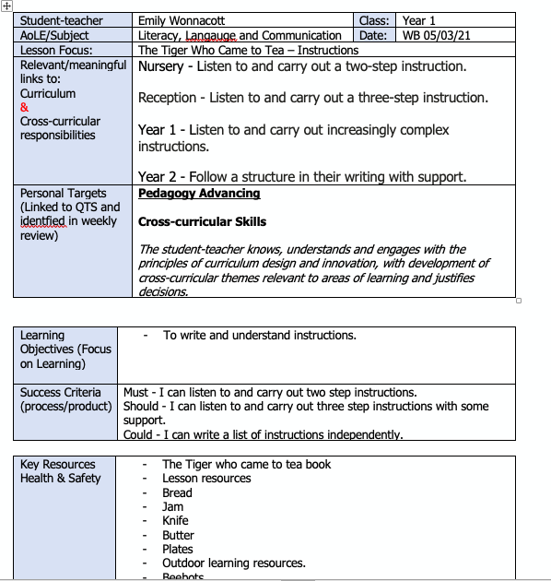

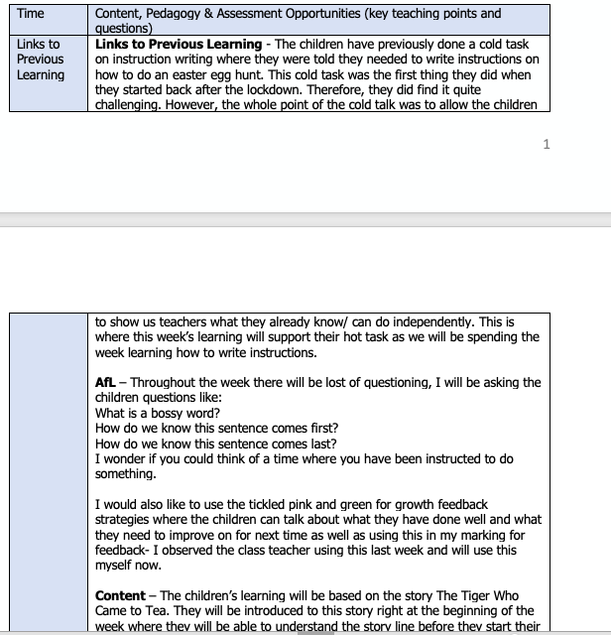

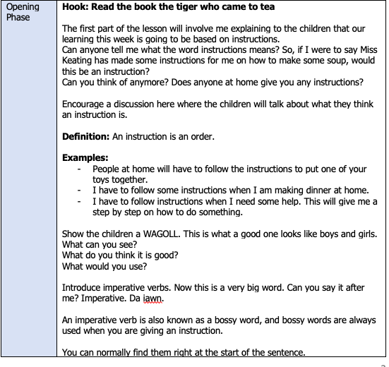
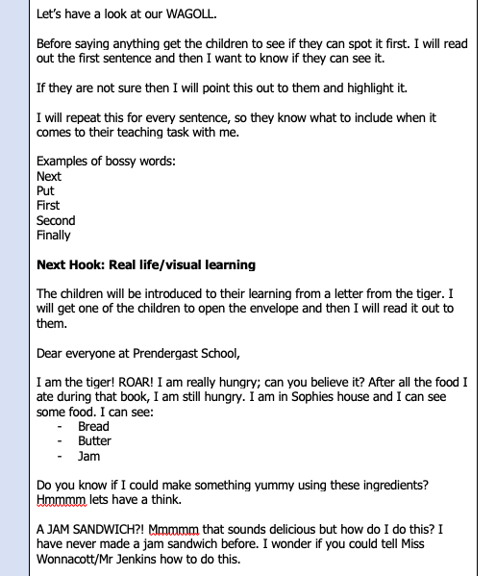

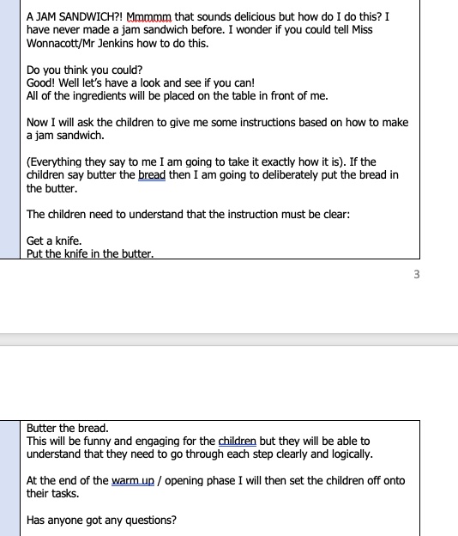

Lesson Plan 2 Instructional Writing – Showing Progression in Learning.
The yellow highlighter shows where the children will progress in their learning following the first lesson.
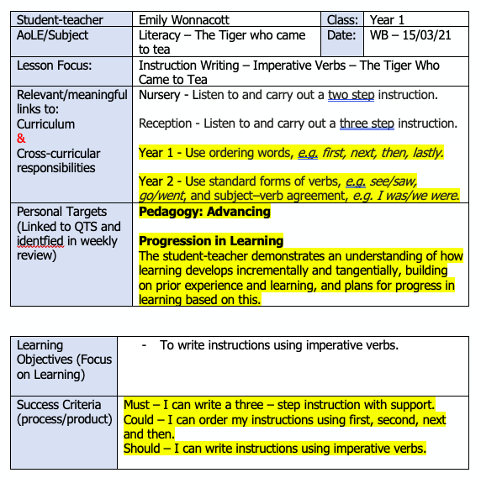

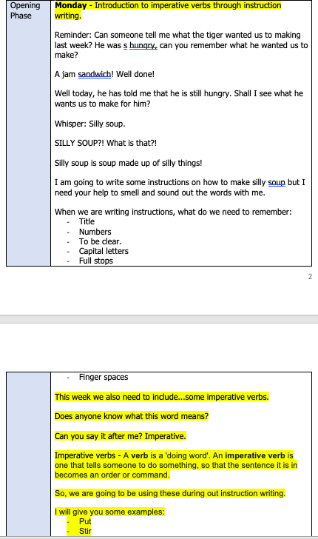
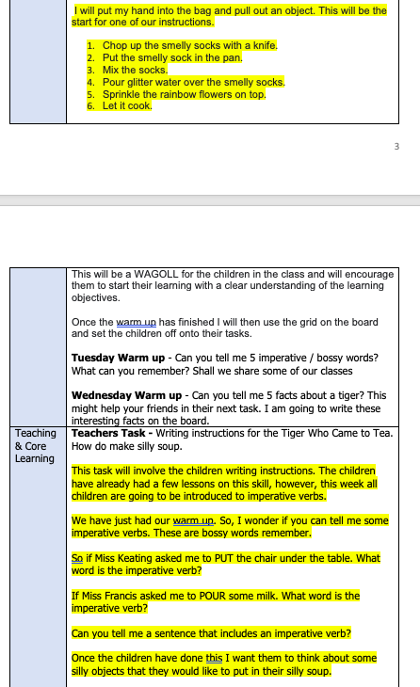

Appendix 2
Cold Task Instruction Writing
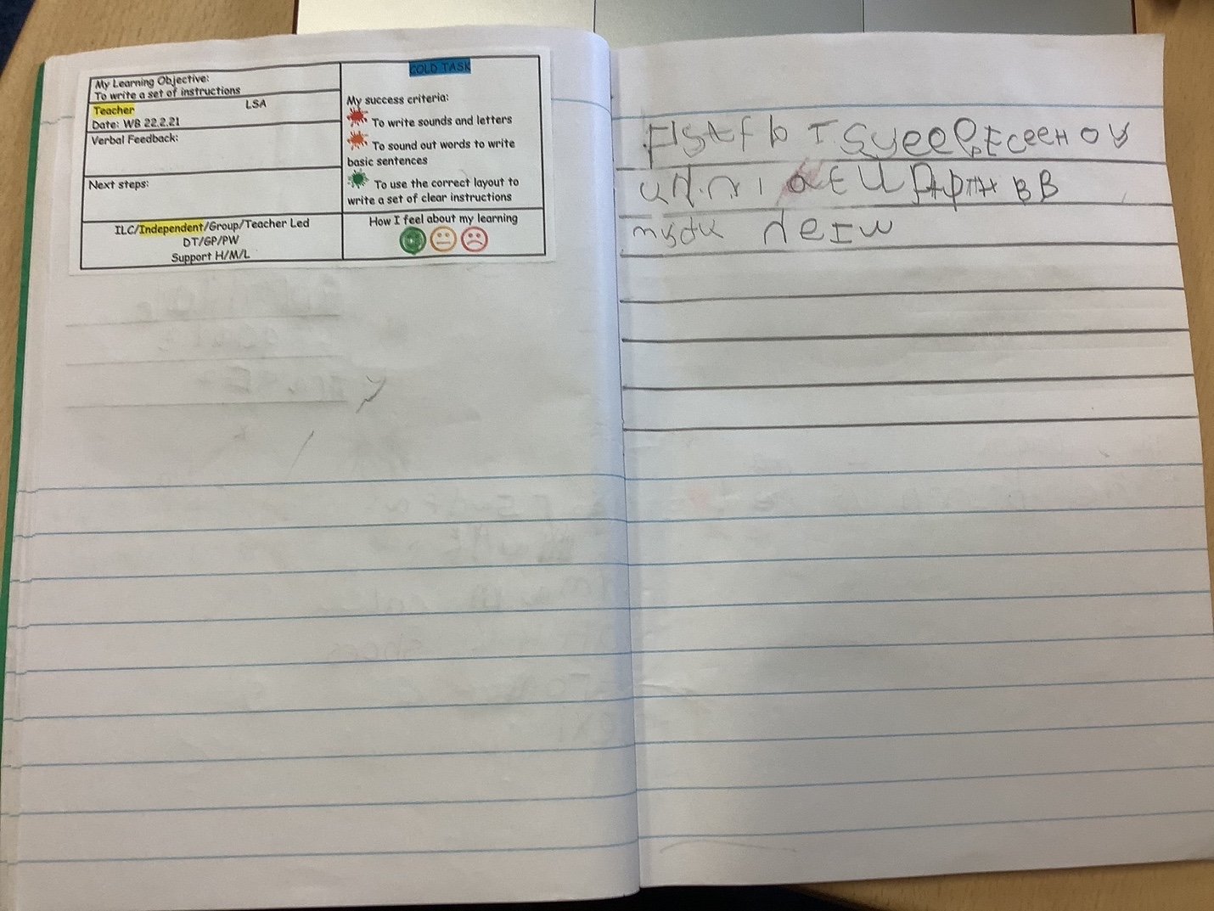

Appendix 3
Locating the gaps in learning through live marking and green for growth and tickled pink markers.
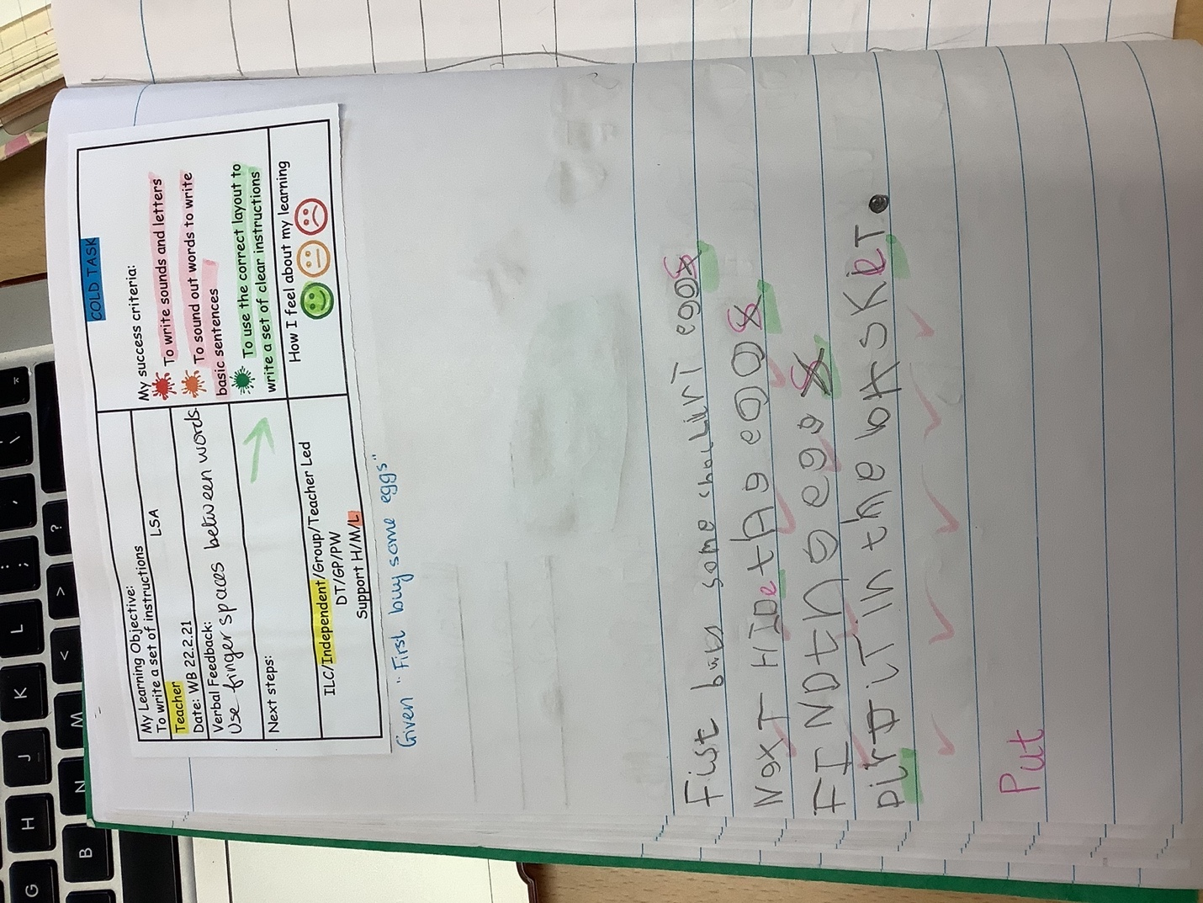

Appendix 4
Hot Task – The majority of children were able to show progression in their instructional writing as they used ordering numbers and imperative verbs.
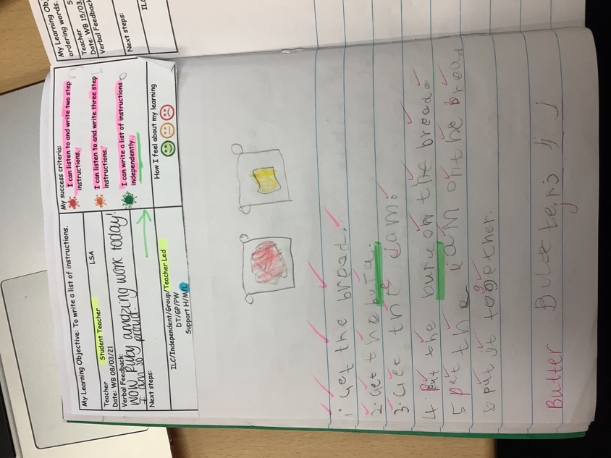
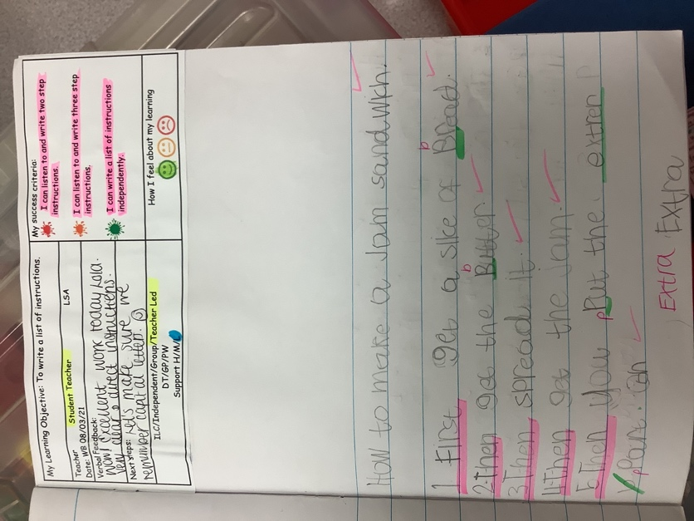
Appendix 5
PE Lesson Plan 1 Throwing and Catching – Showing progression in learning
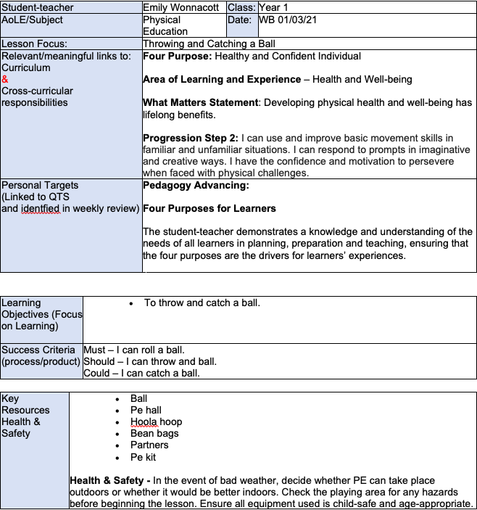

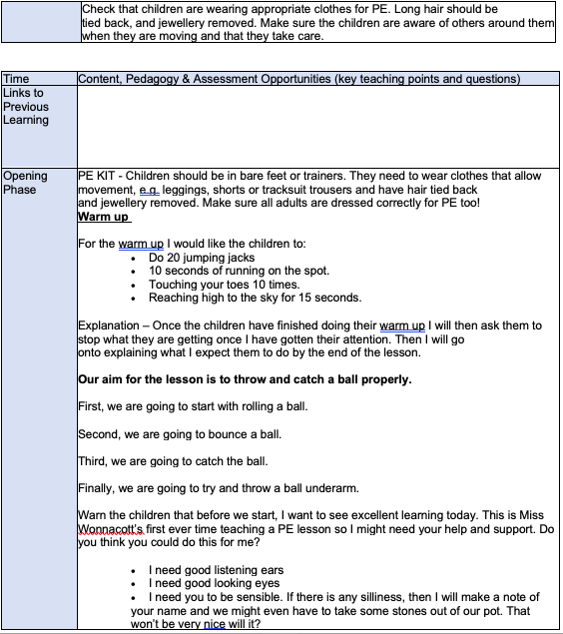
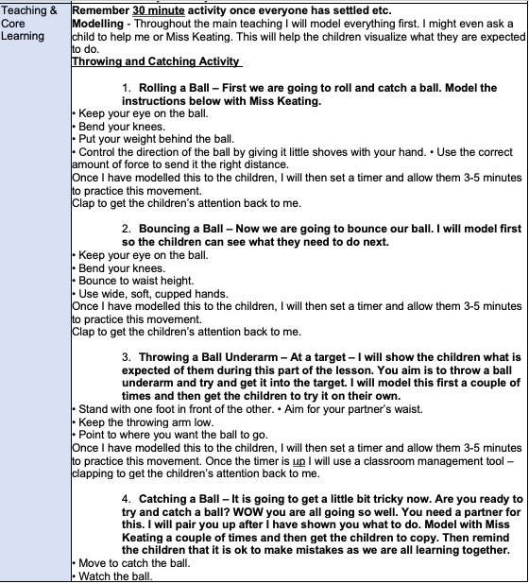

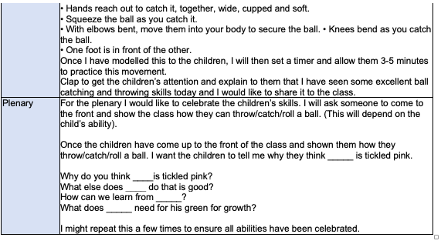

PE Lesson Plan 2 – Showing progression in throwing and catching.
The yellow highlighter shows where the children will progress in their learning following the first lesson.

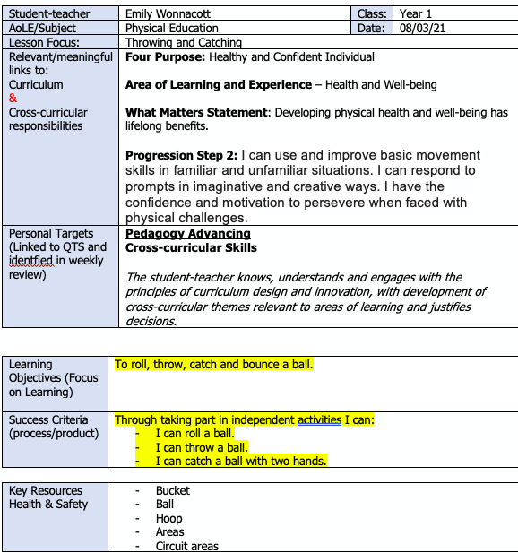

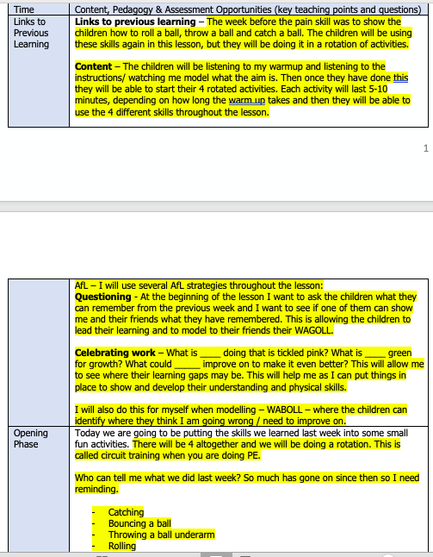

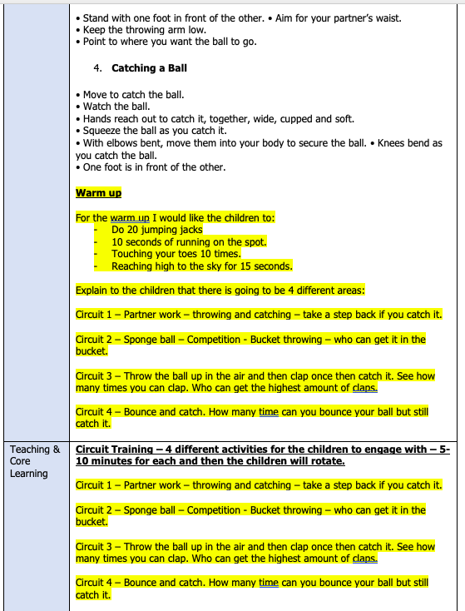

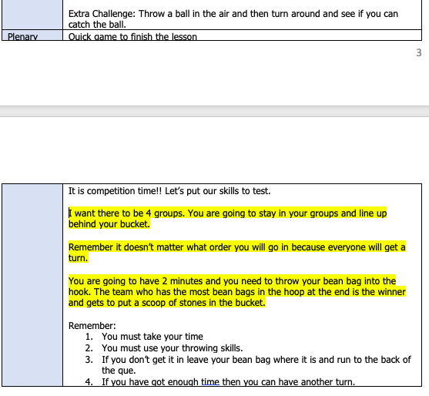

Appendix 6

Lesson 1 – Using bibs to practise their skills with partner.

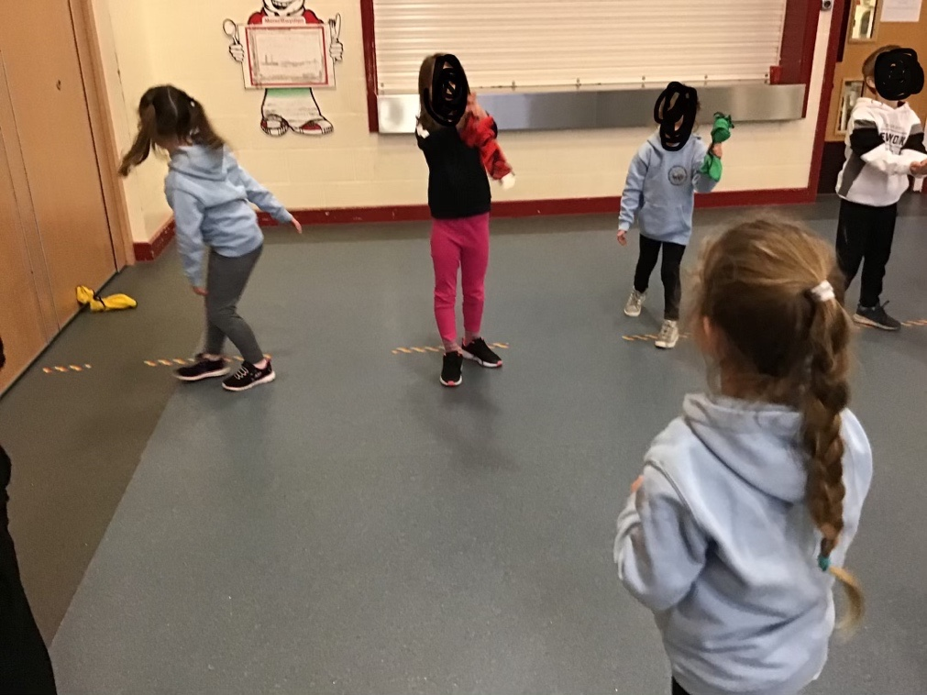

Appendix 7

Lesson 2 – Showing progression in their learning as they were able to work independently through the PE circuit, whilst using bean bags to practise their throwing and catching.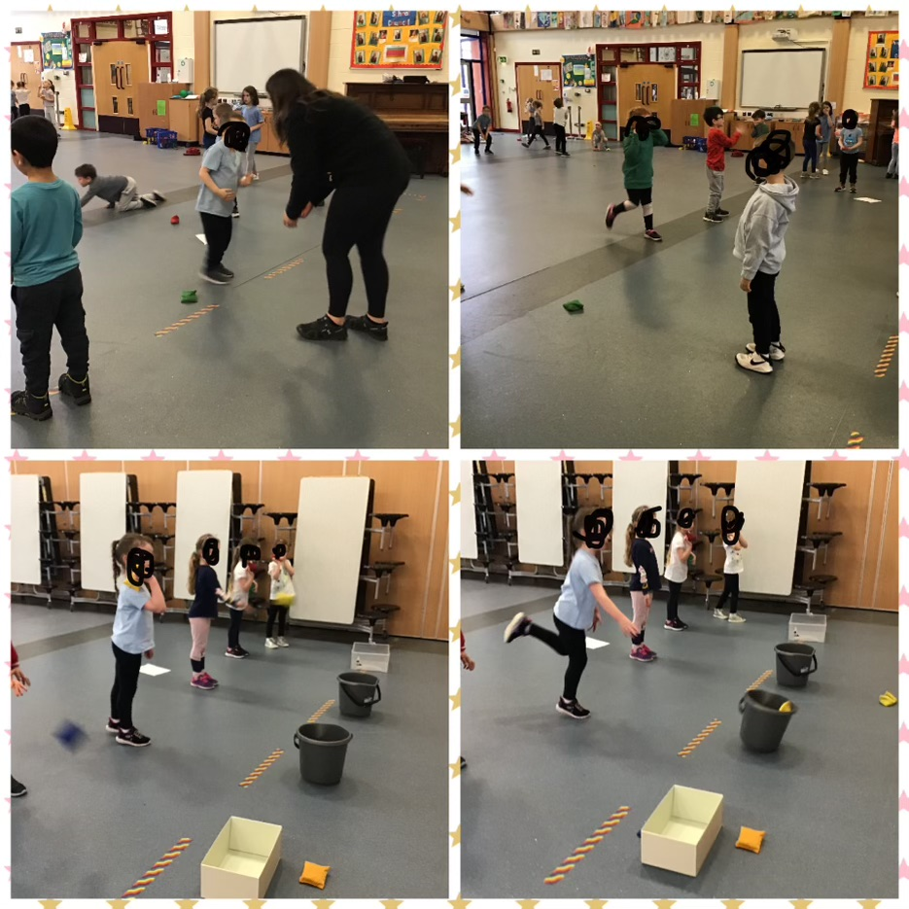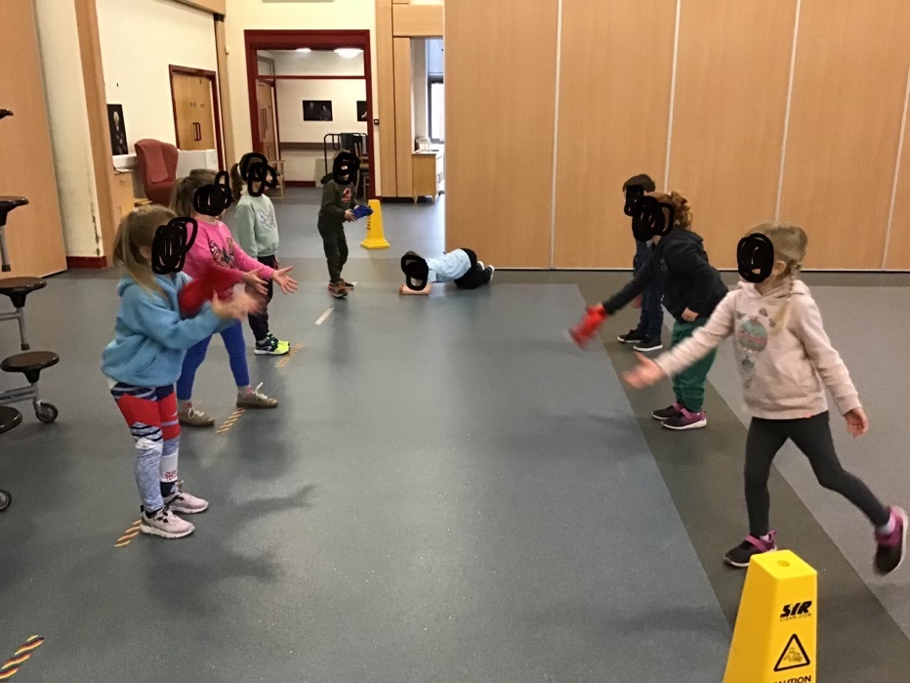

Appendix 8

Inviting a member of the local Mosque into school – Developing into ethically informed citizens. 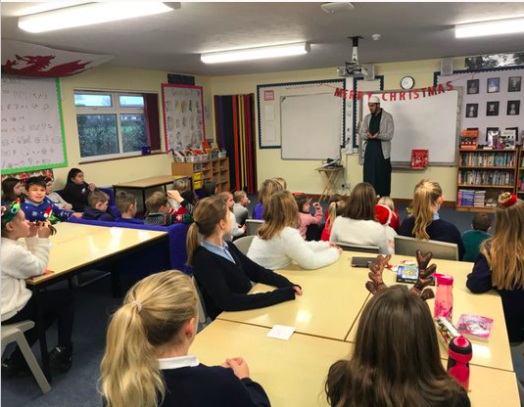

Appendix 9

Enterprising and Creative Contributors – Some evidence of the children’s work whilst working towards creating their Harry Potter Cushions.

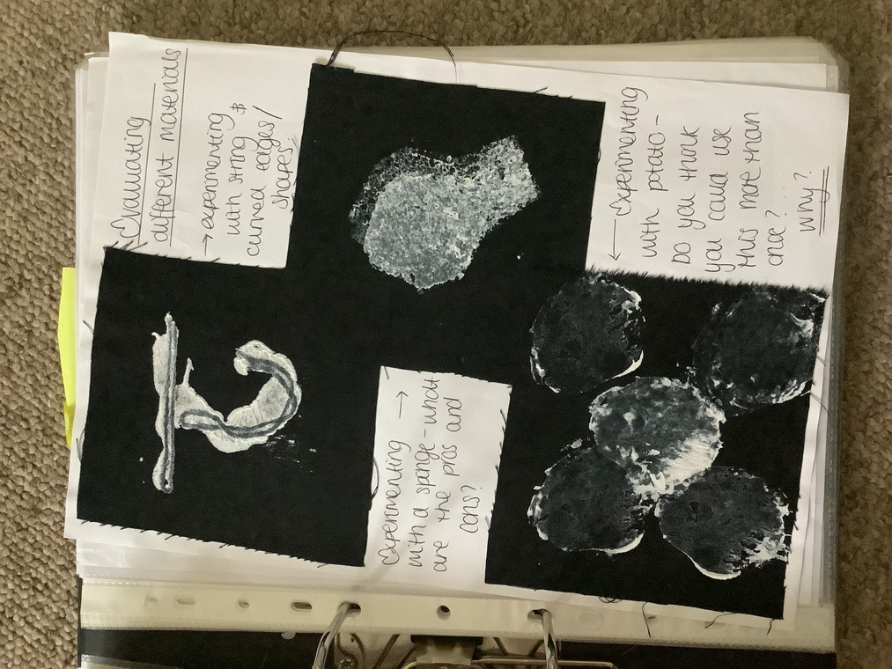

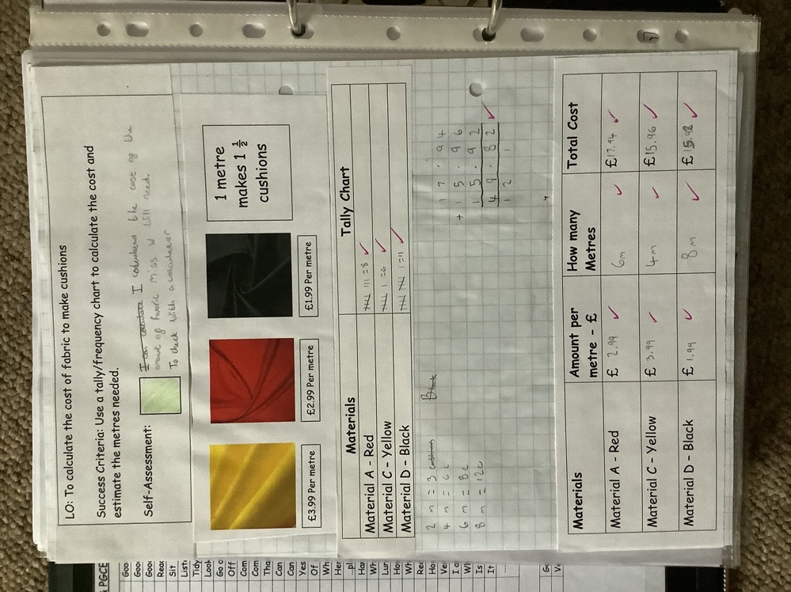

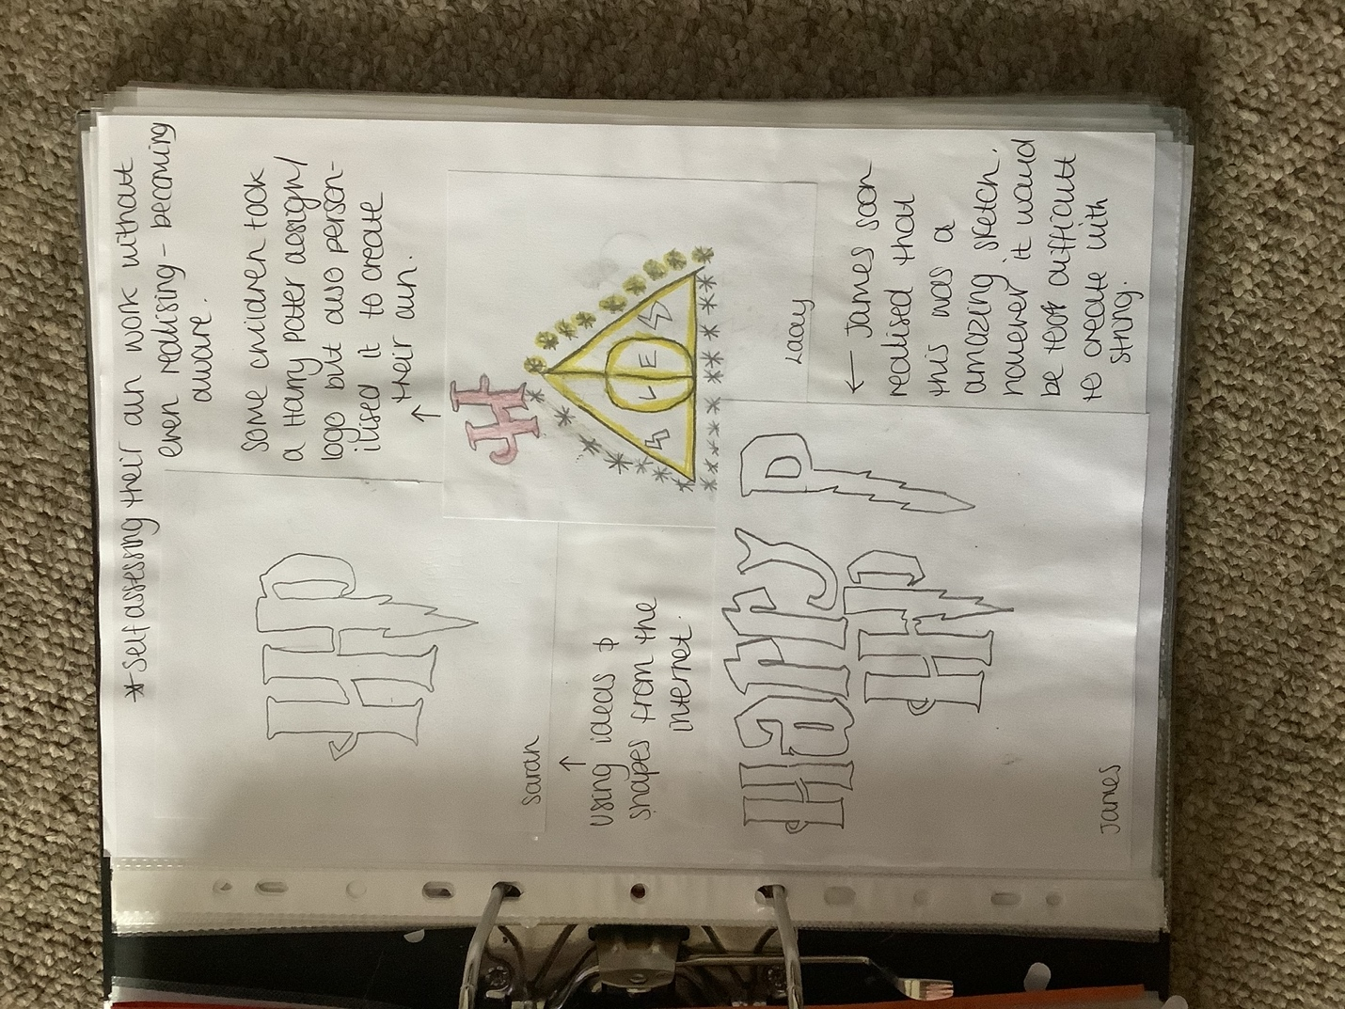

Appendix 10

Selling their Harry Potter Cushions at their school Enterprise Bingo event.



