Learning in the Digital Era

STUDENT’S NAME: Andreea-Teodora Calin
STUDENT’S NUMBER: 2207380

Contents

Task 1. PREPARING FOR HIGHER EDUCATION 3
1.1 Why is higher education important? 4
1.2 Getting ready for higher education 4
1.3 How to prepare for higher education? 5

Task 2. MIND MAP OF BECOMING A DIGITAL LEARNER 6

Task 3. MY PERSONAL IDENTITY 6

Task 4. REFLECTION USING BORTON’S RELFECTIVE TOOL 7

5. REFERENCES 8

Task 1. PREPARING FOR HIGHER EDUCATION

Starting higher education is undoubtedly one of the most exciting times in everyone’s life. The students will be studying for their dream degree and meeting new friends.


Sustaining Higher Ed Blog Series: Is Your Institution Built to Last? (Kaufmanhall, 2022)

While there is a lot of excitement surrounding this new chapter, there may also be some feelings of worry and uncertainty about how to "navigate" to university.

1.1 WHY IS HIGHER EDUCATION IMPORTANT?

- Can lead to many benefits, including a successful career and financial security.
- Can improve the general quality of life.
- Can instil the necessary discipline in the professional world.
- Widens the horizon of knowledge and of thinking.
- Can develop capacity for academic achievement and retention of knowledge.

Therefore, in order to be able to face continuous social changes, it is imperative for all students to learn permanently. (Gleason,2018)

1.2 GETTING READY FOR HIGHER EDUCATION

Nowadays, knowledge has acquired a very great power, representing the basic activity of this world. (Menand,2010)
In order to be successful, the students must not only attend the courses, but they must also understand what are really doing. (Fe News,2021)
Because, the current context determines us all, to evaluate the direction to follow and the right domain for each of us.
The students must have the conviction that the experiences and knowledge gained will define they are as a professional, but also as a person. (Thompson,2014)
Students also need to trust the professors who will polish their preparation during college and guide them along the way.



1.3 HOW TO PREPARE FOR HIGHER EDUCATION?

University is all about a lot of things, and all those new experiences can get overwhelming. (Brown and Salmi, 2020)
That is why it is so important for all students to follow some steps:

- prepare the perfect space for study and be organized.
- think about your goal.
- determine the appropriate time for study hours.
- manage your time.
- set regular breaks to be able to recreate.
- set deadlines to complete the assignment on time and efficiently.
- familiarize yourself with the Microsoft Office operating system.
- give proof of academic honesty and reproduce exactly the references used.
- avoid plagiarism and produce your own ideas based on your research.
- read about the themes and try to understand them.



Task 2. MIND MAP OF BECOMING A DIGITAL LEARNER

What is a Mind Map and what does it do?

- the visual way of organizing information.
- the fantastic way to capture your thoughts and organize them visually.
- represents ideas and concepts hierarchically.
- helps synthesize and structure information.
- it is a radical structure.
- it stimulates several areas of the brain that aid memory.
- uses graphic entities.
- it can be drawn by hand or with the help of a software application.
- stimulates creativity.
Rodrigues (2011) was a useful source of information.

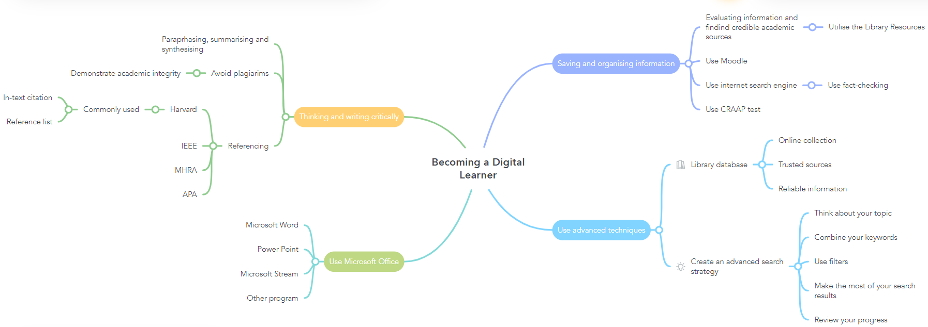

Task 3. MY PERSONAL IDENTITY

By accessing the following link, you will get to know Andreea and her personal identity: https://youtu.be/WjhcvxbbBJk.

Task 4. REFLECTION USING BORTON’S RELFECTIVE TOOL

‘’Borton’s model of reflection is a framework for reflection. It was developed by Terry Borton, an American school teacher in 1970. He published the method in the book ‘Reach, Touch and Teach.’ In the book he calls it the ‘What, So What, Now What’-method of reflective education.’’ Janse (2022) was a useful source of information.
Borton's model is the easiest model to understand and apply. Given the fact that the university encourages reflection, the chain of questions will have to start with:
- What? This is the most important starting question. It will help the student describe the experience in retrospect by giving him the facts of a situation.
The student must answer the following questions concisely: What happened? What was the result of his experience? What he did or others do in this situation? What is the reason for who looking back at that moment?
- So what? The next step is the critical analysis of the situation. What lessons can be gained and what the student understands from what happened. It can also determine what the corrective measures will be.
- What next? Finally comes the stage where the student identifies action steps to address lessons learned and consequences identified. Taking new actions in any given situation in student life will always lead to new consequences, and that is what the student wants to watch out for.
Given the above, when the student can answer these questions concisely, will know what must do both at the university and in life.
Also, online learning could help students' educational progress. In fact, it not only helps students acquire knowledge, but also improves their satisfaction in the learning experience. It helps students develop different skills, promotes self-respect, preparing them to face real life problems and solve them successfully.
Online learning is especially important for the future of learning. Can motivate students, capture their attention, make them transform, develop their personality and attitude. At the same time, it offers them all the necessary resources for the purpose of research, to be able to create exceptional missions. It can also develop social skills such as leadership, decision making, problem solving, mutual trust, goals and give them a better chance for their future. John Dabell (2018) described Borton’s Model of Reflection.

5. REFERENCES

Brown, C. and Salmi, J. (2020) ‘Putting fairness at the heart of higher education’, University World News, 18 April.
Available at: https://www.universityworldnews.com/post.php?story=20200417094523729 (Accessed: 12 October 2022).

Dabell, J. (2018) ‘Borton’s Model of Reflection’, Every day is a school day [blog]. 5 August. Available at: https://johndabell.com/2018/08/05/models-of-reflection/ (Accessed: 14 October 2022).

Fe, (2021) ‘What students need to know about transitioning into higher education’, Fe News, 12 August.
Available at: https://www.fenews.co.uk/skills/what-students-need-to-know-about-transitioning-into-higher-education/ (Accessed: 11 October 2022).

Gleason, N.W. (2018) Higher Education in the Era of the Fourth, Singapore, Springer Nature Singapore Pte Ltd.

GoConqr, (2016) Connect the dots with a mind map. Available at: https://www.goconqr.com/en/mind-maps/ (Accessed: 14 October 2022).

Janse, B. (2022) Borton’s Model of Relection. Available at: https://www.toolshero.com/personal-development/borton-model-of-reflection/ (Accessed: 15 October 2022).

Kaufmanhall (2022) Sustaining Higher Ed Blog Series: Is Your Institution Built to Last? Available at: https://www.kaufmanhall.com/insights/article/is-your-higher-ed-institution-built-to-last. (Accessed: 25.10.2022).

Menand, L. (2010) The Marketplace of Ideas: Reform and Resistance in the American University, New York, W.W. Norton Company.

Rodrigues, J. (2011) Everything you need to know about mind mapping. Available at: https://uwtsd.ac.uk/media/uwtsd-website/content-assets/documents/library-and-learning-resources/infoskills/Harvard-eng_v.1.2.pdf (Accessed: 13 October 2022).

Thompson, R.J. (2014) Beyond Reason and Tolerance: The Purpose and Practice of Higher Education, New York, Press Oxford University.

