DS 1 Template

My Screenshots/Photos
- Please add 4–6 screenshots or photos of your digital life.
- You can use your phone or laptop.
- For each screenshot, write one or two sentences explaining what it shows.

Screenshot/Photo 1
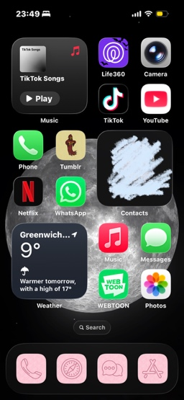
This is my Home Screen, which shows the apps I use the most.

Screenshot/Photo 2
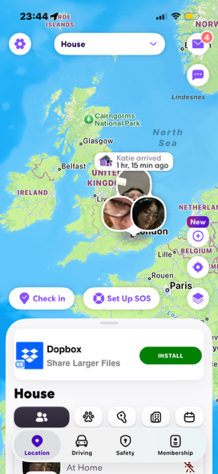
This is me on the app Life360, an app I use daily to see the locations of my those close to me, in the example above it’s my housemates locations obviously censored.

Screenshot/Photo 3
[Insert Photo/Screenshot below]
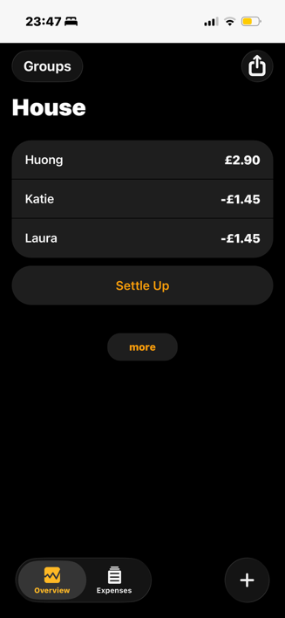
This image shows me in the app splid where me and my house mates put up shared house hold costs and the app devices it evenly.

My Short Reflection
- Write 5–8 simple sentences about your digital life.
- You can use the sentence starters below if helpful.
I use digital skills in many different way, ranging from finance help, entertainment and to stay connected with my friends. I feel confident in how I use my skills in my daily life.

Sentence starters
- I use digital tools to …
- I feel confident when I …
- I want to improve …
- I often use these tools: …
- I sometimes feel nervous about …
- I hope this module will help me …
- Digital skills are important for me because …
You can write more if you want.

Submission Checklist
Before you submit, please check:
​​​ ☐ I added 4–6 screenshots
☐ I wrote short sentences for each screenshot
☐ I wrote my short reflection
☐ My work is my own
☐ My file opens correctly
​​☐ My file opens correctly

