UNIVERSITU OF WALES TRINITY SAINT DAVID
BA BUSINESS MANAGEMENT
Strategic Management and Sustainability
LCBB6004

Assessment 1
Volkswagen and the company’s competitive environment
Case study analysis
(2500w)

Angela Celac (2023256)

Table of Contents

INTRODUCTION 3
MAIN BODY 3
Company background 3
Business strategy 4
Defining business strategy 4
Types of business strategies 4
Identify and Analyse significant company strategies. 5
RESOURCES AND CAPABILITIES 5
Definition of Resources and Capabilities 5
Resources and capabilities of company 6
Compatibility with Business Strategies 6
COMPETITIVE ADVANTAGE 8
Competitive strategy 8
Sources of competitive advantage 8
Competitiveness of Volkswagen's environmental sustainability efforts 9
RECOMMENDATION 10
CONCLUSION 11
REFERENCES 11
APENDIX 12

INTRODUCTION
Nowadays, both the population and business companies try to mobilize as much as possible to be involved in sustainable processes and products, thus contributing to the state of the environment. Organizations are among the most important factors that must draw attention to a sustainable future, so most of them are already taking actions and implementing new strategies for more sustainable and harmless products. One of the top automakers in the world, Volkswagen, and its competitive climate will be the subject of the case study investigation. The competitive environment in which Volkswagen operates will be analysed in this study, along with the company's main rivals, market trends, and difficulties.

MAIN BODY

Company background
One of the biggest automakers in the world and a well-known German car business, Volkswagen was founded in 1937. Germany's Wolfsburg is home to the company's headquarters. Volkswagen has a wide range of brands under its umbrella, including Volkswagen Passenger Cars, Audi, Porsche, SEAT, Skoda, Lamborghini, Bentley, Bugatti, and Ducati. Volkswagen operates on a global scale. Known as "Dieselgate," the 2015 diesel scandal was a momentous incident that had a lasting effect on Volkswagen and its brand. Volkswagen received a notice of violation from the United States Environmental Protection Agency (EPA) in September 2015, disclosing that the corporation had put software in its diesel vehicles to rig emission tests (BBC, 2015).
Following the crisis, Volkswagen tried to fix the problem and win back the public's faith. As part of its commitment to sustainability, the firm launched a substantial recall of the impacted vehicles, put internal reforms in place to increase compliance and transparency, and committed significant resources to the development of electric and hybrid vehicles. The Volkswagen diesel scandal served as a wake-up call for the car industry and regulatory authorities around the world, resulting in more thorough investigation of emissions testing practices and stronger rules. The tragedy brought home how crucial ethical behaviour, openness, and environmental responsibility are in the car industry. Volkswagen has been putting a lot of effort into repairing its reputation since the disaster and winning back customer trust. The business has invested a lot in electric car technology to move toward a more ecologically friendly and sustainable future (The Guardian, 2022).

Business strategy

Defining business strategy
A comprehensive plan or series of actions that an organization takes to accomplish its long-term goals and objectives is referred to as a business strategy. It entails making strategic decisions and deploying resources to forge a distinct competitive position, provide customers with value, and increase profitability and sustainability. An organization can navigate its competitive landscape, manage market issues, and seize opportunities using a well-defined business plan as a guide. It describes the purpose, range, and emphasis of the company and directs choices in numerous functional areas (Heubel, 2023).

Types of business strategies
Organizations frequently combine different strategies or modify them over time in response to shifting market conditions and organizational objectives. The organization's resources, market position, intended results, and capabilities all play a role in the strategy decision. Organizations can use a variety of business strategies, based on their objectives, the state of the market, and the level of competition.
- Cost Leadership Strategy: They put a lot of effort into establishing operational effectiveness, cost cutting, economies of scale, and strict cost management. With the help of this tactic, businesses can provide goods and services at fair pricing and draw in budget-conscious clients.
- Differentiation Strategy: Organizations implementing this strategy concentrate on brand image, design, quality, customer experience, and innovative product development. They can command higher rates and foster consumer loyalty by offering customers something that is truly unique (Heubel, 2023).
- Focus Strategy: Businesses that use this tactic concentrate their efforts on catering to the needs of a specific demographic of clients or geographic region. By knowing and serving the targeted clients better than broader competition, this technique enables businesses to gain a competitive edge.
- Innovation Strategy: Continuous innovation in products, processes, or business models is the emphasis of organizations pursuing an innovation strategy. To keep ahead of the competition, they make investments in research and development, promote a creative environment, and investigate new technologies and concepts (VERBEKE & LEE, 2022).

Identify and Analyse significant company strategies.
Volkswagen has put into place several important measures to support its expansion, competitiveness, and sustainability in the automotive sector.
Volkswagen has recently placed a significant emphasis on electric transportation and sustainability. The business wants to decrease its carbon impact and take the lead in the electric vehicle (EV) sector. With a goal of introducing more than 70 all-electric models by 2030, the firm intends to make significant investments in the manufacture and infrastructure of electric vehicles. The company introduced its Transform 2025+ plan in 2015, which aims to improve the organization's competitiveness, profitability, and innovation. The plan includes a few projects that streamline processes, boost effectiveness, and cut costs. Additionally, it entails making investments in cutting-edge technology, including digitalization, mobility services, and electric and autonomous driving. The objective is to establish Volkswagen as a top supplier of cutting-edge, environmentally friendly transportation options. Also, they are constantly exploring digitalization and utilizing technology to change its business processes and improve the consumer experience. The business has made investments in digital projects like data analytics, connected car technologies, and digital services. In order to benefit from their expertise in fields like artificial intelligence, autonomous driving, and mobility solutions, Volkswagen is also looking at joint ventures and collaborations with digital businesses (Annual Report, 2022).
These plans demonstrate Volkswagen's dedication to embracing innovation, sustainability, and digitalization while reacting to shifting consumer needs and market trends. Volkswagen intends to maintain its position as a top global automaker and influence the future of mobility by concentrating on electric mobility, modular production, market-specific strategies, and digital transformation.

RESOURCES AND CAPABILITIES

Definition of Resources and Capabilities
The competitive advantage and performance of an organization are largely determined by two key strategic management concepts: resources and capabilities.
Resources are the possessions, tangible and intangible, that an organization has and can use to accomplish its goals. Organizations mix and use resources as building pieces to create value and achieve their strategic objectives. The ability of an organization to effectively and efficiently use its resources to carry out tasks or activities is referred to as its capability. Resources, information, skills, processes, and organizational practices are all combined to develop capabilities (Whittington, Regner, & Angwin, 2020).

Resources and capabilities of company
The Volkswagen corporation has a vast array of assets and skills that help it maintain a competitive edge and achieve success in the automotive sector. Volkswagen operates multiple production facilities worldwide, giving it a strong global manufacturing presence. These facilities allow for the productive production and assembly of cars, parts, and components. Volkswagen offers a wide range of well-known brands in its brand portfolio, including Volkswagen, Audi, Porsche, Bentley, Lamborghini, and Bugatti (Volkswagen Group , 2021).
Volkswagen can serve a variety of market niches and customer preferences thanks to these brands' well-established reputations for quality, innovation, and performance. Volkswagen has strong R&D resources and makes large investments in technological innovation and advancement. The business carries out R&D projects in fields like connectivity, autonomous driving, electric mobility, and alternative fuels. With the help of these resources, Volkswagen can create cutting-edge technology and maintain its position as an industry innovator. Also, the company has tremendous manufacturing and technical competence. To ensure high-quality manufacturing standards, the company has deployed innovative production systems and processes. Volkswagen's experience in engineering, manufacturing planning, and quality control enables it to create vehicles on a wide scale effectively. The company has a long history of global distribution and sales. The company operates through a network of dealerships and authorized sales partners in various countries, ensuring that its automobiles are available to clients all over the world. Volkswagen is in good financial shape. The financial stability of the organization enables it to weather market swings and seek long-term growth prospects. In addition, the organization promotes an environment of creativity, teamwork, and continual progress. Volkswagen's human resources comprise competent personnel in a variety of sectors, including engineering, design, marketing, and management, all of which contribute to the company's skills and competitiveness (Volkswagen Group, 2022).

Compatibility with Business Strategies
Electric Mobility and Sustainability: As seen by its expenditures in EV R&D and the creation of the MEB platform, VW's resources and capabilities are in line with its aim to become a leader in electric mobility.
- Market Expansion and Diversification: Volkswagen's strategy of entering new markets and catering to various client categories is supported by its robust brand portfolio, production capabilities, and distribution network.
- Technology Innovation and Digital Transformation: The company’s research and development resources and emphasis on technology developments are in line with its plan to embrace connectivity, digitalization, and autonomous driving.
- Operational Efficiency and Cost Reduction: VW's focus on supply chain management and manufacturing skills complement its objective to increase operational effectiveness and cut costs (Volkswagen Group, 2022).
Below is an image of Volkswagen's SWOT analysis. Strengths, Weaknesses, Opportunities, and Threats are identified and addressed in this context as the four stages of this study. (Appendix - Table 1)
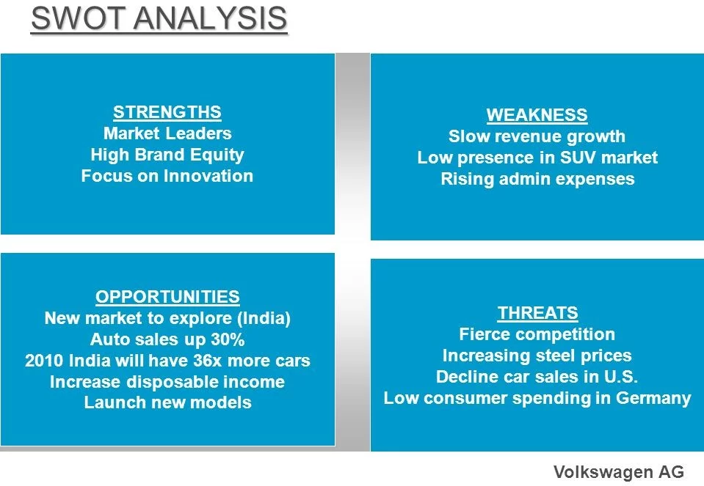
Figure nr:1 Volkswagen SWOT Analysis
Another efficient tool is he VRIO that can help in determining how much a company has in the way of resources and competences that are valuable, unusual, special, and supported by the company. (Appendix - Table 2)
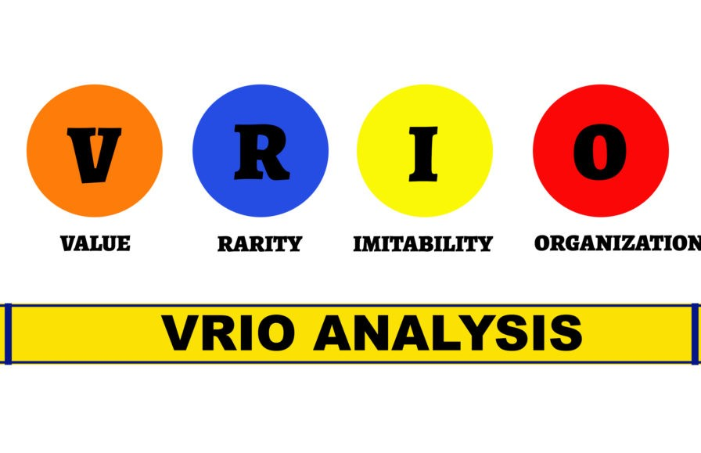
Figure nr:2 VRIO Framework

COMPETITIVE ADVANTAGE

Competitive strategy
A company's competitive strategy is a collection of long-term goals and initiatives developed to provide it a lasting competitive advantage in its market or sector. It entails making decisions and allocating resources in a way that puts the company ahead of its rivals and empowers it to perform better than them (Whittington, Regner, & Angwin, 2020).
Understanding the competitive environment, identifying sources of advantage, and developing a strategy to establish and maintain a positive market position are all components of competitive strategy. It involves both a clear vision for how to create value and outperform rivals in the long run, as well as a profound awareness of the organization's strengths, limitations, opportunities, and threats (Barney & Hesterly, 2019).

Sources of competitive advantage
When referring to an organization's ability to outperform rivals and achieve greater performance in the marketplace, the term "competitive advantage" is used.
By generating cheaper manufacturing, operating, or distribution costs than their rivals, organizations might acquire a competitive edge. A competitive advantage can be gained by providing goods or services that are viewed as distinctive, superior, or more valuable than those of rivals. Innovative items or advanced technologies can provide businesses a competitive edge. Being on the cutting edge of technical developments enables businesses to provide better performance, functionality, or efficiency, enticing customers and surpassing rivals. A strong corporate culture that encourages creativity, teamwork, and employee engagement can provide a firm a competitive edge. Companies that can outperform rivals include those that cultivate a healthy work atmosphere, recruit and keep top personnel, and enhance employees' skill (Alexandra Twin, 2023).

Competitiveness of Volkswagen's environmental sustainability efforts
Particularly in response to the "dieselgate" controversy in 2015, Volkswagen (VW) has made substantial efforts in recent years to enhance its environmental sustainability policies.
By introducing its specialized electric vehicle (EV) architecture known as the Modular Electric Drive Matrix (MEB), Volkswagen has demonstrated its strong commitment to electric transportation. The corporation has set ambitious goals to develop and sell millions of EVs over the next few years to establish itself as a market leader in electric vehicles. This dedication puts Volkswagen in a competitive position in the expanding market for electric cars and supports the worldwide movement towards decarbonization and a reduction in the use of fossil fuels. Volkswagen has been constantly adding new electric vehicle models to its lineup, including the ID.3, ID.4, and ID. Buzz. Volkswagen is putting itself in a competitive position in the shift to electric mobility by providing a broad range of electric vehicles across several categories (Volkswagen Group , 2021). Volkswagen is aware of how crucial a reliable charging infrastructure is to the uptake of electric vehicles. In order to improve the comfort and accessibility of EV charging, the company has invested in the construction of a network of charging stations, including high-power charging stations. With this investment, Volkswagen is demonstrating its dedication to tackling the infrastructural issues related to electric mobility, which could improve its competitiveness in the EV market. Volkswagen wants to use renewable energy sources to power its manufacturing sites. The business has improved the proportion of renewable energy in its energy mix and put policies in place to lower energy use in manufacturing processes. Volkswagen exhibits its dedication to lowering its carbon footprint and conducting business sustainably by embracing renewable energy and energy efficiency. In order to improve accountability and openness in its sustainability operations, Volkswagen has acted. The business releases yearly sustainability reports, makes its environmental performance indicators public, and interacts with stakeholders to address issues and get input. Volkswagen's reputation may be improved, customers' trust can be grown, and the company can be competitive in the sustainability market by being accountable and transparent with its reporting (Volkswagen Group, 2022).
Volkswagen has made excellent steps to be environmentally sustainable, but it's crucial to recognize the difficulties still present and the need for further development. Regarding the company's past scandal of cheating on emissions reporting, there is still scrutiny and criticism, which may influence its standing and ability to compete in the sustainability market. Additionally, Volkswagen will need to keep showcasing innovation, efficiency, and a strong commitment to sustainability to maintain its competitiveness as the automotive industry develops and more rivals enter the electric car market (Forbes, 2023).

RECOMMENDATION
- Boost Electric Vehicle Innovation
In order to progress the technology behind its electric vehicles, Volkswagen should keep spending money on R&D. This entails advancing battery technology, expanding the range, and speeding up charging. Volkswagen can keep its competitive edge in the quickly developing electric vehicle sector by continuing to be at the forefront of innovation.
- Expand Charging Infrastructure Partnerships
In order to promote the broad use of electric vehicles, Volkswagen should enhance its alliances and partnerships with providers of charging infrastructure. Together, they can hasten the installation of charging stations and guarantee that customers have a smooth charging process.
- Strengthen Collaboration with Renewable Energy Providers
Volkswagen should establish alliances with renewable energy suppliers in order to realize its objective of supplying industrial facilities with renewable energy. This may entail making direct investments in renewable energy projects, buying renewable energy directly, or concluding power purchase agreements. Volkswagen will hasten the shift to clean energy by working with suppliers of renewable energy.
- Enhance Sustainability in the Supply Chain
The company needs to give sustainability more of a priority throughout its supply chain. This entails collaborating closely with suppliers to advance moral behaviour, lessen negative environmental effects, and guarantee openness regarding the procurement of raw materials. Volkswagen's total sustainability performance can be improved by incorporating sustainability throughout the supply chain.
- Increase Transparency and Rebuild Trust
Volkswagen should keep putting an emphasis on responsibility and transparency in its business practices. This involves proactive interaction with stakeholders, the regular production of sustainability reports, and transparent communication about environmental and social performance. Volkswagen's long-term profitability depends on regaining the public's and authorities' trust.

CONCLUSION
The analysis of this case study and the research done on the above aspects, current to this company, leads us to conclude that the lesson was learned by them and that the business prospects now are much bigger and more valuable for people and the environment. The company's future strategies are proof that they are focused on consumer needs and have accurately assumed the role of Volkswagen products on the market. The case study analysis of Volkswagen illustrates the firm's commitment to environmental sustainability, its efforts to reestablish trust, and its dedication to maintaining competitiveness in a market that is changing quickly. Volkswagen wants to establish itself as a pioneer in the environmentally friendly and technologically cutting-edge future of the automotive industry. To do this, it is putting a lot of emphasis on electric mobility, enhancing sustainability standards, embracing digitalization, and encouraging innovation.

REFERENCES

Alexandra Twin. (2023, August 03). Competitive Advantage Definition With Types and Examples. Retrieved from INVESTOPEDIA: https://www.investopedia.com/terms/c/competitive_advantage.asp
Annual Report. (2022). Goals ang Strategies. Volkswagen Group .
Barney, J. B., & Hesterly, W. S. (2019). Strategic Management and Competitive Advantage. Pearson.
BBC. (2015, Octomber 2). Volkswagen: From the Third Reich to emissions scandal. London, UK.
Forbes. (2023, March 19). Volkswagen Positive For 2023 Profits, But Doubts Build. Retrieved from Forbes: https://www.forbes.com/sites/neilwinton/2023/03/19/volkswagen-positive-for-2023-profits-but-doubts-build/
Heubel, M. (2023). What is Strategy? Definition, Components & Examples Explained. Consulterce.
The Guardian. (2022, May 25). Volkswagen settles initial ‘dieselgate’ claims with £193m payout. London, UK.
VERBEKE, A., & LEE, I. (2022). International Business Strategy. Cambridge: Cambridge University Press.
Volkswagen Group . (2021). Annual Report, Division: Brands and Business Fields. Volkswagen Group.
Volkswagen Group. (2022). Annual Report. Volkswagen Group.
Volkswagen Group. (2022). Annual Report: Structure and Business Activities. Volkswagen Group.
Volkswagen Group. (2022). Annual Report: Sustainable value enhancement.
Whittington, R., Regner, P., & Angwin, D. (2020). EXPLORING STRATEGY. Harlow: Pearson.

APENDIX
Appendix 1
Table 1- SWOT analysis: BMW and Volkswagen
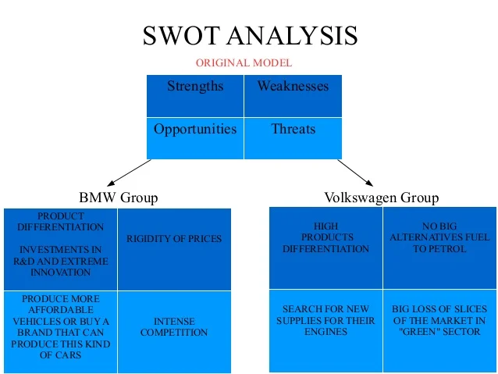

Appendix 2
Table 2- VRIO analysis


