2022

L7 – NETWORK SECURITY (ACCA7019)
Assignment submitted as part of the requirement for the award
of
MSC IN COMPUTER NETWORK AND CYBER SECURITY
BY
Fatema Namazi (2119925)


SCHOOL OF APPLIED COMPUTING
UNIVERSITY OF WALES TRINITY SAINT DAVID
(UWTSD)

INDEX
SNO | CONTENT | PAGE NO.
1. | PART 1  Introduction | 2
2. | Security threats faced by modern network infrastructure [1A-H] | 2
3. | AAA implementation on Cisco [3A] | 10
4. | Implementing secure network design, management and reporting [5A – 5B] | 11
5. | Common Layer 2 attack [6A] | 13
6. | Cisco IOS IPS feature set [8A – 8B] | 13
7. | Site-to-site VPN  [9A – 9G] | 14
8. | Deploy for Cisco ASA for firewalling [11A] | 15
9. | PART 2 | 16
10. | References | 23
PART 1
INTRODUCTION

1A. Network Security

Network security is defined as an action drawn towards protecting your network and data in terms of usability and integrity [1].Network security works as a hardware security as well as software technologies , it includes either of them [1].It deals with targeting several different kinds of threats [1] .It basically stops them from entering or spreading onto your network [1].And controls and manages who can access your network [1].A system of interconnected computers is called computer network [2].

1B. Types of Network Threats and how they can be mitigated: -

Threats come in several kinds and forms that can engage components such as links, malicious attachment, and application or network misconfigurations to penetrate the framework [3].
Let’s look at the most commonly faces network threats: -

1.Phishing – the familiar foe

Phishing is a social engineered procedure that is used by attackers to achieve access to certain data such as personally identifiable information (PII) , for example, credit card details , credentials such as usernames and passwords, etc[3].Commissioned tools in the framework are often used for harmful activity and exploitation by attackers [3].

The following diagram shows a phishing procedure from the starting phase to the final stage, i.e., the phishing email (spoofed) is made to look like it came from a renowned company [3].
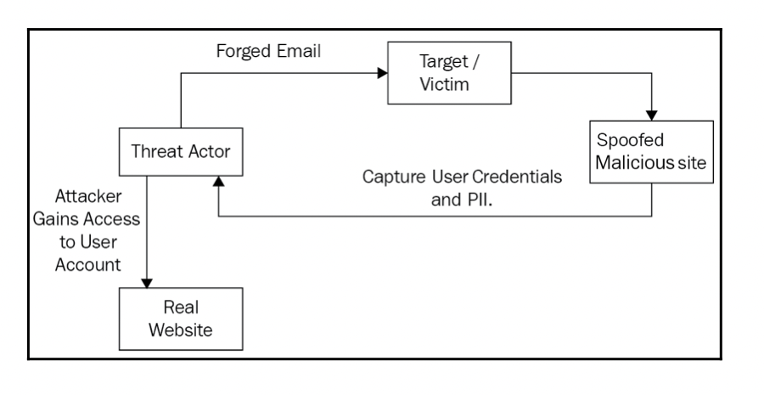
Figure 1.

To Fix Phishing threats

To mitigate the Phishing threats, we should concentrate on the appliance of a strong threat intelligence program to enterprisingly block malicious content, links, email senders, and domains in the company [3]. Look for the following signs to detect a potential phishing attempt:
- The display name and the email address don’t match
- There is a sense of urgency
- The email signature is not appropriate.
- It may have attachments or links that don’t look right.
- It may have speeling errors, a generic salutation, or a sender asking private information.

2. Rogue Applications and Fake Security Alerts - Intimidation and Limitation

This is one of the terrifying network threats experienced by any company or independent user [3].Rogue applications, browser plugins, and advertisement on the cyberspace take upper hand on users panic when they encounter a system virus notification [3].By utilizing this fear, hackers grasp on it to perpetrate swindling on the cyberspace [3].It makes a user think that there are viruses, malware or trojans in their server or system [3].Anyhow, the user upgrade the program provided, and changes the system settings , compromises confidentiality , integrity and availability [3].The installed malware grant hackers full access to confidential data and sensitive information such as passwords, personal credentials and other confidential information [3].

To Fix Rogue Applications and Software Threats

To keep away such possible fake updates, configuring the firewall and intermediary to block traffic from bad reputation sites is encouraged [3]. A skilled EDR solution or antivirus function should be placed at every endpoint with rules configured to deny the installation of any unauthorized application on the server or system [3].

3. Insider Threats – The Enemy Inside the Gates

This is one of the most objectionable network threats faced by companies [3].It occurs when a user or group of users working in the given organization or are close to the organization having partial or full access to licensed information about the company use their benefits and authorize malicious activity to maltreat the organization [3].

To Fix Insider Threats

Few methods that can be employed include the following:
- Utilization of network monitoring
- Access control management
- User and entity behaviour analytics (UEBA)
- Data-centric audit and protection (DCAP)
- Integration of SIEM to for greater visibility, and identifying anomalous behaviour
- Putting prioritized monitoring around crown jewels and high value targets
- Development of an insider threat program and employee security training.

4. Viruses and Worms – A Prevailing Peril

Viruses and worms have always been the main worry in terms of network security [3]. These viruses and worms are menacing as they clone and imitate themselves into a computer system and manipulate the files and folders and adversely corrupts the administrating of the system [3].Worms tends to clone themselves through the network by way to ambush other host systems in the network and self-reproduction , this may influence the system and cause system to crash, unusual application or program behaviour, abnormal web browser pursuit , missing or modified files, and the creation of unknown application icons and processes , among others [3]. There are different types of computer viruses and works, some of them include: -
- Resident virus
- Stealth
- Internet worms
- Space filler virus
- Macro virus

To Fix Viruses and Worms Threats

Companies should be prompted in installing antivirus throughout the organization endpoints and make sure that they are administrating the most recent version to lessen the risk [3]. Assure that all operating systems and installed applications are updated to the newest security fix or patch to build the best security posture against developed threats that look to manipulate known vulnerabilities and application flaws [3].

5.Botnets – An Adversarial Army at Disposal

Botnets is in alliance of interconnected internet devices managed by malicious hackers for a multitude threat vectors that can be accomplished to improvise the attacker [3]. Traditionally, botnets were used for DDoS attacks but with time, they have been used for crypto-mining, data extraction, email spam, click frauds, supporting C2C infrastructure, and so on [3].

To Fix Botnets Threats

Here are a few other steps that can be taken in this regard:
- Blocking unwanted inbound and outbound requests
- Implementation of additional authorization and authentication checks
- Network compartmentalization
- Getting rid of defaults and week usernames and passwords
- Enforcing authorized software and firmware updates in a timely fashion
- Implantation of least privileges
- Upscaling monitoring capability
- Analysing network anomalies

6.Trojan Horse – Covert Entry

Attackers use strategic approach to penetrate infrastructures and surrounding using malicious applications known as trojans [3]. Trojans are a sort of malicious software that is programmed to take over the target device to collide the confidentiality, integrity and availability of the targeted system[3].They mimic legitimate applications or software intending to be used by a user post, which they start executing the embedded malicious code to activate [3].

To Fix Trojan Threats

It should be ensured that users are following the basic practices of security clearance and applications and systems are hardened using the best security practices such as EDR and firewall [3].

7.Rootkit – Clandestine Malicious Applications

Rootkits are malicious applications that focus on providing benefitted perseverance in the target system [3]. They allow the attacker to control the target system and allow remote implementation of commands by the attacker [3].

To Fix Rootkit Threats

It is highly recommended to scan signature, behavioural-based methods and memory dumps [3].

8.Malvertising – Ads of Chaos

This is one of the usual threat vectors used by attackers to target independent users and businesses [3]. the strategy is designed to send code that is invalid by maliciously administering it on genuine online advertisements [3]. This mostly occurs in web pages and advertising networks [3]. The injected code hacks users and redirects them to the dangerous websites that have been linked [3].

To Fix Malvertising Threats

Users can safeguard themselves with the implementation of browser-security plugins, incapacitating the running of automatic Flash player scripts and scripts from websites, using a estimable ad-blocker, and keeping away from clicking on ads from suspicious websites [3] .

9.DDos – Defending Against One Too Many

This is one of the most extensively borne cyber disruption/attacks targeting companies these days [3]. These attacks focus on destressing the target by sending an overwhelming number of requests [3]. They are hazardous to the servers by requesting for data and services, hence rendering them malfunctioned [3].

To Fix DDos Threats

To prevent infection, organizations should focus on the following :
- Having a transparent well-exercised mitigation plan that is practically tested against mock DDoS attacks
- Use of DNS and BGP traffic routing
- Increase bandwidth and network capacity
- Use of contact delivery network for content delivery
- Implementing traffic filtering
- Leveraging connection tracking, IP reputation, deep packet inspecting , blacklisting/whitelisting , and rate-limiting

10.Ransomware – Cyber Extortions

This is the most widespread and awful cyber-attack in recent times that has alarmed most of the organizations [3].In this attack, target system or device is sealed by an encrypted mechanism and has limited access to any data from that system [3].The target can be systems that carry sensitive data or a part of the operational team of company [3].The user is directed to communicate the threat actor for the decryption key to unlock the system and gain access to the data after paying an extricated amount to the threat actor [3].

To Fix Ransomware Threats

Here are a few measures that you can initiate to stay away from ransomware threats: -
- Regularly back up your files: Ransomware functions by restricting access to data and system operations and in turn locking out the user and disrupting business operations [3].
- Keep applications and OSes updated: Often, ransomware that focuses on encrypting files leverage application and/or OS vulnerabilities to infiltrate into the system [3].
- Securely use system components and administration tools: Cybercriminals are misusing legitimate utilities and system administration tools to install and execute malware and conduct malicious activities [3].

1D. The Fundamental Principles of Securing Network

When designing the network security system, the following fundamental IT systems security should be taken into account [4]:-
- Défense-in-depth – Protection of IT system resources is based on many security layers [4]. Extensions of the defence-in-depth principles are the following – Layered protections, defence in multiple places and defence through diversification [4].
- Compartmentalization of information – IT system resources of different sensitivity levels should be in different security zones [4].
- Principles of least privilege – IT system subjects should have minimal privileges necessary for proper functioning within the organization [4].
- Weakest link in the chain – The security level of the IT system depends on the least secured element of the system [4].
- Security zones – The basic means of keeping network traffic flowing where you want and restricting it where you do not is the firewall [4]. With proper placement and configuration, firewalls help create secure architectures, dividing the IT system network infrastructure into security zones and controlling communication between them [4].
- Intrusion prevention – IPS devices are responsible and blocking penetrations and attacks conducted by intruders and malicious malware applications [4]. They should be installed in the network path between potential threat sources and sensitive IT system resources [4].

1E. Describing the Fundamental Principles of Securing a Network

There are 5 major perspectives as different types of cyber security risk management which will be discussed below [5] : -
- Cybersecurity threats in SME’s – Describing cybersecurity threats in SMEs could be a key solution in helping SMEs to understand the main concept of cybersecurity [5].
- Cybersecurity behaviours in SME’s – Employee behaviour in SME’s could account for many cybersecurity threats [5]. Training and education are important for improving knowledge, while in some cases even knowledge cannot guarantee the right behaviour [5].
- Cybersecurity practices in SME’s – A consistent concern in literature has been the lack of seriousness in SME’s usual ways of dealing with cybersecurity threats [5]. Therefore, authorized people usually participate unconsciously in risky practices which might affect the institutions security, privacy, data and current technical preventative measure [5].
- Cybersecurity awareness in SME’s – SME’s need to be aware of consequences of cybersecurity and try to address it, as this awareness could potentially cause them to adopt the right behaviours [5].
- Cybersecurity decision-making in SME’s – Decision making in information risk management, owners and managers play a major role, which shows how important the managerial level is for cybersecurity threats [5].Effective managers are always decision-makers in most situations, especially in deciding on the firms’ strategies for information security [5].

1F. Cisco network foundation protection (NFP) framework is used to secure a network

Network Foundation Protection (NFP) is a framework designed by Cisco to logically group functions that occur on a network [6].The framework combines several security techniques to secure routers and switches and ensure the availability of the network even when it is under attack [6].It breaks down into three basic sections: -
- Management plane – The protocols and traffic that a network administrator uses to configure network devices from his computer [6].An example of the management plane traffic is the SSH or Telnet data generated by a network administrator when a Cisco IOS device is configured remotely [6].
- Control plane – the protocols and traffic that the network devices send between each other for automation network discovery and configurations [6]. Examples of such traffic are ARP messages or routing protocol updates [6].
- Data plane – The end-user traffic [6]. This is the traffic that is going through your network, and not to a network device [6].For example, the traffic generated when a user in your network browses a website, if a failure occurs in this place, the user might be prevented from completing his work [6].

1G. Mitigating the Effects of Viruses, Worms, And Trojan Horses in A Small to Medium Business

Small business needs to implement numerous security controls provided within the ISO/IEC 27002 information technology – security techniques – code of practice for information security management [7]. However, implementation of this layered approach is no defence against a determined attacker who can bypass these best practice security controls [7].In this sense, unless small businesses address security requirements daily by updating antivirus software and analysing network performance, they cannot consider themselves to be secure [7].Additionally , small businesses may utilise insufficiently configured wireless networks that can be easily penetrated by determined attacker [7]. PDAs, iPhones and laptops further introduce areas of vulnerability for small businesses [7]. If small business utilises freeware antivirus it may be possible that there is a delay in the release and resultant updating new virus definitions, thereby leaving small business systems vulnerable [7]. Systems that are not regularly patched , especially the browser application introduce add-ons vulnerabilities such as for active x , Flash and Adobe PDF [7].Installation of software such as antivirus and intrusion prevention (IPS) software, could further protect against intrusion [7] .Intrusion of small business systems could range from a simple scan of the network in order to determine system vulnerabilities or a hacking attack, or as using malicious code to view all files on a computer [7].The majority of these threats can be managed by implementing traditional safeguards, staff awareness and security training and managing information made available[7]online[7].There are other initiative that the government could take responsibility for that would improve security for small business : national program to raise awareness, funding for training which could be through associations such as the small business association [7].
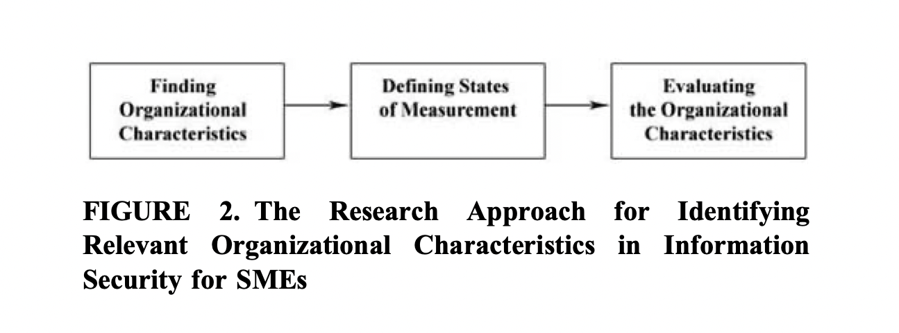

1H. Describe Endpoint Vulnerabilities and Protection Methods

Memory attacks penetrate via endpoints and malware evades security defences by exploiting vulnerabilities in application and operating system processes [1].A majority of these attacks operate in the memory space of the exploited application and remain untouched by most security solutions once they gain access to the memory [1] .AMP for endpoints exploit prevention provides an integral preventative security layer for protecting endpoints, services, and virtual environment from file-less and memory injection attacks, as well as obfuscated malware [1] .It does so by changing the static nature of the defence landscape to a dynamic one and makes it more difficult for attackers to plan and execute successful attacks [1]. Cisco AMP for endpoints protection capabilities comprise several technologies that work together to prevent, detect and remediate malicious code at the endpoint [1] .The core in-memory prevention technologies include:
- Exploit prevention – defends endpoints from memory attacks commonly used by obfuscated malware and exploits targeting software vulnerabilities of protected processes [1].
- System Process Protection defends critical windows system processes from being tampered with or compromised through memory injection attacks by ither offending processes [1].
The Core On-Disk Detection Technologies Include:
- AMP Cloud blocks malware using the global threat intelligence that is constantly augmented with new threat knowledge from cisco Talos, cisco threat grid, and cognitive intelligence research [1]
- TETRA is a traditional signature-based antivirus engine, resides on the endpoint, and provides on-disk malware detection capabilities; TETRA is a part of the AMP Connector for windows [1].
The core post-infection detection technologies include:
- Device flow correlation inspects incoming and outgoing network communications of a process/file on the endpoint and allows the enforcement of a restrictive action according to the policy [1].
- Cloud Indicators of Compromise help surface suspicious activity observed on the endpoints through pattern recognition; related alerts serve as the trigger for more in-depth investigations and response [1].
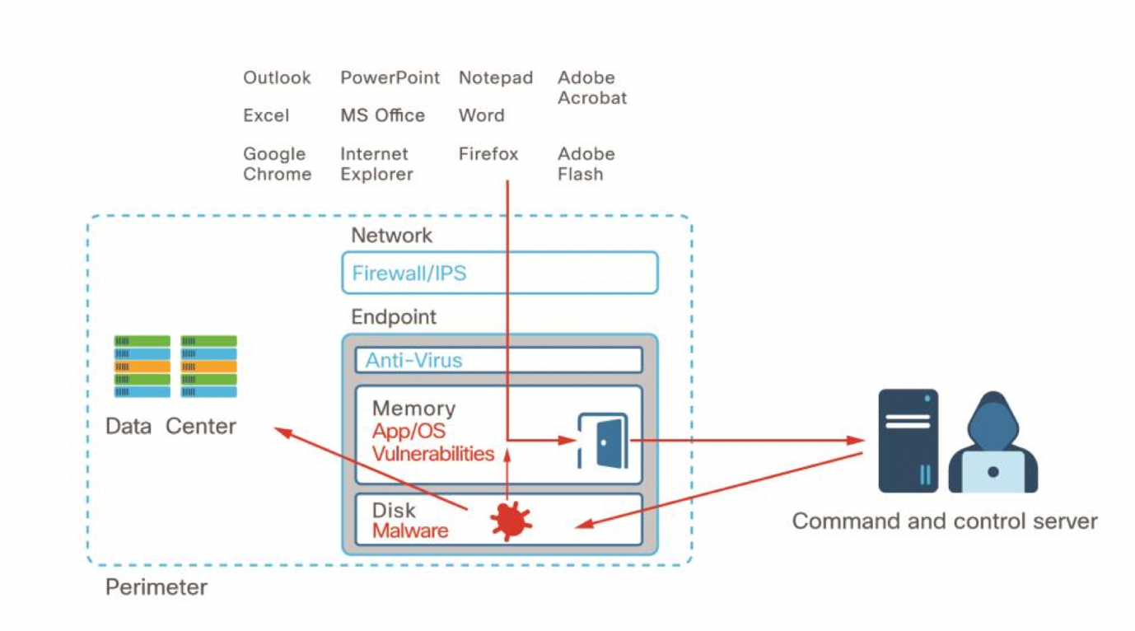

3A. AAA Is Used to Secure a Network

In our days there exists special needs for authentication, authorization and accounting for the network services of any kind, and especially for the billing ones [8].These security purposes are fulfilled with the AAA standard [8].AAA architecture and infrastructure, has been defined and standardized by the internet engineering task force (IETF) and internet research task force (IRTF) [8].
Authentication Process – it’s a process of two different actions : provision and verification [8].For the transmitted information, an authentication mechanism must provide an electronic evidence of authenticity , as proof for the data procedure [8].In the second phase, this proof must be verified [8].Two different actions of authentication are critically security mechanisms, which are needed for the secure access to networks , for both servers and clients [8].
Authorization – It refers to the second A of “AAA”, in most of the cases, authentication refers to the permission based on credentials, in order a user to have access to a network provider [8].The service provider network administrates the resources manager [8].
Accounting Process – AAA also supports accounting process. Accounting defines all the information collected for the resource’s usage of a network [8].Networks services and resources use them, and this service and resources allocation is translated to consumption, which is finally counted by this process, according to the applied accounting protocols [8].AAA operation is based on a set of processes that are performed, in order a secure communication to be established [8].
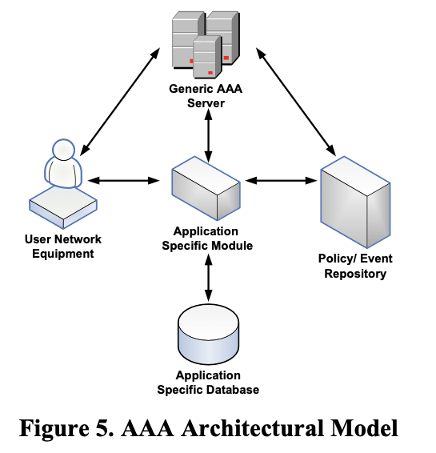

5A. Implementations Of a Comprehensive Security Policy

The Comprehensive Internet Security Policy (CISP) provide organisations with a generic model to use when designing their own IS policies [9].Therefore, any IT government related organisation that needs to design or upgrade there is policies may adopt the CISP [9].Consistent with the changing nature of technology , the IS policies will be subject to change as well [9].Accordingly the CISP may be valid for a set period due to technology improvements and will need to be upgraded [9].
The protection of information and its systems can be achieved by employing IS policies within the government and the business organisation [9]. Many governments department and the business organisation [9]. Many governmental departments have adopted the use of these policies as the primary way to achieve their goals and business continuity [9].
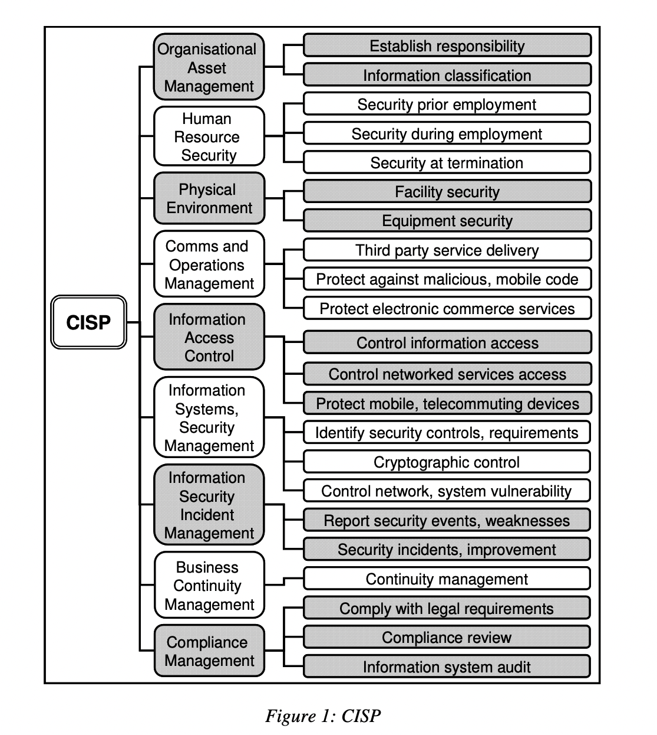

5B. The various techniques and tools used for network security testing

There are several techniques used for network security testing, they include the following: -
- Model-based testing
- Code-based testing and static analysis
- Penetration testing & Dynamic analysis
- Regression testing
1.Model – based Security testing – Is an MBT approach that validates software system requirements related to security properties[10].It combines security properties like confidentiality, integrity, availability, authentication, authorization and non-exponentiality with a model of the SUT and identifies whether the specified or intended security feature hold the model [10].
2. Code-Based Testing and Static Analysis -Code reviews can either be done manually or automated [10].The latter is often called static code analysis (SCA) or Static Application Security Testing (SAST) [10] .Moreover we can either analyse the source code of the program or the complied source code. [10]
3.Penetration Testing and Dynamic Analysis - A well-known form of black-box security testing is Penetration Testing [10].In a penetration test, an application or system is tested from the outside in a setup that is comparable to an actual attack from a malicious third party [10].It is commonly done for applications that are open for networked communication [10].The NIST Technical Guide To Information Security Testing And Assessment partitions the penetration testing process in 4 phases – Planning, Discovery, Attack and Reporting [10].
4.Security Regression Testing – A combination of regression and security testing called security regression testing, which ensures that changes made to a system do not harm its security, are therefore of high significance and the interest in such approached has steadily increased [10].It ensures that changes made to existing software do not cause unintended effects on uncharged parts and changes parts of the software behave as intended [10].

6A. The vulnerabilities of and mitigations techniques for securing the layer 2 infrastructure

Layer 2 in IP over Ethernet networks is prone to several attacks. Three most known Layer 2 sniffing attacks are Address Resolution Protocol (ARP) poisoning, Media Access Control (MAC) flooding, and port stealing [11].
ARP is a network later protocol used to map an IP address to a physical machine address recognizable in the local network, such as an Ethernet address [11].The process of updating a target hosts ARP cache with a forged entry is referred to as poisoning [11].
In MAC flooding attack, the attacker floods the switch with MAC addresses using forged gratuitous ARP packets until the CAM table is full [11].
The port stealing attack uses the ability of the switches to learn to bind MAC addresses to ports [11].When a switch receivers’ traffic from a port with a MAC source address, it binds the port number and the MAC address [11].
There are several ways to mitigate these types of attacks. One of these actions is to enable port security on switches [11].The best practice is to shut down the port that exceeds the limit [11].Another recommended action is to employ static ARP entries [11].The third method of defence is to utilize intrusion detection systems (IDS) [11].

8A. Network-based intrusion prevention systems are used to help secure a network

Network intrusion Detection System is used to monitor networks for attacks or intrusions and report these intrusions to the administrator in order to take evasive action [12].A large NIDS server can be set up on a backbone network , to monitor traffic ; or smaller systems can be set up to monitor traffic for a particular server , switch , gateway, or router [12].Intrusion detection is needed in today’s computing environment because it is impossible to keep pace with the current and potential threats and vulnerabilities in our computing systems[12].The environment is constantly evolving and changing field by new technology and the internet [12].Intrusion detection products are tools to assist in managing threats and vulnerabilities in this changing environment [12].Intrusion Detection System helps to identify the intrusions [12].without an NIDS, to monitor any network activity , possibly resulting in irreparable damage to an organizations network intrusion attacks are those in which an attacker enters your network to read, damage , and/or steal your data [12]. These attacks can be divided into two subcategories – pre intrusion activities and intrusions [12].

8B. Signatures Are Used to Detect Malicious Network Traffic

Intruders have signatures like computer viruses that can be detected using software [13]. An attempt is made to find data packets that contain any known intrusion related signatures on set of signatures and rules the detection system can configure log suspicious activity and generate alerts [12]. Signatures is pattern inside a data packet [12]. Signature is used to detect one or multiple types of attacks [12].
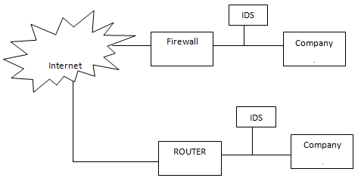

9. The Purpose of VPNs

The main purpose of a VPN is to give enterprises the same capabilities , or even better ,as on private networks , but at a much lower cost [13].Enterprises benefit from VPN in reducing the cost, increasing the scalability ,and increasing the productivity , without imparting the security [13].VPN should provide authentication , access control , confidentiality , and data integrity to ensure security of the data [13].A VPN should typically support the architecture that consists from main LAN at the headquarters of an enterprise, other LANs at remote offices, partner or customer company LANs and individual users connecting from out in the field [13] .There are basically two types of VPNs remote access VPN and site-to-site VPN. Site to site VPN can be further divided into intranet VPN and extranet VPN [13].
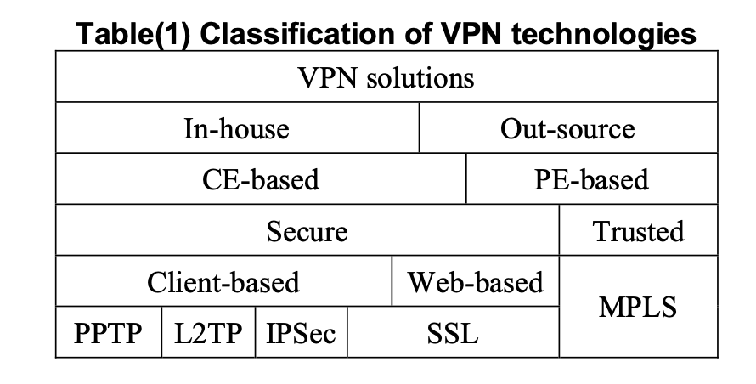

9. IPSEC VPNs Operation

Internet protocol security (IPSec) is a framework of IETF open standards aim at securing traffic on the network layer [13]. Client-based VPNs are based on IPSec, PPTP, L2TP and SSL [13]. IPsec planning and implementation should be addressed in a phased approach [14]. A successful deployment of IPsec can be achieved by following a clear, step-by-step planning and implementation process [14].The use of a phased approach for deployment can minimize unforeseen issues and identify potential pitfalls early in the process [14].This model also allows for the incorporation of advances in new technology, as well as adapting IPsec to the ever-changing enterprise [14]
- Identifying needs – The first phase of the process involves identifying the need to protect network communications [14]. This phase involves determining how that need can best be met (e.g., IPsec, TLS, SSH) and deciding where and how the security should be implemented [14].
- Design the Solution – The second phase involves all facets of designing the IPsec solution [14]. I.e., architectural considerations, authentication methods, cryptography policy, performance, and packet filters [14].
- Implement and test a Prototype – The next phase involves implementing and testing a prototype of the designed solution in a lab or test environment [14].
- Deploy the solution – Once the testing is completed and all issues are resolved, the next phase includes the gradual deployment of IPsec throughout the enterprise [14].
- Manage the solution – After the IPsec solution has been deployed, it is managed throughout its lifecycle [14]. Management includes maintenance of the IPsec components and support for operational issues [14].

9. How the Types of Encryptions, Hashes, And Digital Signatures Work Together to Provide Confidentiality, Integrity, And Authentication

Cryptographic algorithms and key lengths that are considered secure for current practice should be used for encryption and integrity protection [14]. AES-GCM with a 128-bit key or 256-bit key is recommended for encryption and integrity [14].DH ECP groups and the MODP group 14 (2048) are recommended for IKE for key establishment [14].More than one algorithm can be specified in each case to ease the transition to new, updated algorithm [14].

9. Cryptographic Hashes Are Used to Ensure Data Integrity and Authentication

Setting the cryptographic policy for confidentiality and integrity protection and for key exchange involves choosing encryption and integrity protection algorithms , key lengths , DH groups for key exchange, and IKE and ESP lifetimes [14].For up-to-date policies and advice on these settings, see NIST SP 800-131A (14) and FIPS 140 (14) as well as the recommendations of the IETF for IKE (14) and ESP [14].IKE protocol sends just a few packets per hour , so it makes sense to be extra cautious and pick strong algorithms with large enough keys and , specifically , a strong DH group [14].

PART 2

To design a model based on the given scenario for A2Z technologies LTD. We will be using some specific hardware and software solutions. PC and laptop can be used as a hardware solution while for the software solution we will be using Packet Tracer from Cisco, VMware – Virtual Machine, Microsoft Server 2008 R2 and Windows 7 [15].
With the help of Packet Tracer, we can create the entire network, including all the functionalities and security functions presented in detail [15].

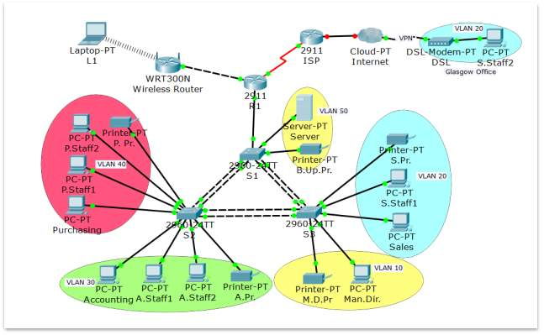

As it can be seen in the network design, the network has been divided into multiple parts accordingly for better functionality and security, hence creating multiple subnets [15]. VLSM has been used to part the network. Few of the subnets are VLANs while the other few are non-VLANs.
Every department in the network is designed in such a way that all devices of that department are clubbed together under one and are assigned with an individual VLAN.
The non-VLANs include the following
- The wireless component
- The links btw the internet router with ISP and the wireless router
All the wired devices are assembled on one corner of the internal router, devices such as PCs, printers’ and server. This is going to divide them (core parts of the network) from the wireless network components.
They need to be separated in order to secure the network and add additional precautionary measures related to this because the wireless components tend to be the most vulnerable parts of any computer network. Hence, we need to separate the ethernet network from the wireless network using the internal router. Internal router is where all the security measure will be implemented such as firewall/ACLs, passwords, routing restriction, port security etc.
These security measures will help us to create obstacles and act as a barrier between these two components of the network. In order to limit the possible external attacks, traffic filtering strategy is applied making the internal router act as a barrier between the company’s network and the internet [15].
While the VLANs are distributed among the departments an extra VLAN will be configured for supervisory functions, which would allow for remote access in switches. This strategy is used to divide the departments from each other, so the employees won’t have access to department other than their own. The only communication possible between the departments will be through the internal router. This method is called Inter-VLAN routing and each VLAN will own a sub interface configured.
ACLs are implemented with different rules to meet the company’s needs to restrict traffic between departments. VLAN strategy has multiple benefits such as: - Broadcast domains size decrement, no waste of IP addresses, segment traffic, etc.
Since the Cardiff department is geographically separated from the head office they must be in the same network and be part of the same VLAN as the rest of the employees in Swansea to gain same level access to the server. The managers should be able to have access to the manufacturing plant as they do to the head office. To make this possible, VPN technology is used, VPN technology helps to connect the two offices of the company. Every device under the Ethernal Network is assigned a static IP address. This helps in allocating them manually and ensures a better network security. The Ethernet Network will be divided into six VLANs, 5 IP addresses will be used in each VLAN. Each of the VLAN has allocated 14 IP addresses which will be available for scalability. There will be a separate non-VLAN subnet for the Wireless Network because it is strictly dedicated to mobile devices that belong to employees and visitors. The Wireless Router will be configured with special security measures to limit vulnerability of the wireless component.
The main parts of the network will be the Ethernet Network with all the VLANs and the Wireless Network.
The prototype for the network will be configured using the following devices: -
- 1 wireless router
- 5 printers
- 2 routers
- 3 switches
- 1 server
- 10 pcs
- 1 wireless device

4.
The costs of security framework for the A2Z technologies LTD includes costs of software and physical products that will help fortify the network against attacks. The following are the costs of the required accessories:-
- Firewall – The price range of firewalls is between 325 £ to 4900 £.
- Firewall Configuration - It is recommended to have the firewall installed by a security professional. The cost of firewall configuration includes 370 £ to 2000£.
- Administrator Console – A2Z technologies need a subscription from the vendor to use administrator console. Administrator Console gives notifications of any threats and helps in configuring the network if additional devices or workstation are required.
- End point Detection and Response (EDR) – EDR allows greater control and visibility over the company’s network by managing the network and connected devices from one central location. Average cost range 4£ - 7£ per user per month and 8£-17£ per server per month.
- Mail protection – Price ranges between 2£ to 5£ per user per month for protecting email and maintaining quality protection service.
- Two-factor authentication – The price for two- factor authentication can range from 0£ - 9£ per month
- Hardware Security Key – The cost for hardware keys ranges anywhere between 24£ to 48£ depending on the manufacture.
- Vulnerability Assessment – This assessment can help the company expose the significant risks for cyber threats. Expected costs varies from 4000£ to 8000£.

5.
It takes 3 months for the security network to be implemented and executed on the company.
We can start by types of hardware and software; configurations and defensive mechanism apply.
Firstly, we need to set up a DNS (Domain name System) by assigning an IP address for DNS server and Pcs server. Then given a name to the domain linking it to the IP address. Lastly, Add the DNS to the database and test the new network on the web browser.
Once the network has been constructed and its functionality has been tested. We can move onto configuring the prototype.
To make difficult for the attackers to gain access into the server, security solution must be found and applied, this process of finding and applying solutions is called Hardening.
- Router Hardening
Router hardening is closure of unused ports. It involves securing network by giving remote access using SSH and to gain access to it one should create a secure login.
Access Control List (ACL) is used to filter traffic on the server for making the device act as a firewall.
- Switch Hardening
Switches are hardened just how routers are for securing network. Switch hardening involves setting up login security, configuring remote access via telnet and closing unused interfaces.
- Hardening the Wireless Router
Wireless Router is paid special attention since it comes under the most vulnerable part.
- Hardening the printers
- Server configurations
- Setup prototype computer
- Deploying basic settings by using Group Policy
- Network Policy and Access Services (NPAS)
- Hardening a server
- Setup windows server Backup
- Setup printer server
- IPSec Configuration
- Setup Antivirus on Server

6.
Denial of Service Attack –
Computer resources for normal use are disrupted. DoS makes a huge number of requests to the server, make a resource unavailable for legitimate use and is difficult to distinguish from legitimate requests.
Eavesdropping Attacks –
Its communication path is compromised, and it relies on it as network device tapping, ARP poisoning and DNS poisoning.
Man-in-the-Middle Attack –
It’s an attack where the attacker secretly relays and alters the communication between two parties without their any knowledge.

7.
Black Box testing
A test is performed by an average hacker with minimal knowledge of the network. Its quick and it employs tools to exploit and identify vulnerabilities in the outward facing network.
Gray Box Testing
A test is performed by the user that can access the system including elevated privileges. It provides insights into the internal and external vulnerabilities and is more focussed assessment of the network.
White Box Testing
A test is performed by an IT or IS user, that can access the architecture documentation and source code. It’s the longest test because large amount of data is being scrutinized to identify vulnerabilities.

No. | Test Carried On | Expected Result | Actual Test | Pass Y/N | Fault
1. | Black Box testing  A test is performed by an average hacker with minimal knowledge of the network. Its quick and it employs tools to exploit and identify vulnerabilities in the outward facing network. | Should work fine, if a sub-interface is set up as default gateway for every VLANs. | It is possible | Y | N/A
2. | Gray Box Testing  A test is performed by the user that can access the system including elevated privileges. It provides insights into the internal and external vulnerabilities and is more focussed assessment of the network. | The staff shouldn’t have access form his PC to any private files stored on server belongs to other members of staff. Only he, Manager and managing director should have access to files stored on server. | Its working properly | Y | N/A
No. | Test carried on | What is the Fault | How was it resolved | Fault Fixed | Re-test No.
3. | White Box Testing  A test is performed by an IT or IS user, that can access the architecture documentation and source code. Its the longest test because large amount of data is being scrutinized to identify vulnerabilities. | The results assist in adjusting risk analysis and mitigation strategy | Reconfigure  OSPF routing protocol | Y | 3

8.
Invoice From the Network Security Services: -
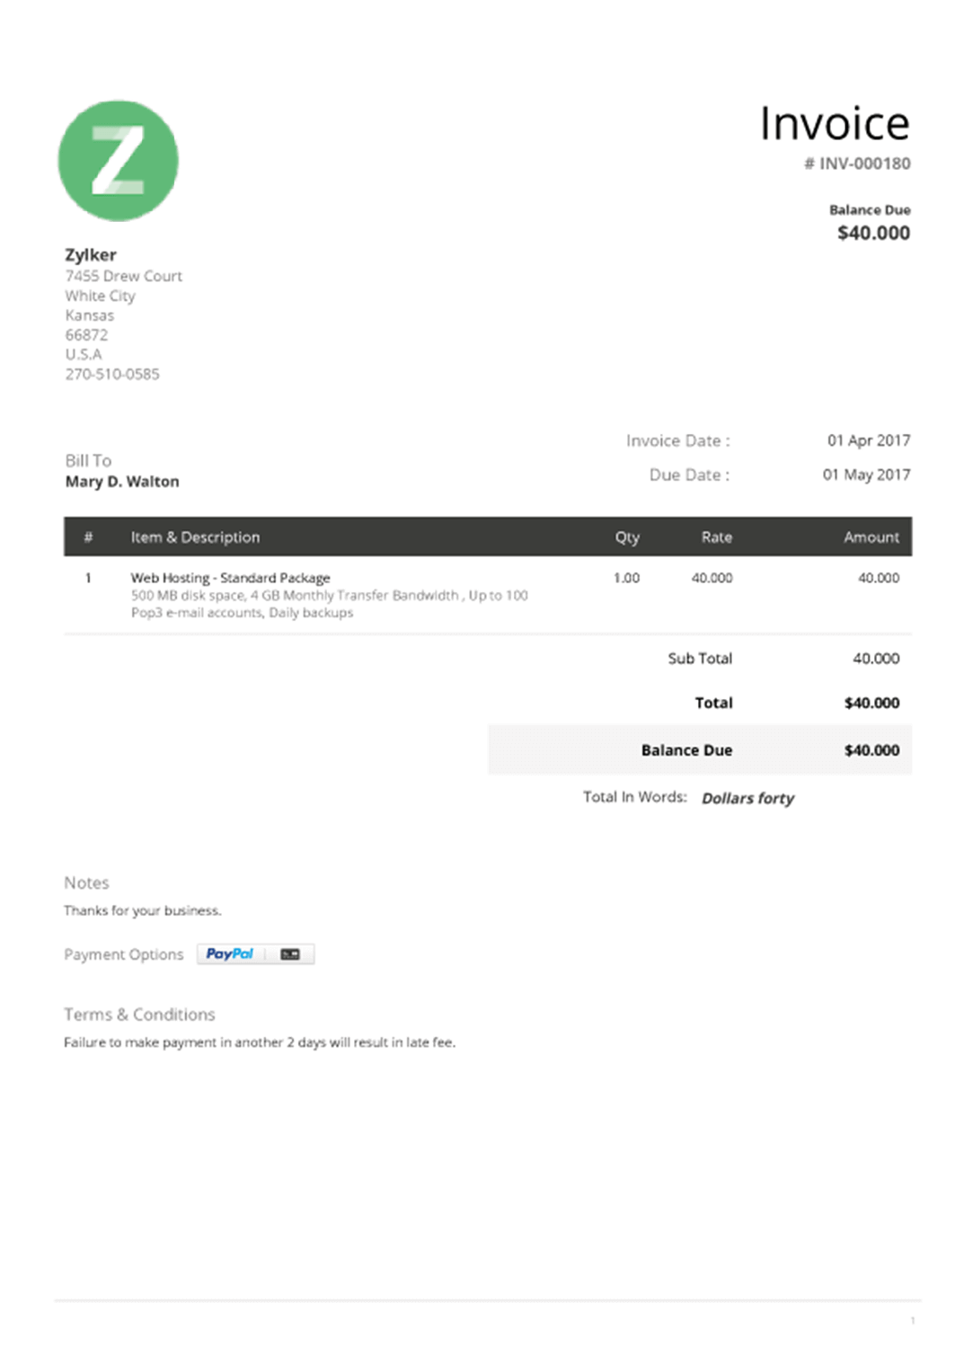

REFERENCES
[1] (). https://www.cisco.com
. Available: https://www.cisco.com.
[2] Abhinav V. Deshpande, "Introduction to Network Security," International Journal of Computer Sciences and Engineering (IJCSE), vol. 3, (9), 2015. Available: www.ijcseonline.org.
[3] Aditya Mukherjee, Network Security Strategies , .
[4] Mariusz Stawowski, "The Principles of Network Security Design," The Global Voice of Information Security (ISSA ), pp. 29-31, 2007. Available: http://advancedcybersolutions.com/HTML/Articles/PrinciplesNetworkSecurityDesign.pdf.
[5] Abdulmajeed Alahmari and Bob Duncan, "Cybersecurity Risk Management in Small and Medium-Sized Enterprises : A Systematic Review of Recent Evidence," 2020.
[6] (). Cisco Network Foundation Protection (NFP) framework. Available: https://geek-university.com/cisco-network-foundation-protection-nfp-framework/.
[7] Patricia A H Williams and Rachel J.Manheke, "Small business - A cyber resilience vulnerability," in International Cyber Resilience Conference, 2010, .
[8] Nicolas Sklavos, Spyros Denazis and Odysseas Koufopavlou, "AAA and mobile networks:
Security aspects and architectural efficiency," in 3rd International Mobile Multimedia Communication Conference&nbsp; 2007, .
[9] SJ Ngobeni1 and MM Grobler2, "The design of a comprehensive information security policy (cisp)," in Council for Scientific and Industrial Research (CSIR), 2009, .
[10] Michael Felderer et al, "Security Testing : A Survey," 2016.
[11] Hayriye Altunbasak et al, "Securing Layer 2 in Local Area Networks ," 2020.
[12] Vidya V.Shelke and P.P.Kulkarni, "Network-based intrusion detection and prevention system in an enterprise network using IP tables on linux platform," in Proceeding of Annual International Conference IRAJ, 2014, .
[13] Ahmed A.Jaha and Majdi Ashibani, "Proper Virtual Private Network (VPN) Solution," 2008.
[14] Elaine Barker et al, Guide to IPsec VPNs, .
[15] (). https://ukdiss.com/examples/small-computer-network-security-procedures.php#_Toc483149956. Available: https://ukdiss.com/examples/small-computer-network-security-procedures.php#_Toc483149956.

