
Impact of Seasonality on Project Management
Masters Project [ACEA7003]
By Jordan Thomas [1503513]
Lecturer – Andrew Thorn

Table of Contents
Table of Figures 3
Abstract 4
Declaration Statement 4
Introduction 6
Project Relevance to Industry 6
Shutdown Maintenance 7
Literature Review 8
Project planning 8
Winter Seasonal Difficulties 10
Industries Affected by Seasonality 11
Project Risk 11
Risk Analysis 13
Risk Matrix 14
FMEA – Failure Mode Effect Analysis 15
Risk Management 16
Supply chain management 17
Inventory Management 17
Main Body Chapters 19
Gant chart 19
Initial Gantt Chart 20
Identify & Assess 21
Carry out an FMEA analysis 21
FMEA Analysis – Maintenance Shutdown 23
Mitigate 25
Pert Analysis 25
Role of communication 28
Emergency Key Decision Makers 29
Communications Plan 30
Kanban Display Board 31
Availability of Spares 33
Inventory management 33
Methods of Inventory Management 34
Impact of stockouts 35
Steps to make the supply chain more resilient 35
Diversity of suppliers 36
Quartzelec Project Plan 36
Results / Review of project 38
Permit Delays 39
Workshop 40
Handover Issues 41
Incorrect risk identification 41
Conclusion 42
Recommendations & Further Work 43
Bibliography 45

Table of Figures
Figure 1 - Critical steps of project planning 9
Figure 2 - Risk Analysis Process 14
Figure 3 - Risk Matrix (Boogaard, 2021) 15
Figure 4 - Cost-benefit of Risk Management (Merisalu, 2021) 16
Figure 5 - Initial Gantt Chart 20
Figure 6 - FMEA Headings 21
Figure 7 - Degree of Severity Rating 22
Figure 8 - Probability of Failure Occurrence 22
Figure 9 - Probability of Detection 23
Figure 10 - FMEA Analysis 23
Figure 11 - FMEA Highest Risk 24
Figure 12 - PERT Calculation 25
Figure 13 - Gantt Chart After Risk Management 28
Figure 14 - Price of poor communication 28
Figure 15 - Key Decision Makers 29
Figure 16 - Communication Plan 31
Figure 17 - Kanban Board (Kanban Zone, n.d.) 32
Figure 18 - Gantt Chart Review 39

Abstract

This dissertation focuses on the difficulties faced when running a maintenance project during the Christmas holidays, the additional risk these difficulties create and what steps can be taken to mitigate these risks. The introduction gves an overview of the project, whilst indicating the project relavance to a number of industries. A literature review is carried out to understand the key considerations and obsticles that would be faced during the project duration, the area of risk management is highlighted as an area of importance. The report then follows a live project being carried out at Quartzelec, with the findings from the literature review implemented. A project review is then carried out to undertsand the effectiveness of the methods implemented and to meassure the success of the project. Finally a conculsion has been carried out which includes opportunities for further improvements.

Declaration Statement

Author’s Declaration
I declare that the work in this dissertation was carried out in accordance with the regulations of UWTSD. The work is original except where indicated by special references in the text and no part of the dissertation has been submitted for any other degree.
Any views expressed in the dissertation are those of the author and in no way represent those of the UWTSD.
The dissertation has not been presented to any other University for examination either in the United Kingdom or overseas.
I hereby give permission for my work, if accepted, to be available for photocopying and inter-library loan, and for the title and summary to be made available to outside organisations.

Signed: JAThomas……………………….

Date: 30/04/2024…………………….

Introduction
This report will look into the effect seasonality has on successful project delivery and the various additional challenges that will be faced. Managing projects during seasonal events can create additional challenges such as inflated budgets, variations to skill and resource availability and delays or challenges from extreme weather. Despite the challenges, this is common within the rail and manufacturing industries in order to reduce overall disruption and downtime. Maintenance activities at some production plants can only be performed out of normal production conditions and these activities are commonly referred to as Shutdown Maintenance. The report will attempt to investigate the challenges faced when carrying out these maintenance projects and identify techniques capable of mitigating the risks involved.
Project Relevance to Industry
I have previously worked as a project manager for a rotating machines repair company, Quartzelec Ltd, for a number of years. The core of the business is fault finding, rewinding and overhauling AC/DC electrical motors for the local industries including Steel Works, Power Stations and Oil Refineries. As part of the service regular engineering maintenance shutdowns are carried out by our customers where a high volume of is undertaken in a short period of time. These outages take place on a variety of dates throughout the year however, they often take place over bank holidays and/or seasonal events such as Christmas holidays in order to allow staff time off when desired. The repairs require a large amount tasks and processes to be completed as part of the work scope and as a result, require a large variety of components and skilled labour to complete the work in a timely manner.
Recent global events have created a situation which has put this repair market under great strain. Firstly, there is a labour shortage of skilled workers around the south wales area which is affecting the major industries. The result has seen an increase of repairs required due to (1) a lack of on-site understanding causing an increase in faults (2) an increase of repairs which typically would have been carried out by the customers engineering department. The second issue is the impact on global trade and global supply chains which have still not full caught up with pre-covid service levels. Whilst the lead time on many every day products has increased, an area of particular concern Is the supply of DC motors and large AC motors, typically the lead time had increased from 8 weeks (2020) to 40 – 52 weeks (2023). Whilst the lead times have slightly improved at the beginning of 2024, they have not returned to the levels prior to 2020. This situation has maintained an increase in the amount of motor rewinds carried due to the inability to source replacement equipment within the required timeframe.
There are many benefits or consequences as a result of successful or unsuccessful project delivery to both the company and the customer. The benefits could include increased efficiency and profit making for the business whilst reducing the burden on employees, improving the company reputation with local engineers and increasing market competitiveness. The findings could result in fundamental changes to the way these shutdown periods are managed for both Quartzelec and their customers. Successful project delivery is crucial and the associated risk can be reduced by identifying problems and solutions.
The consequences of project failure can be severe to both our company and the customer. Initially the financial loss will hit the company due to the requirement of additional materials or resources. Assuming these additional resources haven’t prevented failure then the company’s reputation would be tarnished and would likely affect long-term business relationships. Additionally, penalty clauses could be part of the contract which would lead to heavy financial penalties and in some cases destroy businesses. From the customer perspective, failure to complete the maintenance in the required period would result in reduced production and/or loss of contracts.
The above issues increase the potential obstacles and risk associated with delivering a project during seasonal events such as Christmas holidays however, the principles and techniques will remain the same. Managing projects at this time of year places greater importance on the risk analysis, the accuracy of a project timeline and an importance on communication to ensure all parties understand how the holidays will impact the project.

Shutdown Maintenance
Large preventative maintenance shutdowns are unable to take place whilst production is on-going, therefore requiring production to stop for a defined period. During these periods’ engineers will attempt to service as much equipment as practically possible. This form of servicing will incur a greater cost due to the urgency and extended hours worked in order to achieve the set goals. Although more expensive, this will remain the most cost-effective solution for industries such as power generation, steel works and refineries due to the high value of production. Shutdown maintenance periods are essential to unsure safety and reliability. These periods typically consist of an intense period of work in a short ‘shutdown’ period (Sha Zhu, 2022). These periods will greatly increase the project complexity due to the quantity of work and various moving components.

Literature Review

Project planning
A successfully managed project is required to achieve the pre-agreed project objectives in the most efficient way available. As part of the responsibilities, the project manager would be accountable for the quality management, planning, financial management and risk management (Bartlett, 2004). Project Planning is a critical component of project management as effective project planning lay the foundations for the project ahead. The Association for Project Management define project planning as ‘The application of management processes that bring together the planning of benefits, success criteria, scope, quality, time, resources, costs, risk and communications to create the project plan’ (Murry-Webster, 2019). The goal for any project manager is to achieve the desired outcome on-time, within budget and to the required pre-agreed standard, none of which can achieved without successful project planning (Prodromos D Chatzoglou, 1996). Project complexity is not directly dependent on the project value. Complexity generally increases when the number of organisations, stakeholders and job list increases in size (Ahuja, 1994).
Complex project planning requires specific steps to be followed in-order to achieve the desired goals. Figure 1 below shows the main key steps involved for project planning.

Critical Steps of Project Planning
Define project scope | Agreement with stakeholders and all interested parties is required before beginning the project with clear goals and project deliverables.
Define Project budget and schedule | A project budget and schedule will commonly define what can be achieved during the project. It is required to agree on these in order to have realistic expectations.
Create a Work Breakdown Structure | A WBS is required in order to breakdown the project into smaller manageable tasks. This will aid understanding and reduce complexity
Analyse project risk and mitigate risks | Understanding and managing risk is fundamentally important to any project. Effective risk management techniques should be utilised to identify and mitigate project risks
Carry out resource management responsibilities | Understand and manage the resources that are required for the project. This will include availability of skilled labour, materials and equipment
Understand scheduling techniques | Scheduling tools suck as CPM or PERT are required in order to improve project accuracy and to reduce the overall project length
Understand and create parallel workstreams if possible | This can allow separate tasks to be completed simultaneously to reduce overall lead time.
Communication Plan | Develop a robust communication plan with feedback, that is capable of sharing information across all levels of interested parties.
Quality Assurance & Control | Quality standards to be agreed prior to project start date. During the project quality inspections and procedures to be followed to prevent costly rework
Project handover and review | All information and documents to be handed to customer. A review of project success and lessons learnt to assist with continuous improvement.
Figure 1 - Critical steps of project planning
(Sha Zhu, 2022)

Winter Seasonal Difficulties

Projects that run during winter can face a number of additional challenges, not least the additional disruption form the Christmas holidays. Many workers see this as an opportunity to rest, close down their business and enjoy family celebrations. On the other hand, many industries focus on this time of year to carry out essential tasks due to a reduction in overall disruption. As a result project managers will face a wide variety of additional challenges that will impact project timelines and project success. Research has shown that the below issues are raised when completing such work:
- Logistics – The reliance of on demand logistics has never been higher and causes a particular concern during this time of year. There are a number of reasons which can affect logistics during this time of year such as weather-related shipping or freight delays, reduced working hours, additional delivery times due to additional traffic, shortage of labour to meet the additional demand and additional non-working days, such as bank holidays. For these reasons areas such as supply chain management are particularly important.
- Availability of labour – Many employees across many levels of the business will request time off during the period. The same will also apply to our supply chain and potential subcontractors. This can often result in conflict when not all requests are approved or individuals are required to cover additional responsibilities. A plan should be created at the earliest opportunity to allow for effective resource planning.
- Availability of key decision makers – Similar to the previous point, the lack of availability of stakeholders, management and customer will impact the efficiency of any project if processes are not put in place in order to mitigate the effects. Prior planning is required to clearly identify the required outcome along with contingency planning if problems arise during the project.
- Team morale and productivity – Working during the holidays can be difficult for moral, particularly If individuals were denied holidays. This along with the many distractions can impact the productivity if not correctly managed. Efforts should be made to show appreciation of the employees working, create daily targets to maintain output and allow a reasonable amount of flexibility.
- Communication – During this period communication can be difficult as key personnel could be off and the usual lines of communication are disrupted. Communication with outside parties can become particularly difficult. A lack of direction and collaboration can negatively impact the level of positivity if not correctly planned and managed.
(Kerzner, 2017) (Brown, 2000) (A, 2016)

Industries Affected by Seasonality

Rail
A large quantity of maintenance and upgrade projects carried out by Network Rail take place over bank holidays. These projects usually involve multi-million-pound investments and therefore disruption is unavoidable. Projects take place over bank holidays and weekends as typically a lower number of passengers will be affected. Whilst doing the work over a bank holiday can reduce disruption, it does place a greater importance on project planning to ensure the required resources and skills are available (Network Rail, 2021). In December 2015 the largest rail improvement project to date was carried out at Kings Cross and Paddington station. The project had a number of problems which caused a delay to normal services resuming. On reflection, Anthony Smith (Chief executive of the rail customer watchdog) stated there was no reliable plan B, to few available staff, to little available information and a lack of overall control (Press Association, 2015). Network rail carried out an internal review which concluded that a lack of senior management on site was a contributing factor to the failures (Rail Technology Magazine, 2015).

Winter Construction Projects
Winter construction projects face a number of challenges during the volatile weather conditions due to the behaviour of materials during freezing temperatures, snow and ice. These conditions will cause the ground to thaw as the temperatures rise and if concrete or bricks are laid onto frozen grown then the movement during thawing will cause a significant weakness within the structure (Sun, 2023). As a result, control measures are implemented to mitigate risks the identified during the planning phase. A construction plan is based on daily climate conditions, notes specific processes and create clear construction details to ensure employees understand the requirements (Sun, 2023).
These temperatures also make transport to site difficult for both materials and employees which commonly results in an increase to project delivery time. During extreme weather increased road accidents can impact the availability of labour and prevent machinery being used on site through safety concerns. These safety concerns can also delay projects as historically, winter construction projects are prone to safety accidents and concerns (Yang, 2020).

Project Risk
What is risk? Risk can be described as an intuitive notion that resists formal definition (Holton, 2004). The association for project management describes a risk as “the potential of a situation or event to impact on the achievement of specific objectives” (APM, n.d.). A project risk could be any unexpected event that could delay or postpone a project. Frank Knight stated that uncertainty is to be considered a key factor when calculating risk (Knight, 2013). If the outcome of a process is certain then it can be considered riskless. If a process or outcome is uncertain and cannot be predicted then there will be an element of risk involved. (Adeleye, 2018). When defining risk, Glyn Holton’s view is to consider the probability and significance of an event or situation in order to make a strong description (Holton, 2004). From a business perspective a high-risk situation would occur if important assets such as reputation and money are at stake or if business targets are difficult to forecast and achieve. These could be operational or financial targets (Henry Birdseye, 1992). These risks could relate to any aspect of the project with profit, customer relationships, business reputation, overall effectiveness and market position at stake (Henry Birdseye, 1992). There are also a number of different areas which the risk could be developed from such as and operational risk, technical risk or financial risk. Table 1 shows different risks projects could face.
Table 1 - Types of Risk
Types of Risk
Financial Risk | Refers to any potential loss or deterioration of assets or money. Fluctuations in exchange rates is one example.
Operational Risk | This risk involves anything that has the ability to halt or delay production or affect the day to day operations. This could be due to level of resources or errors in production.
Reputational Risk | This risk can result in customers losing confidence in the company and gaining negative public perception due to a number of reasons such as, acting dishonestly or acting irresponsibly.
Technical Risk | This is a risk associated with technology. Most businesses are heavily reliant on technology and any issue would cause major disruption. An incident could occur where serious software or hardware issues cause disruption to the business. Additionally, the advancement of technology could be a risk if the company fails to invest.
Safety Risk | Safety risks refer to any potential of injury or damage to individuals or company property. The number of these risks will be dependent on the industry.
Business Risk | Business risks refer to any events that could affect the overall business performance. This could be the financial performance of the business or a change in market direction.
(Strike Graph, n.d.) (Modarres, 2006)
These risks will often be interconnected; therefore, the correct management decisions are essential to prevent a snowball effect to project timelines. Risk management plans and tools will help identify risks and the impact these can have on a project. The level of risk first needs to be identified in order to apply the techniques and resources (Couillard, 1995).

Risk Analysis
Risk analysis and risk mitigation are fundamentally important for any organisation in order to understand and reduce the exposure to the identified risks. The full impact of any risk is difficult to perceive until the incident has occurred. This is partly due to the fact many risks are interconnected which have the potential to cause many project delays and prompt dysfunctional management actions. (Henry Birdseye, 1992). Risk analysis involves characterizing, managing and informing others of the potential and contributing factors of any risks (Modarres, 2006). This will involve a process where the project team will identify the risk, assess the potential of the risk occurring and prioritize the risks requiring action. The National Research Council defines risk analysis as having three core elements, risk assessment, risk management and risk communication (Modarres, 2006). The goal of this analysis is to identify the risks and allow for informed decision making. Risk analysis is a task that should be carried out throughout a project to help the organisation stay up to date with the current actions.
The risk analysis process is critical to the overall risk management process and will have a standard structure that is independent of the area of application. Figure 2 shows the main steps of a risk analysis process which could be implemented for a number of applications or industries.
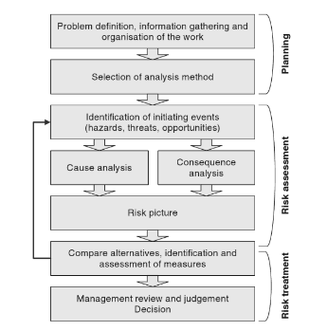
Figure 2 - Risk Analysis Process

There are a number of techniques available to the project manager to analyse risk and prioritise the identified risks. The selected techniques will depend on the available data and specific business needs (Aven, 2015).

Risk Matrix
A risk matrix is a visual tool that use a structured approach to process and organise risks based on their priority. Risks are assessed based on the impact if the risks occur and the likelihood of the risk occurring, therefore allowing the organisation to make informed decisions. The design of this tool allows project managers to quickly identify the main risks associated with the project and begin creating contingency plans to mitigate these risks in a minimal timeframe (Murray, 2011). This technique was first developed by the Airforce Electronic Systems Centre (ESC) in 1995 and was widely used across the organisation by 1996 (Garvey, 1998). Figure 3 shows a generic 5x5 risk matrix that can be applied to multiple situations or processes. The table has 5 categories which score the severity and likelihood ranging from Insignificant to catastrophic. The colour coded table gives an output for each risk ranging from low to high.
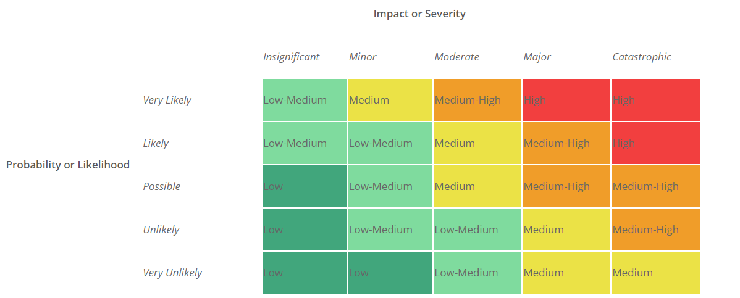
Figure 3 - Risk Matrix (Boogaard, 2021)

FMEA – Failure Mode Effect Analysis

FMEA is a risk analysis and management tool which stands for Failure Mode and Effects Analysis. This is a methodology which dates back to 1949 where it was used by the United States military (Tippett, 2004). In the late 1970’s the methodology was successfully implemented by the Ford motor company and is now widely used in the automotive industry (Srivastava, 2018). This tool looks to identify vulnerabilities in complex high-risk projects (Ashley, 2010). It looks to assess risk by identifying any potential failure modes of a service or product. Once the initial failure has been identified the tool will look to evaluate the potential impact on the process. The potential effect of the failure will be categorised based on the criticality to the process. Each individual step of the process will need to be analysed in order to develop a detailed risk mitigation plan. Each failure mode will be scored on the severity, probability of occurrence & probability of detection. This will allow each risk to be ranked in order of RPN (Risk Priority Number) (Zaifang Zhang, 2011). There are a number of benefits associated with the FMEA methodology such as early identification of potential failure modes, risk identification and prioritisation of the corrective actions required (Haq, 2011). As a result, this will provide opportunity to reduce costs throughout the supply chain, increase customer satisfaction and enable improved decision making. Whilst there are many benefits, FMEA does require expert knowledge of the process and can be quite time consuming to complete (Hodge, 2014). FMEA is widely used in multiple industries such as manufacturing, automotive, health and aerospace.

Risk Management
Risk cannot be totally avoided and is inherent within the majority of activities carried out by engineering professionals (Engineering Council, n.d.). Project risk management is a commonly used tool to assist with the successful delivery of a project. Risk management will relate to any activity or event that that has the potential to affect an organisation and the ability of the organisation to achieve its goals (Aven, 2015). Risk management starts by identifying the source of key performance risks to any business. (Henry Birdseye, 1992). Once completed by the appointed person, they will be required to define and evaluate the options available to mitigate these risks. Furthermore, the appointed person must decide if these risks add value to the business once the effort/cost of mitigation is considered. A trade-off should then be carefully agreed with the aim of adapting the processes or business objectives in order to eliminate the risks and costly mitigation activities (Henry Birdseye, 1992). There is a wide variety of risk management approaches available and it is a requirement of the project manager to determine the correct approach. Basic forms of risk management involve identifying the risks, searching for alternative paths, creating and action plan or developing a contingency fund. Although these steps would go some way to managing risks, it is seen as too reactive and would not suit complex projects (Bartlett, 2004).
Often Project Managers will face a resistance from employees when implementing the required risk management processes. These processes are commonly seen as unnecessary, time consuming and a cost burden.
Figure 4 shows the cost-benefit when considering risk management. The majority of the costs involved with risk management are required at the front end of the project however, successful risk management will ensure a project is far more efficient, safe and cost effective over the full duration (Kerzner, 2017). It is important however to find the optimal risk level as to much risk mitigation can result in large costs, a loss of productivity and can make the project non-economically viable.
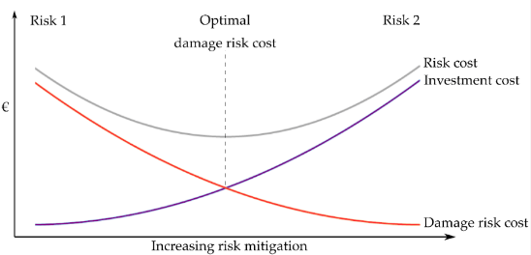
Figure 4 - Cost-benefit of Risk Management (Merisalu, 2021)

Supply chain management

Effective supply chain management is commonly used by managers in order to improve factory or workshop performance (Davis, 1993). Supply chains are under increased pressure and strain as a result of recent global events and an over reliance on global supply chains (Zhao, 2023). These events have repeatedly disrupted multiple supply chains which has resulted in a significant impact to short-term performance (Tang, 2006). Due to the on-going pressures, effective supply chain risk management is required. Successfully implemented supply chain risk management (SCRM) is critical when looking to reduce business risk and maintain or improve overall customer satisfaction (Curkovic, 2013). SCRM refers to how a business looks to manage the flow of materials or products, including the processes involved with adding value to the raw material. Risks need to be managed both internally and externally. An example of an internal risk would be changes to the experienced and skilled personnel, an example of an external risk would be unforeseen external demand for the required raw material. Risk management techniques need to be implemented to effectively manage these risks.

Inventory Management
Inventory management will be linked to supply chain management in being a critical process to ensure businesses can operate to their full potential and is a significant area which requires efficient management (Bose, 2026). Inventory management is a process of co-ordinating key activities such as purchasing, manufacturing and distributing to meet the market requirements (Wild, 2018). The correct level of stock can greatly impact the performance of a business as many activities will depend upon. The issue commonly faced is the variation of ‘correct level’ as this can depend on who defines it (Wild, 2018). The level of inventory can affect the business performance in one of 2 ways, a lack of inventory will halt production due to stock outs whilst very high inventory can increase production costs and negatively impact space utilization (Bose, 2026). A key component of inventory management is understanding the volume required and correctly managing the available stock. There are a number of different factors to consider when determining inventory levels:

Table 2 - Inventory Levels
Inventory Level Considerations
Predictability | These levels of inventory can be calculated when viewing the production schedule and understanding the process requirements. It is advised to include a buffer in addition to the process requirements.
Fluctuations in Demand | It is a requirement to satisfy the customer or production demand at any given time therefore, an allowance for a sudden fluctuation should be considered. Understanding the supply chain and pre-empting these fluctuations can reduce the safety stock requirement.
Unreliability of Supply | Inventory offers protection from unreliable suppliers or protection if a component is difficult to source. Whilst efforts should be made to replace unreliable suppliers, inventory levels should reflect current situation.
Price Protection | Buying large quantities of inventory fixes the material costs for the business and helps prevent gradual price increases.
Quantity Discount | Buying in bulk can often result in additional savings. It is important to consider the business requirements and not be left holding surplus stock.
Lower Ordering Costs | Increasing the order volume and reducing the number of individual orders can provide a cost saving. This also requires a strong understanding production schedule and the availability of storage
(Muller, 2019)
There will be a greater emphasis on inventory when preparing for a project over the Christmas period. For electrical motors there are multiple materials and component required, all with varying lead times and demands. Inventory management requires a strong understanding of the product in order to be successful. It involves the steps of overseeing and controlling the levels of stock that are held within the factory, ensuring fulfilment of orders, forecasting future demand and availability and building strong relationships with suppliers. A suggested area to target would be the correct amount of safety stock to deal with realistic fluctuations of demand for unexpected repairs and improve the overall efficiency. All of these benefits should reduce the risk of successful project delivery and help to improve customer satisfaction.

Main Body Chapters

The main body will look at the tools and techniques identified in the literature review that can be utilised to identify risk, assess the significance of these risks and then what is required to mitigate these risks. The project will involve removing and overhauling a pre-determined amount of electrical motors and generators. Some of these machines were originally manufactured in the 1970’s and as a result, spare parts can be particularly difficult to source under normal circumstances.
Historical data tells us that resources will be stretched during this period and the ability to purchase additional items at shirt notice will be lost due to the holidays and other businesses closing. For the work discussed within this report the start date will be 16th December and will equipment will need to be re-installed by 31st December. The lines will undergo one day of commissioning, which will take place on the 2nd of January. All lines will need to be fully operational by 10:00am on Wednesday 3rd of January. Meetings will be required with the customers engineers to identify the quantity of work which will be carried out during this period and to understand the associated risks. Failure to return all items and complete commissioning will result in heavy financial penalties for the customer due to their contractual agreements.
The minimum work scope required for each piece of equipment is; disconnect on-site and lift onto Quarztelec transport using overhead crane, transport to our workshop and fully dismantle, clean and stove all components, inspect and test all components, carry out any repairs that have been identified, source any replacement parts, re-assemble all components and test, return items to customer site, lift and re-fit items and then complete the electrical/mechanical connections.

Gant chart
A Gantt chart is a highly popular project management tool that uses a graphical representation of task against time. This scheduling tool is used on projects of all sizes to simplify activates and timescales. (APM, n.d.) A Gantt chart works by listing all of the project deliverables on the left-hand vertical column against the timescale in the horizontal row. One of the first forms of deliverables vs time concepts were developed in the 19th century by Henry L. Gantt and close associate Frederick W. Taylor (Wilson, 2003) (APM, n.d.). The Gantt chart allows organisations and managers to plan a project by individual task timescales and clearly visualise the effects of any sequential task delays. When each individual task has been listed the project manager will be able to establish the resources required and a realistic time frame for project completion.
During the Christmas period the working days will be severely reduced due to 3 bank holidays. The project plan states the project will run for 17 days however, only 14 of these will be working days. The Gantt chart is a useful visual tool will help identify any potential clashes with different working parties and to easily tack the progress of the work being undertaken.

Initial Gantt Chart
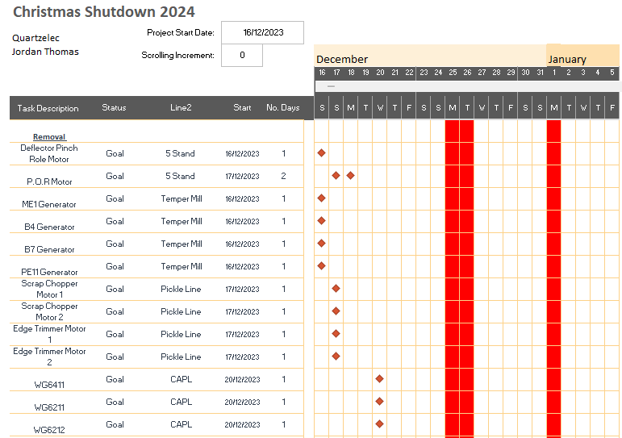
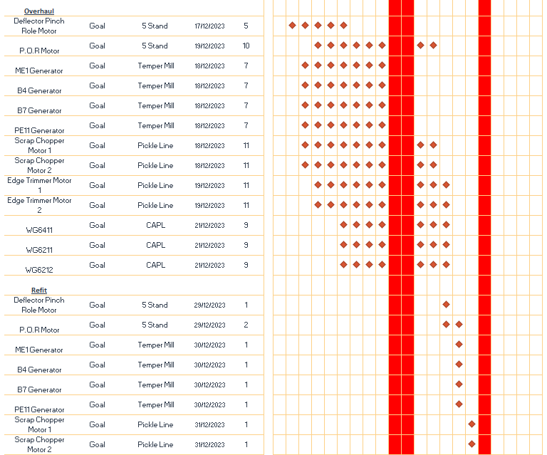
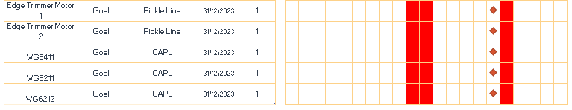
Figure 5 - Initial Gantt Chart
Figure 5 is a copy of the initial Gantt chart that has been created to give an overview of the main tasks that need to be completed as part of the shutdown. The requirements listed are a result of an initial meeting with the engineers, the work scope will be dependent on the resources available and will need to be confirmed prior to the project start date. The Gantt chart has three main sections which covers removing the equipment, overhauling the equipment and refitting the equipment. Each of these tasks will have multiple sub-tasks that will need to be completed in order to deliver a successful project. As shown in the Gantt chart, 3 motors that require overhaul on the CAPL line are unavailable due to urgent crane repairs being carried out. As a result, these motors are unavailable until the 20th and won’t be returned until the 31st. This leaves 7 motors to be refitted on the last day of the project which creates additional risk which will need to be discussed with the engineer.

Identify & Assess
As stated in the literature review, the first step of effective risk management is to implement risk identification tools that can identify processes or procedures that pose a threat to the success for the project. Successfully identifying risks will allow the management team and stakeholders the opportunity to proactively act on these risks before they occur. Once the risks have been identified the team will be required to asses these risks in order to determine a priority rating.

Carry out an FMEA analysis
Identifying project risk is a critical to any project. The requirement carries even greater importance for this Christmas maintenance shut down due to the reduced resources and timeframe available. By completing an FMEA analysis in good time it will help to identify and anticipate potential issues the project will face, whilst giving an opportunity to mitigate these risks as far as possible. The RPN value will allow the project team to assess the identified risks and understand where the main focus should be.
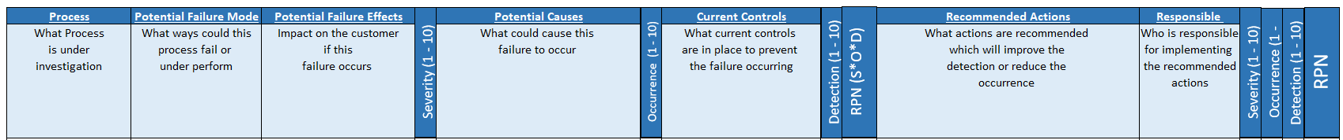
Figure 6 - FMEA Headings
Figure 6 above shows the template that has been created for the FMEA to be carried out on this project. The main purpose of this analysis is to identify the original RPN (Risk Priority Number) value and then implement the required changes to reduce the final RPN. The RPN is determined by an analysis team which will use past experience and engineering judgement to calculate Severity x Occurrence x Detection. The top row of the template includes the major titles which make the FMEA analysis. The second row gives a description of each title and states what information is required in order to carry out the analysis effectively. Each process of the project will be listed and analysed by populating each row of the table. Once the potential failures have been identified the users will need to assign a severity rating. The severity will represent the potential seriousness of the failure and the impact this would have on the project should it occur. The next consideration is the potential causes of the failure and the likelihood off the occurrence. The occurrence rating refers to the frequency or probability of the failure happening during normal operation. This value will be determined with the aid of historical data from previous shutdown periods. The final component for the RPN calculation is the current control measures and detection value. The detection value will be based on the effectiveness of the current control measures and the likelihood of these measures detecting a failure before it occurs. Once this calculation has been completed the table will clearly identify the processes with the highest PRN number and therefore, the processes which carry the greatest risk to the project. Recommended actions should be completed in order to mitigate the risks identified. The aim is to reduce the RPN value as much as reasonably practicable. Table 1, 2 & 3 below will explain the criteria for each rating number:
Degree of Severity
Severity | Description | Rating
High | The failure has or is likely to result in an unsafe condition and/or a breach of government regulations. A no warning failure would result in the highest rating (10) | 9 - 10
Medium – High | Can cause disruption to multiple processes and resulting a high level of customer dissatisfaction. Potential for damage to reputation. | 7 – 8
Medium | The effects have resulted in customer dissatisfaction. Causing delays and or damage to equipment | 4 – 5 - 6
Low – Medium | A failure would cause some disruption without effecting the process too much | 2 – 3
Low | Unlikely for a failure to cause disruption to the process or supply chain | 1
Figure 7 - Degree of Severity Rating
Figure 7 shows the degree of severity off the effect to the customer. The lowest rating will be 1 and the highest rating for an unsafe condition will be 10.
Probability of Failure Occurrence
Probability | Description | Rating
High | Failure is imminent and expected | 9 - 10
Medium – High | Failures have been common during previous experience | 7 – 8
Medium | Failures have occurred occasionally | 4 – 5 - 6
Low – Medium | Under certain limited conditions there is a chance of failure | 2 – 3
Low | Highly unlikely for a failure to occur | 1
Figure 8 - Probability of Failure Occurrence
Figure 8 gives a breakdown of the occurrence rating, this is the frequency which the failure is likely to occur. The least likely to occur will receive a rating of 1 and the most likely will receive a rating of 10.
Probability of Detection
Probability | Description | Rating
Low | Unable to detect the problem | 9 - 10
Low – Medium | Strong probability that the problem will not be detected | 7 – 8
Medium | Control measures have detected some problems whilst also missing some | 4 – 5 - 6
Medium - High | Strong possibility that the measures in place will detect a problem | 2 – 3
High | Highly likely that any control measures in place will detect a problem | 1
Figure 9 - Probability of Detection
Figure 9 shows the rating for the probability of detection. The Rating points are different on this table as the lowest probability will receive the highest rating and the highest probability ill receive the lowest rating.
Before carrying out the full FMEA analysis it is an important requirement to establish an agreed criteria for identifying the relevant values. This will ensure consistency throughout the analysis and improve the overall effectiveness. It is also important to monitor the processes throughout the project life in order to identify any changes that have occurred or to identify any improvements.

FMEA Analysis – Maintenance Shutdown
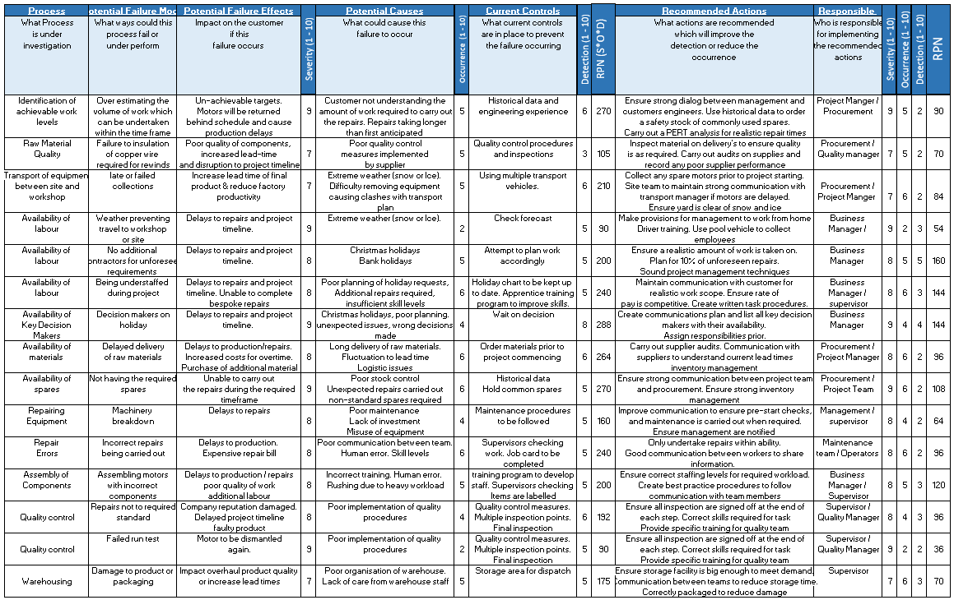
Figure 10 - FMEA Analysis
Figure 10 shows the completed FMEA analysis for maintenance shutdown. The RPN rating after the preventative actions have been implemented has improved, which indicates a reduced risk to the project.
There is no set RPN value which requires attention, instead it is for the project team to identify the areas which requires most attention. Additionally, factors such as safety or legal risks could take priority even with a lower RPN value. Figure 11 below shows the 3 highest scoring tasks within the project and therefore these tasks carry the greatest risk. In order to reduce the severity, it would require significant change to the processes and equipment being used which is unlikely to be achieved. The suggested actions will be implemented in this project in an attempt to reduce the value by preventing the failure from occurring. Until these changes have been implemented then the final RPN value can only be an estimation.
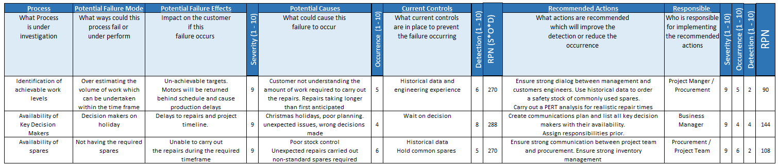
Figure 11 - FMEA Highest Risk
As shown the 3 processes which pose the greatest risk to the project are (1) Identification of Achievable Work Levels, (2) Availability of Key Decision Makers & (3) Availability of Correct Spares. The report will show the steps that have been taken to mitigate the identified risks. This includes carrying out a PERT analysis to identify a manageable work load, looking at the role of communication and communication plans to mitigate delays from decision making and finally the importance of implementing sound inventory management techniques to deal with the challenges of having the required spare parts available during an outage over the Christmas period.

Mitigate

Pert Analysis
A critical objective prior to starting any project is to schedule all requirements in an efficient manner in order for the project to be completed in the required timeframe and minimum costs. Running projects over the Christmas holidays places greater importance of accuracy as there is very little options available should additional components, labour or equipment be required. Program Evaluation and Review Technique (PERT) is a project management tool used to determine the maximum and minimum time that project tasks could take to complete. This was first developed in the 1950’s by a research team carrying out scheduling activities for the US Navy with the aim of effectively planning the development of the Polaris nuclear submarine missile system (Sharma, 2006). Following this, the technique was employed across a wide range of industries including defence, space and industrial. This tool is particularly useful when working on projects with uncertain task durations as it is an event-orientated technique (Sharma, 2006). This method involves estimating the length a task will take to complete. These estimates will include an optimistic value, planned value and a pessimistic value. This information will create a scenario for the project manager which will identify the best and worst-case timeframes for each task. This tool can be used to create a realistic schedule to suit the available resources. This will assist with making informed decisions when trying to anticipate a manageable work scope within a set timeframe.
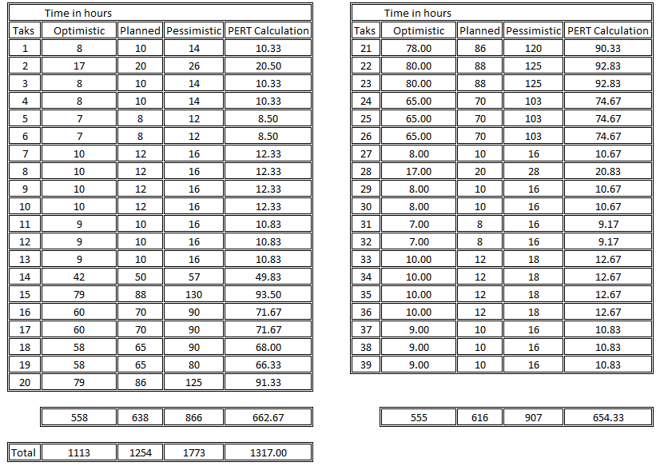
Figure 12 - PERT Calculation
Figure 12 shows the completed table with the PERT calculations. For this project the planned time frame is what would be required to achieve the current targets. The Optimistic time is a best-case scenario where the employees face little to no disruption when carrying out each task. The pessimistic time is based upon the employees facing any number of the issues identified in the FMEA analysis. If additional faults are found on equipment and the spares are not available from stock then it will seriously impact the lead time. Once these 3 values have been decided the PERT value can be calculated. The calculation the calculation to determine the PERT value is:
$$\frac{Optimistic+\left(likely x 4\right)+Pessimistic}{6}$$
For the shutdown project the PERT calculation has indicated the project duration will be 5% longer that anticipated. The project length is non-negotiable and it is critical the lines and up and running at the required times. Due to the nature of this project, very little room for delay has been accounted for and all available resources are committed. The analysis has identified an increased risk to the project which will be discussed with the customers engineers.
After further meetings the customer has decided to reduce the list of motor repairs by 3. The motors were unable to be removed on the initial start date due to critical crane repairs, as a result 2 days had been lost which instantly created more pressure. The CAPL line motors were being removed solely for the purpose of preventative maintenance and have had successful readings with on-site vibration analysis and insulation resistance. As a result, removing these motors would create additional unnecessary risk. There is availability to remove these motors during any short production breaks later in the year. This decision was based on the cost of lost production should the motors return late.

Figure 13 shows the amended Gantt chart after the risk management process has been carried out. The reduction in work will reduce the risk and leave more resources available to assist with the other tasks being undertaken. The reduction might also lead to a cost saving due to a reduced amount of work being carried out at premium rate (Night shifts) and offers further protection if unexpected repairs are required.
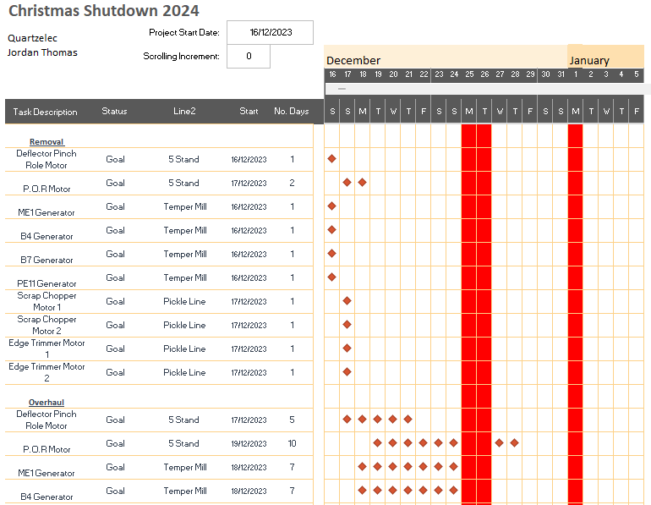
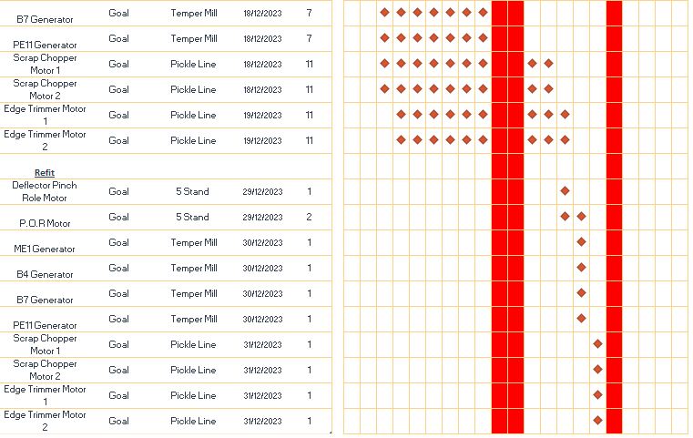
Figure 13 - Gantt Chart After Risk Management

Role of communication

The success of any project relies on a number of critical skills, non-more important than communication. The importance of which significantly increases during maintenance outages when multiple parties are working with together. At a minimum this would typically include Customer Engineer, Quartzelec Management, Quartzelec craft and additional contractors working in the area. Multiple tasks will be carried out by all parties and resources such has overhead cranes will be extremely busy. Strong communication skills are required to coordinate all aspects of a project and ensure all information is sheared around the team as required. This will greatly improve the efficiency of the project and also contribute to ensuring a safe working environment at all times.
When communicating it is important to remember that the receiver of the information could interpret the message differently to what was intended. For this reason, the project manager should consider the importance of any miscommunication and appropriately select the suitable form of communication. (Rajkumar, 2010) Any miscommunication will have financial implications on a project. Figure 14 shows the effect of bad communication and how poor communication has a greater impact at the end of a project.
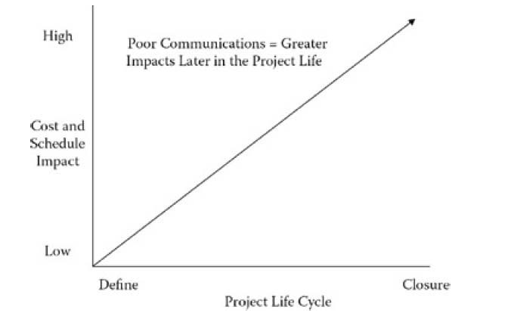
Figure 14 - Price of poor communication

A successful communications process relies on a number of key considerations. A communication process requires a sender and a received. When information is transferred the received should confirm that the information is understood before beginning to act. The response can be complex when a larger number of people are involved. A receiver will have a preferred method of communications and could also affect the interpretation of the message. (Rajkumar, 2010)
Successful projects rely on strong communication from the project manager to the stakeholders and to the project team. The communication to the project team can become complex during maintenance shutdowns and the effects of seasonality can place even greater strain. During the outage a number of key decision makers will be taking holidays for both Quartzelec and the customer. This means thorough planning is required to ensure all employees understand the roles and requirements. Unfortunately, no amount of planning will prevent unforeseen problems, typically created when additional faults have been found with the customers equipment. As such, a communications plan and key decision makers chart should be created prior to the project start date to ensure any decisions are made swiftly to prevent delays to the project timeline.

Emergency Key Decision Makers

Quartzelec |  |  | Holidays? | Dates
Simon O’Leary | Business Manager | Elec/Mech | Yes | 27 – 29th December
Stephen Cox | Operations Manager | Elec office | No | -
Jordan Thomas | Project manager | Elec site | Yes | 27th
Jonathan James | Site Supervisor | Elec | No | -
Phil Connor | Site Supervisor | Mech | No | -
Scott Rees | Workshop Supervisor | Elec | Yes | 29th – 31st December
Customers Site |  |  | Holidays? | Dates
Gethin Jones | Engineering Manager | Elec/mech | Yes | 27th & 28th
Josh Rees | Team Leader | Elec | Yes | 30th – 31st December
Jason Thomas | Team Leader | Elec | Yes | 28th – 29th December
Figure 15 - Key Decision Makers
Figure 15 is a table of key decision makers for both Quartzelec and our customer. This information will be shared around all interested parties to expedite all decision making and problem solving. Should an unexpected issue arise for either party then this table can be used to understand the hierarchy of key decision making and who is available. During shutdowns it is common practice to find additional repairs that are required or to face disruption to the original plan. Being able to make fast and effective decisions can be the difference between project success and failure.

Communications Plan
A communications plan is a strategy to help establish key communication details prior to a project beginning. An effective plan aims to anticipate the information that requires communicated throughout the team during a project. This strategy will help ensure all members of the project team are aware of key project targets and how information will be communicated throughout the project. The will help to ensure communication is maintained internally and externally throughout the project in an effort to minimise disruption and delays. Many difficulties with delivering a project of this nature could be more easily dealt with by a ensuring a well-planned and effective communications process is implemented (Klein, 1996).
During the project multiple teams will be working at various locations on-site and in the workshop. Communication within each team is easily maintained however, communication across different teams, management and the customer are commonly neglected and creates a weakness within the system. Figure 16 shows a concise communications plan which states the minimum communications requirements for all involved. This will be shared prior to project commencing and each individual can identify their personal requirements to ensure the communication targets are met.
During the project feedback will requested and any recommendations will be added to the communication plan.
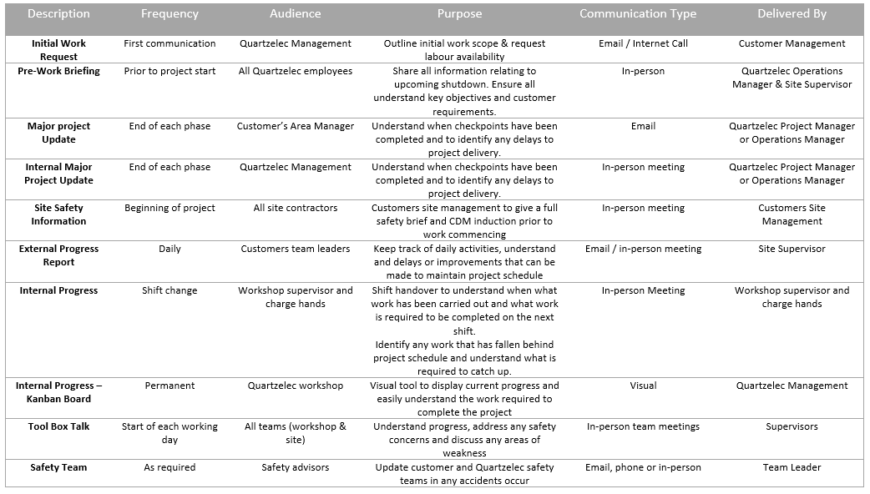
Figure 16 - Communication Plan

Kanban Display Board

A Kanban Board is a visual display tool that can be used to improve the management of workflow by utilizing WIP – work In Progress. Kanban board has become a widely used project management and lean management tool which has origins to japan in the late 1940’s. The first concept of Kanban was developed by Taiichi Ohno who was an engineer with the Toyota Motor company (S, 2023) and was created as a simple planning tool designed to assist with production and optimize inventory and the management of workflow. The name “Kanban” is formed with two Japanese words which translate roughly to “sign” and “board”. During the 1980’s and 1990’s many industries and organisations started to adopt these principles with the aim of improving efficiencies and achieving a smoother production flow (S, 2023).
The basic concept of this principle is to clearly identify the progress of multiple tasks from start to finish. Typically done with a visual board that has three sections, ‘work waiting’, ‘Work in progress’ and ‘work completed. More specific sections can be added by individual teams however, the basic principles remain the same. The aim is to limit the amount of work in progress to a manageable amount, allowing the team to completed the ongoing tasks before taking up new work. This has been found to improve efficiency as the employees do not feel overburdened by large volumes of work and can maintain a clear thought process for the task in hand (Dalton, 2019). Transparency and communication are other clear advantages of this system as all employees at any level of the organisation can clearly see the work currently being undertaken and the work which is next in line. The improved collaboration should reduce misunderstandings and overlaps of tasks carried out. The system can be as simple as a white board and sticky labels that get moved from stage to stage as necessary or a more advanced IT based system. A Number of large whiteboards are available in the workshop so it is likely the basic model will be adopted as a way of minimizing costs and still achieving the desired outcome. The naturally poor and dirty condition of the workshop would also increase the chance of damages and reduce the user friendliness should an IT based system be chosen.
This transparency also provides great opportunity to improve the Inventory management process. The visual tool will allow the stock controllers to have a real time update of the current work levels and the materials required to complete. This will assist with preventing stockouts, overstocking and correct identification of the components required. Kanban has been widely accepted as a successful inventory control tool for Just-In-Time (JIT) manufacturing around the world.
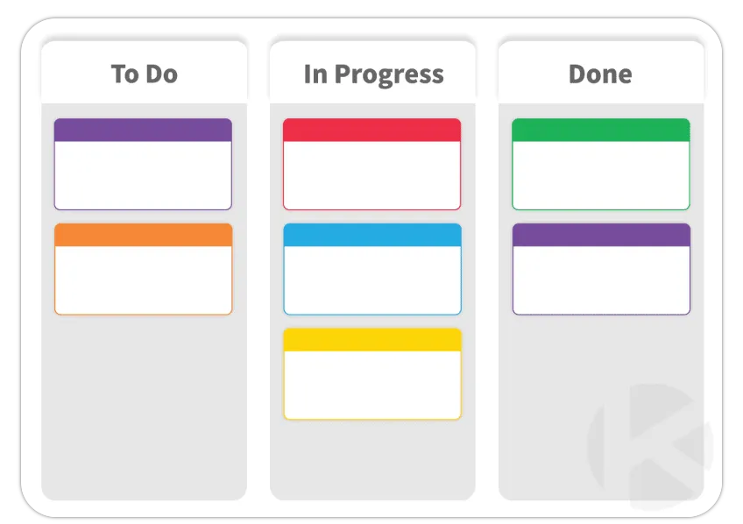
Figure 17 - Kanban Board (Kanban Zone, n.d.)
Figure 17 shows the concept of a basic Kanban Board that could be implemented within the workshop during the project, with the aim of improving communication, efficiency, and the control of inventory. Each piece of equipment would be assigned a tag which would be attached to the ‘TO DO’ category, each of the employees could then easily identify work which is required to be completed. In the event of a build-up of task. This would be particularly beneficial during shift handovers and night shifts where less decision makers will be within the workplace. By placing a cap on ‘In Progress’ work, we can ensure the workshop space is utilised and prevent wasted time as a result of blocked walkways or lack of equipment. If each item was dismantled at the same time the workshop would not have the capacity to store all the components, nor have the required volume of equipment. This would result in a noticeable reduction in efficiency.
There are a number of considerations as to which is the best application of this tool. A board could be used in each of the 3 main departments, the size of which and number of categories should be considered along with the responsibility for moving each task into the next category.
As the 2 electrical departments work in close proximity, it has been decided that one main board will display the all equipment as they arrive. Mechanical repairs are partially only required if damages are found therefore, all mechanical jobs will be recorded on their of department board with the same theory implemented. The Project manager will be available to assist with what is required and the set up of the board.
Should this prove successful, Quartzelec will look at the effectiveness of using this during normal operation or during busier periods at other times of the year.

Availability of Spares
Availability of spares was also identified as a significant risk with a high RPN number. In order to mitigate this the area of inventory management and the supply chain will be investigated. A large number of repairs will be carried out, each requiring a significant number of components. These processes will be vitally important to achieve project success. The ordering of spare parts and components is crucial to avoid costly delays during the execution of the project (Sha Zhu, 2022). During the maintenance project a number of components will undergo thorough investigation before a decision on replacement is made. Some components have a higher likelihood of needing replacement than others although the exact number of each component is not clear. Insufficient availability of any parts will lead to emergency purchasing which can result in project delays and an increase in costs. Planning could include stocking long Leadtime parts however, lead times are constantly fluctuating, some components are very expensive and there is no guarantee all components will be required (Sha Zhu, 2022), This makes the stocking strategy complex:

Inventory management
Inventory management covers a wide topic and as stated previously, is a critical process to ensure businesses can operate to their full potential. Effective inventory management requires optimizing inventory levels as the company’s stock levels tie up financial resources whilst also potentially incurring additional costs for stocking and maintaining the inventory, such as stock level checks (Teplicka, 2020). For the electrical motors there are multiple materials and component required, all with varying lead times and demands. Inventory management requires a strong understanding of the product in order to be successful. It involves the steps of overseeing and controlling the levels of stock that are held within the factory, ensuring fulfilment of orders, forecasting future demand and availability and building strong relationships with suppliers.
By correctly managing the inventory levels it will ensure the company is fully utilizing floor space, has the correct amount of safety stock to deal with realistic fluctuations of demand / product availability and improve the overhaul efficiency. All of these benefits will help to improve customer satisfaction and improve company profits.

Methods of Inventory Management
There are various methods which are utilized in industry to manage the movement of materials within an organisation. These strategies can offer businesses different routes to meeting customer demand. Below are four main methods chosen for discussion:

- Just-In-Time (JIT) – JIT was first developed by the Japanese and is a system which has stock arrive when required to meet customer demand, but is not held any sooner. This is known as a lean management tool and can eliminate waste whilst increasing the efficiency of the operations due to the reduced stock levels and better utilized work place. This system also reduces the financial strain on a business as products are only purchased when required, therefore the upfront costs are reduced. The downside of this system is the reliance on precise forecasting, strong supplier relations and the availability of dated components.
- Economic Order Quantity (EOQ) – EOQ is a system with looks to calculate the ideal order quantity for a company by balancing the inventory and holding costs against the costs of product shortage. This system looks to ensure the correct amount of inventory is ordered per batch to ensure the company does not order too frequently and hold excess stock. Whilst this might be the most cost-effective model, the system assumes the customer demand is predictable and it cannot account for unpredictable customer demand or seasonal price changes.
- Material Requirements Planning (MRP) – MRP is a software-based inventory management system which can assist businesses to determine how much stock is needed and when it is needed based on the information on the production plan. The software will create a list of materials and components required along with the required date which can improve scheduling accuracy and reduce the burden of the purchasing team. Whilst there are benefits, this system requires a reliable production schedule, can be expensive to implement and has a tendency to hold excess inventory.
- ABC Analysis – One of the most widely used techniques, the ABC classification allows the planner to categorise all stock into 3 groups, A – Very important, B – important, C – least important. There are a few considerations used whilst categorising each item, the effect of a stock-out, the rate of obsolescence, the availability and the minimum order quantity.
(Teplicka, 2020) (Milner, 2015) (Toomey, 2000) (Ching-Wu Chu, 2008)
Each of the above methods have their advantages however, neither method fully meets the unique requirement of the shutdown maintenance. Further consideration will be required before implementing the Quartzelec project plan.

Impact of stockouts
Stockouts, also referred to as stock shortages, are a feature of inventory systems and can occur during the presence of uncertain demand or supply chain failures (Jasmine (Ai-Chih) Chang, 2019). The process is notorious for causing obstacles for business success and can result in substantial financial losses if solutions cannot be found. The cost associated with stockouts should be considered when completing a business cost optimization plan. Stockouts can be a hazard for not only the organization but for the supply chain that feeds it. Efforts should be made to ensure a strong supply chain is available with contingency options available should the regular supplier fail to deliver.
For Quartzelec, a stockout could occur at one of three stages in the process. Firstly, some components will be free issued by the client. A discussion should take place with their purchasing manager to ensure they have the required materials available prior to the project start date. Secondly, stock management in the Quartzelec warehouse will need to be carefully managed as an in-house stockout during the Christmas period could be very difficult to resolve and also result in a high level of scrutiny. Finally, a stockout could happen at our suppliers if we fail to prepare as much as possible and overload them during the shutdown period. All 3 areas of risk can be mitigated by the implementation of thorough planning prior to the project start, effective inventory management and through building strong relationships with the supply chain.

Steps to make the supply chain more resilient
Making a supply chain more resilient will help a business adapt to disruptions more efficiently and improve supply chain success. Correct management of supplier relationships is critical for supply chain success. This process involves three key stages, supplier selection, supplier development and supplier evaluation. By following these three stages a business can help to ensure the supply chain is ready to meet the required demands (Landeros, 2006). The resilience of many companies supply chain has not increased with the ever-rising level of logistical complexity (Saenz, 2014). Today’s supply chains are vulnerable to many issues such as world events, political uncertainty, globalised markets and ever rising costs.
Having a resilient supply chain involves having an ability to bounce back from disruptions without incurring financial losses or damage to reputation (Merkuryev, 2014). Disruptions can be mitigated when an organization acknowledges the importance of planning and implementing a strong inventory management plan, a robust supplier selection policy which includes a diverse range of suppliers and have the ability to react when issues are faced.
Suppliers should be regularly audited and generally monitored to ensure they operate in an ethical way and have the correct quality control measures in place. Any new suppliers should under go relevant checks to unsure they have the required credit rating which will allow them to purchase the quality and quantity of products required whilst also ensuring they have the correct certificates and insurances to allow them to operate as required.
Building strong relationships with key suppliers can improve the quality of the goods a service purchased from the suppliers whilst also increasing the information available when an issue occurs. Suppliers often work together and can offer alternative routes of purchase If they chose, this additional service would usually only be available to customers with strong relationships.

Diversity of suppliers
Over a number of years supplier diversity has proven an important aspect of inventory management. Supplier diversity is a concept of purchasing products or services from a range and suppliers with the aim of reducing reliance and improving security. There is a fine balance however, as it is important that all suppliers conform to the requirements and these checks take additional resource from the company. It is for this reason that many large-scale companies are choosing to have a streamlined first-tier supplier list that can deliver high volumes (Henry Adobor, 2006).
By relying on a diverse pool of suppliers the risk of disruption is reduced along with the chances of stockouts. This will also enhance the range of skills and added value that suppliers can provide which can prove to be invaluable during challenging periods. This can be particularly advantageous when dealing with a large volume of old equipment and machinery. For the project a proportion of the required spares will be issued to reduce our purchasing requirements. Additionally, Quartzelec has built up a strong group of suppliers that deal with a range of products.

Quartzelec Project Plan
Looking at the information gathered, it will be critical to the project that the correct amount of stock is purchased for the project. The maintenance schedule will be particularly difficult to predict as 20% of components will be changed regardless of condition and the remaining components will be inspected first to determine the condition.
It is difficult to fully establish an inventory management style due to the unique requirements of the project. Many of the methods rely on consistent production rates in order to correctly predict and source the inventory required. The ABC analysis can be partially utilized by identifying the most critical components for the project. All the bearings and seals would be classed as ‘class a’ due to an agreement that all these components will be changed regardless of condition. Discussions have taken place with the client who has agreed to free issue all bearings & seals for the motors as they have details on file and keep spares in their workshop for emergency repairs. This will instantly reduce the strain on Quartzelec supervisors and management as each part would need to be identified and sourced individually. This also means that our up-front costs will be slightly reduced due to less equipment being purchased. Furthermore, in our workshop we stock a wide range of insulated copper wire in readiness for any rewinds or electrical repairs that could be required, these would also be classes as ‘class a’. Our workshop store holds a wide range of consumables and a black stock of unused spares which should help provide a contingency should additional components be required. The rest of the required parts are very difficult to categorise due to the unknown quantity needed and, in some cases, unknown component ID. Many items would be in class a or b however, due to the potential value of these items it is not feasible to stock any components that wouldn’t be used on a monthly basis. Due to this reason we will have to look at the other mitigation methods discussed.
Creating a diverse range of suppliers is an option that could give Quartzelec the greatest success as we do not currently know the items required and it is unlikely that one or two suppliers would have in stock all the unique products required. As a result, Quartzelec has recently been working to find a number of suppliers that specialise in niche product markets which will reduce the amount machining required by the workforce. Small purchases have been made in order to test the service provided and with the aim of building strong relationships prior to the outage start date. Furthermore, we have discussed with all key suppliers to understand their working arrangements over this period and collected emergency contact details should any out of hour purchases be required. Due to the findings we have also made contact with a local 24/7 courier service to see if they can support us should we need to purchase any items from around the country on a same day collection.
A tool box talk will be carried out prior to the project start with an emphasis on the importance of identifying the required parts as soon as possible and passing on this information to the project manager. This will give management the biggest window available to source the required parts. Another key point will be the importance of taking care of all equipment as many of these machines will be 50+ years old and common spares will not always be available on a short lead time.
A final stock check of the workshop will be carried out two weeks before start date to sure all departments have the required common stock, tooling and accessorise that they require.

Results / Review of project

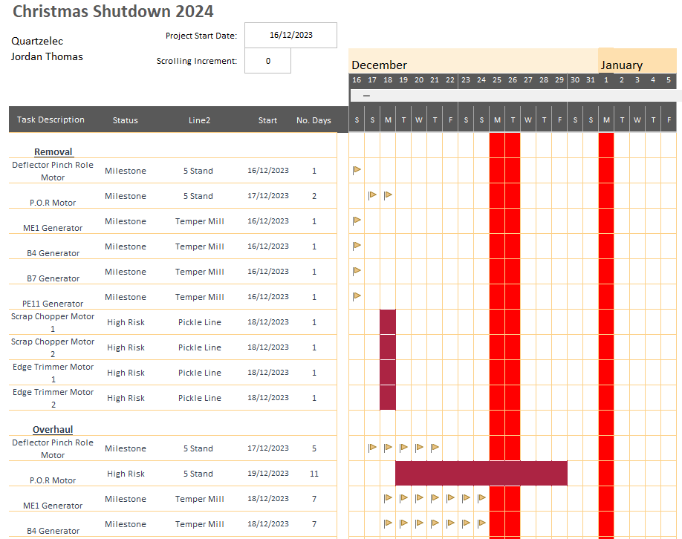
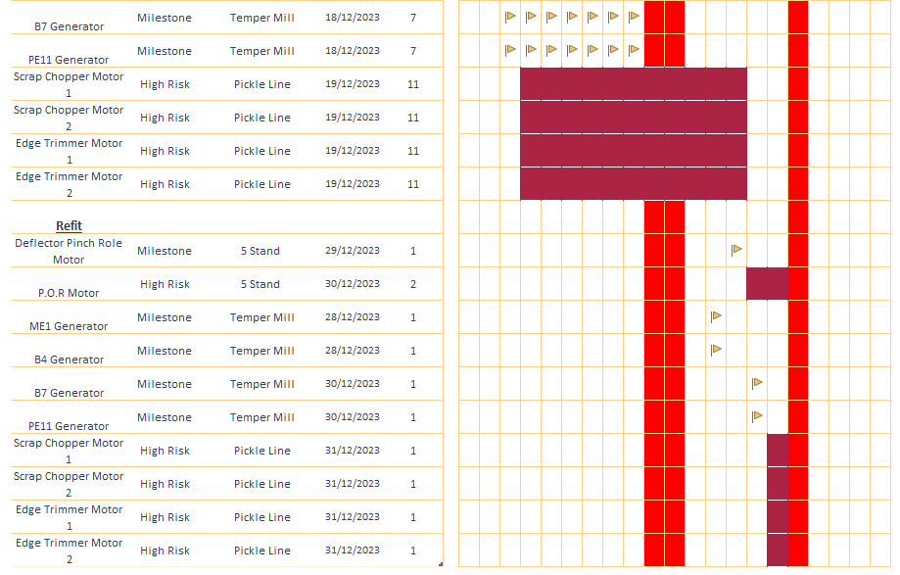
Figure 18 - Gantt Chart Review
Figure 18 shows the accurate Gantt chart on completion of the project. The flags indicate tasks that were carried out in the planned time. The burgundy colour represents tasks that were delayed and created a high-risk environment which required additional resources.

Permit Delays
The first delays to the project were found with the Pickle Line motors being delayed by one day which caused additional strain to an already tight schedule. On investigation, the volume of permits required at the beginning of the maintenance was to much for our client’s employees to cope. Not enough preparation was carried out prior to the project start due to the engineers still needing to fulfil their everyday tasks. During any short summer outages, the client will use a dedicated permit issuing team from another location in order to prevent these issues. Due to the requirement of being away from home over the Christmas Holidays, there was no take up on the offer and the permits where kept in house. Whilst this issue was not a fault of Quartzelec, this was still a negative impact to the project which had knock on effects throughout. The issue of communication and availability of labour were Identified during the project however, the main focus of these issues was within Quartzelec and not our client. The failures have the same potential to impact project success and will need to be addressed on the next occasion. A senior planning meeting would have helped identify the shortage employees with the required authority for issuing permits along with the volume of tasks planned to start during the first 3 days.
Inventory management and stock control was identified as an area of importance prior to the project start date. A number of measures where Implemented in an attempt to mitigate the risks of project delays. Generally, there was enough stock available to carry out the required tasks however, no consideration was taken for the impact of human error whilst fitting and handling the components. Two 6224 c3 bearings were rejected due to markings possibly caused during transport and one bearing was incorrectly fitted. Once identified, this resulted in additional purchasing requirements, causing delays to workshop activities and increasing overtime costs. Fortunately, these bearings could be supplied within the required time frame with an out of hours courier. On review, all components should have been purchased early enough to allow for a detailed inspection prior to the project start date.
Despite these issues all motors were correctly overhauled, returned to site and installed within the set time frame, to the required standard and carried out in a safe manor.
The decision to reduce the amount of equipment being removed due to the PERT analysis was not only the correct decision but possibly saved the project from going severely behind schedule which would’ve had significant financial consequence for our customer and significant reputation damage for Quartzelec.
Finally, due to the delays during the project there was a requirement for additional equipment to be installed on the final day of the outage. This resulted in a shortage of scaffolders available to set up the temporary platforms required to safely secure the motors. The key communication table was able to assist our craftsmen contact the current engineers however, the shortage of scaffolders could not be resolved which resulted in additional overtime costs for the Quartzelec staff. A regular review meeting could have assisted with communication and the project team could have adjusted the work plan to accommodate all requirements within the normal hours.

Workshop
Due to some of the pre-planned holidays and labour shortages, a number of skill shortages were identified for various tasks. Prior to the project start, numbers were counted for each individual department to ensure the workforce could handle the workload. What wasn’t considered was the range of skills within these teams and the shortage reduced the efficiency of the repairs and placed a greater burden on some of the most experienced employees. These skill shortages will take a number of years to fully improve however, the apprentice number is currently high and therefore a focus on more intense training should take place. A skills matrix should be created in order to record the level of skills each employee holds and to identify areas for training. Whilst this is done by management and supervisors verbally, there is no paper record to assist with decision making.

Handover Issues
24-hour operations can commonly cause handover issues between teams, resulting in reduced efficiency and a lack of continuity. Communication was identified during the risk assessment as a priority for project success and the Kanban progress board was one measure implemented to mitigate the associated risk. Unfortunately, during the project inter-team hand over issues were identified which had contributed to delays carrying out the workshop-based overhauls and repairs.
Firstly, this was due to insufficient supervisors or management being available for each department for 2 shifts a day. Some shifts were forcibly run with no supervisors, this led to individuals working to their best intentions however, not to the project plan. Although unintentional, this created bottle necks for specialist tooling and equipment such as the drying oven which works on 16 – 24 hour cycles. It was also noticed that there was a slight lack of standardization in terms of the repairs carried out and the quality of work.
Secondly, the Kanban board was great at identifying ‘Work To Do’ however due to a lack of priority rating for each task, individuals were choosing their preferred task or motor to start next. This again resulted in some motors being completed well ahead of schedule and some motors required significant amount of additional labour in order to achieve the required delivery. During the next project all tasks would be assigned a priority number and completion date on entry by management to ensure the work is processed in line with the project plan. Although these issues resulted in additional time and cost to the project, these did not result in delays for the customers overall project plan.
If these issues were addressed prior to the next project with appropriate strategies and organization then the project success will increase due to increased efficiency and seamless transitions.

Incorrect risk identification
A large majority of the project went as predicted with the major risks correctly identified and many mitigation strategies being effective however there were two standout issues incorrectly identified.
Availability of labour was clearly identified as a concern and many steps were taken in order to mitigate the risks associated along with ensuring a manageable workload. What wasn’t considered were contingency plans if any of the workforce become unavailable due to sickness or ill health. This was the case for a member of the mechanical site team who specialised in laser alignment. As it stands, Quartzelec only have 3 fully trained employees and one of which had been allowed time off. This resulted in only 1 fully trained employee to carry out the alignment tasks during a set period. All tasks were completed within the project time frame however, once again this resulted in additional overtime hours. Importantly this highlighted a need to ensure more employees are trained on a wider variety of equipment to reduce the reliance on certain individuals. Had this been the case prior to the project start date then it would have resulted in significant cost savings and recovered the training expenditure.
Secondly overlooked was the area of quality control and failed test runs. This process had one of the lowest initial scores on the FMEA analysis and as a result, standard quality control procedures were left in place for the project. As mentioned above, a 6224 C3 bearing was incorrectly fitted during one of the overhauls. This fault was not identified until the motor was fully assembled and had been test run. During the run a knocking sound and vibration spikes were identified due to the incorrect positioning of the bearing. This resulted in the motor being retuned to the work shop to be partially dismantled for fault finding. Had the FMEA RPN value been higher, then additional measures could have been put in place to identify the issue at source and reduce the multiple wasted hours from the failure point. On reflection, any failed run test would be a great concern with significant severity.

Conclusion
In conclusion, seasonality and key events such as the Christmas Holidays can greatly increase the strain on a business when trying to successfully execute a critical project. As a result, the business must take the appropriate steps to effectively manage the risks identified and carry out the required risk mitigation. Whilst appropriate literature on similar Christmas shutdown projects was extremely scarce, the reports looks to cover all relevant topics through a mixture of literature review and real-world project review.
Firstly, we can conclude that any projects being undertaken during the Christmas holidays will face a number of additional challenges in order to achieve the required project success due to lack of available labour, reduction of on demand inventory due to weather related logistical challenges, the availability of labour to process said parts and the difficulty to effectively communicate across all interested parties when key decisions are required.
As a result, the importance of risk management was highlighted and it became apparent that effective risk management through risk identification, risk analysis and risk mitigation had a direct relation to the success of a project and the performance of the project team. By Identifying the risks in good time, it will allow the project team to proactively manage the risks prior to the project start date and improve the overall resilience of the project.
The FMEA analysis carried was out as an identification and mitigation tool and clearly improved the overall success of the project and ultimately ensured the project was delivered within the set dates. The main areas for improvement were down to the application of the tool and the initial RPN ratings rather than the FMEA technique itself.
Additionally, effective communication was identified as a key component to success in a number of ways. Whilst there was room for improvement, the level of communication during this project ensured all work was completed to the customer requirements.
Ultimately, the project was delivered within the required duration and to the required standard. The mitigation factors implemented would have been key to ensuring this was possible however, the project success came at an additional cost to Quartzelec due to the additional overtime requirement for the issues mentioned. Whilst these costs were disappointing, the avoidance of harm to customer relations and company reputation is far greater.

Recommendations & Further Work

Whilst overall the project can be deemed as a success, there are still opportunities for improvement and further work.
Firstly, carrying out research to understand how other companies deal with similar projects would be beneficial. This could be done through interviews or surveys and could help gather information tats not readily available. This topic is not covered by online articles so the approach would require information gathering from engineering connections at various companies working in the same industry. This could also include suppliers and/or agencies who would have experience dealing with the same projects. Whilst the project challenges are unique, Quartzelec would not be the only company to face these and it would be in the interest of our client for all contractors to manage their projects as smoothly and efficiently as possible. The process of sharing information and techniques happens internally however, if this was enabled between all contractors then all projects would run smother and our client would achieve a cost saving.
Additional research for alternative risk identification and risk mitigation methods could add value to the company as this would improve the project managers knowledge of various techniques. This would reduce the reliance on a smaller number of methods and improve the overall success of the project.
Communication was identified as a key requirement for success. Internal communication was achieved however communication between all working parties on-site was below the required standard. A recommendation would be for all contractor managers to meet with the client at set intervals to reduce the number of clashes on site and therefore reduce the amount of non-productive time.
Additionally, a brainstorming exercise should be carried to help identify ways in with non-productive time on site can be reduced in order to fully utilize the already stretched workforce. Commonly when the workshop experience delays of materials or repairs, the site team will be left with minimal work to be carried out. Likewise, when we experienced permit delays at the beginning of the project, this resulted in a lot of non-productive time when the labour could’ve been utilized elsewhere. If this situation can be improved it will reduce the total work load and improve the level of morale.
Another area of improvement for Quartzelec would be the maintenance and availability of workshop tooling and equipment. Looks of the machinery in the mechanical bay is old and less accurate. This resulted in a number of minor delays throughout the project due to the inexperience of the younger employees and the requirement to minor emergency repairs. Investing in additional newer machinery would improve the accuracy of the machines and reduce the bottle necks in certain sections of the workshop.
Some of our suppliers struggled with the influx of orders over a short period. Research around the topic of supply chain readiness would help to establish an improved plan for the purchasing requirements on the next project. This would reduce paying a premium to purchase from non-standard suppliers or reduce the need for emergency couriers.
Whilst on this project all the required spare parts and components were able to be source correctly, a number of the motors had components that would be extremely difficult to source if needed to be changed. As these projects are due to increase in frequency and involve a lot of repetitive equipment, a new tracking system should be designed which is used to log information on historic components and where in the production plant the equipment is used. This would help identify when specialist and/or unique parts will be required and would allow the project team prepare before the event. This information would also provide the customer with added value and help ensure Quartzelec are chosen to carry out the works each year.
Continuous improvement is key for the success of any business. Creating a review questionnaire which can be circulated amongst employees, a number of our client’s employees and to some of our suppliers would generate a large amount of information and feedback for analysis. Whilst not all feed back would be expected to be beneficial, a number of people involved in the project might have improvements or solutions to problems they have witnessed during the project. It is important to gather this information in order to improve, whilst also important for employees to feel their voice is listened too after a busy few weeks.
It has been well documented during this report that labour shortages are one of the biggest issues to face contractors during these shutdowns. Currently Quartzelec tries to accommodate as many holiday requests as possible over this period however, this does create additional strain and can impact moral. Going forward it would be a sensible improvement to create an equal split of the skills available and split the holidays accepted each year. This would help ensure a minimum number of employees off during the period and also ensure a good range of skills are available.
Finally, If the volume of repairs are significant in comparison to the available workforce then the company should look into the suitability of outsourcing minor tasks or repairs. This would free up labour to focus on high priority tasks and reduce bottle necks where limited specialist machinery is required. If this was to be trialled then it would be recommended to build relationships during the quiet periods of the year to ensure suitability.

Bibliography
Adeleye, K., 2018. Project Risk and Its Concept in Management. [Online]
Available at: https://www.linkedin.com/pulse/project-risk-its-concept-management-kayode-adeleye-/
[Accessed 24 01 2024].
Ahuja, H. D. S. a. A. S., 1994. Project management: techniques in planning and controlling construction projects.. s.l.:John Wiley & Sons..
A, M., 2016. Setting the stage for the holidays. PM Network, 30(11), pp. 14-15.
APM, n.d. APM Body of Knowledge 7th edition. s.l.:APM.
Ashley, L. a. G. A., 2010. Failure Mode and Effects Analysis. Journal of Patient Safety , 6(4), pp. 210-215.
Aven, T., 2015. Risk Analysis. Second ed. Stavanger: John Wiley & Sons.
Bartlett, J., 2004. Project Risk Analysis and Management Guide. In: Buckinghamshire: APM Publishing.
Boogaard, K., 2021. What is a risk matrix. [Online]
Available at: https://www.wrike.com/blog/what-is-risk-matrix/#What-is-a-risk-assessment-matrix-in-project-management
[Accessed 10 05 2022].
Bose, D. C., 2026. Inventory Management . In: New Delhi: Prentice Hall of India Private Limited.
Brotherton, S. A. |. F. R. T. |. N. E. S., 2008. Applying the work breakdown structure to the project management lifecycle. [Online]
Available at: https://www.pmi.org/learning/library/applying-work-breakdown-structure-project-lifecycle-6979#:~:text=A%20WBS%2C%20as%20defined%20in,total%20scope%20of%20the%20project.
[Accessed 02 April 2022].
Brown, K. A., 2000. Developing project management skills: A service learning approach. The Project Management Journal, 30(4), pp. 53-58.
Ching-Wu Chu, G.-S. L. C.-T. L., 2008. Controlling inventory by combining ABC analysis and fuzzy classification. Computers & Industrial Engineering, Volume 55, pp. 841 - 851.
Couillard, J., 1995. The Role of Project Risk in Determining Project Management Approach. Project Management Journal , p. 3.
Curkovic, S. &. W., 2013. Using FMEA for Supply Chain Risk Management. Modern Management Science & Engineering, 1(2), pp. 251 - 263.
Dalton, J., 2019. Great Big Agile. s.l.:Apress, Berkely, CA.
Davis, T., 1993. Effective supply chain management. Sloan Management Review , 34(4), pp. 35-46.
Engineering Council, n.d. Guidance on Risk. [Online]
Available at: https://www.engc.org.uk/risk
[Accessed 25 01 2024].
Garvey, P. a. L. Z., 1998. Risk matrix: an approach for identifying, assessing, and ranking program risks.. Air Force Journal of Logistics, 22(1), pp. 18-21.
Haq, l. &., 2011. Risk analysis method: FMEA/FMECA in the organizations.. International Journal of Basic & Applied Sciences, 11(05), pp. 74 - 81.
Henry Adobor, R. M., 2006. Supplier diversity and supply chain management:. Business Horizons, 50(3), pp. 219-229.
Henry Birdseye, W. W. &. J. D., 1992. Risk Management in Complex Projects. Pugh-Roberts Associates.
Hodge, S., 2014. Six Sigma Daily. [Online]
Available at: https://www.sixsigmadaily.com/understanding-fmea-benefits-pitfalls/
[Accessed 28 04 2023].
Holton, G. A., 2004. Defining Risk. Financial Analysts Journal, Volume 60, pp. 19-25.
Jasmine (Ai-Chih) Chang, H. L. K. (. S., 2019. Stockout risk of production-inventory systems with compound Poisson. Omega, Volume 83, pp. 181 - 198.
Kanban Zone, n.d. What is Kanban. [Online]
Available at: https://kanbanzone.com/resources/kanban/
[Accessed 03 04 2024].
Kerzner, H., 2017. In: Project Management: A systems approach to planning, schedulaing and controlling. s.l.:John Wiley & Sons.
Klein, S. M., 1996. A management communication strategy for change. Journal of Organizational Change Management, pp. 32-46.
Knight, F., 2013. Risk, Uncertainty and Profit. In: s.l.:Vernon Press Titles in Economics.
Landeros, G. W. a. R., 2006. Supplier Diversity Effectiveness: Does Organizational Culture Really Matter?. Journal of Supply Chain Management, pp. 16-28.
Merisalu, S. &. R., 2021. A Framework for Risk-Based Cost–Benefit Analysis for Decision Support on Hydrogeological Risks in Underground Construction. Geosciences, 11(5), p. 221.
Merkuryev, P. M. &. Y., 2014. Developing a resilient supply chain. Procedia - Social and Behavioral Sciences, Volume 110, pp. 309 - 319.
Milner, G. R. a. C., 2015. nventory Management: Advanced methods for managing inventory within business systems. London: Kogan Page Publishers.
Modarres, M., 2006. Risk analysis in engineering. New York: Taylor & Francis.
Muller, M., 2019. Essentials of Inventory Management . In: s.l.:Harper Collins Leadership, p. 272.
Murray, S. L. G. K. D. S. B., 2011. Development of a Generic Risk Matrix to Manage Project Risks. Journal of Industrial and Systems Engineering, 5(1), pp. 35-51.
Murry-Webster, R. &. D. D., 2019. APM Body of Knowledge. 7th ed. s.l.:Association for Project Management .
Network Rail, 2021. Why we carry out engineering works over bank holidays. [Online]
Available at: https://www.networkrail.co.uk/stories/why-we-carry-out-engineering-works-over-bank-holidays/
[Accessed 05 February 2024].
Press Association, 2015. The Guardian. [Online]
Available at: https://www.theguardian.com/uk-news/2015/jan/12/network-rail-report-christmas-rail-engineering-chaos-poor-planning#:~:text=Poor%20planning%2C%20equipment%20failures%20and,Network%20Rail%20report%20has%20said.
[Accessed 20 02 2024].
Prodromos D Chatzoglou, L. A. M., 1996. A review of existing models for project planning and estimation and the need for a new approach. International Journal of Project Management, 14(3), pp. 173-183.
Rail Technology Magazine, 2015. RTM - Network rail regulation and performance. [Online]
Available at: https://www.railtechnologymagazine.com/Inbox/operational-and-managerial-failures-behind-christmas-chaos-nr-/93522
[Accessed 21 02 2024].
Rajkumar, S., 2010. Art of communication in project mangement. Washington, s.n.
Saenz, M. J. a. E. R., 2014. Creating more resilient supply chains. MIT Sloan management review.
S, B., 2023. What is Kanban?. [Online]
Available at: https://www.nimblework.com/kanban/what-is-kanban/
[Accessed 03 04 2024].
Sha Zhu, W. v. J. &. R. D., 2022. Critical project planning and spare parts inventory management in shutdown maintenance. Reliability Engineering & System Safety, 219(0951-8320).
Sha Zhu, W. v. J. R. D., 2022. Critical project planning and spare parts inventory management in shutdown maintenance. Reliability Engineering & System Safety, Volume 219.
Sharma, S., 2006. Operation research: Pert, Cpm & cost analysis.. Discovery Publishing House.
Srivastava, K. S. &. S., 2018. Failure Mode and Effect Analysis (FMEA) Inplementation. Journal of Advanced Research in Aeronautics and Space Science , 5(1 & 2), pp. 1-17.
Strike Graph, n.d. What are the 7 types of risk?. [Online]
Available at: https://www.strikegraph.com/blog/what-are-the-7-types-of-risk
[Accessed 2024 01 2024].
Sun, J., 2023. Winter Construction Measures for Roadbed. Journal of Theory and Practice of Engineering Science, Volume 3, pp. 14-20.
Tang, C. S., 2006. erspectives in supply chain risk management. Int. J. Production Economics , Volume 103, pp. 451 - 488.
Teplicka, K., 2020. USING OF OPTIMIZING METHODS IN INVENTORY MANAGEMENT OF. International Scientific Journal about Logistics, 7(1), pp. 9-16.
Tippett, C. &., 2004. Project Risk Management Using the Project Risk FMEA. Engineering Management Journal, 16(4), pp. 28 - 35.
Toomey, J. W., 2000. Inventory management: principles, concepts and techniques. Boston / Dordrecht / London: Kluwer Academic Publishers .
Wild, T., 2018. Best Practice in Inventory Management . In: s.l.:Routledge.
Wilson, J. M., 2003. Gantt charts: A centenary appreciation. European Journal of Operational Research, 149(2), pp. 430-437.
Yang, S. &. L., 2020. Study on Construction Safety Management of Construction Engineering in Winter. International Core Journal of Engineering, 6(6), pp. 1-5.
Zaifang Zhang, X. C., 2011. Risk prioritization in failure mode and effects analysis under uncertainty. Expert Systems with Applications, 38(1), pp. 206-214.
Zhao, H. &. L., 2023. Impact of supply chain digitalization on supply chain resilience and performance: A multi-mediation model. International Journal of Production Economics , p. 259.

