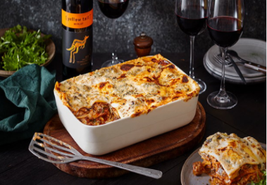
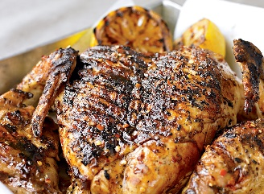
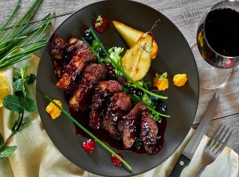
Hou, Y., Yang, W. and Sun, Y., 2017. Do pictures help? The effects of pictures and food names on menu evaluations. International Journal of Hospitality Management, 60, pp.94-103.
Hayes, D.K. and Huffman, L., 2019. Menu analysis: a better way. Cornell Hotel and Restaurant Administration Quarterly, 25(4), pp.64-70.
Beverages
  - Latte Snakebite Wassail
  - Coke Bramble Boilermaker
Price
15Є
SMBL Veg
- Spinach
- Mushroom
- Blue cheese lasagne
- Yellow Tail
Chicken Under a Brick
- Chicken
- A glass of Chardonnay
Price
18Є
Price
22Є
Merlot with Roast
- Roasted Chicken/Beef/Duck
- Merlot
Food Menu
Takeaway service
www.th.com
htfoodservice@gmail.com
Phone: +353 54 678903
Fabian Way, Crymlyn Burrows, Skewen, Swansea
Hotel Trinity
HT

