
Network Operating Systems and Services
ACCA5023

Matthew evans 2319368

Contents
Task 1 – Research 3
Research on Hypervisor 3
Research on IP Addressing 4
Structure, format, and representation of IPv4 and IPv6, subnetting, and efficient utilisation of IP addresses 4
Research on Routing 6
Research on Network Services 7
Task 2 - Technical Documentation 8
Virtual machine setup 8
Windows 11 Client 9
IP Config 9
Successful Ping (Windows 11 Client) 9
Successful Ping (Windows 11 Server) 10
Verify windows Client IP settings 10
Intentional Ping Failures (Win 11 Client) 11
Win 11 Client Net Adapter settings 12
Windows Server 2022 13
Windows-Server-2022 Installation 13
Network Adapters 14
Windows Server LAN IP (192.168.1.1) 15
Windows Server Transit IP (20.0.0.1) 16
Enable Ping on Windows Server (Firewall rules) 17
Ping tests Debian CLI transit 17
Ping Windows Client 18
Debian server CLI 20
Debian Server CLI config 20
Network configuration 21
Using nano to create LAN interface for Server 23
Ping connectivity tests 25
Intentional Failures 26
Debian Client GUI 28
Installation (showing as this was difficult for me) 28
VM Network Adapter Settings 31
Debian GUI – Set static IPv4 Address (192.168.2.10) 32
Successful Ping to Debian CLI Server 32
Windows Network Ping Failures 33
Confirming correct Linux Network Configuration 34
Task 3 Reflection (Max 250 words) 35
Technical Reflection 35
Head scratchers 35
Personal Reflection 35
Bibliography 36

Task 1 – Research

Research on Hypervisor
Desai et al [1] describe a Type-1 hypervisor, also known as a “bare-metal” hypervisor, as a virtualization layer that runs directly on the underlying physical hardware. As no operating system exists beneath it, the hypervisor maintains direct control over hardware resources which enables efficient management and direct interaction with the hardware thus enhancing performance and reducing overhead compared to hosted hypervisors.

Studies from D. Pousa [1] and A. Desai [2] infer that Type-2 hypervisors, or hosted virtual machine monitors, run on top of a host OS, which manages I/O for guest Oss while treating the hypervisor as a normal process. In this architecture, the host OS is installed first, then the hypervisor, enabling multiple isolated guest Oss to operate independently within virtual environments.

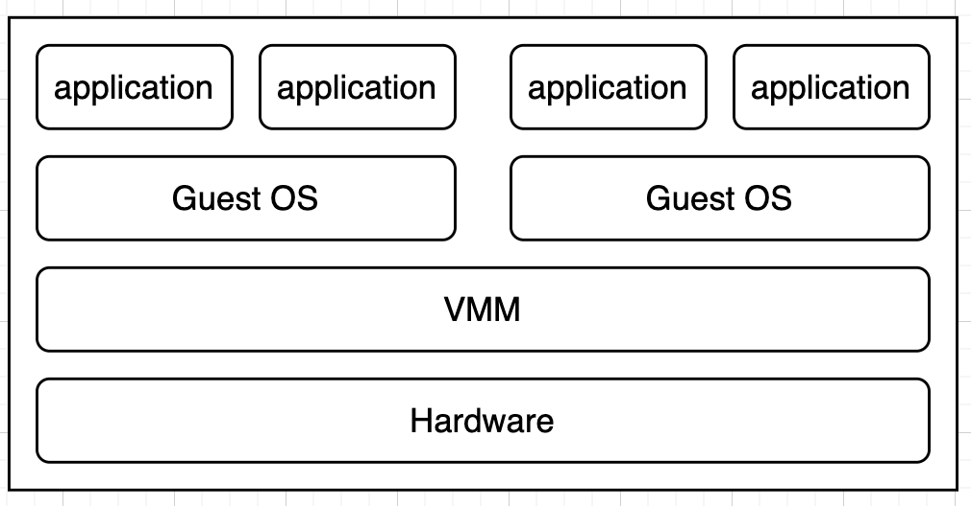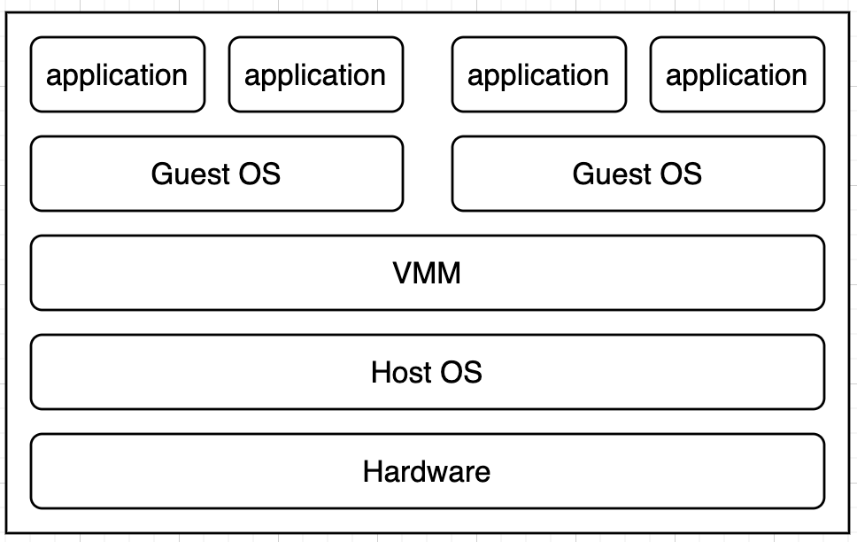
Type 1 Hypervisor Type 2 Hypervisor

Figure 1. Different types of hypervisors.

Based on guidance by my lecturer provided on 03/02/2026 and consideration of the UWTSD architecture, I will choose a Type-2 hypervisor for the NOSS2026 topology and the SWANSEA.ACCA domain.

To my benefit, a hosted hypervisor is easily accessible using Oracle Virtual Machine which is installed on SOAC devices on campus.
As a Type-2 hypervisor runs on top of an existing host operating system (as seen in Figure 1), it will allow me to configure all devices (server and client) and monitor the virtual environment with relative ease.
While in a professional setting, a Type-1 hypervisor may be better from a data security standpoint, for this module, a Type-2 hypervisor provides the flexibility and simplicity required for this topology without compromising the core functionality of the network.

Research on IP Addressing
IP addressing is fundamental to the functionality and effectiveness of a network. Devices are assigned a unique address allowing them to communicate reliably with one another. This is similar to a home address on a street. The street is the network, and the home address is the asset.
Every device connected to a network is assigned an IP address, which acts as a logical identifier used for locating the source and destination of data packets [4].
This addressing mechanism allows routers to make forwarding decisions and determine efficient paths for data transmission across interconnected networks. Without IP addressing, end-to-end communication would not be possible. Furthermore, IP addressing supports network management, troubleshooting, and security by allowing administrators to identify devices and control traffic flow. As highlighted in [5], structured IP addressing enables networks to operate efficiently at scale, ensuring data is delivered accurately while minimising congestion and improving overall network performance.

Structure, format, and representation of IPv4 and IPv6, subnetting, and efficient utilisation of IP addresses
IPv4 and IPv6 are the two primary versions of IP addressing used in modern networks. IPv4 uses a 32-bit address format represented in dotted-decimal notation, allowing for approximately 4.3 billion unique addresses [6]. Although we never imagined it at the time, due to the rapid growth of Internet-connected devices, such as smart-watches, smart-TV’s and even smart-fridges, this address space became insufficient. IPv6 was introduced to resolve this limitation by using a 128-bit hexadecimal address format, providing a vastly larger address pool [4]. The number of available IP addresses in this address pool now is almost infinite. It is very unlikely that we will exhaust IPv6’s address pool.
To improve efficiency within IPv4 networks, subnetting was introduced, as defined in RFC 950. Subnetting divides a network into smaller logical sub-networks by borrowing bits from the host portion of an address. This provides a more comprehensive network and reduces broadcast traffic [7].

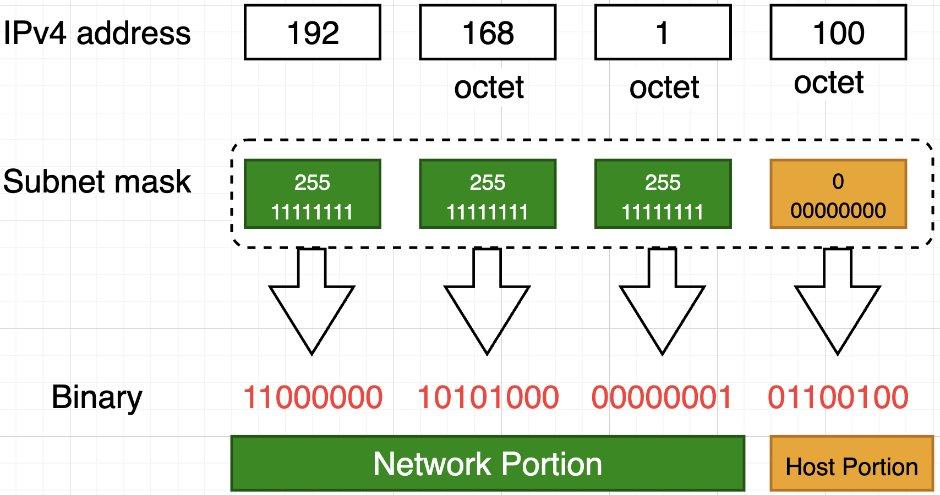

Figure 2 IPv4 addressing diagram.

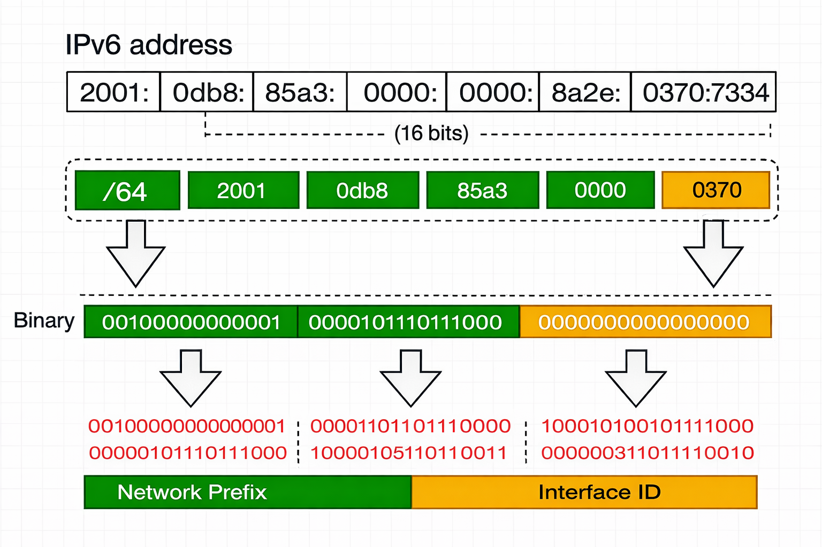

Figure 3 IPv6 addressing diagram.

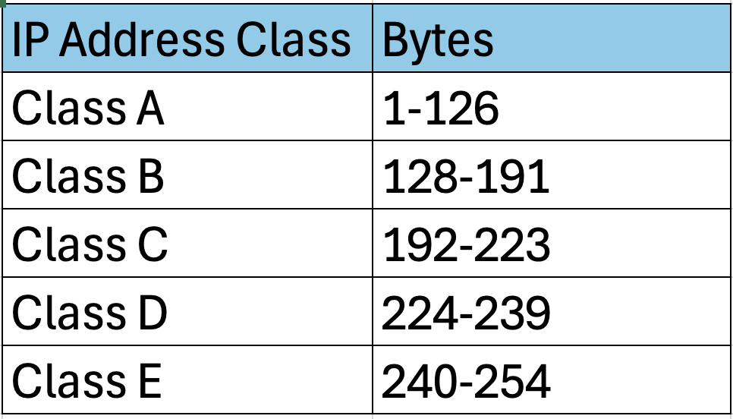

Figure 4. We can quickly identify the class of an IP address by observing only the first byte.

Research on Routing

Routing is an important part of how computer networks work because it decides the best path for data to travel between devices. When data is sent, it is split into packets that include the destination IP address. Routers interpret this address and consult their routing tables to determine the destination of each packet. This process continues across several routers until the packets reach their destination. GeeksforGeeks [13] explains that routing can be static, dynamic or default. Static routing uses manually set paths, dynamic routing updates routes automatically, and default routing sends packets to a set gateway when no specific route exists.

GeeksforGeeks also explains that routing protocols help routers share information and determine best routes [8]. These protocols are grouped into distance vector, link-state and hybrid types. Distance vector protocols, such as RIP, choose routes mainly based on hop count. Link-state protocols like OSPF build a wider view of the network to make more accurate decisions. Hybrid protocols, such as EIGRP, use ideas from both approaches to improve performance and accuracy.

For the network setup described, dynamic routing is the most suitable option. The Debian DHCP relay needs to forward DHCP requests across several subnets to the Windows Server, and dynamic routing supports this more reliably. OSPF is a good example, as it learns routes automatically, handles new VLANs or subnets well and reduces the need for manual configuration. It also improves network resilience by finding new paths if a link fails, ensuring DHCP traffic continues to reach the server.

Research on Network Services

NordVPN; leading virtual private network (VPN) service provider shares that a VPN is a tool that establishes an encrypted tunnel for your data. A VPN protects your online identity, concealing your IP address and enhancing security across all networks.

Put simply a VPN is:

- “virtual” due to the way it creates a simulated connection over the internet rather than using a physical one.
- “private” as the encryption works to shield your personal internet traffic from attackers.
- A “network” because a VPN will securely connect your device to a remote network of choice.

From Dubey et al.’s research [10], we find that DHCP is a connectionless protocol that dynamically assigns unique IP addresses to clients on a network. One key feature of DHCP is its ‘plug and play’ functionality, which allows users to configure their network and system without worrying about the DHCP protocol using the network facilities automatically.

DHCP uses UDP (User Datagram Protocol). It uses two ports, 67 & 68.

- Port 67 – used by server to receive client requests
- Port 68 – used by client to receive server responses

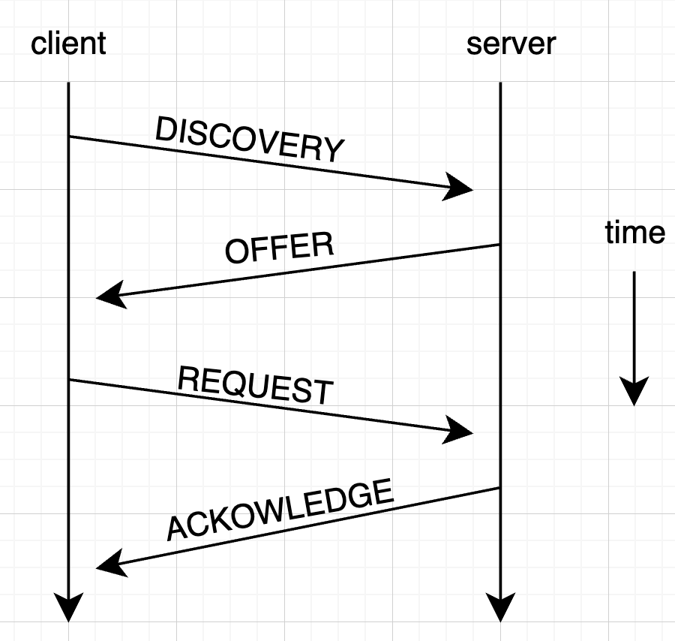
Figure 5.

Microsoft.com [11], shares, “Active Directory” is a hierarchical structure used to store information about objects on a network. Active Directory Domain Services (ADDS) provides the methods for storing and making this data accessible to network users and administrators. For instance, ADDS stores user account information including names passwords phone numbers and more. It also allows authorised users within the same network to access this data.

Task 2 - Technical Documentation

Virtual machine setup
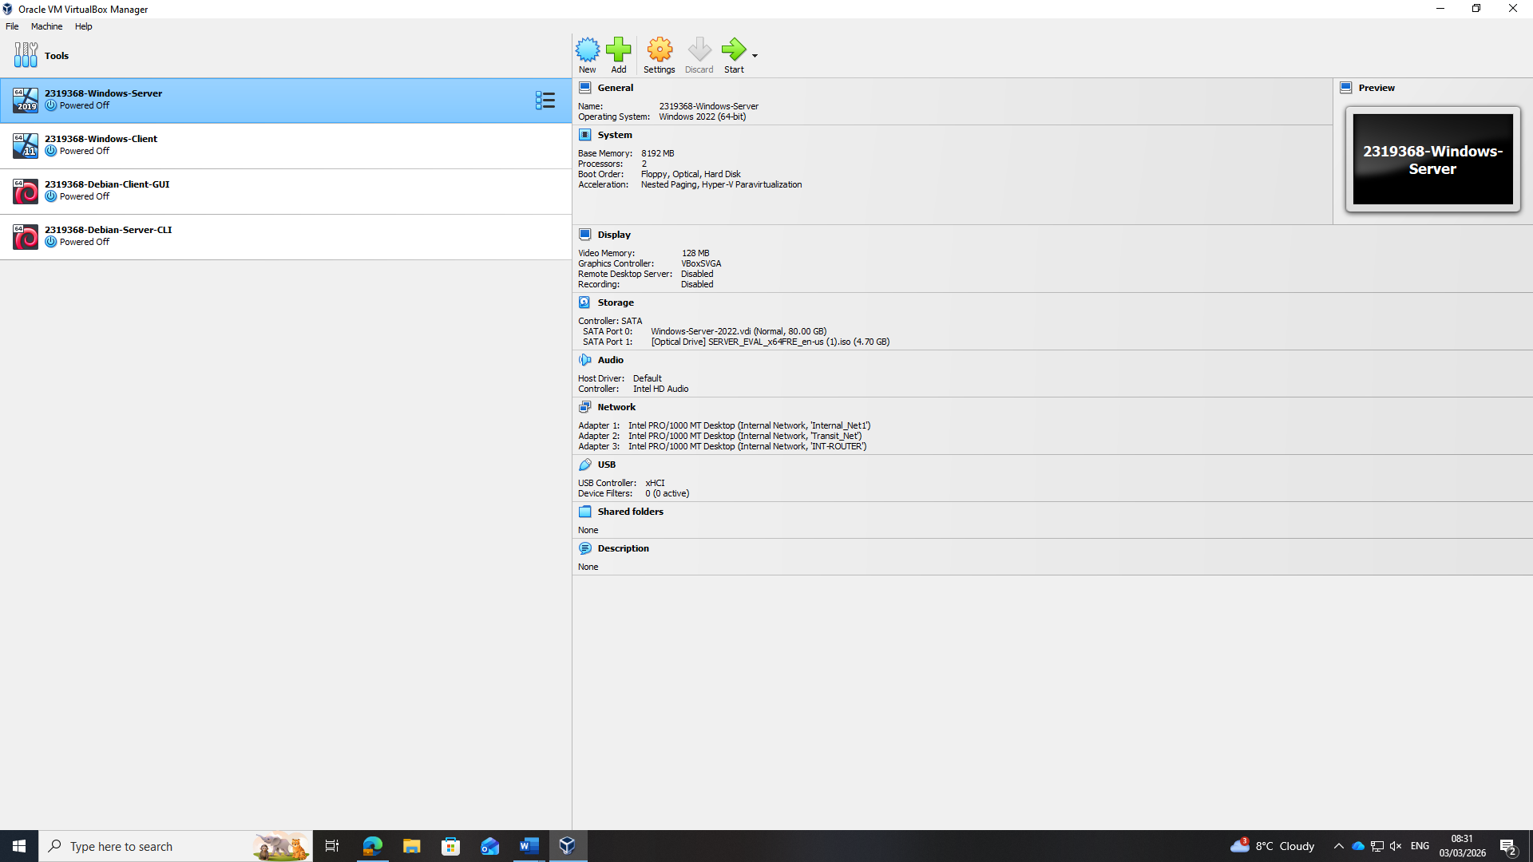

Windows 11 Client

IP Config
Here I am configuring the IPv4 static IP settings
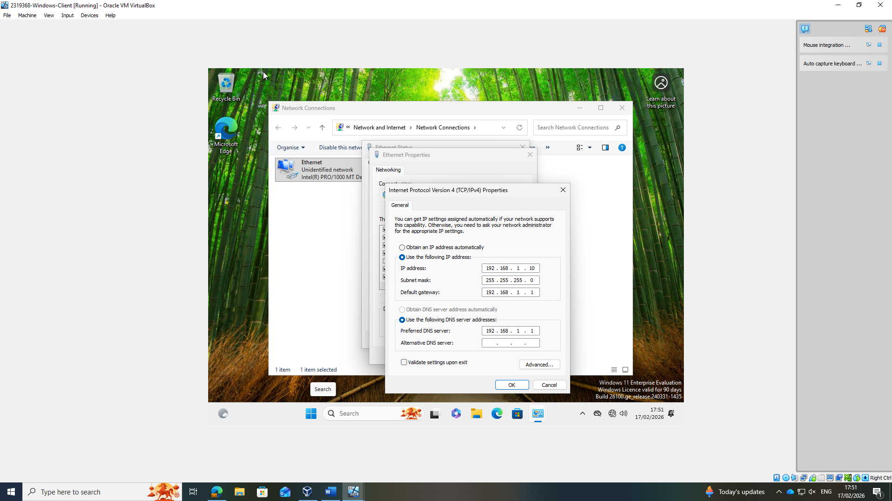

Successful Ping (Windows 11 Client)
Windows Server Successful ping from command prompt, it replies to itself fine.
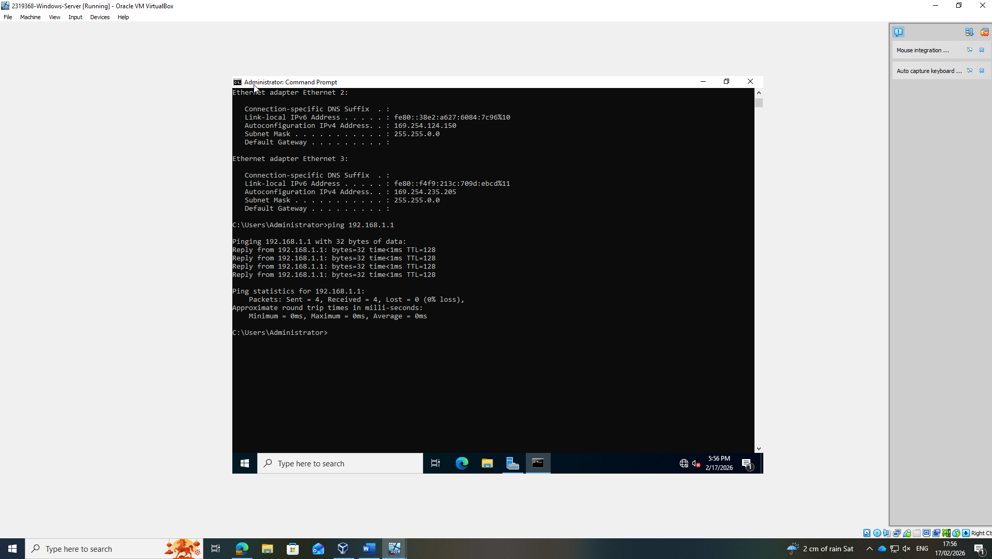

Successful Ping (Windows 11 Server)

Windows 11 Client successfully pinging windows server!

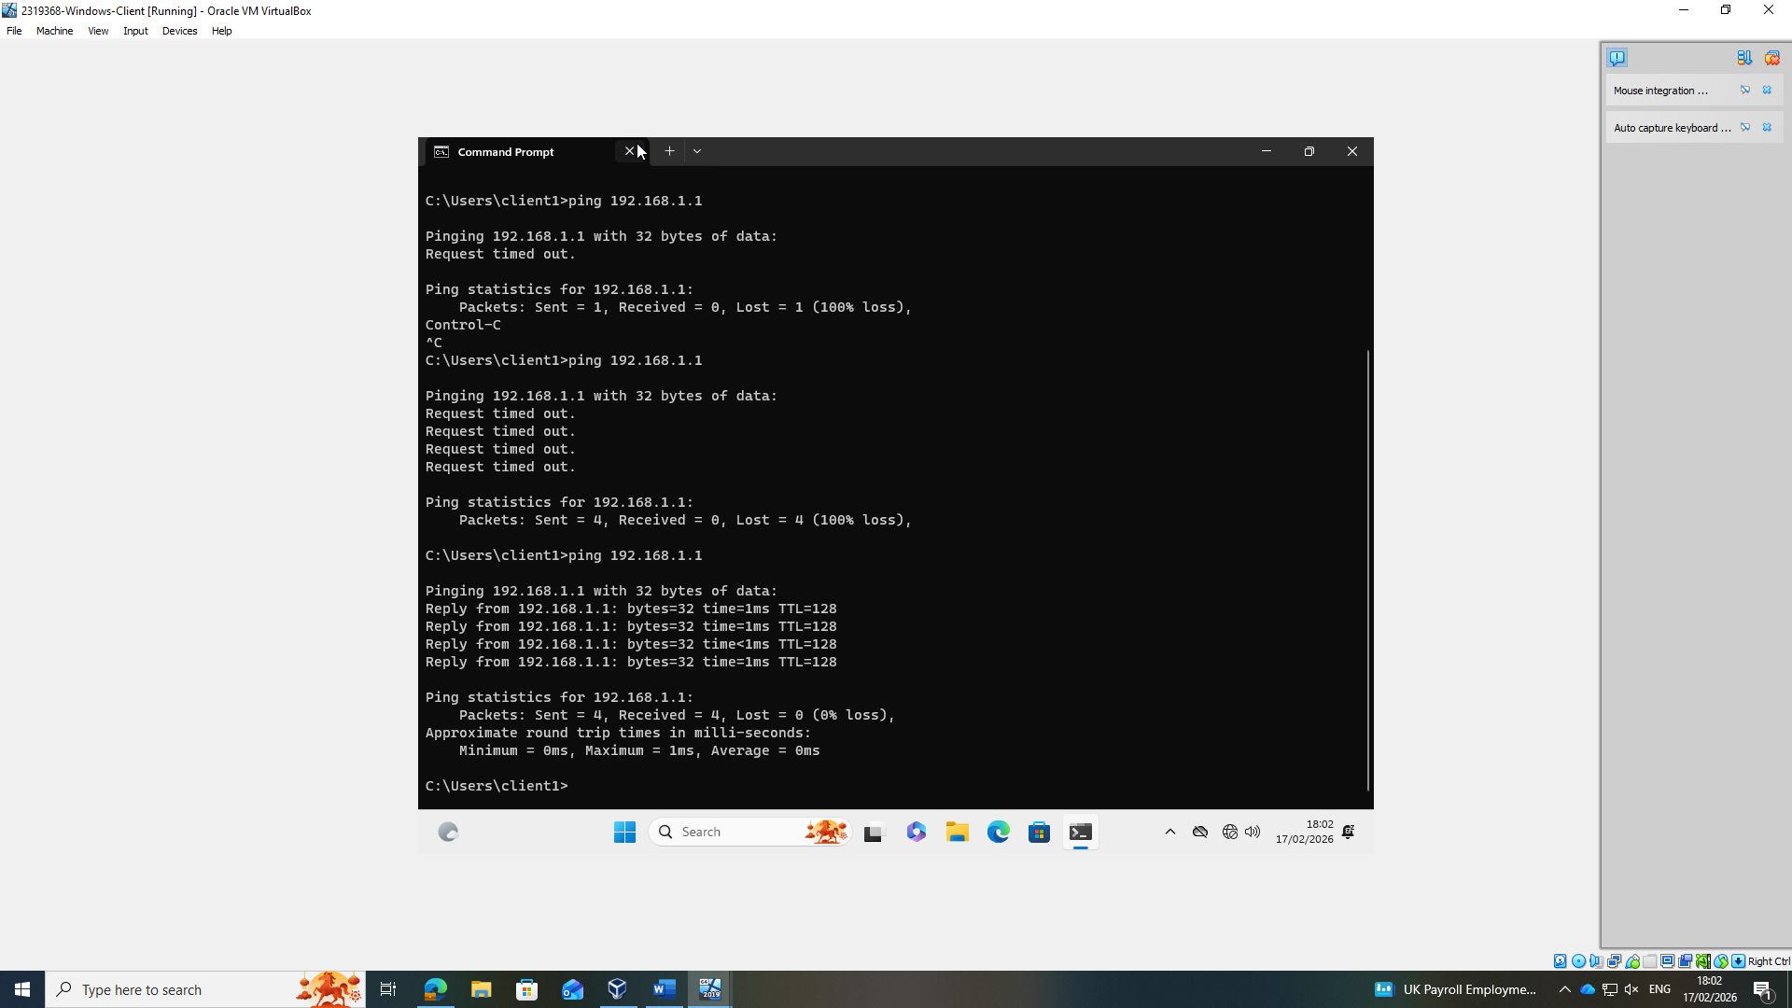

Verify windows Client IP settings

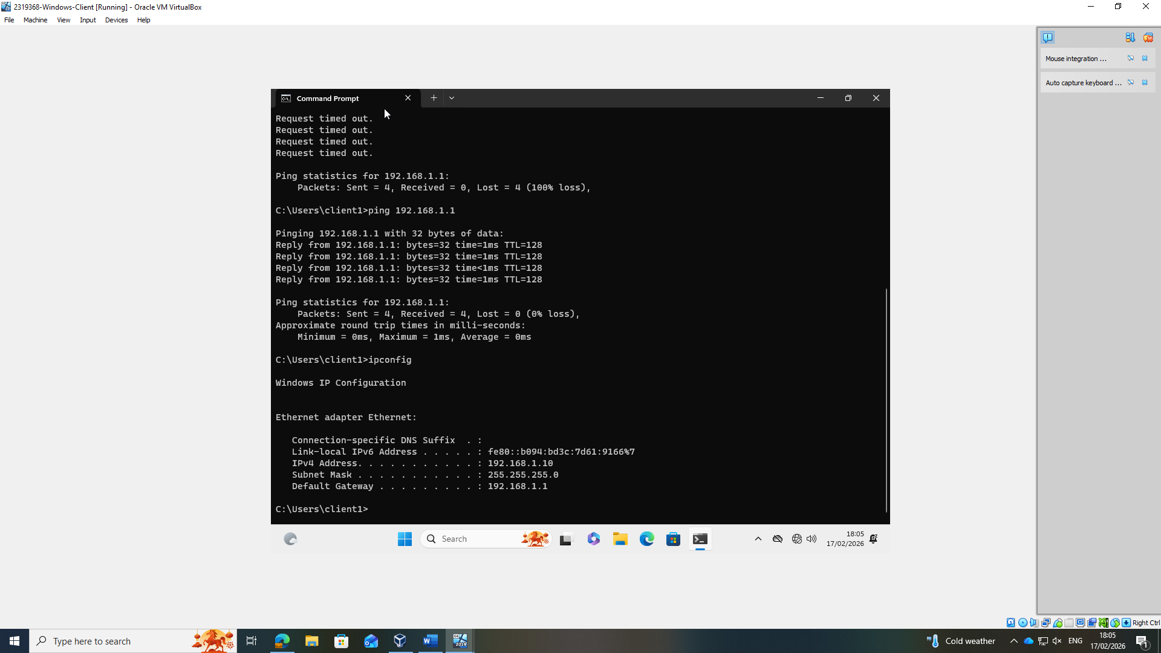

Intentional Ping Failures (Win 11 Client)

Ping Debian Server LAN fail

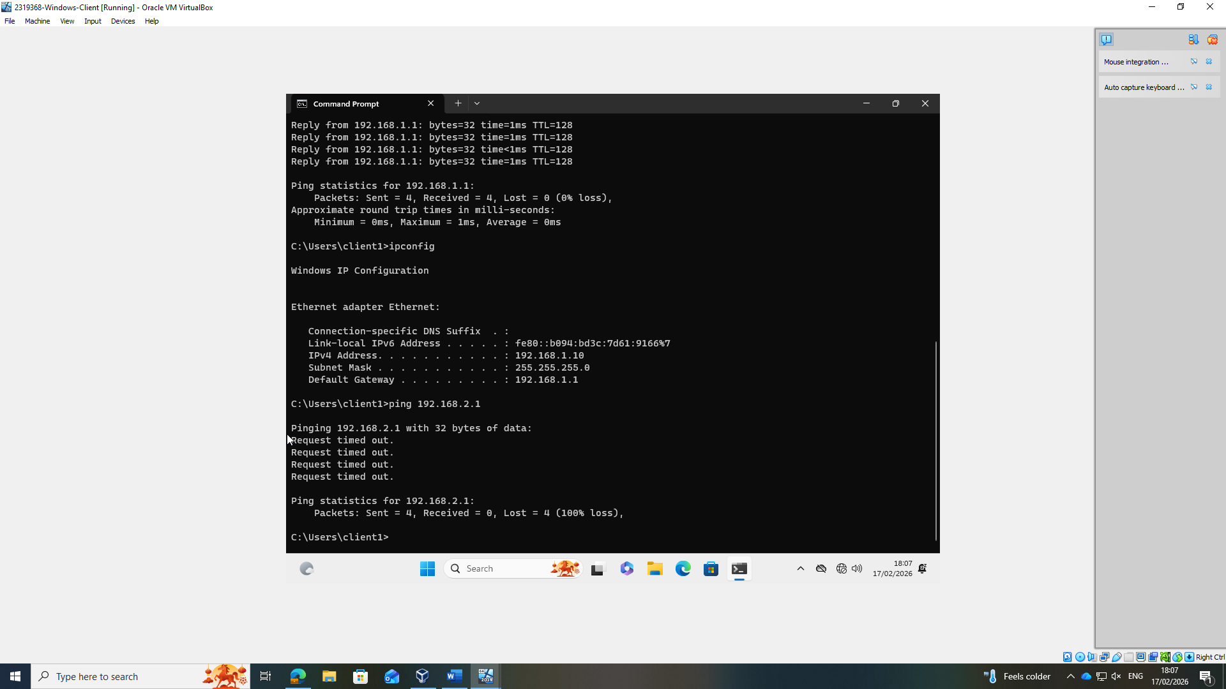

Ping Debian GUI Client fail

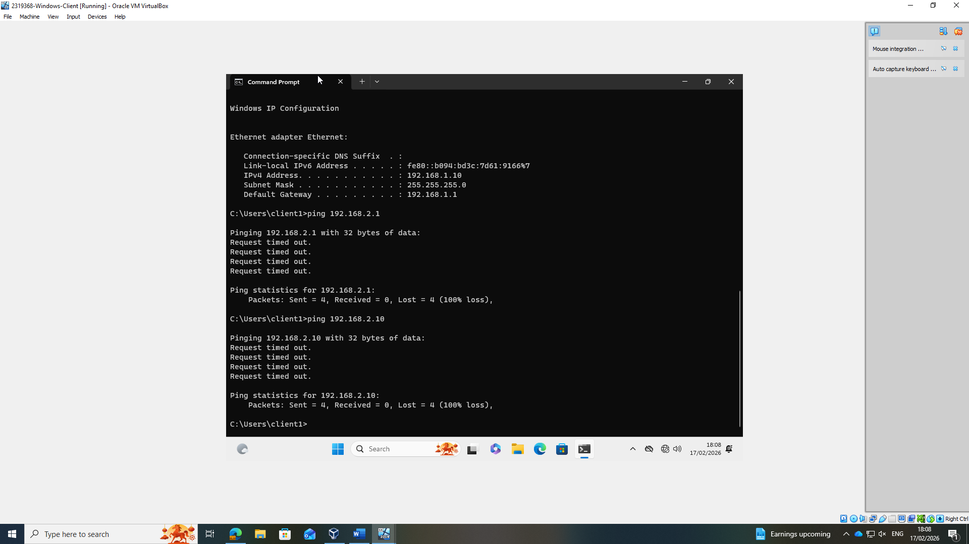

Win 11 Client Net Adapter settings

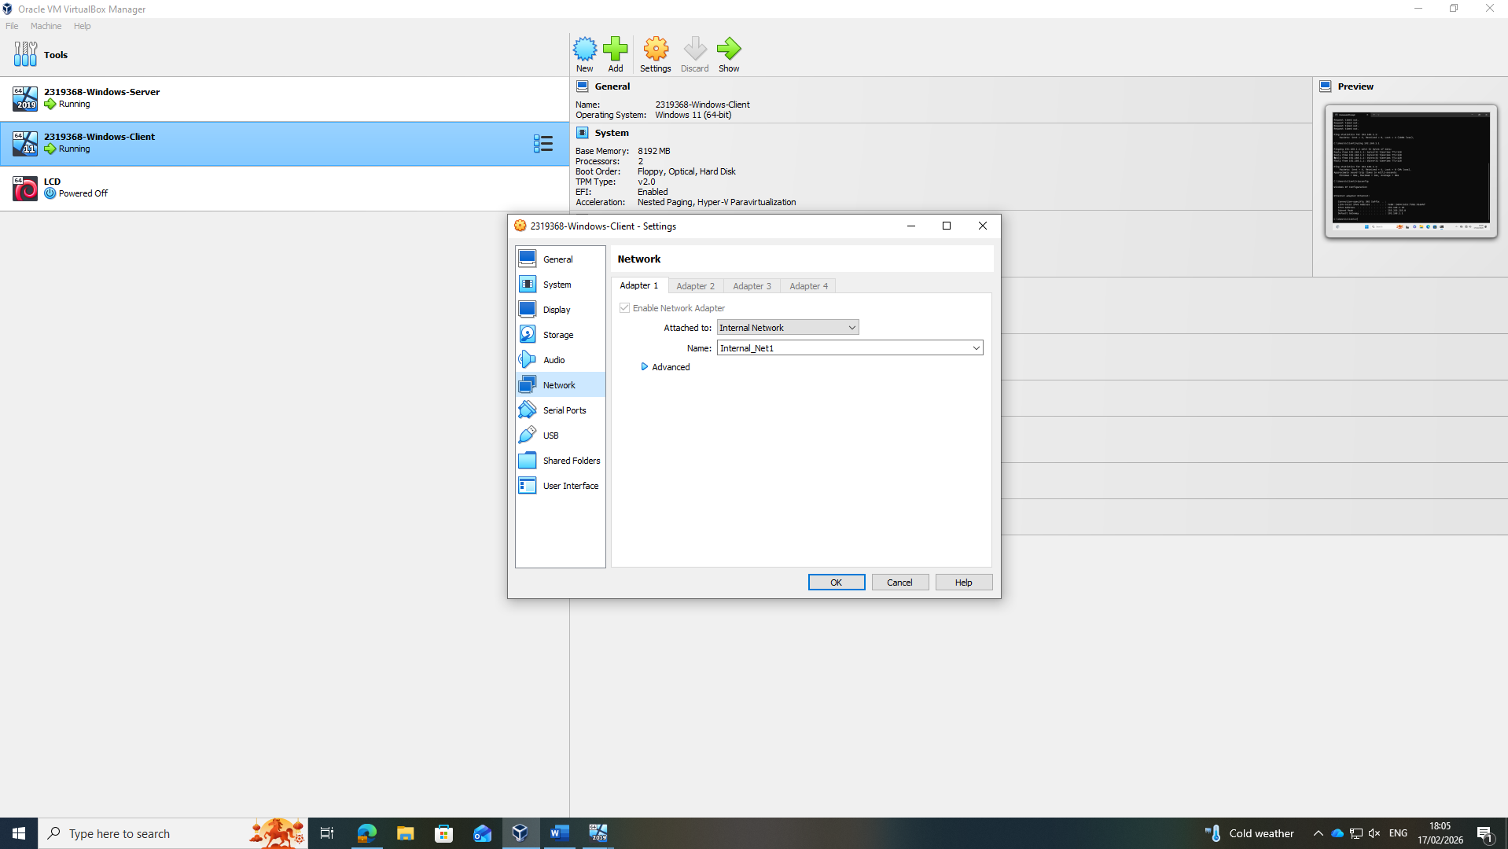

Windows Server 2022

Windows-Server-2022 Installation

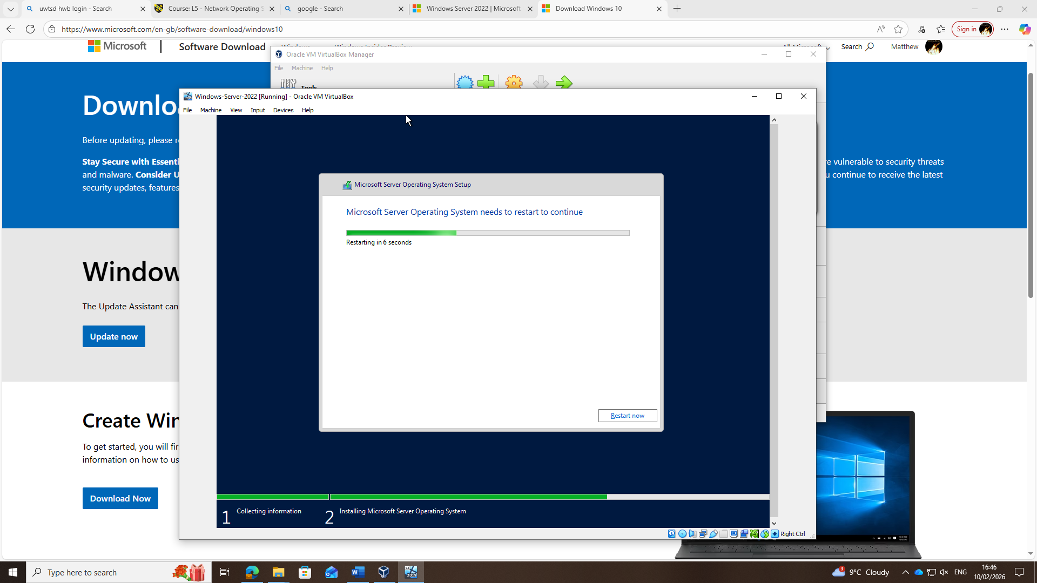

Network Adapters

Adapter 1 (LAN)
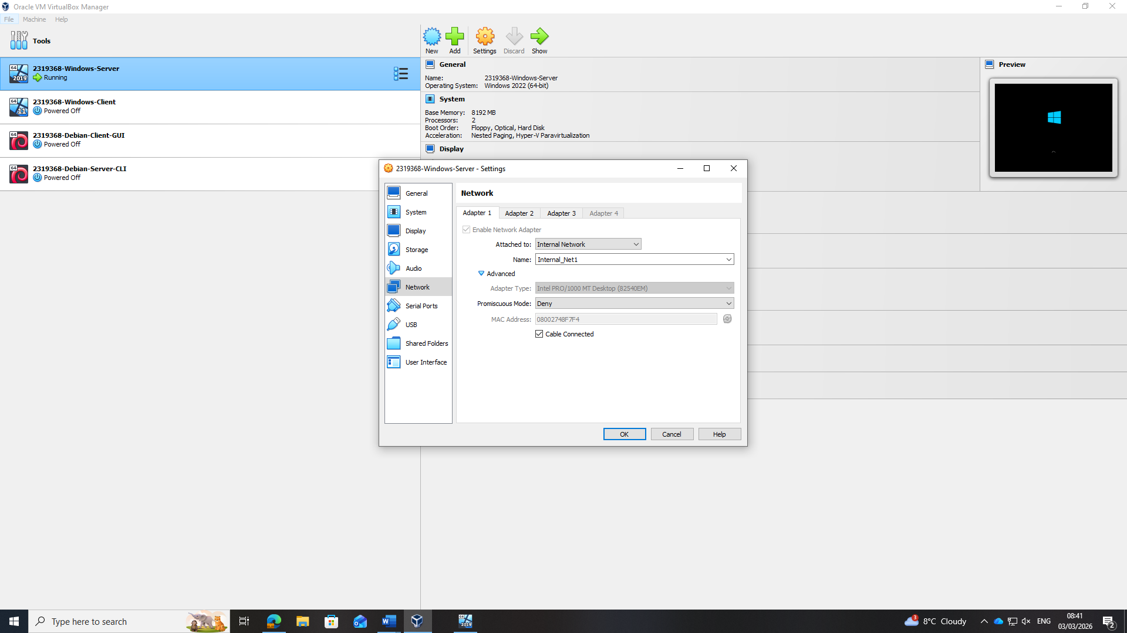

Adapter 2 (Transit)
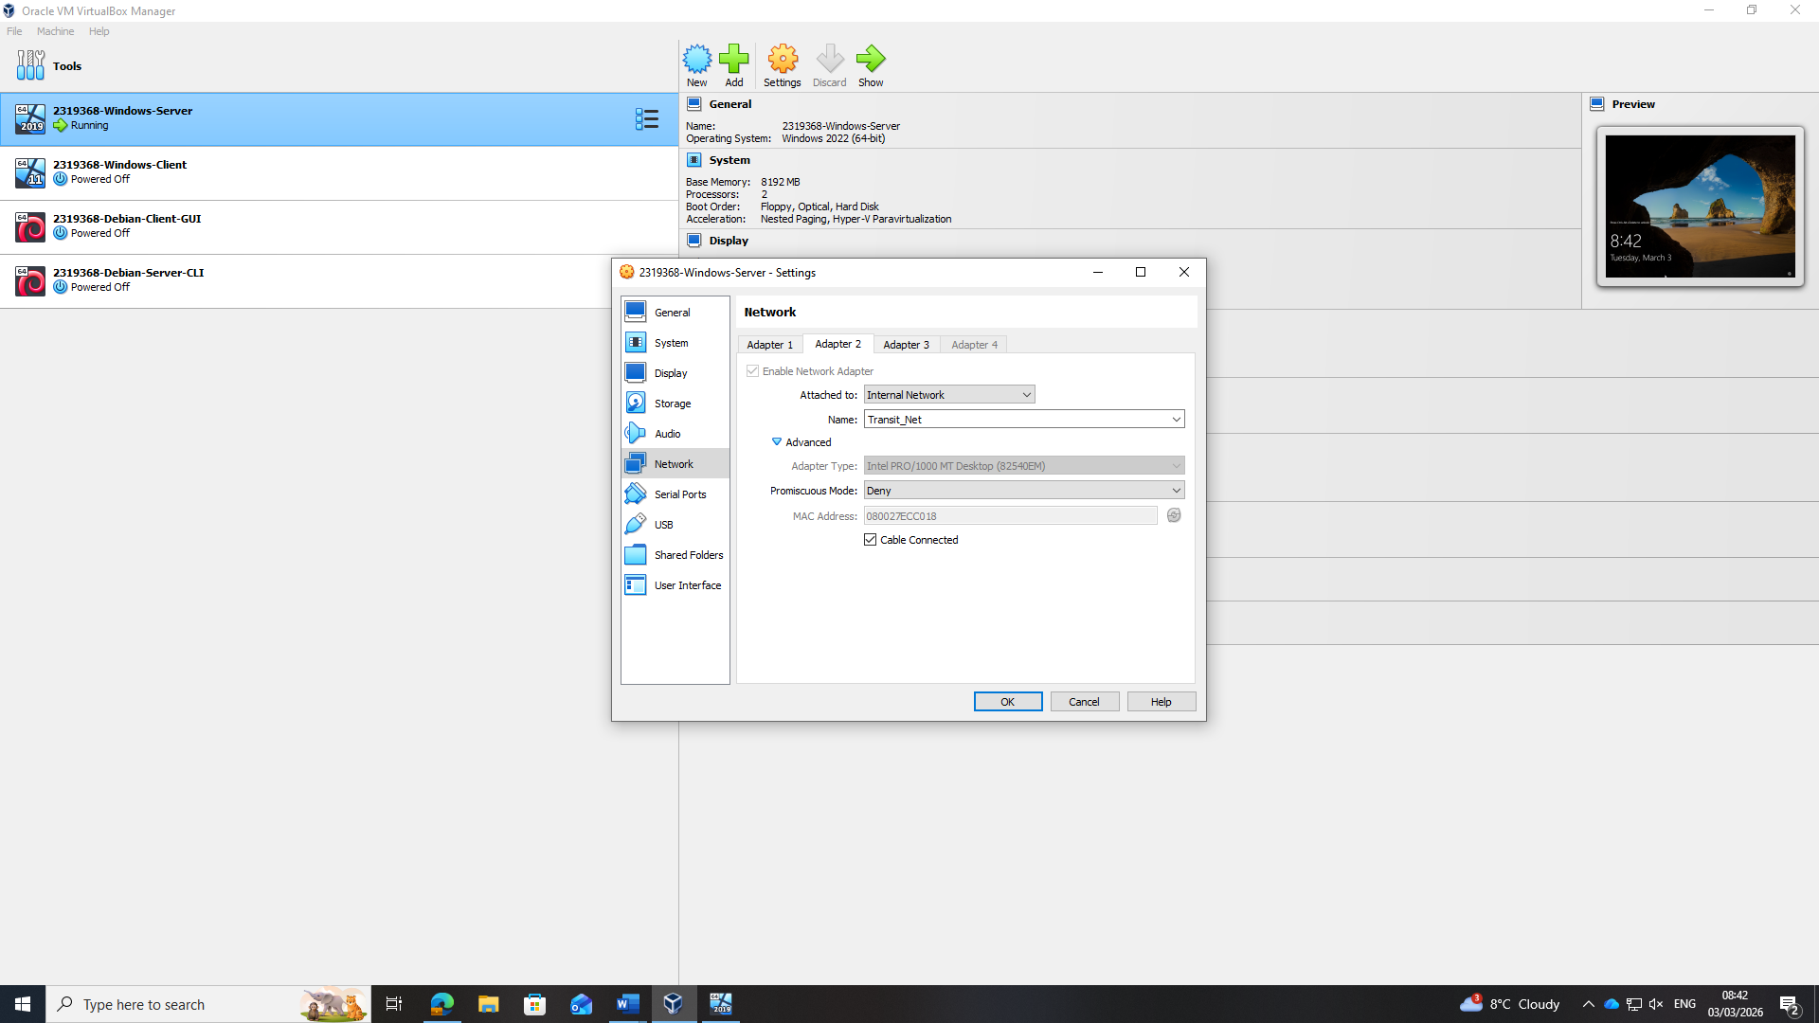

Windows Server LAN IP (192.168.1.1)

Lan config
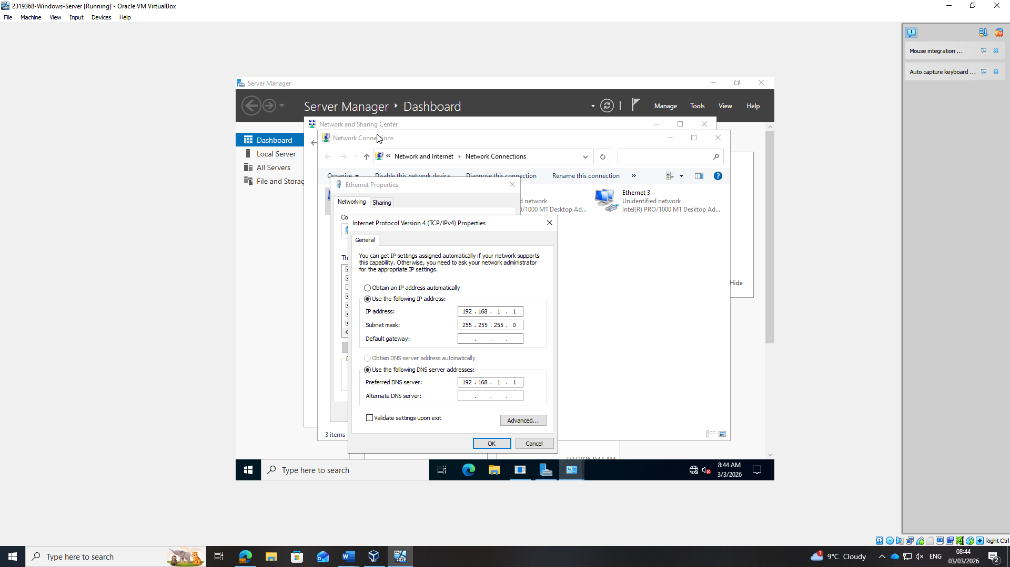

IPv4 address displayed in ipconfig correctly
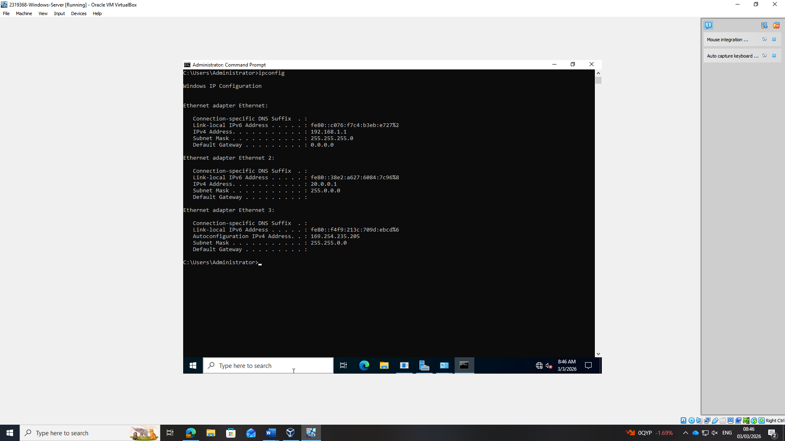

Windows Server Transit IP (20.0.0.1)

Transit Config

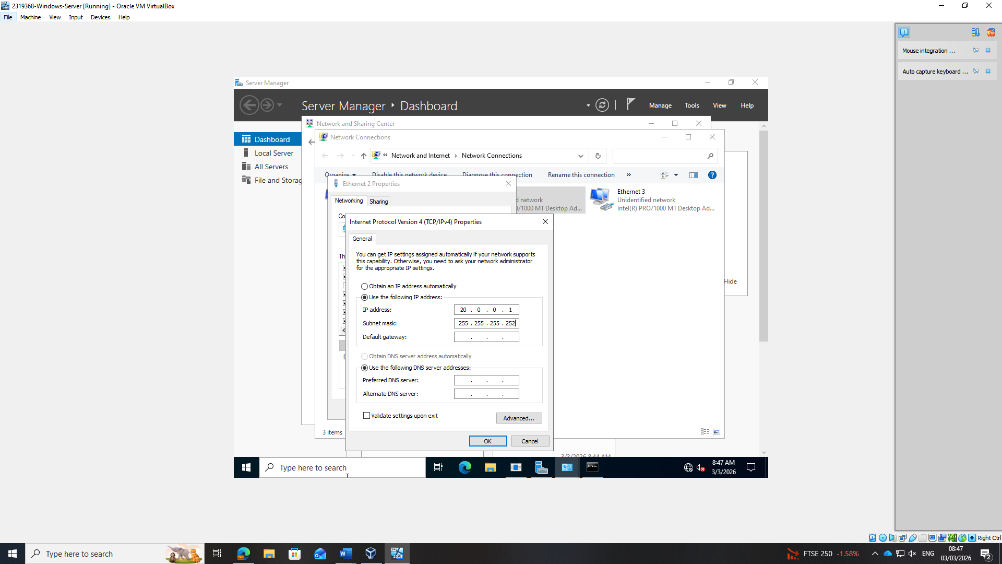

Transit IP
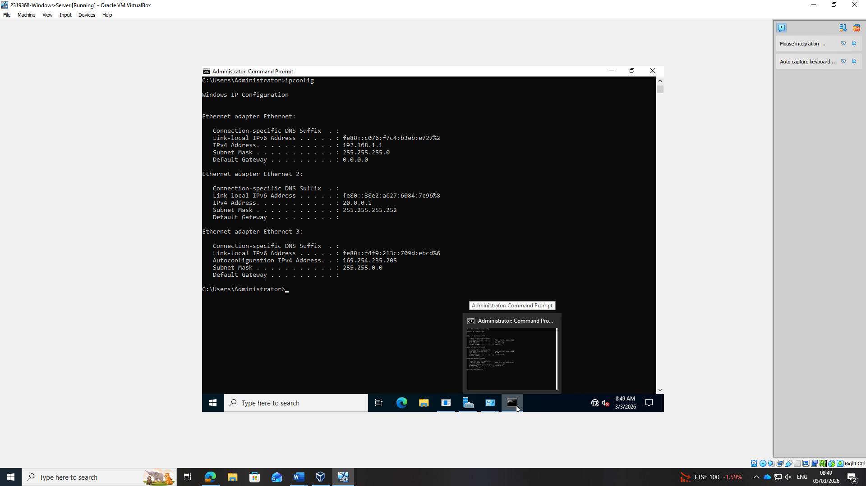

Enable Ping on Windows Server (Firewall rules)

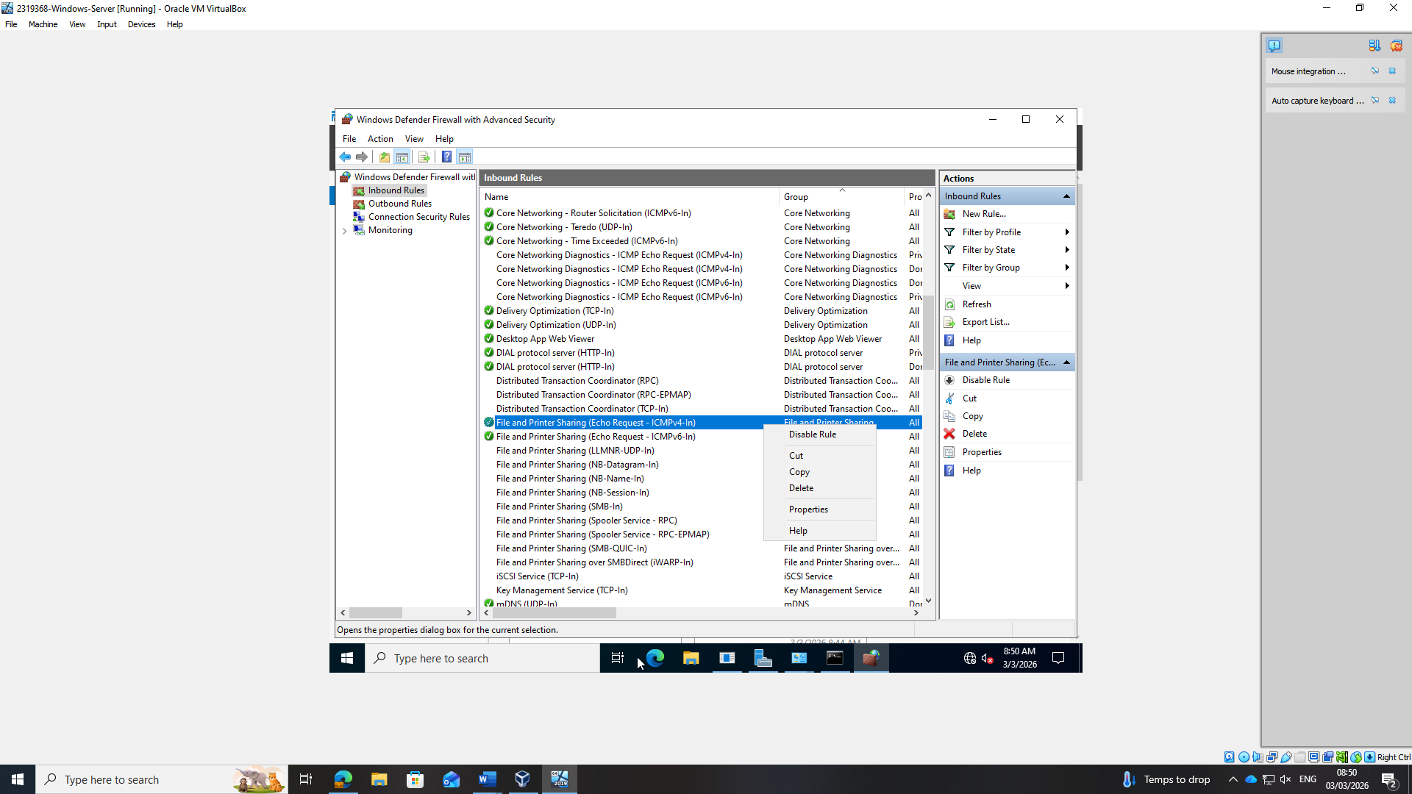

Ping tests Debian CLI transit

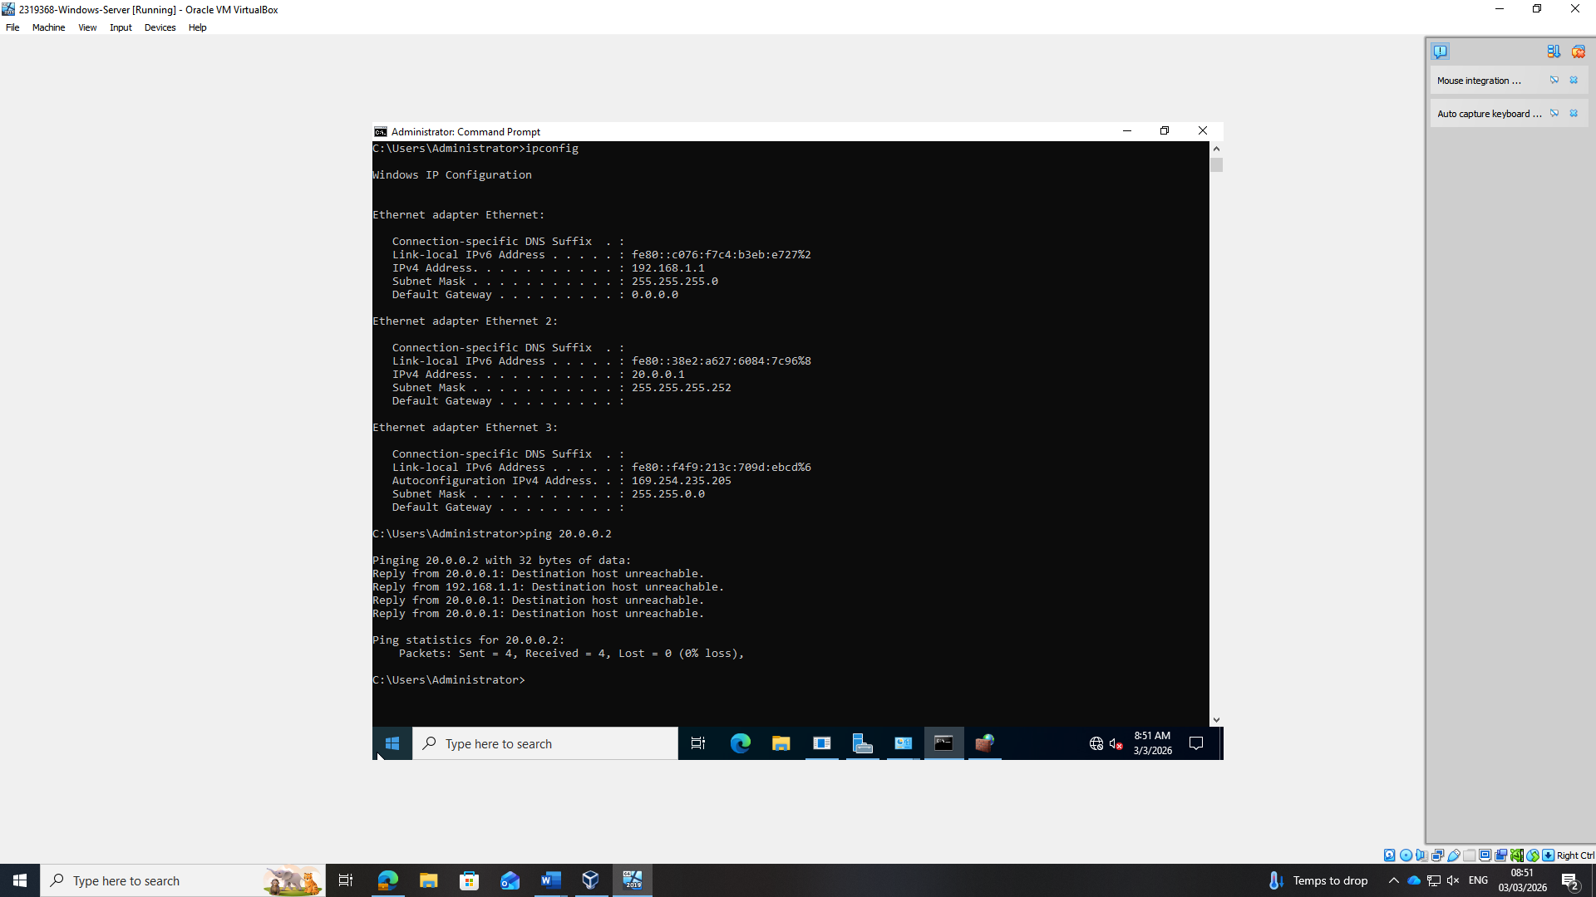

Ping Windows Client
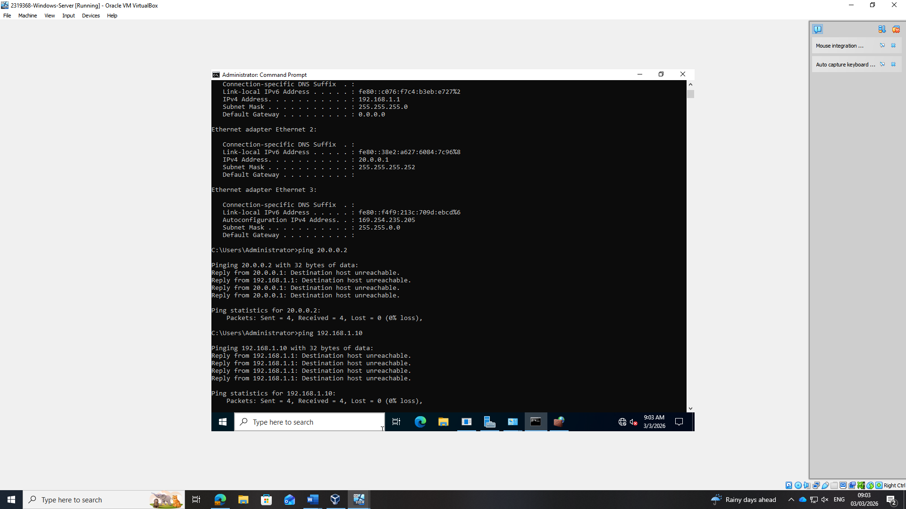

Debian server CLI

Debian Server CLI config

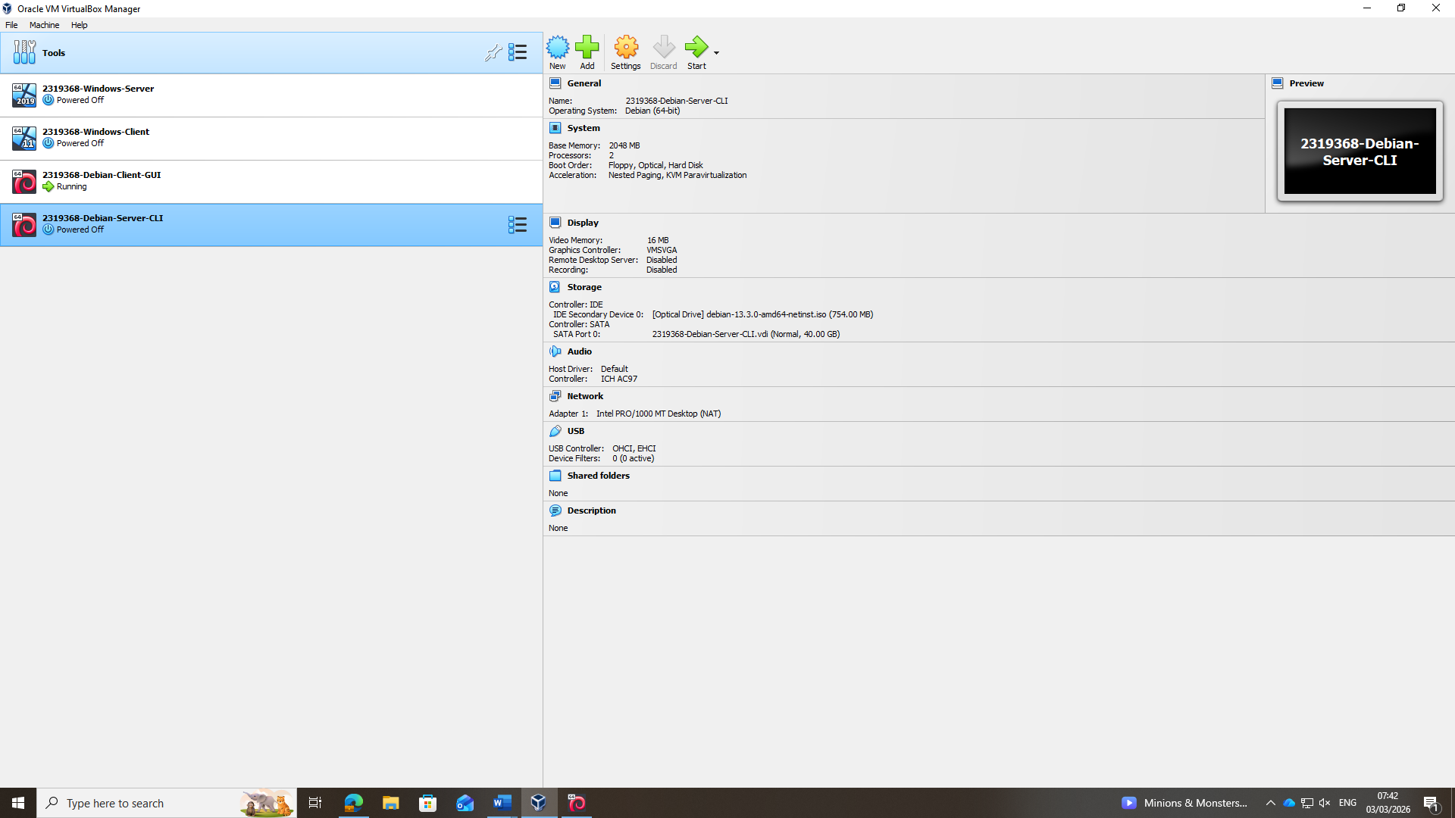

Network configuration
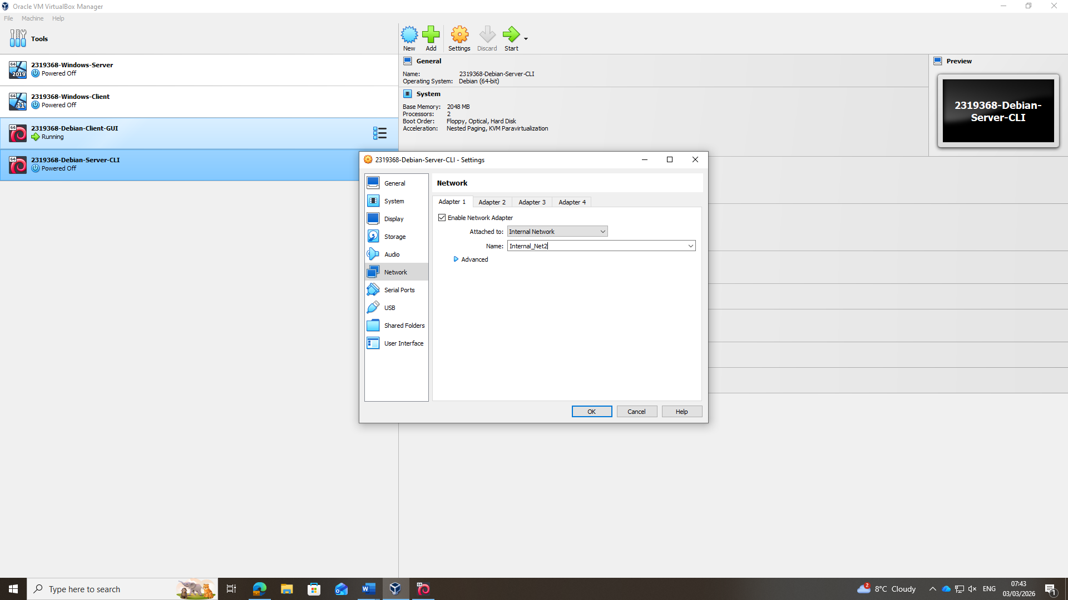

Configure transit to windows server
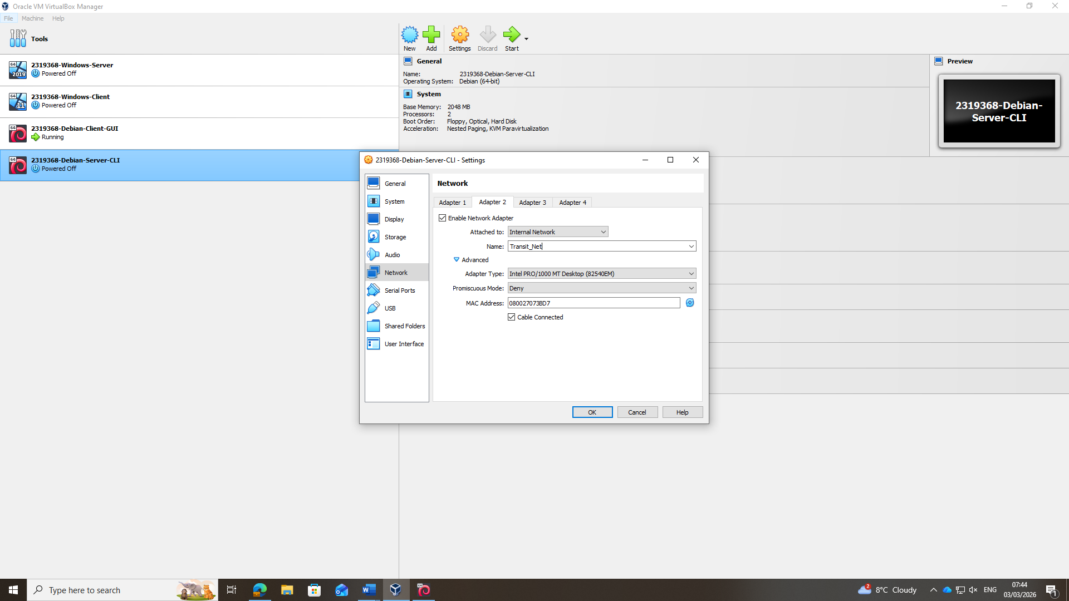

Configure network, choosing LAN interface (Internal_Net2)

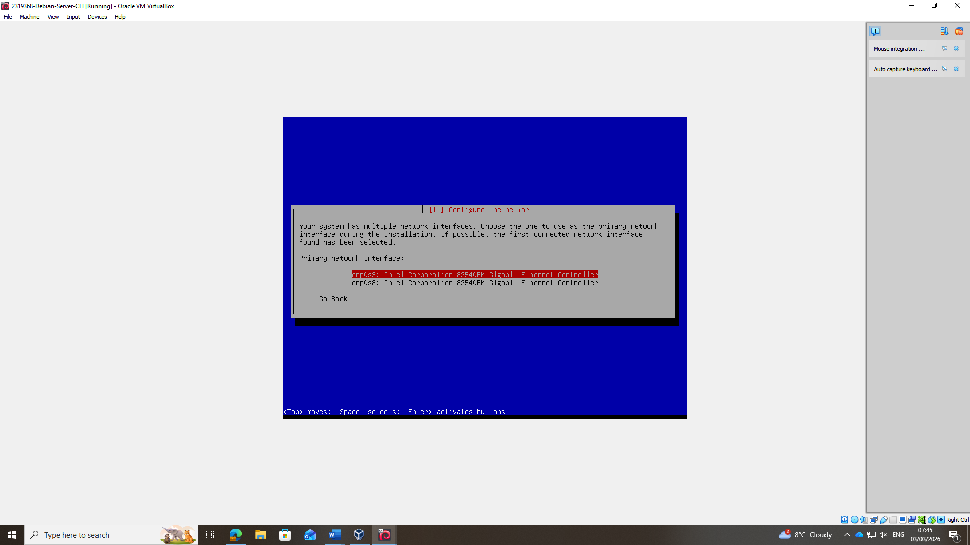

CLI Login prompt
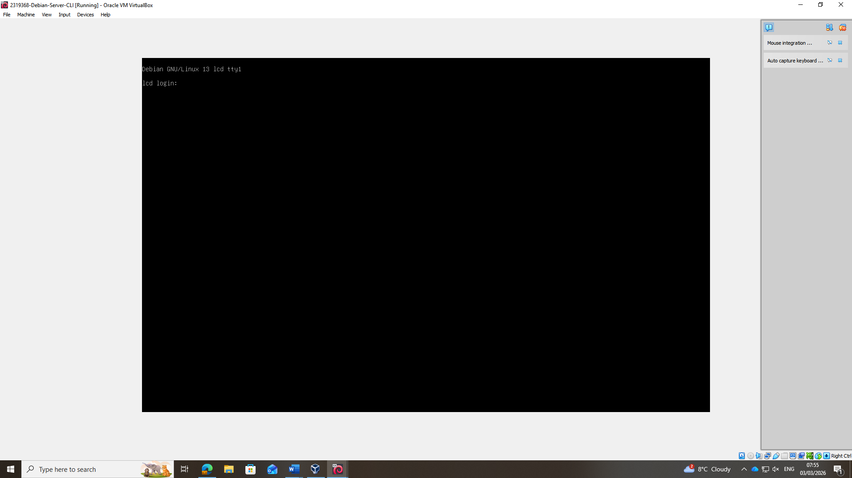

Using nano to create LAN interface for Server

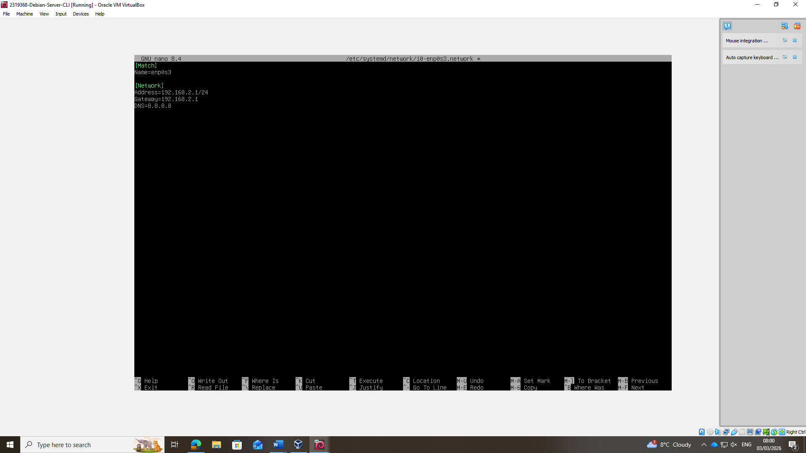

Error as Debian 13 installed WITHOUT systemd-networkd
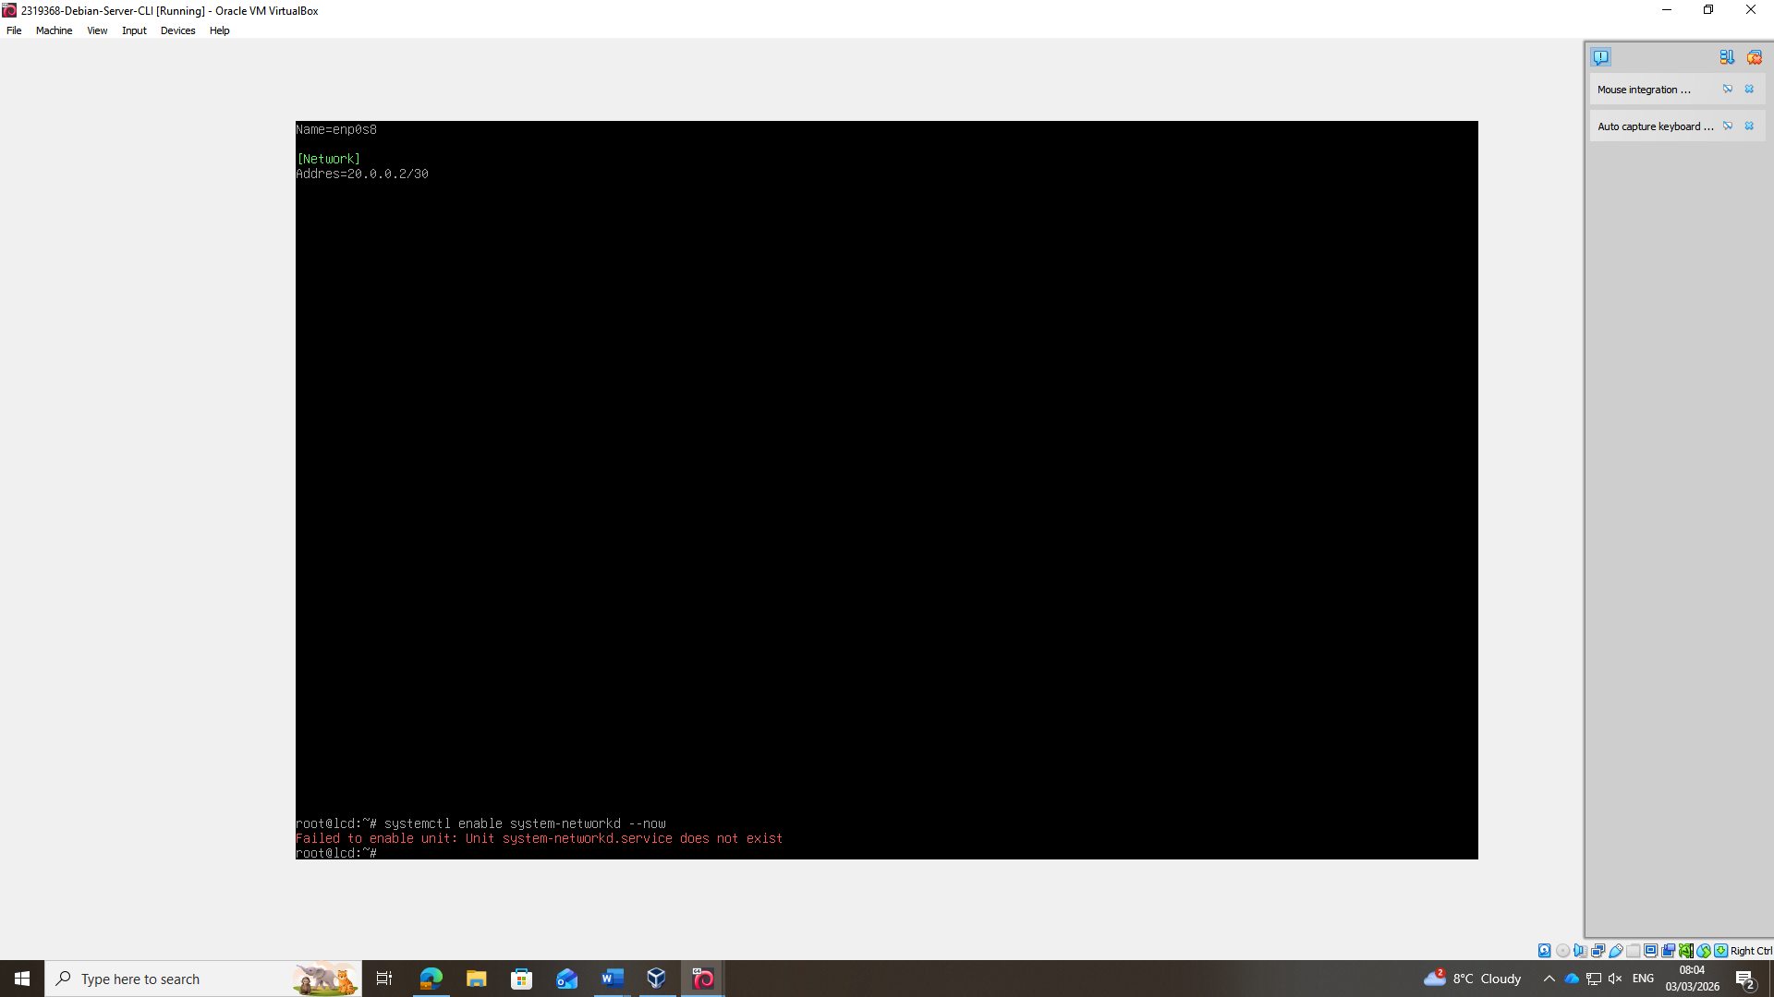

Changing network config to solve error

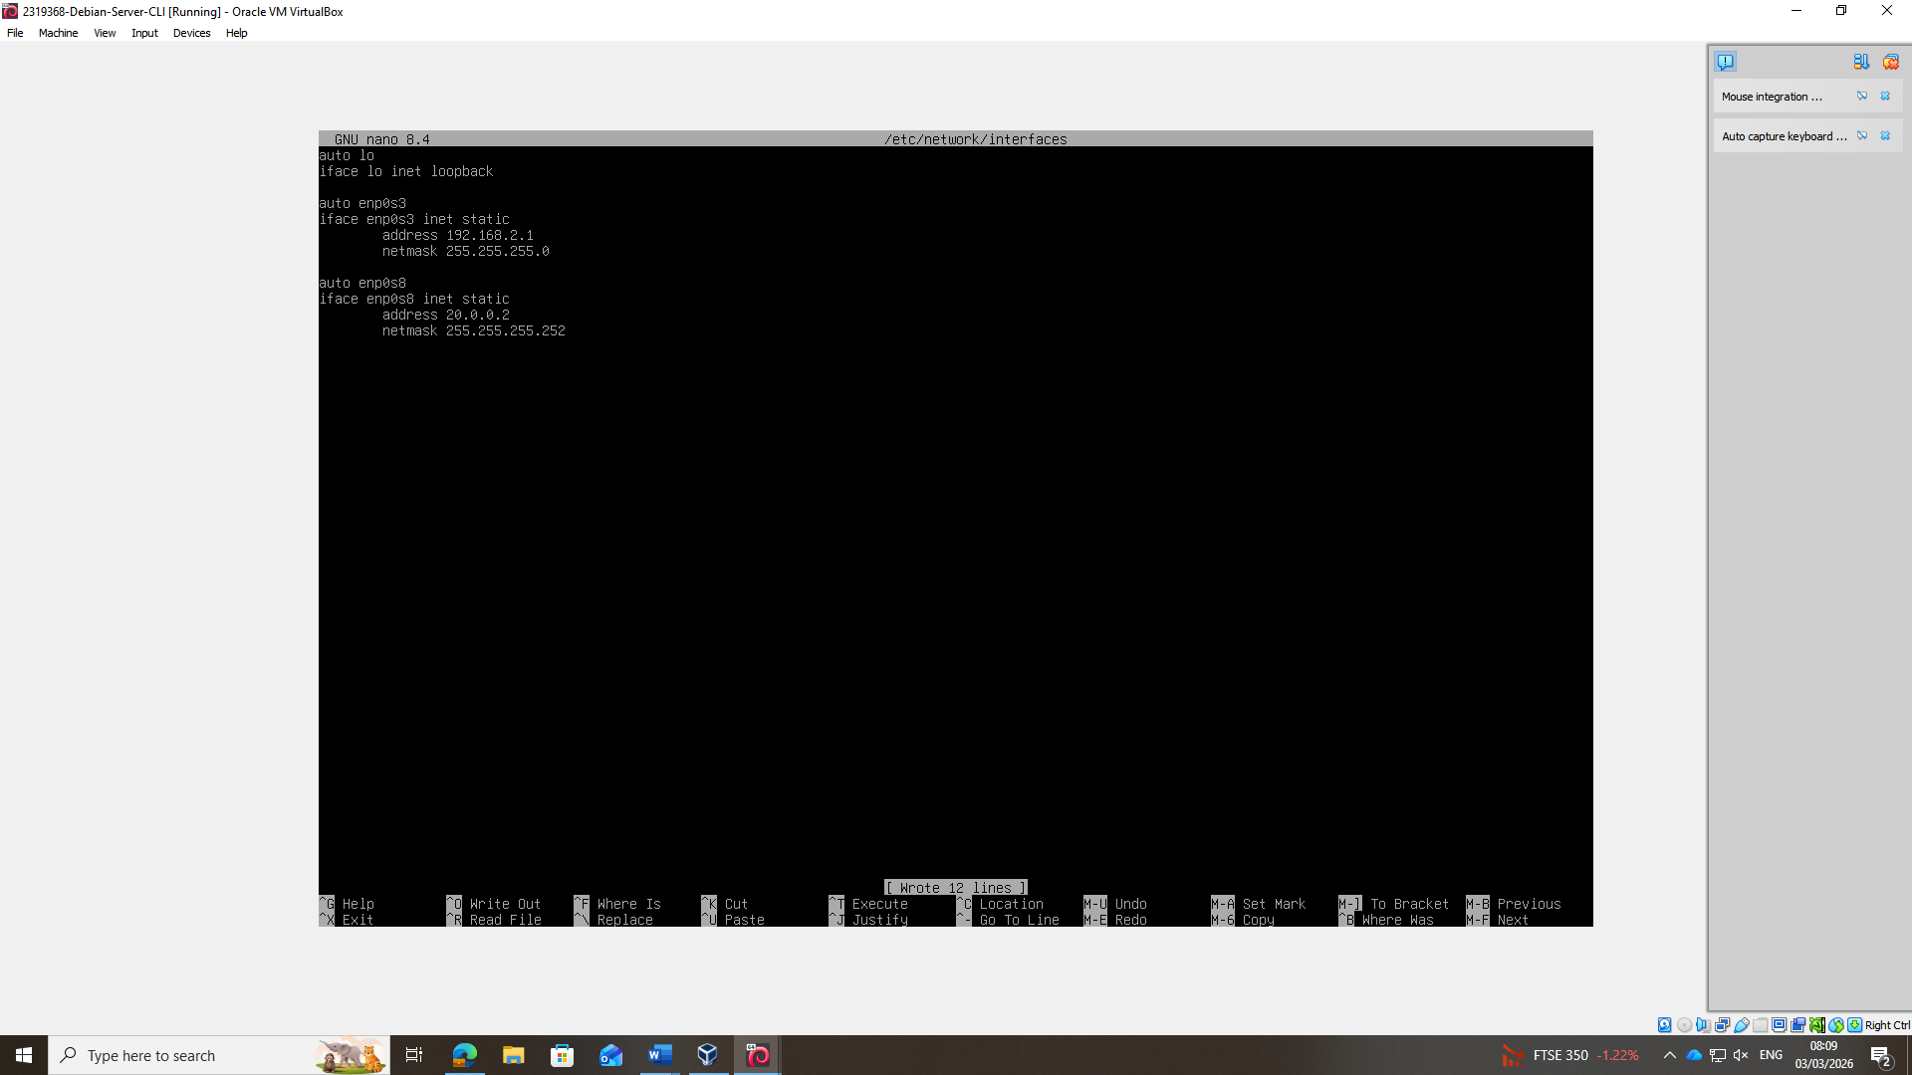

Network Adapters working correctly
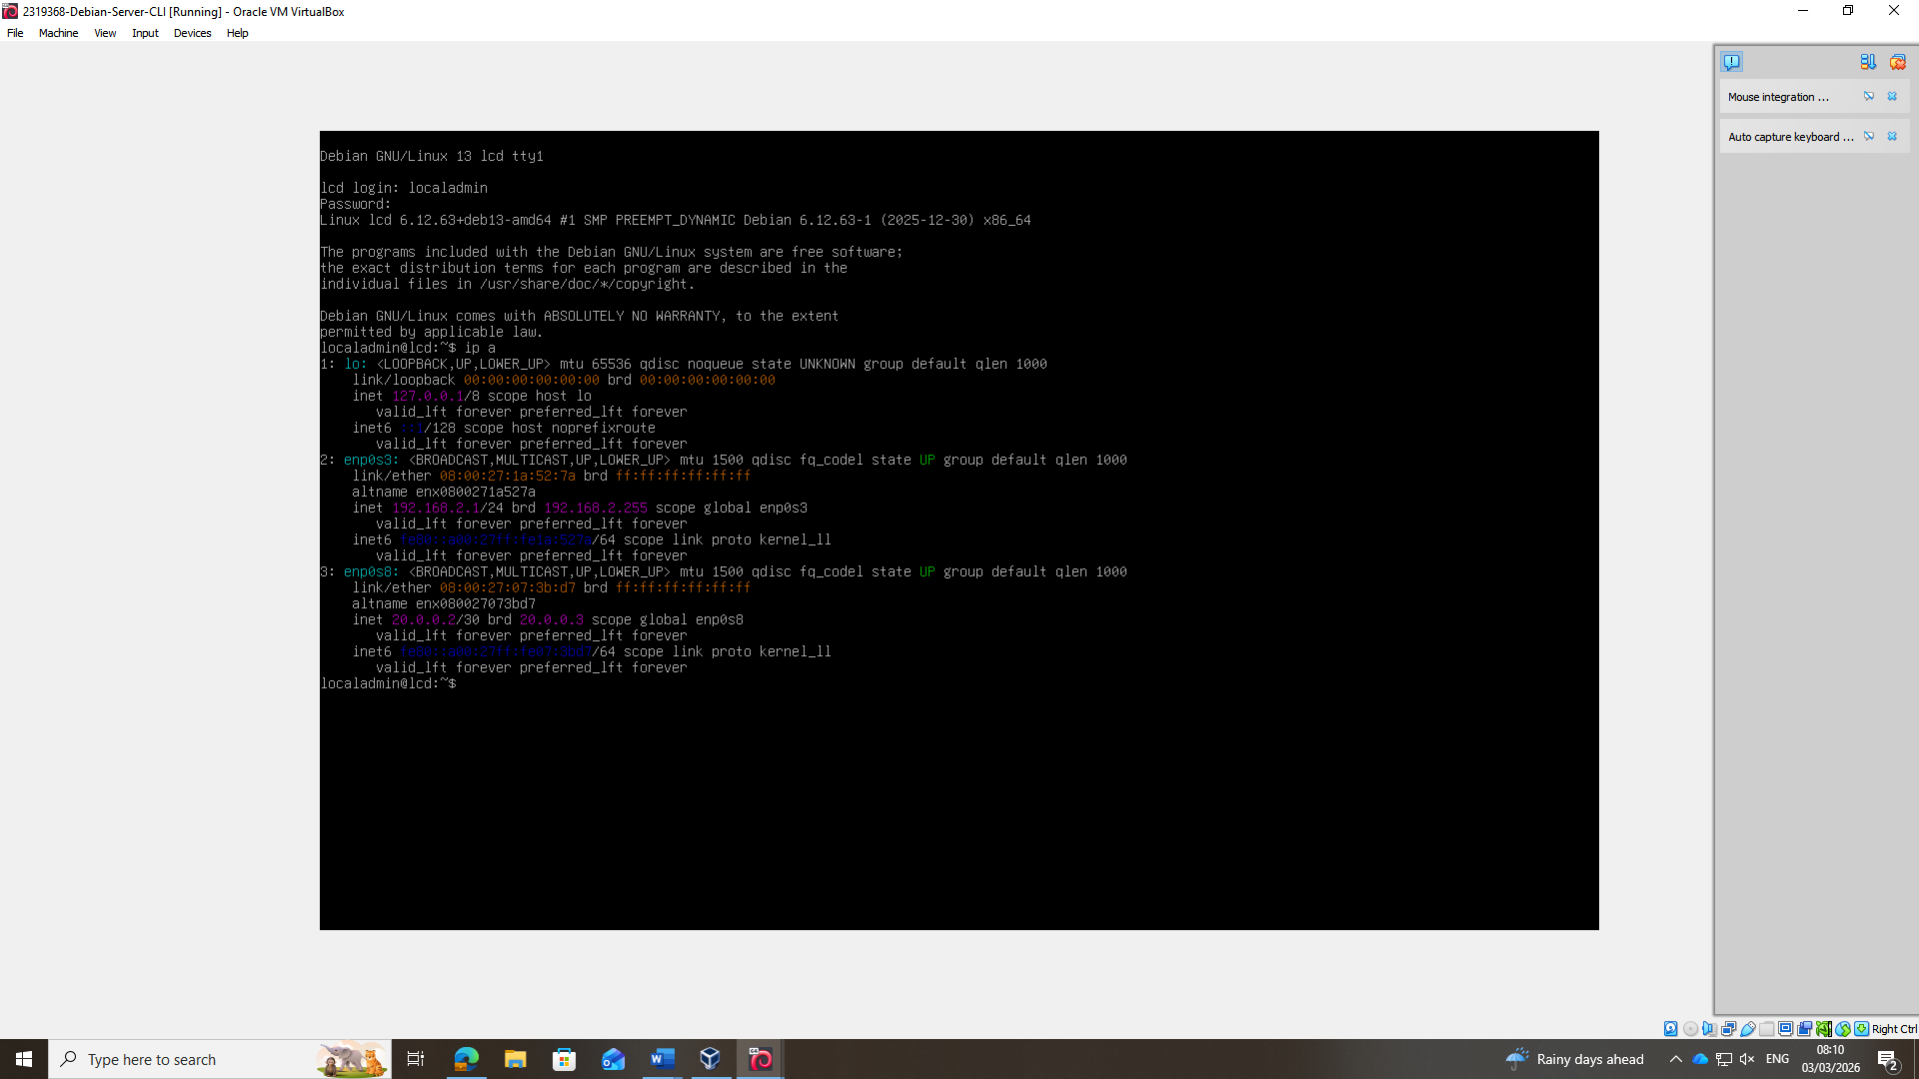

Ping connectivity tests

Successful ping (Debian GUI Client)

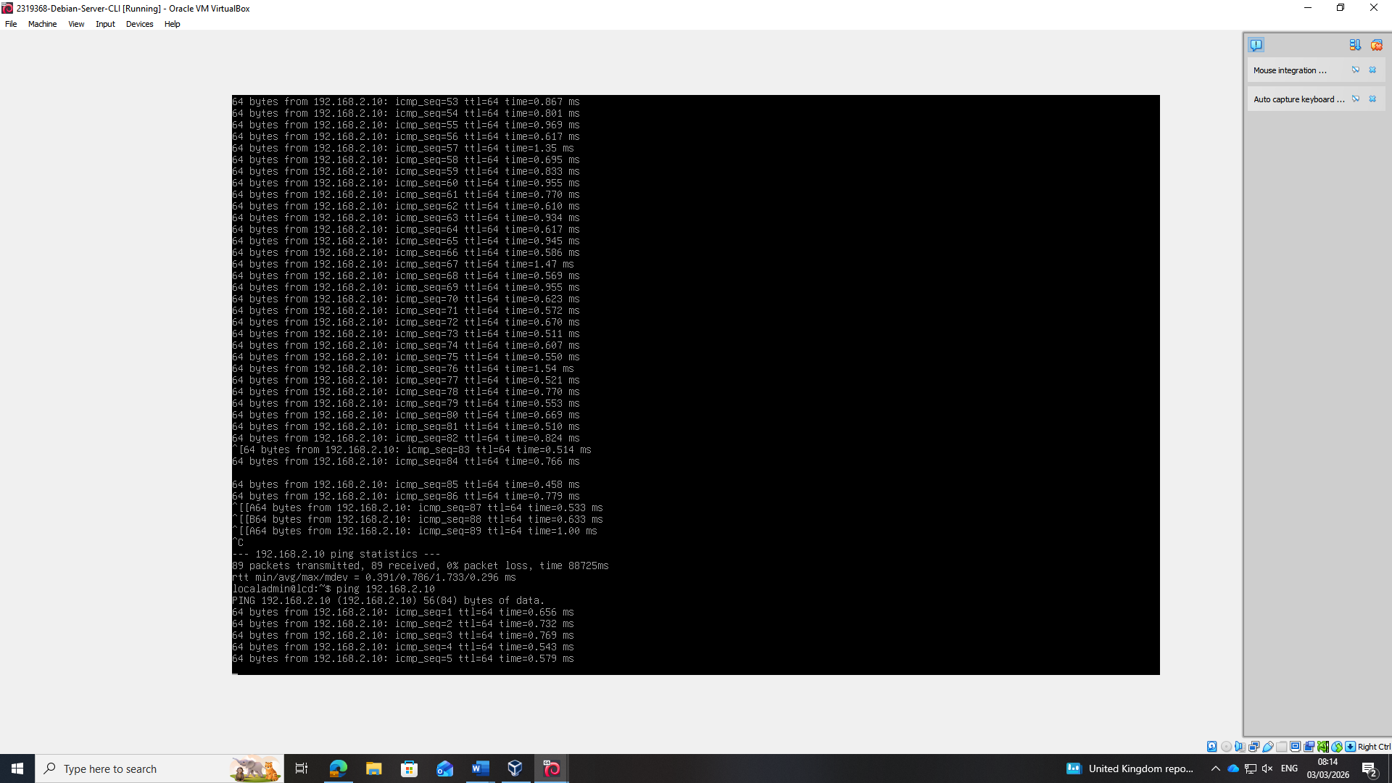

Successful ping (Transit)

Windows Server can successfully ping Debian

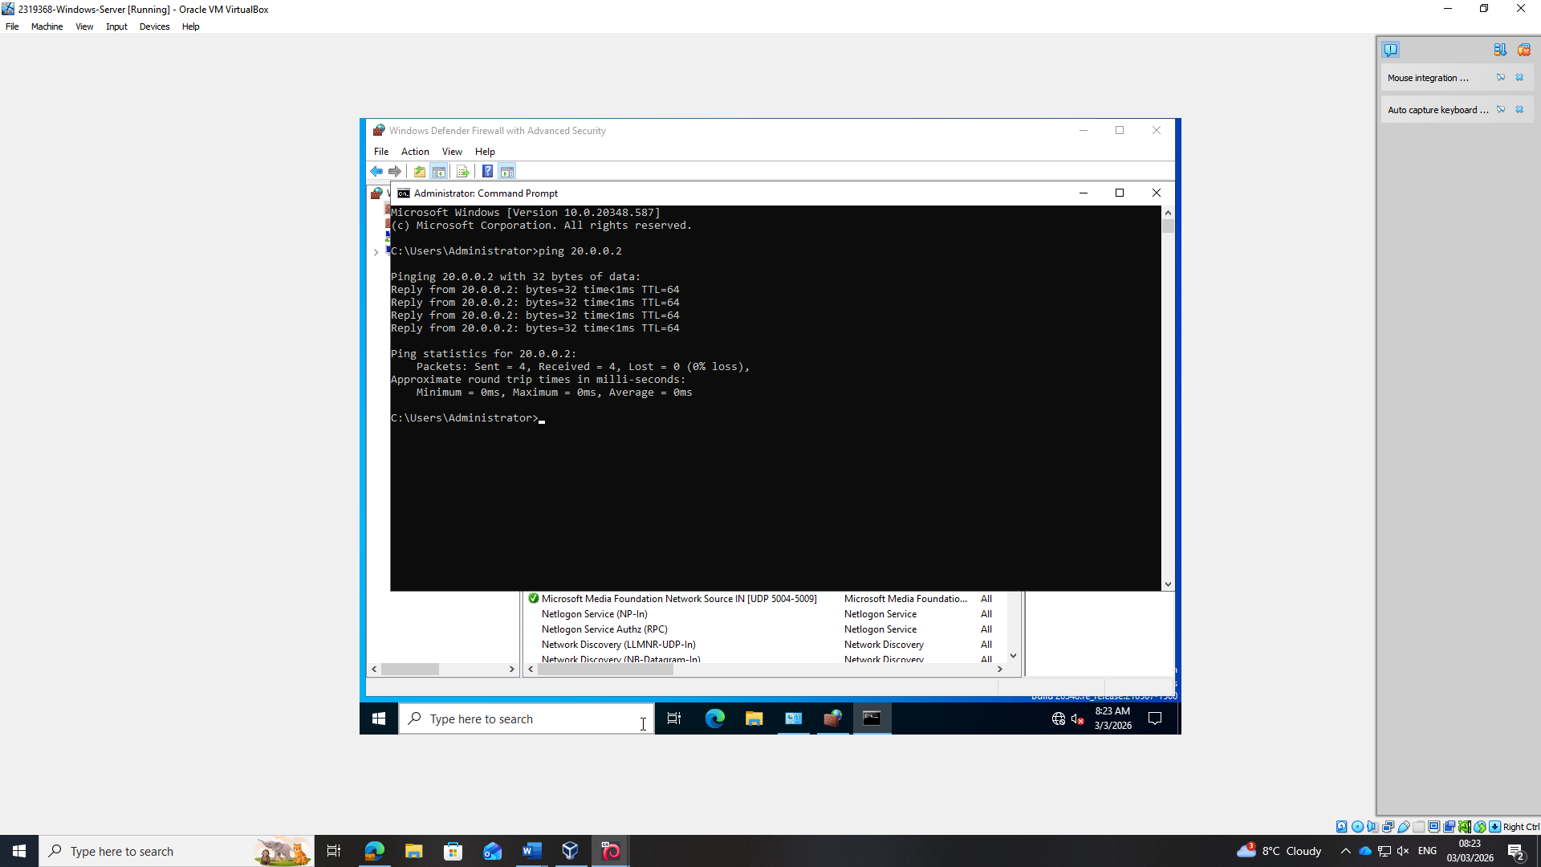

Successful Transit! Debian is pinging Windows Server

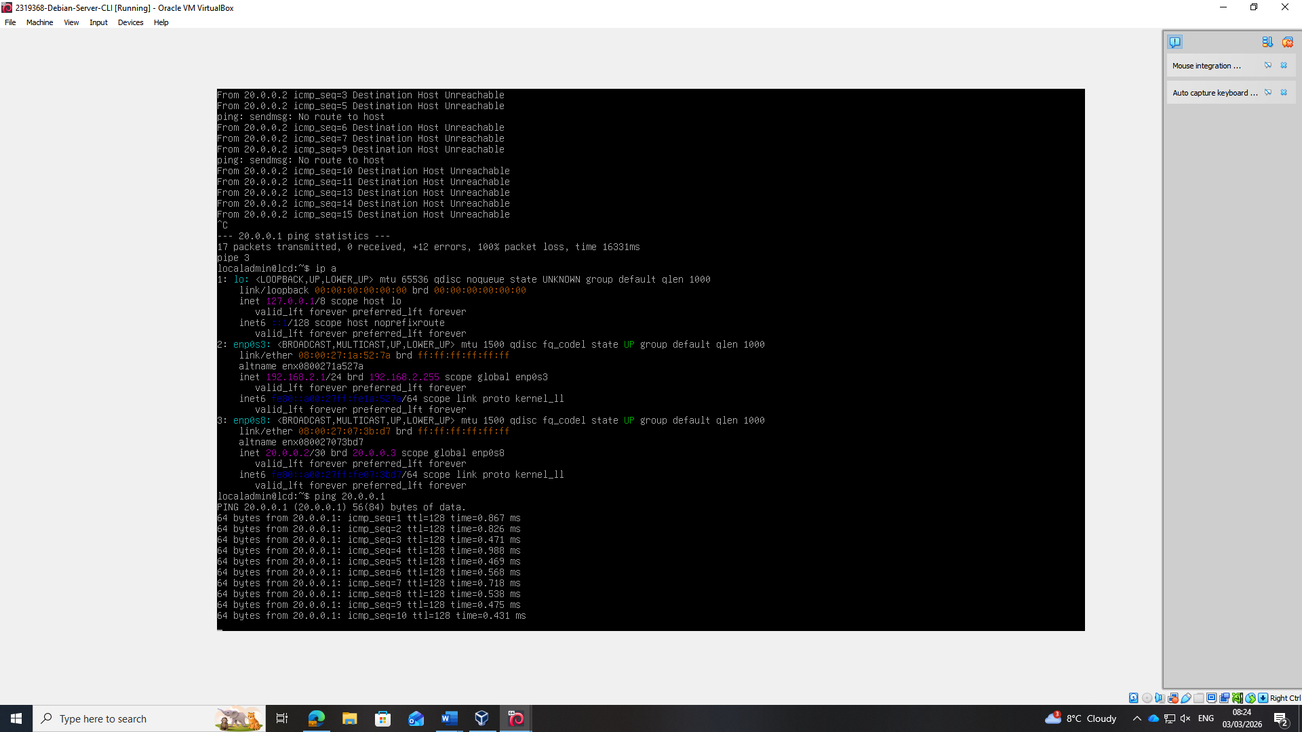

Intentional Failures

Failed ping 192.168.1.1 & 192.168.1.10
Intentional Failures (192.168.1.1) and (192.168.1.10) should fail as devices inside the same network can talk but devices in DIFFERENT networks cannot

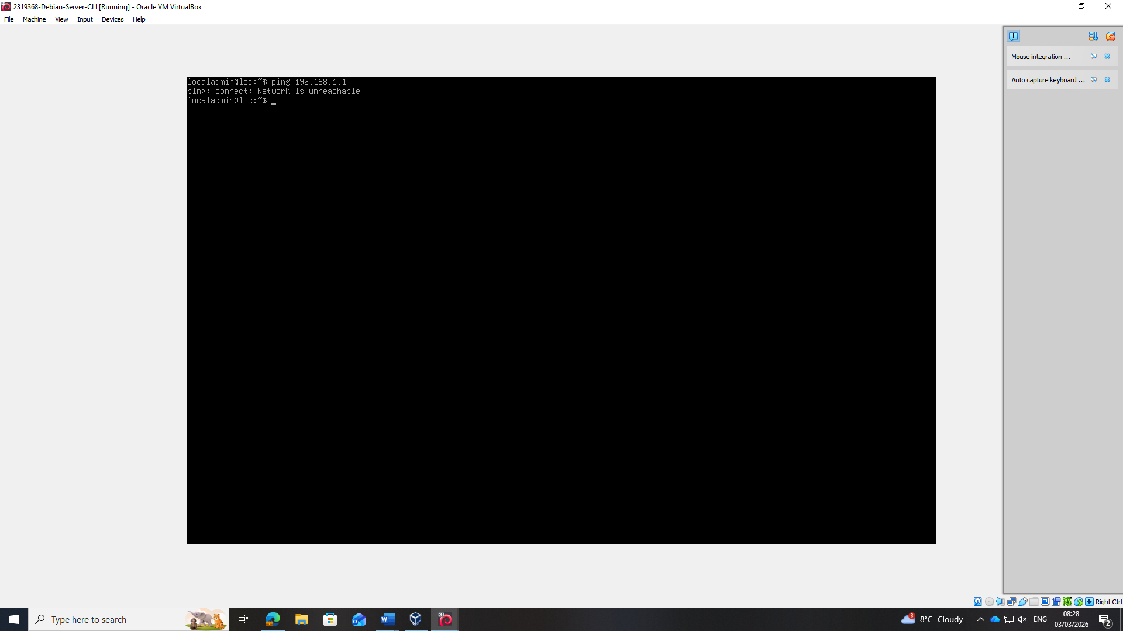

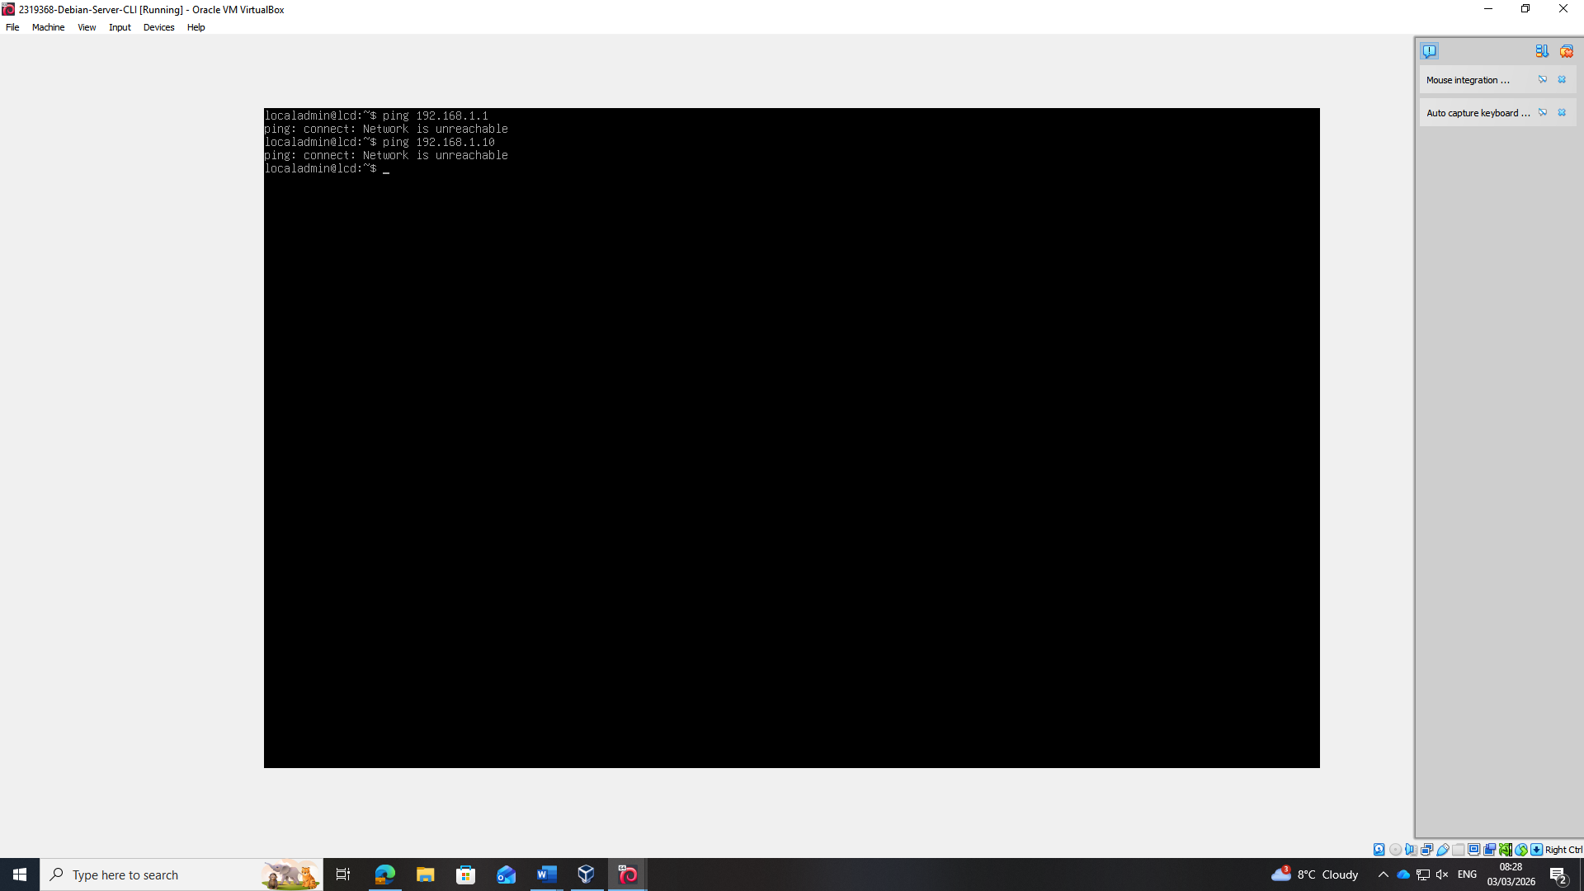

Debian Client GUI

Installation (showing as this was difficult for me)

Debian Client Machine Configured.

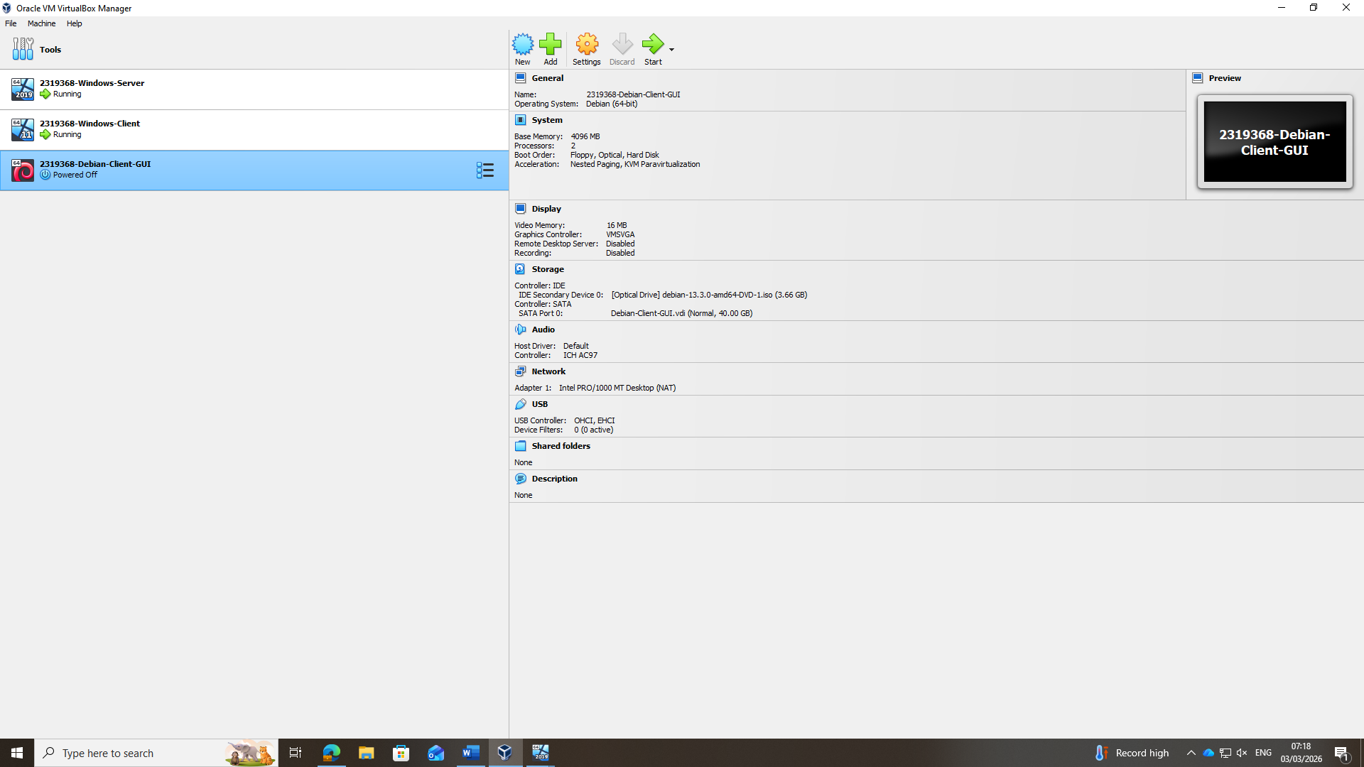

Unticking Live CD/DVD
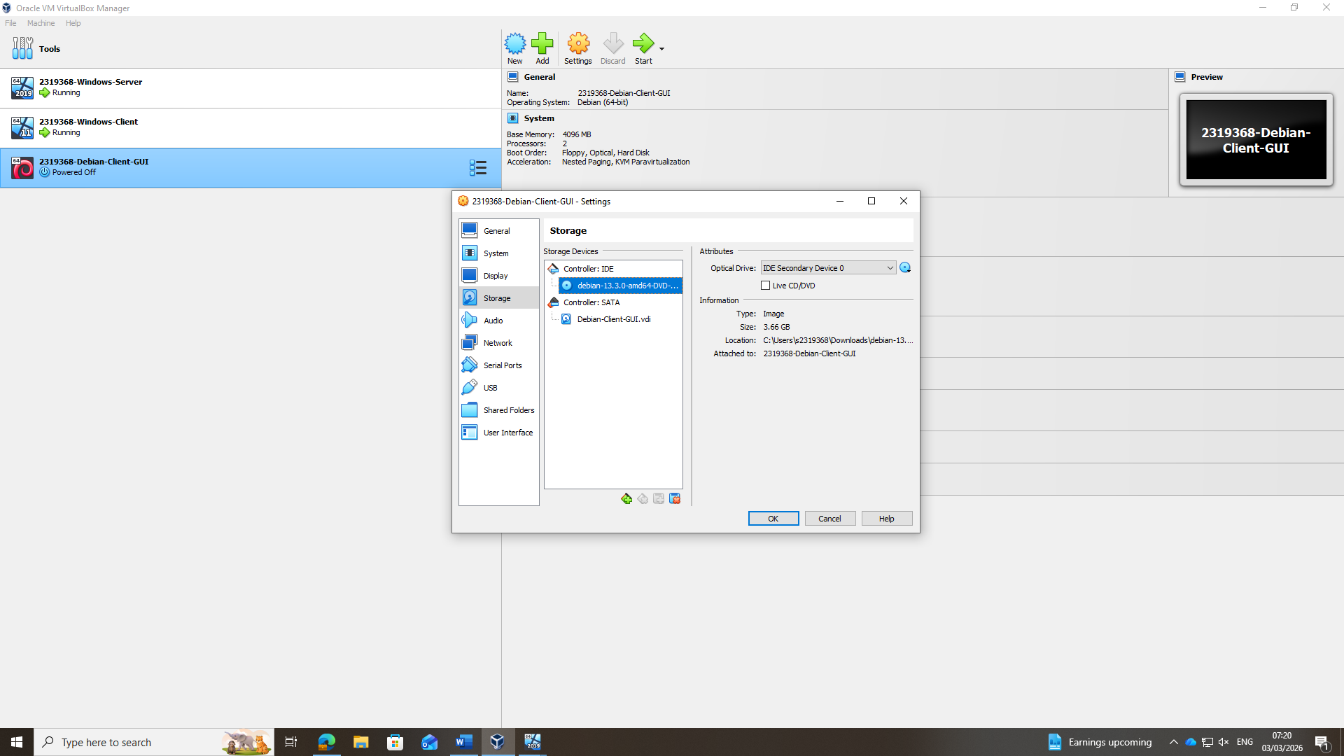

Naming client2 as windows client is client1
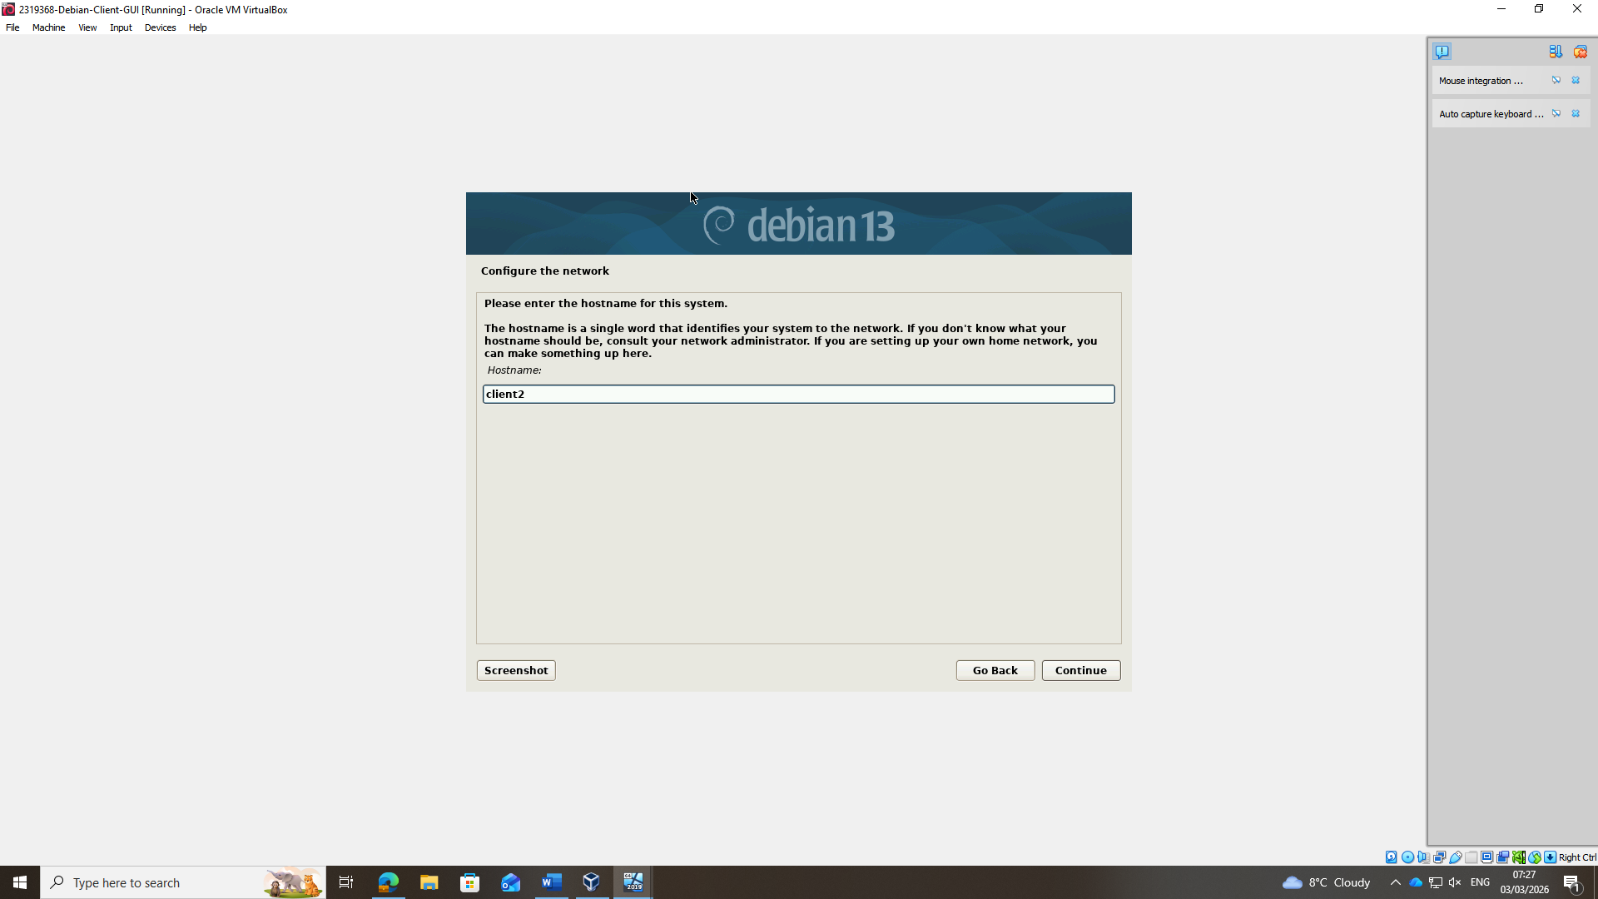

Installing base system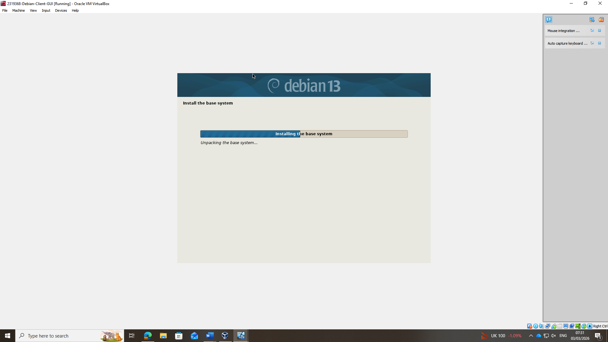

Installing!

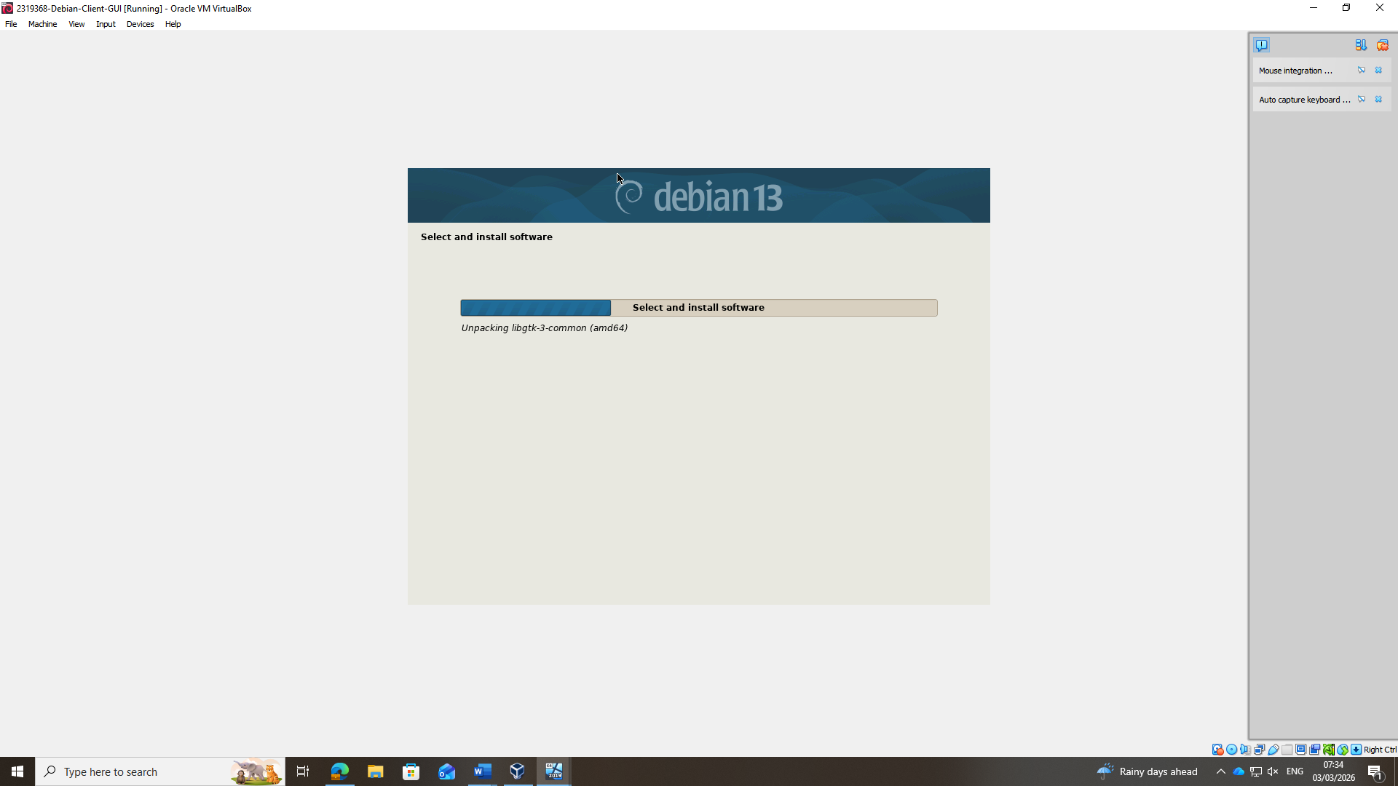

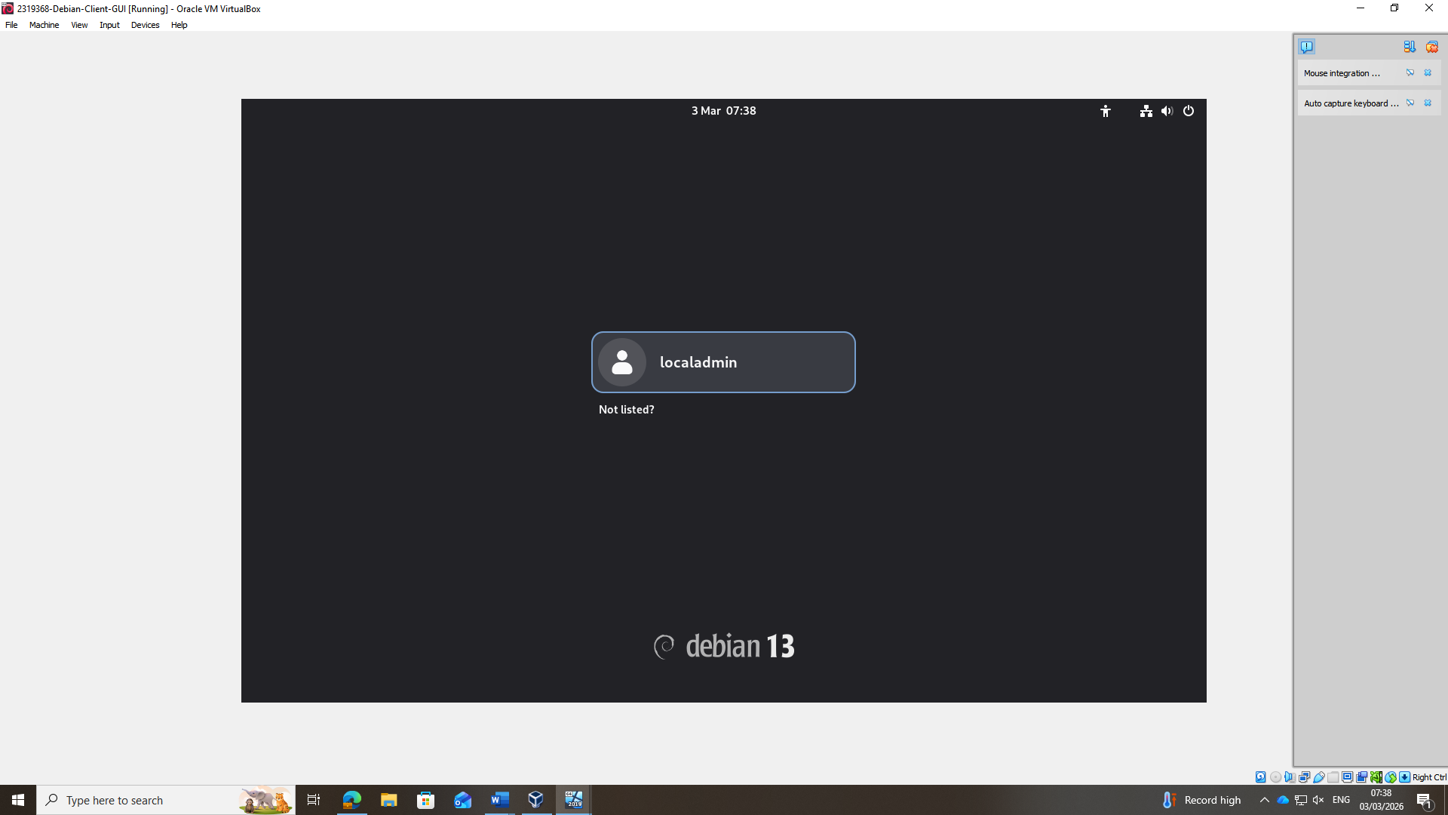

VM Network Adapter Settings

Network Configuration
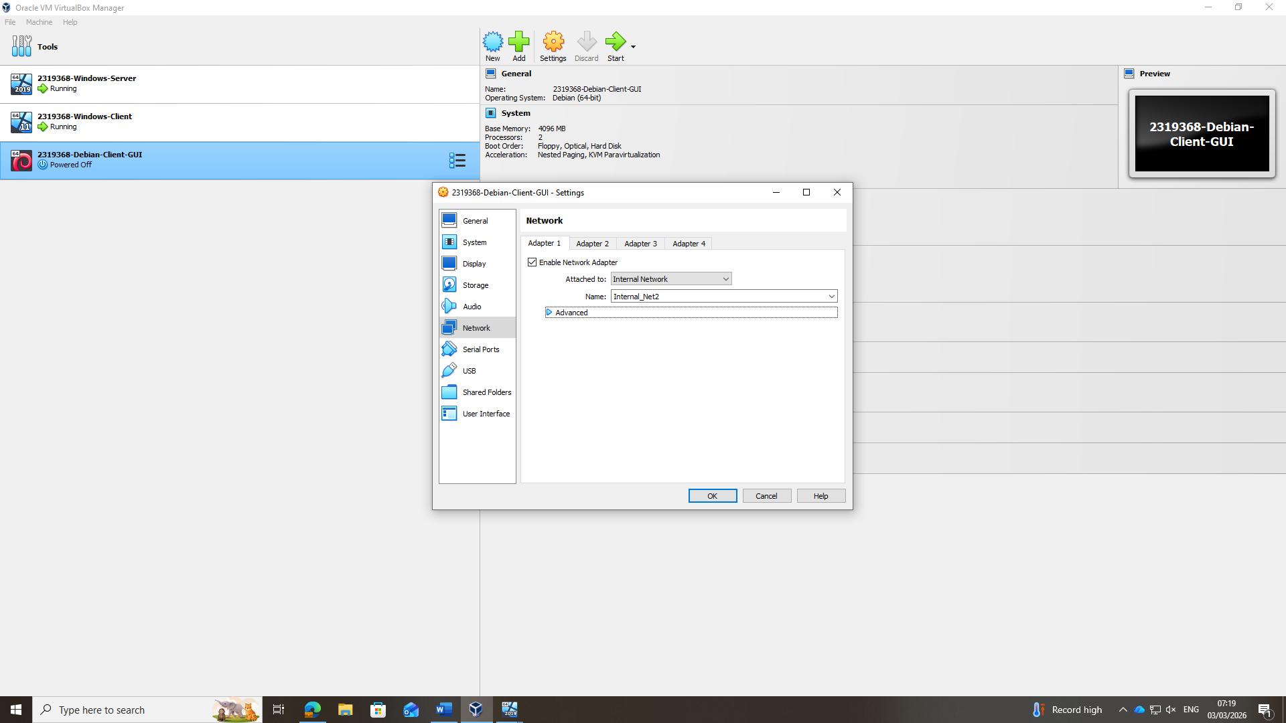

Debian GUI – Set static IPv4 Address (192.168.2.10)
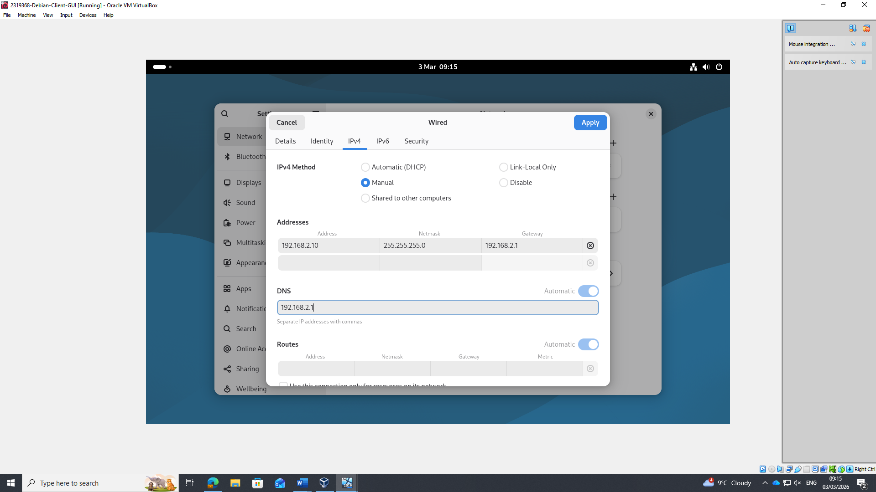

Successful Ping to Debian CLI Server
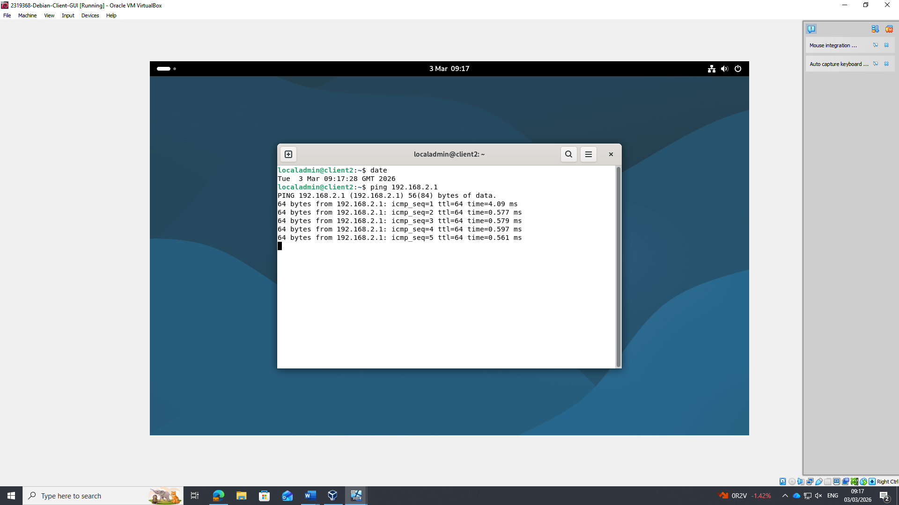

Windows Network Ping Failures
I expected to see “Destination Host unreachable” but for some reason it kept crashing. I researched this and it’s common behaviour.
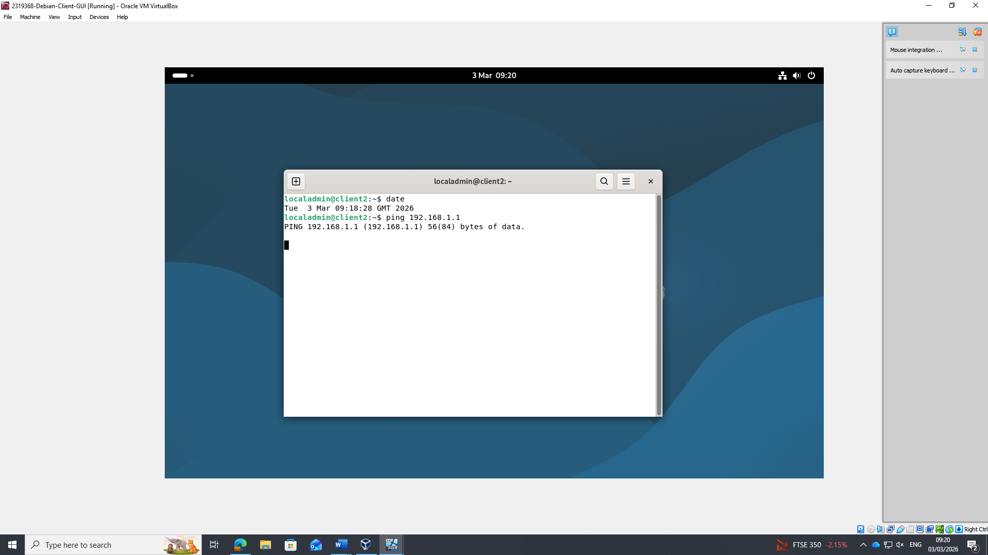

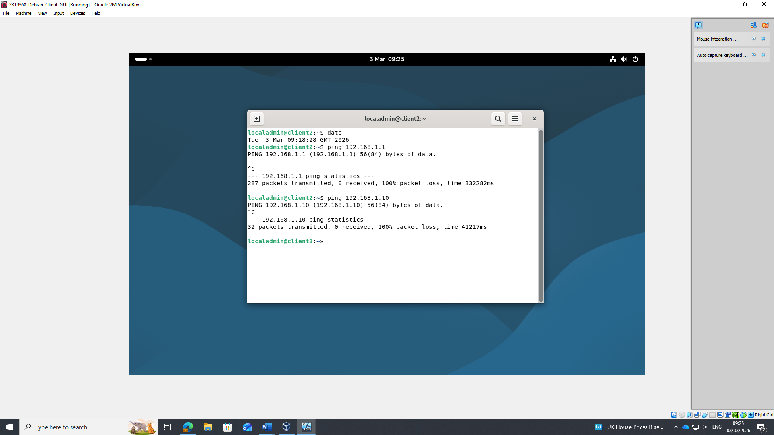

Confirming correct Linux Network Configuration
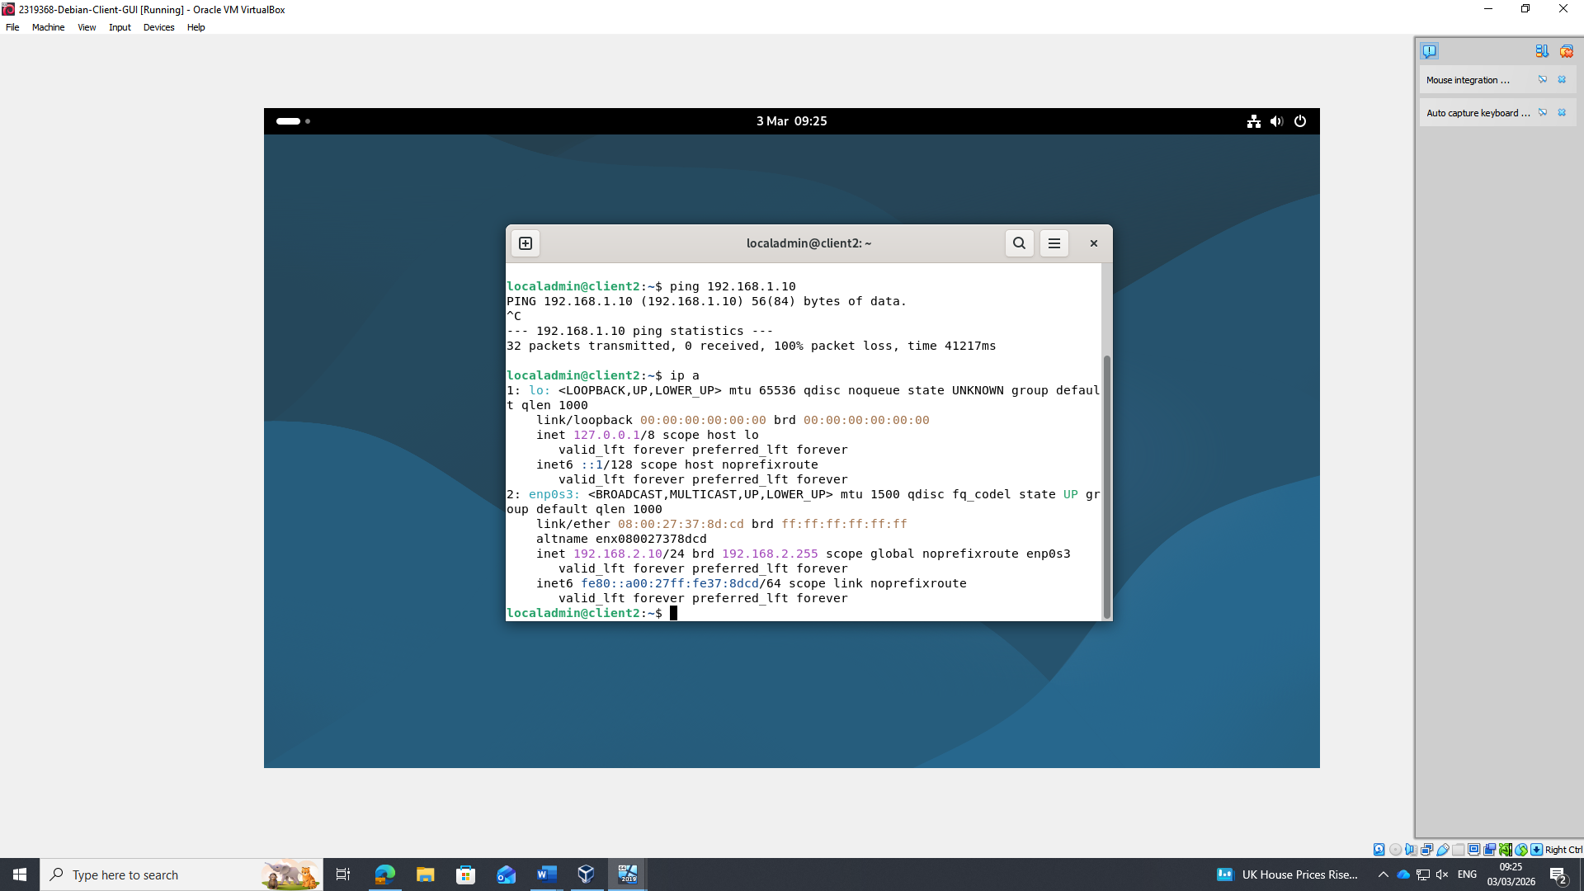

Task 3 Reflection

Technical Reflection
Throughout this project, I developed a stronger understanding of virtual network operation and the ways in which different operating systems communicate within isolated environments. The configuration of the Windows Server, Windows Client, Debian command-line interface system and Debian graphical interface system provided practical experience in IP addressing, internal network design, static routing principles and the network segmentation mechanisms used within VirtualBox.

A key technical element involved correctly configuring each network interface card and observing system behaviour in the absence of routing. This process clarified the concepts of subnetting and network isolation.

Head scratchers
Several challenges occurred during the build. The Debian CLI system presented the most difficulty, as Debian 13 employs different default networking components. As a result, initial attempts to configure IP addressing using expected tools were unsuccessful. Identifying the absence of systemd-networkd and NetworkManager, and subsequently resolving the issue through the traditional /etc/network/interfaces method, demonstrated the flexibility of Linux networking. Another notable issue involved the Windows Server machine, which did not respond to ping requests until the ICMP firewall rule was enabled. Although the adjustment was straightforward, it highlighted the influence of multiple layers on host connectivity.

Personal Reflection
Completing the overall topology was a rewarding process. Each system began as a blank environment and was developed into a functioning multi-network configuration that permitted both successful and intentionally unsuccessful connectivity tests. The project improved my confidence in troubleshooting, documentation and understanding real network behaviour. Overall, it strengthened both my technical skills and my ability to remain patient when resolving unexpected problems.

Bibliography
[1]
D. Pousa and J. Rufino, “Evaluation of type-1 hypervisors on desktop-class virtualization hosts,” Bibliotecadigital.ipb.pt, 2017. https://bibliotecadigital.ipb.pt/entities/publication/0dea68a5-aadc-4036-a478-0db5645b2935 (accessed Jan. 27, 2026).
[2]
A. Desai, R. Oza, P. Sharma, and B. Patel, “International Journal of Innovative Technology and Exploring Engineering (IJITEE),” Hypervisor: A Survey on Concepts and Taxonomy, vol. 2, no. 3, Feb. 2013, Accessed: Jan. 27, 2026. [Online]. Available: https://wanivipin.wordpress.com/wp-content/uploads/2016/11/hypervisor.pdf
[3]
D. T. Vojnak, B. S. Eordevic, V. V. Timcenko, and S. M. Strbac, “Performance Comparison of the type-2 hypervisor VirtualBox and VMWare Workstation,” 2019 27th Telecommunications Forum (TELFOR), vol. N/A, no. N/A, Nov. 2019, doi: https://doi.org/10.1109/telfor48224.2019.8971213.
[4]
Z. Hamid, S. Daud, I. S. Abd. Razak, and N. Abd. Razak, “A Comparative Study between IPv4 and IPv6,” ANP Journal Of Social Sciences And Humanities, vol. 2, no. 1, pp. 68–72, Feb. 2021, doi: https://doi.org/10.53797/anpjssh.v2i1.9.2021.
[5]
P. Foremski, D. Plonka, and A. Berger, “Entropy/IP,” Proceedings of the 2016 Internet Measurement Conference, vol. N/A, no. N/A, Nov. 2016, doi: https://doi.org/10.1145/2987443.2987445.
[6]
A. Amer, “Comparison study between IPV4 & IPV6,” ; Mahebourg, vol. 9, no. 3, pp. 314–317, 2012, Available: https://www.proquest.com/scholarly-journals/comparison-study-between-ipv4-ipv6/docview/1030094256/se-2?accountid=130472
[7]
G. Thomas, “The Extension,” Introduction to Subnetting, vol. 1, no. 8, pp. 1–4, Oct. 2000, doi: https://doi.org/N/A.
[8]
GeeksforGeeks, “Classes of Routing Protocols,” GeeksforGeeks, May 2018. https://www.geeksforgeeks.org/computer-networks/classes-of-routing-protocols/
[9]
NordVPN, “What is a VPN? Virtual private network meaning,” NordVPN, 2026. https://nordvpn.com/what-is-a-vpn/?srsltid=AfmBOoqwzLhRbNbQD-qkHXw_kiaR-Qlluz8rF_pOIjY-muzLTcI891lv (accessed Feb. 10, 2026).
[10]
A. K. Rajput, R. Tewani, A. Dubey, and BVCOE, New Delhi, “The helping protocol ‘DHCP,’” Ieee.org, 2016. https://ieeexplore.ieee.org/stampPDF/getPDF.jsp?tp=&arnumber=7724340&ref=aHR0cHM6Ly9pZWVleHBsb3JlLmllZWUub3JnL2Fic3RyYWN0L2RvY3VtZW50Lzc3MjQzNDA= (accessed Feb. 10, 2026).
[11]
Microsoft, “Active directory domain services overview,” Microsoft, Mar. 11, 2025. https://learn.microsoft.com/en-us/windows-server/identity/ad-ds/get-started/virtual-dc/active-directory-domain-services-overview (accessed Feb. 10, 2026).
[12]
M. Abolhasan, T. Wysocki, and E. Dutkiewicz, “A review of routing protocols for mobile ad hoc networks,” Ad Hoc Networks, vol. 2, no. 1, pp. 1–22, Jan. 2004, doi: https://doi.org/10.1016/s1570-8705(03)00043-x.
[13]
GeeksforGeeks, “What is Routing?,” GeeksforGeeks, Dec. 11, 2023. https://www.geeksforgeeks.org/computer-networks/what-is-routing/

