

Birmingham Campus

STUDENT NAME: PADAM BAHADUR SHAHI
STUDENT NUMBER: 1711132
PROGRAMME: BA (Hons) MANAGEMENT AND LEADERSHIP SKILLS FOR THE WORKPLACE
MODULE: BMSW5005- WORKPLACE CULTURE AND ITS IMPACT ON ORGANISATIONAL EFFICIENCY
GROUP: 2
LECTURER: ERIC OSEI

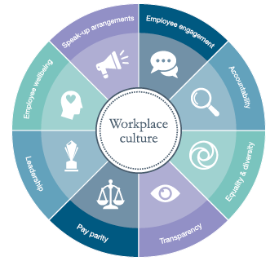

Executive Summery:

In this management report, you will find how workplace culture impacts on organisational efficiency. You will also find external environmental analysis using appropriate tool PESTLE and internal context analysis using McKensy’s 7s framework tool of the organisation.
This academic report will assess the context and workplace culture of Tesco UK. Further it will evaluate an organisation within its broader environment using appropriate environmental and organisational analysis technique using. In the end report will highlight cultural and ethical behaviour present in Tesco UK.

Table of Contents
2
Introduction: 4
4
The External/Macro Environment Of Chosen Company Tesco UK using Tool PESTEL: 5
Elements, Elaboration and Implication of PESTEL in context of Tesco UK. 5
Political Environment: 5
Economic Environment: 5
Technological Environment: 7
Environmental/ Ethical Environment: 7
7
Legal Environment: 7
McKensy’s 7S Model: 8 8
Strategy: 8
Style: 9
System: 9
Staff: 9
Skills: 9
Shared Values: 10
Implication and Discussion of Ethical Stance at Tesco: 10
Business Culture: 11
Elements of Culture: 12
Tesco and Siemens- a comparison of workplace culture: 12
My Recommendations: 13
13
Conclusion: 14
14
Reference: 15

Introduction:

Workplace culture is the way that things are done in an organisation; It is an unwritten rule that which influence individual and group behaviour and attitudes. Understanding workplace culture is very important for an employee; it can help him or her to be in a better position and achieve their goals if they understand culture of their organisation.

Workplace culture is the concept of managing and doing things around the workplace. Most of the times it is based on values, traditions, policies, beliefs and attitudes of the workers and employers. “It is very crucial for the organisations to make the workplace a more diverse and inclusive environment where everyone feels comfortable, regardless of gender, race, sexual orientation, ability and background” (Glavin, 2018).

The External/Macro Environment Of Chosen Company Tesco UK using Tool PESTEL:

PESTEL Analysis is a tool utilised to assess the macro environmental factors of the company. This comprised on the Political, social, economical, technological, legal and ethical factors of the company (Kefalas, 2012). The external environment is an aspect that requires maximum attention especially by those multinational businesses that are intending to be efficacious in the market (Berkhout, 2012). In this report, we will have a more profound look at the impact of the global organizational environment on Tesco Plc. in UK. Tesco is UK’s multinational general merchandise retailer founded by Jack Cohen in 1919 (The Guardian, 2010). Their headquarters are based in the United Kingdom but has opened stores in many other countries across Europe and Asia. The company has become geographically diversified, and it has dominated the market in the grocery industry. It is also among the best-performing companies listed on the London Stock Exchange (Wearden & Graeme, 2010). Some researchers have argued that external environment imposes a big challenge for business and this has resulted in a decision of UK pulling out from the European Union (Brexit). UK has formally voted to split itself from EU, and the decision has imposed an economic crisis. The pound is getting annihilated since Brexit (Brinded, 2016).

Elements, Elaboration and Implication of PESTEL in context of Tesco UK.

Political Environment:

Political factors are the elements affecting the business operations due to the dynamism in the government policies and procedures (Choucri, 2013). These factors have different importance for both local and international businesses. Political arena imposes significant influence due to the government regulations as well as the political stability in the country (Harrel & Vukmanic, 2014). Companies that operate in the European Union including Tesco Plc. Are expected to abide by the regulations and directives created by the European Union. The political environment facing multinational enterprises is directly affecting businesses. Most companies have taken the rules enforced by European Union as a challenge to their operations to the extent of some of them withdrawing from the union such as Brexit. Similarly, political crises are common in various countries, and they directly affect operations of businesses.

Economic Environment:
It constitutes the changes global economy that directly or indirectly influences the business operations. A rise in the general economic status and the living standards provide favourable opportunities for businesses to make more revenue. The economists have advocated that positive fluctuations in economic activities offer the consumers with higher purchasing power. It creates an excellent opportunity for the business to boost their sales due to the increased demand for goods and services. The economic elements influencing business operations the changes in the interest rates, exchange rates, inflation, the balance of payment, wage rate as well as the GDP in the countries. For example, Tesco Plc. is an international company operating in various countries with different currencies. Therefore, the business performance is always affected by the exchange rates fluctuations. A loss in value of the Pound compared to other currencies experienced during the great recession is a good example of social factors affecting businesses. During that period, the imports became more expensive while exports lost their value. Consequently, most businesses reported operating losses in consecutive financial years during the period.

Social Environment:
The social factors comprise the changes in the social structure that may affect the consumer behaviour. Elements such as; age, gender, religion, language lifestyle and social class of the population have a great influence the buying pattern in the businesses. Understanding of the population in the foreign market imposes a challenge to international companies. Those who manage to develop strategies that are in line the social structure in both foreign and local firms are more advantageous in the industry (Wearden & Graeme, 2010). The social environment is as important as competition aspect in the business. Pricing strategies are one of the primary tools used by companies in addressing the social structure. Low living standards deny consumers a purchasing power and hence the firms’ sales reduce drastically. Consequently, businesses report huge operating loses whenever the consumer buying behaviour is unfavourable. For instance, take an example of a business in the port industry. A ban on pork meat by a particular religion that dominates the pork market will automatically result in a big loss to the firms in this industry. Another example could be change in the people’s beliefs that could influence the decision-making process of the business.

Technological Environment:

Technological changes have a significant influence on the business strategies (Teriba, 2010). It provides an opportunity for adopting new inventions and innovations. Application of modern technology reduces the operational costs for the businesses. Organisations seek to consider the latest and relevant technological aspect to stay competitive in the industry (Greenbank, 2016). Advanced technology boosts the information system and facilitates database management in the business. Use of Internet and technology has helped Tesco Plc. in increasing their market share through online marketing. For instance, Online selling helps the customers in saving time for shopping as they order from wherever they are and goods reach them at a low cost. The company also reduces the cost of selling, and it is capable of reaching broad market coverage. Another good example of technological changes is evidenced on the phone industry. Advancement in technology always creates new market of smartphones.

Environmental/ Ethical Environment:

It is very crucial for the Companies to be responsible for community and environment. Tesco is taking responsibility to provide some benefits to the community. Tesco has decided to reduce the carbon imprint by 50% by 2020. A good example of the ethical factors is the organizational culture. For instance, an organization that upholds democratic leadership will have to take into account the opinion of all the stakeholders before executing any decision made. Employees in various organisations are rewarded to create incentive to them to foster and maintain organisational ethics (Haque & Ali, 2016).

Legal Environment:

Legal forces refer to the government regulation and legislation. Different countries have got a different legal framework. Government policies have a substantial impact on the organisations through regulatory bodies. In each state, independent institutions are established to oversee the operations of every business and ensure compliance with the law. The business management needs to have a clear understanding of the legal environment in the country they are operating. In the recent years, the UK has been experiencing significant constitutional changes that some of them have direct impact on the businesses. Some of these provisions may include; tax provisions, trade barriers, Labour Act, price ceiling, the banning of some products, etc. (Norman, 2016). Taking an example, the government of Kenya recently banned the use of nylon bags the country. Tesco Plc. Is one of the companies offering products and services to Kenyan market are forced to ensure repackaging of their products to avoid being victims of the ban.

McKensy’s 7S Model:

The McKensey 7S model helps in assessing different organizations and departments. In this case, we analyse the Tesco Plc. After reviewing the Tesco Company, the 7S framework will help in understanding the various components. Different components such as the strategy, style, staff, skills and shared values help in building a stable organization. The different aspects that we approach these main components will help in knowing how to move forward and minimise the challenges we face.

McKensy’s 7S in the context of Tesco:

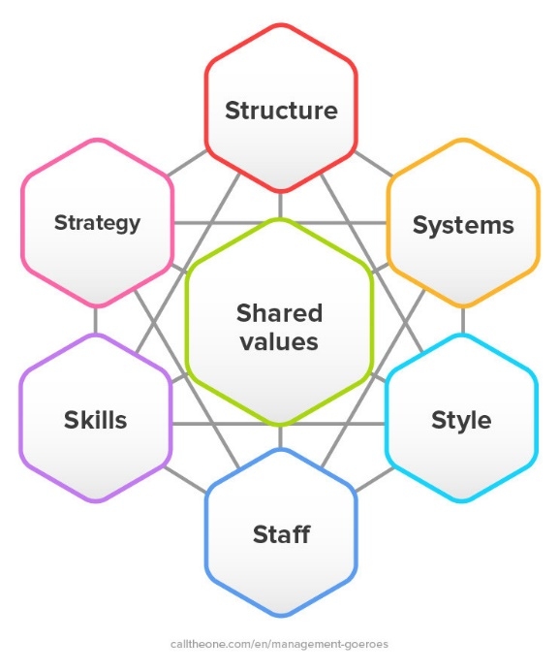

Strategy:

Tesco is the leading retailer internationally. The company has to make sure that it has a strategy and order to make sure that it achieves its objectives. Strategies are subdivided into smaller sub-strategies such as the operational strategy, which helps in the pushing the organisation forward. It will help in improving consumption and revenue earned as well. Business strategy is another sub-strategy where Tesco aims to provide its customers with the drinks they require. Aligning the workforce strategy with the business strategy is essential. Tesco aims at embracing diversity and the views of different people. By ensuring that the human resource strategy aligns with the business strategy makes it possible for the company to achieve its goal.

Style:

Generally, the style of management that a company uses is vital in motivating the employees. There are three different types of management, which include; autocratic, laissez-faire and democratic management styles. Tesco uses the laissez-faire style of management. Laissez-faire management is where the leader avoids giving many instructions to the employees. Employees can connect and share their interests. To some extent, this style of management has motivated the employees towards working.

System:

The challenges that Tesco face may be a problem for the management style that they use. This style of management has many disadvantages such as exploitation from employees, and in the case of a problem that needs a fast reaction, this style of management will most probably fail. Despite this being their style of management, it does not always work correctly for them.

Staff:
Tesco, being an international company, aims at providing products to customers all around the world. The company has been growing, and in recent years it has remained at the top in the industry. The company has around 450000 employees worldwide. In comparison to the services that the employees have to offer, there are an appropriate number of employees to. However, for the company to keep growing and realise its long-term goals, there is the need to add more employees. In the case where there is a shortage of employees, the company has an easy time recruiting its employees. It is because the company upholds career growth as well as the service to its customers. How different employees relate to each other helps in their career growth as well as incorporating new employees into the company. The style of management that Tesco has provides an excellent opportunity for recruiting new employees efficiently.

Skills:
Tesco has set standards that it requires its employees to observe at any time while performing different tasks. Such is the culture that has been set by the company. As an employee with Tesco, you have to ensure that you are as productive as expected of you. Tesco has clear information concerning what an employee has to observe to improve the company. It is the employee who has the mandate to make sure that their interests align with those of the organisation. Currently, Tesco has the required competencies for its staff. A clear indicator that the company has employees with the skills necessary is the clear indication concerning the progress of the company with time. It is a company that has seen its long-term plans comes to reality. The company has enjoyed the chance of overpowering its competitors, increased its productivity, which means more profits.

Shared Values:
Employees need to have similar values to those of the organisation. It is necessary to ensure that every person in the company is on the same page, thus making it easy for the organisation to operate and achieve its goals. Tesco has indicated values, mission and vision statements as well. These statements guide the employees. The norms are crystal clear ensures that all employees understand what the company requires of them. Issues such as embracing diversity, quality, passion and integrity are among the norms that the company expects its employees to observe. In this case, the employees will surely have the organisations norms in their minds. There are many ways that we can improve the continuity of the organisational norms. One of the methods is through ensuring they are written in the organisation for employees to keep it in mind. Through this means, even the newly recruited employees read the statements, thus ensuring continuity of the norms. Secondly, making sure that after some time the company does remind the employees during meetings helps in enhancing the continuity of norms. Having an institutional culture is essential in making sure that the company is stable in how it operates. Holding on board training will ensure that the organisations standards are always fresh in the minds of the employees.

An analysis of the Tesco’s ethical stance:
Ethics is having a set of principles that determine right and wrong. Ethics show moral principles that can lead up to the best or worst individual core values. Ethical behaviour demonstrates: honesty, diversity, discipline, equality, and individual rights. Ethical environment constitute the companies mission, vision goals and objectives as well as the keys to success. A change in the ethical elements of the business may influence the decision made by the firm. “ Ethical is the one of the element that organisations view as protocols” (Gupta, 2016).

Implication and Discussion of Ethical Stance at Tesco:
A good example of the ethical factors is the organisational culture. For instance, an organisation that upholds democratic leadership will have to take into account the opinion of all the stakeholders before executing any decision made. Employees in various organisations are rewarded to create incentive to them to foster and maintain organisational ethics (Haque & Ali, 2016). Relevant law has been put in place to govern the organisational ethics. The law prohibits firms from carrying out illegal transactions such as money laundering of the sale of banned products. If most employees at Tesco portray ethical leadership, then they are the ones that do the right thing. When no one is looking and have a sense of ownership for their employees and company. Leaders that tend to be exceptionally diverse show mutual respect for all organisational beliefs and positive can do attitude.

When we talk about Ethics with respect to a firm or company, there are 5 core principles. First of all, there is beneficence, which is the idea that people should always provide help to other people. Secondly, Non maleficence, people should avoid causing harm to others. Next, Autonomy, people should be free to make their own choices. Justice, people ought to give others what they are due to operate with fairness. Lastly, responsibility, people have certain expectations of themselves, which they expect in return from others. Tesco can be analysed in terms of whether they follow these principles or not. In many ways Tesco follow these ethical principles. However there is some past incident, which they missed to do so. For example they didn’t have same pay for everyone, it was decided by their colour and gender.

Business Culture:
Business culture is defines as a set of various norms and accepted values within the organisation. The way of doing thing in the company is known as their culture. Organisational culture is the concept of managing and doing thing around the workplace. Most of the time it is based on values, traditions, policies, beliefs and attitudes of the workers and employers.

Elements of Culture:
Handy’s model of cultures in the company is the best tool to explain all the elements of culture within the company. According to this model there are four major type of organisational culture including role culture, power culture, person culture and task culture. Following is the explanation of all these types of cultures.

Handy’s Model of Culture
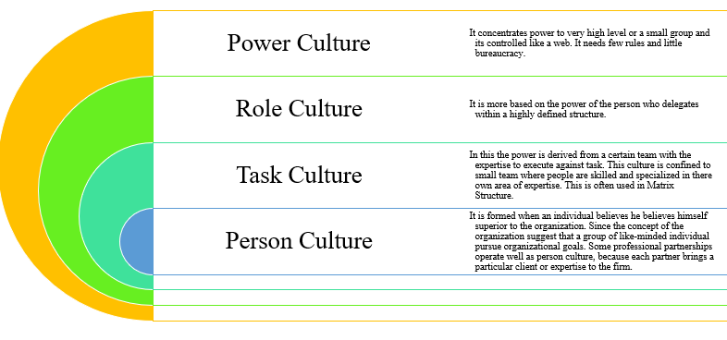

Tesco and Siemens- a comparison of workplace culture:

Tesco and Siemens are two of the most important names in UK retail industry.
The organisational culture is so much dependent on the structure of the company. The Siemen operates under mid-level management that operates as a flat type of company structure. Siemens encourages productive workers on merit basis that would ultimately discourage the culture of biasness on gender or religious bases. This allows skilled workers to be involved in the decision-making process. The organisational culture is low of low-level hierarchy. They promote the employees by decentralised decision-making process. The elimination of mid level management at Siemens promotes the feedback and comment of baseline by reaching in the notice of higher management. In this way the company follows the personal and task culture. This also allows the company the high performance. This allows various divisions in the same location.

However, the case of Tesco Plc. is a bit different in case of organisational culture. All the employees here are closely monitored and supervised in a narrow span of control. The company is manages by the managers for each division who are responsible for different employees under team. The system of Tesco is more internalised and that the really friendly to remote change. This particularly demonstrates the culture of role and power. Tesco has very clear and definite promotional ladder and reward system, which is a plus point.

My Recommendations:

Organisational culture sets the behaviours, attitudes, and perceptions that employees would have towards an organisation. It is one of the things that have a direct impact on organisational efficiency and it helps managers to execute there with ease. The more reason is that mangers have to play a role in creating an organisational culture that would help in creating an environment that would favour their leadership. From ancient days when the term organisational culture was first heard, it has proven to possess the ability to turn around even the worst organisational scenarios. It is a concept that keeps managers in control and guides the employees towards organisational goals achievement in a satisfactory manner. Moreover, organisational culture should also takes into consideration the needs and wants of employees hence making an organisation conducive for all stakeholders.

Tesco has realised making connection with the community, especially motivating and empowering children, would improve the company’s brand image and the public is likely to support such organisations by purchasing their products. I suggest that the company should not only talk about their community initiatives but also instead lead by their actions and truly improve the lives of others.

Conclusion:

The above analysis has revealed that external business environment is as important as competition environment. Most businesses have failed due to their inability to survive in the in the uncertainties in the global system. Some companies, which might be performing well in the domestic country, may fail to excel globally. It is essential for organisations to develop strategies for adapting to the environment of the foreign market. It is also critical for nations coming together to do businesses in collaboration to mitigate the trade barriers imposed by the organisational changes.

Reference:

- Berkhout, F. (2012). Technological regimes, path dependency, and the environment. Global Environmental Change, 12(1), pp. 1-4.

- Brinded, L. (2016). Britain is broken beyond repair and the worst is yet to come. Available at: https://www.businessinsider.com/brexit-eu-referendum-result-political-economic-and-social-analysis-and-whats-next-2016-6?r=US&IR=T , Accessed on: 02.10.2019.

- Choucri, N. (2013). Political Economy of the Global Environment. International Political Science Review, 14(1), pp. 103-106.

- GLAVIN, S., (2018). How To Create A More Inclusive Workplace Culture. Recognition and Engagement Excellence Essentials, .

- Greenbank, P. (2016). Starting up in Business. The International Journal of Entrepreneurship and Innovation, 7(3), pp. 149-159.

- Gupta, A. (2016). External Business Environment. Available at: http://www.practicalmanagement.com/Organization-Development/Organization-s/ExternalEnvironment.html. Accessed on: 25.10.2019.

- Harrel N. & Vukmanic, G. (2014). Bilateral Trade Relations. Proceedings of the Academy of Political Science. Vol. 34(1), P. 136-145.

- Haque, M. & Ali, I. (2016). Uncertain Environment and Organisational Performance: The Mediating Role of Organisational Innovation. Asian Social Science, 12(9), p. 124.

- Kefalas, A. (2012). Analysing changes in the external business environment. Planning review, 9(4), pp.26-46.

- Norman, K. (2016). The Business Environment of Organisations. Available at: https://www.moneyinstructor.com/doc/managementviron.asp , Accessed on: 19.10.2019.

- Teriba, A. (2010). The outlook of the Macroeconomic Environment of Business. LBS Management Review, 8(1).

- The Guardian, (2010). Company profile for Tesco. Available at: https://www.theguardian.com/sustainable-business/profile-tesco, Accessed on: 01.10.2019.

- Wearden, S. & Graeme, A. (2010). Tesco rings up record profit. Available at: https://www.theguardian.com/business/2010/apr/20/tesco-rings-up-record-profits-again
Accessed on: 01.10.2019.

