

LOCATION: Swansea | LLEOLIAD: abertawe
LEVEL 4 | LEFEL 4
EXAMINATION PERIOD | CYFNOD ARHOLIADAU
May 2025 | MAI 2025

MODULE CODE: ACDA4009
Signals and System

TIME: 2 HOURS

Equipment or materials required – None
Adnoddau neu ddefnyddiau sydd eu hangen -

QUESTION 1
- For function given below.
$$x(t)=\left\{ \begin{aligned}1, if t 1 \\ 0,Otherwise \end{aligned}\right.$$
- Identify the Signals x(t) and provide the name of the function. [2 Marks]
- Illustrate its graphical representation. [3 Marks]
- Apply the transformation y(t) = x(2t + 3) to the above function x(t).
[4 Marks]
- Show the effect of transformation by generating the graphs for effects.
[6 Marks]
- State and Briefly the effect of Time shifting Property. [5 Marks]
QUESTION 2

- Answer the following related to signals
- Identify the Signal and the function of
r$\left[n\right]=\left\{\begin{aligned}n, if 0≤n≤3 \\ 0, n=0\end{aligned}\right.$ [3 Marks]
- Sketch the above given function. [3 Marks]
- Find the Even signal $r_{e}[n]$ , and the Odd Signal $r_{o}\left[n\right]$ from the above given condition $r\left[n\right].$ [11 Marks]
- If $w[n]=r_{o}\left[n\right]$ then, find the value of $w[-n]$ [3 Marks]

QUESTION 3
- Suppose that the system of Figure: 1(a) has the impulse response h(t) given in Figure : 1(b). The system input is the unit step function $x(t)= u(t).$
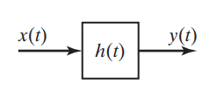
Figure: 1(a)
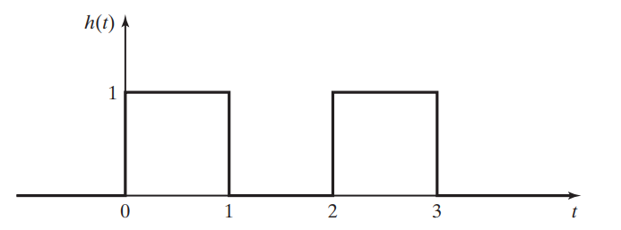
Figure : 1(b)
Answer the following to generate $y(t).$
- Mathematical Representation of $h\left(t\right)$ [2 Marks]
- Formula for Convolution Integral. [2 Marks]
- Simply the unit step. [1 Mark]
- Evaluate for different Intervals [8 Marks]
- Find the final mathematical expression for $y\left(t\right)$ [3 Marks]
- Sketch the Output of $y\left(t\right)$ [4 Marks]

QUESTION 4
- Provide answers to the below questions related to Counter type ADC.
  - Draw the block diagram of the counter type ADC. [4 Marks]
  - List the components used in counter type ADC. [3 Marks]
  - Explain in detail about how working principle of comparator utilised in the Counter type ADC. [7 Marks]
  - Explain why DAC is needed in the counter type ADC? [6 Marks]

QUESTION 5
- Consider a UART communication scenario where the string "PRINT" is transmitted.
- Provide the binary representation of each ASCII character in the string.
[5 Marks]
- Demonstrate how the UART data frame would be constructed for each
character by providing relevant diagram. [15 Marks]

Diwedd/End

Standard ASCII character table

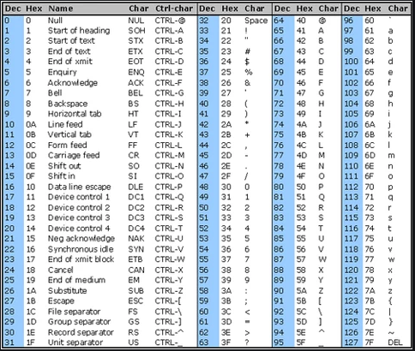

Diwedd/End

