An Anthropological Analysis of a Material Object

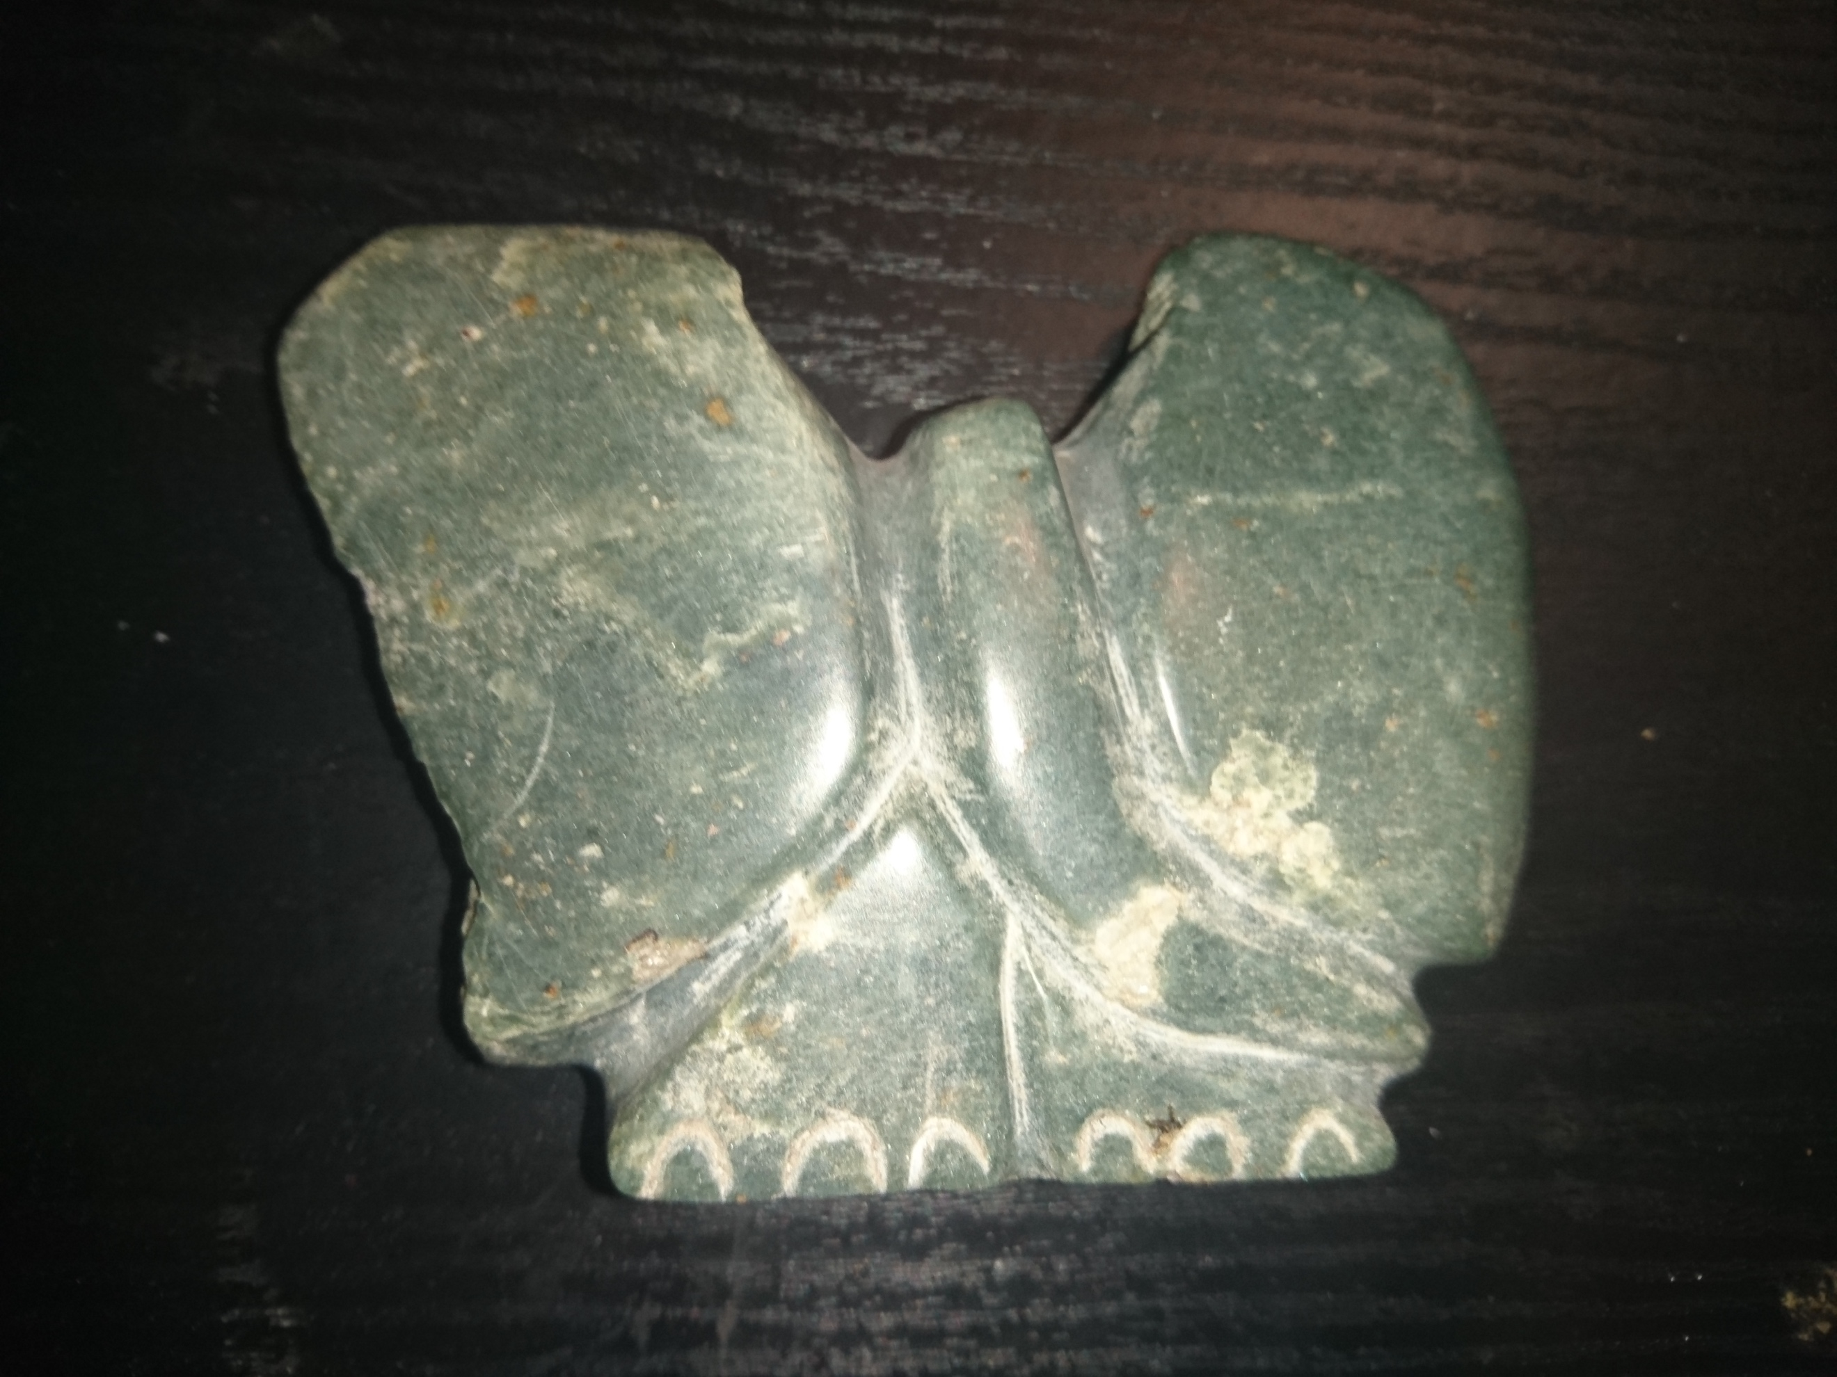
Figure 1. A stone sculpture of an elephant shaped by myself and Cleto during my time in Chinamhora (Evans & Cleto, 2017)

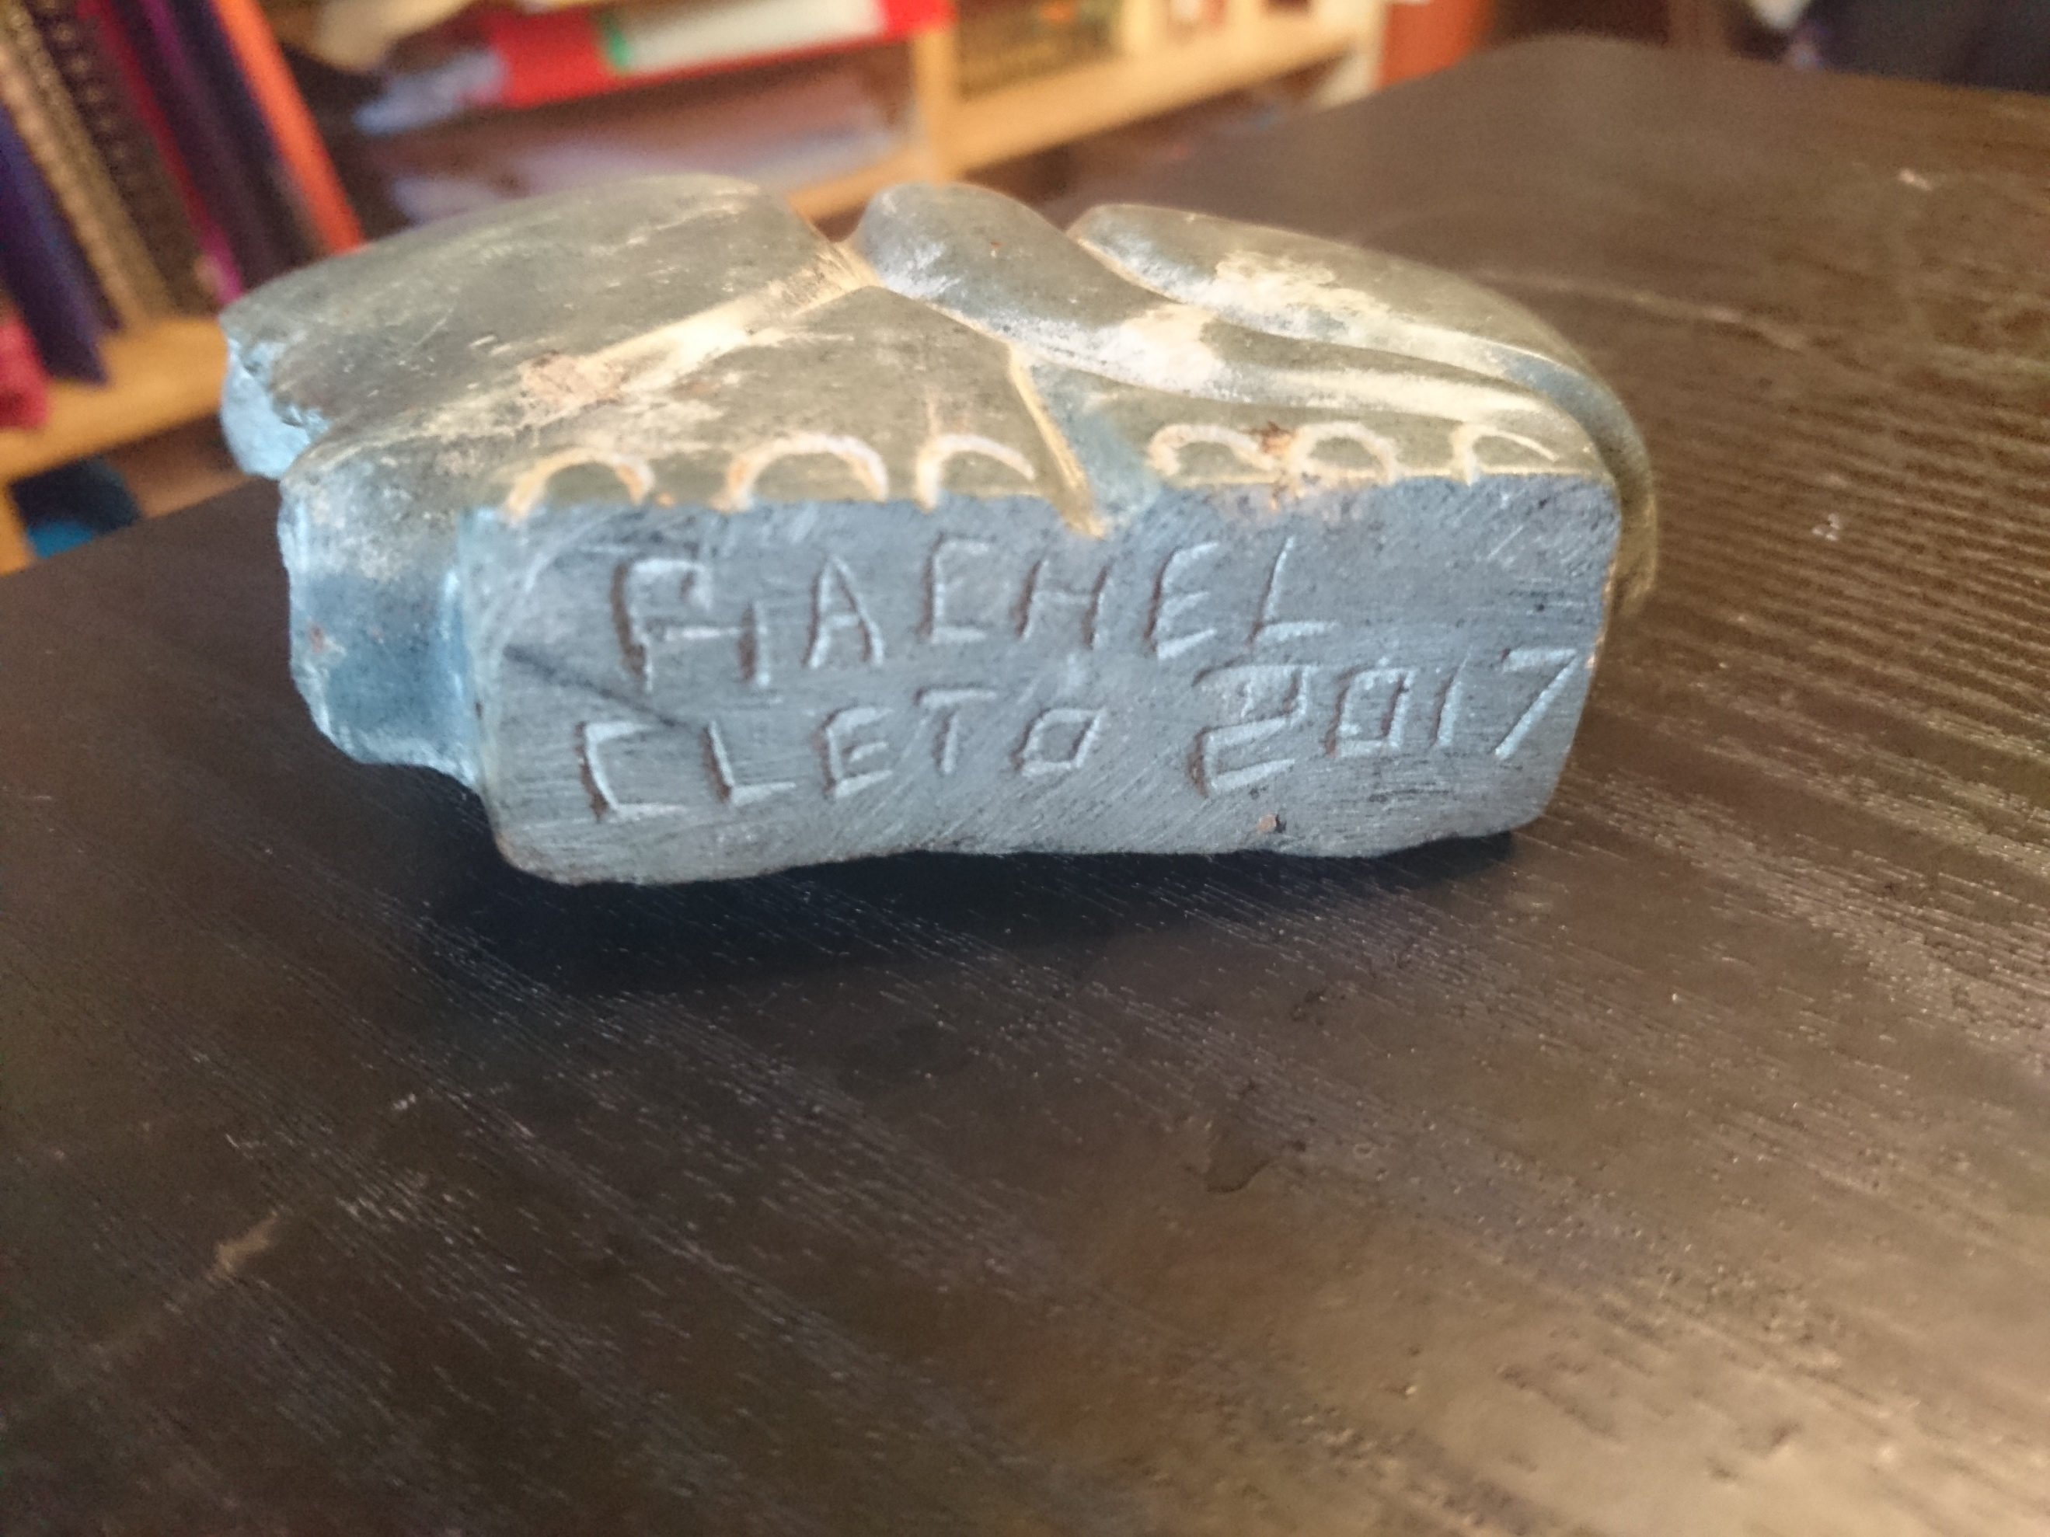

Figure 2. The bottom of a stone sculpture of an elephant shaped by myself and Cleto during my time in Chinamhora (Evans & Cleto, 2017)

The material object that I have chosen for this anthropological analysis is a sculpture of an elephant, carved out of opal stone by myself and a gentleman called Cleto (Fig. 1 & Fig.2). I have chosen this material object due to the significance that it holds to myself, and to the time that I spent in Zimbabwe whilst helping to construct keyhole gardens and a community centre for the village of Chinamhora.
Before delving in to the analysis of the stone sculpture, I will set out how I have come to be in possession of this object; illuminating its significance and providing leads for my anthropological analysis. The next step will be an analysis of the exchange of this object, and the spheres of exchange that it occupies and moves between, particularly its transgression of the boundary between commodity and gift. Following this, I will then move on to an analysis of its biography, tracing the objects journey from creation to exchange. Throughout, the analysis will partially focus on the value that the sculpture holds, both as a commodity for trade, and as a gift to keep.
During April 2017, I travelled to the village of Chinamhora in Zimbabwe with the charity Love Zimbabwe (Love Zimbabwe, n.d.). My purpose for this visit was fourfold. Firstly, it was to construct a community centre for the village, a place where the villagers could gather and learn. Secondly, I wanted to experience the culture of the village, to learn about the villagers’ way of life and customs. Thirdly, we were there to stimulate their economy through the purchase of food, and their arts and crafts. Finally, we were there to spread our knowledge of growing food for sustenance.
During my visit to Chinamhora, I met a man called Cleto. He was quite friendly, and looked after us well. He shared with us the knowledge of his past, and how things used to be done in his village. What I remember particularly is his knowledge of which trees were useful for washing your hair with! Cleto would help out in the community centre, and he gained his sustenance through carving stones in order for them to be sold to tourists that would visit Chinamhora, much like myself. Cleto and I carved this particular stone together (Fig. 1 & Fig. 2), it took us an afternoon to shape and finish. At the end of the process, Cleto gave the sculpture to me as a gift to take back to Wales and keep. It has since occupied a space on my mantelpiece, and often is a conversational piece.
In my conversations with Cleto, he had professed how much he liked my hat, a burgundy bucket style hat. On my last day in Chinamhora, I gave Cleto my hat as a gift. We exchanged addresses, in the hope of not losing contact with one another.
The gift of the stone sculpture, and he gift of the time spent creating it, appear to be ripe and fruitful ground for an anthropological analysis, particularly as it appears in the centre of a chain of reciprocal gifts which could be said to have started with the gift of my labour, labour used to construct a community centre for the benefit of the village. In this analysis of the material stone sculpture, an analysis of its place in the chain of reciprocal gift giving seems like an ideal place to start this enquiry.
In the ‘seminal essay’ (Sherry Jr, 1983, p. 157) The Gift (Mauss, 2011), gift giving is brought into focus with the way that the exchange of objects between people strengthens social ties and acts as the cementing substance in inter-personal relationships. Gifts are given voluntarily, often spontaneously, and seemingly without thought of reciprocity. Mauss observes in his seminal essay that within this universal language of exchange, things are not always as they seem (2011, p. 1).
When the stones sculpture was given to me, there was no formal arrangement of reciprocity. Yet, I felt obliged to give a gift in return; the gift of the hat that I had worn during my time in Zimbabwe, just as I was obliged to accept the gift of the stone sculpture from Cleto. The stone sculpture was a physical representation of our time together, the time spent building the community centre and the time spent carving the sculpture itself. The social bond that had developed between us was strengthened by the gift, I had a keepsake to remind me of our time together. A keepsake that had no utility value, only the value that the relationship between myself and Cleto that had been imbibed in the stone. Mauss observes that there is more than just this obligation to reciprocate gifts (2011, p. 10). If I had refused the gift, it would be as if I was rejecting the strengthening of the bonds of the relationship that I had forged with Cleto. I was obliged not only to continue the chain of reciprocal gift giving, I was also obliged to receive the gift of the stone sculpture from Cleto. Had I offered Cleto money in return for the sculpture, a sculpture he would normally sell to tourists, this could be interpreted by him as a rejection of the offered social bonds, a ‘refusal of friendship’ (Mauss, 2011, p. 11). Perhaps, even, given the relative differences in our economic positions within global society, to accept money for what is offered as a gift may, in a way, violate etiquette and cause Cleto to lose ‘rank’ (Mauss, 2011, p. 38), a rank that the giving of a gift seeks to attain.
The exchange of the stone, the hat, and the charitable time and monetary donations were not direct exchanges. These exchanges of gifts can be seen as such when ‘juxtaposed with direct exchanges’ (Sherry Jr, 1983, p. 158); not one of the exchanges in the chain of trade was direct and explicit with respect to what was to be exchanged and when the exchange was to take place (with, perhaps, the exception of the first in the chain, the charitable donations raised and the labour in creating the community centre). The exchanges were, for the most part, ambiguous and seemingly spontaneous. The need to reciprocate these gifts, although somewhat ambiguously felt, is seemingly no less forceful than an explicit exchange. The reciprocation is enforced through the pressure of avoiding ‘feeling inferior and to safeguard reputation’ (Sherry Jr, 1983, p. 159).
The stone collected by Cleto, originally intended to be carved, shaped, polished, then sold, begins its life as a commodity, a commodity to which human labour is added before it is exchanged. The labour that Cleto expends in sculpting the stone gives value to the stone under a Marxist interpretation (Marx, 1971, pp. 13-14). The value, however, is quite different from the exchange value that it would have if the stone were to be sold as a gift, the value, instead, comes from it being ‘embedded…in the flow of social relations’ (Appadurai, 2011, p. 11). It is steeped in the moral constraints of reciprocity, quite opposed to the ‘self-centred’ motives of the exchange of commodities. This dichotomy, between commodity and gift, is not as solid and unmoving as it may prima facie seem. The stone, once carved and sold as a commodity with an exchange value, moves from the world of commodities and into the world of gifts. Its source of value changes from the value it holds in exchange for Cleto, to the inalienable value it then possesses as a gift or souvenir (Weiner, 1985, p. 210). The stone that the sculpture in fig. 1 and fig. 2 is carved from may have started life as intended for exchange for a cash value, but it transgressed the boundary from alienable wealth, into its inalienable wealth that it now holds, having been removed from the sphere of exchange.
In examining the inalienable wealth of the stone sculpture gifted to me by Cleto, we now focus on where, exactly, this object gains its inalienable wealth. In order to do this, I will now turn to the examination of the biography of the stone sculpture.
Traditionally in some schools of philosophy, the contrast to the object is the subject (Rettler & Bailey, 2017), the subject has some sort of experience of the world, the object does not. As solid as this line may seem, the postmodern turn in Western thought has blurred this once solid line. Slavery, the treating of a person as an object to be bought, stolen, or sold, places the subject into the realm of the object, blurring the distinction (Kopytoff, 2011). Moreover, the distinction between subject and object is blurred further by Gell (1998, pp. 126-128) in his Wittgensteinian analysis of the worship of idols, and furthermore, by Geary in his analysis of the circulation of medieval relics (2011, p. 169). This path of an externalist route to ‘agency attribution’ through the obeying of social rules give the idols some sense of subjectivity; they ‘play the game’ in the Wittgensteinian sense, it is a language game, with the language represented in the following of the social rules.
The stone sculpture gifted to me by Cleto can be seen along the same sort of lines as the idols under discussion by Gell. It certainly has some sort of agency, particularly over myself. It motivates me through its texture to remember when I created the sculpture with Cleto, the afternoon spent with him first carving then polishing the stone into the smooth texture I now feel in my hand as I hold it. The agency of the stone over my memory strengthens the bond I feel towards Cleto.
In following the life cycle of the stone sculpture, I might hope to, as Kopytoff puts it, ‘make salient what might otherwise remain obscure’ (2011, p. 67). The stone that the sculpture is carved from is collected by Cleto on his travels. He collects stones that speak to him with their shape, the form that they take in their pre-carved condition dictate what Cleto sculpts; he merely releases the inner form from the stone. In this way, the stone has some sort of agency over Cleto, rather than Cleto having full agency over the stone. Cleto, having collected the commodity of stone, further adds exchange value to the commodity by adding his labour once more; the carving, shaping, and polishing of the stone in order to release the form held within extends the personhood of Cleto, so that part of him and part of his culture and place enter into the stone, ‘totalizing his biography, his labour, his social milieu, in the form of an object’ (Gell, 2011).
The particular stone in Fig. 1 and Fig. 2 spoke to both myself and Cleto, the stone compelled us to realise its potential as a sculpture of an elephant. In our shaping of the stone, and in the gifting of the stone to myself, both Cleto and I have entwined our biographies with that of the sculpture. The sculpture, in this way, contains part of both myself and Cleto, it extends both our personhood and self from our own bodies and into the object. The sculpture, in being gifted to me, allows me to take part of Cleto home to Wales with me, and to continue our bond even though the geographical distance between us is vastly increased. Economically, the stone sculpture has passed through the stage of its life where it is considered as a commodity, with alienable wealth, to being removed from the circle of commodity trade. This part of the stones biography then adds to its inalienable wealth, and the biography of its creation and exchange further reinforces its value in this context.
The stone sculpture presented in Fig. 1 and Fig. 2 offers fruitful grounds for an anthropological analysis. In conclusion, it occupies an ambiguous grey area, the area between what we class as a commodity, and what we class as beyond the scope of the category of the commodity. It’s value changes along with its significance within the social life that it occupies; moreover, its social life, its story, creates and maintains its inalienable wealth, enabling it to transgress the boundary from its trade value to its value as an object that elicits agency to the person who possesses it and retains it because of its inalienable wealth to them, in this case, myself.

Works Cited
Appadurai, A., 2011. Introduction: commodities and the politics of value. In: A. Appadurai, ed. The Social Life of Things, Commodities in Cultural Perspective. Cambridge: Cambridge University Press, pp. 3-63.

Evans, R. & Cleto, 2017. Elephant Stone Sculpture. Chinamhora: s.n.

Geary, P., 2011. Sacred Commodities: The Circulation of Medieval Relics. In: A. Appadurai, ed. The Social Life of Things, Commodities in Cultural `perspective. Cambridge: Cambridge University Press, pp. 169-191.

Gell, A., 1998. Art and Agency. Oxford : Clarendon Press.

Gell, A., 2011. Newcomers to the World of Goods: the Muria Gonds. In: A. Appadurai, ed. The Social Life of Things, Commodities in Cultural Perspective. Cambridge: Cambridge University Press, pp. 110-138.

Kopytoff, I., 2011. The Cultural Biography of Things: Commoditization as Process. In: A. Appadurai, ed. The Social Life of Things, Commodities in Cultural Perspective. Cambridge: Cambridge University Press, pp. 64-91.

Love Zimbabwe, n.d. Love Zimbabwe Home Page. [Online]
Available at: http://lovezimbabwe.org/

Marx, K., 1971. Capital. London: William Benton.

Mauss, M., 2011. The Gift, Forms and Functions of Exchange in Archaic Societies. Glencoe, Illinois: Martino Publishing.

Rettler, B. & Bailey, A., 2017. Object. [Online]
Available at: https://plato.stanford.edu/archives/win2017/entries/object/
[Accessed 15 01 2018].

Sherry Jr, J. F., 1983. Gift Giving in Anthropological Perspective. The Journal of Consumer Research, September, 10(2), pp. 157-168.

Weiner, A. B., 1985. Inalieable Wealth. American Ethnologist, May, 12(2), pp. 210-227.

