

Strategic Management (LCMB7003)
Strategic Analysis of British American Company
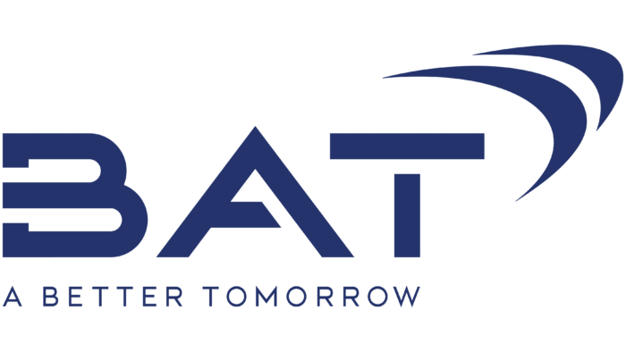

Student name: NABHAN PUZHAKKATTIL
Student Number: 2215386
Lecturer: Dr GLADIUS KULOTHUNGAN
Word count: 5465
Submission Date: 30/08/2023
TABLE OF CONTENT

INTRODUCTION 3
BACKGROUND 3
MISSION AND OBJECTIVE 4
MACRO-ENVIRONMENT ANALYSIS 5
PESTEL ANALYSIS 6
MICRO-ENVIRONMENT ANALYSIS 8
INDUSTRY LIFE CYCLE 8
PORTER’S INDUSTRY FIVE FORCES ANALYSIS 9
INTERNAL ANALYSIS 12
GLO’S STRATEGIC RESOURCES AND CAPABILITIES 12
VALUE CHAIN ANALYSIS 13
PRIMARY ACTIVITIES 13
SECONDARY ACTIVITIES 13
VRIO ANALYSIS OF DISTINCTIVE RESOURCES AND CAPABILITIES 14
SWOT ANALYSIS 16
STRATEGIES TO SUSTAIN COMPETITIVE ADVANTAGE 17
GROWTH STRATEGIES 17
GREEN STRATEGY AND CSR 19
CONCLUSION 20
RECOMMENDATION 21
REFERENCE 22

INTRODUCTION
The coordinated management of an organization's resources with the intention of accomplishing its intended goals and objectives is referred to as strategic management. This entails setting goals, assessing the internal and external environments in which the organisation functions, reviewing strategies, and ensuring that management has adopted the selected strategy widely across the whole organisation (Kenton, 2023).
In the ever-changing tobacco business landscape, where regulations, customer tastes, and cultural standards continue to alter, the capacity to adapt and innovate becomes critical. British American Tobacco (BAT), a worldwide tobacco industry leader, exhibited its strategic management skills with the creation of "Glo," a tobacco heating product that hit the Japanese market in December 2016. This paper offers a thorough strategic analysis of Glo, diving into the models, theories, and frameworks from the strategic management module to determine how BAT effectively solved key difficulties and gained a competitive advantage in the tobacco heating device industry.

BACKGROUND
According to Britannica (2023), British American Tobacco PLC (BAT) is a British multinational tobacco company that conducts business all over the world. It is one of the biggest cigarette firms in the world. involved in the production, promotion, and retail sale of cigarettes, cigars, and other tobacco products, as well as tobacco and items linked to tobacco. The company's range of brands is wide.
British American Tobacco (BAT), like its rivals, has been making investments in more recent nicotine and tobacco goods that, unlike cigarettes, have the potential to thrive in developed economies. Snus, nicotine pouches, e-cigarettes, and heated tobacco products (HTPs) (Tobacco Tactics, 2023).
BAT and Philip Morris were the first of the major tobacco companies to invest in cigarette substitutes as conventional smoking declines due to increased health consciousness (Reuters, 2017). Heat-not-burn (HNB) tobacco products are electronic devices that heat tobacco leaf and produce aerosol, similar to electronic cigarettes (e-cigarettes). In 2014, Philip Morris International (PMI) exclusively released the IQOS in Japan and Italy. It is a revolutionary HNB cigarette product. In March 2016, Japan Tobacco introduced a new product called "Ploom Tech" in that country. In December 2016, British American Tobacco started selling the HNB tobacco product glo in Japan.
Japan is renowned for its distinctive tobacco culture, where smoking is still very widespread and there is a great demand for high-quality tobacco products (Craft, 2012). In Japan, "heat but not burn" tobacco is quickly rising in favour (Reuters, 2017). BAT joined the HTP industry later than its rivals Japan Tobacco International (JTI) and Philip Morris International (PMI) because of its emphasis on e-cigarettes (Tobacco Tactics, 2023). Both glo and IQOS employ tobacco leaves in the form of cigarettes. However, the battery-operated gadgets heat the sticks to produce steams rather of burning them. The manufacturers claimed that their goods smell far less than regular cigarettes do (Reuters, 2017). BAT asserted that glo was "a real game changer for consumers" and a simpler and more practical alternative to IQOS (Tobacco Tactics, 2023).
The in-depth strategic analysis examines British American Tobacco's (BAT) strategic decisions and management practises with an emphasis on its ground-breaking product, "Glo," and its entry into the cutthroat Japanese tobacco industry. This analysis will show how BAT tackled key difficulties and gained a competitive edge in a changing sector by applying strategic management models, theories, and frameworks.
Strategic management has a variety of tools and insights that can be used to analyse business plans and understand how organisations overcome obstacles and seize opportunities (Messineo, 2023). These ideas are applied to BAT's Glo innovation in this paper, which also examines the main problems the firm faced and the tactical choices that fuelled its competitive edge. Unravel the complexities of BAT's entry into the Japanese market with Glo by using well-established theories like Porter's Five Forces, SWOT analysis, and the Resource-Based View.

MISSION AND OBJECTIVE
Mission: According to Reilly (2022), Glo’s goal was to reinvent the smoking experience by providing traditional cigarettes with a lower-risk alternative using innovative technology and consumer-focused design. BAT aimed to provide smokers with a premium product that was enjoyable and in step with evolving market and regulatory trends.
Objective:
Market leadership: Glo's main goal was to have a big impact on the tobacco heating device industry. With a product that not only met but also excelled at consumer expectations in terms of appearance, practicality, and flavour, BAT aimed to take on rivals, particularly Philip Morris' IQOS (Reuters, 2017).
Differentiation and Innovation: One of Glo's main goals was to set itself apart from the market's other players. BAT attempted to do this by including distinctive characteristics such a simple one-button design, extended battery life, and a variety of enticing flavours that were in line with the tastes of Japanese smokers (Tobacco Tactics, 2023).
Customer satisfaction: BAT sought to go above and beyond customer expectations by providing a tobacco heating device that satisfied both the basic need for nicotine and the desire for flavour. The goal was to raise consumer happiness and promote a switch from conventional cigarettes to Glo's cutting-edge product (Reuters, 2017).
Market Expansion: Since Glo was first introduced in Japan, BAT aimed to increase the company's market presence there as well. To expand and penetrate new markets, the business sought to bring Glo to a number of overseas regions while capitalising on its strong performance in Japan (Tobacco Tactics, 2023).
Sustainability and Responsibility: BAT aimed to integrate Glo's purpose with more general environmental and social responsibility objectives. This required ensuring that the environmental effect of the product was kept to a minimum and that Glo's claims of decreased risk were supported by scientific research, which added to BAT's general commitment to ethical business practices.

MACRO-ENVIRONMENT ANALYSIS
In many businesses, strategic management includes macro-environment analysis, which entails locating and weighing possible benefits and drawbacks in the larger external context. This analysis's main goal is to provide management with precise data that will help them make wise operational decisions. Macroenvironmental influences are often categorised as social, economic, technical, and political/regulatory for analytical reasons. Examining current and forthcoming shifts and ascertaining their implications for the organization are integral aspects of this analysis. Undoubtedly, developments in these domains, such as the aging of populations, the shift from manufacturing to service-oriented sectors, and the increasing adoption of robotics, will exert substantial influence on organizations spanning various industries (Ginter & Jack Duncan, 1990).
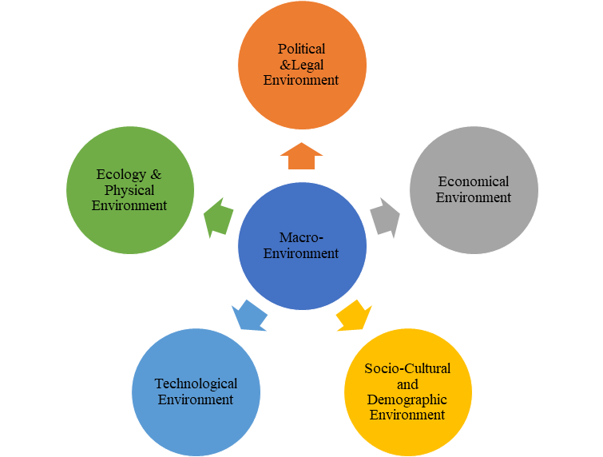
Figure 1: Macro- Environment (S, 2020).

PESTEL ANALYSIS
A corporation can carefully consider several aspects of its external environment using the PESTEL framework. By gathering information on political advancements and economic patterns, enterprises acquire insights to enhance their adjustment of strategic management and decision-making procedures in alignment with their surrounding environment. The PESTEL framework may be used by organisations as a model to assess how various external influences affect their operations. Political, Economic, Social, Technological, Environmental, and Legal issues are referred to by the abbreviation PESTEL (MasterClass, 2022).
According to Bruin (2023),
- Political factor: These considerations centre on how and to what extent the government is involved in the economy or certain businesses. In essence, all effects that governmental actions may have on a firm are included in this group. Government policies, political stability or instability, degrees of corruption, taxation rules, labour laws, environmental legislation, and trade restrictions are a few examples of these. In addition, a country's infrastructure, healthcare laws, and educational system may be impacted by the government. All of these elements require careful consideration when determining a potential market's desirability.
- Economic factor: Economic growth, changes in exchange rates, inflation, interest rates, consumer disposable income, and the prevalence of unemployment are just a few examples of factors that can have an immediate and long-term influence on a company. These impacts derive from their ability to change consumer purchasing power and possibly shift economic supply and demand dynamics. As a result, these considerations may cause changes in how businesses construct price systems for their products and services.
- Social factor: The community's demographics, beliefs, traditions, and conventions where the organisation operates are included in the sociological component of the total environment. Population expansion, age distribution, wealth and lifestyle trends, health awareness, and cultural obstacles are a few examples of these issues. This knowledge helps marketers target consumers and reflects the preferences of the workforce.
- Technological factor: These aspects relate to technical developments that may have positive or negative consequences on market and industrial operations. This includes the degree of technology knowledge within a market, technological changes, research and development (R&D) activities, automation, and innovation. These factors may have an impact on decisions made about entering particular industries, bringing certain goods to market, or outsourcing manufacturing to other nations. A corporation may be prevented from making major investments in technology that might quickly become outdated owing to disruptive breakthroughs taking place elsewhere by being educated about global technological trends.
- Environmental factor: Environmental issues have just lately become more well-known. They have become more significant as a result of governments' growing focus on reducing pollution, carbon footprint, and raw resource shortages. These factors include ecological and environmental characteristics including weather, climate, environmental offsets, and climate change, which might have a big influence on industries like tourism, farming, agriculture, and insurance. Additionally, the way that businesses operate and the products they offer are changing as a result of growing knowledge of the potential effects of climate change. As a result, many companies are becoming more engaged in concepts like sustainability and corporate social responsibility (CSR).
- Legal factor: Distinct from political factors, these encompass specific laws such as anti-discrimination, antitrust, employment, consumer protection, copyright, patent, and health regulations. Clear understanding of legality is vital for ethical and successful trade. Global trade complicates matters due to diverse regulations. Staying informed about potential legal changes and their impact is essential, often necessitating legal counsel.
The PESTEL analysis applies to British American Tobacco's Glo based on the provided case study: A detailed macro-environment research in the Glo context would have helped BAT develop strategies that are in line with market developments, consumer preferences, and legal obligations. This research makes it easier to create a thorough strategic plan that takes advantage of possibilities and reduces risks, which ultimately helps explain the product's amazing market success.

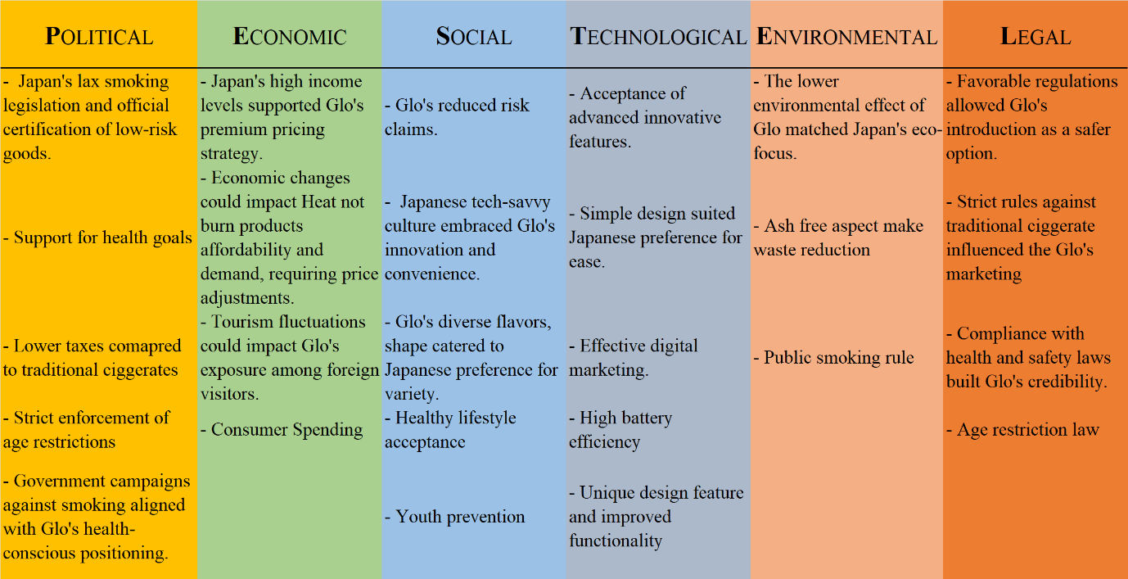
Figure 2: Pestle analysis
By considering PESTEL into consideration, BAT can more effectively create its plans to overcome barriers, seize opportunities, and guarantee Glo's continuous success in the competitive tobacco heating device market.

MICRO-ENVIRONMENT ANALYSIS
The immediate surroundings of a firm that have the power to quickly affect its operations are referred to as the microenvironment. It includes everything that makes up the firm, including the surrounding area where the business operates. These factors are unique to the specific company and have the power to influence both its short-term success and daily operations. Suppliers, rivals, marketing middlemen, clients, and the firm itself all make up its components (S, 2020).
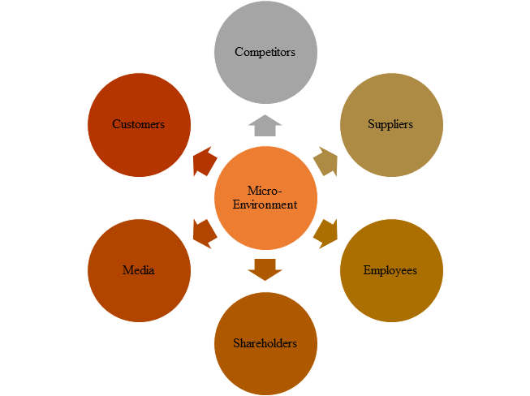
Figure 3: Micro- Environment (S, 2020).

INDUSTRY LIFE CYCLE
According to the business characteristics that are predominant in each stage, the industry life cycle depicts the evolution of a company through four phases. An industry's life cycle is divided into four phases: introduction, growth, maturity, and decline. There is a lot of uncertainty when new products are generated regarding the size of the market, the features of the products, and the main competitors (Team, 2023).
According to the case study paper, understanding the tobacco heating device market life cycle in the context of British American Tobacco's Glo provides insight into the product's positioning, growth potential, and strategic concerns.

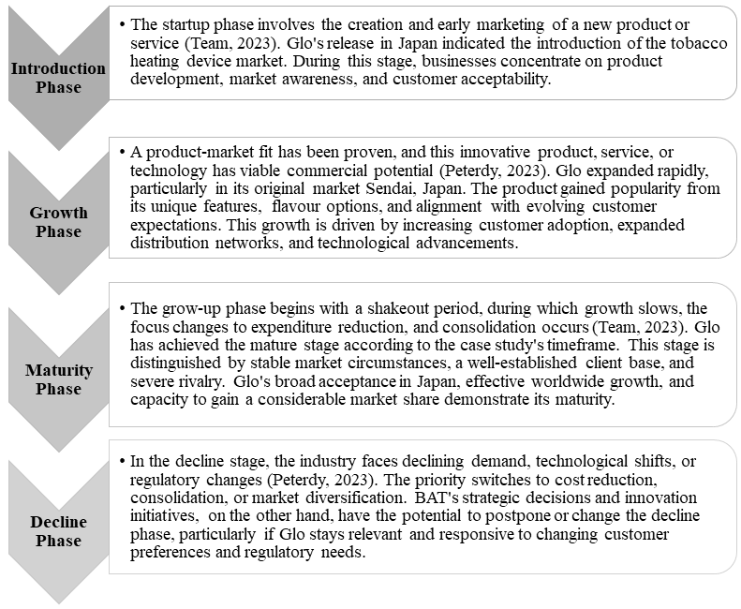
Figure 4: Industry Lifecycle

In the case of Glo, understanding where the tobacco heating device industry stands in its life cycle helps BAT make informed decisions regarding innovation, market expansion and differentiation. By aligning strategies with the industry's stage, BAT can effectively navigate the competitive landscape and position Glo for long-term success, extending the product's relevance and impact.

PORTER’S INDUSTRY FIVE FORCES ANALYSIS
It is a tactical framework that facilitates the discovery and examination of the five factors that affect a company's profitability in any particular industry (Alonso, 2023). M. Porter developed the five forces model in 1979 to better understand how five primary competitive factors impact an industry (Jurevicius, 2021).
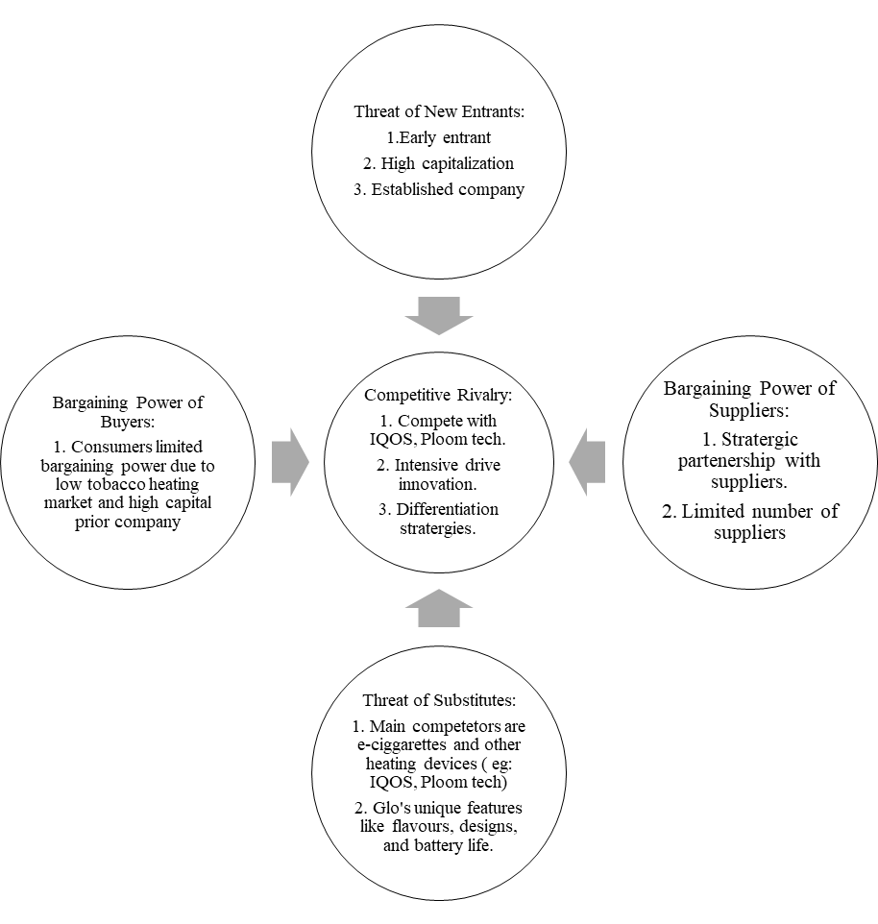
Figure 5: Porter's Five Forces diagram (Alonso, 2023).
Applying Porter's Five Forces analysis to the tobacco heating device industry, including British American Tobacco's Glo, provides valuable insights into the competitive landscape and strategic considerations.
- The Threat of New Entrants: According to Alonso (2023), When an industry becomes successful, it invites additional participants. If the barriers to entry are low, new entrants can easily capture market share and threaten profitability.
In this case this is a Low to moderate threat. This influenced by several factors.
  - Scale and Experience: BAT's experience and established market presence in the tobacco industry give it an advantage over potential new entrants of product like Glo.
  - Access to Supply or Distribution Channels: BAT has an advantage since it already has contacts with suppliers and distributors.
  - Legislation or Government Action: Government policies and strong regulations aimed at promoting public health are applied to the tobacco sector. Additionally, encourage low-risk product options like Glo to improve market entry.
  - Incumbency Advantages: Consumers are more likely to trust well-known brands like Glo.
  - Capital requirement: The existing barrier is High R&D cost.
- Bargaining Power of Suppliers: Suppliers with strong bargaining power might sell higher-priced or lower-quality raw materials to their consumers. This has a direct impact on the earnings of the purchasing corporations since they must pay more for supplies (Jurevicius, 2021).
BAT's established relationships and procurement strategies may help mitigate this power. Reliable suppliers are necessary to produce components essential to Glo, such as heating technology, batteries, and flavour enhancers (Reilly, 2022). The entire product quality and operational effectiveness are impacted by suppliers' capacity to guarantee on-time delivery, uphold quality standards, and manage costs. To get the necessary components while minimising potential supply chain disruptions, strategic collaborations and supplier relationships are crucial.
- Bargaining Power of Buyers: Strong buyer power may cut prices, put competitors against one other, and demand greater quality or service at the expense of industry profits (Alonso, 2023).
The bargaining power of buyers in the case of British American Tobacco's Glo is moderate. Even though consumers can choose between products like Ploom, IQOS, traditional cigarettes, and goods like Glo, Glo stands out due to its distinctive flavours and appearance. As a result, purchasers' power is somewhat constrained because they might favour these distinctive goods. Glo's market positioning and price tactics are impacted by factors including customer loyalty, switching costs, and preferences, which continue to have an impact on consumers' purchase decisions.
- Threat of Substitutes: Every business in an industry faces competition from other industries that produce comparable goods or services (Morrison, 2021).
In the case of Glo by British American Tobacco, the threat of alternatives is significant. Traditional cigarettes, e-cigarettes, and other risk-reduced options are substitutes. Glo competes not only with IQOS, a direct rival, but also with these alternatives. In order to properly resist this danger, Glo must distinguish itself from competing products through characteristics like flavours, designs, and battery life.
- Competitive Rivalry: An industry's level of profitability and competition is largely determined by this factor. Low earnings occur in industries where businesses must engage in strong competition for a market share (Jurevicius, 2021).
  - Competitor Concentration and Balance:
    - The presence of a large number of prominent rivals, such as Glo, Ploom and IQOS, intensifies competition.
    - Balanced competitors with similar resources drive competitive pressure.
  - Industry Growth Rate:
    - Rapidly growing tobacco heating device industry intensifies competition.
    - Competitors with large market capitalization.
  - High Fixed Costs:
    - Costly production, marketing, and R&D results in fierce rivalry.
  - High Exit Barriers:
    - Competitors are kept apart by obstacles to leaving the industry.
    - Companies continue operations despite challenges, maintaining competition.
  - Low Differentiation:
    - Similar products and low customer loyalty drive price competition. Glo's flavours and design, for example, differentiate it through special features and assist to reduce this.
By using Porter's Five Forces analysis to analyse the tobacco heating device market, BAT is better able to create strategies that successfully deal with market pressures, seize opportunities, and position Glo for long-term success.

INTERNAL ANALYSIS
Analysing the company's operations, resources, and assets entails looking closely at a variety of internal aspects, both tangible and intangible. This helps the company's decision-makers locate growing markets and develop a realistic business plan and business strategy (Shaw, 2021).
Conducting an internal analysis in the context of British American Tobacco's Glo can assist reveal insights about the product's distinctive characteristics and areas for possible improvement.

GLO’S STRATEGIC RESOURCES AND CAPABILITIES
Resources and capabilities both refer to what an organisation possesses and is able to do. More specifically, a company's skills are related to its ability to organise, manage, or otherwise utilise its resources in a way that provides value and, ideally, offers it an advantage over competitors (U, 2018). The success and positioning of British American Tobacco's Glo in the market for tobacco heating devices are heavily influenced by strategic resources and competencies.
Marketing case study of British American tobacco’s Glo report explain that the resource and capabilities as follows:
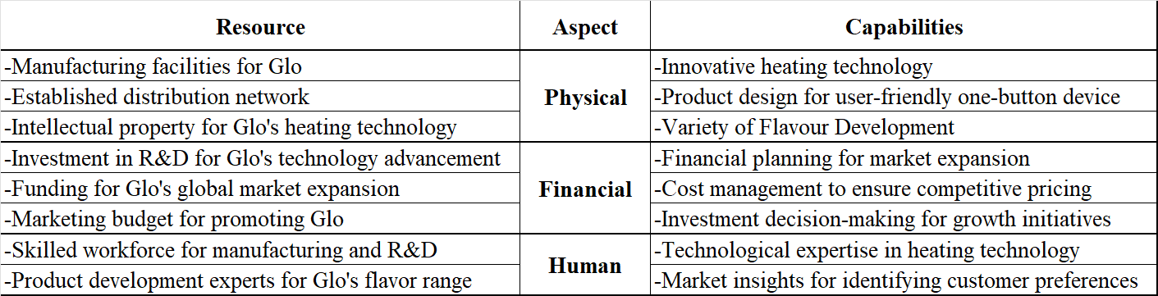
Figure 6. Resource and capabilities
In conclusion, BAT gains insight into its internal strengths and areas of expertise that support Glo's competitive advantage through the strategic resources and capabilities analysis. By utilising these tools and resources, BAT is better able to optimise its strategic decisions, strengthen Glo's market position, and achieve long-term success.

VALUE CHAIN ANALYSIS
Encompassing the complete sequence of a business's activities involved in producing a product or service, it spans from the initial acquisition of materials to the final distribution of the product or service in the market, encompassing all intermediate steps (Chai, 2021).
According to Treece (2023), value chain analysis is divided into two.

PRIMARY ACTIVITIES
These are a company's main functions, or all the tasks required to make and market their product.
- Inbound Logistics involves the receiving, storing, and distribution of raw materials utilised in the manufacturing process.
- Operations is the stage where the final product is created from the raw elements.
- Outbound logistics entails giving the consumer ownership of the finished product.
- Marketing and Sales encompass overseeing the end product to ensure its alignment with the appropriate customer segments, achieved by supervising aspects such as pricing, distribution channels, organization of the sales force, and promotional activities.
- Setup, instruction, maintenance, repair, warranty, and after-sale services are all operations necessary to maintain the functionality of the product after it has been made.

SECONDARY ACTIVITIES
- The process of buying the raw materials required for the product is known as procurement.
- Human Resource Management encompasses the actions taken to recruit and retain suitable employees who contribute to the product's design, development, and marketing.
- Technology Development can be employed throughout the research and development stage, in the crafting and conception of novel products, and in the automation of processes.
- Firm infrastructure refers to a company's management, planning, accounting, financial, and quality-control systems as well as its organisational structure.
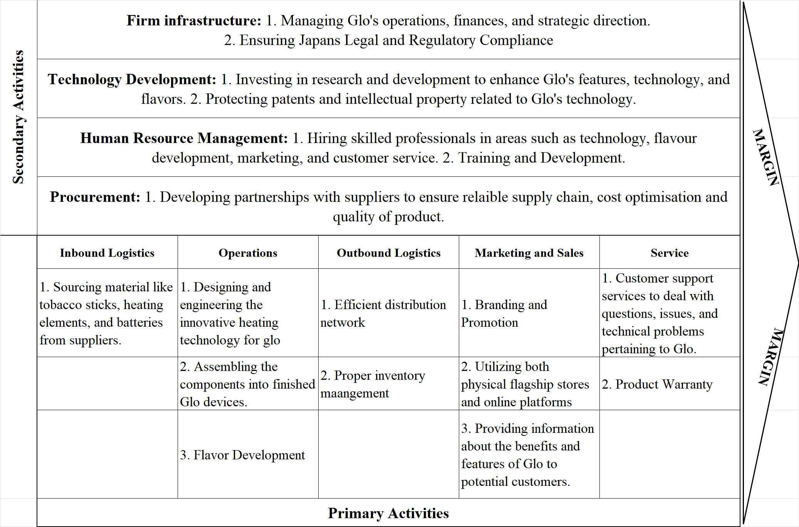
Figure 7. Value chain analysis (Chai, 2021).

VRIO ANALYSIS OF DISTINCTIVE RESOURCES AND CAPABILITIES
Utilising internal resources and competencies, the VRIO analysis is a method used to undertake internal analysis of a company. The letters VRIO stand for valuable, rare, Imitability, and organization (Gordon, 2023).
Core competencies also known distinctive resource and capabilities are the distinguishing qualities that set a company or a person apart from the competition (Twin, 2022).
The author VanZandt (2023) explain VRIO as follows:
- Valuable: It is related to the abilities that offer and the particular demands that are met by the good or service.
- Rarity: The availability of the resources and their level of accessibility to the rivals are two factors that affects.
- Imitability: Similar to rarity, it concerns the competitor’s capacity to adopt the solution into their company strategy.
- Organization: An analysis of the internal functions of the company and how it is set up to succeed.

The following is taken from the case study "British American Tobacco's Glo: Emerging tobacco innovation escalates competition in Japan." Declare that,
Distinctive Resources
- Intellectual Property for Glo's Heating Technology
  - Valuable: Yes, the intellectual property preserves the special heating technique used by Glo.
  - Rare: Yes, proprietary technology is uncommon and difficult to copy.
  - Inimitable: Yes, difficult to replicate patented technology.
  - Organization: Yes, the intellectual property is organised and protected by law.
- Skilled workforce for manufacturing and R&D
  - Valuable: Yes, skilled workforce contributes to product quality and innovation.
  - Rare: Yes, skilled workforce might be difficult to find and keep.
  - Inimitable: Yes, difficult to replicate same skilled workforce.
  - Organization: Yes, the workforce is organized to support manufacturing and R&D.
Distinctive Capabilities
- Innovative Heating Technology
  - Valuable: Yes, it addresses lower health issues and reduced risk alternatives.
  - Rare: Yes, Competitors do not possess same heating technology.
  - Inimitable: Yes, Glo’s R&D provides unique advantageous.
  - Organization: BAT effectively incorporates this technology into Glo's design and marketing.
- Product design for user-friendly one-button device
  - Valuable: Yes, user-friendly design enhances customer experience.
  - Rare: Yes, simple and effective design than the priors.
  - Inimitable: Yes, may not replicate the same design expertise.
  - Organization: Yes, design efforts are coordinated in order to build a user-friendly product.
- Variety of Flavour Development
  - Valuable: Yes, flavour is a top priority for Japanese smokers
  - Rare: Yes, to offer a wide range of high-quality flavours is not common.
  - Inimitable: Yes, BAT has developed a unique set of flavour creation skills that are difficult to duplicate.
  - Organization: Yes, BAT successfully integrates and emphasises many flavours in Glo.
- Technical and Regulatory Expertise
  - Valuable: Yes, technological, and regulatory expertise drives innovation and product development.
  - Rare: Yes, expertise in specific fields is not common.
  - Inimitable: Yes, priors may not possess the same level of expertise.
  - Organization: Yes, expertise is organized to support innovation.

SWOT ANALYSIS
A SWOT analysis is a straightforward but effective framework for assessing a company's strengths, weaknesses, opportunities, and threats. It can also be used to evaluate almost any element of business. To assist in making more informed selections (Lindley, 2023).
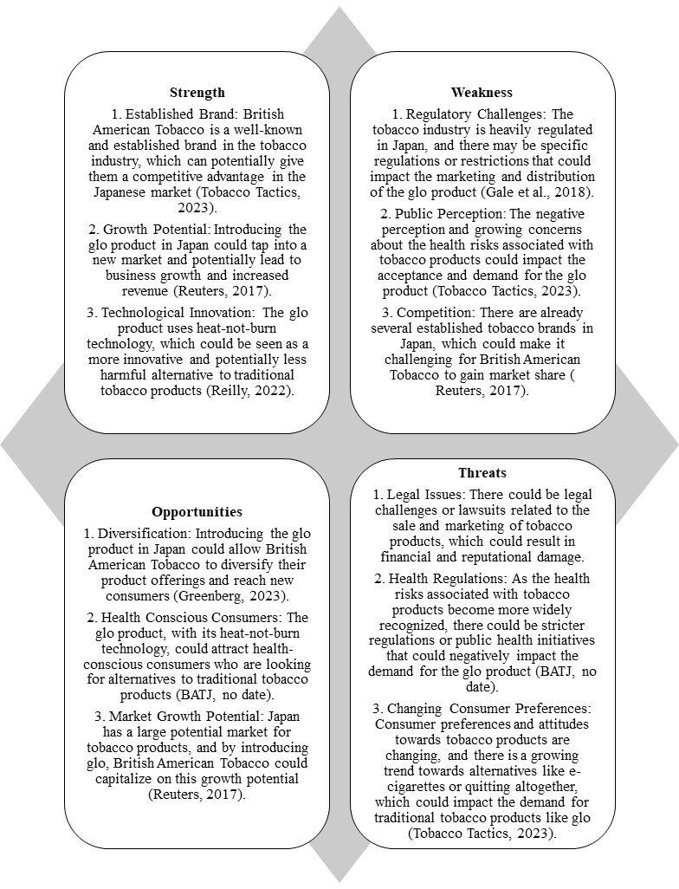
Figure 8. SWOT analysis
BAT may create well-informed plans that build on its strengths, address its weaknesses, grab opportunities, and reduce threats by taking into account the findings from this SWOT analysis. This thorough understanding directs decisions to strengthen Glo's competitive advantage and long-term performance in the market for cigarette heating devices.

STRATEGIES TO SUSTAIN COMPETITIVE ADVANTAGE
When there are competing companies in an industry selling the same products or offering comparable services, the company must develop advantages that will persuade customers to select the company. This is referred to as developing a competitive advantage in that industry (Milano, 2021). Based on the analysis provided in the main report, here are several strategies that British American Tobacco (BAT) can consider to sustain the competitive advantage of its tobacco heating device, Glo:
- Continuous Innovation
The product will remain relevant and enticing by making regular investments in R&D to improve Glo's heating technology, flavour selection, and gadget design. Glo's commitment to innovation keeps it at the forefront of technical developments and in step with changing consumer tastes (Reilly, 2022).
- Global Market Expansion
Reduce the risk of dependence on specific markets by expanding Glo's market presence into new, high-growth areas. Diverse client segments can be attracted by enlarging the distribution network and adjusting marketing tactics to different cultural contexts (Tobacco Tactics, 2023).
- Customization and Personalization
Introduce new colours, designs, and accessories that appeal to a range of consumer tastes to further expand customising options. Providing individualised experiences can boost client happiness and loyalty (Reuters, 2017).
- Brand Enhancement
Enhance Glo's perception as a reliable and innovative product by utilising BAT's solid brand reputation. Strong customer loyalty, user recruitment, and competitive differentiation are all possible with the right branding and marketing initiatives (Chapman, 2021).
- Regulatory Compliance and Advocacy
Keep abreast of evolving laws pertaining to tobacco products and push for laws that favour low-risk alternatives. Promote Glo as a sensible option that complies with legal requirements (Tobacco Tactics, 2023).

GROWTH STRATEGIES
The majority of businesses aspire to broaden their activities and enhance sales and profits. However, achieving a growth strategy necessitates the implementation of specific approaches. The approach a company adopts to foster expansion is significantly shaped by its financial condition, the degree of competition, and even governmental regulations. British American Tobacco (BAT) has a number of growth tactics it can use for its Glo tobacco heating product in order to promote expansion and take advantage of its competitive edge. (Suttle, 2019). This is analysed by Ansoff matrix.
Ansoff Matrix: According to Joshi (2021), This approach, often known as the "product and market expansion matrix," provides four methods for accelerating a business's expansion while simultaneously identifying associated dangers. This framework helps business owners and leaders create long-term growth strategies and operational plans. The Ansoff Matrix was created to evaluate company decisions and offer direction throughout the creation of a new growth strategy. Since its introduction, organisations have used this planning tool to efficiently organise marketing plans that are essential to success.
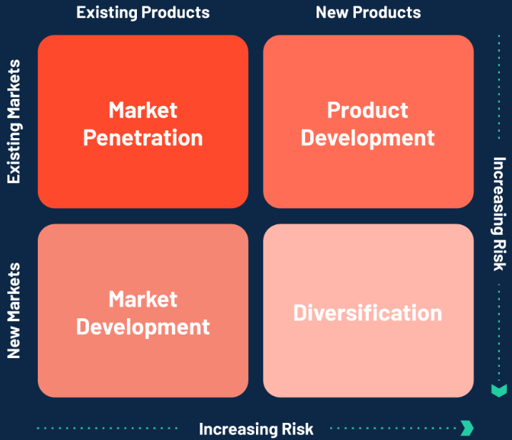
Figure 9. Ansoff matrix (Joshi, 2021).
- Market penetration:
  - Promotional campaigns like executing concentrate marketing initiatives to raise Glo's profile and uptake in current areas. To draw in more customers, highlight its advantages, like lowered health risks and a variety of flavour alternatives.
  - Utilise aggressive pricing tactics to get users who are price-conscious to switch to Glo from conventional cigarettes (Suttle, 2019).
- Market development
  - Global Expansion with a rise in the demand for lower-risk cigarette alternatives and supportive regulatory frameworks. Utilise the model's success in Japan to spread it to other areas (Tobacco Tactics, 2023).
  - Carry out in-depth market research to discover market segments, which are defined as specific subsets of a larger population (Greenberg, 2023).
- Product development
  - Continuously invest in R&D to improve Glo's features such as heating technology, battery life, and customising possibilities. Introduce new features to satisfy changing consumer demands (Reilly, 2022).
  - Launch limited-edition flavours to generate excitement and a sense of exclusivity among customers, resulting in repeat purchases and new users.
- Diversification
  - Introduce complementary products that are aligned with the reduced-risk concept, such as smokeless tobacco or nicotine-free alternatives. This diversification capitalises on BAT's existing consumer trust (Greenberg, 2023).

GREEN STRATEGY AND CSR
It can be described as the capacity to maintain or sustain a process consistently across time. In terms of commercial and policy contexts, sustainability aims to avoid the depletion of natural or physical resources in order to maintain their availability in the future (Mollenkamp, 2023). Green Strategy is a wide subject that offers an ideological analysis of the current environmental sustainability movement and focuses on how to establish a huge global movement that will bring about fundamental change, which is the only way to address climate change and all of our environmental challenges (Brodine, 2018).
Here are some concrete examples of how BAT might consider the seven main challenges listed in the green strategy:
- Effective Energy Use: BAT reduces energy usage by implementing energy-saving technology and procedures in manufacturing and distribution facilities (BAT, no date).
- Sustainable Resource Use: Wherever possible, use renewable and eco-friendly materials for Glo gadgets and packaging. Choose materials with the least amount of environmental impact (Reilly, 2022).
- Protection of the Biosphere: Carbon Neutrality: Establish specific goals for reducing carbon emissions linked with Glo's manufacturing and distribution. To attain carbon neutrality, invest in carbon offset projects (BAT, no date). Also, research and development for Low-Carbon Technologies (Reilly, 2022).
- Country Self-Sufficiency: Establish local manufacturing facilities in Japan’s key markets to reduce the need for energy-intensive international transportation and promote self-sufficiency (BATJ, no date).
- Energy and Resource Efficiency: Design Glo devices with energy-efficient components and systems, extending battery life and reducing energy consumption during use (Reilly, 2022).
- Waste Reduction and Disposal: Remove single-use plastics and make plastic packaging recyclable (BATJ, no date).
- Change of Attitudes and Lifestyles: Conduct educational initiatives to educate consumers on the environmental benefits of Glo and to encourage them to adopt more sustainable lifestyles (BAT, no date).
Corporate social responsibility (CSR) is an autonomous corporate strategy that enables an organisation to take on social responsibility for its own operations, stakeholders, and the general public. Companies who practise corporate social responsibility, also known as corporate citizenship, show that they are mindful of how their actions affect the economic, social, and environmental facets of society (Fernando, 2023).
By integrating CSR initiatives into the Glo tobacco heating product's lifecycle, BAT can contribute positively to communities, consumers, and the environment. Here's how BAT can implement CSR for Glo:
- Health awareness: According to BATJ (no date), the company collaborate with renowned health organisations to promote awareness about the health benefits of Glo over regular cigarettes. Enhance Educational Campaigns.
- Youth Prevention and Education: Implement strong age verification methods to prohibit minors from accessing and using Glo gadgets (Chapman, 2021).
- Transparency and Reporting: Publish regular CSR reports that detail BAT's progress in various CSR initiatives, including health promotion, environmental impact, and community engagement (BAT, no date).
- Ethical Marketing and Advertising: Ensure that Glo's marketing and advertising initiatives accurately and ethically highlight its lower-risk benefits, while avoiding misleading claims (Tobacco Tactics, 2023).
- Environmental protection: Integrate environmentally friendly practices throughout Glo's manufacturing, packaging, and distribution operations to reduce the company's ecological footprint (BATJ, no date).

CONCLUSION
The case study of British American tobacco's Glo emphasises the strategic management decisions and innovative tactics that have propelled Glo to a competitive edge in the cigarette heating device market. Key insights regarding how Glo has positioned itself for success have been revealed through a comprehensive examination of its macro and microenvironment, industry life cycle, Porter's Five Forces, internal capabilities, value chain, and more.
Glo's journey began with a focus on addressing the shortcomings of its predecessors, Philip Morris' IQOS and Japan Tobacco International's Ploom Tech, as well as providing a differentiated product that resonated with the Japanese market. Its simple one-button design, numerous flavour options, and distinctive shape piqued the interest of time-pressed Japanese smokers. Glo's success in Japan was a testament to the company's ability to recognise and address the needs of its target customers.
In summary, British American Tobacco's Glo stands as a prime example of effective strategic management in a dynamic industry. By understanding the market, leveraging distinctive capabilities, pursuing innovation, and embracing responsible practices, Glo has positioned itself for continued success, growth, and positive impact in the evolving landscape of reduced-risk tobacco products. As the market evolves and regulations change, Glo's strategic agility and commitment to meeting consumer needs will play a pivotal role in shaping its future trajectory.

RECOMMENDATION
- Invest in Research and Development: Continue to invest in R&D to develop Glo's technology, with an emphasis on longer battery life, faster heating, and higher vapour quality. Glo's competitive advantage will be maintained through innovation.
- Diversify Flavours and Options: To retain consumer interest and accommodate changing preferences, expand the variety of Glo's flavour options and add limited-edition flavours.
- Accelerate global expansion: By focusing on new markets with favourable regulatory conditions and substantial demand for low-risk cigarette products. Customise your offers to reflect local preferences.
- Improve Online Marketing: Improve the e-commerce platform to create a more fluid buying experience. Use digital marketing methods to engage customers and advertise Glo's benefits.
- Collaborate with Health Organisations: Collaborate with respectable health organisations to undertake research that supports Glo's low-risk claims. Publish findings to boost credibility.
- Monitoring Competitors: To keep a competitive edge, be aware of the tactics and products offered by competitors and be ready to modify Glo's positioning and selection.
- Expand CSR Initiatives: Create all-encompassing CSR projects that focus on youth prevention, community development, public health, and environmental responsibility. This exemplifies BAT's dedication to societal well-being.
- Ethical Marketing Approaches: Continue using ethical marketing techniques, refraining from appealing to children, and highlighting Glo as an option for adult smokers looking for lower-risk substitutes.

REFERENCE
Alonso, T. (2023) Porter’s Five forces (2023): The definitive overview (+ examples), Strategy Software for Planning & Execution. Available at: https://www.cascade.app/blog/porters-5-forces#:~:text=Porter’s%20Five%20Forces%20are%20Threat,needed%20to%20make%20strategic%20choices. (Accessed: 16 August 2023).
BAT (no date) A better tomorrow - bat.com, BAT. Available at: https://www.bat.com/group/sites/UK__CRHJSY.nsf/vwPagesWebLive/DOAWWEKR/$file/BAT_ESG_Summary_Report_2020.pdf (Accessed: 25 August 2023).
BATJ (no date) Bat Japan - BATが考えるサステナビリティ, BATジャパン - BATが考えるサステナビリティ. Available at: https://www.batj.com/group/sites/BAT_CCHLR2.nsf/vwPagesWebLive/DO9YABCP (Accessed: 25 August 2023).
Britannica, T.E. of E. (2023) British American Tobacco plc, Encyclopædia Britannica. Available at: https://www.britannica.com/topic/British-American-Tobacco-PLC (Accessed: 11 August 2023).
Brodine, M.R. (2018) Green strategy: The path to fundamental transformation. New York, NY: International Publishers.
Bruin, L. de (2023) Pestel analysis (pest analysis) explained with examples: B2u, Business. Available at: https://www.business-to-you.com/scanning-the-environment-pestel-analysis/ (Accessed: 12 August 2023).
Chai, W. (2021) What is a value chain and why is it important?, CIO. Available at: https://www.techtarget.com/searchcio/definition/value-chain (Accessed: 16 August 2023).
Chapman, M. (2021) How British American Tobacco sells nicotine to young people, Campaign UK. Available at: https://www.campaignlive.co.uk/article/british-american-tobacco-sells-nicotine-young-people/1708259 (Accessed: 24 August 2023).
Craft, L. (2012) Japanese smoking culture proves hard to snuff out, NPR. Available at: https://www.npr.org/2012/01/02/144451043/japanese-smoking-culture-proves-hard-to-snuff-out (Accessed: 11 August 2023).
Fernando, J. (2023) Corporate Social Responsibility (CSR) explained with examples, Investopedia. Available at: https://www.investopedia.com/terms/c/corp-social-responsibility.asp (Accessed: 25 August 2023).
Gale, N. et al. (2018) ‘Changes in biomarkers of exposure on switching from a conventional cigarette to tobacco heating products: A randomized, controlled study in healthy Japanese subjects’, Nicotine &amp; Tobacco Research, 21(9), pp. 1220–1227. doi:10.1093/ntr/nty104.
Ginter, P.M. and Jack Duncan, W. (1990) ‘Macroenvironmental analysis for Strategic Management’, Long Range Planning, 23(6), pp. 91–100. doi:10.1016/0024-6301(90)90106-e.
Gordon, J. (2023) Vrio Analysis (strategy) - explained, The Business Professor, LLC. Available at: https://thebusinessprofessor.com/en_US/business-management-amp-operations-strategy-entrepreneurship-amp-innovation/vrio-analysis-strategy-explained (Accessed: 18 August 2023).
Greenberg, O. (2023) What are the 4 growth strategies?, Kurve Marketing Consultancy. Available at: https://kurve.co.uk/blog/what-are-the-4-growth-strategies/ (Accessed: 24 August 2023).
Joshi, S. (2021) Ansoff matrix: 4 strategies leaders use to grow business - G2, G2. Available at: https://www.g2.com/articles/ansoff-matrix (Accessed: 24 August 2023).
Jurevicius, O. (2021) Porter’s five forces: The ultimate guide - SM insight, Strategic Management Insight. Available at: https://strategicmanagementinsight.com/tools/porters-five-forces/ (Accessed: 16 August 2023).
Kenton, W. (2023) What is strategic management?, Investopedia. Available at: https://www.investopedia.com/terms/s/strategic-management.asp (Accessed: 11 August 2023).
Lindley, A. (2023) SWOT analysis: What it is & how to do it [examples + template], Semrush Blog. Available at: https://www.semrush.com/blog/swot-analysis-examples/ (Accessed: 25 August 2023).
MasterClass (2022) Pestel framework: The 6 elements of a Pestel Analysis - 2023, MasterClass. Available at: https://www.masterclass.com/articles/pestel-framework (Accessed: 12 August 2023).
Messineo, R. (2023) Strategic analysis: What it is & how to do it effectively: ClearPoint strategy, Brand. Available at: https://www.clearpointstrategy.com/blog/strategic-analysis (Accessed: 11 August 2023).
Milano, S. (2021) Factors that go into sustaining competitive advantage, Small Business - Chron.com. Available at: https://smallbusiness.chron.com/factors-sustaining-competitive-advantage-58322.html (Accessed: 23 August 2023).
Mollenkamp, D.T. (2023) What is sustainability? how sustainabilities work, benefits, and example, Investopedia. Available at: https://www.investopedia.com/terms/s/sustainability.asp (Accessed: 25 August 2023).
Morrison, M. (2021) Porter’s Five Forces - Competitor Analysis (Michael Porter), RapidBI. Available at: https://rapidbi.com/porters-five-forces-competitor-analysis-michael-porter/ (Accessed: 16 August 2023).
Peterdy, K. (2023) Industry life cycle, Corporate Finance Institute. Available at: https://corporatefinanceinstitute.com/resources/management/industry-life-cycle/ (Accessed: 13 August 2023).
Reilly, D.O. (2022) British American Tobacco - new study reveals positive long-term impact of switching from cigarettes to GloTM. Available at: https://www.bat.com/group/sites/UK__9D9KCY.nsf/vwPagesWebLive/DOCHUEF8 (Accessed: 11 August 2023).
Reuters (2017) Bat says strong demand for ‘glo’ smokeless tobacco, CNBC. Available at: https://www.cnbc.com/2017/03/16/bat-says-strong-demand-for-glo-smokeless-tobacco.html (Accessed: 11 August 2023).
S, S. (2020) Difference between micro and macro environment (with comparison chart), Key Differences. Available at: https://keydifferences.com/difference-between-micro-internal-and-macro-external-environment.html (Accessed: 13 August 2023).
Shaw, A.A. (2021) Internal analysis - definition, importance, tools & how-to guide, Marketing Tutor. Available at: https://www.marketingtutor.net/internal-analysis/ (Accessed: 16 August 2023).
Suttle, R. (2019) Different types of business strategies, Small Business - Chron.com. Available at: https://smallbusiness.chron.com/different-types-business-strategies-4634.html (Accessed: 24 August 2023).
Team, T.I. (2023) Industry life cycle definition, Investopedia. Available at: https://www.investopedia.com/terms/i/industrylifecycle.asp#:~:text=The%20industry%20life%20cycle%20refers,%2C%20maturity%2C%20and%20decline%20stages. (Accessed: 13 August 2023).
Tobacco Tactics (2023) Newer nicotine and tobacco products: British American Tobacco, TobaccoTactics. Available at: https://tobaccotactics.org/article/newer-nicotine-and-tobacco-products-british-american-tobacco/ (Accessed: 11 August 2023).
Treece, D. (2023) What is value chain analysis and how do you use it?, Business News Daily. Available at: https://www.businessnewsdaily.com/5678-value-chain-analysis.html (Accessed: 17 August 2023).
Twin, A. (2022) Core competencies in business: Finding a competitive advantage, Investopedia. Available at: https://www.investopedia.com/terms/c/core_competencies.asp (Accessed: 19 August 2023).
U, G. (2018) Resources and capabilities, YouTube. Available at: https://www.youtube.com/watch?v=s0_37_yASao (Accessed: 16 August 2023).
VanZandt, P. (2023) VRIO framework: What it is, Tips & Advantages, QuestionPro. Available at: https://www.questionpro.com/blog/vrio-framework/ (Accessed: 18 August 2023).

