

TITLE: INFORMATION SYSTEM IMPROVEMENT
MALDIVA LTD. OVERCOMING OPERATIONAL CHALLENGES

STUDENT NAME : YUSTINA DA COSTA
STUDENT ID : 2403457
MODULE : MANAGING BUSINESS INFORMATION
MODULE CODE : LCLM5004
LECTURER : Dr AMER KAREEM
ASSIGNMENT : INDIVIDUAL REPORT
DEADLINE : 21/08/2026

Improving Information Systems at Maldiva Ltd.
An integrated retail platform for inventory, customers, analytics and GDPR

Cover picture: Maldiva Ltd. staff use a tablet, barcode scanner, packing station and business intelligence dashboard to solve inventory, order-processing and reporting problems (AI-generated image, 2026).

Table of Contents
1. Introduction 1-2
2. Methodology 2
3. Evaluation of Existing Systems 2-4
3.1 Inventory and order processing 3
3.2 Customer relationship management 4
3.3 Reporting, security and integration 4
4. Recommended Solution 4
4.1 Real-time inventory and omnichannel fulfilment 5
4.2 Unified CRM and customer service 6
4.3 Business intelligence and decision-making 6
4.4 Security, cost and scalability justification 7
4.5 TAM and TCO Model Evaluation 8
5. Implementation Plan 9-10
5.1 Phased delivery 9-10
5.2 Training and risk management 10
6. Conclusion 10
Reference List 11-12
Appendix A: Detailed Implementation Schedule 13
Appendix B: KPI and Benefits Framework 14
Appendix C: Implementation Risk Register 15
Appendix D: Figure 1 Scoring Basis 16

1. Introduction

Maldiva Ltd. is a growing consumer-electronics retailer with 30 stores and an e-commerce platform. Rapid sales growth has exposed a gap between business demand and system capability. Inventory is tracked manually, customer records are fragmented, reports rely on spreadsheets, security is weak, and departments re-enter data. These arrangements reduce accuracy, delay work and restrict efficient expansion.
Customers can order unavailable products, causing cancellations, refunds and complaints, while managers cannot control shortages and excess stock across locations. Disconnected customer data prevents personalised marketing and slows complaint handling; outdated reports weaken forecasting. Weak access controls also create legal and reputational exposure under the UK GDPR and Data Protection Act 2018. Maldiva therefore needs an integrated, secure and scalable information system.

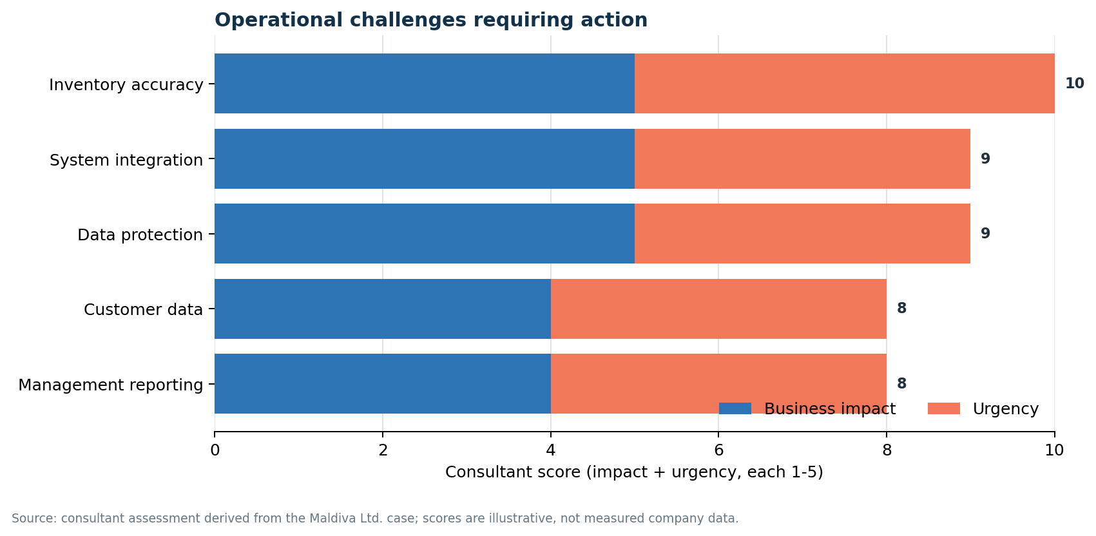
Figure 1. Operational challenges requiring action. Scores are consultant estimates from the fictional case (1 = low; 5 = very high), not measured company data; see Appendix D.
This proposal recommends a phased, cloud-based Microsoft Dynamics 365 retail platform. Commerce, Supply Chain Management and Finance would connect sales, stock and accounting; Customer Insights would unify customer profiles; Power BI would provide governed dashboards; and Microsoft Entra would control access. A shared data environment would standardise processes across stores, e-commerce and back-office teams, improving control and supporting growth.

2. Methodology
A qualitative, desk-based case-study method was used. The Maldiva scenario identified five connected problems: inventory, customer data, reporting, security and departmental integration. Current arrangements were then assessed against academic literature, official data-protection and cyber-security guidance, and vendor documentation published between 2021 and 2026. This provides an evidence-based basis for evaluating system gaps and selecting a solution.
Options were assessed for business fit, integration, scalability, security and implementation risk. Because digital transformation requires coordinated change across technology, processes, data and people (Plekhanov, Franke and Netland, 2023), the evaluation uses TAM to test perceived usefulness and ease of use, and TCO to compare five-year direct and indirect costs. As Maldiva is fictional, estimates and targets require validation during discovery and pilot testing.
Because the case contains no transaction records or staff interviews, the assessment cannot calculate actual stock variance, cancellation rates, data-quality levels or implementation cost. The proposed priorities are therefore planning assumptions rather than audited results. During discovery, Maldiva should triangulate system logs, financial records, customer complaints and employee interviews, establish a baseline for each KPI, and revise the recommendations where evidence contradicts the initial diagnosis.

3. Evaluation of Existing Systems
Maldiva Ltd.'s current arrangements do not operate as a coherent information system. Effective systems integrate technology, data, people and processes to support operations and management (Laudon & Laudon, 2022). By contrast, Maldiva's technology is fragmented, data is duplicated, employees rely on manual workarounds and processes are not controlled from end to end. Consequently, the company has no single source of truth for stock, customers or sales, which weakens both operational efficiency and management decision-making.
The five problems are interdependent rather than separate. Inaccurate inventory affects online promises, refunds, financial postings, and management reports; fragmented customer records weaken both marketing and service; and manual transfers create security and accuracy risks. Treating only one symptom would shift work to another department. The solution must therefore combine process redesign, shared data definitions, integration controls and staff accountability, with inventory and security addressed first because their operational and regulatory consequences are greatest.

Table 1. Summary of system gaps and required capabilities
Current system | Main gap | Business effect | Required capability
Manual inventory | No live, network-wide stock position | Overselling, excess stock, refunds and delays | Real-time inventory, reservations and replenishment
Disconnected customer files | Duplicate and incomplete profiles | Generic marketing and slow complaint handling | Unified profile, consent and service history
Spreadsheet reporting | Errors, inconsistent definitions and delay | Weak forecasting and missed opportunities | Governed dashboards and shared KPIs
Weak access and manual transfers | Limited control, audit trail and integration | GDPR, cyber and operational risk | Role-based access, MFA, APIs and logs

3.1 Inventory and order processing
Manual updates cannot capture sales, returns, transfers and reservations in real time. The website may therefore sell an item after the last store unit is gone, causing refunds and dissatisfaction. Limited visibility also leaves stock unused in one location while another loses sales. Maldiva needs a network-wide inventory record with automatic replenishment and exception alerts.

3.2 Customer relationship management
Separate sales, marketing and support applications create duplicate or incomplete customer records, preventing reliable segmentation and delaying complaint checks. An integrated CRM would provide one customer view and coordinated service. Maldiva must also define data ownership, consent and service procedures because software alone cannot create a reliable shared process.

3.3 Reporting, security and integration
Spreadsheet reporting creates version conflicts, formula errors and delays, so information may be outdated before managers receive it. Business intelligence will improve forecasting only if source data and KPI definitions are governed. Otherwise, faster dashboards will reproduce existing inconsistencies rather than correct them.
Maldiva's weak security controls also create compliance and operational risk. Organisations must protect integrity, confidentiality and accountability through appropriate technical and organisational measures (ICO, 2023; 2026a). Manual transfers increase exposure because customer and business data may remain in local files or email attachments. The financial significance is substantial: the global average cost of a data breach was estimated at US$4.4 million in 2025 (IBM, 2025). Preventive governance therefore protects both regulatory compliance and business value.

4. Recommended Solution
Maldiva should implement an integrated Dynamics 365 retail environment rather than purchase separate replacements for each problem. ERP systems create the greatest value when common processes and shared data connect business functions. Dynamics 365 Commerce integrates digital, store and back-office retail components within the wider Dynamics ecosystem (Microsoft, 2026a), making it suitable for Maldiva's multi-channel operations. The proposed architecture would connect point-of-sale terminals, e-commerce, inventory, finance, marketing and customer service through controlled interfaces and a common data model.
Integration should be governed through documented APIs, master-data rules and automated reconciliation rather than informal spreadsheet exports. Each transaction needs a clear owner, validation rule and audit trail, while failed messages must enter a monitored exception queue. This design would reduce duplicate entry and make errors visible before they affect customers or financial reporting. It would also allow future stores or channels to join the same controlled operating model without recreating disconnected systems.
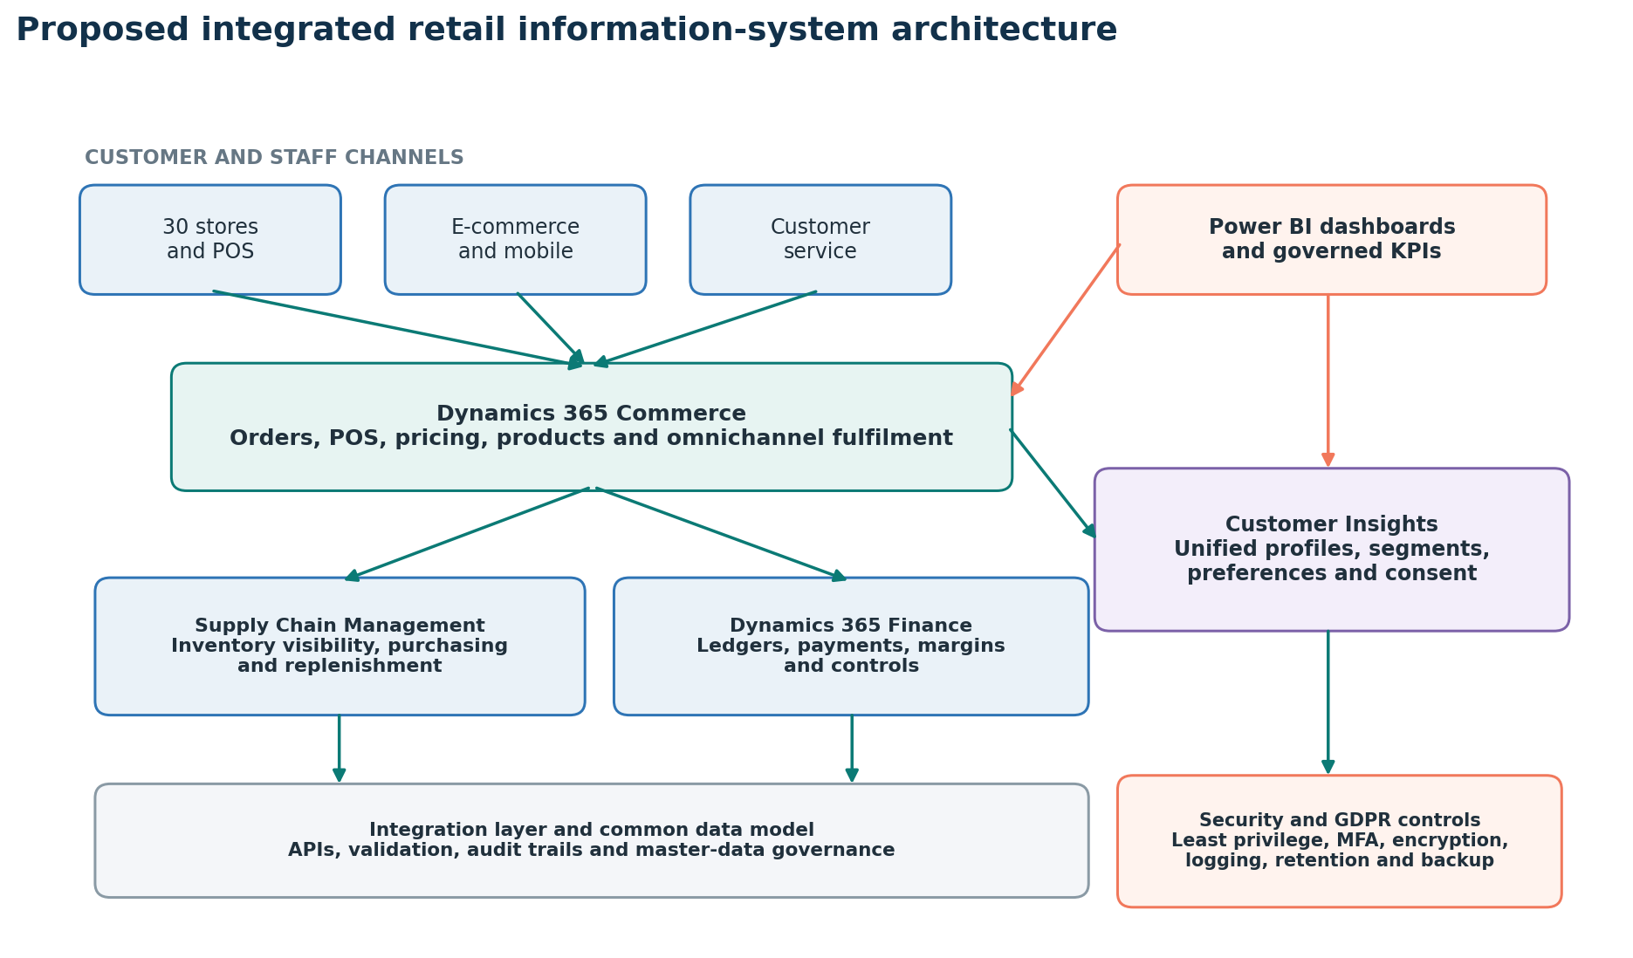
Figure 2. Proposed integrated retail information-system architecture.

4.1 Real-time inventory and omnichannel fulfilment
Dynamics 365 Supply Chain Management should become the authoritative inventory record, while Commerce manages store and online transactions. The Inventory Visibility service can post and track on-hand changes across data sources and channels in real time (Microsoft, 2025a). This capability would update stock availability after every sale, return, transfer or reservation, reducing the delay that currently causes overselling and discrepancies. It would also give managers a reliable, network-wide view of inventory.
Reservations and channel allocation would display accurate availability and route orders to the location able to fulfil them. Commerce supports pickup and delivery orders (Microsoft, 2026b), strengthening click-and-collect and cross-store fulfilment. Replenishment alerts would help managers balance shortages and excess stock, improving availability and satisfaction.
Sales, returns and transfers should update inventory and finance automatically, removing duplicate entry and improving fulfilment and margin reporting. Exception workflows should flag negative stock, failed integrations and unusual refunds so errors are reviewed promptly rather than remaining hidden.

4.2 Unified CRM and customer service
Customer Insights should combine store, e-commerce, campaign and support data into one governed profile. Its data-unification capability matches sources and removes duplicates (Microsoft, 2025b). Data stewards must review uncertain matches and correction requests because automated matching cannot replace human accountability.
Consent and preference data would support segments such as recent buyers, inactive customers and high-value repeat purchasers. Marketing could send relevant promotions, while service agents could see orders, returns and complaints in one workspace, improving personalisation and resolution time.
Customer personalisation must remain proportionate, transparent and lawful. Maldiva should define a lawful basis for each processing purpose, minimise the fields collected, record marketing preferences and apply retention schedules. Privacy by design should continue from initial system design through live operation (ICO, 2026b); therefore, predictive recommendations must be tested for bias and monitored after deployment. Sensitive data should be excluded unless the company can demonstrate a justified purpose and appropriate safeguards.

4.3 Business intelligence and decision-making
Power BI should replace manually consolidated spreadsheets with role-based dashboards connected to Dynamics (Microsoft, 2024). Executives could monitor sales, margin and forecasts; store managers could track availability and returns; and buyers could assess demand and suppliers. A governed semantic model must define measures such as net sales and available stock consistently.
Alerts could identify unusual sales, rising cancellations or low stock. Forecasts should combine transaction history, seasonality and promotions, while managers retain oversight. Displaying data quality, refresh status and assumptions would prevent polished dashboards from creating false confidence.

4.4 Security, cost and scalability justification
Least-privilege access should give each role only the functions and records required. Maldiva should require multi-factor authentication for privileged and remote access, encrypt data in transit and at rest, maintain audit logs, test backups and review permissions. These controls reduce unauthorised access and strengthen accountability.
Technical controls require formal privacy and resilience processes. Since multi-factor authentication is stronger than passwords alone (NCSC, 2024), Maldiva should combine it with a Data Protection Impact Assessment, processor-contract review and tested incident response before migration. This would demonstrate compliance and improve response to security events.
Named owners should govern product, customer, supplier, price and location data, approving definitions and corrections. Automated validation should block invalid records, while dashboards monitor duplicates, missing fields and failed interfaces. Integration creates control only when data is accurate, consistently defined and responsibly managed.
Vendor selection should test both functional capability and delivery risk. Before contract award, shortlisted suppliers should demonstrate an online order, store sale, return, stock transfer, complaint and finance posting using Maldiva-like data. Evaluation criteria should include integration, service levels, UK data location, disaster recovery, accessibility, delivery capacity and exit provisions. Reference checks with similar retailers should then confirm whether each supplier can perform at realistic scale.

4.5 TAM and TCO Model Evaluation
Staff adoption should be assessed through the Technology Acceptance Model (TAM). Adoption intention is influenced by perceived usefulness and perceived ease of use (Nagy & Hajdu, 2021). For Maldiva, usefulness would mean faster stock checks, less repeated entry and clearer decisions, while ease of use would require simple, role-based workflows. Pilot surveys should score both constructs from 1 to 5 alongside task-completion time, errors and active use. Weak results should trigger interface, training or process improvements before wider rollout.
A five-year Total Cost of Ownership (TCO) model should compare the complete cost of each option. It should include licences, configuration, integration, data cleansing, devices, migration, training, support, upgrades, security, downtime and exit costs. Cost-estimation guidance also includes operating skills, training and process change (Microsoft, 2025c), so all suppliers must price the same scope and growth assumptions. Savings from fewer refunds, reduced manual work and better stock use should remain in separate return-on-investment and payback calculations. Licensing can then follow demonstrated need (Microsoft, 2026c), avoiding unnecessary modules during the pilot.
Stand-alone tools may cost less initially but preserve integration and governance problems; a custom platform offers control but increases development and maintenance risk. Dynamics therefore provides the best balance of business fit, scalability, efficiency and manageable risk for a 30-store retailer.

5. Implementation Plan

5.1 Phased delivery
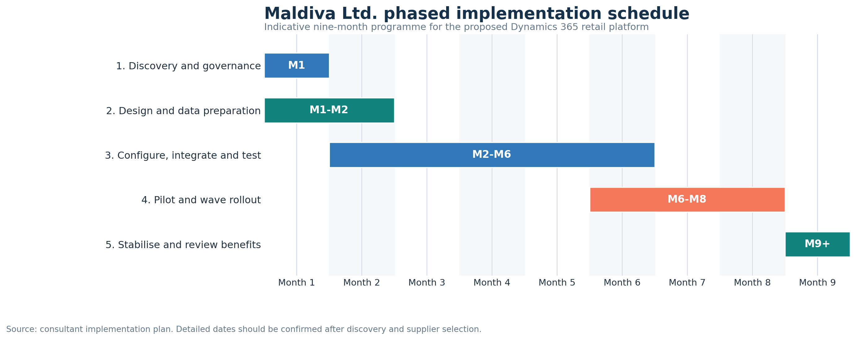
Figure 3. Indicative nine-month implementation Gantt chart.
Figure 3 organises the implementation into five controlled phases. Discovery establishes scope, governance and baseline measures in month 1, while design and data preparation continue into month 2. Configuration, integration and testing occupy months 2-6 because the full platform must operate reliably before deployment. The pilot and wave rollout follow during months 6-8, with stabilisation and benefits review beginning in month 9. This sequence creates clear approval points, supports accountability and reduces disruption to stores and online sales.
Progression between phases should depend on evidence, not the calendar alone. Before pilot approval, migrated balances must reconcile, priority security tests must pass, and key store workflows must meet agreed accuracy and response-time thresholds. Before wider rollout, pilot users should demonstrate acceptable TAM results and unresolved critical defects should be zero.

Phase 1 - discovery and governance (month 1): appoint sponsors and process owners, map current processes, confirm scope, baseline performance and approve success measures covering stores, online sales, finance, service and security.
Phase 2 - design and data preparation (months 1-2): define data, interfaces, access, retention and reporting rules. Clean product, supplier, customer, and inventory records; remove duplicates; and test migration samples before moving data.
Phase 3 - configuration, integration and testing (months 2-6): configure the Dynamics applications and Power BI, connect e-commerce, payments, store hardware and delivery services, then complete integration, security, performance and user-acceptance tests.
Phase 4 - pilot and rollout (months 6-8): pilot three representative stores and the online channel, reconcile stock and finance, resolve priority issues and approve go-live. Deploy remaining stores in waves with rollback and enhanced support.
Phase 5 - stabilisation and benefits review (month 9 onward): monitor integrations, data quality, support and adoption. Compare inventory accuracy, cancellations, reporting time, service performance and benefits against the month 1 baseline.

5.2 Training and risk management
Training should be role-based and timed to each wave. Staff should practise transactions, returns, stock, customer profiles, consent and dashboards according to role. TAM results should identify weak usefulness or ease of use, while short guides, a sandbox, super-users and floor support address barriers before deployment.
Key risks are resistance, poor data, integration failure, disruption, scope growth and underestimated cost. Maldiva should use visible leadership, user involvement, reconciliation, testing, phased rollout, change control and contingency funding. Owners must monitor inventory accuracy, cancellations, processing and reporting time, complaint resolution, adoption and security incidents.

6. Conclusion
Maldiva's fragmented stock, customer, reporting and security systems cannot support omnichannel growth. Integrated Dynamics 365 and Power BI would provide real-time inventory, unified profiles, governed dashboards and connected processes. A phased rollout, supported by TAM, TCO, data governance, security and training, would control risk and provide a scalable foundation for better service and future growth.

Reference List
IBM (2025) Cost of a Data Breach Report 2025. Available at: https://www.ibm.com/reports/data-breach (Accessed: 26 July 2026).
Information Commissioner's Office (ICO) (2023) A guide to data security. Available at: https://ico.org.uk/for-organisations/uk-gdpr-guidance-and-resources/security/a-guide-to-data-security/ (Accessed: 26 July 2026).
Information Commissioner's Office (ICO) (2026a) A guide to the data protection principles. Available at: https://ico.org.uk/for-organisations/uk-gdpr-guidance-and-resources/data-protection-principles/a-guide-to-the-data-protection-principles/ (Accessed: 26 July 2026).
Information Commissioner's Office (ICO) (2026b) Data protection by design and by default. Available at: https://ico.org.uk/for-organisations/uk-gdpr-guidance-and-resources/accountability-and-governance/guide-to-accountability-and-governance/data-protection-by-design-and-by-default/ (Accessed: 26 July 2026).
Laudon, K.C. & Laudon, J.P. (2022). Management Information Systems: Managing the Digital Firm. 17th edn. Harlow: Pearson.
Microsoft (2024) Connect to the services you use with Power BI. Available at: https://learn.microsoft.com/en-us/power-bi/connect-data/service-connect-to-services (Accessed: 26 July 2026).
Microsoft (2025a) Inventory Visibility Add-in overview. Available at: https://learn.microsoft.com/en-us/dynamics365/supply-chain/inventory/inventory-visibility (Accessed: 26 July 2026).
Microsoft (2025b) Data unification overview - Dynamics 365 Customer Insights. Available at: https://learn.microsoft.com/en-us/dynamics365/customer-insights/data/data-unification (Accessed: 26 July 2026).
Microsoft (2025c) Plan your Azure environment for cost estimation. Available at: https://learn.microsoft.com/en-us/azure/cloud-adoption-framework/plan/estimate-total-cost-of-ownership (Accessed: 3 August 2026).
Microsoft (2026a) Dynamics 365 Commerce architecture overview. Available at: https://learn.microsoft.com/en-us/dynamics365/commerce/dev-itpro/commerce-architecture (Accessed: 26 July 2026).
Microsoft (2026b) Customer orders in point of sale (POS). Available at: https://learn.microsoft.com/en-us/dynamics365/commerce/customer-orders-overview (Accessed: 26 July 2026).
Microsoft (2026c) Dynamics 365 pricing overview. Available at: https://www.microsoft.com/en-gb/dynamics-365/pricing-overview (Accessed: 26 July 2026).
Nagy, S. & Hajdu, N. (2021). 'Consumer acceptance of the use of artificial intelligence in online shopping: evidence from Hungary', Amfiteatru Economic, 23(56), pp. 155–173. doi: 10.24818/EA/2021/56/155.
National Cyber Security Centre (NCSC) (2024) Multi-factor authentication for your corporate online services. Available at: https://www.ncsc.gov.uk/collection/mfa-for-your-corporate-online-services (Accessed: 26 July 2026).
Plekhanov, D., Franke, H. & Netland, T.H. (2023). 'Digital transformation: A review and research agenda', European Management Journal, 41(6), pp. 821–844. doi: 10.1016/j.emj.2022.09.007.

Appendix A: Detailed Implementation Schedule
The schedule expands the nine-month Gantt chart in Figure 3. Detailed dates should be confirmed after discovery and supplier selection.
Phase | Timing | Main activities | Output/approval
1. Discovery and governance | Month 1 | Appoint sponsor and team; map processes; confirm scope, risks, baseline KPIs and data-protection responsibilities. | Approved requirements, governance and baseline.
2. Design and data preparation | Months 1-2 | Design the data model, interfaces, roles, retention rules and reports; cleanse product and customer data. | Solution blueprint and migration plan.
3. Configure, integrate and test | Months 2-6 | Configure Dynamics 365 and Power BI; build APIs; rehearse migration; complete security, performance and user testing. | Tested release approved for pilot.
4. Pilot and rollout | Months 6-8 | Pilot the online channel and three stores; reconcile stock and finance; deploy remaining stores in controlled waves. | Production rollout and operational acceptance.
5. Stabilise and review benefits | Month 9 onward | Resolve defects; monitor data quality and adoption; compare results with KPI targets; transfer ownership to operations. | Closure report and benefits plan.
Table 2. Detailed implementation schedule.

Appendix B: KPI and Benefits Framework
Baseline values should be measured in month 1. The named owner should confirm each definition, data source and reporting frequency before the steering group approves the final target.
KPI | Baseline | Six-month target | Owner | Frequency
Inventory accuracy | Measure in month 1 | At least 98% | Inventory Director | Weekly
Stock-error cancellations | Measure in month 1 | 40% reduction | E-commerce Manager | Weekly
Manual report preparation time | Measure in month 1 | 70% reduction | BI Lead | Monthly
Customer-record lookup time | Measure in month 1 | 50% reduction | Service Manager | Monthly
Trained-user adoption | Not applicable | At least 90% active use | Change Lead | Weekly after go-live
Access reviews completed | Measure in month 1 | 100% | Security Lead | Quarterly
Table 3. Proposed KPI and benefits framework.

Appendix C: Implementation Risk Register
Likelihood and impact use a 1-5 scale. Risk score equals likelihood multiplied by impact. The register should be reviewed at every steering-group meeting.
Risk | L | I | Score | Main mitigation | Owner
Poor data quality | 4 | 5 | 20 | Cleanse, deduplicate, reconcile and obtain owner sign-off. | Data Lead
Integration failure | 3 | 5 | 15 | End-to-end tests, monitoring, message queues and rollback plan. | Technical Lead
Staff resistance | 3 | 4 | 12 | Super-users, role training, practice and feedback. | Change Lead
Cost or scope growth | 3 | 4 | 12 | Stage gates, change control and contingency funding. | Project Manager
Cyber or privacy incident | 3 | 5 | 15 | DPIA, RBAC, MFA, encryption, logs and incident testing. | Security Lead
Sales disruption at cutover | 2 | 5 | 10 | Pilot, wave rollout, floor support and rollback criteria. | Operations Lead
Table 4. Implementation risk register.

Appendix D: Figure 1 Scoring Basis
Maldiva Ltd. is fictional, and the assignment case provides no measured operational data. Figure 1 therefore uses a qualitative consultant assessment based only on the problems stated in the case. Business impact and urgency are each rated from 1 (low) to 5 (very high). The total priority score is calculated as business impact plus urgency, giving a possible range from 2 to 10. The scores are transparent planning assumptions and must be validated during discovery using company records and stakeholder evidence.
Table 5. Evidence and scoring basis for Figure 1.
Challenge | Case evidence and scoring justification | Impact (1-5) | Urgency (1-5) | Total
Inventory accuracy | Manual stock records cause discrepancies, online overselling, refunds, complaints, overstock or understock, and fulfilment delays. The problem has very high operational and customer impact and is already occurring during rapid growth. | 5 | 5 | 10
System integration | Sales, finance and inventory teams use separate software and transfer data manually, creating delays and errors. This affects transactions across the business and restricts efficient expansion, so impact is very high, and urgency is high. | 5 | 4 | 9
Data protection | The case states that Maldiva is not fully GDPR-compliant and lacks secure access controls. Possible breaches, penalties and reputational damage create very high impact; urgency is high because no confirmed breach is reported. | 5 | 4 | 9
Customer data | Disconnected records prevent purchase-history tracking, targeted promotions and efficient complaint handling. The effect on service and revenue is high and already visible, although it is less critical than inventory and legal exposure. | 4 | 4 | 8
Management reporting | Manual spreadsheets contain errors and outdated data, slowing decisions, weakening forecasts and losing opportunities. Impact and urgency are high, although operations can continue temporarily while live dashboards are introduced. | 4 | 4 | 8
Source: Consultant analysis of the Maldiva Ltd. business case supplied in the assignment brief. Scores are illustrative and require validation during discovery.
During implementation, Maldiva should replace these illustrative scores with verified evidence from inventory variance reports, order cancellations and refunds, CRM data-quality checks, report-production times, security audits and integration error logs.

