
Module code: LCLM 5005
Module: Organizational Culture
Module Leader:
Rameses Manalang
Assignment Title: Component 1
Organizational Culture Report: John Lewis Partnership
Student Name: Yasmin Hussain
Student ID: 2334056

Table of Contents
Introduction 3
Organisational Culture of John Lewis 3
How Organisational Culture Helps Shape the Company’s Structure and Decision-Making 5
Relevant Frameworks, Models or Theories 6
Organisational Culture and Adaptation to the External Environment 9
Organisational Culture and Effective Functioning 10
Evaluation of the Impact of Organisational Culture on Organisational Performance 12
Conclusion 13
References 15

Introduction
Organizational culture may be defined as a collection of beliefs, values, behaviors and norms on which the individuals present in the organization associate and perform their various duties. Culture affects the decision-making process and behavior of the employees as well as how organizations respond to internal and external problems (Mullins and Christy, 2016). The organizational culture can influence employee motivation and organizational structure as well as long-term performance.
This report is a critical discussion of the organizational culture of the John Lewis Partnership, a large UK-based retail organization with its employee-ownership system and partnership philosophy. The report explores the characteristics of the organizational culture of the company and defines how the organizational culture affects the organizational structure and decision-making processes. Theoretical frameworks that relate are applied in the determination of the cultural traits in the organization.
In addition, the report looks at how the organization reacted to external environmental pressure by using organizational culture and whether the organizational culture is an enabler or a deterrent to the performance of the organization. Finally, the report is an analysis of the influence of organizational culture on the performance of the organization and recommendations on how this performance can be enhanced.

Organizational Culture of John Lewis
Organization culture is one of the determinants of how firms should operate and interact with other stakeholders and workers. The culture may be described as the manner of doing things within an organization, which is a collection of shared assumptions and behaviors that guide the manner of doing things at the workplace (Schein, 2010). Retail organizations’ culture can have an impact on the customer service level, level of staff engagement and leadership.
The John Lewis Partnership is said to have a distinct organizational culture, but this is founded on the principles of employee ownership and partnerships. The organization is a partnership structure with the employees being referred to as 'partners', i.e., they are the owners of the business. This approach creates a spirit of accountability and commitment among the employees, and that results in the culture of teamwork within the workplace (John Lewis Partnership, 2024).
One of the most significant cultural factors of organizations is that it is possible to distinguish the emphasis on equality and mutual success. Employees also benefit from the scheme of profit-sharing since the company profits are divided among the partners and it enhances the concept of the collective approach to performance (Pendleton and Robinson, 2015). These practices strengthen the degree of employee contribution and instill a sense of belongingness in the organization.
Communication is another significant element of the organizational culture at John Lewis. The organization encourages a free flow of information between the staff members and the management through official channels of communication such as the Partnership Council and employee forums. The partners can express their opinions through these systems and participate in organizational discussion (CIPD, 2023).
Customer service is the other essential component of the company culture but is based on high quality. The retail employees are expected to take initiative when dealing with customer problems and when it comes to improved delivery service. This culture of being customer-orientated reflects the long-standing tradition of the organization to guarantee good relationships with the customers (Berman et al., 2018).
The organizational culture is also characterized by close ethical values and social responsibilities. The company attaches the spirit of sustainability, ethical sourcing and responsible business behavior, and this is in line with the general expectations of corporate responsibility in society (Crane and Matten, 2021).
However, there are also barriers to organizational culture. Very high cultural practices in some cases may result in failure of organizations to implement quick strategic changes. Particularly, it applies to retail businesses because companies must be quick to respond to the new technology and alterations in consumer behaviors (Hatch and Cunliffe, 2019).
Generally, the organizational culture within John Lewis has been characterized by the involvement of employees and positive ethical practices as well as customer service. These cultural elements have helped to create the image of the organization and eventually made it successful in the competitive UK retail market.

How Organizational Culture Helps Shape the Company’s Structure and Decision-Making
The organizational culture has a direct influence on the way organizations structure their activities and endeavors and strategic choices. Culture determines leadership, communication trends and level of involvement of employees in organizations (Daft, 2020).
The John Lewis Partnership has an exclusive organizational structure that is highly influenced by partnership culture. John Lewis has a democratic management structure that contributes to the fact that employees are involved in the governance processes as opposed to traditional retail companies that operate in hierarchical structures. This model is anchored on the belief by an organization that employees should have a say in the decisions that are taken regarding the business (Buchanan and Huczynski, 2019).
The company has representative organs such as the Partnership Council and Partnership Board by the government. Such groups provide channels upon which the corporate bodies representing the employees will receive an opportunity to be involved in the deliberations regarding the company strategy and policies. Such participatory constructions strengthen transparency and accountability in the organization (Wilkinson et al., 2020).
Organizational culture is also another determinant of decision-making in the company. Cooperation and consultation are another practice that leaders use when making a strategic decision. It is a participatory style which ensures that multiple perspectives are considered before the changes in organizations are undertaken (Northouse, 2021).
The company has a decentralized management structure, and accordingly, store managers and department heads can be enabled to make operational decisions depending on the customer’s needs at the local level. This flexibility will enable the organization to be more adaptive to the demands of the market and improve customer experience (Jones and George, 2022).
The participatory decision-making is, however, at times linked to slackening the organizational processes. In the decision-making process where top management are engaged with multiple stakeholders, there is a possibility that it will take longer than the traditional top-down management structure. Retail markets which are highly competitive can result in the organization becoming less responsive in case of slowness of decision-making (Mintzberg, 2009).
Despite this, the organizational structure of the company is still positive because of the cultural emphasis on partnership and collaboration. Employees would be more inclined to lend their support to the strategic initiatives, which in turn would boost commitment and trust in the organization when they realize that the strategic initiatives are made with them in mind (Robbins and Judge, 2022).
Therefore, the organizational culture of John Lewis plays a significant role in shaping its structural design, not to mention that it affects the processes of making decisions. The partnership model encourages openness, teamwork and employee participation that makes the organization different compared with most traditional retail competitors.

Relevant Frameworks, Models or Theories
To understand organizational culture, theoretical frameworks must be used that describe how culture develops and influences organizational behavior. Two of the most popular models of organizational culture analysis are Schein's Model of organizational Culture and Culture Types by Handy.
Edgar Schein has proposed three levels of organizational culture that are artefacts, espoused values and underlying assumptions (Schein, 2010). The facts that it is observable and can be used to describe the culture that encompasses organizational structures, symbols, and behaviors at the workplace are known as artefacts.
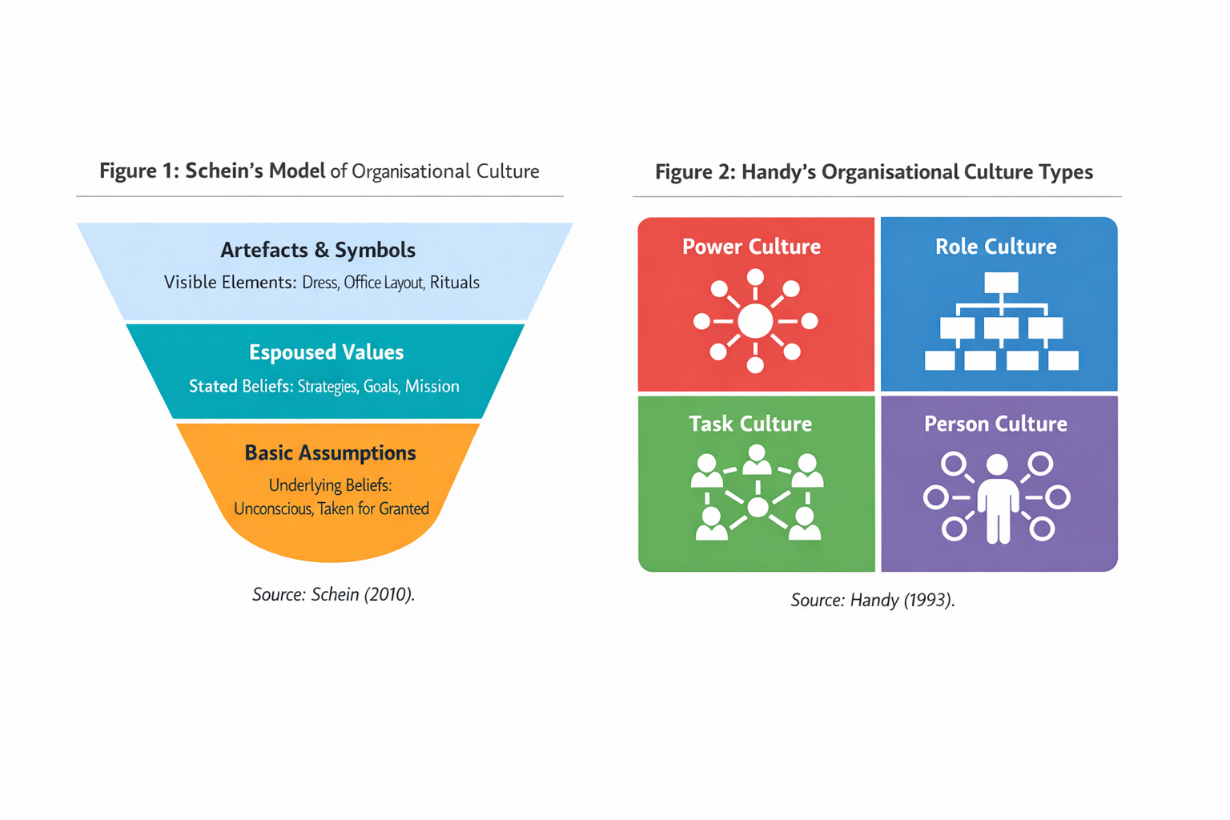
Figure 1: Schein’s Model of organizational Culture, (Schein, 2010).
Some of the artefacts within the John Lewis Partnership are the employee-ownership structure, the referring of employees as partners and the presence of democratic governance structures. These evident attributes demonstrate the fact that the organization is concerned with equality and involvement of employees (Johnson et al., 2017).
The second level of the Schein model is the level of espoused values that are the organizational values and the organizational philosophies. Such values include fairness and respect and mutual success, which are the focus of John Lewis. The policies such as profit-sharing and employee engagement programmers also reflect some of these values (Armstrong, 2020).
Basic underlying assumptions are on the lowest level of culture. A critical assumption that is taken in the case of John Lewis is that motivated employees can deliver better customer services and improve the performance of the organization. This is the assumption that can be traced in the emphasis of the company on employee welfare and workplace participation (Alvesson, 2013).
Another model that can be applied in studying the culture of organizations was developed by Charles Handy, and this is known as the Handy cultural types. Handy identified four types of culture: power culture, role culture, task culture and personal culture (Handy, 1993).
Figure 2: Handy’s organizational Culture Types, (Handy, 1993).
The John Lewis organization culture has indications of role culture that dwells on structured responsibilities and specific organizational roles. The structures of governance in the partnership give out the allocation of duties within the different levels of the management.
At the same time, certain elements of the task culture are also evident in the team-based activity that is geared towards improving customer service and innovation. Task culture is premised on teamwork and problem-solving, where employees work in groups in a bid to achieve organizational goals (Cameron and Quinn, 2011).
Through these models, John Lewis has a hybrid culture of structured governance and teamwork. These qualities enable the organization to be capable of being at its level of operational stability, also encouraging the involvement of the employees and innovation.

organizational Culture and Adaptation to the External Environment
In the present business environments, organizations are forced to continuously adapt to external forces that encompass changes in technology, changes in economics and the increase in competition. The organizational culture can identify how companies respond to these external challenges (Kotter, 2012).
The John Lewis Partnership is an organization that is in a highly competitive retail business, which has experienced significant changes with the advent of online shopping and digital technologies. The new digital strategies have also been adopted by the organization to remain competitive by not forsaking its old traditional values of partnership (Deloitte, 2023).
The organizational culture of teamwork encourages the employees to share knowledge and innovations. The partners would also be encouraged to make suggestions on how the products, services and processes could be improved. This kind of organizational culture of openness enables the organization to react to the changing consumer demands in a more efficient manner (Burnes, 2017).
The new trend in consumer behavior is online shopping, particularly following the economic shocks that have been witnessed across the globe as well as technology. To respond to this, the organization has been expanding its online retail solution and investing in online infrastructure to make customer convenience more convenient (PwC, 2024).
Another aspect that defines the welcome of change initiatives by the employees is the organizational culture. The strategic changes will be endorsed by employees who trust leadership and feel a part of a process of making organizational-level decisions. This is particularly during the organizational change (Kotter and Schlesinger, 2008).
Nevertheless, there is a risk that outside forces will become an issue during the adaptation process. The organizational traditions are high, and this could lead to resistance to change, particularly where the employees have been accustomed to the usual practice. To deal with cultural change, then, effective leadership and clear communication are required (Senior and Swailes, 2016).
However, the partnership culture of John Lewis can guarantee organizational resilience despite the challenges. Engaged and valued employees are more in a position to protect innovation and assist organizations in adjusting.
Generally, organizational culture is relevant in enabling John Lewis Partnership to respond fittingly to the external environmental forces such as technological change, competition in the market, and evolving consumer behavior. At the same time, the organization retains its core values of partnership, interaction with the employees and customer service that allow it to be versatile and preserve the ethical and collaborative corporate philosophy of the company since its founding.

organizational Culture and Effective Functioning
The organizational culture has the capacity to inspire the performance of the organizational activities significantly. The culture of encouragement may boost employee motivation, teamwork and productivity, and vice versa, in a similar manner that may cause hiccups to performance (Deal and Kennedy, 2000). Culture is a guide that the employees can perform against working relationships and the achievement of the organizational goals. The more organizational values are communicated and shared between the employees, the more willing they will be to work in teams and make a positive contribution to organizational goals.
It can be explained with reference to the John Lewis Partnership as an example of how organizational culture might also be considered as the means of facilitating effective functioning. The partnership model also leaves the employees with the perception that they own the success of the organization, and it prevents commitment and accountability (Story, 2016). The employees are perceived to be partners in the business and hence are more responsible for the outcomes of the organization. This type of ownership that is widespread helps in the fact that the employees are trying to address the goal of long-term success instead of addressing individual performance.
Another notable area that influences the efficiency of the organizations is involvement of the employees. When its employees believe that they are respected and regarded highly in the workplace, then they are likely to depict high motivation and even job satisfaction. The partnership culture at John Lewis advocates engagement whereby the employees are given a chance to engage in decision-making or organizational discussions (Kahn, 1990). Such involvement helps in building a feeling of belonging and empowerment that can result in a higher level of productivity and more workers' commitment.
The teamwork and collaboration culture is also high in the organization. The employees have been conducting cross-departmental work with the intention of enhancing the quality of services offered and the proper management of the organization. This form of cooperation will allow disseminating knowledge and assisting employees in the manner of formulating solutions to customer service issues. This translates to the customer satisfaction levels in the competitive retail market and the organization being high (Schneider et al., 2013).
However, the potential barriers may also be caused by the organizational culture. Conflict The form of governance practiced in the company is participatory and may delay the decision-making processes in scenarios where urgent decision-making is needed. Strategy decisions can be postponed in industries where speed and innovation are important determinants, a factor that could lead to the lack of competitiveness of the organizations (Tushman and O'Reilly, 1997).
The next possible weakness is the inability to be culturally coherent in various stores. As larger organizations develop and become bigger, the harder it becomes to ensure that every single employee share cultural values and is led by them (Schein and Schein, 2017).
Nevertheless, with these issues, the organizational culture in general of the John Lewis Partnership leans towards good operation. The partnership model is responsible for holding the employees accountable, fostering teamwork and dedicating them to their responsibilities, and this has a positive impact on organizational performance and sustainability.

Evaluation of the Impact of organizational Culture on organizational Performance
The organizational culture directly affects the organizational performance because it determines how workers behave and the rapport, they share with their customers as well as how they make strategic decisions. A well-being and strong culture also assist in aligning the workers to the goal of the organization, promoting teamwork and increasing high quality of service. Researchers have pointed out that good culture organizations are more productive and have high employee commitment and job satisfaction, which eventually leads to enhancement of the performance of the organizations (Denison, 1990).
John Lewis Partnership can be referred to as one of the success stories of the impact that organizational culture can have on performance results. The employee-ownership model also makes partners actively involved in ensuring that the organization succeeds since they also benefit financially from the success achieved through performance improved by working better. It is this sense of group benefits that makes employees work at high levels of good services and be useful to organizational interests (Blasi et al., 2014).
Quality in customer service is also dependent on the culture. The engaged and appreciated employees will provide great customer experience. John Lewis's service-based culture has afforded it a high reputation for reliability and trust in the retail market in the UK (Heskett et al., 2008).
Another organizational culture factor is brand identity and competition advantage. A company that is morally upright and has a healthy working atmosphere will likely attract clients who will be loyal to the company and competent employees (Barney, 1986).
However, there are other extrinsic forces that may shape the performance of an organization such as economic environment, industry rivalry and technological turmoil. The retail organizations are encouraged to continue revising their strategies to generate quickly evolving markets (Porter, 2008).
With John Lewis, there is a need to strike a balance between tradition and innovation, in which long-term success is considered. Despite all the benefits of the partnership model, the organization must continue to develop its culture to remain in line with the transforming times in retail issues.
Overall, the organizational culture at John Lewis Partnership has been instrumental in the organization maintaining its performance over a long period of time, positive brand image, and the involvement of staff. The partnership model will enhance collaboration, duty and collective well-being, this will contribute to the retention of the customers, and organizational stability in the competitive retail market.

Conclusion
It has evaluated the organizational culture of the John Lewis Partnership and discussed the role played by organizational culture in determining organizational structure, decision-making and overall performance.
As the analysis has demonstrated, the model of partnership followed by the company established favors employee involvement and collaboration with each other and shared responsibility. The theoretical frameworks of Schein and Handy were used to shed light on how the cultural values were entrenched in the structure of the governance in the organization as well as their practices in the workplace.
The other element that the report discussed is how organizational culture has helped the company adapt to external environmental forces like technological change and consumer behavior change. Although it is true that the participatory culture corresponds to numerous positive outcomes, it can also present another issue of the decision-making rate and agility rate of organizations.
Comprehensively, John Lewis' organizational culture is a facilitator of good practices and organizational performance. By balancing its long-term principles of partnering with people and business innovation, the organization can remain successful in the long term in the competitive retail industry.

References
Alvesson, M. (2013). Understanding Organizational Culture. Sage.
Armstrong, M. (2020). Armstrong’s Handbook of HRM Practice. Kogan Page.
Barney, J. (1986). Organizational culture as a competitive advantage. Academy of Management Review. https://doi.org/10.5465/amr.1986.4306261
Berman, B., Evans, J. and Chatterjee, P. (2018). Retail Management. Pearson.
Blasi, J., Freeman, R. and Kruse, D. (2014). The Citizen’s Share. Yale University Press.
Buchanan, D. and Huczynski, A. (2019). Organizational Behavior. Pearson.
Burnes, B. (2017). Managing Change. Pearson.
Cameron, K. and Quinn, R. (2011). Diagnosing and Changing organizational Culture. Jossey-Bass.
CIPD (2023). Employee Engagement Factsheet. Available at: https://www.cipd.org/uk/knowledge/factsheets/engagement-factsheet/
Crane, A. and Matten, D. (2021). Business Ethics. Oxford University Press.
Daft, R. (2020). Organization Theory and Design. Cengage.
Deal, T. and Kennedy, A. (2000). Corporate Cultures. Basic Books.
Denison, D. (1990). Corporate Culture and Organizational Effectiveness. Wiley.
Deloitte (2023). UK Retail Industry Outlook. Available at: https://www.deloitte.com/global/en/Industries/consumer/analysis/global-powers-of-retailing.html
Hatch, M. and Cunliffe, A. (2019). Organization Theory. Oxford.
Heskett, J. et al. (2008). The Service Profit Chain. Harvard Business School Press. Available at: https://www.hbs.edu/faculty/Pages/item.aspx?num=284
Johnson, G. et al. (2017). Exploring Strategy. Pearson.
Jones, G. R., & George, J. M. (2022). Contemporary management (11th ed.). McGraw-Hill Education.
Kahn, W. (1990). Psychological conditions of personal engagement. Academy of Management Journal. https://doi.org/10.5465/256287
Kotter, J. (2012). Leading Change. Harvard Business Review Press.
Mintzberg, H. (2009). Managing. Berrett-Koehler.
Mullins, L. and Christy, G. (2016). Management and organizational Behavior. 11th ed. Harlow: Pearson Education Limited.
Northouse, P. G. (2021). Leadership: Theory and practice (8th ed.). Sage Publications.
Pendleton, A. and Robinson, A. (2015). Employee Ownership in Britain Today. Interim Findings From the 2014-15 Employee Ownership Survey. http://dx.doi.org/10.2139/ssrn.2578921
Porter, M. (2008). Competitive Strategy. Free Press.
PwC (2024). Retail Trends Report.
Robbins, S. and Judge, T. (2022). organizational Behavior. Pearson.
Schein, E. and Schein, P. (2017). organizational Culture and Leadership. Wiley.
Schneider, B., Ehrhart, M. G., & Macey, W. H. (2013). Organizational climate and culture. Annual Review of Psychology, 64(1), 361–388. https://doi.org/10.1146/annurev-psych-113011-143809
Senior, B. and Swailes, S. (2016). organizational Change. Pearson.
Storey, J. (2016). Leadership in Organizations. Routledge.
Tushman, M. and O’Reilly, C. (1997). Winning Through Innovation. Harvard Business School Press. Available at: https://www.hbs.edu/faculty/Pages/item.aspx?num=200
Wilkinson, A. et al. (2020). The Oxford Handbook of Participation in Organizations. Oxford.

