
COACHING AND MENTORING WITHIN AN ORGANISATIONAL context
Written Reflection

March 4, 2022
Sanjeedah Rahman (1816790)
University of Wales Trinity Saint David
BA Leadership and Management Skills for the Workplace
BMSW6105

Executive Summary

This report is about coaching and mentoring within the organisation. How coaching and mentoring benefits the organisation and the employees.

Identifying what coaching and mentoring are in the workplace. Coaching and mentoring are not just for workplace, coaching and mentoring develop individual in different setting such as football.

Similarity and difference between coaching and mentoring and comparing it with other learnings. It has identified coaching and mentoring have similarity and difference with different approaches. While comparing with different learning, workplace-based and action learning, they have similarities the way they work with individuals.

The are tangible and intangible benefits of coaching and mentoring in workplace. Tangible benefits are lower cost, productivity, engage with employee and growth. Intangible benefits communication, confidence, better relationship and stability between life and work.

Line manager as coach/mentor, has the line manager got the skills to be a coach/mentor and the benefits of line manager being a coach/mentor.

Managing change within the organisation, how can coach/mentor help with the employees to manage change. Coach/mentor can implement a change management model to help the employees, by applying change management model Kubler Ross.

At the end of the report is how the research reflected on coaching session and prepared a PDP for future development.

Contents
Executive Summary 1
1.0 Introduction 3
2.0 Main Findings 4
2.1 Coaching and Mentoring 4
2.1.1 Coaching 4
2.1.2 Mentoring 5
2.1.3 Similarities and Differences of Coaching and Mentoring 5
2.1.4 Comparing Coaching and Mentoring with other two learning initiatives 6
2.1.5 Tangible and Intangible benefits of Coaching and Mentoring 6
2.2 Line Manager as Coaching/Mentoring 7
2.3 Building resilience and dealing with change 8
2.4 Reflection of being a Coach 9
3.0 Conclusion 12
Reference 13

1.0 Introduction

The purpose of this report is to evaluate of coaching and mentoring within the organisation, which will include the difference and similarity between coaching and mentoring. Comparing coaching and mentoring with other two learning initiatives, tangible and intangible benefits of coaching and mentoring to employer and employees. Looking at how line manager will be as coach/mentor, what skills and behaviours are required. How coaching and mentoring manages with resilience and change within an organisation. At the end of the report the researcher’s written reflection on experience as a coach or mentoring, which will conduct a Personal Development Plan along with the strength and weakness.

2.0 Main Findings

2.1 Coaching and Mentoring

2.1.1 Coaching

According to MacLennan (2017), coaching is not which can be teach, train or instruct. Coaching does not need to be someone from the expert field. Coach is a person who is available for an individual to learn with, which enables individuals to unlock their natural ability, to learn, perform and achieve. To identify the internal barriers by removing for achievement.

An example all sports has a coach, such as football team, the coach will help the team to improve their performance. According to Charles and Rock (2017), to deliver an exceptional coaching session the football coaches need a range of resources. The coaching session strengthens the youth players to achieve success and improvement.

According to CIPD (2021), coaching in the workplace is ideally to perform and make improvement, which focuses on an individual’s skills and goals. It was mentioned coaching can impact personal attributes of an individuals.

There are well known coaching models that can be utilise such as GROW model, OSCAR and Instant Pay-off. The most popular coaching model is the GROW, this framework was created by Sir John Whitmore in the late 1980s (Performance Consultants, 2019).

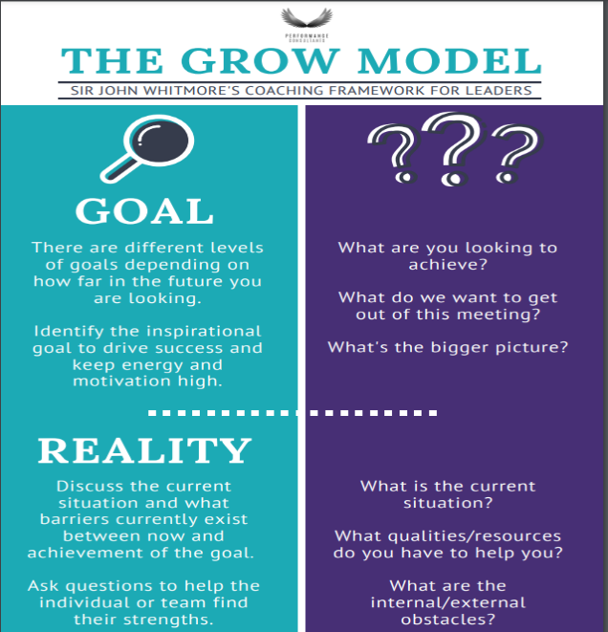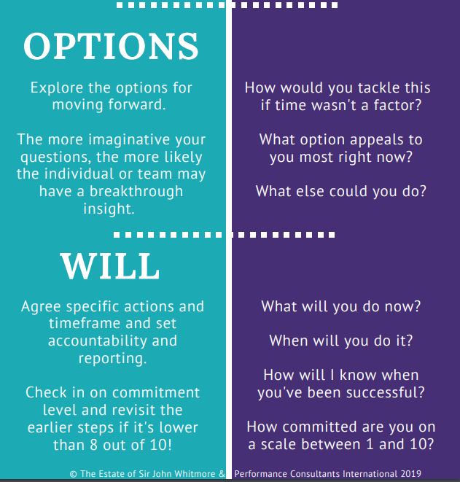
(Performance Consultants, 2019)
The model helps with coaching in stages, G – is for goal, setting a goal for the outcome which an individuals would like to achieve, once the goal has been set checking R – reality, this is to analyse the current situation to identify any obstacles which stop reaching the goal. Then the O – options exploring more and asking questions which will help the individuals to look beyond and discover the insight, the final is W -will, this is the action setting the timeframe and being committed, to achieve the goal.

2.1.2 Mentoring

According to Klasen and Clutterbuck (2012) mentoring is like assisting the individual, to learn, develop and improve performance. Mentor is aiding the individual to learn from the successes and failures from the past.

Mentoring is when an experience person advising or supporting an inexperience person. Mentoring is like a relationship of nature and intention (Starr, 2014). Mentoring is seen as a structured procedure inside an organisation that facilitates the professional development of a peer for the benefit of both the organisation and the individual (Kerry and Mayes, 2014).

2.1.3 Similarities and Differences of Coaching and Mentoring

According to McCarthy (2014), coaching and mentoring have similarities such as both helps the individual to improve their development and performance. McCarthy (2014) has mentioned the common skills between coaching and mentoring are listening, questioning, goal setting and feedback.

The differences between coaching and mentoring according to Clutterbuck (2016), coaching is a short-term and non-directive. As coaching is more task centered, skills focus and performance which primarily works with the line manager, the plans are agreed by both coach and coachee and feedbacks are given to coachee from the coach. Mentoring is long-term and is directive, it brings out the capability and potential of the mentee and the plans are decided by mentee.

In businesses coaching can coach without experience and expertise, as coaching is a skill. The approach is skilled by structured conversation and asking question. Whereas mentoring is knowledge, experience and expertise (Bates, 2022).

Coaching and Mentoring similarities according to Bates (2022) are:
- Supports development of individuals
- 1-1 communications
- Good personal understanding between the two parties
- Include meetings over several months
- Coming to agreement
- Incorporated into L&D programs

The similarities of both coaching and mentoring are to help individual performance and development for the organisation.

2.1.4 Comparing Coaching and Mentoring with other two learning initiatives

Coaching and Mentoring can be compared with other learning and development initiatives, such as workplace-based learning and action learning.

Workplace-based learning is within the organisation which the learning outcome is relevant for work purposes. Workplace-based is on-the-job training which will be observed by a work colleague who has more experience to perform the task (CIPD, 2021b).

Action learning is an external learning setting which does not happen in workplace. Action learning helps an individuals or groups from the same organisation to work through the issues. Action learning is more finding the problem, being placed at action learning setting, taking action and the final stage is the result of the issue (ALA, 2022).

When the learnings are compared with coaching and mentoring, they are similar, each learning setting are to help the individual to develop and progress within their organisation. All learning has a coaching and mentoring with different approach as workplace-based is an observer within the workplace and action learning manages out of workplace.

2.1.5 Tangible and Intangible benefits of Coaching and Mentoring

In businesses there are two parts of assets, the tangible and intangible. Tangible assets is a physical items which can be physically touched such as balance sheet, equipment, tools, vehicles and furniture and fixtures. Intangible assets is something that cannot be touched such as goodwill, closing cost, rights and research and development expenditures (BDC, n/a).

Tangible benefits of coaching include lowered expenses, enhanced productivity and performance, higher retention and engagement of employees and growth in revenue and sales.

Intangible benefits of coaching, improve communication, confidence of being coached, better connection with stakeholders, career advancement and better stability between life and work.

2.2 Line Manager as Coaching/Mentoring

A line manager has different roles within the organisation from managing employees, day-to-day responsibilities, preparing work and rotas, managing the cost, monitoring and developing employees (CIPD, 2020).

Line manager may take the responsibility to coach the employees, the skills that a manager may require to coach are:
- Cooperating
- Assigning responsibility
- Listening
- Asking questions
- Feedbacks
Line manager would need to move from controlling to working with the employee. As manager are more of giving orders but while coaching the managers would need to ask more questions. Managers will need to give feedback to helping the employees to achieve their goals or results (Crowe Associates, 2022).

As a line manager working as coaching/mentoring there are advantages and disadvantages, according to CIPP (2017) the advantages and disadvantage are:

Advantages:
- The manager already has the trust bond with their employees
- As the manager performing coaching/mentoring within the organisation the support is available
- Having manager as coaching/mentoring the organisation saving the cost
- The manager working in the organisation already has the knowledge of the politics and culture
- Developing the loyalty to the organisation

Disadvantages:
- Having the task done the way the manager prefers
- The manager and employees not being objective which will impact on their bond
- Not having the experience of coaching/mentoring could impact on the performance and development

According to Goldschmid (2016), mentioned the advantage for the line manager as a coach allowed managers to move away from the toxic and stressful boss image, improve skills, and receive rapid feedback on their actions.

2.3 Building resilience and dealing with change

According to McEwen (2011), there are many definition of resilience, involving resisting and overcoming the difficulties during the unpleasant events and successfully adjusting to the change and indecision. Bounce back is frequently used for individual to describe how resilient they are and the reaction on managing the set-back and barriers. Resilience can be within individual such as personality, how resilient individual are.

Harrington and Voehl (2017) stated, change management is to aid in making an organisation from its present day situation to a desired future one via a transition state. The purpose of change management is to assist each individual affected by the change in making a successful transition, given what the solution requires.

The business industry are changing, there are more competition which businesses needs to stay ahead, technology improvement and project-based working. There are many change management models that organisation chooses to take the best step putting the change into effect (Hicks, 2020).

An organisation can implement a change management model to avoid any disruptive or failure. To find how individual reacts to the change, Kubler Ross change cycle can be implemented. Kubler Ross change model has five stage, the cycle was aimed to support people with bereavement. The change model has been implemented at workplace for any major change (McGrath and Bates, 2013), the stages are:
- Denial – this is when a person is in shock or being lack of feeling. Does not want to know about the change. Coaching/mentoring would help each individual to understand why the change is needed.
- Anger – this stage is when the change is happening which the person did not want. Coaching/mentoring can help the individual by talking to understand why they are angry.
- Bargaining – this stage where a person will look for ways to make the change not to happen.
- Depression – this stage is when the bargaining did not help to stop the change, a person would feel emotionally down that will affect demotivated in work.
- Acceptance – Final stage where a person agrees to the change and have the options open to see the end of tunnel.

Coaching/mentoring performs a vital part in all five stages, which helps the employees to understand why the change is taking place and to follow the procedure of change.

2.4 Reflection of being a Coach

This part is my reflection on the coaching session that took place at the University. To coach an individuals or an employee’s there are many coaching models which can be utilise such as GROW model and OSCAR model. For my coaching session the model applied was Instant Pay-Off model by Max Landsberg (2015). Applying the model to the coachee issues, the four stages of the model are, describing the problem, ideal outcome, the blocks and the brainstorm.

To reflect my performance of being coach, I will utilise a reflection cycle by Graham Gibbs which was developed in 1988. Gibbs cycle has six stages which are description, feelings, evaluation, analysis, conclusion and action plan (University, 2020). At the end of the reflection I will complete a PDP to make any improvement that I can do for future coaching.

Description
The first task was a coaching peer session, forming a group of three. The three people will take in turn to perform as a coach while the others will be coachee and observer. As this coaching session was within the group and in the classroom, the team has been told which coaching model to apply and that was the Instant Pay-Off model. The coaching session had a time set, which was 15 minutes to finish the coaching.

Feelings
Before the coaching session I was a bit nervous as to I never done any coaching. I did not know if I have done enough for the coaching session and was I able to achieve the 15 minute time mark. When I entered the classroom to present the coaching session, I was thinking to myself I will not be able to do this as I was feeling nervous. After the coaching session I felt relieved as the nerves calmed down. I was not able to achieve the 15 minutes mark, I did the session in 5-6 minutes which I felt was not enough. I was not that confidence while performing the coaching session.

Evaluation
Well I think the coaching session went well, although it could have went better. As I was reading from my notes I did miss some bit out where I talk about the coaching model of Instant Pay-Off but I could have explain the model stages as well not just saying each stages. I did think there was not much interactive with the coachee like others, it was just like asking question and the coachee answering. As I was nervous it impacted on my confidence which put me down to interact with the coachee.

Analysis
I think my coaching session was not that bad, as I have asked the question but it was not like a conversation, I did not talk to the coachee beyond the question where I could have talked more to find more information. As this coaching session was my first, I did not know what to do I just followed the Instant Pay-Off model. I have notice that I can work on my questioning to the coachee and look further just asking question. I have seen other teams interacting with each, I could learn more on how to interact with coachee.

Conclusion
I have learned that before doing a coaching session I will need to do some research on how to perform coaching, which can help me next time to coachee someone. As I have not prepared more question to be asked it was not flowing with the coachee. I have also learned that being nervous during the coaching session will not help, this has minimised the conversation with the coachee. Just asking the question does not help the coachee with the solution.

Action Plan
I have completed my Personal Development Plan (see below), this will help me to achieve next time when a coaching session happens. I will need to be more prepared next time and practice more so I can overcome my stress/nervous, be able to approach more confident which does not affect my balance. By looking up coaching questioning which will help to find the coachee problem and the solution. I will need to be more interactive with the coachee rather than asking question, to be able to make the coachee see the solution. To be able to do that I will need to look for effective communication techniques which will help me.
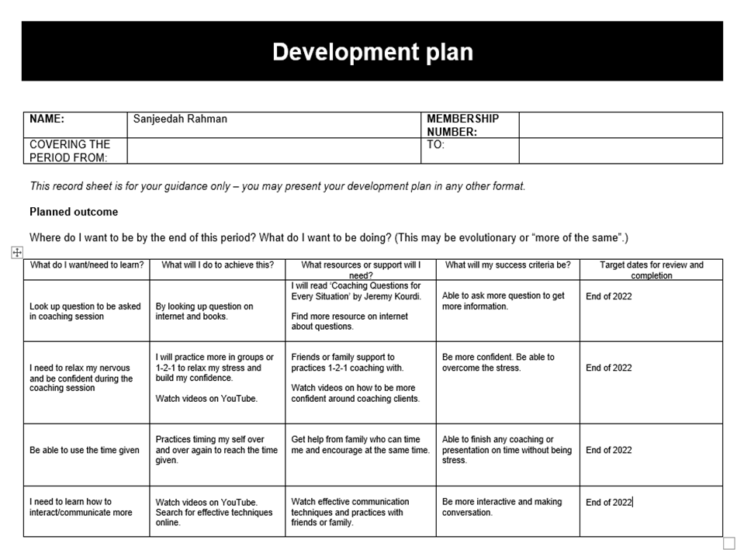

3.0 Conclusion

Evaluating the coaching and mentoring within the organisation, coaching and mentoring has a vital role within the organisation, it helps the employees to perform and develop with coaching and mentoring assisting the individuals.

Coaching and mentoring have similar skill to help an individual and as well both are different in their own approach. Coaching approach is more short term and non-directive and mentoring approach in long term and directive.

Comparing coaching and mentoring with other learnings it has come to understanding that they have similarity but with different approach. All learnings are there to help individuals with development and with issues.

Line manager has the skills to be a coaching and mentoring, there are advantages and disadvantages. An organisation can benefit having a line manager as coach/mentor as the line manager already understands the workplace and has the trust and bonding with the employees.

Coaching/mentoring would help the organisation with managing the change. When the organisation implement a change, it impacts employees. Coaching/mentoring can help individuals by implementing the change management model.

Reference

Action Learning Associates (ALA), (2022). What is action learning? Available at: https://www.actionlearningassociates.co.uk/action-learning/ [Accessed on: 16th February 2022].

Bates, C. (2022). Coaching vs Mentoring: many similarities, one critical difference. Available at: https://www.skillpacks.com/coaching-vs-mentoring/ [Accessed on: 15th February 2022].

Bates, B. and McGrath, J. (2017). The Little Book of Big Management Theories: ... and how to Use Them. United Kingdom: Pearson Education Limited.

BDC, (n/a). Tangible and intangible assets. Available at: https://www.bdc.ca/en/articles-tools/entrepreneur-toolkit/templates-business-guides/glossary/tangible-and-intangible-assets [Accessed on: 15th February 2022].

Charles, T. and Rook, S. (2017). 101 Youth Football Coaching Sessions Volume 2. United Kingdom: Bloomsbury Publishing.

CIPD, (2020). Line managers’ role in supporting the people profession. Available at: https://www.cipd.co.uk/knowledge/fundamentals/people/hr/line-managers-factsheet#gref [Accessed on: 9th December 2021].

CIPD, (2021). Coaching and mentoring. Identify ways to apply coaching and mentoring principles as part of an overall learning and development Strategy. Available at: https://www.cipd.co.uk/knowledge/fundamentals/people/development/coaching-mentoring-factsheet#gref [Accessed on: 1st February 2022].

CIPD, (2021b). Learning Methods. Available at: https://moodle.uwtsd.ac.uk/pluginfile.php/532947/mod_resource/content/1/learning-methods-factsheet_20211001T114615.pdf [Accessed on: 16th February 2022].

Clutterbuck, D. (2016). Everyone needs a mentor. 5th ed. London: Chartered Institute of Personnel and Development.

Crane, M.F. (2017). Managing for Resilience: A Practical Guide for Employee Wellbeing and Organizational Performance. United Kingdom: Taylor & Francis.

Crowe Associates, (2022). Coaching skills for Managers. Available at: http://www.crowe-associates.co.uk/coaching-and-mentoring-skills/coaching-skills-for-managers/ [Accessed on: 19th February 2022].

Goldschmid, Dr. M. L. (2016). The Manager-Coach: 7 Critical Benefits of Coaching Employees. Management Training Coaching. Available at: https://management-training-coaching-ch/?p=162 [Accessed on: 9th December 2021].

Harrington, H. J. and Voehl, F. (2017). Change Management: Manage the Change Or It Will Manage You. United States: Taylor & Francis.

Hicks, K. (2020). Organizational change management: 8 proven models to help navigate change. Available at: https://www.zendesk.com/blog/change-management-models/ [Accessed on: 9th December 2021].

Kerry, T. and Mayes, A. S. (2014). Issues in Mentoring. (n.p.): Taylor & Francis.

Klasen, N. and Clutterbuck, D. (2012). Implementing Mentoring Schemes. (n.p.): Taylor & Francis.

Landsberg, M. (2015). The Tao of Coaching: Boost your effectiveness at wok by inspiring and developing those around you. London: Profile Books Ltd

MacLennan, N. (2017). Coaching and Mentoring. United Kingdom: Taylor & Francis.
McCarthy, G. (2014). Coaching and Mentoring for Business. United Kingdom: SAGE Publications.

McEwen, K. (2011). Building Resilience at Work. Australia: Australian Academic Press.

Performance Consultants, (2019). The GROW Model. Available at: https://www.performanceconsultants.com/grow-model [Accessed on: 1st February 2022].

Starr, J. (2014). The Mentoring Manual: Your Step by Step Guide to Being a Better Mentor. United Kingdom: Pearson Education Limited.

University of Edinburgh, (2020). Gibbs’ Reflective Cycle. Available at: https://www.ed.ac.uk/reflection/reflectors-toolkit/reflecting-on-experience/gibbs-reflective-cycle [Accessed on: 9th December 2021].

