Pollen assessment and analysis of the borehole at Tan Y Bwlch Beach, Lower Ystwyth Valley

This assessment of pollen samples will discuss the process of the pollen analysis from the gathering of pollen samples to the analysis and counting of the pollen samples in the laboratory.
The samples were attained from a borehole cored at Tan Y Bwlch Beach in the Lower Ystwyth Valley, just south of Aberystwyth. The coordinates for the borehole are SN 57889 79689, the top of the borehole was 3m OD. The OD for this borehole was calculated from a nearby solid point, this point was a manhole cover in a concrete setting. The borehole itself was 4m deep and ended when we hit a hard surface. The top 80cm of the borehole were discarded due to being top soil as well as this soil being very crumbly and fell away from the core.
The core from the borehole was segmented into 4cm sections. These sections were individually bagged with the site name and year, as well as the depth range the sample was from. Unfortunately with this process we did not know when part of the sample refers to which part of the bore. I.e. the sample used for the pollen preparation could have been from anywhere between 80cm and 84cm for the 80cm-84cm sample. This leads onto another issue which will be discussed a little later in this work.
For the preparation of the pollen samples there are two similar methods which were presented to me to use. The method that was used in the preparation of these samples was the more extensive of the two.
1. Fill a 10ml glass measuring cylinder with 4ml 5% NaOH, (or distilled water). Add 1ml of sample. Wash into centrifuge tube. Stir, centrifuge at 3500 revs. for 4 minutes and decant. Add between 2 and S Lycopodium spore tablets to the 1ml of sediment, add 10% 10ml HCI, Allow effervesce to settle, stir [boil for 5 mins (caps off!) and centrifuge. Decant, wash with distilled water, stir, centrifuge and decant. Repeat wash, stir, centrifuge and decant.
2. Add c. 15ml of 5% NaOH or KOH (50g NaOH pellets to 1L of distilled water). Stir well and place in water bath. Leave for 5 [15] mins, stirring occasionally. (Removal of alkali soluble hu mic compounds) [check water level in bath]
3. Remove from water bath, cool, and pass through 100um sieve into microsieve. Tap sieves to accelerate throughflow. Wash. Wash residues into centrifuge tube with distilled water.
4, Stir, centrifuge, decant, wash with distilled water, stir, centrifuge and decant.
5. Put on protective gloves and glasses for the next process.
6. Add c. 10-15ml Hydrofluoric Acid (HF). Stir (very carefully) with polypropylene rods and place in water bath. Leave for 15 mins [up to I hour], stirring ocasionally (carefully). (removal of silica) Prepare slide labels.
7. Remove from water bath, [cool, centrifuge and decant], and add 10-15m 5N HCI (conc. or dilute). [Place in water bath (5 mins?). Stir well and centrifuge. Removal of colloidal silicon dioxide and silicofluorides)
8. Decant, wash with distilled water and centrifuge.
9. Decant /add 10-15ml Glacial Acetic Acid, stir well and centrifuge. (Removal of cellulose)
10. Decant, add 9ml (pre-measured) Acetic Anhydride. Using gloves and glasses. Carefully add 1ml Cocentrated Sulphuric Acid by pipette. (NOTE: Concentrated Sulphuric Acid reacts violently with water, so proceed with care.) Stir (carefully) [ie. not with totamix!] and place in water bath for 1.5 mins (removal of cellulose).
11. Remove from water bath, allow to cool, stir and centrifuge.
12. Decant, wash with distilled water and centrifuge. Repeat if necessary to clear sample.
13. Decant a sample into small glass tubes and add safarin (3 to 4 drops).

For the samples of pollen themselves I had to choose a selection of the soil samples to reduce down to get the pollen. For this I had 78 soil samples and was instructed to choose 16 of these soil samples to get the pollen from them for this analysis. The process I used for this was trying to select one or two from each of the stratigraphy layers in order to try and get a good idea of what the pollen was doing throughout the whole borehole sample.
Here is a list of the depths of the samples selected in CM: 80, 88, 92, 130, 166, 190, 201, 240, 256, 265, 274, 298, 314, 338, 362, 398. For the actual pollen counts these were done at a 150 count. This was for the purpose of time saving, whilst also hopefully getting a decent enough pollen sample out of them.
After spending two weeks doing the pollen counting of the 16 samples of pollen prepared this is the table that was produced. 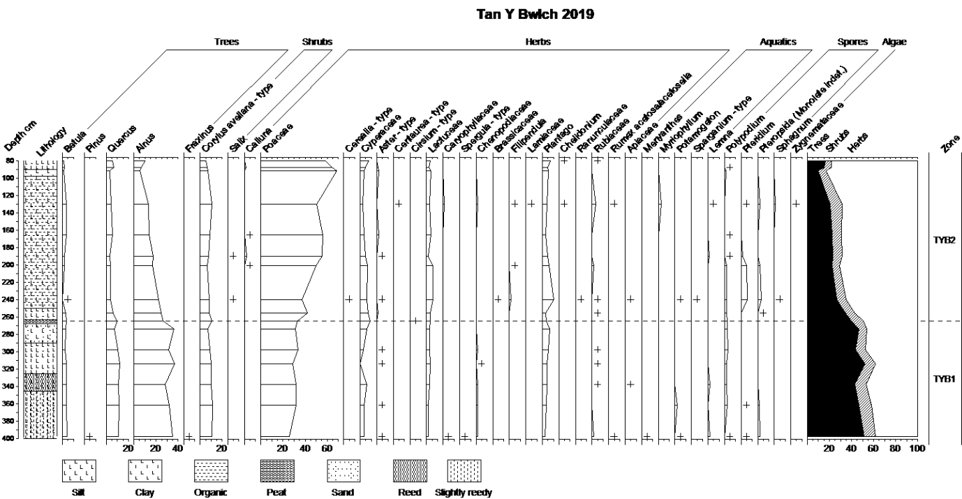
This pollen diagram was produced using the Tilia programme, this was a fairly easy task to undergo. Looking at the diagram you can see the dashed line running at the 270cm depth margin. Along the left hand side of the diagram is the stratigraphy for the site at Tan Y Bwlch, this is (in CM):
0-10 top soil
10-50 dark brown/grey fine gravel with small rounded pebbles 1cm in size. Wet.
50-90 mid grey silty clay with rooting. Soft.
90-98 abrupt change grey silt.
98-250 abrupt change brown silt (higher organic content) 100-200 campacted to 80cm on auger.
250-263 pale blue grey silt clay.
263-268 peat.
268-290 grey brown sandy silt.
290-326 pale brown clay silt.
326-346 grey brown, organic sediment with reed fragments.
346-400 grey brown slightly organic reddy fragments.
Stopped at 400 on a hard surface.
The samples used in the pollen analysis were taken from throughout this stratigraphy.
When looking at the pollen diagram you can see there are some clear correlations between the concentration of pollen samples and the depth in the bore hole. One of the clearest examples of this is the Poaceae or grass pollens. Looking at the top of the recorded depth of the borehole the concentration in 88 pollen grains out of 151 pollen grains counted, making more than 50% of the pollen grains of the sample. At the middle of the recorded range of the borehole shows that at the 240cm depth there were 56 pollen grains of Poaceae out of a 156 pollen grains counted. At the bottom of the recorded range of the borehole there was only 39 pollen grains of Poaceae recorded out of 152 pollen grains counted. This is shown very clearly on the pollen diagram above.
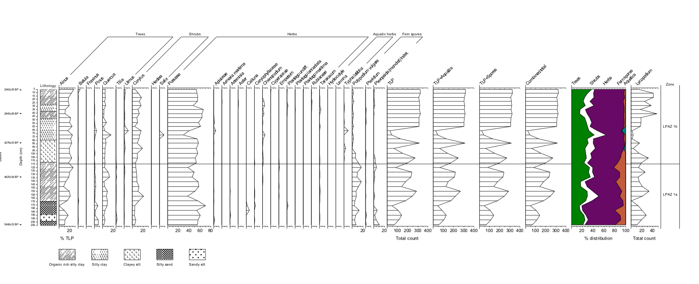
Pollen diagram from Rosie Everett of the 2018 season at Tan Y Bwlch.
The above pollen diagram was made with a low count of pollen samples, being only produced with a 50 count of pollen grains. Despite this it does show what the results came out with. The test pit from which these pollen samples were taken was on the foreshore of the Tan Y Bwlch beach. The top of which lays at 0.2m OD. This means that there is a 2.8m overlap of data between the pollen diagram of Rosie Everett and the pollen diagram that I had produced. Unfortunately that is about where the similarities end for these two pollen diagrams. If we were to try and make a judgement from these two pollen diagrams we would not be able to get a clear and accurate representation of what the pollen levels in the area of Tan Y Bwlch are. However Astrid Caseldine of the University of Wales Trinity St David underwent a pollen count of the 2018 year at Tan y Bwlch, this pollen diagram matched up with the pollen diagram that I have produced. This would lend the diagram produced in the 2019 season to perhaps be more representative of what the pollen levels are like at Tan Y Bwlch. Another corroborating piece of source material is that of the analysis of Clarach (Taylor, 1973). Clarach is a similar type site to Tan Y Bwlch on the Northern side of Aberystwyth whereas Tan Y Bwlch is on the southern side of Aberystwyth.

References:

Everett, R. 2018. Pollen diagram Tan Y Bwlch 2018.
TAYLOR, J. A. (1973). Chronometers and chronicles: a study of palaeo-environments in west central Wales. London, Arnold.

