An exploration into the effect that the schooling system in the UK has on gender stereotyping and how this affects job prospects and the roles individuals play as adults

An Independent Project in Education Studies by Rebecca Crane (1701993)

2020

Declarations

DECLARATION

This work has not previously been accepted in substance for any degrees and is not being concurrently submitted in candidature for any degrees.

Signed Rebecca Crane (candidate)

Date 25/04/2020

STATEMENT 1

This project is being submitted in partial fulfilment of the requirements for the degree of

Education Studies

Signed Rebecca Crane (candidate)

Date 25/04/2020

STATEMENT 2

This project is the result of my own independent work/investigation, except where otherwise stated.

Other sources are acknowledged by giving explicit references. A reference list is appended.

Signed Rebecca Crane (candidate)

Date 25/04/2020

STATEMENT 3

I hereby give consent for my project, if accepted, to be available for photocopying and for inter-library loan, and for the title and summary to be made available to outside organisations.

Signed Rebecca Crane (candidate)

Date 25/04/2020

Acknowledgements

Throughout this degree and the process of writing my independent project I have had many people who have been there for me.
I would like to start by thanking my lecturers at the University of Wales Trinity St David Caroline Lewis and Laura Hutchings who have supervised me and supported me throughout this process.
Secondly I’d like to thank my parents Andrew and Amanda Crane who have pushed me to do my best and succeed in the researching and writing of this project.
Thirdly I would like to thank my brother for taking the time to read through my work and for encouraging me to keep doing little bits everyday to ensure this project was finished and successful.
Fourthly I would like to thank my partner Tim, his parents and my friends Angharad and Lucy who have all kept me on track and motivated me to complete this project.
Lastly I would like to thank my dog Lola who has been a companion keeping me company through the stressful moments when writing this independent project.

Abstract

The aims of this independent project are to find out how gender stereotyping affects individuals throughout their time in early years education, primary education, secondary education and future careers and gender role identity. Srivastava (2017) states that gender is a social construct, which has a strong influence on men and women’s roles in society, their attitude, responsibilities and behaviour. The reason I decided to research this area is because I wanted to find out how much sexism still exists today, how we learn to stereotype, and how stereotyping affects an individual’s life after education has been completed. When it comes to gender equality and gaps the UK doesn’t even rank in the top 10 countries globally, this includes economic participation and opportunities, educational attainment, health and political empowerment (WEF, 2020).

The major findings from this project are that gender inequality and sexism still exists and is prominent in education and the workplace (See appendices 1 for WEF ranking tables) even though there is supposed to be more equality than there used to be, HM Government (2019) state they are committed to ensuring equality and the smooth running of a country that lets everyone reach their full potential. Women are still seen as a second-class gender, young girls are annoyed with the false empowerment of women; there is more talk than action for women’s rights (Plan, 2020).

Women also do worse overall in their career in comparison to men, even though they tend to achieve better in education, more women now enter work in the UK with higher qualifications than men but somehow still receive less pay per hour (HM Government, 2019). Teachers struggle to change the views formed by children from a young age, this is because the education system usually teaches the values and culture of the surrounding society. Sometimes surrounding societal influences are too much to overcome and it’s hard for teachers to stop unconscious gender bias in the classroom (COE, 2014).

Often the self identity of children develops based on their primary care givers attitudes, values and views and also the outside influences such as the media and television, which really instil gender role ideas into children. The findings show that if parents and schools don’t work together to change things for children before they start making decisions on thing such as GCSE subjects then they will continue to fall into traditional stereotypical behaviour and roles set out for them. The decisions people make from an early age can affect the outcome of their life as an adult, if perceptions of gender continue to limit what people feel they can achieve based on their gender they will be held back from many opportunities in life (HM Government, 2019).

Contents

Page 1 – Title page

Pages 2 to 3 – Declarations

Page 4 - Acknowledgements

Pages 5 to 6 – Abstract

Page 7 – Contents

Page 8 – Introduction

Pages 9 to 19 - Literature review

Pages 20 to 21 - Conclusion

Pages 22 to 28 – References

Pages 29 to 30 - Appendices

Introduction

Gender stereotyping should be challenged consistently in UK schools; instead it is counterintuitively made worse (Lifting limits, 2020). The following independent project has been written to discuss the affects of gender stereotyping in educational institutes within the United Kingdom. How this stereotyping goes on to affect the life of the individual, when they leave education in regards to their career prospects and the roles they take on based upon their perceived gender limitations. The paper will also briefly look into how family and the media influence the views of the individual to feel and act in regards to their gender. Collins and Russell (1991) believe that the sex behaviour modelled by parents and other primary family members influence the behaviour and gender socialization of children.
The paper will take a broad look at the lifespan and how humans develop at each age; this is so that the reader will understand the development of a human without their life being affected by gender stereotyping and to understand age groupings in regards to school. The paper will discuss what stereotyping and gender stereotyping is, where it comes from, when it begins in an individuals life, who stereotypes, how individuals learn to stereotype, the type of behaviour made towards specific genders and how these behaviours explain how a person develops and succeeds in life. The information in this paper will be based on a narrative literature review; the main body will include findings from books, journal articles and other academic sources that discuss gender stereotyping. The information discovered will be critiqued and will draw upon conclusions in this subject area. The writer of this paper was led to this topic due to how she personally still believes that gender stereotyping is actively used in education and also in her adult life where she feels that she is expected to fill a certain role and will struggle to reach certain positions in future careers due to her gender. In a previous job at a nursery the writer noticed the types of toys that children played with and witnessed a situation where a male parent was very unhappy seeing their son dressed up in a princess dress. The writer thinks back to that moment and wonders how that parent’s attitude would affect the life of that child and the child’s own views on gender. It is said that parents are the first instructors of gender socialisation and gender roles (Lytton and Romney, 1991).

Literature review

Stereotyping and gender

Stereotyping is naturally a cognitive process, parts of the human brain will recognise something and automatically connect the generalization that belongs to it (Hinton, 2017). In 1922 stereotyping was first seen in a book written by Walter Lippmann, a journalist. His book discussed how stereotypes are “general cognitive structures”, for his time he had a very modern approach to stereotypes and believed that they were distorting the truth, were biased and stopped people from seeing the world for what it really is (Schneider, 2004, P.8). Schneider (2004, P.8) states that the most common way to describe a stereotype is when characteristics are applied to an individual or social group based on their ethnicity, nationality or gender. He says that stereotypes are usually not fair and are negative towards people, usually lies based on assumptions.
According to the OHCHR (2020) stereotyping based on gender is when generalised views and prejudice are made about a person’s character or how they should act and what role they should play because they are a man or woman. Gender stereotypes can affect the capacity of development and the abilities a person has to create a life they want for themselves and to enter into a professional career. There have been campaigns for non-gendered careers; however traditional gender stereotyping appears hard to change, the Fawcett society (2019) state that gender stereotyping has a “lifelong impact” on individuals. Simply gender stereotypes decide what jobs individuals can do despite encouragement and equality changes (Millar and Budd, 1999). Human rights prohibit any stereotyping and according to article 14 this act is there to ensure everyone enjoys the same free life and right to humans rights as anyone else (Equality and human rights commission, 2018). Gender stereotyping should not violate an individual’s rights to basic human needs or their human rights such as the right to education or work.

Lifespan and development

The lifespan starts at the moment of conception and ends the day a person dies. During the lifespan individuals are categorised into stages based on their age.
Armstrong (2019) wrote about twelve stages of life.
Pre-birth- the first stage is pre-birth where the individual has the potential to become anything.
Birth- then comes birth, which to parents brings a new chapter to their life, and hope for better things.
Infancy- next is infancy (0-3 years old) a stage where the individual is full of energy.
Early childhood- the fourth stage is early childhood (3-6 years old) where the individual spends most of their time playing and being creative.
Middle childhood- then comes middle childhood (6-8 years old) where the individual becomes more aware of themselves as people and imaginative about what the future holds.
Late childhood - next is late childhood (9-11 years old) the time where individuals start to feel more pressure from the world around them and they strategize on how they can solve the problems.
Adolescence - the seventh stage is adolescence (12 -20 years old) where the individual goes through puberty and their life changes in so many ways from physical to socially, they become more passionate about what they believe in and tend to become more stubborn.
Adulthood - the next stage is early adulthood (20 -35 years old) where the individual is ready to go out in to the world and their responsibilities change.
Midlife- then comes midlife (35 -50 years old) where the individual starts to reflect and contemplate on what they have done thus far with their life and what is next, what will enrich their life further.
Mature adulthood- (Ages 50- 80) the stage where most have raised children, turned their house in to a home and have excelled in a career.
The last two stages are late adulthood (80+) and death, in later adulthood individuals have experienced many things in life and become beacons of wisdom for the younger generation especially their family and when a person passes it allows others to realise how valuable life is and how the small things an individual does are apart of the bigger picture in life.
At every stage of life individuals develop physically, intellectually, emotionally and socially. However how a person develops and many things can affect how well their life turns out, gender stereotyping being a major one. Gender stereotypes can affect the way individuals see themselves and others, they can affect the relationships an individual builds. How they perform in school, their experience in education and work. How people in their lives treat them and how their opportunities could possibly be increased or crushed based on the body they were born into (Institute of Physics, 2018).

When does gender stereotyping begin?

According to Brown (2014) when a woman becomes pregnant and a bump starts to form the unavoidable questions of “Do you know what you’re having?”, “Is it a boy or a girl?” are possibly the most common questions heard throughout the whole nine month ordeal of pregnancy. There are charts that can tell you what gender your child will be from answering a few simple questions; even Pampers nappies advertise the popular Chinese gender predictor tool, although they do state it is not scientifically proven to be accurate (Pampers, 2020). People will tell you that your bump looks low and so you must be having a boy. The idea that these characteristics can explain what gender the child is sound absurd and in any case is the need to know the gender of a baby really that important. It seems that the moment parents and the people around the parents find out what gender the baby will be they can start planning. If it’s a girl they can get some nice pink baby grows and dolls and if it’s a boy they could get blue blankets and toy cars. Parents think about the future and how their child who is a girl, will probably need them to save money for the ballet lessons she will definitely want because she is a girl, and that’s what girls do. Gender stereotypes are put upon individuals before they even enter into the world (Brown, 2014).

Factors that influence gender socialization outside of education

Gender socialisation starts with the family, the people that live with the child and primary care givers of the child. Families help children in early childhood piece together their own identity; part of this identity is their gender. The family help shape and build upon children’s self-identity (Aistear, 2009, P.25). Depending on the gender of the child, parents treat them differently (Mascaro et al, 2017), they use different pronouns and language to describe what their child is like based on their gender (Giddens, 1993). The baby boy is getting really strong but the baby girl of the same age is still so fragile. The way the family treat children from birth helps the child decide what their boundaries are and how they are to behave. If the family encourage their young boy child to take part in team sports, he is more likely to grow up and be someone who makes ties with many people. Where as if their girl child is encouraged to have one on one play dates and not take part in sports they may grow up to be more reserved, and not feel like they can make friends with too many people (Archer and Lloyd, 2002, P.79). By watching their family children learn what it means to be masculine and feminine. Boys tend to show behaviour that is opposite of the mother figure in their life. When children are able to learn how gender relates to the building of their self-identity it allows them to see what their gender roles are and will be in the future. For girls they may see themselves as becoming a mother, wife and homemaker, but boys may feel they have more opportunities to become anything an athlete, a businessman and maybe a father one day. The way in which the family treat the children in their house affects how children see their future, if children are told they can be equal and that both boys and girls can do whatever they want for a career they may become more ambitious and not feel so restricted by their gender roles (Carter, 2014).
Media is a huge influencer of gender roles, gender socialisation and also showing a stereotypical and mostly unrealistic version that create the mass publics views on women and men in real life. Media has a lot more men in the limelight and women are underrepresented. Lots of television shows and movies portray men and as masculine and women as feminine and they also normalise violence against women (Wood, N.D, P31). According to Feierabend et al (2017) even though there are many sources of media available in the 21st century, children still tend to view most of it via television. Children’s television shows have started to include more STEM (Science, Technology, Engineering and Mathematics) content due to the rise in Science, Maths and Engineering careers required in the current world. These programmes influence children to like this type of subject or dislike it depending on how their gender is portrayed in the programme. For example boys may be better at the science and maths and help the girls in the programme which would then positively affect boys and negatively affect the girls view on these subject which could go on to decide the effort they put in to it in school and influence their attainment (Collins, 2011).
Disney is an extremely popular source of media for children and adults alike; over the years it has changed to stop it’s stereotypical ways (See Appendices 2 for transition table). Disney started off with films that had women portrayed as damsels and obedient. In Snow White and Cinderella, both characters don’t speak as much as male characters and they are seen to be doing stereotypical roles such as cleaning and looking after the men in their life. Older Disney films also show men as the hero and the saviour of women, making women think they must rely on men. The transition in Disney see’s women becoming more defiant of the roles they have been given, Mulan fights dressed as a man, Belle from Beauty and the Beast reads books and doesn’t marry someone based on their position, and in The Princes and the Frog Tiana makes her dreams of owning a restaurant come true by working really hard for it. However all these women still needed a man to help them achieve their goals. In the most recent Disney films such as Frozen there is more speaking from women characters and it is also a woman character that saves the day, this shows how Disney is now starting to empower both genders and show more equality rather than oppressing women through their films (Garabedian, 2015)

Gender stereotyping in foundation stage settings

The foundation stage covers infancy and early childhood, according to Brown (2014) at this age children are learning constantly and mainly from the adults in their lives, parents and teachers at their nurseries. Piaget (1961) stated that children are active learners and they construct ideas of the world around them from the environment they are in, and the interactions they make with people around them. At nursery boys and girls are labelled by their gender and even though adults try to send the message that both genders are equal and treated the same, children pick up on the differences. Children tend to learn what they hear, if they overhear an adult saying that the girls were better at tidying in nursery that day, their minds will put two and two together and believe that if you’re a girl you are better at tidying than boys are, and boys may assume they don’t need to tidy because that’s a girls job. because they aren’t good at it. Kohlberg (1981) believed that the way a child cognitively perceived gender affected the way they behaved.
Gender roles are developed in early years settings and influenced by most interactions a child experiences. According to Freeman (2007) at this age children are aware if they are a boy or a girl and they start to play and behave based on this knowledge, and the roles played that they see around them that links to gender. For example; children may see that their mother does a lot of cooking in the house and their father does the gardening, this could influence the choices they make when it comes to play materials. Girls are more likely to copy their mother who is the same gender and they will play with the kitchen items in nursery, where as boys may copy their father by pretending to dig and mow the lawn. Eccles et al (1998) said that children tend to create gender stereotypes and condition themselves to follow the rules based on their gender, children also copy each other and if a young child notices that their friends of the same sex only plays with a certain types of toys they will start to do the same.
Before attending nursery parents influence their children’s gender and this changes how their child develops. Parents decide what colour the child’s room is, what colour outfit the child will wear, what types of toys the child has access to. If the child will participate in activities like baking, or if they will join sports teams, and also how they interact with their child (Thorne, 1993). Parents may initiate a tea party with their little Princess or play trucks with their little Prince and it seems from research that fathers are more likely to push these stereotypical behaviours on their children (Ruble, 1988), this could explain the aforementioned situation witnessed by the writer where the father became unhappy with seeing their son dressed in stereotypical girls choice of outfit and play items.
An experiment took place in a nursery where babies were put in a room all wearing pink baby grows and adults were instructed to go in and play with the babies, the adults went out and the same babies were redressed in blue baby grows and another group of adults came in to play, the practitioner watching the play noticed that when adults played with what they thought were baby girls they were much more gentle, and with what they thought were baby boys, they bounced the babies around more (Tayler and Price, 2016).
For a child to start learning to be more gender neutral and not feel that their gender should affect what they do, practitioners and parents need to work together to ensure that children are given equal opportunities and do not learn stereotypes from adults. Skelton et al (2006) said that practitioners and parents should make sure that they don’t put gender on the end of words, for example fireman and policewoman, they instead should use fire officer or police officer. Settings should also ensure that pictures and drawings of men and women doing the same activities are around for children to see so that they do not assume that only the boys should dress up as doctors or that only girls should play with Barbie dolls. Practitioners should encourage children to play with all activities regardless of their gender and advise parents to allow their children to have a variety of toys at home.

Gender stereotyping in Primary school

In primary school and some secondary schools uniform defines a difference in gender, most secondary schools allow for girls to wear trousers but in lots of primary schools, boys wear trousers or shorts and girls wear skirts or summer dresses. Uniforms enforce traditional gender roles and affect how girls are seen, treated and also how they are able to do activities, in many primary schools young girls are seen pulling their tights up and their knickers end up on show (Happel, 2013). Children enter primary school knowing which gender they identify as, how boys and girls dress, act and what is a girl or boy name (Serbin, 1983). According to King (1978) schools often use the words boys and girls, they separate boys and girls coats, children sit and line up boy, girl, boy girl and often teachers colour coordinate files for boys and files for girls. This type of organisation often leads to children having same sex friendships and often seeing themselves in competition with the opposite sex, some teachers even encourage competition to keep control of the class by saying things such as “who will finish their work first, the boys or the girls?”(Hartley, 1985).
It seems that in the primary classroom, boys are more likely to answer questions and therefore get more attention from the teacher, the teacher is also more likely to call boys out for their behaviour and more likely to tell girls that they have done something wrong with their work (Rogers and Kutnick, 1992). To ensure that primary school children do not let the roles learnt at this age affect their future it is important that a whole school approach is made to adapt the curriculum and pedagogy to allow for children to feel that they can achieve anything no matter their gender (NEU, 2016). Worldwide Iceland ranks the best for gender equality; one model of education used in their primary schools is the Hjalli model, which is something UK primary schools could use to fix the development of gender stereotypes and gender roles. The Hjalli model ensures that children are given equal attention and pushed to do things outside of stereotypical gender roles. Children learn about human qualities and being tolerant to everyone. Iceland is seen as the best place to be a woman, in primary girls are trained to be courageous, use their voices and even take part in strength training (Hjallastefnan, 2018). The experience a child has in education influences how they perceive themselves and also the role they should play in society (UNESCO, 2017).

Gender stereotyping in secondary school

Secondary school is where students start to form their own interests and know what subjects they enjoy and what they don’t enjoy. In secondary school students choose a few subjects that they would like to sit exams in and these GCSE results decide what they can go on to take in further higher education (BBC Bitesize, 2020). If a student decided to take home economics and textiles along with their core exams they are unlikely to then go to college and be able to take engineering, as they would not have the qualifications needed for this subject. At school it seems that boys are self directed to do subjects within the STEM category where as girls are self directed to do subjects like childcare or drama this is because their gender ideology makes them feel that they can only do subjects that their traditional gender stereotypes allow (Vleuten, 2016). Career advisors in school also tend to be sexist and advise girls especially to do jobs that are within their reach easily and not to try and do a job that is traditionally a mans job, this results with girls becoming young women working in low paid and low skilled jobs where there is little to no progression for the future (Coote and Gill, 1981). Girls have gone from being a hindrance to the education system to rising above boys and achieving better grades for most subjects and on par in Sciences at GCSE level (Walsh and Morley, 1996). Gender in secondary education seems to affect results more as males and females are very different at this age and there are many other factors that change how they feel about education. Females are more mature at this age and they tend to get work done, where as their male counterparts tend to have a masculine attitude of school is rubbish and uncool and they would rather be doing sports or playing video games (Deem, 1992), this in itself is a stereotype. Research has shown that stereotyping in general can affect an individual in either a positive or negative way and that in school when children received positive gender stereotyping in comparison to negative they tend to achieve better grades and are more confident socially (Igbo et al, 2015, P.2). Although Bandura (1977) insisted that a person’s environment is just as important as gender stereotyping when it comes to achievement, he believed the area a person lives in, with whom they live with, the school environment and the people in the individuals everyday life affect how well a person does in school. However he also suggested that gender is a huge part of self–concept and stereotypes can be so impressionable that the individual will succeed or fail depending on how they see themselves in relation to their gender, subject choices and the role they play. Gibb et al (2008) explains why there is a gap between genders in educational achievement, it’s not a cognitive difference as girls and boys have similar intelligence. The issue is behaviour, boys are more likely to be distracted and misbehave in school, so to fix the gender gap behaviour needs to be improved in schools.
There is evidence that secondary school students, especially females face sexual harassment, sexist language and gender stereotyping throughout their time in school. Teachers and students have seen or been a victim of sexual harassment in school, 37% of female students reported being sexually harassed in comparison to 6% of boys. Sexual harassment can affect female students self esteem and confidence and can be detrimental to their education and future. Individuals, who have a better self-esteem tend to be happier, more motivated and have the ability to do well and succeed (Vishalakshi and Yeshodhara, 2012). It’s also very common to hear students calling each other derogatory names that are offensive to other genders, for example “stop being a pussy” and female students usually receive insults such as “slag”, this affects the self worth of the students. There are policies in place in most secondary schools to show good practice in regards to bullying and issues related to gender stereotyping, however teachers can’t stop gender stereotyping in every individual but they do treat that type of behaviour on par with bullying and students get punished for gender stereotyping of any form (OFSTED, 2012, P.57). Even teachers have been heard using language that is sexist like telling males students to “man up” or even talking to other teachers and jokingly telling them that their acting like the opposite sex, which is seen as an insult. Students in secondary school are also often unable to follow their interests or bullied for doing so based on their gender. Female students and male students are often made to do different subjects based on gender, males will do rugby for physical education and the females will have to do gymnastics or netball, and when it comes to hobbies like choir, male students often receive homophobic abuse for enjoying something that is seen as feminine (NEU, 2019).

Gender stereotyping’s affect of career prospects and gender roles

When it comes to work women have always been seen to be below men, as mentioned earlier in this paper, when children receive gender socialisation they tend to put certain jobs to a gender, if this view isn’t changed through education and other influences then inequality still triumphs into future careers and the roles a person plays in adulthood. Although there has been a gender gap in school attainment in the UK for many years (See Appendices 3,4 and 5) showing that girls are achieving better than boys (QCA, 2008), workplaces still seem to favour men in managerial positions. According to UKCES (2015) women are now receiving more opportunities within the workplace, however gender inequality still exists. Women are likely to still have certain gender roles fall on them, especially caring for their children and homemaking, these roles now however have to coincide with jobs that are full or part time. Although it seems work places are trying to be more flexible towards women and their responsibilities, there often aren’t many well paid part time jobs available and being a mother and wife whilst trying to uphold a career is extremely difficult for many. Often the managerial positions that are open to both genders require someone who works full time and can give extra time when needed, this is part of the reason why women fail to hold these more authoritative positions. More women tend to have too many other responsibilities, which makes them a weaker candidate for the higher paid professional jobs, even if they are more than qualified for the position. This along with more men in authority anyway who make decisions based on assumptions and stereotypical gender views (UK Government, 2019).
As of 1970 the UK made a law that should have ensured parity in the work place for both genders and also equal pay (UK Government, 1970). Having said that there is still an issue with the gender gap in regards to pay in the UK and workplaces still have gender segregation. Even the WJEC which is an education exam board in Wales pay women 15p less for very £1 earned by a man (UK Government, 2018). Although women are being encouraged to broaden their vision of careers they could do. An example of this is in Wales where there is a campaign called “Women of steel” which encourages women to apply for careers within the steel works (TATA Steel, 2019), it is important that opportunities like this exist so that they can break the stigma around stereotypical women and male careers. In school there are more vocational courses available and the worry is that if teachers do not help students to realise they can do any career, then these courses will only secure traditional gender issues within the work place (IES, 2004). From this research it is clear that one sex is still being unfairly treated but with campaigns and more positivity towards equality in the workplace the attitudes of individuals may change and the workplace may develop the parity it should have anyway.

Conclusion

To conclude, it is obvious from the literate evidence that gender inequality exists in all aspects of life and that the gender socialisation from early childhood onwards affects how individuals develop in to young adults, how they see themselves and the decisions they makes as they get older in regards to education and work. It is not just down to schools to eliminate the inequality that still happens in everyday life, parents, family, friends, society, government and the media should all work together to ensure that everyone has an equal chance in education, and to fulfil a career in anything they are interested in. The literature found for this paper has definitely allowed the writer to see how she would make a difference as a teacher in the UK schooling system, she would steer clear of gender orientated language when it comes to career choices like mentioned in the early years section of this project “police officer” not “policeman”. She would also encourage students to play with different toys, do different sports, work in mixed gendered groups and help them to become individuals who want equal rights in all aspects of life. The writer recommends that UK schools look at schools in countries like Iceland who are the best for gender equality and take on their values, curriculum and adapt their approach of gender shouldn’t hold anyone back to the UK system. To do this UK schools could do a teacher exchange with schools in Europe that have better scores for gender equality, this would allow for different countries to learn from each other and better school experience. This change could allow for the gender attainment gap to close, students could enjoy their interest without being judged because of their sex and boys and girls could feel equal and become friends who push each other to success. The writer also feels that allowing students to choose their interests and to be encouraged to do them even if they are usually a “boy subject” or “girl subject” could lead to more individuals entering into careers that they enjoy and that break traditional gender stereotypes and influence others to do the same and changing societies opinion.
The writer also states that from the information she has read that the gap in pay and work opportunities needs to be looked at and challenged, more women need to have positions of authority and men and women need to be encouraged to do different jobs outside of their gender roles, not because society calls for it to make figures look better but because they want to pursue those careers and their gender should never of held them back in the beginning. Nobody should be put off a job because it’s not seen as a job they should do. There are many women teachers in schools but by allowing for more female head teachers etc., children will look up to the authority in their school and see that particular job as something for both genders. This paper has shown that gender socialisation from primary carers and teachers through school needs to be non-biased and children should not be treated differently because of the body they were born in. Traditional attitudes supress development and can affect individuals negatively most of the time. If individuals feel they can do anything and that they have the support and opportunities in the future they will become much happier and tolerant individuals who respect everyone and believe in the importance of gender equality.

Reference list

Aistear (2009) ‘The early childhood curriculum framework’ NCCA: Dublin

Archer, J and Lloyd, B. (2002) ‘Sex and Gender’ second edition: Cambridge university press

Armstrong, A. (2019) ‘The human odyssey: navigating the twelve stages of life’ Ixia Press, Dover publications

Bandura, A. (1977). Social learning theory. Englewood Cliffs, NJ: Prentice-Hall

BBC Bitesize (2020) ‘GCSE Options: everything you need to know about choosing your GCSE subjects’ https://www.bbc.co.uk/bitesize/articles/zrjh92p (Accessed 05/05/2020)

Brown, S, C. (2014) ‘Parenting beyond pink and blue: how to raise your kids free of gender stereotypes’ Ten speed press: United States

Carter, J, M. (2014) ‘Gender socialisation and identity theory’ Department of sociology: California

Collins WA, Russell G. (1991) ‘Mother-child and father-child relationships in middle childhood and adolescence: A developmental analysis’ Developmental Review: Elsevier Inc

Collins, R. L. (2011). ‘Content analysis of gender roles in media: where are we now and where should we go?’ Sex roles; Springer Science

Coote A., Gill T. (1981) ‘Women’s Rights: A Practical Guide’ Harmondsworth, Penguin, 3rd edition

COE (2014) ‘Combating gender stereotypes in and through education’ the council of Europe: Helsinki

Deem R. (1992) 'Feminist Intervention in Schooling 1975-1990: Rethinking Radical Education’, London, Lawrence & Wishart,

Eccles, J. S., Wigfield, A. and Schiefele, U (1998) ‘Motivation to Succeed’ Handbook of Child Psychology: Vol. 3. Social, Emotional, and Personality Development, New York: Wiley.

Fawcett (2019) ‘Fawcett research shows exposure to gender stereotypes as a child causes harm in later life’ https://www.fawcettsociety.org.uk/news/fawcett-research-exposure-gender-stereotypes-child-causes-harm-later-life (Accessed 09/05/2020)

Feierabend, S., Plankenhorn, T., and Rathgeb, T. (2017). ‘KIM-Studie 2016: Kindheit, Internet, Medien’ Stuttgart: Deutschland

Freeman, N. (2007) ‘Pre-schoolers’ perceptions of gender-appropriate toys and their parents’ beliefs about genderized behaviours: Miscommunication, mixed messages, or hidden truths?’ Early Childhood Education Journal

Garabedian (2015) ‘Animating gender roles: how Disney is redefining the modern Princess’ James Madison undergraduate journal, volume 2, issue 1.

Gibb, S, Fergusson,D and Horwood, L. (2008) ‘Gender differences in educational achievement to age 25’ Australian journal of education

Giddens, A. (1993). Sociology. Cambridge, UK: Polity Press.

Happel, A. (2013) ‘Ritualized girling: school uniforms and the compulsory performance of gender’ Journal of Gender Studies

Hartley, D. (1985) ‘Understanding the primary school’ London: Croom Helm

Hinton, P. (2017) ‘Implicit stereotyping and the predictive brain: cognition and culture in “biased” person perception’ Palgrave Communications

Hjallastefnan (2018) ‘Introduction – healthy and powerful gender self image’
https://www.hjallimodel.com/ (Accessed 06/05/2020)

HM Government (2019) ‘Gender equality at every stage: a roadmap for change’ https://assets.publishing.service.gov.uk/government/uploads/system/uploads/attachment_data/file/821889/GEO_GEEE_Strategy_Gender_Equality_Roadmap_Rev_1__1_.pdf (Accessed 07/0/2020)

IES (2004) ‘Occupational segregation, gender gaps and skill gaps’ http://citeseerx.ist.psu.edu/viewdoc/download?doi=10.1.1.465.8928&rep=rep1&type=pdf (Accessed 07/05/2020)

Institute of Physics (2018) ‘Gender stereotypes and their effect on young people’ IOP: London

J. N. Igbo1, V. C. Onu1 , and N. O. Obiyo. (2015) ‘Impact of Gender Stereotype on Secondary School Students’ Self-Concept and Academic Achievement’ Sage publishing

King, R. (1978) ‘All things bright and beautiful’ Chichester: Wiley

Kohlberg, L. (1981) ‘Essays in moral development’ San Francisco: Harper & Row

Lifting Limits (2020) ‘delivering gender equality through education’ https://www.liftinglimits.org.uk/stereotypes/gender-stereotypes-in-schools/ (06/05/2020)

Lytton H, Romney DM. (1991) ‘Parents' differential socialization of boys and girls: A meta-analysis’ Psychological Bulletin: APA

Mascaro, S, J., Hackett, D, P., Rentscher, E, K., Mehl, R, M. and Rilling,K, J. (2017) ‘Child Gender Influences Paternal Behaviour, Language, and Brain Function’ Behavioural neuroscience: Educational Psychology: American Psychological Association

Millar, L. and Budd, J. (1999) ‘The Development of Occupational Sex-role
Stereotypes, Occupational Preferences and Academic Subject Preferences in Children at Ages 8, 12 and 16’
Volume. 19

NEU (2016) ‘challenging gender stereotypes through primary education’ https://neu.org.uk/media/2926/view (Accessed 06/05/2020)

NEU (2019) ‘It’s just everywhere – sexism in schools’ https://neu.org.uk/advice/its-just-everywhere-sexism-schools (Accessed 06/05/2020)

OHCHR (2020) ‘Gender stereotyping’
https://www.ohchr.org/EN/Issues/Women/WRGS/Pages/GenderStereotypes.aspx (Accessed 27/04/2020)

OFSTED (2012) ‘No place for bullying How schools create a positive culture and prevent and tackle bullying’ Crown copyright: Manchester

Piaget, J. (1961) ‘The child’s conception of number’ New York: Norton.

Plan (2020) ‘At the turn of the decade, gender inequality still affects majority of UK girls’ https://plan-uk.org/media-centre/at-the-turn-of-the-decade-gender-inequality-still-affects-majority-of-uk-girls-reveals (Accessed 07/05/2020)

QCA (2008) ‘The gender gap in attainment’ https://assets.publishing.service.gov.uk/government/uploads/system/uploads/attachment_data/file/605467/0208_QCA_Gender_gap_in_attainment_report.pdf (Accessed 05/05/2020)

Rogers, C. Kutnick, P. (1992)‘The social psychology of the primary school’ Routledge: London

Ruble, D. N. (1988) ‘Sex role development’ Developmental psychology: An advanced textbook, 2nd ed.

Schneider, J, D. (2004) ‘The psychology of stereotyping’ The Guilford Press: London, New York

Serbin, L. (1983) ‘The hidden curriculum: academic consequences of teacher expectations’ London: Heineman

Skelton, C. Francis,B. and Smulyan, L. (2006) ‘The SAGE handbook of gender and education’ Sage

TATA Steel (2019) ‘Steel matters, your community magazine’ Issue 4 https://www.tatasteeleurope.com/static_files/Downloads/Corporate/Sustainability/Sustainability/South%20Wales%20Community/SteelMatters/ISSUE%204%20FINAL.pdf (Accessed 07/05/2020)

Tayler, K. and Price, D. (2016) ‘Gender diversity and inclusion in early years education’ Routledge: London

Thorne, B. (1993) ‘Gender play: Girls and boys in school’ New Brunswick: Rutgers University Press.

UK Government (1970) ‘Equal pay act’ http://www.legislation.gov.uk/ukpga/1970/41/enacted (Accessed 08/05/2020)

UK Government (2018) ‘Gender pay gap report’ https://gender-pay-gap.service.gov.uk/Employer/MPxkBnkl/2018 (Accessed 07/05/2020)

UK Government (2019) ‘Improving women’s progression in the workplace’ Government equalities office, Crown: London

UNESCO. (2017) ‘Global education monitoring report’ https://gem-report-2017.unesco.org/en/chapter/gender_accountability_through_school/ (Accessed 06/05/2020)

Vishalakshi K. K and K. Yeshodhara. (2012) ‘Relationship Between Self-Esteem and Academic Achievement of Secondary School Students’ Department of studies in education: University of Mysore

Vleuten, M. (2016) ‘Boys’ and girls’ educational choices in secondary education. The role of gender ideology’ Educational studies: Taylor and Francis

Walsh V., Morley L. (1996) ‘Breaking Boundaries: Women in Higher Education’ London: Taylor & Francis

Wood, T, J. (N.D) ‘Gendered media: The influence of media on views of gender’ Department of communication: University of North Carolina

Appendices

Appendices 1- WEF ranking tables

http://www3.weforum.org/docs/WEF_GGGR_2020.pdf

Appendices 2 –
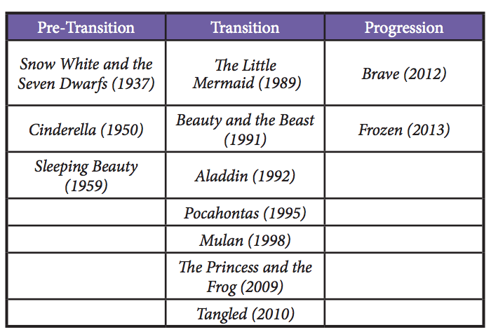

Garabedian (2015)

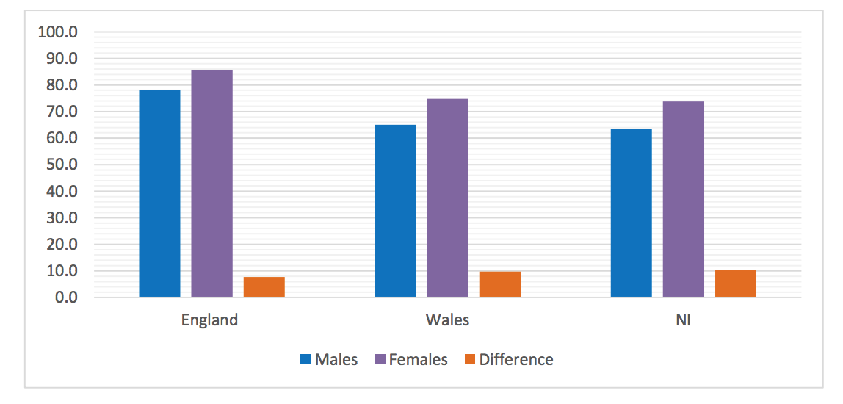
Appendices 3-
Stats Wales (UKCES, 2015)
Appendices 4-
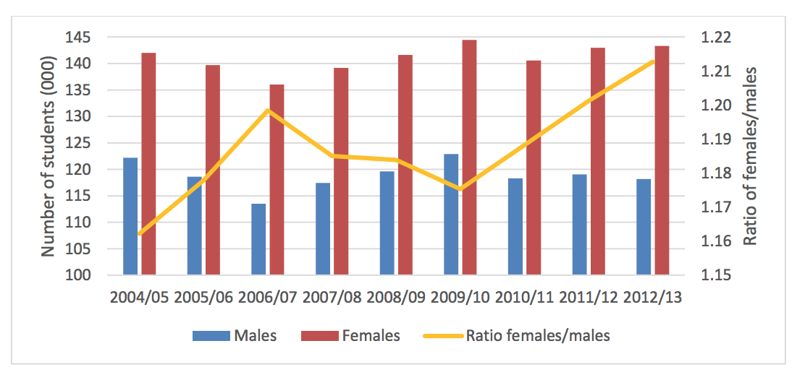
Results in England:
Department of Education (UKCES, 2015)

Appendices 5-
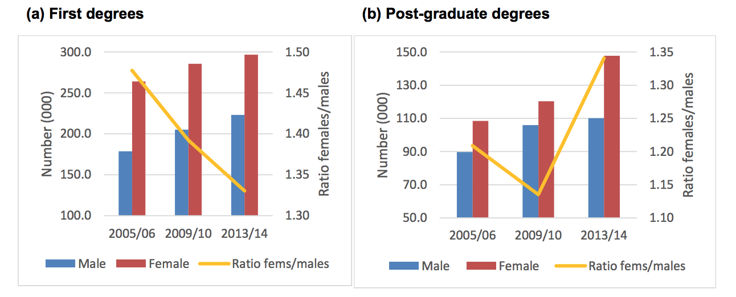
Results in England
Higher education statistics agency (UKCES, 2015)

