Acting 2: Written Evaluation

A scene starts to become colourful when two actors stop performing and start really responding to each other.
Acting for Musical Theatre 2 has made me so much more aware of being present with my peers through creating a genuine connection that makes any piece real. In this reflective essay, I will be using (1984) Kolb’s Learning Cycle to provide structure, encourage deep reflection, thinking, and application. This framework begins with Concrete Experience, Reflective Observations, Abstract Conceptualization and lastly Active Experimentation.

Concrete Experience
Before the summer I took part in the production Amazing Grace, by Mal Pope. After returning I contributed to creating an original musical developed collaboratively with my peers, titled Camp Count Down. More recently, our level presented I Love You, You’re Perfect Now Change, a revue written by Joe DiPietro with Music by Jimmy Roberts. In this production, I portrayed multiple characters, including Chuck from The Lasagna Incident, a wife in On the Highway of Love, while also contributing as a member of the ensemble. All productions consist of regular rehearsals that focus on vocal work, ensemble scenes, blocking, and different dance styles like Jazz. Besides Camp Count Down, Both Amazing Grace and ILYYPNC involved working closely with both the director and musical director. This revue process also involved additional responsibilities, including prop management, in which I had so much fun throughout the process.

Reflective Observation
The opportunity to work on a new project again filled me with excitement alongside some uncertainty as the term revue was foreign to me. I felt curious about how the process would develop and the overall shape of ILYYPNC whereas Amazing Grace and Camp Count Down was “straight forward” given their clear storyline.
I anticipated that the rehearsal process would be enjoyable after our director, Robbie Bowman, stated that he wanted it to be a fun and exploratory experience. With his specialty in the Meisner Technique he encouraged me to experiment, to play and discover what worked for me rather focusing on getting everything “right”. This approach was something I really enjoyed when working with Mr. Bowman and reminded me of Elen Bowman’s influence on the rehearsal process journey.
Throughout the ILYYPNC experience, I felt the stages were a breeze. The lessons that Elen taught me have really enhanced my way of handling material before the rehearsals. I have applied three key areas of the rehearsal process from Stanislavsky’s Toolkit guide:
- Mining the Text
The first reading, where I read the entire script out loud and played the songs from each scene that helped me get to know the themes and styles of the play.

Shown below are some characters' work that I have completed. By doing this, this enacts me to fully understand my characters both physically and psychologically.
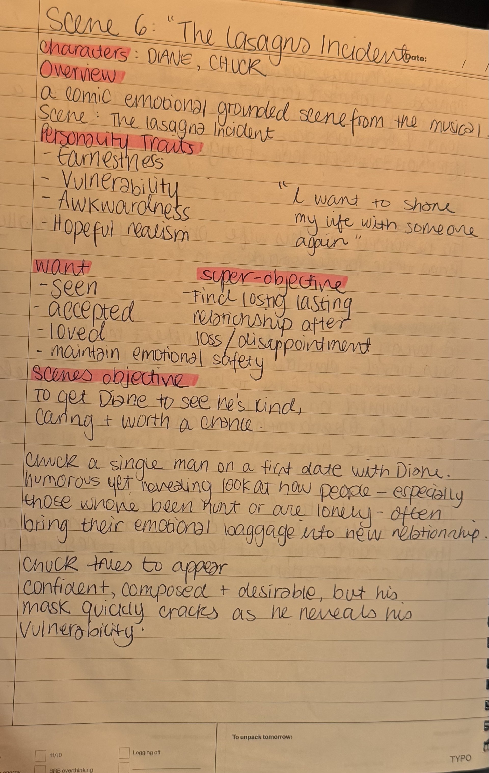
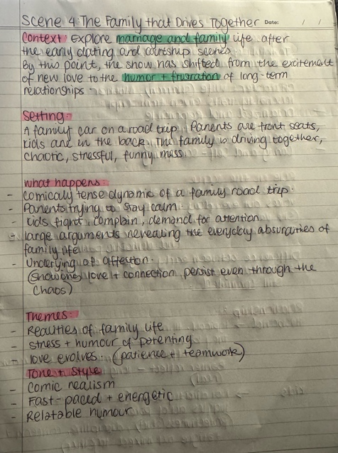

Here were reaping the facts and figures in the text which helped me with the obvious given circumstances and answering some of the six fundamental questions (e.g. who, what, why, where, when and how)
- Embodying the Role
The exercise that helped me embody both Chuck and the wife was Michael Chekhov’s physical and psychological gesture to express my character. I used Uta Hagen’s method, using my personal experience to play a character (e.g. being a mum who feels like she must get everyone in order, relating to being a big sister growing up having to tell the rest of my siblings what to do.)
- Approaches to Rehearsals
In the space, to be able to give the truth there were a lot of Imagining, Picturing (e.g. picturing the road Infront of us in Highway of Love) and Observation (Noticing my scene partners movements to provoke a natural reaction from me.)

What went well:
Due to knowing the material quite well. I spent the entire rehearsal time exploring and playing around. In all the ensemble, I could give it my all because I know I did all the work above, whereas if I did its last minute, I don’t think I would take extra jobs within the production or have that much confidence. Listening to the soundtrack definitely helped a lot. And because DGH has done such a great job drilling me into learning how to restrain harmonies in which my pickups were ‘fast’. Lastly, what worked really well for me was all the voice warmups. Being able to -

What didn’t work well:
I found it challenging to encourage and help my scene partner for Highway of Love as they did not manage to do any work until two days before the showcasing, which made the rehearsal process quite difficult. It made me feel a bit frustrated and stressed. To help, I created a group chat online, to schedule independent time rehearsals, shared my notes and research for my scene partners to get ideas from or comments. There were moments that I let my energy die down in The Lasagna Incident which I wasn’t aware of at the time. The tricky bit of making the scene as natural as possible and remembering that it was staged was something I wasn’t mindful enough and lastly one major thing that was pointed out was me ‘ad lib-Ing' quite a fair amount. I felt too comfortable and playful at the time, which as Robbie’s case is okay but not letting it take out from the writer's context too much.

Abstract Conceptualization
The rehearsal process revealed its importance of shared responsibility, collaboration, teamwork, and preparation within the ensemble rehearsal process. Being in a revue taught me that being adaptive was always going to be important, given the rapid transitions between characters. I learned to embody different characters drastically while reflecting Meisner’s technique and emphasizing truthful listening and reaction. This approach allowed my scenes to be honest and relatable. Although the overall theme of the musical is a comedic, I strived to maintain that raw, underlying emotions of characters so that the audience could laugh with them through relatability.

Active Experimentation
Building on this experience, I intend to continue getting better at my preparation skills. Develop my adaptability skills by taking on multirole with much more flexibility and more creativity. I plan to use not only Meisner techniques but other techniques, that way I can play various roles in various different ways and continue to explore the techniques that are working well for me.

Bibliography
Kolb, D.A. (1984). Experiential learning: experience as the source of learning and development. Englewood Cliffs, NJ: Prentice Hall
Merlin, B. (2014). The Complete Stanislavsky Toolkit. London: Nick Herns Books.
Backstage (2022). What Is the Chekhov Technique? Here’s Everything Actors Need to Know. backstage.com. Available at: https://www.backstage.com/magazine/article/what-is-chekhov-technique-acting-explained-74762/.

Murphy, D. (2025). Uta Hagen’s Acting Technique, Explained. [online] Mandy.com. Available at: https://www.mandy.com/magazine/article/uta-hagens-acting-technique-explained-78452/.

