

DISSERTATION

“A critical analysis of whether student police officers should leave their initial police training as Taser authorised officers, or not?”

BSc (Hons) PROFESSIONAL POLICE PRACTICE

Researcher: Ffion Morgan
University Registration Number: 2124990
October 6, 2024
Acknowledgements
I would like to record my thanks to the tutors and staff of the University of Wales Trinity Saint David, particularly Jane Davies and Samantha Wilson, for all the support and guidance whenever I reached out for it.
In addition, I would like to thank my supervisors within South Wales Police for their support and understanding on the countless occasions when the studying and policing paths seemed destined to collide. Support, advice and wise counsel so often saw many a collision averted.
Then of course my family. The experience of sixty years of policing between both my parents took some time initially to understand. Their support has been unending.
Finally, to my colleagues at work who have seen me arrive and then, I hope, mature into somebody deemed worthy of their professional company who are the most reliable sources of immediate advice as to my developments and who, in numbers I could never have truly predicted responded in so many numbers to make this research all the more credible.
I thank you all from the bottom of my heart.

Declaration
This work has not previously been accepted in substance for any degree and is not being concurrently submitted in candidature for any degree.
Signed: F. E. Morgan October 6, 2024

Statement 1:
This dissertation is being submitted in partial fulfilment of the requirements for the degree of BSc (Hons) Professional Police Practice.
Signed: F. E. Morgan October 6, 2024

Statement 2:
This dissertation is the result of my own independent work/investigation, except where otherwise stated. Other sources are acknowledged by footnotes giving explicit references. A bibliography is appended.
Signed: F. E. Morgan October 6, 2024

Statement 3:
I hereby give consent for my dissertation, if accepted, to be available for photocopying and for inter-library loan and for the title and summary to be made available to outside organisations.
Signed: F. E. Morgan October 6, 2024

Statement 4:
I hereby give consent for my dissertation, if accepted, to be available on the university’s IT system to those who have consent to use the system.
Signed: F. E. Morgan October 6, 2024

Abstract
Policing involves keeping the King’s peace and in so doing frequently involves the use of force either to effect entry to a property, to search someone for potentially stolen items or increasingly to quell the offer of force that others seek to use against law enforcement officers.
The police officer of today is trained in conflict management from the outset of their training and then when commencing their duties for the first time, often come into contact with other officers who are in possession of the Taser – a device used to incapacitate someone temporarily by way of the application of a specialist electrical current.
An argument exists that to best protect officers from violence, that Taser ought to be trained for use from the outset of an officer’s career. The opposing view is that officers ‘need to learn to walk, before they can run’ with such devices and to learn the rudiments of the role, first.
Initial research revealed a lack of text on this specific question that then realised an opportunity to speak with such users generally, as well as their supervisors, to better inform opinion and perhaps even offer some recommendations as to police training requirements of the future.
What follows is the result.

Contents
 | Page:
Introduction ……………………………………………………………………… | 6
Literature Review ………………………………………………………………. | 8
Methodology …………………………………………………………………….. | 13
Data Findings and Initial Analysis …………………………………………….. | 16
Conclusions and Findings ……………………………………………………… | 26
Research Recommendations …………………………………………………. | 29
Bibliography & Reference Lists ……………………………………………….. | 30
Appendices ……………………………………………………………………… | 35
Appendix 1: Application for Ethical Approval ……………………………. | 35
Appendix 2: Research Proposal Form …………………………………… | 52
Appendix 3: Research Questions and Invitation ……………………….. | 57
Appendix 4: Questionnaire Responses Schedule ……………………… | 70
Appendix 5: Subject Matter Expert Questions ………………………….. | 96
Appendix 6: Subject Matter Expert Answer (1) …………………………. | 105
Appendix 7: Subject Matter Expert Answer (2) …………………………. | 108
Glossary of Terms ……………………………………………………………… | 110

Introduction
A great deal of thought has gone into this submission along with a variety of other potential submission topics. The subject matter that follows has challenge both researcher and their peer group, where initial further investigations only added to the debate.
What was clear from the outset was an apparent lack of evidence-based research on the subject of whether police officers should leave their Initial Police Training authorised to carry and already trained to use Taser - or whether such officers should firstly settle into their new roles and understand the science behind effective communications with people first, before advancing to additional uses of forces such as Taser and even the police use of firearms.
The researcher is well placed on the currency of the debate and the operational arguments and counter arguments that exist in the workplace. Of those that do not have it, some aspire to do so and indeed wonder why they don’t already.
Those that have it have differing views on that debate, too. Most revolve around when such training ought to be considered, allowed and should it be mandated?
Supervisors also express comment and in doing so open the doors to the more strategic issues and implications of such decision-making. The ethical concerns are raised is respect of the counter debate as well as who and what is the consequential impact on those most affected by such changes - the enforcer and indeed those enforced upon and indeed how should such messages be communicated?
The main objectives of the research are to endeavour to provide answers to this debate - one that is current and relevant within policing today and to address the wider issues that become apparent as the issue of Taser is examined through the considerations of those who operate closest to it.
It is not simply the question of the provision of the training, it is to consider the ancillary factors around what may need to change to facilitate it, or what value-added can be applied instead to existing structures to improve current training regimes?
If it is found to be not supported, what would the options or consequences be? Could it be facilitated later in training, should a longer period of time pass before such permission is granted, ought it to be mandated and what happens to the officer who declines such training?
Clearly worthy of further consideration, research will surely add value to ongoing occupational and academic debate by way of primary and secondary research to identify both practical and academic arguments for and against both opinions, before analysing the same to offer recommendations to better inform opinion in respect of future training delivery.
A brief probe of existing texts sees (Independent Office for Police Conduct 2021) intrusion where the alleged excessive police use of Taser suggested links to a person’s death, another saw a police officer convicted of manslaughter.
(Dymond 2018) explored further factors associated with the police use of Taser and used dramatic phraseology to stir the emotions not only by referring to policing’s ‘unique capacity’ to use force in all situations, but perhaps worse by referring to the Taser device as an ‘electric shock weapon’ to further inflame the negative debate narrative.
Conversely, (IPOC 2021) research reminded that Taser offered protection in policing incidents, where its use was suggested as both reasonable and proportionate to the threats and risks faced by police officers – interestingly, even when it isn’t actually used. Why?
A number of questions therefore need answers and additionally, there is clear justification of further debate on this particularly topical element of police use of force, encapsulated by the consideration of whether access to Taser earlier in police training could either increase risks of over-use, or perhaps instead become an officers first choice rather than conversation to reduce or negate perceived threats.
Firstly, there was a need to examine relevant existing doctrine.

Literature Review
Policing and the multitude of roles within it is undergoing change at arguably its fastest ever rate. Images of open hostility to the role and instances of the use of force by and against law enforcement agencies the world over is beamed to homes at relentless speed.
Emerging technologies afford greater safety to officers, yet debate continues over when and where such technology or indeed it’s training should be provided. The traditional police officer’s pocket notebook has, in most cases, been assigned to history – instead replaced with equipment that sees evidence not just digitally recorded but transferred across criminal justice agencies and partners instantaneously.
If the technology exists to keep officers safer, should it not also be taught from the outset of their training alongside other subjects? As well as providing an awareness of general policing powers and duties, equipment that could keep officers safer could also be provided and taught from the outset of their careers.
Or, much like officers trained to use firearms for example, should an acceptable level of prior experience and assessment take place first, before consideration is given to such additional powers?
Commentary exists to support both sides of this argument and the researcher chose to focus specifically on whether a Conducted Energy Device (hereafter CED), but also known under a registered trade name of Taser, should feature as part of such basic training – or wait until greater experience is secured first.
In terms of the securing present opinion and position, an initial literary search offered a harvest of academically-based produce and that divided opinion and highlighted a lack of evidence-based doctrine which could definitively support one side of the argument, or the other.
At the commencement of training, each police officer swears an Oath of Office to serve the King that, summarised, commits them to the best of their power to keep the peace and prevent offences to the best of their skill or knowledge, according to law, (Police Federation of England and Wales 2019).
Whilst discharging those duties, suitably trained officers may be called upon to use reasonable force upon others as a method of exercising such powers, in forcing entry to property, arresting someone or indeed to protect themselves or another from those who default to the use, or threat of, violence (Police and Criminal Evidence Act 1984).
Each year, to maintain that authority to use such force, officers must undergo refresher training to keep abreast of the law, their powers within it and the approved permitted practices and procedures. Such training would also include refresher tactical communications opportunities.
Only after the satisfactory completion of this training are officers then permitted to carry and use equipment that includes handcuffs, a baton and even CS incapacitant spray, or similar (Association of Chief Police Officers 2009). This equipment taken together with other items is referred to as an officer’s Appointments.
At present, officers who then wish to be considered for additional Taser training, apply for it to seek authorisation to carry it in addition to the other equipment.
The aim of this research is to critically analyse whether Student Police Officers should leave their Initial Police Training as authorised users of a CED (College of Policing 2022).
First introduced into police forces across England and Wales in 2003, Taser was initially only issued to Authorised Firearms Officers (hereafter AFO’s) who already had advanced training and already held the responsibility of carrying police firearms operationally, (McGuinness 2016).
This added value to the existing (National Police Chiefs Council 2011) argument justifying its use and effectiveness in securing control in violent circumstances even without its discharge - when its mere ‘presence’ was enough to secure safer outcomes.
A relaxation of that original stance occurred in 2007 which meant that non-AFO officers, once trained, were also permitted to carry Taser upon completion of that newly-requisite training (McGuinness 2016). That secondary training regime was completed by 2013, by which time the roll-out of the device was completed in all UK forces, supported also by the various police staff associations who were keen to protect both members as well as the communities they served (Police Federation no date).
(Rees 2019) discusses the sheer increase of Taser usage at incidents across Wales and quoted a rise of nearly 30%, or a thousand more incidents per year. Add to that (Home Office 2024) rises in knife-enabled incidents and a clear indication that officers are encountering the said weapons in increasing numbers once more is demonstrated. Such encounters had waned during the Covid pandemic, but such rises resulted in a clear need for Taser, or other technologies, to be carried to negate these increased threats.
(Morris 2023) suggests that despite use of Home Office approved training techniques, the police use of force remained as controversial as ever when deployed by officers – with or without Taser – where such uses are likely to attract a level of significant scrutiny and portrayed negatively within communities, as well as being reported in both social and traditional media outlets faster than ever before.
Should the Student Officer’s exposure to incidents where such violence is offered be a challenge in itself? Further, would the additional training load of Taser strengthen or weaken that newly-found skill set – and what are the factors and issues in debating both?
To take apart these issues still further, it was necessary to conduct a Literature Review, or ‘comprehensive review and analysis of the published literature on a specific topic or research question.’ (Winchester and Salji 2016).
There is a school of thought that suggests Taser should be offered to Student Officers at the commencement of their careers, a point once supported by a pilot study (Home Office 2019) where a selected number applied for such training under strict conditions and against the traditionally accepted view was that only those officers who had successfully completed the two-year probation period in place at the time, were eligible.
This followed the argument that the availability of Taser allows officers not only to engage, but to do so safer, with its introduction allowing for more distance to be created in incidents (College of Policing 2013), allowing more of what is described as perhaps the most precious gift of all to officers, namely ‘time’.
(National Police Chiefs Council 2019) supported this view with the lowest recording of assaults and injuries caused to officers found when they are in possession of Taser. (Drummond-Smith 2019) adds further support to the safer distance tactic that significantly reduces the potential for injury compared to traditional appointments used at far closer range.
(Baker 2019) offers the contrary view of the status quo and the completion of the Police Constable Degree Apprenticeship (hereafter PCDA) probationary period, requiring three years of service before such consideration is merited. It also cites the Police Federation view that 94% of frontline officers supported its wider issue - with signatures petitioning for such change running into six figures.
The decision to authorise such training change presently remains with Chief Officers at each force (College of Policing 2022) with the Police Federation arguing in the above article that the Home Office should train all officers – but the question that doesn’t seem to be easily or readily found is precisely when that training should occur.
The enhanced argument of self-protection or that of others is again made, but controversy continues to follow the debate. Amnesty International (White 2021) suggested Taser training isn’t suitable for all officers as some fail such training – or is that a vote of confidence in the delivery of such exacting standards that not all students pass and which tends to stand such scrutiny?
(Dummer-Smith 2020) offers from a public perspective that less than 10% of complaints received from the public over such uses of force were as a result of the discharge of Taser where, astonishingly, eight times that number were recorded where the force was used where Taser was not available. Why?
Does the significantly lower percentage of Taser-related complaints reinforce its efficiency as a tactic to keep frontline officers and the public safer when dealing with those previously described hostile and challenging incidents?
Amnesty International also offered that at that time of the above study, that 18 people had lost their lives since Taser’s introduction in the UK, but further (Baker 2019) analysis revealed several of the related Inquests did not record the device as the cause of death in proceedings.
(Miller 2023) offered an additional argument supporting the increased protection afforded by Taser whilst warning of ‘over reliance’ on the device, adding that better training was needed out of concerns that policing could lose the ‘legitimacy argument’ over its use.
Such dependency could create even more risk with officers having lost other opportunities to reduce threats through traditional training methods to gain compliance at incidents, which would clearly tend to support a delay in Taser training before the art of speaking with people is mastered first?
Over reliance and safety versus the art of speaking to somebody?
(Independent Office for Police Conduct 2021) also cited the ‘legitimacy’ worry as fears grew with some groups complaining of its use which, when investigated, tended to find officers hadn’t correctly identified the level of threat or risk faced, as would have been expected.
Opposed to this stance, (Dymond 2019) identified that officers equipped with Taser tended to deal with such matters more confidently with improved overall decision-making and better incident resolutions generally. This also tended to support another (White 2014) assertion that Taser possession increased officer safety.
However, (Dymond 2019) also offered that Taser trained officers became more complacent by defaulting to its use, even when on reflection such use was thought unnecessary – an argument supported by (Adams and Jennison 2007) suggesting officers were perceived as more aggressive or ‘trigger-happy’ as a result of weakened conversational skills.
Interestingly, (Somers et a202) offers a combination of the above views as preferable where the mere presence of Taser, supported by effective tactical communications, realised less use of the device as offenders saw it is a powerful deterrent in itself.
However, academically, things are seldom that simple and further (Ariel 2018) reading saw that ‘visibility’ realised more hostility where officers, accepting it has been seen, became more aggressive knowing of its availability – a phenomenon referred to as ‘the weapon effect.’
Perhaps never a more opportune time to restore trust and close (Independent Office for Police Conduct 2021) has been named the ‘public confidence gap’ where without such additional training, student officers have to rely on the mouth as opposed to a device. However, Taser doubt remains with (Independent Office for Police Conduct 2021) acceptance it keeps people safe, still argue that greater scrutiny be applied whenever it is used.
Is structured training in its use supported before the onset of external pressures or bias have had the opportunity to present themselves to Student Officers a solution? The Literary Review failed to yield a definitive view and indeed whether change is need to alter that position.
The intention is therefore to conduct primary research with practitioners at varying levels of service and rank to determine the view from the ‘shop floor’ which would tend to inform future thinking and improve the debate on the subject.
In summary, this review failed to yield a definitive view on precisely when such Taser training ought to commence and whether a change is need. What is however clear is that, as is often found in policing matters relating to technology and equipment, there is very little evidence-based study specifically relating to the question. As a result, opinion continues to be divided.
This is the reason the researcher has chosen further study. Recently trained, the researcher is all too aware of the challenges presented by both sides of the Taser argument. The above exercise to establish current thinking shows that opinion appears to differ greatly.
Simply, to investigate to whether Taser should, or indeed could not be incorporated into Initial Police Training or whether an argument exists to first settle into that new role, without the added pressure and concerns relating to the device.
Research aims to deliver a greater understanding of the issues by adding relevant, topical and current argument to provide a fundamentally better understanding of whether Taser training is a strength or indeed a liability to a newly trained officer. This will be done through primary research to add evidenced value to the debate as well as securing subject matter expert opinion, for still further clarity – all from the views of the practitioner, to inform the training needs and direction involved in engaging with training technologies of the future.
Armed with the knowledge of existing texts, the question now to be considered is how to take matters further.

Methodology
Considering the question of whether police officers should leave their initial training authorised to use Taser, or not, a collection and analysis of data is necessary as the researcher found that much existed in terms of the arguments for or against the use of Taser generally – but very little indeed from the perspective of the practitioner and almost nothing in terms of when the best time was to deliver such training.
The absence of that doctrine was the driver to deliver such research – further that it should be occupational, evidenced-based research.

Research Design
Having already discussed both primary and secondary research methods, (Church 2002) reminded the researcher that Secondary Research is ‘the collection of data previously collected and published,’ whereas (Driscoll 2011) clarifies that Primary Research is that collected ‘first-hand’ by a researcher who is then better equipped to present work around the matter at hand, because primary data allows specific research of a specific subject for answers, using a specific approach.
(Cambridge Dictionary 2024) defines research as ‘the systematic and creative collection of data that increases knowledge’ whilst (Hassan 2024) offered guidance on eight different types of research methodology, with the researcher deciding on a Mixed-methods Research structure to incorporate the Quantitative, Qualitative and Survey Research methodologies, considered the most appropriate to achieve the required objectives of the study.
Other methods were considered, firstly Case Study Methodology. Dismissed as it typically engages with the study of a single or small number of cases and is best suited when more understanding of a person or type of person is sought.
Action Research Methodology, although similar to the preferred methodologies, was also dismissed as they are best suited in areas of research involving social work. Similarities were also found with Grounded Theory Research, which was again dismissed as it doesn’t provide for the specific outcomes the researcher preferred.
Finally, Experimental Research Methodology, would have been a contender if the question was to look at the issues of Taser and then consider its removal – so it, too, was set aside.
Consequently, (Troy 2021) offered that Quantitative Research related to numerical forms of data, frequently used where information had to be gathered from larger groups, while (Bisht 2024) suggested Qualitative Research realised a deeper understanding, with perhaps a higher quality of research achieved.
(McCombes 2022) offered the addition of Survey-based Research as the choice where the pursuit of experiential ‘characteristics, preferences, opinions, or beliefs of a group of people’ was sought.
(Gaille 2019) offered advice on the benefits and challenges of quantitative research methodology, collecting and analysing data quickly and remotely from larger numbers, randomly and anonymously to give a reliable product which identified themes or issues quickly as a ‘one-off method of data extraction’ but without the option of clarification. Warning was also provided that group results sometimes realised an ‘unnatural environment’ sometimes opposed to the public at large.
(Gaille 2017) also offered opinion on qualitive data where greater, perhaps even predictable detail offered by people with experience could be found, which could be adapted and although structured, was also fluid and added depth to statistical data as well as what was referred to as ‘industry-specific insights’ as well as offering explanations to some data rends or observations found.
Conversely, it was clearly highly subjective, time consuming, harder to assess independently and, in isolation, troublesome to display. Also suggested as prone to bias and is why the researcher, having experience of the subject matter, could identify potential bias if it appeared.
(Gaille 2020) offered opinion on survey data – described as anonymous, inexpensive, quick and practical with many responding at the same time, but where the researcher could control volume and easily compare and analyse results.
There remained the risk of less than truthful answers as respondents hide away from their own personalities, others could choose to avoid some or all answers, people’s understanding of question context cannot be guaranteed and emotion can often be found missing which can see some responses as being difficult to recognise or relate to – again bias or pre-formed needed to be carefully managed. The researcher was also aware of the dreaded ‘survey fatigue’ as also apparent when looking at initial appeals for assistance.

The Method of Data Collection and Ethical Considerations
As a result, the researcher chose to adopt quantitative research by way of a questionnaire/survey to all officers within the same general geographical policing area, regardless of rank. That survey also managed all potential ethical considerations over matters such as senior officer approval in the first instance, as at the very start of the invitation survey, all concerns over true and informed consent, confidentiality and anonymity were addressed. The area was considered manageable in terms of the aims of the research, but is also arguably large enough to be reflective of the wider policing population as a whole.
Each participant was then invited to complete some eighteen questions, some initially on purely demographic content, before subject-specific questions that also invited written responses to reinforce the quantitative element.
Additionally, the researcher also sought the engagement of two subject matter experts to add additional qualitative value to the research and to deliver the true, mixed methodology sought from the outset, by way of the completion of a semi-structured questionnaire that realised that extra detail sought – all with the same ethical considerations managed.

The Method of Data Analysis
Having harvested the research data, the intention was to inspect and then interpret results in their most informative manner. The intention was to investigate the content, identify themes and challenges before offering conclusions and recommendations based on those findings. Microsoft Forms would be used to assist in the presentation and visualisation of quantitative data.
The qualitative analysis of data from expert interviews/questionnaires would be the ‘value-added’ after the initial content analysis was completed, to address any identified themes and to convert all evidence-based practitioner research into a presentable and informative narrative for the ultimate reader.
The purpose of the research is to make the question of that specific, specialist training to be better understood, to further inform decision-makers of the future. This leads to the research findings.

Data Findings and Initial Analysis
Research was conducted question the views of the practitioner, then to critically analyse results with existing frameworks. Seventy-five officers responded providing strong credibility to the primary research with the first few questions serving only to provide demographic information about the profile and background of responders.

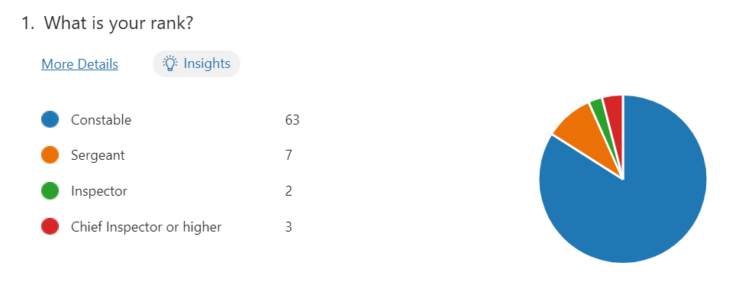

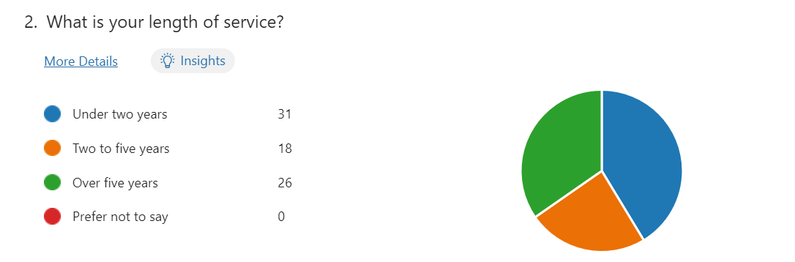

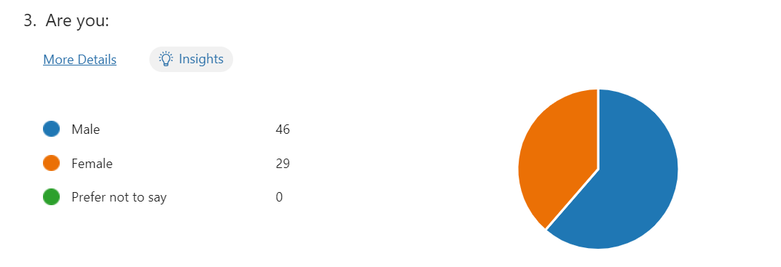
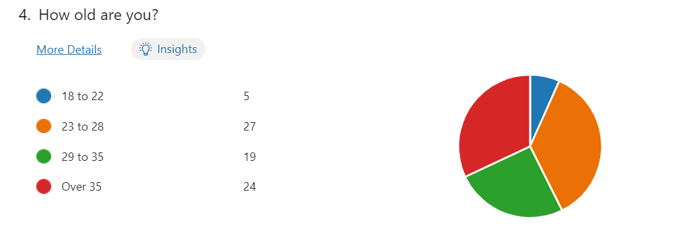

Research realised participants of all ranks from Police Constable up to and including Chief Superintendent as well as a variety of service levels reflective of the sample group which in turn was reflective of the wider Response Policing profile, nationally, which again added to the reliability of the data obtained.

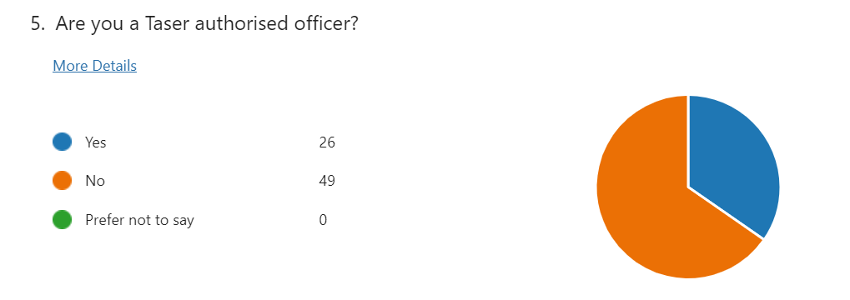
This represents that a far higher number of respondents were not trained in the use of Taser, removing any potential for bias and which adds to the impartiality of the research.

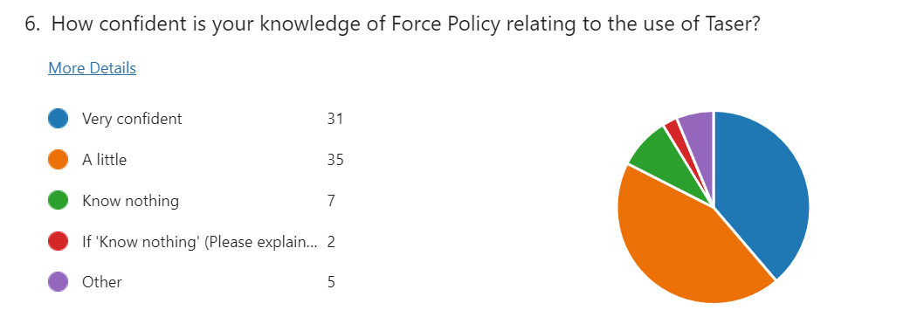
This demonstrates a poor awareness of knowledge of the related Force Policy supported with comments like, “as I am not authorised to use Taser, I have not read up on anything” or “not Taser trained so very limited knowledge" were typical.
The researcher suggests this tended to support a suggestion of malaise in terms of policy access and awareness generally.

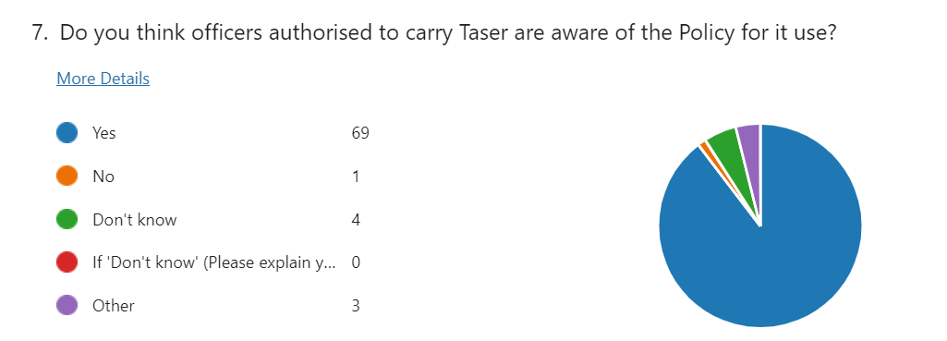
Responses here cast some doubt on malaise, where instead 92% of all responders suggested that Taser users should be aware of its policy. A very strong suggestion of presumed awareness of rules and governance by its users – with one respondent suggesting, “I would like to think Taser carrying officers have a basic knowledge of Policy.”

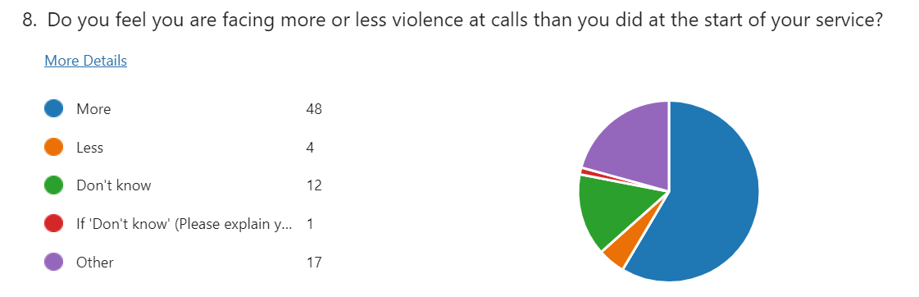
Specifically aimed at the perception of violence officers faced and whether service or experience was a factor, over half agreed that they now faced more. One respondent suggested that having been promoted, they faced less but acknowledged those “in front line roles faced far more.”
This was a view not shared by those with junior service, who saw no increase, whilst another offered differing ‘types’ of violence with “level or methods” having increased, whilst another clarified that, “it depends on how well you communicate and whether you are able to de-escalate the situation you are facing."

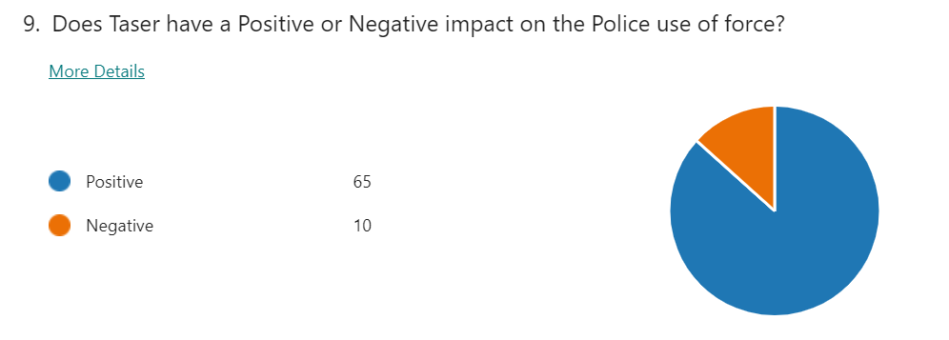

Another clear link to the previous question, which demonstrated very clear finding that the presence of Taser has a very positive impact relating to the use of force, with one respondent suggesting, “members of the public will see the Taser and tend to comply better than without the presence of Taser.”
Other comments suggested it de-escalated situations when people it carried to
produce “less-physical altercations” with overwhelming comments as to its deterrent capabilities.

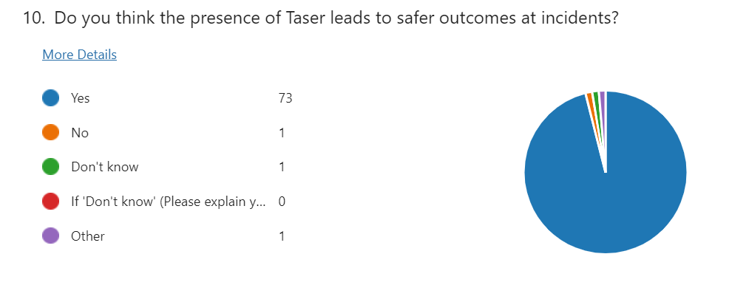
The strongest endorsement with over 97% of respondents in agreement that Taser delivered safer outcomes where even the dissenter suggested safer outcomes depended “upon the nature of the incident.”

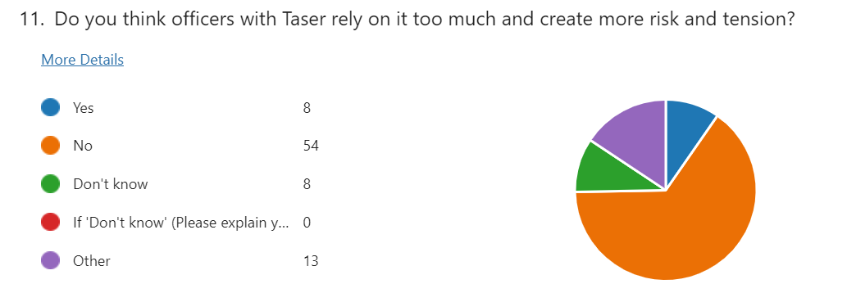
Linked to previous questions, but moving to discuss the reliance upon Taser, a strong response negated the concept of over-reliance, but a qualitative theme emerged that suggested a minority were “over reliant” especially with “those who can’t speak to people” or “rely on it as an early intervention rather than tactical communications.”
One responder also commented further on the ‘danger’ of an officer who would “try to get a swift resolution by deploying Taser before exhausting all opportunities to de-escalate."

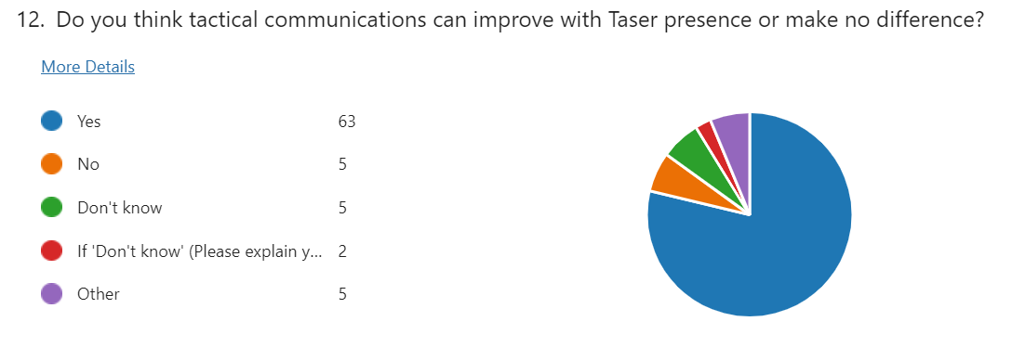
This overwhelmingly suggested, however, that tactical communications could improve when Taser was present, with responders offering it as “hugely important” where officers without it had to rely such communications even more.
Even those with an opposing view suggested that “Taser is usually accompanied by shouting/dominant instructions which can escalate” issues at incidents.

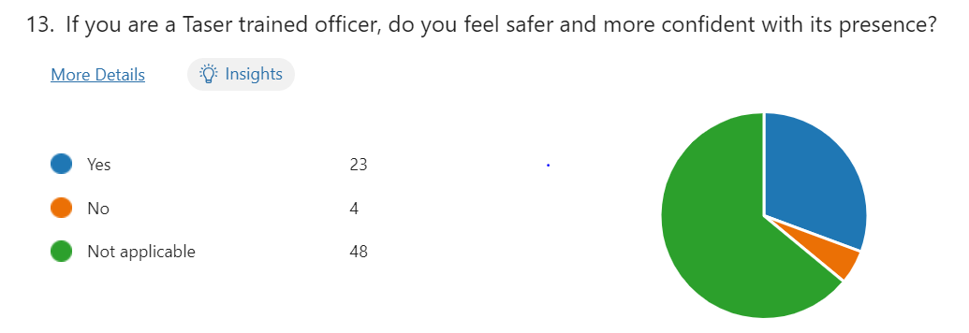
Deferring again to question 5, but now specifically aimed at the Taser practitioner, it realised very strong support for the view that its presence had no bearing on officer safety or confidence.

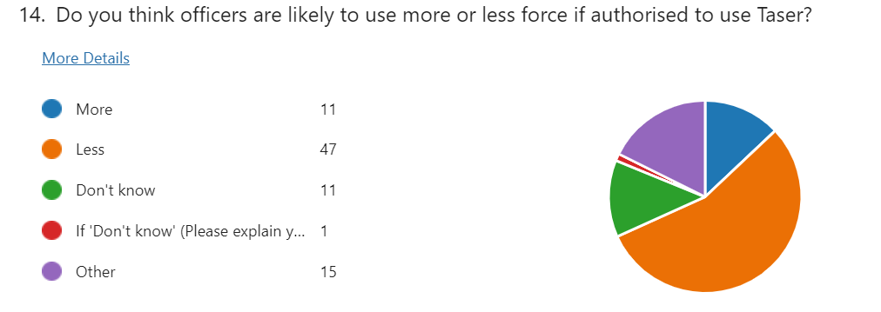
62% suggested less force was likely where Taser was present, but more variance of opinion noted here where some offered, “officers with Taser will use it, officers without Taser will use other tactics.” Another offered, “the presence of Taser should give additional tactical options that can de-escalate.”
Of interest was one respondent, within a group that couldn’t express a clear opinion, suggesting it was “hard to say because there are (sic) so many differing tolerance levels and subjective opinions between officers.”

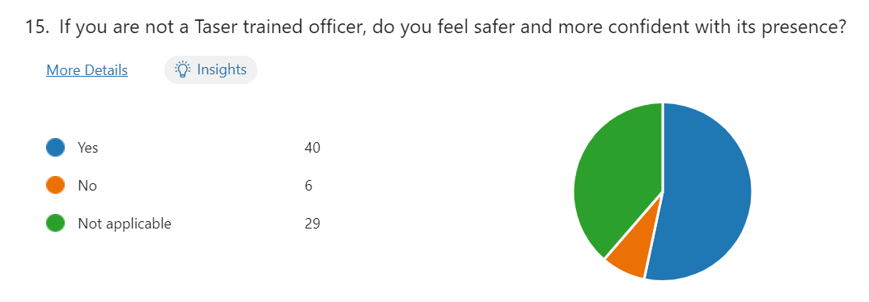
Again, reflecting on question 5 data to take away those trained in its use, support was found within those not trained in its use that they felt safer and more confident when it was present with others.
Regrettably, this question failed to realise any qualitative narrative from responders.

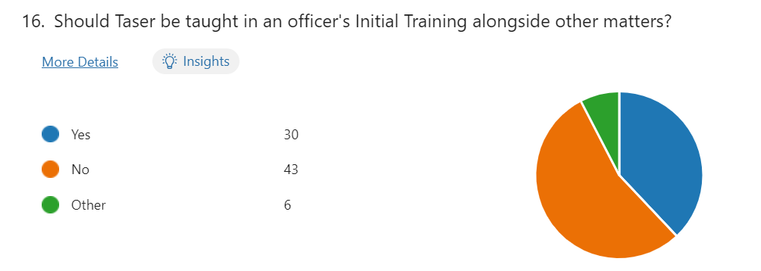

To the crux of the research and a more non-committal environment with 57% supporting Taser should not feature in Initial Police Training.
With an opportunity to provide a narrative, respondents again did not provide any commentary to support inclusion, where the only comments instead suggested officers should “wait for a period of three to six months after tutorship for officers to gain confidence in dealing with confrontation.”
Another responded, “No, I believe if after an officer has shown they are competent in use of force and able to deal with confrontation appropriately, they should be allowed to put themselves forward for the training.”
Another offered a far longer wait of three years, “to allow (sic) a student officer to experience a range of different incidents” first before being better “able to gauge best when to use Taser accordingly.”

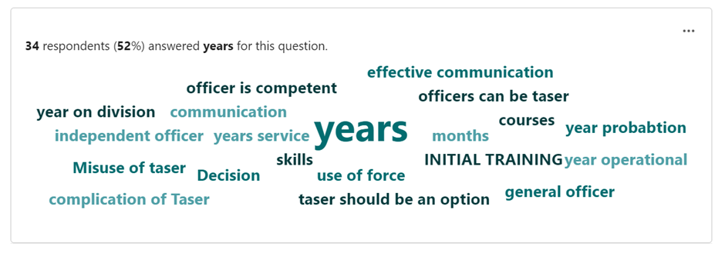

Asked to consider how long to wait, only a handful offered an immediacy of training with “Initial Training,” or “as soon as possible” being typical of that group.
However, in support of the above tag cloud and where 52 of the 75 responders who actually offered a quantifiable figure, an average of those figures was taken which realised period of just over 18 months of service was appropriate before Taser training should be offered.
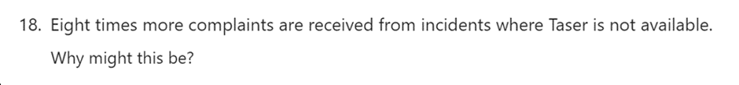

Responders commented her about having to get “hands on” when Taser wasn’t available, which increased risk and “looks messy” to an uninformed public. Another offered “without having Taser, the impact of the public seeing physical force being used may present officers in a bad light.”
Another regular feature suggested the inability of officers to communicate effectively as a trend, whilst another supported its ‘presence’ suggesting “behaviour changes upon seeing Taser and can lead to less force being required by police.”
This was supported by another responder suggesting, “when Taser is not present, members of the public feel they are able to become more violent and aggressive as there is no risk of being tasered.”
Commenting on the ‘normality’ where Taser was present “for knife/weapon incidents” they suggested “unarmed skills could be seen as harder to justify” when injury resulted.
This last question was one which was also offered to two expert witnesses by way of a separate questionnaire, Herbert (2024) suggested communication was still necessary because “a large proportion of our patrol teams still do not carry Taser” but still supported its de-escalating effects.

That view was also supported by Davies (2024) who offered that “in excess of 80% of Taser ‘uses’, the situation is resolved without the device being discharged” and that “as a result of the de-escalation benefits…complaints will inevitably be lower.”

Asked as to when training ought to be provided, he declined to comment but instead offered that “an organisation is duty bound to provide that individual with equipment to allow them maximum safety.”

Delving deeper into the suggestion that Taser training should be offered during initial training, Herbert (2024) stated it was “far too soon” suggesting officers should first learn to de-escalate through speech before relying on a device that “isn’t perfect” and can fail.

Probed further as to whether a trial period could be considered where all are so trained, Herbert (2024) explained the present organisational position where all officers with at least twelve months service could apply for it, but that it ought not to be mandated.

He also commented on concerns over the intrusion of investigation inquiries when matters go wrong (IPOC 2021), whereas (Davies 2024) was clearer in voicing support for such a pilot as “very few he had met, did not want to carry” before adding any decision ought to be for policing and not industry providers to determine. provider.

Both experts cited tactical awareness as promoting the most effective use (or not) of the Taser and indeed vouched for its positive impacts upon local communities in improving confidence in policing – backing that up with high levels of training, scrutiny in terms of the standards for such use.

To conclude this primary research, a brief critical analysis of both primary and secondary findings is prudent. In summary, the majority did not support the inclusion of training to new recruits even where 64% stated they faced more violence than at the start of their own service. Additionally, not all respondents wanted such training in the device, much in the same manner that (White 2021) Amnesty International suggested.

Notwithstanding the above, an overwhelming majority reported Taser had a very positive effect on the use of force tending to compliment (White 2024) findings of increased officer safety and which clearly questioned the perception of the ‘weapon effect’ (Ariel 2018) of more hostility, where conversely, the opposite was found.

Research also challenged (Dymond 2019) complacency of resorting to the Taser device, instead clear support and increased confidence in officers knowing of its presence. No appetite nor evidence found to support (Adams and Jennison 2007) ‘trigger happy officers.’

A clear theme emerged around poor conversation skills, where support was found albeit in a limited number of officers, who may be more reliant on Taser. Notwithstanding that, a very clear majority preferred the assertion that Taser trained officers simply did not rely upon it. This clearly challenged (Miller 2023) over-reliance findings and which, interestingly, also supported the position of first learning the ability to talk to people.

As well as the reassuring and safer presence of Taser, the need for better tactical communications was called for supporting earlier (Somers et al 2020) doctrine as the best ‘combination’ offered as a deterrent.

Finally, adapting and adopting that best form of deterrent in an environment where its presence tends to yield eight times less complaints, that (Independent Office for Police Conduct 2021) public confidence gap is surely narrowed where a clear consensus offered that’s its presence actually leads to less force being used.

Time now to conclude matters and identify the findings of the research.

Conclusions and Findings
The purpose of the research was to provide practitioner-based evidence to assist decision-making on the debate as to whether student police officers should undergo Taser training as part of their initial studies, or firstly settle into their roles having first grasped a basic understanding of how to talk to people in challenging environments, first.
There was early acceptance that research was never going to be limited to the question in isolation, but that other factors would present themselves for further consideration in an expanded debate that would rightly address the related issues too.
The consequential examination of existing literature realised concerns over Taser use as well as a clear need to secure evidence-led occupational opinion from those best placed to give it – the police officers and their supervisors of Response Policing who are most likely to be called upon to use it in operational incidents.
Varying levels of service was key to the research, recording not only observations but securing any additional contributory factors/opinions either way that could influence the type of training offered – where length of service or any other clarifier would be apparent in determining the outcomes to best inform future guidance.
Daily media coverage attested to increasing violence towards officers and the researcher will make no further comment on the political argument and counter argument over a reduction of officer numbers and the consequential loss of experience therein.
Nevertheless, the researcher set about attempting to establish whether Initial Police Training adequately equipped officers to deal with the above threats and whether Taser training in addition would realise a more rounded officer commencing their careers – or conversely whether such provision would realise a higher use of force and perhaps a loss of the art of tactical communications before it had even had a chance to establish itself.
The research pool was a combination of both youth and experience; junior and senior rank; those authorised to carry and those who were not; as well as subject matter experts to provide expert opinion where it was found necessary or of value.
Academic debate found (Dymond 2018) opinion of officers were using ‘electric weapons’ was not found, instead opinion tended to support (IPOC 2021) doctrine that suggested Taser was reasonable and proportionate to use, relative to the threats faced.
Instead, having asked questions of practitioners, responses were examined and analysed in pursuit of the answers as well as any themes or trends that may tend to confirm the position offered in previous texts, or perhaps offer an alternative view – either way with a desire to better inform the decision-makers of the future.
Occupationally credible, evidence-based research from a target profile sought from the outset by the researcher did not find evidence that supported Taser being incorporated into Initial Police Training.
Research failed to realise qualitative comment from those supporting such training, whereas those opposed to it were able to verbalise their rationale and preferred a period of time to first pass where other rudiments of policing were learned first. Research suggested extending the current period of twelve months service before additional Taser training, by at least a further six months.
Strong support remained, however, as to the presence of Taser at incidents where it was carried by others trained to use it, of particular interest was the almost unanimous agreement of non-trained officers that they felt more confident when it was so carried and that less violence and aggression was consequently offered, with less likelihood of them resorting to the use of force.
Research also found commentary in respect of the small numbers of officers who, it was suggested, lacked the ability to deliver better effective tactical communications in violent circumstances and perhaps tended to rely on Taser in support of clumsier, failed attempts at reasoning. This had the potential to increase and not decrease tension. To achieve better such outcomes, the researcher did find a strong need to amend existing training to improve delivery of tactical communications as well as a move to include the ‘notional presence’ of Taser and its authorised officers in safe training environments to better reflect both the reality of the threats and behavioural changes likely to be encountered.
Further, research also found admissions of limited knowledge of the policy relating to Taser use, but with an expectation of exactly the opposite in those authorised to use it. This tended to show a strong argument for improved awareness in policy and guidance generally in respect of Taser in those not routinely carrying it as part of their duties. The above-mentioned notional presence of Taser earlier in training and indeed at refresher intervals thereafter, would also have the effect of increased policy awareness, as well as a better understanding of the capabilities and indeed limitations of the device earlier in an officer’s service in terms of its general ‘presence’.
Further, in terms of that refresher training, research also suggested a review of the requisite authority in despatching Taser trained officers to more types of incidents where violence is offered, to provide greater clarity, consistency and an equality of response in mitigating such threats.
Remaining with that greater training requirement, research also suggested a strategic review of Taser training should be considered to reflect the significant increases in training need within an ever-younger and inexperienced workforce. Research suggested current Taser training demand has courses fully-booked for well over the next twelve months as supply is swamped by significant demand, plus the roll-out of updated training to existing officers. A review would best meet and deliver the needs of all if the benefits offered within this research are to be fully realised.
The researcher accepted that the additional training, greater awareness and uniformity of response has a likelihood of increased visibility of Taser within the community and suggested an accompanying media strategy that explained increased use as well as visibility to better inform, within a wider reassurance and awareness-led campaign.
This weakened considerably the (Morris 2023) controversy and legitimacy argument, instead adding more legitimacy and ability for it to realise opportunities to improve tactical communications which then tended to fly in the face of the (Dymond 2019) argument of complacency, but instead accurately supported the (Somers et al 2020) views of a combination environment where Taser supported communication and more significantly, less use of force as a result.
Moving to the expert witnesses, (Davies 2024) declined to give an opinion on what should be included in training, but offered perhaps a commercially-supported argument that “if an officer is trained and trusted to attend violent calls, then the organisation is duty bound to provide…them maximum safety.”
The researcher was minded to be cautious of perhaps a commercial over-exaggeration, contrasting with (Herbert 2024) who suggested that initial training was too soon to train officers in Taser, who needed to use their words first.
Having therefore fully considered all responses, it was clear to the researcher that Taser as a device is likely to be neither replaced nor removed in the coming years. Indeed, the latest iteration of the device is already being rolled-out to existing Taser-authorised officers who will now receive additional training on significant improvements, such as greater accuracy over more distance and as a result, even more time in which to de-escalate and resolve conflict. Additionally, it will have the ability to deploy up to ten, individually targeted probes, without the need to reload (Wilson 2023).

These advancements come at a time of considerable levels of scrutiny over the police use of force but when increased violence continues to be offered against them. That said, the researcher is also cognisant of the view that not all officers may actually want the device and question arose as to what should happen to those if such a decision was mandated?
The classic two-sided debate. The above is therefore offered as a potential framework to be considered to assist in the training delivery needs of the future. This only leaves the practitioner-based, research-led recommendations to be considered further.

Research Recommendations
- There is no requirement to include Taser training to Initial Policing Training. There is instead, widespread support to first allowing a period of time to elapse before such additional, specialist training is permitted.
- A strategic review of Taser training should be undertaken to take cognisance of and better accommodate the significant increased training needs anticipated in the coming years as staff mature in service and seek additional skills, as well as recognising still further improvements and modernisation of the device.
- Consideration should be given to the existing position of at least twelve months service elapsing before application for consideration of Taser training, being extended by a further six months (this may also alleviate unnecessary demand within already stretched, finite training resources).
- The provision of enhancing the training around improved tactical communications. A strong endorsement was found to retain initial training in its present form, suggesting current practices are appropriate, but a debate continues on how to improve the ancillary matters, such as notional presence of Taser and its capabilities in securing compliance and mitigating risk within dispute resolution as well as improving policy awareness.
- Review existing policy and procedures over the authority to use Taser to consider increased permission for use at where the threat of violence is reported, offered or perceived to be present. This would provide the requisite equality and clarity sought. Such increased capability and its visibility, or what has become termed its ‘presence,’ clearly increases the safety afforded to officers and better defends the organisational duty of care argument, to keep its officers safe
- The formulation of a media strategy to accompany the above changes so as to normalise the presence of Taser within the community, especially important within vulnerable or minority groups, that presents Taser as a device that reduces rather than aggravates risk.
- Any applications for Taser training should remain voluntary as opposed to being mandated, with no adverse reporting being passed where officers do not so volunteer.

It is accepted that these recommendations remain outside of the gift of the researcher. However, from the outset, whilst thanking those who provided wise counsel as well as the responses en masse, the aims as well as the objectives and indeed the final recommendations will all have been worthwhile should any of the above be acknowledged and acted upon in the delivery of Initial Police Training of those that follow.

Bibliography and Reference Lists
Bibliography
- Association of Chief Police Officers (2009) “Guidance on the Use of Incapacitant Spray” https://npcc.police.uk/documents/FoI%20publication/Disclosure%20Logs/Uniformed%20Operations%20FOI/2013/003%2013%20Att%2014%20of%2015%20Guidance%20on%20the%20use%20of%20Incapacitant%20Spray.pdf#:~:text=2.2.1%20CS%20is%20a%20peripheral%20sensory%20irritant.%20In,render%20a%20subject%20incapable%20of%20continuing%20an%20attack. (Accessed: 29 April 2024)
- British Transport Police (2024) “Introduction to CEDs” https://www.btp.police.uk/police-forces/british-transport-police/areas/campaigns/Taser/introduction-to-ceds/ (Accessed: 24 April 2024)
- College of Policing (2013) “Weapons and Equipment” College of Policing. Available at: https://www.college.police.uk/app/armed-policing/weapons-and-equipment (Accessed: 23 April 2024)
- College of Policing (2020) “Conflict Management Skills” Available at: https://www.college.police.uk/guidance/conflict-management/conflict-management-skills (Accessed 28 April 2024)
- College of Policing (2023) “New Safety Training for Officers” College of Policing. Available at: https://www.college.police.uk/article/new-safety-training-officers (Accessed: 23 April 2024)
- College of Policing (2023), ‘’Public and personal safety training APP’’ College of Policing. Available at: https://www.college.police.uk/article/public-personal-safety-training-app-have-your-say (Accessed: 26 January 2024)
- College of Policing (2022) ‘’Conducted Energy Devices (TASER)’’ https://www.college.police.uk/app/armed-policing/conducted-energy-devices-taser (Accessed: 25 January 2024)
- College of Policing (2024) “Authorised Firearms Officer (AFO)” Available at: https://profdev.college.police.uk/professional-profile/authorised-firearms-officer-afo/ (Accessed 28 April 2024)
- Elkin, M. (2022) “Crime in England and Wales: Year Ending March 2022” Office for National Statistics. Available at: https://www.ons.gov.uk/peoplepopulationandcommunity/crimeandjustice/bulletins/crimeinenglandandwales/yearendingmarch2022 (Accessed: 24 April 2024)
- Firearms Act (1968) Available at: https://www.legislation.gov.uk/ukpga/1968/27/contents (Accessed: 28 April 2024)
- Home Office (2019) “Selected Student Police Officers to Receive Taser Training” Available at: https://www.gov.uk/government/news/selected-student-police-officers-to-receive-taser-training (Accessed 28 April, 2024)
- Home Office (2022) “Guide on Firearms Licensing Law” https://www.gov.uk/government/publications/firearms-law-guidance-to-the-police-2012/guide-on-firearms-licensing-law-accessible-version
- Home Office (2024) “Criminal Justice Bill: Knife crime” Available at: https://www.gov.uk/government/publications/criminal-justice-bill-2023-factsheets/criminal-justice-bill-knife-crime (Accessed 27 April, 2024)
- Independent Office for Police Conduct (2021) “Review of IOPC Cases Involving the Use of Taser 2015-2020” Available at: https://www.policeconduct.gov.uk/sites/default/files/documents/IOPC_Taser_review_2021.pdf (Accessed: 26 January 2024)
- Lincolnshire Police (2024) “Police Officer Training Programme” Available at: https://www.lincs.police.uk/police-forces/lincolnshire-police/areas/careers/join-us/police-officers/police-officer-training-programme/ (Accessed 28 April 2024)
- National Police Chiefs Council (2011) “ACPO Comment on Police Use of Taser” Available at: https://news.npcc.police.uk/releases/acpo-comment-on-police-use-of-taser (Accessed: 19 April 2024)
- Police and Criminal Evidence Act (1984) Available at: https://www.legislation.gov.uk/ukpga/1984/60/contents (Accessed: 28 April 2024)
- Police Federation of England and Wales (2019) “The Office of Constable.” Available at: https://www.polfed.org/media/14239/the-office-of-constable-with-links-2018.pdf (Accessed: 29 April 2024)

Books
- Gaille, L (2017) “23 Advantages and Disadvantages of Qualitative Research” https://vittana.org/23-advantages-and-disadvantages-of-qualitative-research (Accessed May 20, 2024)
- Gaille, L (2019) “13 Pros and Cons of Quantitative Research Methods” https://vittana.org/13-pros-and-cons-of-quantitative-research-methods (Accessed May 20, 2024)
- Gaille, L (2020) “20 Advantages and Disadvantages of Survey Research” https://vittana.org/20-advantages-and-disadvantages-of-survey-research (Accessed May 20, 2024)

Websites
- Baker, K (2019) British Broadcasting Corporation “Should All Frontline Police Officers Use Tasers?” Available at: https://www.bbc.co.uk/news/uk-49405999 (Accessed: 23 April 2024)
- Joseph, L (2021) British Broadcasting Corporation “Dalian Atkinson: PC Benjamin Monk Jailed for Ex-Footballer’s Death” Available at: https://www.bbc.co.uk/news/uk-59798500 (Accessed: 24 April 2024)
- Morris, S (2023) The Guardian “Hampshire Police Officer Sacked for Using ‘Extreme’ Force Against Detainees” Available at: https://www.theguardian.com/uk-news/2023/sep/29/hampshire-police-officer-simon-lythgoe-sacked-for-using-extreme-force-against-detainees (Accessed: 24 April 2024)
- Rees, J (2019) British Broadcasting Corporation “Taser Use by Welsh Police Forces Rises 29%” Available at: https://www.bbc.co.uk/news/uk-wales-50867382 (Accessed: 21 April 2024)
- White, N (2021) “Black People More Likely to be Subjected to Prolonged Taser Use, Watchdog Finds” Available at: https://www.independent.co.uk/news/uk/home-news/taser-police-iopc-watchdog-b1908410.html (Accessed 26 April 2024)

Journals
- Adams, K. and Jennison, V. (2007), "What we do not know about police use of Tasers", Policing: An International Journal, Vol. 30 No. 3, pp. 447-465. https://doi.org/10.1108/13639510710778831 (Accessed: 22 January 2024)
- Ariel, B. (2018) “Carrying Tasers Increases Police Use of Force, Study Finds” University of Cambridge. Available at: https://www.cam.ac.uk/research/news/carrying-tasers-increases-police-use-of-force-study-finds (Accessed: 24 April 2024)
- Bisht, Dr R (2024) ‘Qualitative vs Quantitative Research: Differences, Examples, and Methods’ https://researcher.life/blog/article/qualitative-vs-quantitative-research/ (Accessed May 21, 2024)
- Bowling, R. (2023) “History of the Taser: How it Became an Essential Police Tool” Available at: https://www.officer.com/tactical/less-lethal/article/21251746/history-of-the-taser-how-it-became-an-essential-police-tool (Accessed: 23 April 2024)
- Church, R (2002) “The Effective Use of Secondary Data” https://www.sciencedirect.com/science/article/abs/pii/S0023969001910987 (Accessed May 19, 2024)
- Driscoll, D (2011) “Introduction to Primary Research: Observations, Surveys and Interviews” https://wac.colostate.edu/books/writingspaces2/driscoll--introduction-to-primary-research.pdf (Accessed May 24, 2024)
- Drummond-Smith, I. (2019) “Working Group on Less Lethal Weapons.” Available at https://www.npcc.police.uk/SysSiteAssets/media/downloads/publications/publications-log/2020/an-analysis-of-taser-use-in-british-policing.pdf (Accessed: 26 January 2024)
- Dymond, A. (2018) “Taser, Taser! Exploring Factors Associated with Police Use of Taser in England and Wales” Policing and Society, 30(4), pp. 396–411 https://www.tandfonline.com/doi/full/10.1080/10439463.2018.1551392 (Accessed: 29 January 2024)
- Dymond, A. (2019) “Towards a Socio-technical Understanding of Discretion: A Case Study of Taser and Police Use of Force” Policing and Society, 30(9), pp. 998–1012 https://www.tandfonline.com/doi/full/10.1080/10439463.2019.1660338 (Accessed: 28 January 2024)
- Hassan, M (2024) “Research Methodology – Types, Examples and Writing Guide” https://researchmethod.net/methodology/ (Accessed May 24, 2024)
- McCombes, S (2022) “Doing Survey Research: A Step-by-Step Guide & Examples” https://www.scribbr.co.uk/research-methods/surveys/ (Accessed May 21, 2024)
- McGuinness, T (2016) “Taser Use in England and Wales – House of Commons Library.” Available at: https://commonslibrary.parliament.uk/research-briefings/cbp-7701/ (Accessed: 21 April 2024)
- Miller, S (2023) “Rethinking Taser Reliance in Law Enforcement” Available at: https://www.efcombatives.com/blog/rethinking-taser-reliance-in-law-enforcement#:~:text=Over-reliance%20on%20Tasers%3A%20While%20Tasers%20can%20be%20valuable,that%20includes%20a%20wider%20range%20of%20control%20tactics. (Accessed 24 April, 2024)
- Police Federation (No date) “Taser”. Available at: https://www.polfed.org/our-work/operational-policing/taser/#:~:text=Taser%20is%20an%20extremely%20effective%20means%20of%20dealing,communities%20as%20well%20as%20protecting%20officers%20from%20assaults%20. (Accessed:22 April 2024)
- Plouffe, W. (2024) “Taser” Encyclopaedia Britannica. Available at: https://www.britannica.com/topic/TASER (Accessed: 21 April 2024)
- Somers, L.J. et al. (2020) “Examining the Effectiveness of Tasers” Criminal Justice Policy Review, 31(8), pp. 1234–1255 https://journals.sagepub.com/doi/10.1177/0887403419897953 (Accessed: 25 January 2024)
- Tate, A (2024) “Is Taser a Firearm in the UK?” https://thegunzone.com/is-a-taser-a-firearm-in-the-uk/
- Troy, C (2021) “Qualitative vs Quantitative Research – A Comprehensive Guide” https://www.researchprospect.com/quantitative-vs-qualitative-research/ (Accessed May 24, 2024)
- University of Law (2024) “Careers: Police Officer” Available at: https://www.law.ac.uk/employability/career-finder/police-officer/ (Accessed 28 April 2024)
- Watkinson-Miley, C et al (2022) “A New Generation of Police Officers: Experiences of Student Officers Undertaking the Police Constable Degree Apprenticeship in One UK Police Force” Policing: A Journal of Policy and Practice, Volume 16, Issue 1, March 2022, Pages 122–134, Available at: https://academic.oup.com/policing/article-abstract/16/1/122/6421685 (Accessed 28 April 2024)
- Wilson (2023) “Why I Think the TASER 10 May Be the Most Effective Less Lethal Device In History.” Police1.com February 2023 https://www.police1.com/police-products/less-lethal/taser/articles/why-i-think-the-taser-10-may-be-the-most-effective-less-lethal-device-in-history-dmpdMBS5efSNTL6l/ (Accessed 2 October 2024)
- White, M.D. et al. (2014) “Examining the Effects of the Taser on Cognitive Functioning: Findings from a pilot study with police recruits” Journal of Experimental Criminology, 10(3), pp. 267–290 https://link.springer.com/article/10.1007/s11292-013-9197-9 (Accessed: 25 January 2024)
- Winchester, C.L. and Salji, M. (2016) “Writing a Literature Review” Journal of Clinical Urology, 9(5), pp. 308–312. https://journals.sagepub.com/doi/full/10.1177/2051415816650133 (Accessed: 29 April 2024)

APPENDICES
Appendix 1: Application for Ethical Approval
APPLICATION FOR ETHICAL APPROVAL

RESEARCH STUDENTS
This form is to be completed by the student within SIX months for full-time students and TWELVE months for part time students, after the commencement of the research degree or following progression to Part Two of your course.

Once complete, submit this form via the MyTSD Doctoral College Portal at (https://mytsd.uwtsd.ac.uk).

This document is also available in Welsh.

RESEARCH STAFF ONLY
All communications relating to this application during its processing must be in writing and emailed to pgresearch@uwtsd.ac.uk , with the title ‘Ethical Approval’ followed by your name.

STUDENTS ON UNDERGRADUATE OR TAUGHT MASTERS PROGRAMMES should submit this form (and receive the outcome) via systems explained to you by the supervisor/module leader.

In order for research to result in benefit and minimise risk of harm, it must be conducted ethically. A researcher may not be covered by the University’s insurance if ethical approval has not been obtained prior to commencement.
The University follows the OECD Frascati manual definition of research activity: “creative work undertaken on a systematic basis in order to increase the stock of knowledge, including knowledge of man, culture and society, and the use of this stock of knowledge to devise new applications”. As such this covers activities undertaken by members of staff, postgraduate research students, and both taught postgraduate and undergraduate students working on dissertations/projects.
The individual undertaking the research activity is known as the “principal researcher”.
Ethical approval is not required for routine audits, performance reviews, quality assurance studies, testing within normal educational requirements, and literary or artistic criticism.
Please read the notes for guidance before completing ALL sections of the form.
This form must be completed and approved prior to undertaking any research activity. Please see Checklist for details of process for different categories of application.

SECTION A: About You (Principal Researcher)
1 | Full Name: |  | Ffion Emily Morgan
2 | Tick all boxes that apply: |  | Member of staff: | ☐ | Honorary research fellow: | ☐
 | Undergraduate Student | ☒ | Taught Postgraduate Student | ☐ | Postgraduate Research Student | ☐

3 | Institute/Academic Discipline/Centre: | IMH
4 | Campus: | Swansea
5 | E-mail address: | 2124990@student.uwstd.ac.uk
6 | Contact Telephone Number: | N/A
 | For students:
7 | Student Number: | 2124990
8 | Programme of Study: | BSc (Hons) Professional Policing Practice
9 | Director of Studies/Supervisor: | Jane Thomas

SECTION B: Approval for Research Activity
1 | Has the research activity received approval in principle?  (please check the Guidance Notes as to the appropriate approval process for different levels of research by different categories of individual) |  | YES | ☒ | NO | ☐
 |  |  |  |  | Date
2 | If Yes, please indicate source of approval (and date where known): Approval in principle must be obtained from the relevant source prior to seeking ethical approval | Research Degrees Committee |  | ☐
2 |  | Institute Research Committee |  | ☐
2 |  | Other (write in) |  | ☒ | Jane Thomas

SECTION C: Internal and External Ethical Guidance Materials
 | Please list the core ethical guidance documents that have been referred to during the completion of this form (including any discipline-specific codes of research ethics, location-specific codes of research ethics, and also any specific ethical guidance relating to the proposed methodology). Please tick to confirm that your research proposal adheres to these codes and guidelines. You may add rows to this table if needed.
1 | UWTSD Research Ethics & Integrity Code of Practice | ☒
2 | UWTSD Research Data Management Policy | ☒
3 | [List any other relevant documents here] | ☐

SECTION D: External Collaborative Research Activity
If there are external collaborators then you should gain consent from the contact persons to share their personal data with the university. If there are no external collaborators then leave this section blank and continue to section E.
1 | Institution
2 | Contact person name
3 | Contact person e-mail address
4 | Is your research externally funded? |  | YES | ☐ | NO |  | ☐
5 | Are you in receipt of a KESS scholarship? |  | YES | ☐ | NO |  | ☐
6 | Are you specifically employed to undertake this research in either a paid or voluntary capacity? | Voluntary | YES | ☐ | NO | ☐
7 |  | Employed | YES | ☐ | NO | ☐
8 | Is the research being undertaken within an existing UWTSD Athrofa Professional Learning Partnership (APLP)? | If YES then the permission question below does not need to be answered. | YES | ☐ | NO |  | ☐
9 | Has permission to undertake the research has been provided by the partner organisation? | (If YES attach copy)  If NO the application cannot continue | YES | ☐ | NO |  | ☐

Where research activity is carried out in collaboration with an external organisation
10 | Does this organisation have its own ethics approval system? | YES | ☐ | NO | ☐
 | If Yes, please attach a copy of any final approval (or interim approval) from the organisation (this may be a copy of an email if appropriate).

SECTION E: Details of Research Activity
1 | Indicative title: | “A critical analysis of whether student police officers should leave their initial police training as Taser authorised officers, or not?”
2 | Proposed start date: | 26/02/24 | Proposed end date: | 07/10/24
Introduction to the Research (maximum 300 words per section)
Ensure that you write for a Non-Specialist Audience when outlining your response to the points below:
- Purpose of Research Activity
- Proposed Research Question
- Aims of Research Activity
- Objectives of Research Activity
Demonstrate, briefly, how Existing Research has informed the proposed activity and explain
- What the research activity will add to the body of knowledge
- How it addresses an area of importance.
3 | Purpose of Research Activity  The aim of this research is to critically analyse whether student police officers should leave their initial police training as Taser authorised officers, or whether focus should be drawn to adapting to a new role without further added pressures of Taser. This will address the presence of Taser and whether it enhances officer’s safety or simply increases the risk when exposed to new and equally challenging environments.  Throughout this study, the adoption of a survey will be conducted whereby a mix of both qualitative and quantitative data will be collected, analysed and will provide a better understanding of the thoughts and, experiences from front line officers both carrying and not carrying Taser, training departments and their supervisors.  Moreover, by way of conducting surveys and potential interviews, this will allow data to be quantified and to establish its safety aspects if not, risks when carrying Taser as a newly trained officer.  The final aim is to then generate an evidence-based commentary by way of establishing whether Taser training should be incorporated within initial police training.
4 | Research Question  A critical analysis of whether student police officers should leave their initial police training as Taser authorised officers, or not?
5 | Aims of Research Activity  The aim is to provide an evidence – based commentary as to whether the argument to equip officers with Taser is justified when leaving initial police training.  To examine the safety aspects of police officers already equip with Taser and evaluating its effectiveness in comparison to those officers without Taser.  To explore whether there is an organisational based argument to better understand basic tactical communications prior to the availability of a significant and more conventional use of force in officers otherwise young in experience.
6 | Objectives of Research Activity  The objective is to carry out secondary based research from existing doctrine reports, journals and other sources before primary based research is conducted by way administering a questionnaire-based study to officers at a variety of lengths of service, as well as their supervisors, to determine the opinion and where possible evidence the issues faced that may tend to support or, even undermine the proposal if necessary.  The reader withholds the right to conduct a further method of research by way of interviews with subject matter experts if the original evidence tends to prove inconclusive one way or another.  The ultimate objective would be to support the aim and deliver an evidence-based commentary to support what appears to be only academically based opinion.
Proposed methods
Provide a brief summary of all the methods that may be used in the research activity, making it clear what specific techniques may be used. If methods other than those listed in this section are deemed appropriate later, additional ethical approval for those methods will be needed. You do not need to justify the methods here, but should instead describe how you intend to collect the data necessary for you to complete your project.
7 | To explore whether student police officers should leave their initial police training as Taser authorised officers or, is focus better drawn to adopting basic tactical communications prior to the availability of a Taser.  The primary research method of a survey will be administered to officers with a range of service, this will gather both qualitative and quantitative data which will determine opinion, document reviews within the policing organisation and further evidence any potential issues faced.  Data collection may also involve structured/ unstructured interviews with subject matter experts should data be found inconclusive to document reviews.
Location of research activity
Identify all locations where research activity will take place.
8 | N/A
Research activity outside of the UK
If research activity will take place overseas, you are responsible for ensuring that local ethical considerations are complied with and that the relevant permissions are sought. Specify any local guidelines (e.g. from local professional associations/learned societies/universities) that exist and whether these involve any ethical stipulations beyond those usual in the UK (provide details of any licenses or permissions required). Also specify whether there are any specific ethical issues raised by the local context in which the research activity is taking place, for example, particular cultural and/or legal sensitivities or vulnerabilities of participants. If you live in the country where you will do the research then please state this.
9 | N/A  (this box should expand as you type)

10 | Use of documentation not in the public domain: Are any documents NOT publicly available? | NO | ☒
10 |  | YES | ☐
11 | If yes, please provide details here of how you will gain access to specific documentation that is not in the public domain and that this is in accordance with the current data protection law of the country in question and that of England and Wales.  (this box should expand as you type)

 | Does your research relate to one or more of the seven aims of the Well-being of Future Generations (Wales) Act 2015? | YES | NO
12 | A prosperous Wales | ☐ | ☒
13 | A resilient Wales | ☐ | ☒
14 | A healthier Wales | ☐ | ☒
15 | A more equal Wales | ☐ | ☒
16 | A Wales of cohesive communities | ☐ | ☒
17 | A Wales of vibrant culture and thriving Welsh language | ☐ | ☒
18 | A globally responsible Wales | ☐ | ☒
19 | If YES to any of the above, please give details:
 | (this box should expand as you type)

SECTION F: Scope of Research Activity
 | Will the research activity include: | YES | NO
1 | Use of a questionnaire or similar research instrument? | ☒ | ☐
2 | Use of interviews? | ☒ | ☐
3 | Use of focus groups? | ☐ | ☒
4 | Use of participant diaries? | ☐ | ☒
5 | Use of video or audio recording? | ☐ | ☒
6 | Use of computer-generated log files? | ☐ | ☒
7 | Participant observation with their knowledge? | ☐ | ☒
8 | Participant observation without their knowledge? | ☐ | ☒
9 | Access to personal or confidential information without the participants’ specific consent? | ☐ | ☒
10 | Administration of any questions, test stimuli, presentation that may be experienced as physically, mentally or emotionally harmful / offensive? | ☐ | ☒
11 | Performance of any acts which may cause embarrassment or affect self-esteem? | ☐ | ☒
12 | Investigation of participants involved in illegal activities? | ☐ | ☒
13 | Use of procedures that involve deception? | ☐ | ☒
14 | Administration of any substance, agent or placebo? | ☐ | ☒
15 | Working with live vertebrate animals? | ☐ | ☒
16 | Procedures that may have a negative impact on the environment? | ☐ | ☒
17 | Other primary data collection methods. Please indicate the type of data collection method(s) below. | ☐ | ☐
 | Details of any other primary data collection method:  (this box should expand as you type) | ☐ | ☐
If NO to every question, then the research activity is (ethically) low risk and may be exempt from some of the following sections (please refer to Guidance Notes).

If YES to any question, then no research activity should be undertaken until full ethical approval has been obtained.

SECTION G: Intended Participants
If there are no participants then do not complete this section, but go directly to section H.

 | Who are the intended participants: | YES | NO
1 | Students or staff at the University? | ☒ | ☐
2 | Adults (over the age of 18 and competent to give consent)? | ☒ | ☐
3 | Vulnerable adults? | ☐ | ☒
4 | Children and Young People under the age of 18? (Consent from Parent, Carer or Guardian will be required) | ☐ | ☒
5 | Prisoners? | ☐ | ☒
6 | Young offenders? | ☐ | ☒
7 | Those who could be considered to have a particularly dependent relationship with the investigator or a gatekeeper? | ☐ | ☒
8 | People engaged in illegal activities? | ☐ | ☒
9 | Others. Please indicate the participants below, and specifically any group who may be unable to give consent. | ☐ | ☒
 | Details of any other participant groups:  (this box should expand as you type) | ☐ | ☒

Participant numbers and source
Provide an estimate of the expected number of participants. How will you identify participants and how will they be recruited?
10 | How many participants are expected? | 20  (this box should expand as you type)
11 | Who will the participants be? | Police officers, Police staff, Students and also training departments.  (this box should expand as you type)
12 | How will you identify the participants? | Through work  (this box should expand as you type)

 | Information for participants: | YES | NO | N/A
13 | Will you describe the main research procedures to participants in advance, so that they are informed about what to expect? | ☒ | ☐ | ☐
14 | Will you tell participants that their participation is voluntary? | ☒ | ☐ | ☐
15 | Will you obtain written consent for participation? | ☐ | ☒ | ☒
16 | Will you explain to participants that refusal to participate in the research will not affect their treatment or education (if relevant)? | ☐ | ☐ | ☒
17 | If the research is observational, will you ask participants for their consent to being observed? | ☐ | ☐ | ☒
18 | Will you tell participants that they may withdraw from the research at any time and for any reason? | ☒ | ☐ | ☐
19 | With questionnaires, will you give participants the option of omitting questions they do not want to answer? | ☐ | ☐ | ☒
20 | Will you tell participants that their data will be treated with full confidentiality and that, if published, it will not be identifiable as theirs? | ☒ | ☐ | ☐
21 | Will you debrief participants at the end of their participation, in a way appropriate to the type of research undertaken? | ☐ | ☐ | ☐
22 | If NO to any of above questions, please give an explanation
 | (this box should expand as you type)

 | Information for participants: | YES | NO | N/A
24 | Will participants be paid? | ☐ | ☐ | ☒
25 | Is specialist electrical or other equipment to be used with participants? | ☐ | ☐ | ☒
26 | Are there any financial or other interests to the investigator or University arising from this study? | ☐ | ☐ | ☒
27 | Will the research activity involve deliberately misleading participants in any way, or the partial or full concealment of the specific study aims? | ☐ | ☐ | ☒
28 | If YES to any question, please provide full details
 | (this box should expand as you type)

SECTION H: Anticipated Risks

Outline any anticipated risks that may adversely affect any of the participants, the researchers and/or the University, and the steps that will be taken to address them.

If you have completed a full risk assessment (for example as required by a laboratory, or external research collaborator) you may append that to this form.
1 | Full risk assessment completed and appended? |  | Yes | ☐
1 |  |  | No | ☒
2 | Risks to participants  For example: sector-specific health & safety, emotional distress, financial disclosure, physical harm, transfer of personal data, sensitive organisational information
 | Risk to participants:  No Risk  (this box should expand as you type) | How you will mitigate the risk to participants:  (this box should expand as you type)
3 | If research activity may include sensitive, embarrassing or upsetting topics (e.g. sexual activity, drug use) or issues likely to disclose information requiring further action (e.g. criminal activity), give details of the procedures to deal with these issues, including any support/advice (e.g. helpline numbers) to be offered to participants. Note that where applicable, consent procedures should make it clear that if something potentially or actually illegal is discovered in the course of a project, it may need to be disclosed to the proper authorities
 | (this box should expand as you type)
4 | Risks to the investigator  For example: personal health & safety, physical harm, emotional distress, risk of accusation of harm/impropriety, conflict of interest
 | Risk to the investigator:  No Risks  (this box should expand as you type) | How you will mitigate the risk to the investigator:  (this box should expand as you type)
5 | University/institutional risks  For example: adverse publicity, financial loss, data protection
 | Risk to the University:  No Risks  (this box should expand as you type) | How you will mitigate the risk to the University:  (this box should expand as you type)
6 | Environmental risks  For example: accidental spillage of pollutants, damage to local ecosystems
 | Risk to the environment:  No Risks  (this box should expand as you type) | How you will mitigate the risk to environment:  (this box should expand as you type)

 | Disclosure and Barring Service
 | If the research activity involves children or vulnerable adults, a Disclosure and Barring Service (DBS) certificate must be obtained before any contact with such participants. | YES | NO | N/A
7 | Does your research require you to hold a current DBS Certificate? | ☐ | ☐ | ☒
8 | If YES, please give the certificate number. If the certificate number is not available please write “Pending”; in this case any ethical approval will be subject to providing the appropriate certificate number.

SECTION I: Feedback, Consent and Confidentiality

1 | Feedback  What de-briefing and feedback will be provided to participants, how will this be done and when?
- What happens to my research, if a copy is wanted?

(this box should expand as you type)
2 | Informed consent  Describe the arrangements to inform potential participants, before providing consent, of what is involved in participating. Describe the arrangements for participants to provide full consent before data collection begins. If gaining consent in this way is inappropriate, explain how consent will be obtained and recorded in accordance with prevailing data protection legislation.
- All participants will be at the legal age to provide consent

(this box should expand as you type)
3 | Confidentiality / Anonymity  Set out how anonymity of participants and confidentiality will be ensured in any outputs. If anonymity is not being offered, explain why this is the case.
- No confidentiality will be held.

(this box should expand as you type)

SECTION J: Data Protection and Storage

 | Does the research activity involve personal data (as defined by the General Data Protection Regulation 2016 “GDPR” and the Data Protection Act 2018 “DPA”)? | YES | NO
1 | “Personal data” means any information relating to an identified or identifiable natural person (‘data subject’). An identifiable natural person is one who can be identified, directly or indirectly, in particular by reference to an identifier such as a name, an identification number, location data, an online identifier or to one or more factors specific to the physical, physiological, genetic, mental, economic, cultural or social identity of that natural person. Any video or audio recordings of participants is considered to be personal data. | ☐ | ☒
 | If YES, provide a description of the data and explain why this data needs to be collected:
2 | (this box should expand as you type)
 | Does it involve special category data (as defined by the GDPR)? | YES | NO
3 | “Special category data” means sensitive personal data consisting of information as to the data subjects’ –  (a) racial or ethnic origin,  (b) political opinions,  (c ) religious beliefs or other beliefs of a similar nature,  (d) membership of a trade union (within the meaning of the Trade Union and Labour Relations (Consolidation) Act 1992),  (e) physical or mental health or condition,  (f) sexual life,  (g) genetics,  (h) biometric data (as used for ID purposes), | ☐ | ☒
 | If YES, provide a description of the special category data and explain why this data needs to be collected:
4 | (this box should expand as you type)

 | Will data from the research activity (collected data, drafts of the thesis, or materials for publication) be stored in any of the following ways? |  | YES |  | NO
5 | Manual files (i.e. in paper form)? |  | ☐ |  | ☒
6 | University computers? |  | ☐ |  | ☒
7 | Private company computers? |  | ☐ |  | ☒
8 | Home or other personal computers? |  | ☒ |  | ☐
9 | Laptop computers/ CDs/ Portable disk-drives/ memory sticks? |  | ☒ |  | ☒
10 | “Cloud” storage or websites? |  | ☐ |  | ☒
11 | Other – specify: |  | ☐ |  | ☒
12 | For all stored data, explain the measures in place to ensure the security of the data collected, data confidentiality, including details of backup procedures, password protection, encryption, anonymisation and pseudonymisation:
 | (this box should expand as you type)
 | Data Protection
 | Will the research activity involve any of the following activities: | YES |  | NO
13 | Electronic transfer of data in any form? | ☐ |  | ☒
14 | Sharing of data with others at the University outside of the immediate research team? | ☐ |  | ☒
15 | Sharing of data with other organisations? | ☐ |  | ☒
16 | Export of data outside the UK or importing of data from outside the UK? | ☐ |  | ☒
17 | Use of personal addresses, postcodes, faxes, emails or telephone numbers? | ☐ |  | ☒
18 | Publication of data that might allow identification of individuals? | ☐ |  | ☒
19 | Use of data management system? | ☐ |  | ☒
20 | Data archiving? | ☐ |  | ☒
21 | If YES to any question, please provide full details, explaining how this will be conducted in accordance with the GDPR and Data Protection Act (2018) (and any international equivalents, where appropriate):
 | (this box should expand as you type)
22 | List all who will have access to the data generated by the research activity:
 | (this box should expand as you type)
23 | List who will have control of, and act as custodian(s) for, data generated by the research activity:
 | (this box should expand as you type)
24 | Give details of data storage arrangements, including security measures in place to protect the data, where data will be stored, how long for, and in what form. Will data be archived – if so how and if not why not.
 | (this box should expand as you type)
25 | Please indicate if your data will be stored in the UWTSD Research Data Repository (see https://researchdata.uwtsd.ac.uk/ ). If so please explain. (Most relevant to academic staff)
 | (this box should expand as you type)
26 | Confirm that you have read the UWTSD guidance on data management (see https://www.uwtsd.ac.uk/library/research-data-management/) | YES |  | ☐
27 | Confirm that you are aware that you need to keep all data until after your research has completed or the end of your funding | YES |  | ☐
SECTION K: Declaration
The information which I have provided is correct and complete to the best of my knowledge. I have attempted to identify any risks and issues related to the research activity and acknowledge my obligations and the rights of the participants.

In submitting this application I hereby confirm that I undertake to ensure that the above named research activity will meet the University’s Research Ethics and Integrity Code of Practice which is published on the website: https://www.uwtsd.ac.uk/research/research-ethics/
1 | Signature of applicant: |  | Date:  25/02/24

For STUDENT Submissions:
2 | Director of Studies/Supervisor: |  | Date:
3 | Signature: |  | Date:

For STAFF Submissions:
4 | Academic Director/ Assistant Dean: |  | Date:
5 | Signature: |  | Date:

Checklist: Please complete the checklist below to ensure that you have completed the form according to the guidelines and attached any required documentation:
☒ | I have read the guidance notes supplied before completing the form.
☒ | I have completed ALL RELEVANT sections of the form in full.
☒ | I confirm that the research activity has received approval in principle
☒ | I have attached a copy of final/interim approval from external organisation (where appropriate)
☐ | I have attached a full risk assessment (where appropriate) ONLY TICK IF YOU HAVE ATTACHED A FULL RISK ASSESSMENT
☒ | I understand that it is my responsibility to ensure that the above named research activity will meet the University’s Research Ethics and Integrity Code of Practice.
☒ | I understand that before commencing data collection all documents aimed at respondents (including information sheets, consent forms, questionnaires, interview schedules etc.) must be confirmed by the DoS/Supervisor, module tutor or Academic Director.

RESEARCH STUDENTS ONLY
Once complete, submit this form via the MyTSD Doctoral College Portal at (https://mytsd.uwtsd.ac.uk).

RESEARCH STAFF ONLY
All communications relating to this application during its processing must be in writing and emailed to pgresearch@uwtsd.ac.uk , with the title ‘Ethical Approval’ followed by your name.

STUDENTS ON UNDERGRADUATE OR TAUGHT MASTERS PROGRAMMES should submit this form (and receive the outcome) via systems explained to you by the supervisor/module leader.

Appendix 2: Research Proposal Form



UNDERGRADUATE DISSERTATION
RESEARCH PROPOSAL FORM

Please complete the following research proposal and submit it to Turnitin.

Which project option are you taking? Please tick:

8,000 word project: X

4,000 word project and presentation:

NAME: Ffion Emily Morgan | STUDENT ID No.: 2124990
DRAFT RESEARCH TITLE QUESTION:

“A critical analysis of whether student police officers should leave their initial police training as Taser authorised officers, or not?”

INTRODUCTION:

I have given a great deal of thought to this submission and covered a variety of potential submission topics. This is the one that returns to challenge my thoughts and initial enquiries and research gives added value to my concerns.

There appears to be a lack of evidence-based research on the subject of whether officers should leave their initial police training as Taser authorised and carrying officers, or alternatively settle into their role first using tactical communications before deploying to additional uses of forces such as Taser and even the police use of firearms.

I consider it worthy of consideration as it can add value to the ongoing occupational and academic debate by way of primary and secondary research to secure both the practical and academic arguments in favour of both opinions, analysing the same and then offering recommendations in order to persuade or better inform opinion in respect of training delivery of the future.

Background information thus far has already flagged up Independent Office for Police Conduct (IOPC, 2021) concerns over the police use of Taser where in a quarter of studies, officers may have behaved in a manner that would have justified proceedings, where others suggested Taser use was relevant in a person’s death where another saw an officer convicted of manslaughter.

There is clear justification of the need to further the debate on this particular police use of force and whether access to it in earlier training could either increase the risk of over use, or alternatively could become the first choice of officers instead of tactical communications to reduce a perceived threat.

Further reading (Dymond, 2018) explores the factors associated with the police use of Taser in arguably over dramatic tones of the ‘unique capacity’ the police have to use force in all situations and referring to Taser as an ‘electric shock weapon’ to stir the debate over its use to near frenzied levels.

Conversely, a review of IPOC cases (IOPC, 2021) research offers the device to offer protection in some policing incidents where its use is suggested as both reasonable and proportionate to the threats and risks that offices face in the course of their duties – even when it isn’t used.

SUMMARY OF RESEARCH OBJECTIVES:

The research objectives I am seeking is to realise a debate amongst officers as to whether:
- Police training as is stands, without the inclusion of Taser, adequately equips officers to deal with the threats they face in their service
- Whether the addition of such training realises a more rounded officers able to deal with higher threats earlier, or
- Does the presence of the equipment presuppose a reliance on a higher use of force that arguably would not be needed through better use of tactical communications.

The information I am looking to collect would be from practitioners at the front line of policing and with varying levels of service to record observations as well as the potential effects that such service may have on supervisors who are charged with managing officers who use the force in operational incidents.

The research objectives would then hopefully realise any contributing factors to the argument either way that could assess any relationship between training, length of service and the associated needs to use force.

LITERATURE REVIEW:
The aim of my research is to critically analyse whether student police officers should leave their Initial Police Training as authorised users of a Conducted Energy Device (College of Policing 2022), known under the trade name of Taser, or not.
A Literature Review has been undertaken to establish current thinking and it is clear that from a variety of sources that opinion appears to differ. Further, that there is a dearth of evidence-based study relating to the topic.
My research and analysis will therefore provide relevant, topical and current argument and provide the reader with a fundamentally better understanding of the question of whether the additionality of Taser training is a strength or indeed a liability to the newly qualified officer.
The debate rages as to whether an officer should first settle into their role by learning, adopting and then where necessary adapting that initial training in the passing of instruction or information from a police officer to another (what has become known as tactical communications) – and whether that training is then further enhanced or indeed that ability to tactically communicate is eroded because of that existence of Taser.
This is the reason I chose to research the issue further. Recently trained, the reader is all too aware of the challenges presented by both sides of the Taser argument. Further investigation has found a wealth of existing literature that covers matters such as the use of force with (The National Police Chiefs Council 2020) suggesting how such use results in less injury caused to officers attending hostile incidents, but the data is not further broken down to reveal how many relate to student officers authorised or carrying Taser.
(The College of Policing 2023) reminds that a police officer’s sworn duty involves keeping the peace and preventing the commission of offences and it also emphasises how officers, nationally, are trained in both public and personal safety techniques which are deployed whilst engaging in a wide range of often physically demanding environments. Those techniques realise higher states of awareness and tactics that an officer can call upon in what are described as ‘often hostile and challenging situations.’
It can be said that exposure alone to such incidents is a challenge in itself for the student officer and therefore, is the additional training load of Taser likely to aggravate or add to an officer’s skill set – and what are the factors in debating both?
Despite use of Home Office approved training techniques, the police use of force remains as controversial as ever. When deployed by officers – with or without Taser – it is far more likely to attract a level of scrutiny and be portrayed negatively within communities and social media than ever before.
(Drummond-Smith, I 2020) demonstrates that less than ten percent of complaints received from the public over such uses of force were as a result of the discharge of Taser – where eight times that amount, eighty per cent, were complaints where use of force was deployed without the availability or use of Taser. Why?
Does the significantly lower percentage of Taser-related complaints reinforce its efficiency as a tactic to keep frontline officers and the public safer whilst dealing with those previously described hostile and challenging incidents?
Additionally, further studies suggest that officers carrying Taser at such incidents have the tendency to approach them in a far more confident manner and indeed is believed to have changed their thought process on decision-making overall, which ultimately led to more effective and positive comes, (Dymond, A 2019). (White 2014) also asserts that the possession of Taser is often believed to enhance officer safety.
Nevertheless, with officers attending this type of incident where the behaviours of those are managed as far more likely to be more dangerous and violent (L. Somers, W. Terril, M. Rossler, and J. Ingram, 2020) suggest the mere presence of Taser alone, supported by effective tactical communications, result in less discharge of the device as it’s very existence or presence alone is seen both as a tactical tool of gaining compliance in the hands of the officer – as well as the eyes and thoughts of a subject.
However, despite the still relatively newly-found benefits of the use of Taser, studies further suggest that once officers are trained in its use, they become far more complacent whilst attending incidents, deploying it even when its use isn’t always considered necessary (Dymond, A 2019). Further research supports that significant numbers of officers appear to be too ‘trigger-happy’ (Adams, K and Jennison, V 2007). Does Taser therefore weaken the skills of the tactical communicator?
These are just some of the questions that my research looks to answer. If officers, newly trained, are immediately exposed to often traumatic, violent or challenging operational policing situations, this study will investigate to whether Taser should, or indeed should not be incorporated into the initial police training to recruits – or whether an arguments exists to first settle into such a new role by exercising, consolidating and developing enhanced tactical communication skills as a better approach for student officers, without the added pressure and concerns relating to the carriage of Taser.
The reader hopes that such research will deliver a greater understanding of the issues raised and further be supported by primary research on this topical and therefore evidence-based debate.
Moreover, that the reader hopes to achieve a greater understanding as to whether Tasers should be incorporated within initial police training, or whether settling into a new role is a better approach.

SUMMARY OF RESEARCH –SURVEY METHOD:

The proposal will be to complete the secondary research in support of the Literature Review and to uncover existing approaches to issues of the police use of force and the associated counter arguments attached to such use.

I also proposed to consider the issue of age and service as a clarifier in the application of force via Taser and to that end will carry out my own primary evidence-based research by way of a questionnaire targeted towards officers trained to deploy with or without the device, as well as those who supervise them.

Depending on the results of this survey, I retain the decision to seek further expert advice from subject matter experts yet to be identified should the need for expert evidence be called upon to comment upon an undecided issue or indeed one that requires such advice.

The questionnaires are best suited to secure the answers sought as they come from those charged with keeping the peace on a daily basis in the hope that their responses are freely given and freed form any constraints associated with policing service.

It is this practitioner-based forum that is sought to support or provide any counter narrative to assumed best practice.

SUMMARY OF SAMPLING FRAMEWORK:

The target sample are officers working from a particular police station who cover a typical and wide range of policing incidents that require uses of force across accepted scalars – from the tactical communicator through to those who are trusted to carry police firearms.

It is the breadth of the survey that I feel will yield the greatest range of opinions and results as they will be harvested from those young in service, to those more senior; those who have little or no additional means of force available to those who may even have access to specialist munitions.

It is the variety of commentary that I seek to further or dispel the argument as to the issue of Taser into initial police training, or the rationale to maintain the status quo in the pursuit of more tactical conversations being learned before any reliance on additional uses of force.

ETHICAL ISSUES:

The first thing that I feel I must point out is that in terms of ethics, any research that I undertake will comply with all relevant academic guidelines.

All primary research data that will be secured by me, will be provided with the prior consent of my employer and that this consent will be communicated to all persons approached at the outset of any invitation to take part. All such staff will therefore be invited to undertake any questionnaire free from any constraint. That is key to my research – the provision of freely given data.

Nobody will be forced to engage, and neither will there be any consequences toward those who decide not to so engage – anyone may also disengage at any time after initially supporting the research, again without detriment.

Any specific data sets that I would consider using in support of an argument in favour of, or against any viewpoint, would only be those to which the public would also have access.
Privacy will remain paramount and compliance with General Data Protection Regulations (GDPR) will support the provision of anonymity throughout.

The questionnaires, any interview that may prove necessary with any subject matter expert will be undertaken with full consent and academic legitimacy beforehand so as to be equally freely given as a questionnaire.

All such parties will be fully informed of my intentions prior to any intervention in support of my research.

TIME SCALE:

Dissertation Submission Timetable: May – October, 2024
Date | Event
General Matters | Complete all prior workbooks by March/April 2024
 | Secure necessary permissions
 | Literature review and harvest
May 2024
Week 1 | Complete Questionnaire
Week 2 | Distribute Questionnaire and Commence Data Collection
Week 3 | Final collection and liaise with UWTSD Module Tutor over findings
Week 4 | Examine initial results/trends/issues and links to any additional Literature Review
June 2024
Week 1 | Advanced Literature Review following early findings
Week 2 | Specialist interviews that may be necessary (Trainers etc)
Week 3 | Any further expert help
Week 4 | Conclude specialist assistance
July 2024
Week 1 | Commence dissertation
Week 2 | Consult with Module Tutor over early First Draft
Week 3 | Leave – yet to be confirmed
Week 4 | Leave – yet to be confirmed
August 2024
Week 1 | Commence amended draft dissertation
Week 2 | Further consult with Module Tutor
Week 3 | Keep dissertation tight – shaving excesses
Week 4 | Keep dissertation tight
September 2024
Week 1 | Initial submission of final dissertation for initial assessment
Week 2 | Complete any amendments necessary
Week 3 | Final submission preparation
Week 4 | Submission of Dissertation (prior to October 7, 2024)

REFERENCE LIST:

- Adams, K. and Jennison, V. (2007), "What we do not know about police use of Tasers", Policing: An International Journal, Vol. 30 No. 3, pp. 447-465. https://doi.org/10.1108/13639510710778831 (Accessed: 22 January 2024)

- College of Policing (2023), ‘’Public and personal safety training APP’’ College of Policing. Available at: https://www.college.police.uk/article/public-personal-safety-training-app-have-your-say (Accessed: 26 January 2024).

- College of Policing (2022) ‘’Conducted Energy Devices (TASER)’’ https://www.college.police.uk/app/armed-policing/conducted-energy-devices-taser (Accessed: 25 January 2024).

- Drummond- Smith, I. (2019) Working Group on less lethal weapons. Available at https://www.npcc.police.uk/SysSiteAssets/media/downloads/publications/publications-log/2020/an-analysis-of-taser-use-in-british-policing.pdf (Accessed: 26 January 2024).

- Dymond, A. (2018) ‘“taser, taser”! exploring factors associated with police use of Taser in England and Wales’, Policing and Society, 30(4), pp. 396–411. doi:10.1080/10439463.2018.1551392. (Accessed: 29 January 2024).

- Dymond, A. (2019) ‘Towards a socio-technical understanding of discretion: A case study of taser and police use of Force’, Policing and Society, 30(9), pp. 998–1012. doi:10.1080/10439463.2019.1660338. (Accessed: 28 January 2024).

- Dymond, A. (2019) ‘Towards a socio-technical understanding of discretion: A case study of taser and police use of Force’, Policing and Society, 30(9), pp. 998–1012. doi:10.1080/10439463.2019.1660338. (Accessed: 29 January 2024).

- Independent Office for Police Conduct (2021) Review of IOPC cases involving the use of taser 2015-2020. Available at: https://www.policeconduct.gov.uk/sites/default/files/documents/IOPC_Taser_review_2021.pdf (Accessed: 26 January 2024).

- Somers, L.J. et al. (2020) ‘Examining the effectiveness of tasers’, Criminal Justice Policy Review, 31(8), pp. 1234–1255 (Accessed: 25 January 2024).

- White, M.D. et al. (2014) ‘Examining the effects of the Taser on cognitive functioning: Findings from a pilot study with police recruits’, Journal of Experimental Criminology, 10(3), pp. 267–290. doi:10.1007/s11292-013-9197-9. (Accessed: 25 January 2024).

Appendix 3: Research Questions and Invitation
RESEARCH INVITATION – DISSERTATION SUBMISSION

Researcher: Ffion Morgan

Award: BSc (Hons) Professional Police Practice

Title:

“A critical analysis of whether Student Police Officers should leave their Initial Police Training as authorised to use Taser, or not?”

Aim:

The aim of the research is to critically examine from the perspective of the practitioner the question of whether Taser should be more widely available in training police officers, or whether it should be provided later in service when perhaps other aspects of the profession should be better understood first. Policies will be looked at, the arguments for and against the proposal as well as filling any areas where the voice of the user is best sought to provide evidence-based solutions for future consideration.

Objectives:

The objective of the research is to critically review:
- Awareness of Policy in relation to the police use of Taser and whether that awareness has a bearing on such use
- The view from the practitioner and those closest to its day-to-day use – the young in service, the more mature in service and their supervisors
- Then offer advice and recommendations based upon the research in the hop it may be of use to South Wales Police policy creation of the future

This is all done with the purpose of making people better informed of the issues, in the provision of a greater understanding of the concerns and challenges that may exist as well as providing advice to the future by finally answering the debate of whether officers should be trained from the outset in the use of Taser, or not.

Invitation:

To complete my Probation, I must undertake a research study and I would really appreciate your support for your assistance in doing so, which is why I am asking you, a colleague within Mid Glamorgan BCU. Chief Superintendent Jones has approved this request.

You need to know there is no trick to you taking part, but I understand how busy we all are so I want to answer some queries you may have before you complete my survey.

This my own study and not a piece of police work that I have to do. As a result, would you please read the below and if you still have questions, then I have other people you can ask if you don’t want to ask me.

Why?

Well, its to help me – but if you read all the below, it’s also relevant and a topical issue I’d really like your knowledge to potentially assist to provide solutions of the future.

Why you?

As I’ve said already, it’s because you’re a colleague on BCU and what I desperately need is the views of the users and their supervisors. That’s why I’ve come straight to you.

You’re nearest to it and therefore probably have the best opinions and information to help me with my studies. So, it’s that opinion I am looking for – your honest answers and not what you think you should write to please me or indeed anybody else.

Its so important that I get simply that – you, the person who’s keen to say it as it is in the hope that it can be presented as something worthwhile that perhaps the organization may use in the future as something provided from the bottom up, from those that are closest to the research subject.

There are lots of documents written, but very little from those at the coal face - to use a local expression. This is your chance to be a part of a voice of the future. Please?

Why am I doing it?

As I’ve said, I’m nearing the end of my probation and have to, but please see that this is my own research and not police work as I’ve said already. Its about police work, of course, but the hope is to complete it and give something back to my UWTSD tutors and perhaps even South Wales Police on how training is delivered in future.

Do you have to?

Simply, no. I’ve got to say that. That’s because it has to be given by you and given by you voluntarily. So, I can only hope it’s a ‘yes’!

A ‘yes’ because you’re keen to help, keen to tell me as it is and to prove it, I have to ask you to tick some boxes to confirm you understand – you know it as a consent form.

Then I need your autograph to confirm its you at the end.

Can I change my mind after?

Another ‘yes’ here. If you later decide you don’t want to be involved, I won’t argue. You should know this is voluntary and you can voluntarily change your mind later – at any time, without giving a reason if you want.

Hoping it’s a ‘yes’, what next?

Great, you’re happy to help. You now need to know what its all about. Its Taser and whether it should be taught as part of initial training, what are the issues with its use and what can be improved?

Now, I just want the quickest of survey’s done please? The answers will all be collected and used in the main part of my research which I will be submitting as soon as I can and before the end of this summer – so I have a lot of work to do after having had your help.

It should honestly take you just a few minutes to help me by completing the survey – and as ever, the more responses, the more value can be attached to the findings.

I will probably speak to somebody working for Taser as well for their views as an ‘expert witness’ and possibly a senior officer or two, but that should be about it.

So now, would you please complete the consent form and answer my survey questions online with as much honesty as you can / and then return it back to me.

If I tell the truth, will I get into trouble?

This time the answer is ‘no.’

To be clear, there I absolutely no risk at all to you in doing the survey. I give you my word.

I’m going to ask you to help yourself as you explain your answers to some questions. Please make sure you can’t be identified by what you write and also make sure your replies don’t identify other people either.

This all strictly confidential. Anything used from your responses simply will never link to you as the provider of the information. It really is that simple. If you’ve done research yourself, you’ll understand. If you haven’t, you could perhaps speak to someone who has?

The only way you could be so identified is if you agree to it before you start – and I’m not asking you for that type of consent. You will be anonymous throughout, instead.

It’s your answers, not who you are, that’s important to me.

From my side, I have to satisfy others that your answers are freely given and I need your autograph (or printed name). They stay with me for a short time for any later audit – but your replies are what I will be working with, not your personal information.

It will only be used by me on a works laptop. Secure. The survey will be sent from the same laptop, again secure. Maybe two people will be interviews as experts, as I’ve said above, so any contact with them will also be on the same system.

When its all over, I won’t need the data anymore. My Dissertation will be submitted this summer (2024) and my data will be deleted soon after, but I accept the University will still store some for academic purposes until that too is deleted after three years.

What’s in it for me?

It’s an honest chance to say what’s on your mind about this subject, anonymously. I just want you to say things as you see them. That helps you to help me give the most truthful answers to the questions that need to be asked by those best placed to do so.

A I’ve said before, the view from the coalface is critical.

Still not sure?

You may have done these before or you may have avoided them before? You will know how to get hold of me for a chat to explain anything else. If you do, confidentiality is assured.

You may want to speak to someone from the University instead. That’s fine, too. The name of my supervisor is shown below. You can contact her and give my details (also below) to get any additional reassurance you may need.

Anything else?

As I said, the final product may be relevant to our employer to deliver better training in future. You may also want to view it yourself. Again, if you do, just ask – I’d be thrilled to show you what it looks like completed.

Contact information:

Course Undertaken:

BSc (Hons) Professional Police Practice
Faculty of Business and Management
Public Service Programme
University of South Wales Trinity Saint David
College Road
Carmarthen
SA31 3EP

Researcher:

Name: Ffion Morgan
Email: 2124990@student.uwtsd.ac.uk

Dissertation Supervisor:

Name: Jane Davies
Email: j.davies2@uwtsd.ac.uk

DATA / INFORMATION COLLECTION CONSENT FORM

Title: “A critical analysis of whether Student Police Officers should leave their Initial Police Training as authorised to use Taser, or not?”

Researcher:
Ffion Morgan

Name of Supervisors:
Jane Davies

(Ensure each box is ticked)

- I confirm I have read and understand the ‘Invitation’ and have had the chance to think over my answers, to ask anything I am unsure about – and if I have, that the answers were satisfactory

- I confirm my involvement is voluntary and that I can change my mind at any time without giving a reason

- I accept that in answering, the data that results may be used in additional study or feature in published material

- In view of all the above, I consent to take part in this survey

Name | Signed  (If electronic, type your name instead of signing) | Date
Researcher | Signed | Date
Ffion Morgan | Ffion Morgan | Complete

Survey Subject Profile:
(Please select as appropriate)
- What is your rank?
  - Constable
  - Sergeant
  - Inspector
  - Chief Inspector or higher

- What is your length of service?
  - Under two years
  - Two to five years
  - Over five years
  - Prefer not to say

- Are you:
  - Female
  - Male
  - Prefer not to say

- How old are you?
  - 18 to 22
  - 23 to 28
  - 29 to 35
  - Over 35

- Are you a Taser authorised officer?
  - Yes
  - No
  - Prefer not to say
Questions:

- How confident is your knowledge of Force Policy relating to the use of Taser?

- Very
- A little
- Know nothing
(Explain your answer in more detail): ……………………………………………….…………………………. ………………………………………………………………………………….………………………………….. ………………………………………………………………………………………………………………………………………………………………………………………………………………………………………………………………………………………………………………………………………………………………………

- Do you think officers authorised to carry Taser are aware of the Policy for its use?
- Yes
- No
- Don’t know
(Explain your answer in more detail): ……………………………………………….…………………………. ………………………………………………………………………………….………………………………….. ………………………………………………………………………………………………………………………………………………………………………………………………………………………………………………………………………………………………………………………………………………………………………

- Do you feel you are facing more or less violence at calls than you did at the start of your service?
- Yes
- No
- Don’t know
(Explain your answer in more detail): ……………………………………………….…………………………. ………………………………………………………………………………….………………………………….. ………………………………………………………………………………………………………………………………………………………………………………………………………………………………………………………………………………………………………………………………………………………………………

- Does Taser have a positive or negative impact on the police use of force?
- Yes
- No
- Don’t know
(Explain your answer in more detail): ……………………………………………….…………………………. ………………………………………………………………………………….………………………………….. ………………………………………………………………………………………………………………………………………………………………………………………………………………………………………………………………………………………………………………………………………………………………………

- Do you think the presence of Taser leads to safer outcomes at incidents?
- Yes
- No
- Don’t know
(Explain your answer in more detail): ……………………………………………….…………………………. ………………………………………………………………………………….………………………………….. ………………………………………………………………………………………………………………………………………………………………………………………………………………………………………………………………………………………………………………………………………………………………………

- Do you think officers with Taser rely on it too much and create more risk and tension?
- Yes
- No
- Don’t know
(Explain your answer in more detail): ……………………………………………….…………………………. ………………………………………………………………………………….………………………………….. ………………………………………………………………………………………………………………………………………………………………………………………………………………………………………………………………………………………………………………………………………………………………………

- Do you think tactical communications can improve with Taser presence or make no difference?
- Yes
- No
- Don’t know
(Explain your answer in more detail): ……………………………………………….…………………………. ………………………………………………………………………………….………………………………….. ………………………………………………………………………………………………………………………………………………………………………………………………………………………………………………………………………………………………………………………………………………………………………

- If you are a Taser trained officer, do you feel safer and more confident with its presence?
- Yes
- No
- Don’t know
(Explain your answer in more detail): ……………………………………………….…………………………. ………………………………………………………………………………….………………………………….. ………………………………………………………………………………………………………………………………………………………………………………………………………………………………………………………………………………………………………………………………………………………………………

- Do you think they are likely to use more or less force if authorised to use Taser?
- Yes
- No
- Don’t know
(Explain your answer in more detail): ……………………………………………….…………………………. ………………………………………………………………………………….………………………………….. ………………………………………………………………………………………………………………………………………………………………………………………………………………………………………………………………………………………………………………………………………………………………………

- If you are not a Taser trained officer, do you feel safer and more confident with its presence?
- Yes
- No
- Don’t know
(Explain your answer in more detail): ……………………………………………….…………………………. ………………………………………………………………………………….………………………………….. ………………………………………………………………………………………………………………………………………………………………………………………………………………………………………………………………………………………………………………………………………………………………………

- Should Taser be taught in an officer’s Initial Training alongside other matters, or wait – and if so, for how long?
- Yes
- No
- How long?
(Explain your answer in more detail): ……………………………………………….…………………………. ………………………………………………………………………………….………………………………….. ………………………………………………………………………………………………………………………………………………………………………………………………………………………………………………………………………………………………………………………………………………………………………

- Eight times more complaints are received from incidents where Taser is not available. Why might this be?
(Explain your answer in more detail): ……………………………………………….…………………………. ………………………………………………………………………………….………………………………….. ………………………………………………………………………………………………………………………………………………………………………………………………………………………………………………………………………………………………………………………………………………………………………

Appendix 4: Questionnaire Responses Schedule
Questionnaire Responses Schedule
ID | Q1. What is your Rank? | Q.2  What is your length of service? | Q.3  Are you? | Q.4 How old are you? | Q.5  Are you Taser authorised? | Q.6  How confident is your knowledge of Force Policy relating to Taser? | Q.7  Do you think officers authorised to carry Taser are aware of the Policy for it use? | Q.8  Do you feel you are facing more or less violence at calls than you did at the start of your service?
1 | Constable | Two to five years | Female | 23-28 | N | A little | Y | More
2 | Constable | Under two years | Female | 23-28 | N | A little | Y | More
3 | Constable | Over five years | Female | 29-35 | Y | Very confident | Y | More
4 | Constable | Two to five years | Male | 23-28 | Y | Very confident | Y | In different
5 | Constable | Under two years | Male | 29-35 | N | A little | Y | More
6 | Constable | Two to five years | Male | 23-28 | N | A little | Don’t know;  Other officers may be less aware on the policies than I am. | More
7 | Constable | Two to five years | Male | 29-35 | Y | Very confident | Y | Less
8 | Constable | Two to five years | Male | 23-38 | N | Very confident | Y | More
9 | Constable | Over five years | Male | 23-28 | Y | A little | Y | The same amount
10 | Sergeant | Over five years | Female | Over 35 | Y | Very confident | Y | More
11 | Chief Inspector or higher | Over five years | Male | Over 35 | N | Very confident | Y | More
12 | Sergeant | Over five years | Male | Over 35 | Y | Very confident | Y | Haven’t noticed an increase/decrease
13 | Constable | Over five years | Male | 29-35 | N | Very confident | Y | More
14 | Constable | Two to five years | Female | 29-35 | Y | Very confident | Y | More
15 | Constable | Over five years | Male | Over 35 | N | Very confident | Y | More
16 | Constable | Two to five years | Female | 18-22 | Y | Very confident Very confident | Y | Don’t know;  Since carrying taser? As taser carries tend to go to more violent calls.
17 | Constable | Over five years | Male | 29 -35 | Y | A little | Y | More
18 | Constable | Two to five years | Male | 23-28 | Y | Very confident | Y y | Don’t know;  Ever call is different, it’s hard to put a blanket opinion over it.
19 | Constable | Over five years | Male | 29-35 | Y | Very confident | Y | This would not be accurate as the recording of incidents is different-as a senior officer I am not responding to calls so a comparison of violent call to violent call would be difficult to quantify.I do feel that the challenges that officers face now in comparison to when i joined are very different.
20 | Constable | Two to five years | Male | 18-22 | Y | Very confident | Y | More
21 | Chief Inspector or higher | Over five years | Male | Over 35 | N | Very confident | N | More
22 | Inspector | Over five years | Male | Over 35 | N | Very confident | Y | More
23 | Inspector | Over five years | Male | Over 35 | N | A little | Y | I think the same quantity of violence but I believe the level or methods of violence has become greater.
24 | Sergeant | Over five years | Male | Over 35 | Y | Very confident | Y | More
25 | Sergeant | Over five years | Female | Over 35 | Y | Very confident | Y | Don’t know;  Hard to quantify.
26 | Sergeant | Over five years | Male | Over 35 | Y | A little | Y | Not in a public facing role currently.
27 | Sergeant | Over five years | Male | Over 35 | N | A little | Y | More
28 | Sergeant | Over five years | Male | Over 35 | N | Know nothing:  As I am not authorised to use a taser. | Y | More
29 | Sergeant | Over five years | Female | Over 35 | N | A little | Y | Don't know;  I’m facing the same amount of violence now that at the start.
30 | Constable | Over five years | Female | 29-35 | N | Very confident | Don’t know:  I have not spoken to any officers about their knowledge on the policy of taser use. | Around the same.
31 | Constable | Under two years | Female | 29-35 | N | Know nothing;  Not taser authorised | Y | More
32 | Constable | Under two years | Male | 23-28 | N | A little | Y | More
33 | Constable | Two to five years | Female | 18-22 | Y | A little | Y | More
34 | Constable | Two to five years | Male | 23-28 | N | A little | Y | More
35 | Constable | Under two years | Female | 23-28 | N | A little | Y | More
36 | Constable | Under two years | Female | 23-28 | N | A little | Y | More
37 | Constable | Under two years | Female | 18-22 | N | Very confident | Y | More
38 | Constable | Under two years | Male | 23-28 | N | A little | Y | More
39 | Constable | Under two years | Female | 29-35 | N | Know nothing | Y | Don't know;  About the same as at the beginning.
40 | Constable | Two to five years | Female | Over 35 | Y | Very confident | Y | Less
41 | Constable | Two to five years | Male | Over 35 | N | A little | Y | Don’t know
42 | Constable | Under two years | Male | 29-35 | N | Know nothing | Y | More
43 | Constable | Under two years | Female | Over 35 | N | A little | Y | More
44 | Constable | Two to five years | Male | Over 35 | Y | Very confident | Y | More
45 | Constable | Under two years | Male | 29-35 | N | A little | Y;  I would like to think taser Carrington officers at least have basic knowledge of policies. | I don't think violence has increased or decreased.
46 | Constable | Two to five years | Male | 23-28 | Y | Very confident | Y | More
47 | Constable | Under two years | Male | Over 35 | N | A little | Y | More
48 | Constable | Under two years | Male | 29-35 | N | Know nothing | Y | More
49 | Constable | Two to five years | Female | 29-35 | Y | A little | Y | The same amount
50 | Constable | Under two years | Female | 18- 22 | N | A little | Y | Don’t know
51 | Constable | Under two years | Male | 23-28 | Y | Very confident | Y | More
52 | Constable | Under two years | Male | 23-28 | N | A little | y | More
53 | Constable | Two to five years | Female | Over 35 | Y | Very confident | Y | More
54 | Constable | Under two years | Male | 23-28 | N | A little | Y | Less
55 | Constable | Under two years | Male | 29-35 | N | A little | Y | Don’t know
56 | Constable | Under two years | Female | 23-28 | N | A little | Y | More
57 | Constable | Under two years | Male | 29-35 | N | Know nothing | Y | Less
58 | Constable | Under two years | Female | 23-28 | N | A little | Don’t know | More
59 | Constable | Under two years | Female | 23-28 | N | A little | Y | More
60 | Constable | Over five years | Male | 23-28 | Y | Very confident | Y | More
61 | Constable | Under two years | Male | 23-29 | N | A little | Y | Don’t know
62 | Constable | Under two years | Male | 23-29 | N | A little | Y | Don't know;  My service is very short at the moment, I only had 12 weeks on response so could not give a meaningful answer.
63 | Constable | Two to five years | Female | 23-29 | N | A little | Y | Don’t know
64 | Constable | Under two years | Male | 23-29 | N | Very confident | Y | More
65 | Constable | Under two years | Male | 29-25 | N | A little:  know that certain calls have taser policies attached to them depending on the risk that is assessed, but do not know much else. | Y y | More
66 | Constable | Under two years | Female | 29-35 | N | A little | Y | More
67 | Constable | Under two years | Female | 29-35 | N | A little | Y | More
68 | Constable | Under two years | Female | 23-28 | N | Know nothing:  Not trained in one | Y | Don’t know
69 | Constable | Over five years | Female | 23-28 | Y | Very confident | Don’t know | More
70 | Constable | Over five years | Male | Over 35 | N | Know nothing | Y | Don't know;  It depends on how well you communicate and whether you are able to de-escalate the situation you are facing.
71 | Constable | Over five years | Male | Over 25 | Y | Very confident | Y | More
72 | Constable | Over five years | Male | Over 35 | N | A little | Y | More
73 | Chief Inspector or higher | Over five years | Male | Over 35 | N | Very confident | Y | More
74 | Constable | Over five years | Female | Over 35 | N | Know nothing | Y | More
75 | Constable | Under two years | Male | 23-28 | N | A little | Y | More

ID | Does Taser have a Positive or Negative impact on the Police use of force? | Do you think the presence of Taser leads to safer outcomes at incidents? | Do you think officers with Taser rely on it too much and create more risk and tension? | Do you think tactical communications can improve with Taser presence or make no difference? | If you are a Taser trained officer, do you feel safer and more confident with its presence? | Do you think officers are likely to use more or less force if authorised to use Taser? | If you are not a Taser trained officer, do you feel safer and more confident with its presence? | Should Taser be taught in an officer's Initial Training alongside other matters?
1 | Positive, members of the public will see the taser and tend to comply better than without the presence of Taser. | Yes | No | yes | Not applicable | Less | Yes | No, 3 years allows a student officer to experience a range of different range of incidents and will then be able to gage best when to use taser accordingly.
2 | Positive | Yes | No | Yes | Not applicable | Less | Yes | Yes
3 | Positive towards public as it de escalated situations when they see it being carried | Yes | No | Yes | Yes | Don’t know | Not applicable | No
4 | Positive | Yes | No | Yes | Yes | Don't know;  Doesn’t make any difference if it’s authorised as to use of force as it can self authorised anyway. | Yes | Yes
5 | Positive impact, the presence of tazer sometimes prevents escalation. | Yes | No | Yes | Not applicable | Less | Yes | Yes
6 | Positive - it’s seen as a deterrent | Yes | I feel some officers result in the drawn or use of taser over less lethal options | Yes | Yes | Anyway | Yes | Yes
7 | I believe positive | Yes | No | Yes | Yes | Dependent on each situation | Not applicable | No, I believe after an officer has shown they are competent in use of force and able to deal with confrontation appropriately they should be allowed to put themselves forward for the training.
8 | Positive | Yes | No | Yes | Not applicable | Less | Yes | Yes
9 | Positive | Yes | No | Yes | Not applicable | Less | Yes | No
10 | Negative as officers depend on it ovet tactical communication. | No | Yes | Yes | Yes | Less | Yes | No
11 | Positive - the meer tactical advantage this can present in a confrontational setting means, that the presence of an officer with taser could de-escalate the situation. It is a less lethal option, and can in most instances have a lesser impact on longer term consequences of any police use of force. | No | Yes | Yes | Yes | Less | Not applicable | No
12 | Positive - usually a visual deterrent which then produces less physical altercations. | Yes | No | Yes | Not applicable less | More | Not applicable | No
13 | Positive | Yes | No | Yes | Not applicable | More | Yes | No
14 | Positive - it’s generally a great deterrent to make people think twice about committing a violent act while a taser officer is present | Yes | No | No | No | More | Not applicable | Yes
15 | Positive in the outcome usually | Yes | No | Yes | Not applicable | Less | Not applicable | No
16 | Positive | Yes | Positive in the outcome usually | yes | No | less | Yes | No
17 | Positive | Yes | No |  |  |  | Not applicable | No
18 | Positive impact - often negates the need for force to be used | Yes | No | No | Yes | Less | Not applicable | No
19 | Positive | Yes | No | Yes | Yes | Don't know;Hard to say because there’s so many differing tolerance levels and subjective opinions between officers | Not applicable | No
20 | Yes | Yes | Some officers do who cant speak to people | Yes | Yes | I think it makes no difference | Not applicable | No
21 | Positive | Yes | No | Yes | Yes | Less | Not applicable | No
22 | Again a very difficult question to answer as Taser Cleary provides officers with greater tactical options to protect themselves or/and others it could potential reduce officers ability to de-escalate through effective communicaton. | Yes | No | Yes | Yes | Less | Yes | No
23 | Positive if used correctly | Yes | No | Yes | Yes | More | Not applicable | No
24 | Positive - If used proportionately. Public are wary of US influence here and we can't be seen as "trigger happy". | Yes | Don't know ;  Possibly, it could become a go to without exploring other options first. | Yes | Yes | More | Not applicable | Yes
25 | Positive | Yes | No | Yes | Not applicable | Less | Not applicable | No
26 | Positive | Yes | No | Yes | Not applicable | Less | Not applicable | No
27 | POSITIVE | Yes | No | Yes | Not applicable | Less | Yes | No
28 | Positive - provides additional tactical options and greater stand-off distance | Yes | Don't know ;  There could be an over reliance that may breed negligence with other skills. Also subjects are themselves becoming more aware of Taser's limitations and how to defeat the tactic. | Don't know;  It depends. Taser is usually accompanied by shouting/dominant instructions which can escalate a situation beyond de-escalation/negotiation skills. | Yes | More | Not applicable | No
29 | positive, a useful tool for officers to use and a deterrant | Yes | Don't know ;  There could be an over reliance that may breed negligence with other skills. Also subjects are themselves becoming more aware of Taser's limitations and how to defeat the tactic. | Yes | Yes | Less | Yes | No
29 | positive, a useful tool for officers to use and a deterrant | Yes | Don’t know | YES | Yes | Less | Not applicable | No
30 | Positive | Don't know;Dependant upon the nature of the incident | Don't know ;Not really discussed this issue with many Taser carriers. | Yes | Not applicable more | More | Not applicable | Yes
31 | Positive | Yes | Don’t know | Yes | Not applicable | Same | Not applicable | Yes
32 | From my experience a taser can de-escalate a situation | Yes | Yes | Yes | Not applicable | Less | Yes | Yes
33 | Overwhelmingly positive | Yes | No | yes | Not applicable | Less | Yes | No
34 | POSITVE | Yes | Yes | Yes | Not applicable | less | Yes | Yes
35 | Positive | Yes | no | Yes | Not applicable | Less | Not applicable | No
36 | Positive | Yes | No | Yes | Yes | Less | Yes | No
37 | Positive impact can often result in less force being used | Yes | No | Don’t know | Not applicable | More | No | No
38 | Positive | Yes | No | Yes | Not applicable | Less | No | Yes
39 | Positive | Yes | No | Yes | Not applicable | Less | Yes | Yes
40 | Force bring used | Yes | no | Yes | Not applicable | About the same | Not applicable | No
41 | Positive | Yes | No | Yes | Not applicable | More | Yes | No
42 | Positive | Yes | Sometimes | Yes | Not applicable | More | No | Yes
43 | Positive | Yes | No | Yes | Yes | More | No | No
44 | I believe that it has a positive impact with regards to officer and public safety and can assist in controlling situations with its visual presence | Yes | Yes;  A number of officers rely on taser as an early intervention rather that tact comms. | Don't know;  Tact comms are hugely important and officers without taser have to rely on these far more which help to develop this skill. | Not applicable | Don't know;Situation depending | Yes | Yes
45 | Positive | Yes | No | Yes | Not applicable | Don’t know | Not applicable | Yes
46 | Positive | Yes | No | Yes | Not applicable | Less | Yes | Yes
47 | Positive, ifs often the first thing people see and works well a deterant alone. | Yes | Don't know ;  I think it can often be the go to use of force however it should be remembered that there are other options for use of force and taser is not always the answer. | Again, it depends on the circumstances. If you are faced with a subject in possession of a weapon then yes. | No | Depends on the circumstances | No | Yes
48 | Positive | Yes | No | Yes | Not applicable | Don't know;  cannot say, I'm not taser and in my defence, I only use the amount of force required | No | Yes
49 | Positive | Yes | No | Yes | Not applicable | Less | Yes | No
50 | Positive | Yes | Yes | Yes | No | Less | Not applicable | Yes
51 | Positive impact | Yes | No | Yes | Not applicable | Less | Yes | Yes
52 | Taser has the potential to defuse situations from the onset. | Yes | No | Yes | Yes | Less | Yes | Yes
53 | Positive. Deters violence and protects members of the public and officers | Yes | No | Yes | Not applicable | Less | Yes | Yes
57 | Positive impact - always a helpful deterrent and rarely deployed | Yes | No | Yes | Yes | Less | Yes | No
58 | Positive | Yes | No | Don’t know | Not applicable | Don't know;im unsure as the use of taser is using more force however, when taser is used officers will use less force | Yes | Yes
59 | Positive | Yes | Not if their used properly. | Yes | Yes | Less | Not applicable | Yes
60 | It depends on the situation. Taser can often reduce the overall amount of necessary force used, however when used incorrectly it can be negative. | Yes | No | Don’t know;  I have not been in a position where it has been used. Therefore, I am unable to answer. | Not applicable | Don’t know;  Different scenarios call for different ways of dealings. | Yes | Yes
61 | Negative | Yes | No | Yes | Not applicable | Less | Yes | No
62 | Positive | Yes | No | Yes | Not applicable | Less | Yes | No
63 | Positive, I believe it can be used as a good deterrent. | Yes | No | Yes | Not applicable | Don’t know:  I believe this is circumstantial. | Not applicable | No
64 | the public will have a negative opinion of the use of taser, but taser is essential for front line officers to deal with violent incidents such as knife and weapon calls, taser can be effective as a preventive appointment as a suspect may stop being violent should an officer withdraw taser. | Yes | Yes | No | Not applicable | Less | No | No
65 | Positive. I feel that the taser is a good tool for police officers, as even if it is not even drawn, it can be utilised to obtain compliance from a subject that might otherwise be difficult to obtain. | Yes | No | No | Not applicable | Less | Not applicable | No

66 | Positive | Yes | No | Yes | Yes | Less | Not applicable | Yes
67 | Positive | Yes | No | Yes | Not applicable | More | Yes | Yes
68 | Positive | Yes | No | Yes | Not applicable | Less | Not applicable | No
69 | Positive | Yes | No | Yes | Not applicable | Less | Yes | No
70 | Positive – less likely to cause injury | Yes | No | Yes | Not applicable | Don’t know | No | Yes
71 | Positive | Yes | No | Yes | Not applicable | Less | Yes | No
72 | Positive. Just seeing a Taser on an officer's PPE can make a subject calm down. By red dotting someone, that's all an officer needs to do most of the time for a subject to calm down and comply with the officer's instructions. | Yes | No | Yes | Not applicable | Less | Yes | No
73 | Positive | Yes | Don't know ;  Depends on their communication skills and their mindset. There is a danger that the office will try to get a swift resolution by deploying the TASER asset before exhausting all opportunities to de-escalate. | Yes | Yes | Less | Not applicable | No

74 | Positive | Yes | No | No | Don’t know | Don't know;  They are able to move to this option without having to use any holds. This depends on the officers mindset in my opinion. | Yes | No
75 | Positive | Yes | No | Yes | Not applicable | neither. officers with taser will use it. officers without taser will use other use of force tactics and so the same likelihood to use force - just different tactics | No | No
76 | POSTIVE ACTS AS A DETERRENT FIRSTLY, THEN ALLOWS OFFICERS TO ACT ON ALL CALLS | Yes | No | Yes | Not applicable less |  | No | No

Q. 18 How long into an officers service do you best believe Taser should be introduced? (Written responses
I cannot put a timescale on this. The most important aspect of policing remains effective communication. Once the officer is competent, confident and able to demonstrate an ability to communicate in a range of situations I believe taser should be an option open to them. Taser is but one tactical option, it should not be relied on as a threat, but as a visible deterrent to back up effective communication. Misuse of taser, or resorting to taser prior to others around you including the public, forming an opinion that it is proportionate can have adverse consequences.
2 years
2 years
1 year. I think this as officers should have a basic understanding of physical conflict before having a taser in case they panic in their first instance and use it incorrectly.
2 years
12 months
After two years probation period has ended
2 years
After tutorship
1 year
12m
Length of service is irrelevant .. officers need to first evidence being competent in the use of force, effective communication, de-escalation etc
After IPS, with supervisor approval.
2 years
4 years
between 1 and second yr
Again hard to say as it would depend on a number of factors i.e. does the officer work in a rural or urban area? Are they isolated by virtue of their deployment and therefore further from assistance? The officer would also have to be deemed competent in their general officer safety skills and application of the National Decision Making model (NDM). 2 years would be a reasonable bench-mark under normal circumstances.
I think current rules are about right - the students have time to gain policing skills operationally before the added complication of Taser carrying
Following them completing either two or three year probabtion.
after two years service
Whenever the officer feels comfortable in carrying a taser
at least one year,
INITIAL TRAINING
1 year
Within the first year
1 year operational
ASAP
Depending on the officer it could be 12 months to when they're capable.
After a year
18 months
After 12 months - however courses will need to be made available
2 years
after 1 year service
After a year on division.
after you have completed training, officers should be put on the course to be introduced to taser straight away. That way then, officers can be taser trained immedietly without having to fight for the right to book onto a course. This way then, officers would have already been applied and would just simply wait for them to be on the course
Probably a year. Although from a resource and skill aspect it would be great to have all officers taser and blue light trained from initial training I feel this would be too much responsibility too soon for most officers. Officers should experience what the job is like before having taser and get used to engaging with the public and using other levels of force first before being given taser.
2 years
After 2 years service.
12 months
as soon as possible
1 year
straight away
AFTER THE FIRST YEAR
3 years
1 year
Following initial OST
1 year.
ASAP
During the initial training.
After 2 years service
During training
After the completion of the tutorship period.
after tutorship
Between 2 to 3 years.
2 years
after 1 year
As soon as you are an independent officer
Should be part of initial training.
6-12 months
dont know
18 months
2 years
suitable candidates require a competence and suitability assessment based on decision making, communication and proportionate use of force. This is not linked to length of service.
2 years
12/24 MONTHS

Q. 19 Eight times more complaints are received from incidents where Taser is not available. Why might this be? (Written up)
Officers using more force as taser isn’t available and need to get compliance effectively and safely.
More incidents are hands on when taser is not available
A taser de escalates lots of situations by just being present and carried by an officer. When no taser is present members of the public seem to feel as though the police have no power to do much
There are more officers without tasers than with tasers
The presence of a tazer can deter people from being resistant meaning that there is less physical force being used on those people leading to less complaints where tazer is present.
More force may be used due to not having taser available. Without having taser, the impact of the public seeing physical force being used may present officers in a bad light.
I feel that without taser an incident can escalate and end up involving more physical force and tactics such as strikes and restraints that can results in more injuries whereas if a situation calls for it then taser can be deployed and the situation ended with less physical force and as such resulting in less complaints.
People associate the taser as a gun whereas it is actually less lethal and should be referred to as being less lethal and less physical force used.
People are more compliant when taser is present.
Inability of officers to use basic communication skills and effective unarmed tactics.
Could this also be down to the ability of officers to communicate effectively. The vast majority of police complaints are in relation duties and responsibilities - lower level complaints regarding how they have been treated, or communicated with, absence of updates etc. Or is this solely in relation to use of force complaints? IF it is solely use of force complaints, then the requirement to 'go hands on' will attract greater potential for muscular and boney injuries. Any use of force by a police officer towards a member of the public will always look ugly - even walking a compliant but argumentative suspect to a vehicle or out of a house will look excessive to someone else who doesn't have the full context of everything the officer has had to face. If taser reduces the need to go hands on then I believe it will reduce the number of police complaints.
The presence of a taser alone results in less physical altercation. The presence of a taser can prevent escalation without having to draw it from the holster. If a subject is red dotted and complies, application of handcuffs quickly follows and does not result in a fight/struggle. Without taser there is higher risk of injury which can result in complaints.
Hands on use of force
Harder to control the subject and looks messy to the general public. Taser use is professional and when used correctly and a quick way of dealing with the subject in violent situations.
Force used may have more long lasting effects
Officers have to use other use of force for example Barton which some members of the public think is a higher use of force to the the likelihood of injury
Use of force is likely to be higher as less tactical options are available
Taser can be seen as a de-esclation and deterrent to cause harm or violence
Incidents tend to de escalate once the subject sees the taser
Higher levels of force is required when taser is not an option
I would need to see the detail re complaints--is this specific to UOF???
incidents escalating quicker as a result of betaris box as opposed to taser presence as an early deterrent
Hard to say. Could be the types of incident or could be that if force was required, there are more complaints from other PPST techniques than Taser, which could just involve drawing or red-dotting as opposed to baton/pava/strikes etc.
The presence of taser tends to de-escalate a potentially violent incident. Without it's presence, officers may have to get more "hands on" with subjects which leads to complaint of use of force.
I believe persons behaviour changes upon seeing taser and can lead to less force being required by police
Don't have this as an option to use and therefore other options of force have to be used
In the absence of Taser officers are required to rely on other skills that brings them into closer contact with subjects. This provides opportunities for subjects to resist that requires a greater level of force to be used by the officer. Taser also has a significant presence that can often de-escalate a subject's behaviour without the need to deploy (shoot). This can lead to no actual force being used and therefore no injuries to subject or officer.
not sure
Unsure,
As taser is a good deterrent to prevent incidents getting to the point of complaints
When a taser is drawn this can de-escalate a situation. If there is no taser present officers may have to use more force and this could lead to a complaint.
there may be a possible correlation in length of service, the majority of experienced officers in frontline policing have had more opportunities to train for taser, so they have learnt tac coms and how to best handle situations through years of experience and trail and error.
there is also the possibility that having a higher level of force available that is clearly visible to the public and choosing not to use it, may influence the publics opinion on the actions of officers.
there could also be a public view bias as taser officers appear to be a different 'level' to other response officers and thus there are less likely to question their judgement.
POTENTIAL EXSESIVE USE OF FORCE WHEN OFFICERS GET HANDS ON
not sure
When a taser is not present, members of the public feel they are able to become more violent and aggressive as there is no risk of being tasered.
Officers risk becoming panicked without a taser which can escalate the situation.
Taser can be used as a deterrent - even just having it on your person can make the officer feel calmer and more confident within in a incident.
The use of hands on force tends to be used more, resulting in more injuries for both officers and offenders.
I don't know, taser reduces hands on level of force
Some members of the public to not respect police. 'Fighting' is second nature to some and are not afraid to get hands on with officers, especially those without taser.
Unknown
Not sure.
Due to officers having to become "hands on" with people in situations, whereby the presence of taser can de-escalate a violent persons behaviour
do not know
unsure
Subjects will always seek to play the victim, regardless of the crime they have committed. We live in a world where people lodge complaints even when they are to blame for an incident. Sometimes because they have been forcibly arrested duento their behaviour and perhaps ordered to do something for the first time in their lives, at which they feel wronged.
Taser deployments are not that common, I would imagine that there are at least 20-30 + incidents involving force and PAVA to each laser deployment.
cannot say, i'm not taser but I'm assuming because the lack of protection available from officers
Taser is actually a low level force in comparison to baton strikes or punches as subjects are more likely to get injured from this than the correct use of taser which is likely why there are more compliants. Taser is often deployed for knife/ weapon incidents and self harm calls where taser is more than justified, using hard baton strikes or unarmed skills could be seen as harder to justify if it results in injury.
Officers without taser need to find other ways to diffuse situations more often than not using their verbal skills. Members of the public do not like being told what to do.
.
more physical force required when a taser can diffuse the situation
Police without Taser often have to resort to using physical force rather than using the threat of the red dot/taser. Officers seen to use more physical force are often perceived by members of the public to be using unjustified force when it is justified in a policing perspective.
Officers have not been able to use an effectively incapacitate a person and there has been a potential for higher level of injury
due to the fact that there isn't enough officers trained
UNCLEAR WHY
People rush to get hands on when it could have been deescalated by talking with one another
Officers are using excessive use of force and restraints that are not compliant with PPST just to be able to handle a situation. When taser is available, this unauthorised use of force isn't occurring.
More use of physical force as there is not the deterrent of the taser present.
Taser presence alone diffuses a lot of situations as it tends to be an instant deterrent for conflict.
.
Taser can often be a deterrent. When present people are aware of it and tend to act in differently as they know it is there to be used, even if the officer has no intention of using it at the time. Additionally, I think officers who do not have taser, feel less safe and act in self preservation when dealing with violent calls. This can lead to certain uses of force that lead to more injury and therefore complaints.
Officers are more likely to be involved in ‘fist fights’ when Taser is not available which may lead to long lasting injuries. Taser is a distance tools which takes away a hands on approach when facing a violent individual.
.
Carrying a taser can be a deterrent, if officers are dealing with a violent person whilst not in possession of a taser, this person could take advantage knowing that the officers only use of force is their own strength.
unable to answer
I feel that the threat of a taser is often enough for a subject to consider their reaction to officer presence when tensions are escalating. Even when tasers are used I feel that this then allows officers to secure subjects quickly and with little resistance.
More use of force from multiple officers. Taser is straight to the point!
Things can escalate quicker.
Other use of force used to deal with individuals
People see the taser as a deterrent. Therefore, people comply more and less likely to act out.
Injuries sustained by Use of Force.
haven't a clue
Officers having to get hands on with subjects and cause them injuries. Can also be an officer's tac comms and patience if it's been a long shift and they use force a little too early where some more tac comms could have resolved the situation.
Officers are having to make physical contact and use offensive take downs and techniques to gain compliance
impossible to answer without knowing the basis of the complaint?
Because the threat of spray and baton are not enough any longer due to peoples use of drugs and their mental health. Taser and the mention of it can cause a better effect on certain people than the other options that we have. We are less likely to have to get hands on with the mention of taser, but we often get hands on when one is not available and this causes more issues.
SUBJECTS ARE MORE LIKELY TO BE AGGRESSIVE WHICH CAUSES MORE ALTERCATIONS AND OFFICERS HAVING TO BECOME HANDS ON WHICH CAUSES HEIGHTENED TENSIONS

Appendix 5: Subject Matter Expert Questions
RESEARCH INVITATION – DISSERTATION SUBMISSION
Researcher: Ffion Morgan
Award: BSc (Hons) Professional Police Practice
Title: “A critical analysis of whether Student Police Officers should leave their Initial Police Training as authorised to use Taser, or not?”
Aim:
The aim of the research is to critically examine from the perspective of the practitioner the question of whether Taser should be more widely available in training police officers, or whether it should be provided later in service when perhaps other aspects of the profession should be better understood first. Policies will be looked at, the arguments for and against the proposal as well as filling any areas where the voice of the user is best sought to provide evidence-based solutions for future consideration.

Objectives:
The objective of the research is to critically review:
- Awareness of Policy in relation to the police use of Taser and whether that awareness has a bearing on such use
- The view from the practitioner and those closest to its day-to-day use – the young in service, the more mature in service and their supervisors
- Then offer advice and recommendations based upon the research in the hop it may be of use to South Wales Police policy creation of the future

This is all done with the purpose of making people better informed of the issues, in the provision of a greater understanding of the concerns and challenges that may exist as well as providing advice to the future by finally answering the debate of whether officers should be trained from the outset in the use of Taser, or not.

Invitation:
To complete my Probation, I must undertake a research study and I would really appreciate your support for your assistance in doing so, which is why I am asking you, a colleague within Mid Glamorgan BCU. Chief Superintendent Jones has approved this request.
You need to know there is no trick to you taking part, but I understand how busy we all are so I want to answer some queries you may have before you complete my survey.
This my own study and not a piece of police work that I have to do. As a result, would you please read the below and if you still have questions, then I have other people you can ask if you don’t want to ask me.

Why?
Well, its to help me – but if you read all the below, it’s also relevant and a topical issue I’d really like your knowledge to potentially assist to provide solutions of the future.

Why you?
As I’ve said already, it’s because you’re a colleague on BCU and what I desperately need is the views of the users and their supervisors. That’s why I’ve come straight to you.
You’re nearest to it and therefore probably have the best opinions and information to help me with my studies. So, it’s that opinion I am looking for – your honest answers and not what you think you should write to please me or indeed anybody else.
Its so important that I get simply that – you, the person who’s keen to say it as it is in the hope that it can be presented as something worthwhile that perhaps the organization may use in the future as something provided from the bottom up, from those that are closest to the research subject.
There are lots of documents written, but very little from those at the coal face - to use a local expression. This is your chance to be a part of a voice of the future. Please?

Why am I doing it?
As I’ve said, I’m nearing the end of my probation and have to, but please see that this is my own research and not police work as I’ve said already. Its about police work, of course, but the hope is to complete it and give something back to my UWTSD tutors and perhaps even South Wales Police on how training is delivered in future.

Do you have to?
Simply, no. I’ve got to say that. That’s because it has to be given by you and given by you voluntarily. So, I can only hope it’s a ‘yes’!
A ‘yes’ because you’re keen to help, keen to tell me as it is and to prove it, I have to ask you to tick some boxes to confirm you understand – you know it as a consent form.
Then I need your autograph to confirm its you at the end.

Can I change my mind after?
Another ‘yes’ here. If you later decide you don’t want to be involved, I won’t argue. You should know this is voluntary and you can voluntarily change your mind later – at any time, without giving a reason if you want.

Hoping it’s a ‘yes’, what next?
Great, you’re happy to help. You now need to know what its all about. Its Taser and whether it should be taught as part of initial training, what are the issues with its use and what can be improved?
Now, I just want the quickest of survey’s done please? The answers will all be collected and used in the main part of my research which I will be submitting as soon as I can and before the end of this summer – so I have a lot of work to do after having had your help.
It should honestly take you just a few minutes to help me by completing the survey – and as ever, the more responses, the more value can be attached to the findings.
I will probably speak to somebody working for Taser as well for their views as an ‘expert witness’ and possibly a senior officer or two, but that should be about it.
So now, would you please complete the consent form and answer my survey questions.

If I tell the truth, will I get into trouble?
This time the answer is ‘no.’
To be clear, there I absolutely no risk at all to you in doing the survey. I give you my word.
I’m going to ask you to help yourself as you explain your answers to some questions. Please make sure you can’t be identified by what you write and also make sure your replies don’t identify other people either.
This all strictly confidential. Anything used from your responses simply will never link to you as the provider of the information. It really is that simple. If you’ve done research yourself, you’ll understand. If you haven’t, you could perhaps speak to someone who has?
The only way you could be so identified is if you agree to it before you start – and I’m not asking you for that type of consent. You will be anonymous throughout, instead.
It’s your answers, not who you are, that’s important to me.
From my side, I have to satisfy others that your answers are freely given and I need your autograph (or printed name). They stay with me for a short time for any later audit – but your replies are what I will be working with, not your personal information.
It will only be used by me on a works laptop. Secure. The survey will be sent from the same laptop, again secure. Maybe two people will be interviews as experts, as I’ve said above, so any contact with them will also be on the same system.
When its all over, I won’t need the data anymore. My Dissertation will be submitted this summer (2024) and my data will be deleted soon after, but I accept the University will still store some for academic purposes until that too is deleted after three years.

What’s in it for me?
It’s an honest chance to say what’s on your mind about this subject, anonymously. I just want you to say things as you see them. That helps you to help me give the most truthful answers to the questions that need to be asked by those best placed to do so.
A I’ve said before, the view from the coalface is critical.

Still not sure?
You may have done these before or you may have avoided them before? You will know how to get hold of me for a chat to explain anything else. If you do, confidentiality is assured.
You may want to speak to someone from the University instead. That’s fine, too. The name of my supervisor is shown below. You can contact her and give my details (also below) to get any additional reassurance you may need.

Anything else?
As I said, the final product may be relevant to our employer to deliver better training in future. You may also want to view it yourself. Again, if you do, just ask – I’d be thrilled to show you what it looks like completed.

Contact information:
Course Undertaken:
BSc (Hons) Professional Police Practice
Faculty of Business and Management
Public Service Programme
University of South Wales Trinity Saint David
College Road
Carmarthen
SA31 3EP

Researcher:
Name: Ffion Morgan
Email: 2124990@student.uwtsd.ac.uk

Dissertation Supervisor:
Name: Jane Davies
Email: j.davies2@uwtsd.ac.uk

DATA / INFORMATION COLLECTION CONSENT FORM

Title: “A critical analysis of whether Student Police Officers should leave their Initial Police Training as authorised to use Taser, or not?”
Researcher:
Ffion Morgan
Name of Supervisors:
Jane Davies

(Ensure each box is ticked)

- I confirm I have read and understand the ‘Invitation’ and have had the chance to think over my answers, to ask anything I am unsure about – and if I have, that the answers were satisfactory

- I confirm my involvement is voluntary and that I can change my mind at any time without giving a reason

- I accept that in answering, the data that results may be used in additional study or feature in published material

- In view of all the above, I consent to take part in this survey

Name | Signed  (If electronic, type your name instead of signing) | Date
Researcher | Signed | Date
Ffion Morgan | Ffion Morgan | Complete
Additional questions for subject matter experts only:
- You’re now employed by Taser, what is your role?
……………………………………………………………………………………………………………………………………………………………………………………………………………………………………………………………………………………………………………………………………………………………………………………………………………………………………………………………………………………………………………
- What was your police role with Taser?
……………………………………………………………………………………………………………………………………………………………………………………………………………………………………………………………………………………………………………………………………………………………………………………………………………………………………………………………………………………………………………
- What were your earliest thoughts on Taser?
……………………………………………………………………………………………………………………………………………………………………………………………………………………………………………………………………………………………………………………………………………………………………………………………………………………………………………………………………………………………………………
- Eight times as many complaints are received from incidents where Taser is not available. What’s your view on this?
……………………………………………………………………………………………………………………………………………………………………………………………………………………………………………………………………………………………………………………………………………………………………………………………………………………………………………………………………………………………………………
- Why do you think Taser isn’t trained at Initial Training stage?
……………………………………………………………………………………………………………………………………………………………………………………………………………………………………………………………………………………………………………………………………………………………………………………………………………………………………………………………………………………………………………
- Should there be a choice?
……………………………………………………………………………………………………………………………………………………………………………………………………………………………………………………………………………………………………………………………………………………………………………………………………………………………………………………………………………………………………………

- Why do you think some may not want to be so trained?
……………………………………………………………………………………………………………………………………………………………………………………………………………………………………………………………………………………………………………………………………………………………………………………………………………………………………………………………………………………………………………
- If it was mandated, what happens if students fail Taser training?
……………………………………………………………………………………………………………………………………………………………………………………………………………………………………………………………………………………………………………………………………………………………………………………………………………………………………………………………………………………………………………
- Does failure add value or undermine the level of training?
……………………………………………………………………………………………………………………………………………………………………………………………………………………………………………………………………………………………………………………………………………………………………………………………………………………………………………………………………………………………………………
- What do you think would improve training?
……………………………………………………………………………………………………………………………………………………………………………………………………………………………………………………………………………………………………………………………………………………………………………………………………………………………………………………………………………………………………………
- Would you agree with a trial period where all officers were trained in Taser?
……………………………………………………………………………………………………………………………………………………………………………………………………………………………………………………………………………………………………………………………………………………………………………………………………………………………………………………………………………………………………………
- What do you think affects the most effective use of Taser operationally?
……………………………………………………………………………………………………………………………………………………………………………………………………………………………………………………………………………………………………………………………………………………………………………………………………………………………………………………………………………………………………………
- What do you think Taser does to confidence on policing communities?
……………………………………………………………………………………………………………………………………………………………………………………………………………………………………………………………………………………………………………………………………………………………………………………………………………………………………………………………………………………………………………
- What other considerations do you wish to comment on in relation to the training or use of Taser?
……………………………………………………………………………………………………………………………………………………………………………………………………………………………………………………………………………………………………………………………………………………………………………………………………………………………………………………………………………………………………………

Appendix 6: Subject Matter Expert Answer (1)
Expert Witness Questions: Mr Nick Davies, Taser Inc

(Link to the questionnaire sent to colleagues)

Dissertation Questionnaire (office.com)

Expert Interview Questions (Taser):

You’re now employed by Taser, what is your role?
I`m currently Director of International Training covering Global Training excluding USA, Canada and South America.

What were your earliest thoughts on Taser? (when it was introduced)
The company was 30 yr old recently and is on its 8th iteration of TASER sold globally. TASER was introduced in the UK around 2007, Initially into the firearms world but later to Specially Trained Officers (selected patrol officers). I joined TASER, the Company in 2016 and since then been involved in Training and projects in 60+ countries

Eight times as many complaints are received from incidents where Taser is not available. What’s your view on this?

I was aware.. and that’s great news for the company!! We pride ourselves on developing all our products through “listening to the voice of the customer” – and one area that comes through loud and clear is our TASER being used for de-escalation.. there are many specific statistics about TASER use, but a resounding one that shines through is that in excess of 80% of TASER “uses” where an officer has cause to draw his TASER, the situation is resolved without the device being discharged/ fired. This doesn’t account for a bad person seeing the TASER on a Cops belt or the Officer not removing it from the holster but talking about its potential use to the suspect!
As a result of the de-escalation benefits of TASER, complaints will inevitably be lower because incidents are co-operatively resolved / or via TASER incapacitation!!
Well trained officers with TASER can avoid ugly wrestling matches where all are prone to injury and unnecessary assault….

Why do you think Taser isn’t trained at Initial Training stage? and should there be a choice?

As TASER becomes more universally accepted and more a part of main stream policing of conflict situations – there needs to be an internal debate and evolution of who should carry and use a TASER. My personal view is that if an officer is trained and trusted to attend violent calls, then the organisation is duty bound to provide that individual with equipment to allow them maximum safety… However, as an Axon / TASER employee, its not my position to give an opinion – we simply invent, design, produce, sell and train to the best of our ability and allow our products to become embedded in policing – because they are effective!
As a Company we wait and observe how the evolution unfolds without influencing decisions

Why do you think some may not want to be so trained?

A very few Officers I have met don’t want to carry TASER – usually its because they have very little information around how it is used or they perceive it as a type of “gun” – once given all the facts and statistics around its use – their thoughts may be different. Often those not wanting to carry a TASER work in non-confrontational roles or have not encountered extremely violent subjects to date!

If it was mandated, what happens if students fail Taser training?

That’s an Organisational issue if they made TASER carry mandatory. Organisations all over the world have similar issues where it is mandatory to carry a firearm… it just needs to develop a policy with regards this.

Does failure add value or undermine the quality of training?

As a company manufacturing and selling TASERs we have made a conscious decision to keep training within the company, because we value the importance of effective, safe training to empower our users to be as effective as possible – as such there needs to be a standard of competence or we put Officers at risk. Failure can be a bi-product of good training as long as evaluation and assessment is fair.

Would you agree with a trial period where all officers were trained in Taser?

I personally think that is the way to go – but as an Axon / TASER employee Individual Organisations need to make these decisions.

What do you think affects the most effective use of Taser operationally?

The Tactical awareness and decision making of an officer in a high energy, threatening environment – that’s where the importance of effective training and running scenarios can begin to prepare officers to respond safely and professionally when required…

What do you think Taser does to confidence in policing communities?

There have been varying responses from communities when TASER has been used… As a company we are strong advocates for strong community engagement – There is a lot of taboo and myth around TASER use – and we have nothing to hide. Many of our customers, on our advice, have run community engagement days where they show and explain how a TASER works and what it does – these are generally very well received…

What other considerations do you wish to comment on in relation to the training or use of Taser?

As a Training man – effective training is always the route to success. Our technology and products are world leading in their field but without proper training can be problematic. Our company Maxims of Protect Life, Protect Truth and Accelerate Justice are honourable and combined with Body Cameras our TASERs use is visible, auditable and officers are more accountable than ever before! A current well, trained officer with this equipment is able to effectively manage most eventualities they encounter to the satisfaction of the communities they serve.

Appendix 7: Subject Matter Expert Answer (2)
Expert Witness Questions: Chief Inspector Jason Herbert

(Link to the questionnaire sent to colleagues)

Dissertation Questionnaire (office.com)

Expert Interview Questions (Taser):

What were your earliest thoughts on Taser? (when it was introduced)

Taser was originally a less lethal option for firearms operations but as it began to be introduced for STO use I became aware of its advantages and limitations. I had mixed feelings at the time, approx. 2015.

Eight times as many complaints are received from incidents where Taser is not available. What’s your view on this?

A large proportion of our patrol teams still do not carry taser so some of this will be in the stats. Where force must be used it isn’t always pretty and the presence of Taser can have a de-escalating effect on subjects.

Why do you think Taser isn’t trained at Initial Training stage? and should there be a choice?

Initial training is far to soon for this. Th eart of conversational de-escalation is something that needs to be taught first and foremost. As the negotiator lead for SWP we will be better placed putting more effort into new recruits learning how to listen, speak and de-escalate more effectively. Officers need to be exposed to the complexities of policing, fully understand decision making and the National Decision Model, particularly tactical options, prior to being trained. Taser isn’t the perfect tool, it fails. Frequently; and non firearms officers have nothing behind it at that stage to revert to.

Why do you think some may not want to be trained in Taser?

Risk of inquiry when it goes wrong. There is a small risk of DSI and as a result more exposure to IOPC and PSD drawn out investigations. It is seen as a tool of self defence and less so of a tool to protect others.

Would you agree with a trial period where all officers were trained in Taser?

All officers, with at least 12 months experience, are getting this so the question is moot for SWP. The options for all to have access by choice is fine. We should not mandate it, particularly as it isn’t a simple pass for the course (rightfully so).

What do you think affects the most effective use of Taser operationally?

Tactically aware operators, multiple taser carriers where it is required and not being so cold that the clothing layers defeat the barbs.

What do you think Taser does to confidence in policing communities?

Improves it when used effectively. It has little use in the holster but the deterrent effect on those who could be violent does seem to reduce the use of force/numbers at that very high end of the spectrum. On balance improves it. When used correctly.

What other considerations do you wish to comment on in relation to the training or use of Taser?

Scrutiny on taser is significant, this is important to maintain our standards and ensure that we maintain the confidence of our com

Glossary of Terms
- Authorised Firearms Officer (AFO) – a police officer selected, trained, accredited and authorised by a Chief Officer to carry a firearm operationally (College of Policing 2024)
- CED/Taser – A Prohibited Weapon (Firearms Act, 1968) not a firearm, but permitted only for use by authorised officers. A less than lethal weapon that emits an electrical current that temporarily incapacitates the neuromuscular system of a subject whilst at the same time offers intense pain (British Transport Police 2024)
- CS Incapacitant Spray – a sensory irritant, sprayed towards someone with the desired effect of the eyes closing, sometimes a hot/burning sensation to exposed skin surfaces and which can also affect breathing – all designed to temporarily incapacitate and thereby stop an attack or violence
- Initial Police Training – approximately twenty-one weeks of classroom-based initial learning covering the requisite theory and knowledge, with practical scenarios to develop core policing skills plus the associated support (Lincolnshire Police 2024)
- Probation – the period of two or three-years training, depending upon prior qualifications, that an officer undergoes before completion of their initial training
- Response Policing - the teams of police officers that respond to calls for service in emergency and non-emergency categories and which comprise of Police Constables, Sergeants and an Inspector
- Student Police Officer – a police officer undergoing graduate professionalising approved Police Constable Degree Apprenticeship (PCDA) over three years of study
- Tactical Communications – verbal instructions, part of the skills used by officers to secure compliance and control at incidents that could involve harm or force (College of Policing 2023)
- Tutorship – the period of time spent with a Tutor Constable immediately after the twenty-one weeks mentioned above, where an officer is introduced to prescribed events to consolidate initial classroom training and where they are accompanied and monitored by their Tutor as part of the initial stage of their Police Constable Degree Apprenticeship (PCDA) over three years of study

