Name: Banso kang
Student number: 2441756
Module code: LCHS4009
Module title: Professional Development within Health and Social Care
Lecturer: Anika Tahsin

Contents:

A current vacancy
CV
Personal statement
A SWOT analysis
Personal Development Plan
Reflection
References

Job title: Ladywood Community Lead NNS.
Salary: £27,583 per annum.
Hours :21 hours week Flexible.
Unit 2, Alma House, Newtown Shopping Centre, Birmingham 19. 2A. B.
Pension Work: pension with 5% employer contribution.
Tenure: Initial contact 231st 2027.
Report to: NNS Manager

Role Purpose: The Community Lead acts as a bridge between Ladywood Communities and Statuary Service’s -49, ensuring adults aged 18 but with long term disabilities of better connected, heard and supported. The role involves a mapping community asset, building partnerships, identifying gaps in provision so that people can achieve prevention-first outcomes. The postholder improves access to services and local opportunities, support the small grant scheme and capacity- building and champions co-production and citizen's voice.
DBS: This post requires enhanced level DBS clearance.

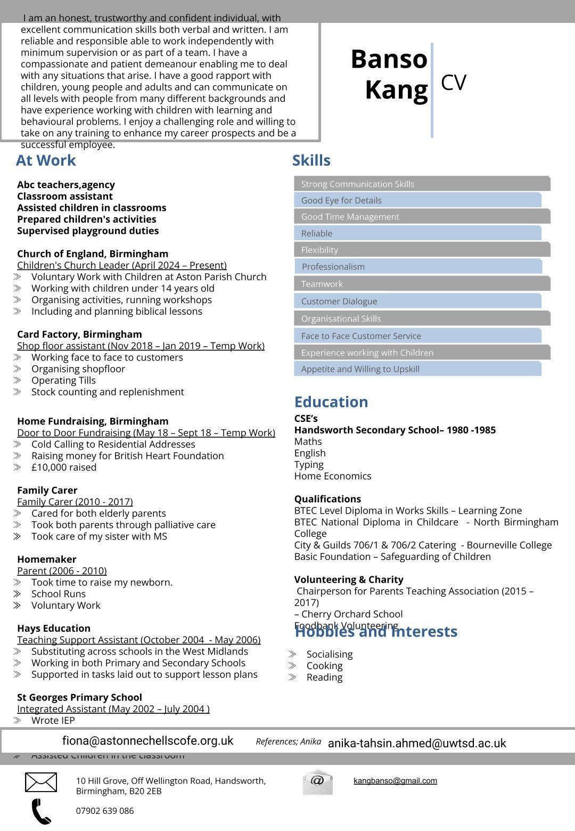
Personal statement. Community lead
I am writing to express my interest in the community lead role. My main agenda is simple. I am a compassionate, reliable, professional, dedicated, supported individuals with diverse needs. I want to make a real positive difference in people's lives. I'm natural people person, I find it incredibly rewarding to help others stay independent, especially within our diverse inner-city communities. I'm community focused. Dedicated to bridging the gap between individuals with long term disabilities and statutory service sees. My goal is to ensure that every citizen feels heard, supported and empowered to lead an independent life.
My background working voluntary in the community has given me a deep understanding of the challenges people with disabilities face.
I can work independently and with and cooperatively work colleagues. I'm a strong believer in equal opportunities and diversity, safeguarding and confidentiality.
I have successfully helped individuals achieve better health and social care outcomes, Including strategy services, charities and local groups. To streamline access to care. I have personally raised a lot of money for charity and have knowledge on how to apply for grants. I have practical experience supporting individuals with physical disability, mental health challenges and learning difficulties. With my level 4 in Health and Social Care skills, needed to lead teams I provide expert person-centred support that helps individuals and build stronger and more independent communities. I am skilled with personalised care following care plans and to meet specific needs and goals of each person. I have built strong trusting relationships with individual's and their families.
I'm a patient and positive person who stays calm under pressure. I believe in person centred support will be put in the individual's choice and preferences at heart of everything I'd they do.
I bring a hardworking, empathetic attitude to the team. I am action-orientated in finding ways to improve individual's well-being and always ready to learn and adapt. I am eager to contribute my skills to your organisation, provide the best possible support to the community. By empowering residents and strengthen local networks, I helped create a stronger, and independent community.

SWOT Analysis Template

Strengths
List your key skills, qualities, and experiences relevant to the chosen role.
- A people person who builds trust and rapport easily with diverse individuals or groups.
- Are able to understand and share the feelings of others to provide genuine person-centered support.
- Excellent at listening and communicating clearly with service users, individuals, families and professions.

Explanation:
Explain how this area impacts your suitability for the role.

Weaknesses
Identify areas for improvement or skills requiring development.
- I can become deeply attached because I am deeply empathetic. I find it a challenge to detach emotionally from individuals and families.
- I'm currently developing my skills in using digital platforms.
- I still need to adapt to specific daily routines and workflows for this new position.

Explanation:
Explain how this area impacts your suitability for the role.

Opportunities
Note external opportunities such as training, placements, and qualifications.
- Complete a first aid course to ensure I can provide immediate, safe emergency support when needed in the Community.
- Building stronger working relations with social workers and healthcare providers to create a better, more connected support network for our service.

- Gaining knowledge from senior support workers to learn from their years of experience.

Explanation:
Explain how this area impacts your suitability for the role.

Threats
Outline external challenges such as competition or limited experience.
- This role is highly demanded, can lead to physical and mental exhaustion if not managed correctly.
- Handling challenging behaviors and unpredictable behaviors from individuals needs to be mentally prepared for tough days.
- Laws and policies are changing all the time, so you have to be updated, and this can be consuming.

Explanation:
Explain how this area impacts your suitability for the role.
My SWOT shows that I am highly suitable because I combine level 4 qualifications with deep empathy. I can stay updated on care policies and laws, to ensure I provide safe, professional, and stable support to the community.

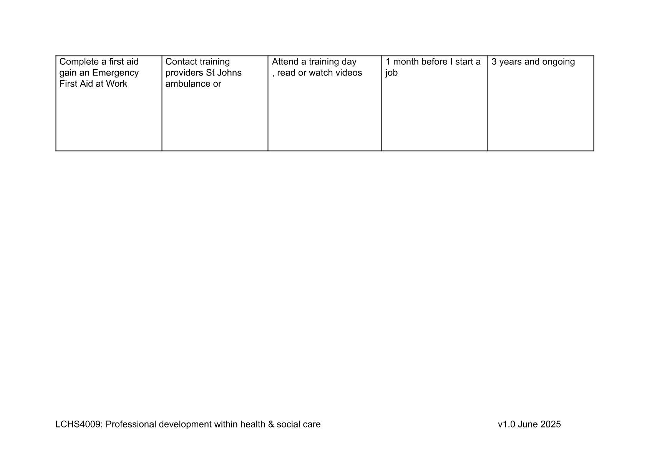
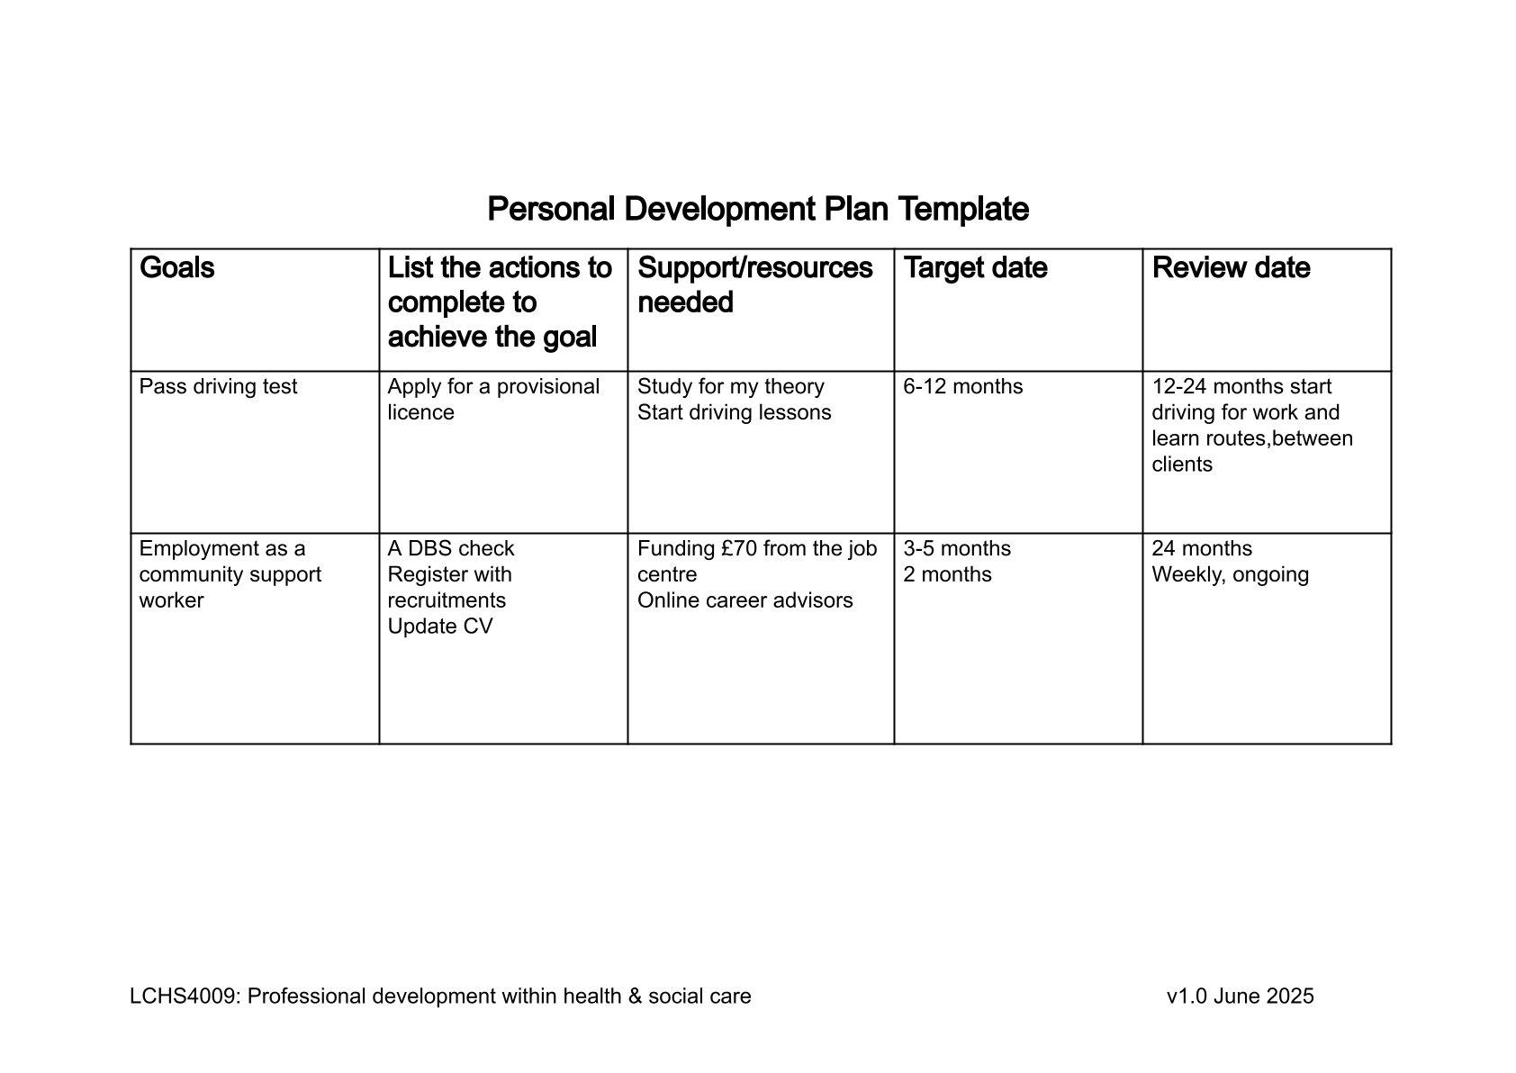

Reflection
Description:
As part of my professional development within the health and social care sector, I was asked to do a classroom presentation, about the importance of communication within a social care setting. For my presentation task, I chose to focus on patient handover within a hospital ward, to illustrate how communication is applied in patient handover on a ward, I implemented the SBAR mode (Situation, Background, Assessment, Recommendation) to guide my thinking. I have used the Gibbs reflective cycle to breakdown this assignment. As well, I can take this forward into my career as a health professional, healthcare professional.
Feelings:
Before presenting the presentation, I was extremely nervous about the task ahead. Public speaking is a challenge for me, and these feelings continued even before I began. During the presentation, my legs were trembling it made it uneasy to stand. I felt a considerable amount of pressure because of the short 5-minute time limit which added to my anxiety. I was worried that I would not be able to cover all the necessary information, the time would run out before reaching my conclusion.
Evaluation:
Looking back at the experience. I realised I was obsessed with the timer. I forgot to look at my lecturer even once. I kept my eyes fixed on the clock on my notes instead of engaging with the lecturer. To manage my nerves, I kept telling myself to speak at a steady pace and remember to breathe. Despite being so nervous, I managed to come over confidently, my content was informative, which I believe was due to thoroughly research I have done previously. It is reassuring to know that even though I am feeling nervous, I can still present myself clearly.
Analysis:
Reflecting on what could have gone better, I recognise that I should have had another key skill for communication on my slides, listening. In patient handover listening is crucial to avoid mistakes, and confusion. During my presentation, I spoke at a fast pace because I felt under pressure due to the length of time allowed. In future presentations I will use a time tool like PowerPoint, rehearing could help me prepare better and stay within the expected time limit without panicking. I also think using a role play technique. Despite the pacing issues, the content was good and informative, which showed my understanding of the subject.
Action Plan:
Looking ahead, I plan to use this experience as a stepping stone for my next presentation. I will check my slides examining them carefully with more attention to detail so that I do not miss key words like listening. I will use rehearsal tools to manage my time so that I do not have to look at the clock constantly. This will allow me to focus on making eye contact with my lecturer. By practising more, I will deliver a better, more balanced presentation next time.
Conclusion:
This assignment has taught me a lot about the importance of communication, especially in social care. Overall, the experience has helped me reflect on how I could prepare better and how to communicate under pressure. I now understand that while my research was strong, my delivery must balance my content with better time management. I'm ready to take on the future assignments with more confidence, knowing which areas of my performance need the most attention.

References:
Gibbs,G.(1988) Learning by doing: A guide to technology teaching and learning methods. Oxford: Further education unit, Oxford Polytechnic.
Moon,J.( 2013) Reflection in Learning and professional development: theory and practise. Reprint. London: Routledge
Gurel,E.and Tat,M(2017)’SWOT analysis: a theoretical reveiw’ The Journal of International Social Research,10 (51), pp.994-1006
Cottrell,S.(2021)The study skill handbook.5th edn.London:Red Globe Press.
Prospects, (2025)How to write a CV. Available at:
Https//www.prospects.ac.uk/careers-advice/cvs-and-covers-how -to -write –a-cv
UCAS (2025) Writing your personal statement. Available at: https//www.ucas.com/applying/applying-university/writing-your-personal-statement

