Full name: Vera Barbos
Student number: 2131047
Module name: Problem-solving and Decision making
Module code: BMSW4004
Assignment title: PRS Assignment 2 Individual Report

Table of Contents
INTRODUCTION 3
ANALYSING INFORMATION 3
ROOT CAUSE ANALYSIS (RCA) 3
APPLYING SITUATIONAL ANALYSIS MODELS 4
RANGE OF ALTERNATIVE SOLUTIONS 9
EVALUATION OF ALTERNATIVE SOLUTIONS 9
IMPLEMENTING THE SOLUTION 10
COMMUNICATION PLAN WITH STAKEHOLDERS 11
MONITORING AND REVIEW TECHNIQUES 15
CONCLUSION 15
REFERENCE LIST 16

INTRODUCTION
The importance of problem-solving skills
Problem-solving skills are essential as it allows the candidates to handle the challenges they face at their workplace. it helps to observe, judge the situation and act quickly when a difficulty arises.
Background of the organisation
The Co-Op Group Society Limited is a small group of retail businesses that includes grocery wholesale and retail services and many more. the organisation has more than 4,000 shops spread across the UK. it has been seen that through the brand is popular in the UK only 20% of consumers who know the brand shop from it (Statista, 2023).

The Workplace Problem
From a survey it has been found that consumers are severely dissatisfied with the organisation in terms of aspects such as the value of the products, availability of the stocks, quality of the fresh products and range of the products as well. In addition to that, there are other issues such as the appearance of the stores and the availability of the staff. it has the scope of reducing the brand value as well as revenue of the Co-op Brand.
A brief discussion on the actual and potential impact on the organisation due to the complex problem.
It has been found that customer dissatisfaction has affected their revenue as well as the productivity of the organisation. According to Butler (2022), the organisation has cut 400 jobs in the Manchester branch and there are continuous job cuts due to rising inflation and loss of annual profit margins. From the perspective of Ahmed et al. (2020), the potential impact of customer dissatisfaction is severe. in the short term, it may affect the sales, but in the longer term, it can affect business dynamically such as harming its reputation of it and many more.

ANALYSING INFORMATION

ROOT CAUSE ANALYSIS (RCA)
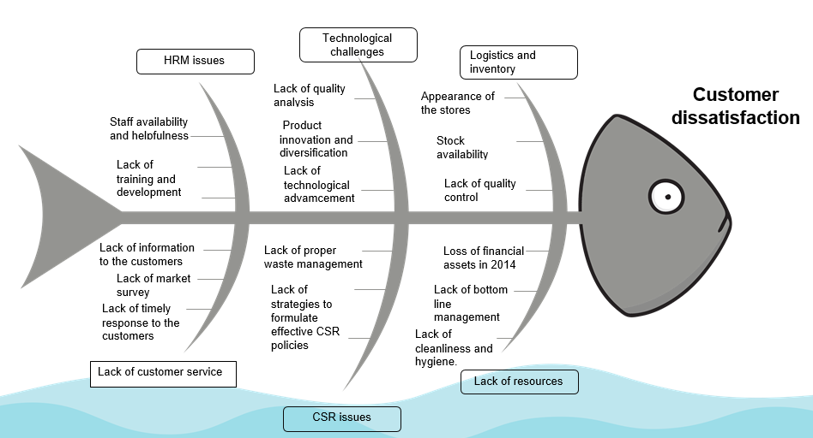
Figure 1: Fishbone analysis
(Source: Created by the learner)
From the data, it has been seen the main cause of customer dissatisfaction is a lack of technical advancement as well as formulation of effective strategies. For instance, the organisation does not provide delivery services at all the places. for instance, in places such as Glasgow and Bournemouth, customers need to order through Amazon in order to buy groceries from Co-op to get a same-day delivery (Nott, 2021). in addition to that, the organisation has a lack of inventory management as many stocks at the end of the product, and consumers feel challenges due to the lack of product availability. As a result, due to a lack of inventory and logistics management, despite having friendly staff the products remain disorganised creating cleanliness issues for the customers, thereby causing customer dissatisfaction.

APPLYING SITUATIONAL ANALYSIS MODELS
SWOT
Strength | Weakness
- The Co-op has nearly 70,000 employees in the organisation (Co-operative, 2023). It supports making operations more efficient.  - The diverse portfolio starting from food retail to banking support the company to provide its services to a large customer base.  - Operating a responsible business in the market through practicing positive CSR initiatives. As the company has the target of achieving Net Zero by 2040 (Coop, 2023). | - The increased cost of operations is a weakness for the company.  - Less presence of stores as compared to market competitors in the food retail sector in the UK.
Opportunities | Threats
- Involving a wide range of products in the food retail business.  - Involving more technological measures is an opportunity for making the business seamless and efficient. | - Higher market competition is a threat to the company in the UK.  - The economic crisis such as a higher inflation rate is a threat to the company considering implementing a solution for resolving work-based problems.
Table 1: SWOT analysis
(Source: Created by the learner)
PESTLE
Elements | Factors | Impact
Political | Corruption perception index | The corruption perception rate of the UK was 78 in 2021 and it has declined in 2022 to 73 (Clark, 2023). Indicating a higher corruption issue in the UK. Increased corruption perception index rate negatively impacts retail sectors as the business will face corruption issues considering running the business with new strategies and decisions. Due to this Co-op will also face the threat of developing a particular solution regarding customer dissatisfaction issues for the business.
Economical | Inflation | The inflation rate in the UK is 6.8 in July 2023 (Clark, 2023). A high inflation rate has a negative impact on the retail sector as the business will face a situation of higher cost of operations and prevent making higher profits for the business. Similarly, it creates a threat for Co-op for outlining a solution regarding the customer dissatisfaction issue as cost operation will prevent putting extra investment into implementing an effective solution.
Social | Population | The population of the UK is high as it has increased from 67 million and crossing 68 million (Plecher, 2021). A higher population puts a positive impact on the retail sector as businesses can target a large customer base in the market. Hence, it will be an opportunity for Co-op towards implementing a solution regarding customer dissatisfaction.
Technological | Internet penetration rate | The Internet penetration rate in the UK is 96.7% which is a higher number (Taylor, 2023). Increased internet penetration rate put a positive impact on the retail sector as the business can focus on making the business more digitalise and aligned with satisfying customers in the digital space. Therefore, Co-op will also get the opportunity to involve technological solutions aligning higher internet penetration for resolving customer dissatisfaction issues.
Legal | “Minimum Wage Act 1998” | It highlights employees must get the minimum wage from employers at the workplace. It put a positive impact as businesses will get higher efficiency in return for providing minimum wage to employees and keeping them satisfied at work. Hence, Co-op will also have the opportunity by giving minimum wage to its employees to consider working collaboratively for overcoming the customer dissatisfaction issue.
Environmental | “Environmental Act 2021” | It ensures environment and natural resources are kept safeguarded. It ensures a positive impact as a business will be focusing on more sustainability of the operations. Hence, Co-op will be liable to involve sustainable measures such as more technological applications considering to satisfy environment protection and planning for mitigating custom dissatisfaction issues.
Table 2: PESTLE analysis
(Source: Created by the learner)

RANGE OF ALTERNATIVE SOLUTIONS
From the cause-effect model, it has been found that the customers are mainly dissatisfied due to a lack of technical advancement. The organisation lacks proper inventory management and use of information technology in order to understand consumer needs and demands. therefore, the proposed solution for the issue can be:
- Solution 1- Implementation of Economic Order Quantity (EOQ) inventory management system.
- Solution 2- Use of AWS to sell the products online through customisable products online and reduce infrastructure costs by 30%.
- Solution 3- Use of information technology to understand consumer demands, trends, sales analysis, monitor and control stocks and many more.

EVALUATION OF ALTERNATIVE SOLUTIONS

In order to understand the perfect solution for a Co-op supermarket, the pros and cons of all three potential solutions are discussed in the below table:

Solutions | Pros | Cons
EOQ | - Minimises storage and holding costs such as handling expenses, shipping charges and so on.  - Avoids over and understocking (Fauziah et al., 2022). | - Runs on the basis of assumptions.  - complex mathematical calculations.
AWS | - Cost effective services  - Fast deployments  - Offers centralised billing and management. | - Downtime  - Limited control  - Backup protection (Gupta, 2021).  - Security limitation
Information technology | - Automating process  - Collecting customer data and feedback  - Communication and adding value to retail transactions.  - Technology-enabled shopping. | - Required complex system due to wide array of products.  - budget constraints can affect the implementation of this system negatively.  - requited staff training and development.
Table 3: pros and cons of the proposed solutions
(Source: Created by the learner)
Based on the discussion the use of an information management system is the best solution for the organisation as it covers a wide aspect of challenges faced by the organisation in myriad ways.

IMPLEMENTING THE SOLUTION
In order to implement the plan a Gantt chart is used here:
Workbook structure
Activities | Start date | Duration | End date
Identification of the challenges | 21.08.2023 | 5 | 26-08-2023
Team assembling and approval from the stakeholders | 26-08-2023 | 6 | 01-09-2023
Investigate new technologies | 01-09-2023 | 8 | 09-09-2023
Mapping out the system | 09-09-2023 | 10 | 19-09-2023
Running a pilot programme | 19-09-2023 | 12 | 01-10-2023
Training employees | 01-10-2023 | 14 | 15-10-2023
Launching and Monitoring the final system | 15-10-2023 | 7 | 22.10.2023
Table 4: Work breakdown structure
(Source: Created by the learner)
Gantt chart
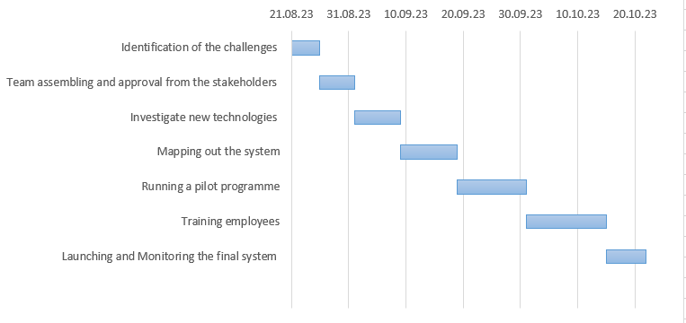
Figure 2: Gantt chart
(Source: Created by the learner)

COMMUNICATION PLAN WITH STAKEHOLDERS
A stakeholder is determined as a person or group of persons with a vested stake in the decision-making or activities of a business organisation and other projects. Stakeholders are categorized into two parts internal stakeholders and external stakeholders (Lehtinen and Aaltonen, 2020). Internal stakeholders involve employees, investors, board of directors and others whereas external stakeholders are customers, suppliers and government agencies. In terms of Co-op, the key stakeholders are its employees, managers, customers, suppliers, community, government agencies and emergency services. All these are both internal and external stakeholders of the company having the power and internet in the decision-making process.
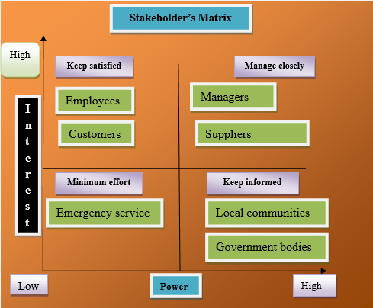
Figure 1: Stakeholder matrix
(Source: Created by the learner)
The above figure highlights that Co-op has different key internal and external stakeholders involved in its organisation. As employees and customers are kept in the keep satisfied section as their needs to be satisfied considering to leverage the business in the market. Following by Managers and suppliers need to be managed closely as they are responsible for implementing solutions identified considering to resolve customer dissatisfaction. Although, emergency services are kept in the lower effort section as they might be required to consider any risk while implementing the solution in the business to overcome custom dissatisfaction. Local communities and government bodies are in the Keep Informed section. As these stakeholders are required to execute the solution most positively and legally by aligning with local law and order. Hence, collaboration with all these stakeholders Co-op can ensure a seamless implementation of the solution involving technological measures as resolving the customer dissatisfaction issue.
Stakeholders | Power/interest | Key internet | Communication vehicle | Frequency
Employees | High | Direct interest in the implementation of technological measures and getting paid on time | Meeting | Weekly
Customers | Moderate | Key interest as the end product and services are developed for them and satisfy their needs | Newsletters | Monthly
Managers | High | Interest in making the operations efficient and making the decision of technological involvement effective and in control | Meeting and e-mail | Daily
Suppliers | High | Core interest in fulfilling the supply-demand of materials for implementing the technological measures as solutions and generating profits | E-mail and phone call | Weekly
Local communities | Low | Interest in getting benefited by the business organisation for development | Newspapers and events | Monthly
Government bodies | Moderate | The interest of ensuring everything is done abiding by law and regulatory | Official e-mail and meeting | Once in a particular time
Emergency service | Low | Interest in overcoming any risk while operations | Phone call | Once
Table 4: Stakeholder communication plan
(Source: Created by the learner)

MONITORING AND REVIEW TECHNIQUES
To plan and monitor the progress of the implementation of information management technology ADKAR Gap model is illustrated below:
There are three stages of the model that help to identify the gaps in the implementation plan (Kaminski, 2022).
Collecting and analysing feedback: Customer satisfaction scores can be used for collecting and analysing information.
Diagnosing gaps and managing resistance: Engagement of the employees and employee turnover rate can be diagnosed in order to identify and manage resistance from the employees.
Implementation of corrective actions and celebrating successes: the corrective actions can be understanding the requirement of the system, conducting training and development, and so on. Antivirus and malware protection should be used as a part of corrective measures.

CONCLUSION
It has been found the organisation is facing major customer dissatisfaction due to a lack of technological advancement and the non-availability of stocks. The internal environment of the company is stable but has more opportunities to work on considering leveraging the business and solving customer dissatisfaction. The external environment highlights political and economic factors as threats to the company. The key stakeholders of the company are described along with their interest in the organisation through a stakeholder communication plan. Therefore, the best plan suggested to the organisation is to implement information technology to understand consumer demands and prepare inventory based on customer feedback.

REFERENCE LIST
Ahmed, R.R., Vveinhardt, J., Warraich, U.A., Hasan, S.S.U. and Baloch, A., 2020. Customer satisfaction & loyalty and organizational complaint handling: Economic aspects of business operation of airline industry. Engineering economics, 31(1), pp.114-125.
Ankit Gupta, 2021. Why AWS ?? ….Advantages and Disadvantages.. [Online] availale at:<https://medium.com/analytics-vidhya/why-aws-advantages-and-disadvantages-f0e666b869b3#:~:text=Disadvantages%20of%20AWS&text=Amazon%20Web%20Services%20may%20have,images%2C%20volumes%2C%20and%20snapshots:> [Accessed on 21st August 2023]
Clark, D. 2023. Corruption perception index score of the UK 2012-2022. [Online] Available at: <https://www.statista.com/statistics/868971/corruption-perception-index-in-the-uk/> [On 21st August 2023]
Clark, D. 2023. Inflation rate in the UK 1989-2023. [Online] Available at: <https://www.statista.com/statistics/306648/inflation-rate-consumer-price-index-cpi-united-kingdom-uk/#:~:text=The%20UK%20inflation%20rate%20was,11.1%20percent%20in%20October%202022.> [On 21st August 2023]
Coop. 2023. Sustainability and Future of Food. [Online] Available at: <https://www.coop.co.uk/sustainability> [On 21st August 2023]
Co-operative. 2023. Our Co-op. [Online] Available at: <https://www.co-operative.coop/about-us/our-co-op> [On 21st August 2023]
Fauziah, I., Rizki, M., Hartati, M., Lubis, F.S. and Lestari, F., 2022, July. Market Basket Analysis with Equivalence Class Transformation Algorithm (ECLAT) For Inventory Management Using Economic Order Quantity (EOQ). In " Proceedings of the 3rd South American International Industrial Engineering and Operations Management Conference, Asuncion, Paraguay, July 19-21, 2022" (No. ID 315, pp. 1552-1561). IEOM Society International.
George Nott, 2021. Co-op extends Amazon store availability to England with Bournemouth launch. [Online] available at:<https://www.thegrocer.co.uk/the-co-operative-group/co-op-extends-amazon-store-availability-to-england-with-bournemouth-launch/660680.article#:~:text=Co%2Dop%20has%20extended%20availability,on%20Amazon.co.uk:> [Accessed on 21st August 2023]
Kaminski, J., 2022. Theory applied to informatics–The Prosci ADKAR Model. Editorial. Canadian Journal of Nursing Informatics, 17(2).
Lehtinen, J. and Aaltonen, K., 2020. Organizing external stakeholder engagement in inter-organizational projects: Opening the black box. International Journal of Project Management, 38(2), pp.85-98.
Plecher,, H. 2021. Population of the United Kingdom (UK) 2015 to 2025. [Online] Available at: <https://www.statista.com/statistics/263754/total-population-of-the-united-kingdom/> [On 21st August 2023]
Sarah Butler, 2022. 2023. Co-op Group to cut 400 jobs at Manchester head office. [Online] Available at:<https://www.theguardian.com/business/2022/jul/22/co-op-group-to-cut-400-jobs-at-manchester-head-office:> [Accessed on 21st August 2023]
Sarah Butler, 2022. Co-op warns about food supplies and inflation as profits fall 57%. [Online] Available at:<https://www.theguardian.com/business/2022/apr/07/co-op-warns-food-supplies-inflation-profits-fall-57-per-cent-2021:> [Accessed on 21st August 2023]
statista, 2023. Co-op brand awareness, usage, popularity, loyalty, and buzz among online grocery delivery users in the United Kingdom in 2022. [Online] Available at:<statista.com/forecasts/1304365/co-op-online-grocery-delivery-brand-profile-in-the-united-kingdom:> [Accessed on 21st August 2023]
Taylor, P, 2023. Internet penetration in the United Kingdom (UK) 2000-2021. [Online] Available at: < https://www.statista.com/statistics/468663/uk-internet-penetration/> [On 21st August 2023]

