Reflection on Academic and Employability Skills

AES Module Assignment
Shaun Davies
2019

Contents
Abstract 2
1. Brief Overview of the Authors Presentation 3
1.1 The Author 3
1.2 Key Points learnt from the Presentation 6
2. Research into Skills Evaluation 6
2.1 Skills Required for Higher Education 6
2.2. Skills Employers Look For 8
2.3 Authors Self-Assessment 9
3. Action Plans 11
3.1 Short- and Long-Term Goals 11
4. Data Management & Time Management 13
4.1 Data Management plan 13
4.2 Time management & Self Organisation 15
5. Conclusion/Evaluation 17
5.1. Conclusions 17
5.2. Recommended Areas for Further Reading 17
6. Appendix 18
Appendix A 18
Appendix B 24
Appendix C 26
Appendix D 40
Appendix E 42
Bibliography 44

Abstract

The following report will provide a description of the author including his personal/academic/work life. The author has conducted personality tests to gain an idea of how his personality is best described and what area of employment he would be best suited to.
He will explain what he believes are the key skills needed for Higher Education and what skills employers will look for when looking to employ. He then will list his short- and long-term goals and explain how he intends to achieve them.
The author goes on to describe what his current data management plan is and why this is. He will describe why he uses his current plan and what risks he aims to avoid by doing so.
The author then ends by comparing his findings from the study and what further learning/action he plans to take.

1. Brief Overview of the Authors Presentation

1.1 The Author

The Author was born on the 26th of July 1987 at Morriston Hospital, Swansea and grew up in the Bryn area of Llanelli, Carmarthenshire with his Mother, Step-Father and younger Brother.
He attended Bryngwyn Comprehensive school from 1998 until 2003 where he then attended Ammanford College studying Plumbing. Whilst at college he worked part-time at McDonalds restaurant, Trostre, Llanelli.
After approximately 14 months the author decided to leave college and McDonalds and then began a strain of differing employment. Starting in telemarketing selling mobile phone contracts, then working as a bar man at a popular Llanelli Nightclub. He then moved away to Butlins, Minehead where he worked at a café/bar, this was a short-lived experience.
When he moved back to Llanelli he briefly worked in Lidl before Joining the Royal Navy on the 5th of December 2005. He enlisted as an Engineering Technician Weapons Engineer. He served for 7 Years mainly on Destroyer class ships, including, HMS York, HMS Nottingham and HMS Diamond.
During his service in the Royal Navy he met his first wife and they had a son together in 2011 called Riley. In 2012 he left the Royal Navy to join Dyfed-Powys Police force as a Police Community Support Officer (PCSO). He started this role in September 2012 and worked as a PCSO in the Cross Hands area of Carmarthenshire.
During his time as a PCSO he enjoyed working closely with the local community and being a Police presence to try and prevent crime. In 2013 he was divorced but soon after met his current wife, Zoe. It was at this time after serving 2 years as a PCSO he decided to join as a Police Constable (PC) in 2014.
In his Police training he was awarded the Chief Constables’ Award for best overall student, an award he is extremely proud of to this day. After training he quickly developed as an effective Police Officer and his work was recognised by his peers and superiors. As his career was in full motion so was his relationship with Zoe which saw him purchase their first property together and not long after have their first child together, a daughter named Evie. He was then asked to join the Criminal Investigation Department (CID) in 2017 and passed the National Investigators Exam. He now works on the Organised Crime Unit and passed the National Police Promotional Framework (Sergeants Exam) in May 2019.
He now lives in the Cross Hands area with his wife Zoe, son Riley and daughter Evie. They are expecting their second child together in September 2019.
Below are some images extracted from the Authors personal presentation.

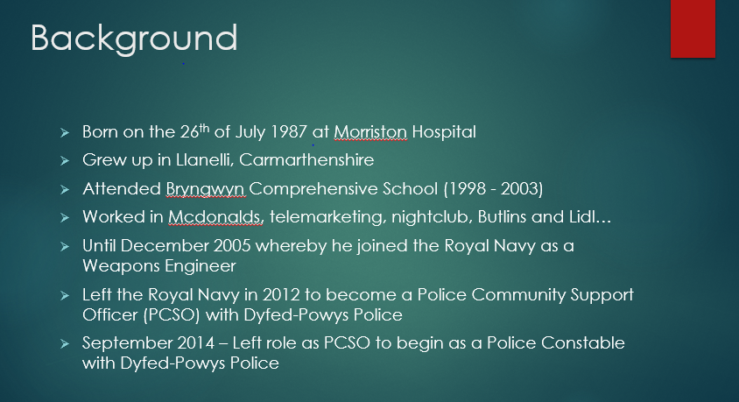
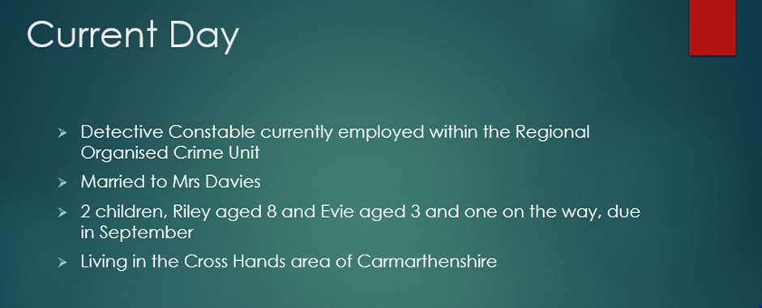
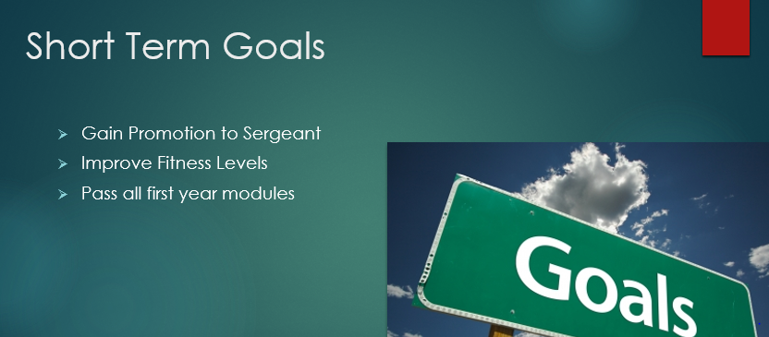
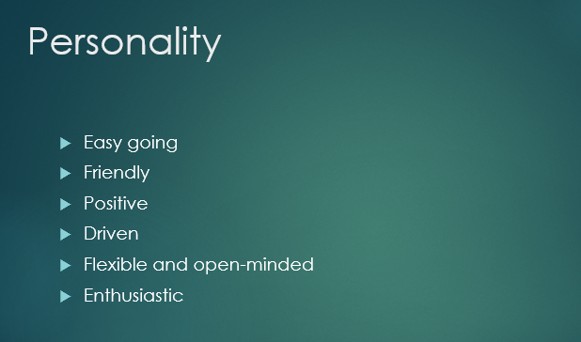

1.2 Key Points learnt from the Presentation

When producing the presentation, what the author found most difficult was defining their personality. The author thought of himself as a friendly, positive person who could be an introvert at times but also perhaps an extrovert at others. Having to think what type of personality traits you have makes you ask a lot of questions about how you think you are perceived which sometimes can be more hopeful than reality.
The author made a list of short- and long-term goals which again took some time. Having to really think what was most important to him and what he wanted to achieve in life. As you can see from the images above, career and family life are the most important to the author. It made the author really think how he was going to plan to achieve his goals.
The author tried to keep the presentation brief whilst giving enough information to inform the selected audience. He felt it was a fine line between too much information which may lead to boredom or having too little information which could leave the presentation being very quick.
The areas which the author thinks they could improve the presentation is mainly design, he believes that if he were to reproduce the presentation then he would add some images of his family to put things into perspective.

2. Research into Skills Evaluation

2.1 Skills Required for Higher Education

When the author researched what skills are essential for higher education learning he found that most research had very similar results. Some of the main qualities included time management, presentation skills, leadership and management, communication, resilience and adaptive thinking [1] [2].
Time management is essential, not just being on time at a lecture or at your place of work but managing your spare time is key when studying in Higher Education. Studying either part time or full time, can become overwhelming if not managed to suit a person’s lifestyle [1].
For example, when studying part-time and in full-time employment, it may seem impossible to effectively manage the both unless you prioritise your time well. You should set suitable time aside to carry out studies during the week and prioritise work according to importance/deadlines [1].
By doing this then there is a clear routine to your studies which will assist in avoiding stress when trying to complete tasks. It will also ensure that you use the time around those study hours to carry out other tasks/hobbies and interests or spend time with family/friends. This is important as having good family support is key when trying to study [1].
Independent learning is a key skill when studying in Higher Education. You need to have the motivation to be able to prepare well for assignments/tasks. You will need to be able to conduct research on your own accord with little or no prompting. By doing this you will find yourself in control of your studies and effectively utilising your productivity [3].
Self-motivation is like the enthusiasm needed for independent learning. You need to remember why you are studying in the first place. What you are aiming to achieve and where you are aiming to be in life. This should help keep you focused and motivated to complete assignments and studies to the best of your ability and on time [3].
Presentation skills will be required throughout Higher Education and into future careers so developing this skill is an investment in your future. You will need to be able to present your workings in a legible and academic format that suits the requirements of the course/University/employer such as referencing/report styles. Being able to give a presentation to an audience of people may seem daunting but like anything, if you properly prepare then this will make it a lot easier [3].
You should plan not only your physical presentation but your speech to and any relevant material that you need to demonstrate or to supply as handouts to the audience. It may seem obvious, but you will also have to know the functionality of software such as PowerPoint and Keynote. Practising public speaking can also prepare you for what a presentation may be like and will assist in timing your presentation correctly [3].
Being able to conduct independent research and read/interpret said research will help when writing reports. Not only will it give you referencing points to evidence your research but also a better understanding of the subject. It is good to read different perspectives on one subject to then make your own opinion based on the differing research [3].

2.2. Skills Employers Look For

If you follow the above, then it will stand you in good stead when starting full time employment as employers will no doubt be looking for the same skills. Employers will be looking to see that you have an adaptive way of thinking. In many of today’s industries there are many developments in the way they work [2].
Particularly in the digital world where software and hardware are forever changing. You will need to be able to change with the times and develop your own ways of developing change to enhance your company’s efficiency [2].
In most employment you will be required to work as part of a team. Some people will struggle with this more than others. It is essential that you can adapt to working as part of a team as within a team there may be others who have differing abilities in different areas and as a team provide great efficiency by utilising their strongest ability and working as a team [4].
As technology waits for no one, you will be required to have a good working knowledge of the technology you will be working with. This could include being able to utilise Microsoft Office or iWork for example. Being able to demonstrate good practice in technology may earn you a position with an employer over someone with less knowledge [4].
Employers will be looking for good communication skills, not only the way you speak to people face to face but how you speak to different people inside and outside of your company. Also, how clearly you can write whether that be in emails or reports etc. Communication can be demonstrated in interview, meetings, presentations and the like [4].
Taking the initiative as an employee and being able to make decisions on your own will demonstrate that you have a good knowledge of your role. It will encourage your employer to trust you to conduct yourself confidently and make decisions that will benefit them [4].

2.3 Authors Self-Assessment

The Author has conducted several self-assessment tests in order to establish his personality traits and what job he would be best suited to.
Firstly, he took part in an online questionnaire named the “Big Five Personality Test” [5]. This test woks on the belief that there are 5 main personality traits, 1 - Extroversion, 2 - Emotional Stability, 3 - Agreeableness, 4 - Conscientiousness and 5 - Intellect/Imagination.
The test takes your answers to the questions and then states what the user scores out of 100 for each trait. The author scored as follows;
1 – 74
2 – 78
3 – 62
4 – 87
5 – 8
Please see Appendix A (Personality Test results).
From it was shown that the author scored highest in conscientiousness meaning he is more likely to be careful and diligent in his actions. This can be associated with being meticulous and organised which is a good trait when planning activities/studies [5].
The lowest area was intellect/imagination with 8. The author was surprised with this result as he believed he had a vivid imagination. Individuals who score higher in this area would be more likely to be innovative and think beyond what is currently in place. Creative people will usually have broader imaginations [5].
The other factors scored quite high too, this would suggest the author is quite confident and comfortable to be a leader whilst being able display empathy to others feelings and needs [5].
The second test taken by the Author was the Open Extended Jungian Type Scales, whereby you state which statement you are more likely to align with or if you are undecided/neutral to both statements. This then shows which personality traits the user is more likely to have [5].
The test results which can be seen in the appendix (Personality Test Results), suggested that the author was more inclined towards extroversion, sensing, thinking and judging (ESTJ).
ESTJ personality types are more likely to be organised, practical and matter –of-fact. They appreciate rules and procedures and adhere to them consistently. This makes them good in a business, engineering, mechanical role.
The author took part in 3 more online tests which can be found in the Appendix A (Personality Test Results) [6] [7] [8].
The test results all appeared to show a common theme, being that they appeared to describe the author as an extrovert who is hard working, loyal and, considers other people’s feeling and emotions. A sociable person who engages with others on a lasting basis. A person who seeks responsibility and takes their employers missions statements/values seriously.
A number of jobs which are best suited with a person of this type of personality range from hands-on work such as a cook, sports coaching, mechanics, building to office based roles such as, sales person, estate agent, public speaker and so on [8].

In comparison to what the author thought of himself the results are similar with the exception of the belief he was more introverted. From the exercise the author was surprised to learn that he would be suited to a role in sales. This is an area he has previously tried and disliked greatly.
The author agreed with most of the findings of the tests and even though their current employment role was not mentioned, he can see how he does appear to suit his current role in the Police.
To be a Police Officer you need to be confident in your decision making with a good knowledge of the law whilst adhering to the Force values and priorities. You need to be resilient and organised when conducting investigations and presenting them in Court.
A Police Officer should be able to empathise with members of the public and not shy away from confrontation. Being an extrovert would assist in being able to talk with many different people from different backgrounds on an appropriate level.
The author believes that the tests have shown that he is in a role that bests suits his type of personality.

3. Action Plans

3.1 Short- and Long-Term Goals

In the authors presentation he listed his short- and long-term goals. The authors’ short-term goals can be seen in section 1.1 of this report and are as follows;
- Gain Promotion to the Rank of Sergeant
- Pass All First Year University Modules
- Improve Fitness Levels
As can be seen the short-term goals appear to be career and health motivated. The authors’ long-term goals stick to the same theme and are listed as follows;
- Steadily gain promotion through higher ranks of the Police Force
- Maintain fitness levels and challenge them with new experiences e.g. swimming, marathon running etc.
- Maintain and improve comfortable financial stability for family
- Complete University degree with a respectable grade
- Maintain family happiness
It is clear from the authors’ short- and long-term goals that their career, family life and personal health are most important to them. The author has used the S.M.A.R.T. action plan to set his goals [9].
S.M.A.R.T. stands for Specific, Measurable, Achievable, Realistic and, Timely [9]. Using this format, the author was able to create an action plan to achieve his short- and long-term goals. The short-term goals can be seen in Appendix B (SMART Action Plan, Short Term Goals).
An example of one of the authors’ short-term goals is as follows;
Specific – Gain promotion to the rank of Sergeant within 12 -18 months
Measurable – Pass the Sergeants exam (May 2019) and gain experience in a Sergeants’ role to gain substantive promotion by November 2020.
Achievable – Successfully passed Sergeants exam and expressed an interest to act in temporary Sergeants’ position. Opportunities for acting roles expected between current date and early 2020.
Realistic – Fully capable and confident to perform the role of a Supervisor. Supported by current Supervisors and all necessary pre-requisites have been completed. Realistic timescale of 12-18 Months.
Timely – Realistic timescale of 12 to 18 months to give enough time to gain experience in a supervisory role. Promotion interview boards begin January 2020 which gives 6 months of preparation to successfully pass interview board.

An example of one of the authors’ long-term goals is as follows;

Specific - Steadily gain promotion through higher ranks of the Police Force. Gain rank to Inspector within the next 5 years.
Measurable – Pass Inspectors exam with support of supervisors. Similar to the Sergeants exam which has already been achieved. Competently perform the role as a Sergeant to gain support from supervisors.
Achievable – By passing Inspectors exam and expressing an interest to perform acting role in Inspectors rank. Gain experience and pass Inspectors promotional board by preparing well in advance and utilising experience gained from period of acting in that role.
Realistic - Commit to study in preparation of Inspectors exam to pass comfortably. Look to gain acting role within 12 months of passing exam to then gain experience and promotion within the following 4 years.
Timely – Realistic timescale of 5 years to gain experience in Sergeants role. Will have successfully completed University degree at this time and will have time free to study for Inspectors exam.

4. Data Management & Time Management

4.1 Data Management plan

The author has in place a data management plan in relation to his personal data such as family photos, videos etc. and for his University work. The reason behind having such a plan is because of the widely held belief that if data is not stored in at least 3 separate locations/devices then it does not exist.
This belief is because data can be lost in various ways which are sometimes irretrievable and out of anyone’s control. Devices such as USB memory sticks and portable/external hard drives can have an expiry date and like most technology, is not immune to breakdown. This can be caused by the software being corrupted or physical damage.
Storing on the hard drive of a laptop/desktop could make your data vulnerable to the same risks and the potential of cyber-attacks such as viruses, Trojans etc. more on cyber-attacks can be found in the Cryptowall report by the author, please see the Appendix C.
The author uses 4 methods for storing his data. The first method used is a USB device, this device is kept with him either whilst at University, work or at home. The device is used almost daily and is currently working efficiently and has the required storage.
The second method is an external Hard drive which is located permanently at the authors’ home address and is updated every 2 weeks by copying data from the USB devices or the third method.
The third method is Google drive which is a “cloud” based account. Google drive is a free service offered by google which allows the user 15GB of free data storage. This allows the user to store data online using their GMAIL account and access it anywhere in the world where they can access a computer/GMAIL.
You can increase the amount of storage space by paying and upgrading to Google One, the first three available options are shown below [10].
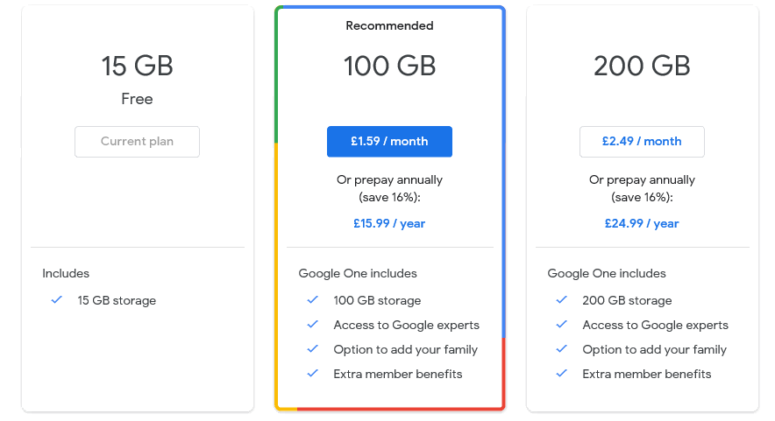 [10]

There are other options available with increased storage and price. Google Drive also allows you to create free web-based applications such as documents, presentations etc. much like Microsoft Office [11].
Google has impressive cyber security measure which gives your data an amount of protection against loss/theft however it is not impenetrable.
The fourth method is a further USB device with adequate storage. This is kept at the authors’ place of work and is updated monthly via the first or third methods.
Using these four methods does not completely protect the authors’ data as this is virtually impossible. It does however give a degree of security. If for instance any of the physical devices should be corrupted, then the data will still be stored online on Google Drive.
If the physical devices were destroyed in a house fire or flood for example, then again, the data would be available on Google Drive and the USB device kept at the authors’ work place. If the data is regularly updated, then data loss should be little to none.
Google Drive could fall victim of a cyber-attack causing the data to be lost/stolen. In this case then the data would still be available on the physical devices. However, if the physical devices were corrupted/damaged/lost and Google Drive fell victim to a cyber-attack then it is highly likely all the data would be lost.
Another way the author could combat this is to save all the data to a separate device such as a laptop which is not automatically connected to the internet to avoid automatic updates of cloud accounts such as Google Drive. This would provide another method of retrieving the data.

4.2 Time management & Self Organisation

The author has taken measures to enhance their productivity, by putting in place some simple measures. By utilising Google Calendar, the author has created a time period in the evenings of week days between 20:00 hours and 22:00 hours, which is dedicated University studies.
By doing this it makes the author and his family aware that during those periods his time is fully committed to University studies. The author has then made “To-do lists” in order of priority to ensure the most important tasks get completed first, in an appropriate timescale.
The author has also assessed their academic skills, this can be seen in the Appendix D. The author has then been able to make note of what areas are positive and what areas need improvement. By doing this the author can then prioritise those areas of improvement in order to improve their academic skills. This can also be seen in the Appendix D.
The author has made an e-Portfolio in order to organise their self-assessment files and academic work. Below is how the e-Portfolio is structured.
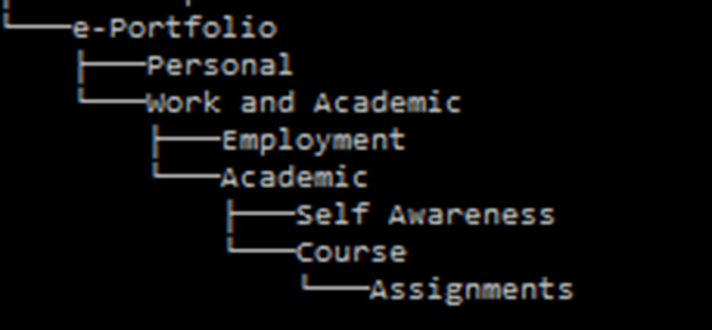
As you can see there are several folders within the file, the first of those being employment. This folder holds the authors C.V. which can then be updated regularly with any relevant information for employers. A list of skills and qualifications which can also be updated accordingly along with their short- and long-term goals.
The next folder is academic which contains a self-awareness folder containing the self-assessments listed above and action plans for self-improvement and self-study. The final folders are for the authors University course and assignments. This contains their to do lists in relation to assignments and tasks and any assignments which are currently in the progress.

5. Conclusion/Evaluation

5.1. Conclusions

As a result of the assessments, tasks, research and, presentation the author has concluded that in order to successfully complete their University course with a respectful grade they will need to take certain steps.
The author will concentrate on the areas of his academic skills he has identified as needing improvement. He will do this by regularly conducting self-assessments and taking feedback from lecturers on assignments and use that to progress.
The author will continue to manage their time correctly giving appropriate time to study and reach deadlines in good time to avoid stressful situations. He will do this whilst maintaining a good work/life balance to ensure family happiness in line with the authors goals.
After producing and delivering a presentation the author has established that he would in future include relevant images in the presentation to give some context to the information. He would ensure to stay within the time parameters by using a script rather than from memory.

5.2. Recommended Areas for Further Reading

The below link gives tips on productivity as a student [12].
https://collegeforadultlearning.edu.au/tips-to-increase-your-productivity/
The next link gives some ideas for studying whilst working full-time [13].

6. Appendix

Appendix A

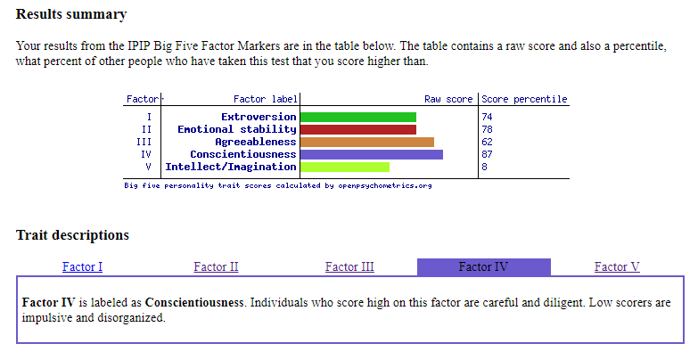 [5]

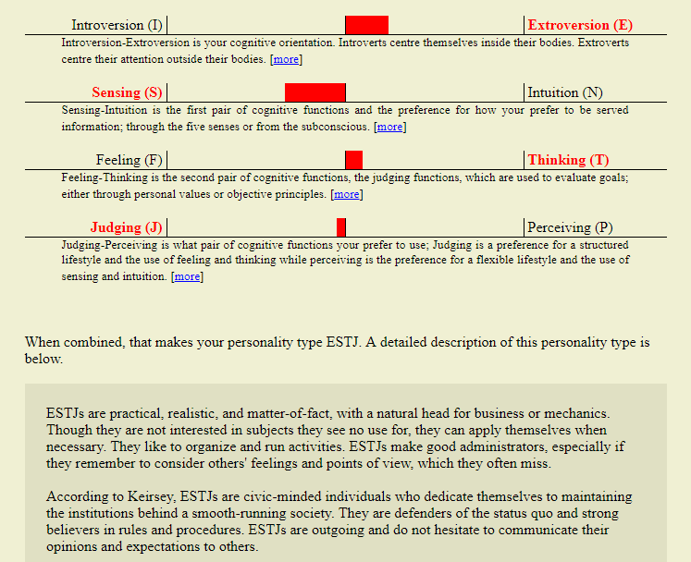 [5]

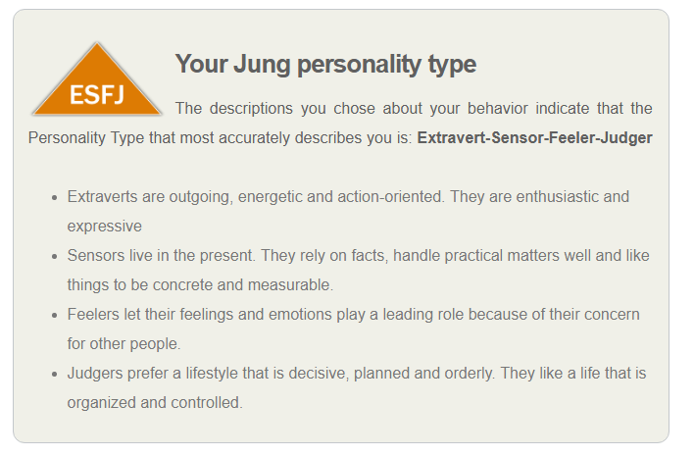 [6]
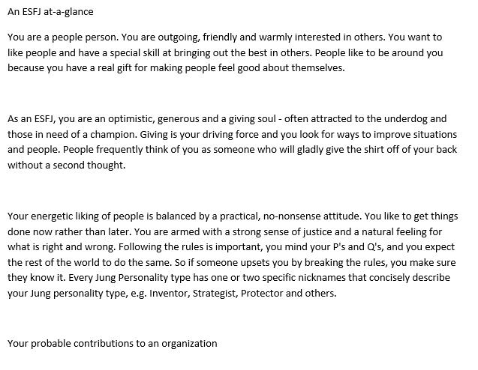[6]
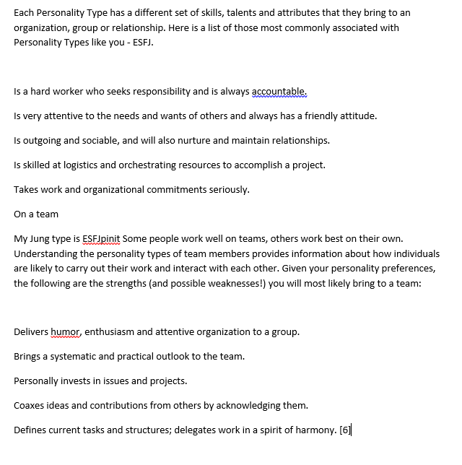
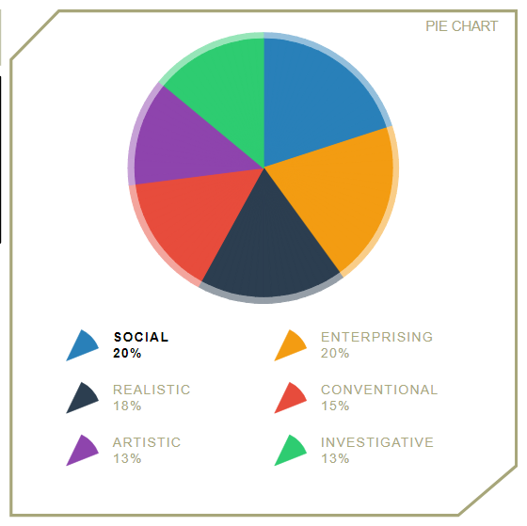 [7]

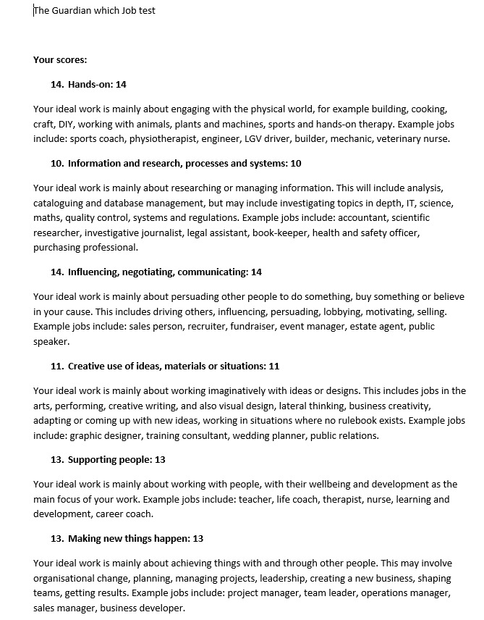

Appendix B

SMART Action Plan, Short Term Goals
Specific – Gain promotion to the rank of Sergeant within 12 -18 months
Measurable – Pass the Sergeants exam (May 2019) and gain experience in a Sergeants’ role to gain substantive promotion by November 2020.
Achievable – Successfully passed Sergeants exam and expressed an interest to act in temporary Sergeants’ position. Opportunities for acting roles expected between current date and early 2020.
Realistic – Fully capable and confident to perform the role of a Supervisor. Supported by current Supervisors and all necessary pre-requisites have been completed. Realistic timescale of 12-18 Months.
Timely – Realistic timescale of 12 to 18 months to give enough time to gain experience in a supervisory role. Promotion interview boards begin January 2020 which gives 6 months of preparation to successfully pass interview board.

Specific – Successfully pass all first year University modules.
Measurable – Ensure time is manged correctly and conduct studies with enthusiasm and efficiency.
Achievable – If the correct study techniques are utilised in combination with research and learning from lecturer feedback.
Realistic – Confident that the learning can be applied appropriately to successfully pass first Year University Modules.
Timely – Assignments completed in good time and self-study completed in preparation for exams.

Specific – Improve Fitness/Health.
Measurable – By setting aside time for physical training during the week and rest days to recuperate.
Achievable – If the proper commitment is made and consistent training along with a healthy diet (Keto).
Realistic – Relatively good fitness levels that are looking to be improved over monthly periods.
Timely – Physical fitness planned for 1 to 2 hours daily with one rest day during a 7-day period. Setting Monthly challenges to steadily improve fitness levels and achieve goals.

Appendix C

Reflection on Academic and Employability Skills
Shaun Davies
University of Wales Trinity Saint David, Swansea Campus

Abstract
The following report explains what is meant by the term Trojan Horse and will go onto explain what they are. It will also explain what Cryptowall ransomware is and what danger it presents to users of personal, small, medium or large networks. The aim of the document is to give an understanding of Trojan Horse malware, ransomware and what can be done to prevent these kind of attacks taking place on your servers and preventing loss of data, potential earnings and confidential information. There are a number of websites referenced through the document which might be of interest following this report.

1. Introduction………………………………………………………………….4
2. Trojans………………………………………………………………………..5
2.1 What are Trojans……………………………………………………….5
2.1.2 How do they work…………………………………………………...5
2.1.3 How to prevent Trojans…………………………………………….6 Trojan Ransomware…………………………………………..…………………….......7
3.1 What is Trojan Ransomware………………………………………………...7
3.1.2 Should payment be made………………………………………………….7
4. Cryptowall Trojan……………………………………………………………….....7
4.1 What is the Cryptowall Trojan……………………………………………....7
4.1.2 Examples of cyber attacks…………………………………………..…....8
4.1.3 How to protect against Cryptowall……………………………………....8
5. Conclusions………………………………………………………………………..9
6. References/Bibliography………………………………………………………..10
7. Appendix…………………………………………………………………………...12

1. Introduction
The following report will explain what Trojan Malware is and what harmful action it can inflict on your data or network. Cryptowall Trojan Ransomware will be the focus of the report and how best to protect against Trojan malware.

1. Trojans
1.1 What are Trojans
Trojan Malware or Trojan Horse is a type of malicious code/software that has been designed to inflict some damage, ransom or to disrupt your data or network. Trojan Horse malicious code/software has been designed to appear as something legitimate. It does this in order to deceive the user into thinking it can be trusted and then inflicts the damage[1].

2.1.2 How do they work
Trojans appear as a legitimate source such as an email for example, then once opened they will begin to download malware onto the computer and start to inflict damage to your data or network. The type of damage or disruption inflicted can vary depending on the type of Trojan installed [1].

For example an infostealer Trojan will look for data within a computer or network and aim to steal this data either for disruption or for future ransom [1].

A Trojan banker will aim at your financial information including what you do online when accessing online banking accounts and will capture bank account details such as account numbers, credit card details and billing information [1].

The Japanese government suffered a Trojan Horse attack in July 2011 allegedly from China. This came after a Politician opened an email attachment which contained Trojan software. It is not known what or how much data was stolen or disruption caused but it was believed that passwords and other data may have been obtained as computers and servers from the lower house of the parliament were infected [2].

2.1.3 How to prevent Trojans

Trojans cannot act unless they are given permission/installed like when an email attachment is opened. This means that one of the simplest ways to prevent a Trojan attack is to not open any attachments or links that cannot 100 percent be trusted or verified; this is somewhat problematic in modern society. However there are numerous other ways to help prevent Trojan attacks.

Ensuring software installed on all systems is updated regularly such as operating systems like Windows. Companies such as Microsoft actively update their software in order to try and detect malware. So by regularly updating the software you ensure that the computers on your network have the most up to date operating systems in place [3].

Ultimately the best defence against a Trojan will be to install anti-virus software onto your systems. According to Techradar.com [4] the top 5 anti-virus software currently on the market are as follows;
1. Bitdefender Antivirus Plus 2019
2. Norton AntiVirus Basic
3. Webroot SecureAnywhere Antivirus
4. ESET NOD32 Antivirus
5. F-Secure Antivirus SAFE

Such software will have to be kept up to date as with the operating systems in order to ensure you have the best protection. It will then regularly scan your systems for any viruses and Trojan software. It will automatically check any attachments, links etc. that are opened and if something is detected then it will aim to prevent the Trojan from causing its intended attack [3].

3. Trojan Ransomware
3.1 What is Trojan Ransomware

Ransomware is a type of Trojan ransomware or malware that will prevent the user from gaining access to their information stored on their network. The ransomware is designed to request a payment or ransom in order to have access to the information returned and the ransomware removed. The payment will usually be requested via a cryptocurrency or a credit card [5].

See Appenix A [6] 1000 small and medium sized organisations surveyed in June 2017.

3.1.2 Should payment be made
Advice from official agencies such as the FBI is that payment should never be made to ransomware cyber criminals as this does not help to prevent further attacks on yourself or others. It may also place you at further risk of additional attacks.
You should aim to prevent attacks but, in the event of an attack then you should consult an IT specialist for advice [5].

4. Cryptowall Trojan
4.1 What is Cryptowall Trojan

Cryptowall is a particularly bad type of Trojan ransomware which aims to embed itself into your operating system, such as Windows and hide there. It then gathers all your personal/important data and encrypts it making it impossible for you to access without an encryption key from the cyber criminals [7].

It then deletes all shadow copies of the files making it virtually impossible for you to restore any previous versions of the data when trying to recover them. As with all ransomware it then asks for payment to be made either via cryptocurrency or credit card. As stated previously, it is never recommended to make any payment however, if payment is made then there is still no guarantee that your data will be decrypted [7].

If after payment an encryption key is provided by the cyber criminals then this process could take quite some time given the amount of data that may have been encrypted. This may also cause further disruption [10].

4.1.2 Examples of cyber attacks
In 2017 the NHS was attacked by a ransomware called Wannacry, it attacked a third of all Hospital trusts in the U.K. and 8 percent of all General Practices. It is estimated to have cost the NHS £92 Million pounds in total. The NHS were criticized for using an old operating system of Windows and failing to take proper cyber security precautions [9].

The U.K.’s Police Federation confirmed that in March 2019 their servers in their Surrey, Headquarters. Their databases had been encrypted along with a number of email systems causing disruption. Their backup data had also been deleted [8].

4.1.3 How to protect against Cryptowall
Ensure that your operating system is constantly up to date with the latest version. Older versions may not have been updated to identify risks of malware.

Use anti-virus software so that it can automatically conduct health checks of your systems and prevent malware attacks from attacking. Remember to always keep them regularly updated as with the operating system so that you have the most up to date version.

Do not open email attachments/links that are not completely trusted, cannot be verified or are from unknown sources.

Regularly backup data in order that it can be restored if anything was to happen to the original data. This is good practice not only in case of cyber-attacks but also in the event of fires or floods etc.

See Appendix B [7].

5. Conclusions
In conclusion it can be seen that Trojan ransomware can be extremely damaging to a network, whether that is of a small, medium or large business or a personal computer. However taking simple preventative measures as stated, can successfully deter attacks from taking place.
For further information regarding ransomware, crypto currency, anti-virus then see Reference/bibliography. Also the below sites could be of interest;
https://www.telegraph.co.uk/technology/0/cryptocurrency/
https://us.norton.com/internetsecurity-malware-7-tips-to-prevent-ransomware.html
https://www.which.co.uk/reviews/antivirus-software-packages/article/how-to-choose-the-best-antivirus-software

6. References/Bibliography
[1] A Symantec Employee (2019). What is a Trojan? Is it a virus or is it malware?. [online] Us.norton.com. Available at: https://us.norton.com/internetsecurity-malware-what-is-a-trojan.html [Accessed 13 Jun. 2019].
[2] Russell, J. (2011). Japanese government hit by Chinese Trojan horse attack. [online] The Next Web. Available at: https://thenextweb.com/asia/2011/10/25/japanese-government-hit-by-chinese-trojan-horse-attack/ [Accessed 13 Jun. 2019].
[3] Kaspersky.co.uk. (2019). [online] Available at: https://www.kaspersky.co.uk/resource-center/preemptive-safety/avoiding-a-trojan-virus [Accessed 13 Jun. 2019].
[4] M. Williams, "The best antivirus software 2019", TechRadar, 2019. [Online]. Available: https://www.techradar.com/uk/best/best-antivirus. [Accessed: 13- Jun- 2019].
[5] "Ransomware - What Is It & How To Remove It", Malwarebytes, 2019. [Online]. Available: https://www.malwarebytes.com/ransomware/. [Accessed: 13- Jun- 2019].
[6]W. Zamora, "The state of ransomware among SMBs", Malwarebytes Labs, 2017. [Online]. Available: https://blog.malwarebytes.com/101/2017/07/the-state-of-ransomware-among-smbs/. [Accessed: 13- Jun- 2019].
[7] J. Petters, "The State of CryptoWall in 2018", Inside Out Security, 2018. [Online]. Available: https://www.varonis.com/blog/cryptowall/. [Accessed: 14- Jun- 2019].
[8] Z. Whittaker, "UK’s Police Federation hit by ransomware – TechCrunch", TechCrunch, 2019. [Online]. Available: https://techcrunch.com/2019/03/21/police-federation-ransomware/?guccounter=1&guce_referrer_us=aHR0cHM6Ly93d3cuZ29vZ2xlLmNvbS8&guce_referrer_cs=aYk9DwW2pS4NfXqI4q6LqQ. [Accessed: 14- Jun- 2019].
[9] M. Field, "WannaCry cyber attack cost the NHS £92m as 19,000 appointments cancelled", The Telegraph, 2018. [Online]. Available: https://www.telegraph.co.uk/technology/2018/10/11/wannacry-cyber-attack-cost-nhs-92m-19000-appointments-cancelled/. [Accessed: 14- Jun- 2019].
[10] "CryptoWall and HELP_DECRYPT Ransomware Information Guide and FAQ", BleepingComputer, 2014. [Online]. Available: https://www.bleepingcomputer.com/virus-removal/cryptowall-ransomware-information#ransom. [Accessed: 14- Jun- 2019].
7. Appendix
Appendix A [6]
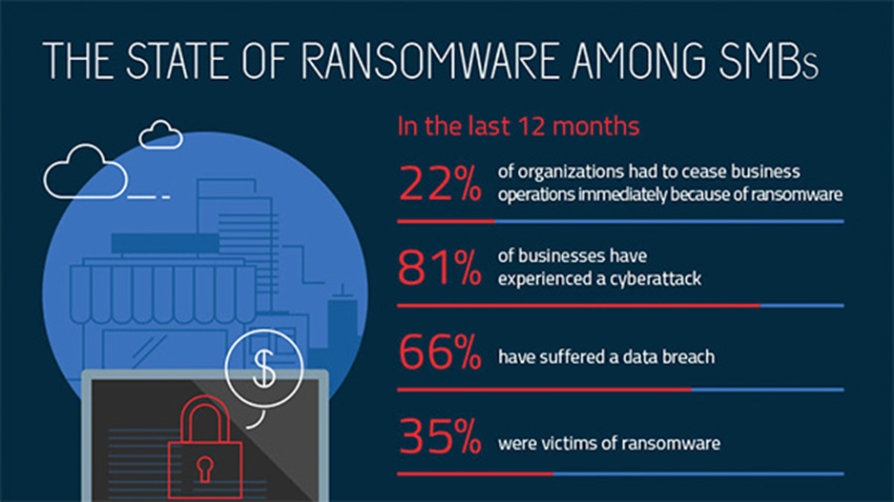

Appendix B [7]
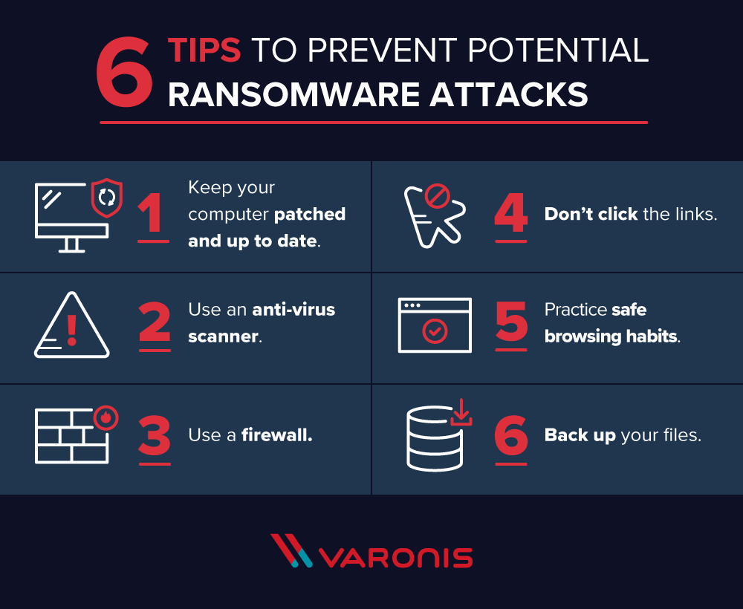

Cryptowall Report Bibliography
[1] A Symantec Employee (2019). What is a Trojan? Is it a virus or is it malware?. [online] Us.norton.com. Available at: https://us.norton.com/internetsecurity-malware-what-is-a-trojan.html [Accessed 13 Jun. 2019].
[2] Russell, J. (2011). Japanese government hit by Chinese Trojan horse attack. [online] The Next Web. Available at: https://thenextweb.com/asia/2011/10/25/japanese-government-hit-by-chinese-trojan-horse-attack/ [Accessed 13 Jun. 2019].
[3] Kaspersky.co.uk. (2019). [online] Available at: https://www.kaspersky.co.uk/resource-center/preemptive-safety/avoiding-a-trojan-virus [Accessed 13 Jun. 2019].
[4] M. Williams, "The best antivirus software 2019", TechRadar, 2019. [Online]. Available: https://www.techradar.com/uk/best/best-antivirus. [Accessed: 13- Jun- 2019].
[5] "Ransomware - What Is It & How To Remove It", Malwarebytes, 2019. [Online]. Available: https://www.malwarebytes.com/ransomware/. [Accessed: 13- Jun- 2019].
[6]W. Zamora, "The state of ransomware among SMBs", Malwarebytes Labs, 2017. [Online]. Available: https://blog.malwarebytes.com/101/2017/07/the-state-of-ransomware-among-smbs/. [Accessed: 13- Jun- 2019].
[7] J. Petters, "The State of CryptoWall in 2018", Inside Out Security, 2018. [Online]. Available: https://www.varonis.com/blog/cryptowall/. [Accessed: 14- Jun- 2019].
[8] Z. Whittaker, "UK’s Police Federation hit by ransomware – TechCrunch", TechCrunch, 2019. [Online]. Available: https://techcrunch.com/2019/03/21/police-federation-ransomware/?guccounter=1&guce_referrer_us=aHR0cHM6Ly93d3cuZ29vZ2xlLmNvbS8&guce_referrer_cs=aYk9DwW2pS4NfXqI4q6LqQ. [Accessed: 14- Jun- 2019].
[9] M. Field, "WannaCry cyber attack cost the NHS £92m as 19,000 appointments cancelled", The Telegraph, 2018. [Online]. Available: https://www.telegraph.co.uk/technology/2018/10/11/wannacry-cyber-attack-cost-nhs-92m-19000-appointments-cancelled/. [Accessed: 14- Jun- 2019].
[10] "CryptoWall and HELP_DECRYPT Ransomware Information Guide and FAQ", BleepingComputer, 2014. [Online]. Available: https://www.bleepingcomputer.com/virus-removal/cryptowall-ransomware-information#ransom. [Accessed: 14- Jun- 2019].

Appendix D

Self-Evaluation of Academic Skills

Thinking about yourself, read and mark each statement out of 5, with 5 being 'Totally Agree' and 1 being 'Totally Disagree'. If a statement doesn’t apply to you, leave it blank

Skill
 | 5 | 4 | 3 | 2 | 1
I have the confidence to try new things and express my ideas |  | x
I am self motivated and will persevere with difficult tasks |  | x
I am organised and can meet set deadlines |  |  | x
I am able to find information from different resources easily |  |  | x
I can read complicated texts and understand the general meaning |  |  | x
I am able to select what is relevant and what is irrelevant in text |  | x
I can compare different opinions and decide what are the best grounds for deciding who is right |  | x
I can write things in my own words |  |  | x
I am able to reflect and evaluate my own work |  |  | x
I have good strategies for starting a new task/assignment |  |  |  | x
I have good time management skills and can organise my workload effectively |  |  | x
I am able to make, store and find my notes |  |  | x
I am able to manage a range of writing skills appropriately |  |  |  | x
I am able to think critically and analytically, and evaluate arguments |  | x
I have good memory strategies |  |  | x
I know how to use IT to help academic study |  |  | x
I am confident at preparing and delivering oral presentations |  | x

Appendix E

Skills Action Plan
Strengths, skills and qualities
1. I have the confidence to try new things and express my ideas
2. I am self-motivated and will persevere with difficult tasks
3. I am confident at preparing and delivering oral presentations
4. I can think critically and analytically, and evaluate arguments

What I need to work on, develop or improve
1. I can manage a range of writing skills appropriately
2. I have good strategies for starting a new task/assignment
3. I can read complicated texts and understand the general meaning
4. I can write things in my own words

My Priorities: What I am going to do, When and How
What? | When? | How?
1.Improve writing skills | Over the next Year | Learn from previous reports and take on board any advice/criticism
2.Form a strategy for starting new tasks | Over the next Year | Learn what best suits me when approaching a new task and documenting it
3.Read more complicated texts | Over the next Year | Reading complicated texts and taking time to properly acknowledge it’s meaning and context
4.Improve writing vocabulary | Over the next Year | Practicing writing material in my own words which are clearly different and legible

How will I measure if I have improved?
By learning from mistakes identified by lecturers and implementing new skills acquired from assignments, research and lectures.

Bibliography

[1] | “"Essential skills and qualities of a successful academic (The University of Manchester)",” Academiccareer.manchester.ac.uk, 2019. [Online]. Available: http://www.academiccareer.manchester.ac.uk/about/do/skills/. [Accessed 15 July 2019].
[2] | O. Shinkten, “"10 Skills All Students Need to Be Successful",” Learning.linkedin.com, 2017. [Online]. Available: https://learning.linkedin.com/blog/education/10-skills-all-students-need-to-be-successful. [Accessed 15 July 2019].
[3] | “"Essential Skills For Undergraduate Life: The 13 Things You Should Know How to Do Before You Go to University",” Oxford School from Oxford Royale Academy, 31 March 2014. [Online]. Available: https://www.oxford-royale.co.uk/articles/13-skills-university.html. [Accessed 15 July 2019].
[4] | B. Davies, “"What Are Employers Looking For? Skills and Qualifications - Career Advice",” jobs.ac.uk, Sept 2009. [Online]. Available: https://www.jobs.ac.uk/careers-advice/interview-tips/1337/what-are-employers-looking-for-skills-and-qualifications. [Accessed 15 July 2019].
[5] | “Take a personality test - Open Source Psychometrics Project,” Personality-testing.info, April 2019. [Online]. Available: http://personality-testing.info/. [Accessed 14 July 2019].
[6] | “"Jung personality test - take this test free jung personality test online at 123test.com",” 123test.com, 2019. [Online]. Available: https://www.123test.com/jung-personality-test/. [Accessed 14 July 2019].
[7] | “Career test - Free online aptitude test 123test.com,” 123test.com, 2019. [Online]. Available: https://www.123test.com/career-test/. [Accessed 13 July 2019].
[8] | J. Lees, “Persoanlity Test: What Job Would Make you Happiest?,” The Guardian, 11 November 2014. [Online]. Available: https://www.theguardian.com/lifeandstyle/2014/nov/11/-sp-questionnaire-what-job-would-make-you-happiest. [Accessed 13 July 2019].
[9] | F. NG, “"Smart action plan: How to set SMART goals",” blog.udemy.com, 2014. [Online]. Available: https://blog.udemy.com/smart-action-plan/. [Accessed 13 July 2019].
[10] | “Upgrade,” one.google.com, 2019. [Online]. Available: https://one.google.com/about#upgrade. [Accessed 15 July 2019].
[11] | “"Google Drive: All About Google Drive",” GCFGlobal.org, 2019. [Online]. Available: https://edu.gcfglobal.org/en/googledriveanddocs/all-about-google-drive/1/. [Accessed 2019 July 2019].
[12] | H. Sabell, “"7 Tips to Increase Your Productivity as a Student - College for Adult Learning",” College for Adult Learning, 2017. [Online]. Available: https://collegeforadultlearning.edu.au/tips-to-increase-your-productivity/. [Accessed 15 July 2019].
[13] | “"Tips for Finding Time to Study While Working Full-Time",” Continuing + Career Education at Assumption College, 2019. [Online]. Available: https://cce.assumption.edu/tips-finding-time-study-while-working-full-time/. [Accessed 15 July 2019].

