Jericho Burials
Examine the attached images carefully
- How big/deep is the tomb?
- How many burials are there in your tomb?
- Were the burials made at the same time?
- Is the burial practice here primary, secondary or both?
- How might be reconstruct funerary ritual in the tomb – what stages can you observe from the tomb plan?
- Which grave goods belong to which burial? (Relate these to the attached images ogf grave goods from the tomb – which are numbered)
- What types/range of objects accompanied the burials

Jericho Tomb P23
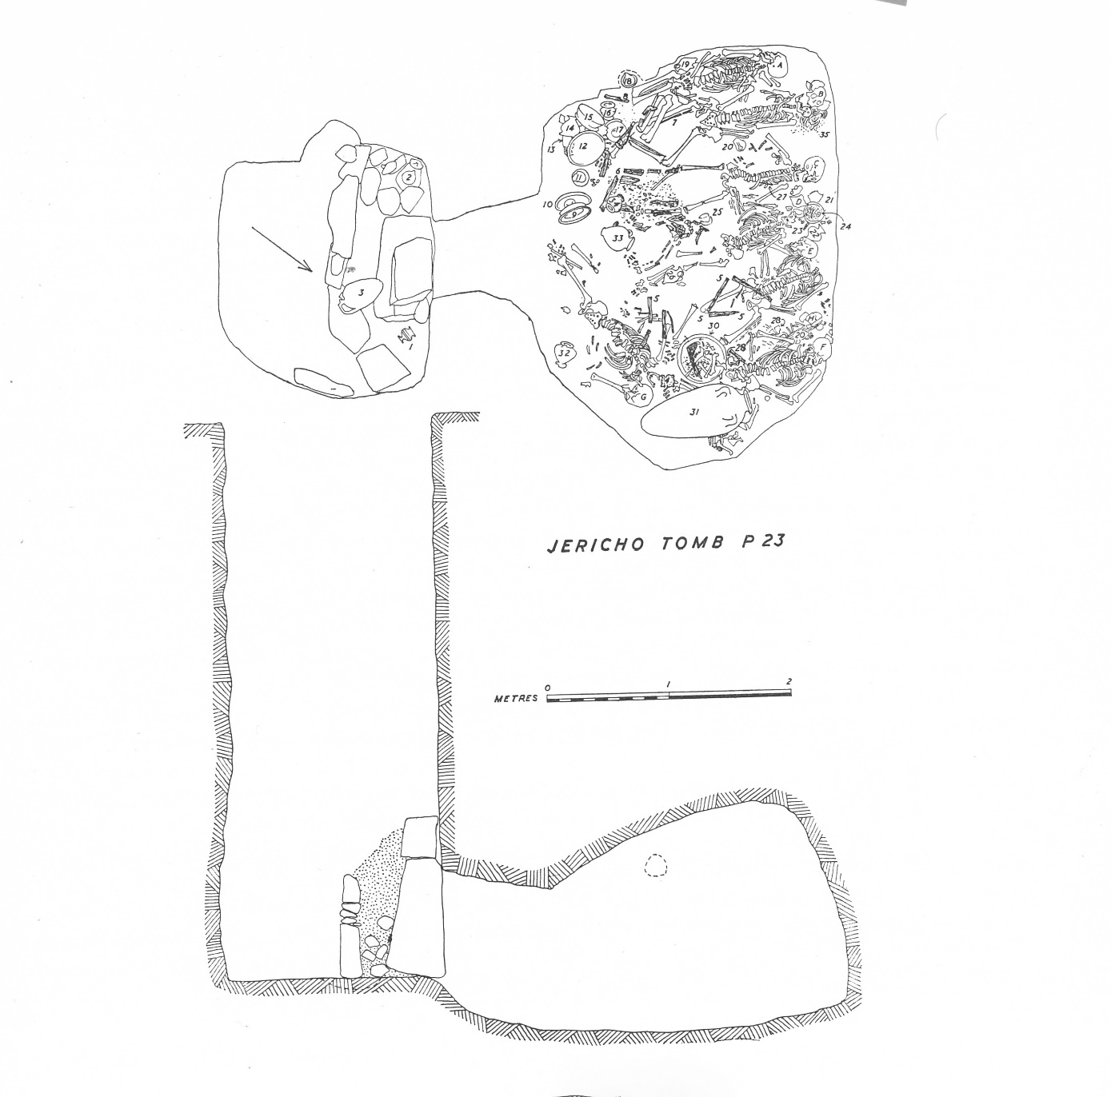

Finds from P 23
Pottery:
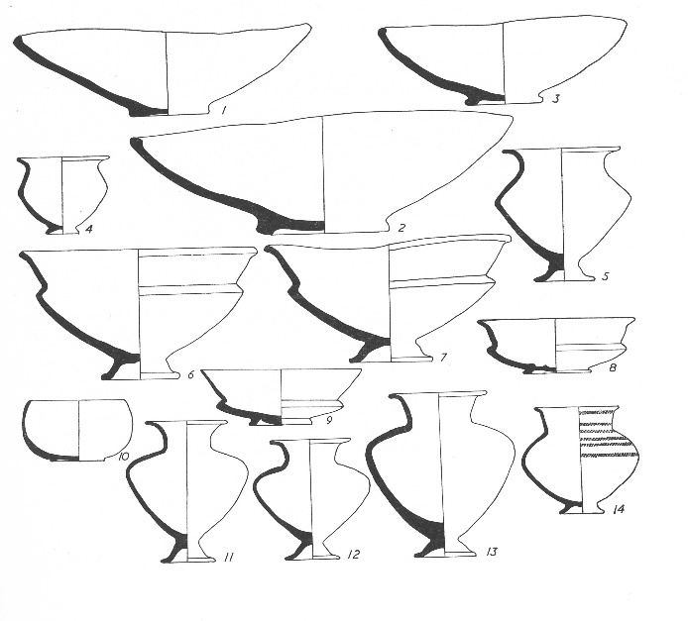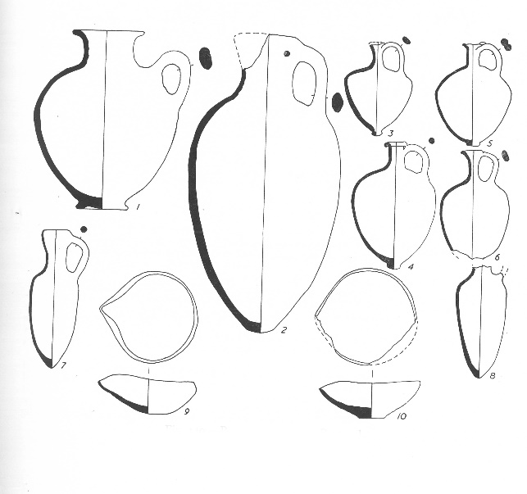
Wooden objects
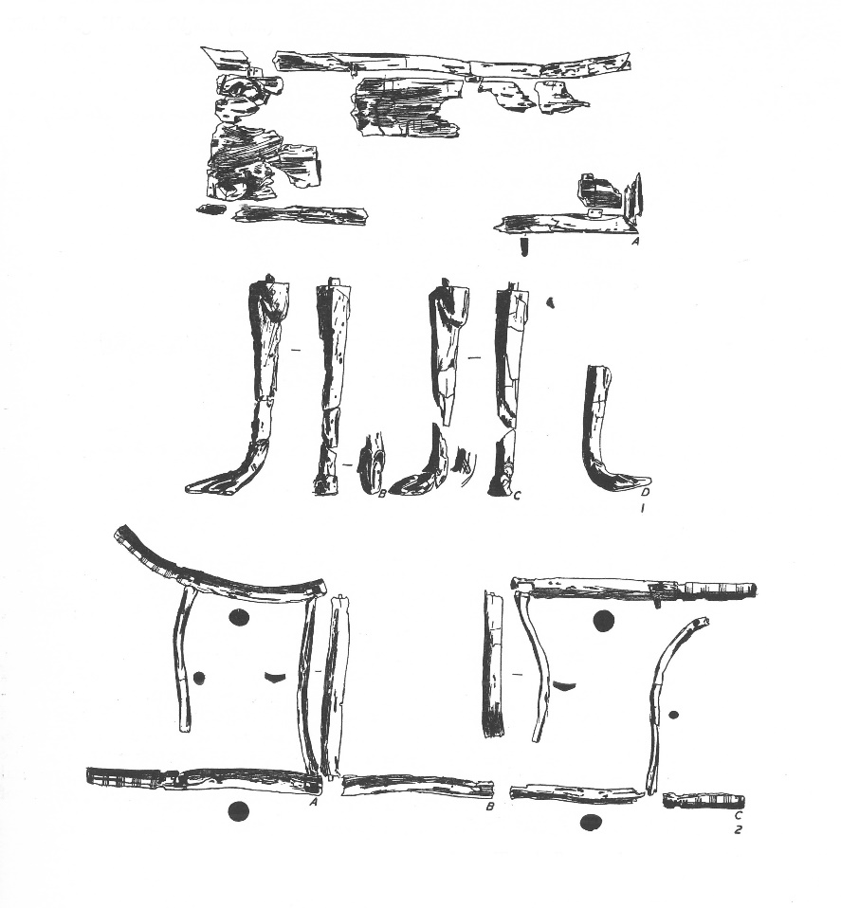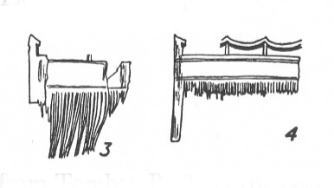

Jericho Tomb P1

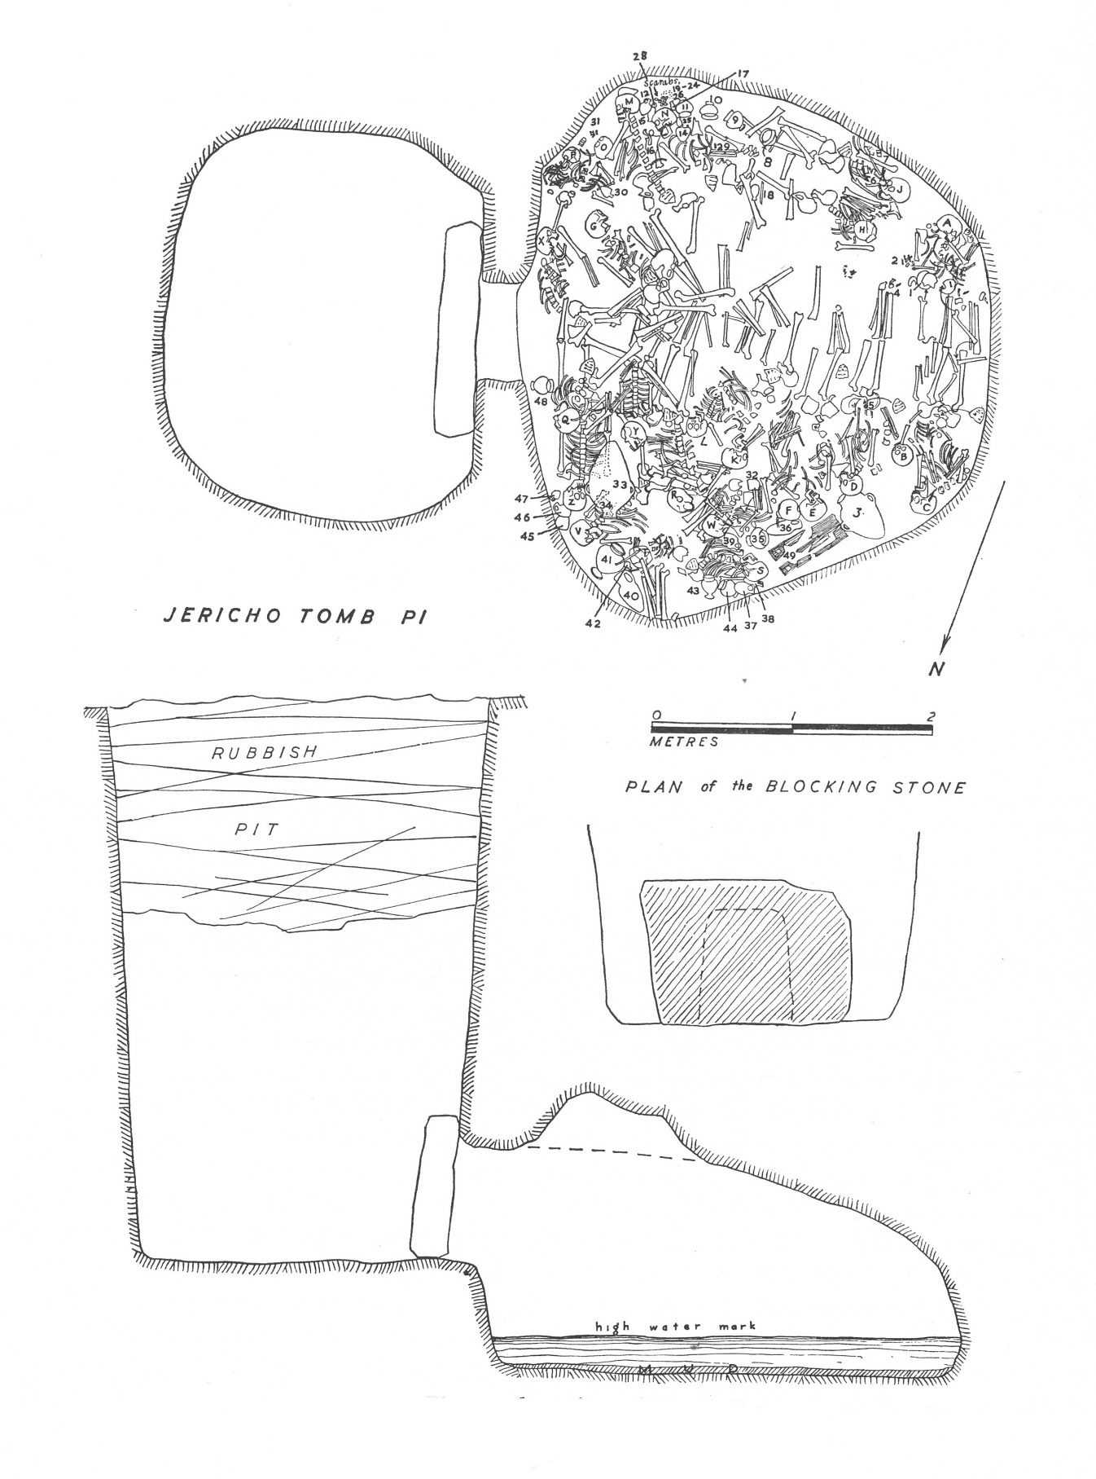

Finds from P1
Pottery:
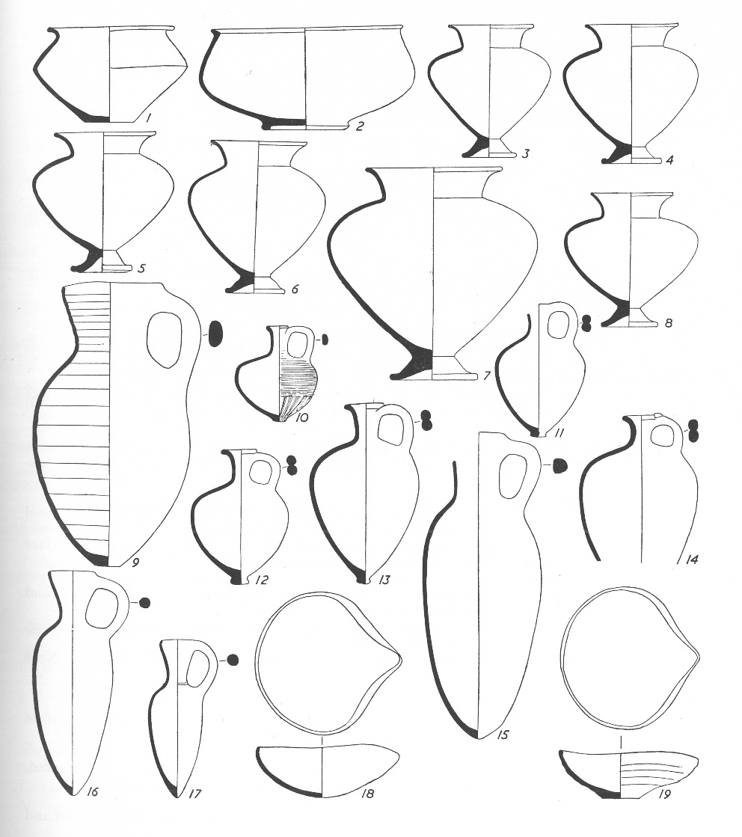

Wooden inlay
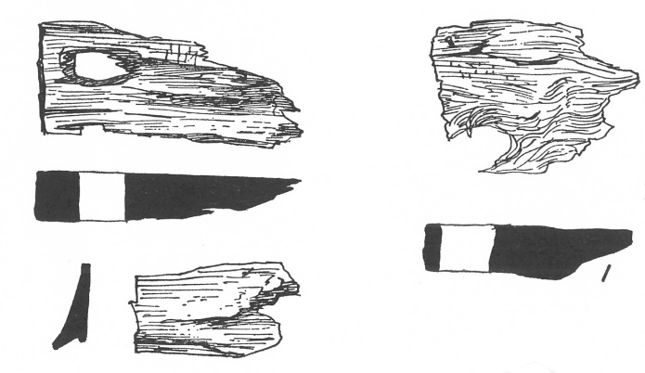

Jericho Tomb P19
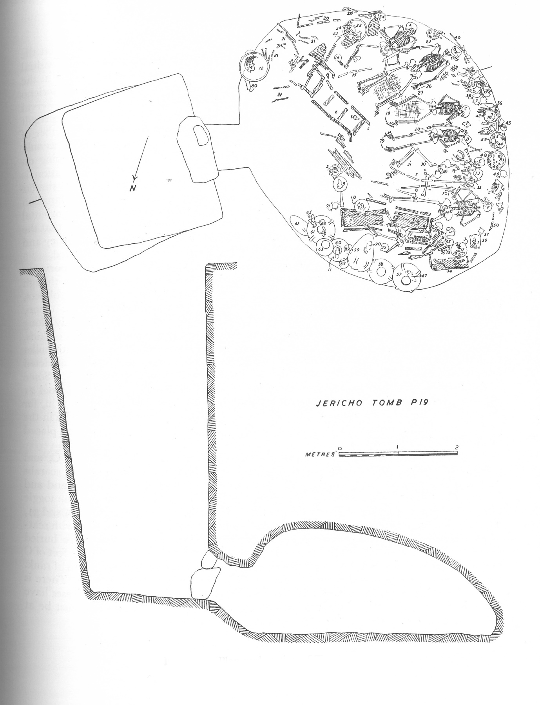

Finds from P19
Pottery:
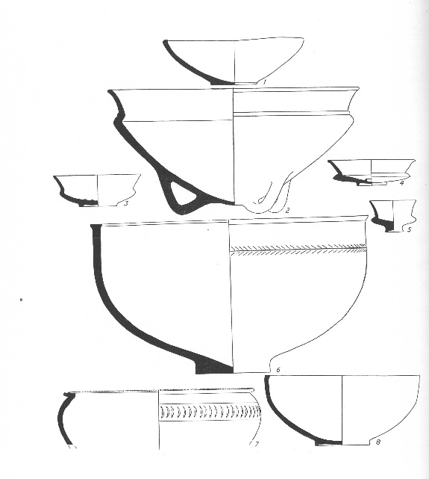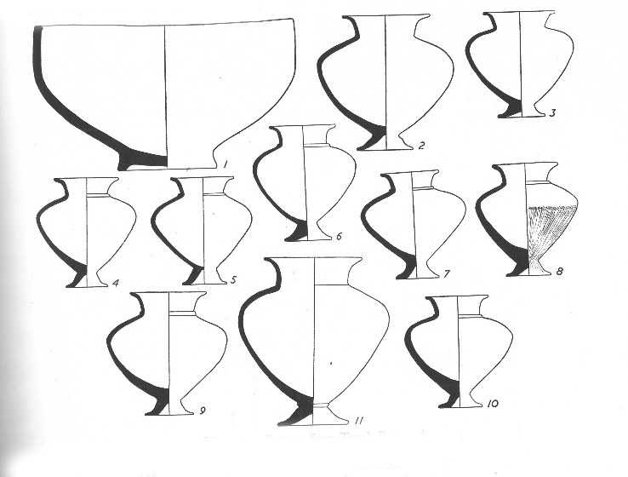

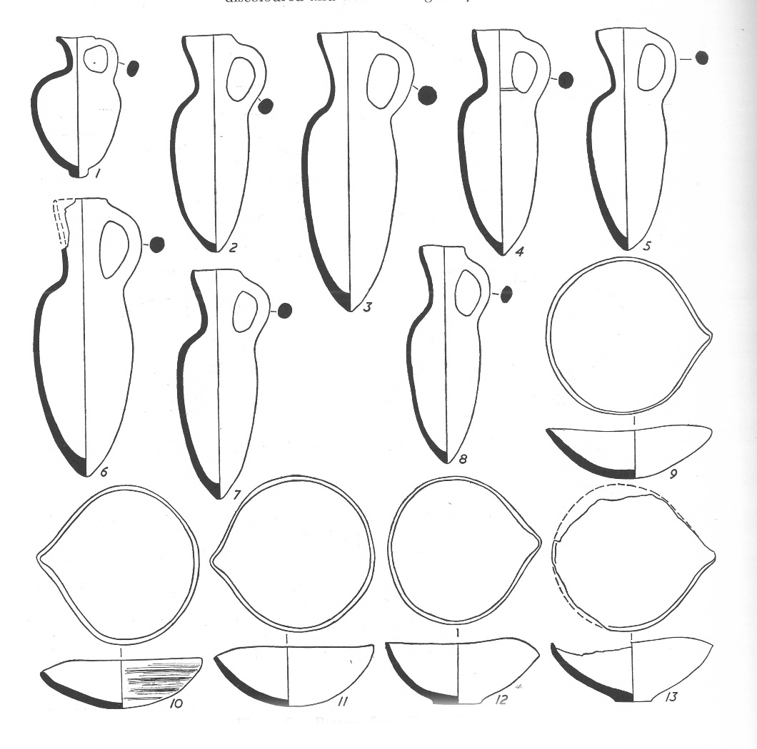

Finds from P19
Pottery:
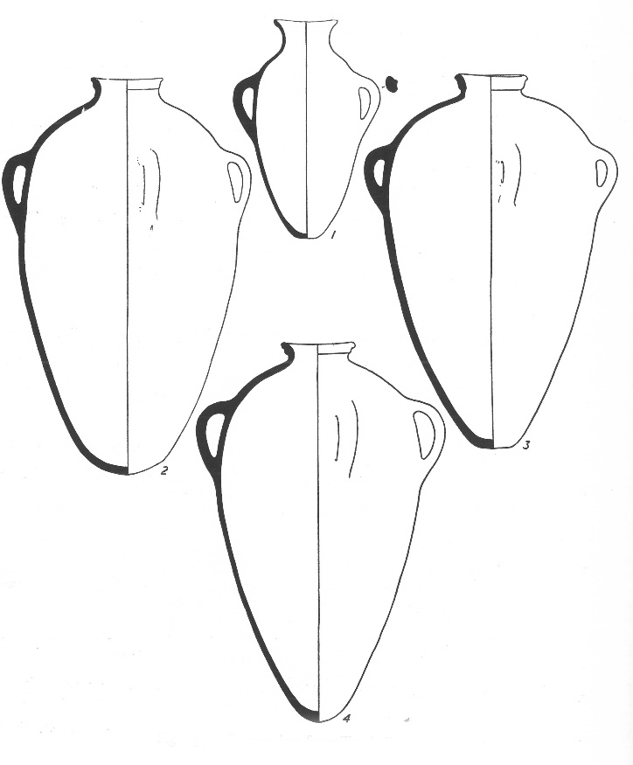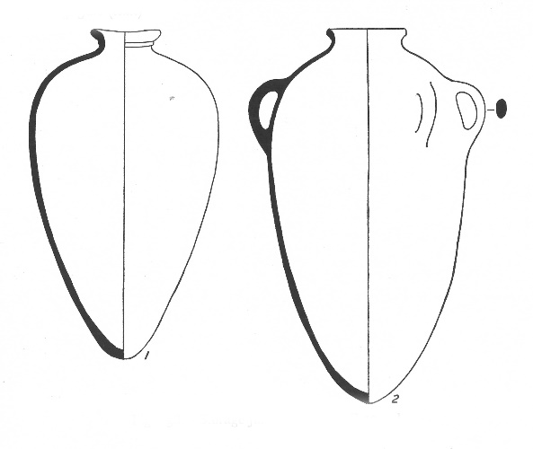

Wooden furniture:
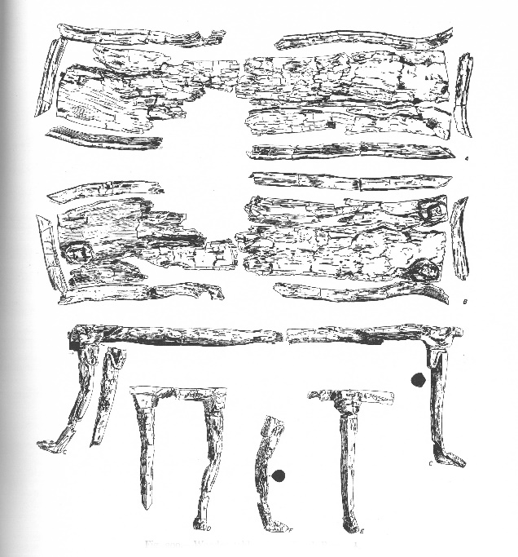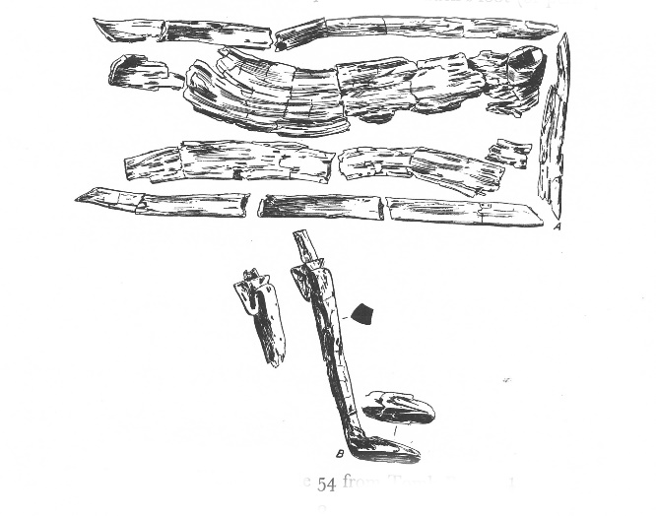
No. 2 no. 54

Finds from P19
Beads:
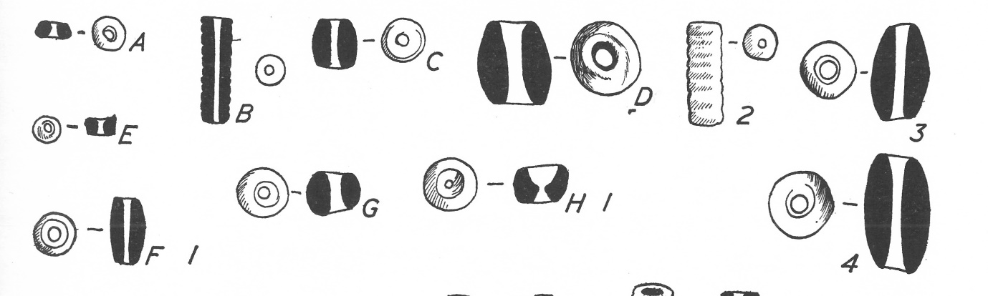
Ostrich egg:
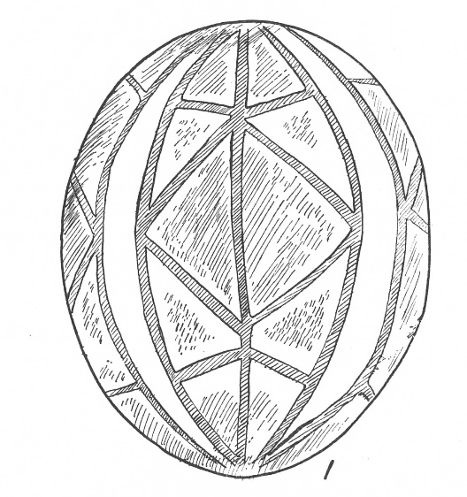
Wooden platters:


