Student Name: Oleh Vasylyshyn
Student Id Number: 1917016
Module Title: International Business Communications LCBB6001
Module Assignment Title: Assessment 1 (2500 Words) Written Report
Module Lecture’s Name: Husam Alharahshen

UNIVERSITY OF WALES
TRINITY SAINT DAVID

May 2022

Analysis of International Business Communications in Morocco, and recommendations to a hypothetical UK business expansion

Contest : Page no.
- Background………………………………………………… 2
- Introduction………………………………………………… 3
- Morocco’s Country Profile………………………….. 3
- Main Body – Hofstede’s Cultural dimensions……………… 7
- Cultural Sensitivities………………………………………… 9
- Recommendations………………………………………..….. 11
- Conclusion…………………………………………………… 12
- References……………………………………………………. 13

BACKGROUND
The Globalization trend, predominantly perceptible and responsible for the ceaseless structure alteration within the contemporary business environment, results in highlighting focal points such as: the competitive advantage and the growing interdependence of countries and corporations, which subsequently highpoint the tendency to claim from companies, an efficient and sustainable management and communication between their stakeholders, particularly aimed at creating additional business value and collective beneficial factors for the society. (Ahmed,2019)

These theoretical patterns will be particularly highlighted in the creation of this report through the analysis of International Business Communication relevance in forecasting successful operational strategies within the hypothetical business scenario of a UK business expanding its operations in Morocco, through the attentive and critical analysis of country culture, communications barriers and a final evaluation and recommendation of most effective intercultural strategies aimed to the successful management of the firm in Morocco.

INTRODUCTION
The expansion of the business operations in foreign countries highlights a series of challenging factors for management teams, which customarily require careful investigation and analysis of the culture, in addition to the specific planning of communication strategies, aimed on delivering efficient happenstance with organizational objectives.
The investigation of communication strategies bases its foundations on the understanding of cultural sensitivities, cultural differences, the creation of social networks based on trust with local-national stakeholders and the efficient infringement of communication barriers, which consequently will be responsible on projecting the appropriate corporate ability to provide and negotiate its goods and services to the target market, fetching collective benefits to the specific community, with the creation of new occupations and thus reducing unemployment rates in the host country, with the exchange of a practical respect for local traditions and regulations and furthermore the generation of an organizational extra value particularly highlighted in profit performances.
(Mcrill.2019) (Ramjee,2017) (Ahmed,2019)

MOROCCO COUNTRY PROFILE

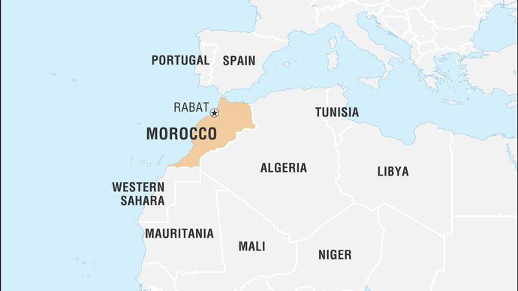
Fig.1 Morocco (Miller,2022)

The north-western African nation, which overlooks the Atlantic Ocean and the Mediterranean Sea, in its history has undergone several migrations, which distinguish today's multicultural society, particularly energetic and tolerant with ethnic minorities. (Miller,2022) (Safa,2018)
The ethnic composition of Morocco’s population, as testified in Fig.2 and Fig.3 is formed mainly by a 73% of young population and molded by majorities of Arabs and Imazighen 'population with Berber origin', both with Islamic belief, with also the peaceful presence of Christian, Jewish and sub-Saharan African communities.
Consequently its ethnic composition and colonial past: Arabic is classified as one of the national languages, in addition to the widely practiced French and Spanish, with the recent addition in trends of wide practices, also reported for the English language. (Miller, 2022)

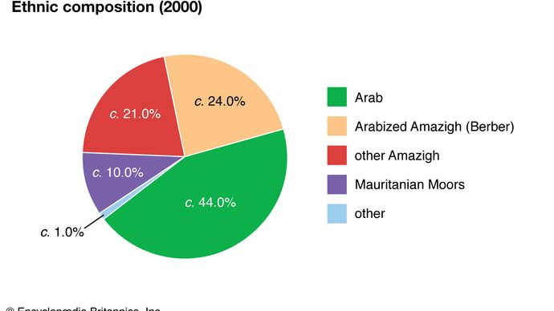

Fig.2 Morocco Ethic Composition (Miller,2022)

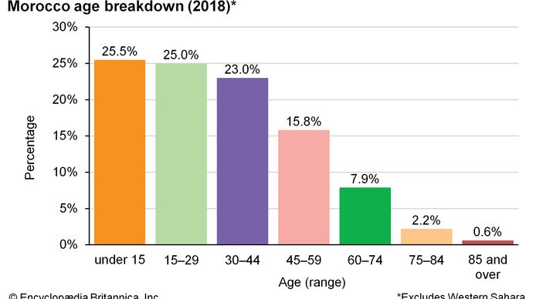
Fig.3 Morocco: Age breakdown (Miller,2022)

Political-Legal System
Morocco is defined as a constitutional monarchy, formed by two legislative chambers, in which legislative power is divided between, the King Muhaammad VI and the parliament, which in turn consists of the Chamber of Concillers and the House of Representatives, of which Prime Minister Aziz Akhannouch is the head of the cabinet and the holder of executive power.
The legal system, in the African country, is still based on the Qur'an practices perceived as a source of law, but the regulations inspired by the legislative French code, are widely used by the judicial authorities; furthermore crimes of corruption as highlighted in Fig. 4 presents a decreasing trend in the country. (Tradingeconomics, 2022)

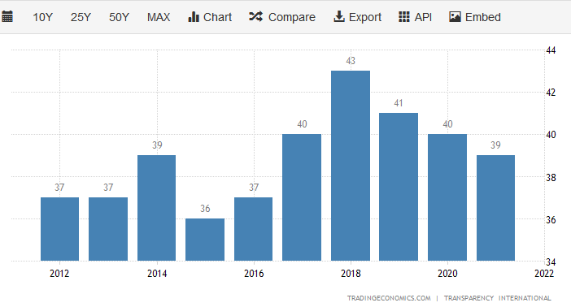
Fig 4. Morocco Corruption Index (TradingEconomics,2022)

The Economical Overview
Morocco's economy in recent decades has recorded high growth rates, driven particularly by competitive rental unit prices within the tourism industry and large private investments, consequently the tertiary sector represents a source of income for 43.6% of the working-age population, but despite that, the African country still inclining, with the tendency in highpoint a high dependence on the primary sector with 33% of the workforce employed in its production processes and in the industry, based mainly on the extraction and processing of phospates that employs 23% of the national workforce. (Safa, 2018) (International,2022) (TheWorldBank,2018) (Sunnyexperiences,2020)
The perpetual economic development recorded in addition to the fetching of the national growth by 3.2% per year of Gross Domestic Product (GDP) has also contributed to projecting the complications within the economy of the African nation, which can be summarized in:
- Absence of market and incorporation of woman’s and youth
- Moderate job creation
- Absence of qualitative career developments

These complications generally are accountable on significant rise of the unemployment rates, which currently are of 12%, significantly highlighted in the 15-24 age group of young adults and women in working age, and consequently with an inappropriate dislocation of resources and talents within the national economic system.
To stand against these inclinations, the Government has established strategies of technological innovation and economic growth through its active commitment to satisfying the entrance into the business environment of an ever-increasing slice of the population in working age. (El Masaiti, 2017) (TheWorldBank, 2018) (Miller, 2022) (ILO, 2017) (Sunnyexcursion,2020)

MAIN BODY - Hofstede’s Cultural Dimensions

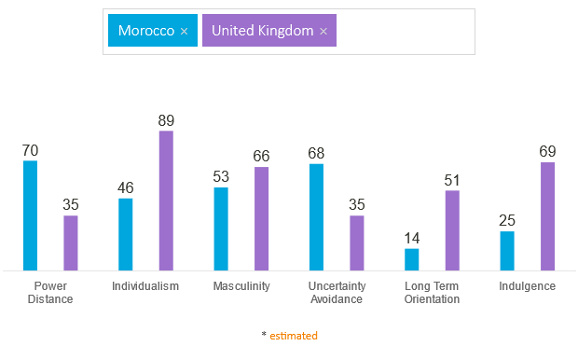
Fig.5 Hofstede’s Cultural Dimensions (HI,2022)

The Investigation and careful planning of communication strategies, as previously mentioned, is based on the analysis of cultural differences between countries, whose most efficient methodology, practices the theory introduced by Geart Hofstede in 1980, which in its structure tends to highlight six different cultural dimensions, whose detailed study provides the management teams with the capabilities to successfully plan the organizational operations of the venture in foreign countries. (CFI, 2022) (HI,2022)

The listed theory is based on six different elements, particularly listed in the part below:

- Power Distance: With power distance, it is defined, the propensity of the population to accept inequalities within the society and its decomposition into well-defined hierarchical structures. Morocco, as highlighted in Fig.4 presents the percentage of 70%, which projects a strong hierarchical culture, in which the subjects of lower hierarchical level are forced to accept the will of the superiors without any prospects of dissent.

- Individualism: The Individualism exemplifies the tendencies of individual members of society to achieve their goals as opposed to collectivism, where the focus is on achieving the goals set by the group or community. Fig.4 projects the percentage of 46% for Morocco, which is supported by a strongly collective society, where secular ethical and moral traditions prevail, the face concept is particularly relevant and indirect communication is preferred, aimed at safeguarding the collective harmony.

- Masculinity: The term masculinity defines the cultural dimension of a goal-oriented society, in which competition and personal achievement, are responsible for motivating every aspect of social life, furthermore as reported in Fig.4 with 54% a strongly masculine society is highlighted.

- Uncertainty Avoidance: It portrays the cultural element in which the community tends to face future challenges, and identifies its ability to react or adopt passivity. Morocco displaying 68%, which highlights a strongly archaic country, which is closed in its secular-old traditions, with a particular slowness in modernizing; and in the working environment, due to a moderate occupational creation, the job security is an element of assertion of the Moroccan population

- Long Term Orientation: It is identified with the cultural dimension in which society is strongly linked to past traditions, with which it resiliently tends to face contemporary and future problems. Fig.4 highlights the 14% that represents a society in which, the respect for ancient traditions is a fundamental element of the country's culture, with a strong aversion to change and the attitude of awareness on the present issues, in complete divergency to a pragmatic planning of the future.

- Indulgence: It is identified with the individual propensity with the members of the population, in satisfying their own desires and goals; Morocco with the percentage of 25% represents a society unaccustomed to individual thinking and more focused and aimed on satisfying and to benefit the wider community, where personal objectives and leisure are seen as negative elements for the community in general. (HI,2022)

CULTURAL SENSITIVITIES

As previously demarcated in the Morocco Country profile, Moroccan society in its history has been the intersection of several migrations from different populations, which over the centuries have contributed to creating a particularly tolerant and multicultural national community. (Miller, 2022) (Safa, 2018) (Lahbabi,2018)

In contemporary overview Morocco presents itself as a country strongly linked to its religious and cultural traditions, whose careful analysis possibly will favor, in every aspect in the destruction of intercultural barriers and benefit efficient relationships construction, based on trust with the target market, considering the hypothetical scenario of an expansion of an United Kingdom business within the African country environment, it is particularly relevant to highlight the success of the Bluespark company, which has displayed strong capabilities in building an efficient corporate culture, through the vital and patient investigation of the cultural sensitivities of Morocco, furthermore the addition of the competent planning of communication strategies, such as the use of daily meetings, aimed on updating, controlling corporate objectives, and motivating the workforce. (Miller, 2022) (Safa, 2018) (Tucker, 2017)

Morocco’s Culture and Traditions

The ancestral Moroccan culture, strongly linked to past traditions, and to the Islamic religion requires foreign travelers its reverence, which in return will be particularly considered and shared by the sturdy hospitality of the local population. (Dyck, 2019) (Safa, 2018) (Lahbabi, 2020) (Miller,2022)
The varied customs can be identified in different aspects of culture, such as:

- Clothing: According to tradition it is necessary to cover private body parts with adequate clothing, this instruction despite being enforced throughout the country, sees greater application in rural areas, as opposed to metropolitan areas with more progressive views.

- Greetings: In Morocco, the custom of practicing any activity with the right hand is distinguished: from the common handshakes to the food consumption and this is due to the Islamic consideration of impurity of the left hand; it is also common to exchange small gifts in case of invitations to dinners of friends or acquaintances, which often represent sweets or gifts for children. (Lahbabi, 2020) (Dyck, 2020)

- Cash Tipping: Morocco is characterized by the regularity of tipping, and the knowledge of the right amounts of ‘Dinars’ could have a positive impact on social relations creation and intercultural barriers dismantle with the local population. (Misachi, 2018)

- Ramadan: It concerns the holy month of celebrations devoted to fasting, which is aimed at as a spiritual act of purification according to the Islamic religion, in this period for non-Muslims, the respect for this tradition is required and consequently drinking and eating in public places could be offensive. (Safa, 2018)

- Eid Al Fitr: It exemplify the celebration that takes place on the day following the Ramadan conclusion, which in contrast celebrates the life and pleasures of food, in this period it is customary for the locals to take 3 days off , aimed on celebrating and meeting family members or relatives, with a further demand, in sharing according to the Islamic tradition to the most needy.

- Eid Al Adha: It represent the celebration, with a week of duration, which consists in the sacrifice of a sheep and the need to spend time with their families at home, which contrary to what seems not to concern leisure but according to tradition, concerns sharing and generosity towards the less fortunate, with the custom of donating a third of the sheep to needy families. (Safa, 2018)

Business Culture
The traditional customs of Moroccan culture are also reflected in corporate culture, consequently the patient creation of interpersonal relationships that indicate a marked respect for the hosting culture, will account for a significant benefits in contractual negotiations, which despite the highlighted slowness, generally take the form of honest, transparent communication and often carried out in French or English, where business meetings in addition to traditional places, sometimes they take place, as in the case highlighted in 'Bluespark' in external activities and not inherent in the pure contractual negotiation, but based purely on the construction of interpersonal trust. (Safa,2018)
Religious traditions and cultural aspects also responsible on influencing the traditional 'Monday to Friday' working patterns that during the 'Ramadan' periods show that the majority of organizations express trends of early closures, immediately after the lunch break, with the exception of banks that conclude their activities at 4pm. (Sunnyexcursion,2020) (Tucker, 2017)

RECCOMENDATIONS
Ensuing the careful analysis of the Bluespark company, of the cultural sensitivities and Hofstede’s dimensions in Morocco, it is strongly suggested to the management teams of hypothetical companies based in the UK, with the brand expansion goals in Morocco, to consider the African country as a potential basis of several opportunities, this is proved by the investigation of sociopolitical- economic trends in the country in which the construction of intercultural relations is based on ethics of mutual respect and tolerance, also the usage of the local workforce, strongly motivated by the lack of job opportunities and an efficient habit of corporate communication strategies, it would deliver major opportunities for local economic development, after which with the critical consideration of secular customs, significant levels of corporate production would be created, supported by relatively moderate costs, and favored by the multiple government plans in attracting new businesses and the vast availability of human capital not actively employed in the labor market. (El Masaiti, 2017) (TheWorldBank, 2018)

CONCLUSION

In conclusion the effective planning and development of brand expansion strategies as previously highlighted in the report, are based on a careful investigation of theoretical Hofstede’s cultural dimensions, political and cultural sensitivities, which are accountable on displaying the pivotal intercultural barriers and proposing the most efficient communication patterns to managerial teams in order to achieve corporation and stakeholders’ objectives.

References

Ahmed (2019) Importance of cross cultural communication in business.Available at: URLhttps://bizfluent.com/info-7761139-importance-communication-international-business.html. (Accessed 15th April 2022)
Corporate Finance Institute (2019) Hofstede’s cultural dimensions theory. Available at: URL https://corporatefinanceinstitute.com/resources/knowledge/other/hofstedes-cultural-dimensions-theory/. (Accessed 15th April 2022)
Dyck (2019)How to be culturally sensitive while travelling in Morocco. Available at: URL https://www.mosaicnorthafrica.com/culturally-sensitive-in-morocco/. (Accessed 15th April 2022)
El Masaiti (2017) Morocco leads in science, technology and innovation in Africa. Available at: URL https://www.moroccoworldnews.com/2017/03/212434/morocco-leads-in-science-technology-and-innovation-in-africa-report. (Accessed 15th April 2022)
Hofstede Insights (2022) Country comparison. Available at: URL https://www.hofstede-insights.com/country-comparison/morocco,the-uk/. (Accessed 15th April 2022)
International Labour Organization (2017) Morocco. Available at: URL https://www.ilo.org/dyn/normlex/en/f?p=NORMLEXPUB:11110:0::NO::P11110_COUNTRY_ID:102993. (Accessed 15th April 2022)
International (2022) Morocco economic and political overview. Available at: URL https://international.groupecreditagricole.com/en/international-support/morocco/economic-overview. (Accessed 15th April 2022)

Lahbabi (2020) Morocco Culture and etiquette: skills to succeed. Available at: URL https://www.journeybeyondtravel.com/morocco/culture-etiquette. (Accessed 15th April 2022)
Mcrill (2019) The Importance of Communication in International Business. Available at: URL https://bizfluent.com/info-7761139-importance-communication-international-business.html. (Accessed 15th April 2022)
Miller (2022) Morocco. Available at: URL https://www.britannica.com/place/Morocco/Climate#ref46574. (Accessed 16th April 2022)
Misachi (2018) Morocco culture,customs and traditions. Available at: URL https://www.worldatlas.com/articles/morocco-culture-customs-and-traditions.html. (Accessed 16th April 2022)
Ramjee (2017) Intercultural communications problems in the workplace. Available at: URL https://bizfluent.com/info-7754347-intercultural-communication-problems-workplace.html. (Accessed 16th April 2022)
Safa (2018) Real charming and strange secrets of Moroccan culture. Available at: URL https://moroccanzest.com/morocco-culture-and-religion-facts/. (Accessed 16th April 2022)
Sunnyexcursion (2020) Business culture in Morocco. Available at: URL https://sunnyexcursion.com/business-culture-in-morocco/. (Accessed 16th April 2022)
The World Bank (2018) Labour Market in Morocco: Challenges and Opportunities. Available at: URL https://www.worldbank.org/en/country/morocco/publication/labor-market-in-morocco-challenges-and-opportunities. (Accessed 17th April 2022)
Trading Economics (2022) Morocco Corruption Index. Availabe at: URL https://tradingeconomics.com/morocco/corruption-index. (Accessed 17th April 2022)
Tucker (2017) Building Relationships, our company retreat to Morocco. Available at: URL https://www.bluespark.com/blog/building-relationships-our-company-retreat-morocco. (Accessed 17th April 2022)
Writer (2016) Morocco’s Intercultural Communication. Available at: URL https://www.moroccoworldnews.com/2016/08/192848/moroccos-intercultural-communication. (Accessed 17th April 2022)

