The Analysis SWOT and PESTLE
In TESCO

Student: Paul Sebastian Parfene
ID Number: 1813737
Lecturer: Gregory Cawn
Module: Community Engagement

Table of Contents
1. Introduction 1
2. Organisational Analysis 2
2.1 An overview of Tesco and the Industry in which it operates 2
2.1.1 Tesco Structure 2
2.1.2 Tesco mission and vision 3
2.2 SWOT analysis of Tesco 4
2.3 Role of employees in achieving the organisational goals of Tesco 5
2.4 Significance of training and development 6
2.5 The significance of personnel managers and skills and knowledge required to carry out the role in Tesco 7
2.5.1 Skills and knowledge required by the HR managers 8
2.6 Training and development requirements to be considered 8
3. Conclusion 9
4. Reference 10
5. PESTLE 11
5.1 Training and development plan 11

Table of Figures
Figure 1: Tesco Corporate Governance Structure 2
Figure 2: Organisational Structure of Tesco at Store Level 3
Figure 3: SWOT analysis of Tesco 4
Figure 4: Significance of Training and Development in Organisations 6
Figure 5: Importance of HR managers in an organisation 8

1. Introduction
This report has been prepared with a view to conducting an organisational analysis considering different transferrable skills and how an organisation should adopt them as per the requirements of the organisation. In this regard, the author has considered analysing one of the largest retail organisations in the UK, Tesco PLC. To conduct the organisational analysis, the author has considered analysing the size, structure, mission, vision and values of the company and a brief discussion about the industry in which the company operates. Also, the significance of employees in attaining the organisational goal has been the subject matter of the report. While outlining the skills and knowledge required for one of the organisational roles in Tesco, the author has discussed such knowledge and skills from the perspective of the HR managers of Tesco.

2. Organisational Analysis

2.1 An overview of Tesco and the Industry in which it operates
The retail sector in the UK, in which Tesco operates, is one of the largest sectors in the UK and as per 2019, the total value of retail sales in the UK is £394 billion and approximately 2.9 billion people in the UK are employed in the retail sector (Retail industry - Office for National Statistics, 2020). The retail sector in the UK contributes 5% of the total GDP of the UK and it is consistently rising with a 3.4% growth in 2019 compared to that of 2018.
Tesco is an international retail shop and the largest retail chain in the UK being listed on the LSC (London Stock Exchange) as Tesco PLC. The company was founded in 1919 and its headquarters is located in Cheshunt, UK (Annual Report 2019 | Tesco, 2020). The company operates in 13 different countries with approximately 6,800 stores among which more than half of the Tesco stores are located in the UK, the approximate number of which is 3,961 (Guo and Wang, 2019). Tesco operates through more than 450,000 employees across the world and the company is regarded as the largest private-sector employer in the UK. Tesco holds the maximum market share in the UK retail market having 27.3% of the total market where the closest competitor of the company in terms of market share is Sainsbury’s which has 15.8%. in 2019 (Retail industry - Office for National Statistics, 2020). The annual revenue of the company was £63.91 billion in having an 11.16% growth than the previous years and a net profit of £1.32 billion having a growth of 9.44% compared to 2018 (Annual Report 2019 | Tesco, 2020).

2.1.1 Tesco Structure
The structure of Tesco can be outlined from two different perspectives namely the corporate governance structure and the store administration structure. Both the organisational structure of Tesco is given below.
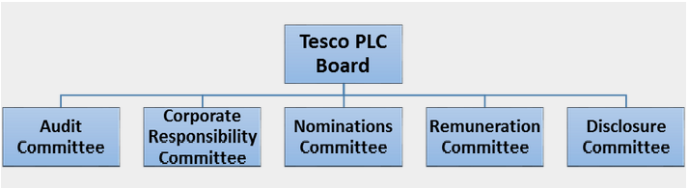
Figure 1: Tesco Corporate Governance Structure
Source: (Guo and Wang, 2019)
In accordance with Guo and Wang (2019) the corporate governance structure of Tesco is comprised of five different committees namely the audit committee, corporate responsibility committee, nominations committee, remuneration committee and disclosure committee.
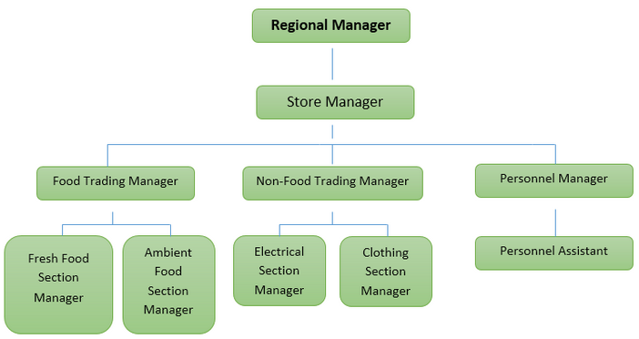
Figure 2: Organisational Structure of Tesco at Store Level
Source: (Guo and Wang, 2019)
The store administration of Tesco is governed by a regional manager under whom three divisional managers are accountable in different divisions including food trading division, non-food trading division and personnel or HR division (Our history, 2020). Apart from this, under food and non-food trading divisional managers, there are different sub-divisions for managing which distinguished managers are appointed and for assisting the HR managers an HR assistant is appointed.

2.1.2 Tesco mission and vision
As per Guo and Wang (2019) The core purpose or mission of Tesco is “We make what matters better, together” with an integrated vision having five different components in it and the vision of the company is to be:
- Wanted and needed around the world
- A growing business, full of opportunities
- Modern, innovative and full of ideas
- Winners locally whilst applying their skills globally
- Inspiring, earning trust and loyalty from customers, our colleagues and communities.
As long as the corporate value of Tesco is concerned, they are as follows.
- “No one tries harder for customers”
- “We treat everyone how we like to be treated”
- “We use our scale for good”

2.2 SWOT analysis of Tesco
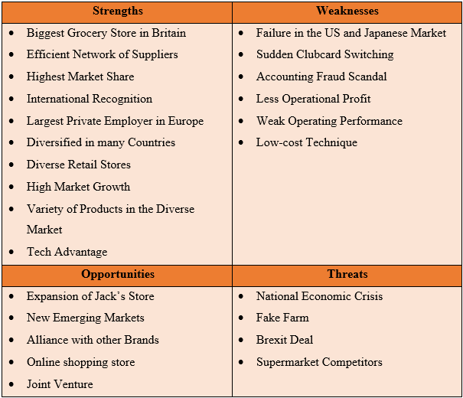
Figure 3: SWOT analysis of Tesco
Source: (Guo and Wang, 2019)
Strengths of Tesco: The most significant strength of Tesco PLC is that it owns the largest number of market share in the retailing sector of the UK and hence regarded as the largest grocery store in the country (Annual Report 2019 | Tesco, 2020). Alongside, the company is expanded diversely around 13 countries in the world and has a wide international recognition. Moreover, the company works with a diverse range of products and has its own technological devices to run its operation such as its “Shop and Go” tech.
Weaknesses of Tesco: Tesco PLC started its operation in the US and Japan where the company faced huge failure and stopped operating in those countries (Our history, 2020). Apart from this, due to several scandals and unfortunate events, the company had a huge decline in its operating performance and operating profit as well.
Opportunities of Tesco: Tesco has a high opportunity to expand its market internationally as several markets are emerging especially in developing countries with its new initiative called the Jack’s Store. Also, the company can expand its market by allying with other brands or joint venture.
Threats of Tesco: Due to the Brexit deal, the economic condition of the UK has faced several difficulties and since the UK is the major market hub for Tesco, it has a significant impact on the operation and outcome of the company (Guo and Wang, 2019). Moreover, the competition in the retail sector and the number of the supermarket chain is rising which is also posing threat to the company.

2.3 Role of employees in achieving the organisational goals of Tesco
According to Bekirogullari (2019) “The purpose of a business organisation is to coordinate the actions of many individuals who are working with individual targets towards attaining a common purpose”. The purpose of the organisations is specified through a set of goals that the organisation wants to achieve through its operation. As per Bobicheva and Revva (2015), the goal of an organisation can be divided into two segments namely short-term goal and long-term goal wherein the short term-goal the organisation intends to maximise its profit and in long-term, the organisation intends to maximise its wealth to ensure sustainable growth in the market. In this regard, the organisation coordinates all the components of the organisation e.g. man, materials, capital etc. to operate the functions of the organisation and attain its goals as determined by the organisation. Among the components of the organisation, man or human resource is the most significant components as all the other organisational components are operated and coordinated by them (Zaitouni, Harraf and Kisswani, 2020). Following Armstrong and Landers (2018) “Employees are the only living organism in an organisation who farther operates and manages all the other components of the organisation”.
The employees of an organisation can be placed in two different positions namely operational position and managerial position (Bobicheva and Revva, 2015). In the managerial position, the role of the employees is to manage the operations of the organisation and provide direction to the operational employees as per which the employees will implement the operation (Bekirogullari, 2019). On the other hand, the operational employees, as per the instruction of the managers performs the organisational operations to attain certain outcomes. Since the business world is going through high competition in the market, the success of an organisation in terms of sustaining in the competitive market highly relies on the employee performance as the overall performance of the organisation and achievement of organisational goals relies on the employee performance as well (Zaitouni, Harraf and Kisswani, 2020).

2.4 Significance of training and development
As mentioned above that the employees are the most significant part of the organisation but not necessarily all the employees of the organisation will have all the knowledge and skills which is required by the organisation in terms of ensuring maximum performance to the company (Armstrong and Landers, 2018). In this regard, training and development program plays a significant role in an organisation to improve the knowledge and skills which is required by the organisations in terms of the performance of every employee while performing the operation of the organisation effectively.
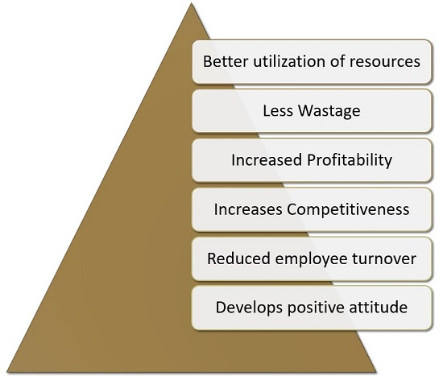
Figure 4: Significance of Training and Development in Organisations
Source: (Armstrong and Landers, 2018)
With the improvement of skills and knowledge of the employees through training and development, the employees can make better use of the organisational resources which further enable the employees to make less wastage by the operation (Bobicheva and Revva, 2015). Thus, with improved employee performance and less wastage, the productivity of the organisation enhances which contributes to attaining more profit by the organisation’s operation (Armstrong and Landers, 2018). Since the organisation productivity and profitability increases due to training and development programs, it facilitates the organisation to have competitive advantages in the industry against the rival organisations (Bobicheva and Revva, 2015). Moreover, training and development by ensuring personal development of the employees facilitate the employees with a better career opportunity and therefore reduced the employee turnover.

2.5 The significance of personnel managers and skills and knowledge required to carry out the role in Tesco
One of the major roles in Tesco is the Human Resource managers of the organisation who manages the relationship between the organisation and its employees (Gilmore, 2009). In this regard, the HR managers of Tesco fulfils the human resource requirements of the organisation by recruiting and selecting effective employees for the organisation who has potential skills and knowledge for performing the operations of the organisations effectively so that the organisation can attain its corporate objectives successfully (Zaitouni, Harraf and Kisswani, 2020).
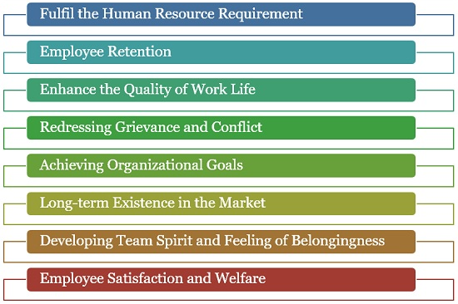
Figure 5: Importance of HR managers in an organisation
Source: (Gilmore, 2009)
The HR managers of Tesco are also concerned with the providence of appropriate training and development programs for the employees of the organisation to improve their knowledge and skills regarding their performance in the operation of the company. Moreover, the HR managers deal with motivating the employees by fulfilling their needs by providing appropriate rewards and compensations and hence ensure retaining effective employees to the organisation (Zaitouni, Harraf and Kisswani, 2020). Above, all the HR managers by ensuring the satisfaction and welfare of the employees and developing teamwork spirit improve the performance of the employees and their engagement to the organisation.

2.5.1 Skills and knowledge required by the HR managers
With regard to performing all the HR functions, the HR managers of Tesco are required standard knowledge and skills regarding performing different HR practices including recruiting and selecting employees, training employees, motivating employees, establishing effective communication with the employees, conflict management and so on (Gilmore, 2009). In order to perform these HR functions effectively, the HR managers will also require several core skills including effective communication skill, motivating skill, analytical skill to analyse and identify problems, problem-solving skills, team management skill etc. (Zaitouni, Harraf and Kisswani, 2020).

2.6 Training and development requirements to be considered
In this part of the paper, the essential training and development initiatives which are required by the HR managers of Tesco in order to ensure effective performance through their performance in the organisation will be highlighted. Determining effective training and development program is one of the core functions for an organisation as per the requirement of the job which is to be performed by the employees (Zaitouni, Harraf and Kisswani, 2020). In this regard, the management of Tesco must come up with effective training and development program for the HR managers with a view to providing them with appropriate training measures to develop their knowledge and skills regarding HR functions. As mentioned above, the HR managers will also require several core skills including effective communication skill, motivating skill, analytical skill to analyse and identify problems, problem-solving skills, team management skill etc. and so the management of Tesco should consider different organisational seminars, workshop, different academic and organisational courses to provide essential training to the HR managers to perform their functions effectively.

3. Conclusion
The term ‘Transferrable skill’ signifies the knowledge and skill which can be transferred from one person to another in terms of developing the knowledge or skill of those to whom the skills are being transferred (Gilmore, 2009). One of the major ways to transfer skill is by providing training to the employees in order to develop their skill (Zaitouni, Harraf and Kisswani, 2020). In this regard, the organisation must analyse the skill requirements of the employees which are needed to be developed and then arrange appropriate training measures to develop the skills.

4. Reference
Armstrong, M. and Landers, R., (2018). Gamification of employee training and development. International Journal of Training and Development, 22(2), pp.162-169.
Bekirogullari, Z., (2019). Employees’ Empowerment and Engagement in Attaining Personal and Organisational Goals. The European Journal of Social & Behavioural Sciences, 26(3), pp.3032-3047.
Bobicheva, V. and Revva, E., (2015). MOTIVATING EMPLOYEES AND INVOLVE THEM IN THE PROCESS OF ACHIEVING THE STRATEGIC GOALS OF COMPANIES WITH STATE PARTICIPATION. Business Strategies, (10), p.3.
Gilmore, S., (2009). Human Resource Management. Oxford: Oxford Univ. Pr.
Guo, L. and Wang, Z., (2019). Ratio Analysis of J Sainsbury plc Financial Performance between 2015 and 2018 in Comparison with Tesco and Morrisons. American Journal of Industrial and Business Management, 09(02), pp.325-341.
Ons.gov.uk. (2020). Retail Industry - Office For National Statistics. [online] Available at: <https://www.ons.gov.uk/businessindustryandtrade/retailindustry> [Accessed 22 April 2020].
Tesco PLC. (2020). Annual Report 2019. [online] Available at: <https://www.tescoplc.com/investors/reports-results-and-presentations/annual-report-2019/> [Accessed 22 April 2020].
Tesco PLC. (2020). Our History. [online] Available at: <https://www.tescoplc.com/about/our-history/> [Accessed 22 April 2020].
Zaitouni, M., Harraf, A. and Kisswani, A., (2020). Resources for development: the relationship of HRM practices and continuous learning culture with training success. International Journal of Human Resources Development and Management, 20(1), p.75.

5. PESTLE

5.1 Training and development plan
As per the above training and development requirements for the HR managers of Tesco, the following training and development plan has been prepared.
Skills | Training objectives | Resources to be used | Estimated time requirement
Communication skill | The employees will be able to establish effective communication using an appropriate communication channel and methods. | Training sessions, seminars, workshop, self-study. | 3 months (starting from May 2020 – July 2020)
Analytical skill | The employees will be able to analyse the situation and identify different aspects of the situation which needs to be fixed. | Training sessions, seminars, workshop. | 3 months (starting from August 2020 – October 2020)
Problem-solving skill | The employees will be able to solve problems arisen from organisational operation effectively with a sustainable solution for the problems occurred | Training sessions, seminars, workshop, self-study. | 4 months (starting from July 2020 – October 2020)
Decision-making skill | Employees will be able to make effective decisions in compliance with the core corporate and operational objective. | Training sessions, seminars, workshop, self-study. | 3 months (starting from November 2020 – January 2021)
Conflict management skill | Employees will be able to assess and resolve conflicts within the organisations effectively and establish a strong relationship among the employees. | Training sessions, seminars, workshop, self-study. | 4 months (starting from July 2020 – October 2020)
Team management skill | The employees will be able to manage team works and also the team members effectively and generate maximum outcome from the team activities. | Training sessions, seminars, workshop, self-study. | 4 months (starting from January 2021 – April 2021)

