GDD

Gameplay
- The player must search the room in order to find missing pieces of the Clockwork dolls. They must fix and wind-up each doll in order to receive a key. Once every doll has been fixed and wound up, the dolls will begin to chase the player through the rooms. Once you’ve fixed all the dolls in Room 3, the dolls will then begin to attack as you attempt to leave to Room 4. The dolls, however, will not follow from Room 3 to Room 4. Upon entering Room 4 (the corridor), the dolls will appear one by one as you reach certain points in the corridor to attack the player; which will trigger quick-time events.
- The player must walk around, open drawers and cupboards, lift floorboards and open doors as well as fix the clockwork dolls. Three quick-time events will occur just before the end of the game.
Mechanics
- Collecting the pieces to fix the dolls.
- Fixing/winding up the doll.

The main goal of the player is to locate and collect all the components of the clockwork dolls’ wind-up mechanisms, then fix the dolls, who will give the player a key they require to open the exit doors.
Controls
The player controls their movement using W, A, S, and D. The mouse controls the camera. Clicking the space bar will open and close the players inventory, while the right mouse key will be used to interact with objects. During the quick-time events in the latter part of the game, the player will have to repeatedly press the space bar.

Game Production Diary

Week 1 – 30th September
This week we’ve been given the assignment brief; which is to make a prototype of a survival horror game. I think this will be an interesting project to work on.
I’ve been brainstorming ideas for my game. I’ve got a few different themes in mind, and I’m struggling to decide what we’d like to do. I’m trying to be realistic with what I can and can’t do; but I still want to make something that will be fun to play.
I have a few different ideas on what I’d like to make, although I feel they’re all a bit too much considering my knowledge of Unreal and Maya.
I’ve done a quick mind map of some ideas and thoughts about the game, but I’m going to take the next week to think over which game idea I’d prefer.
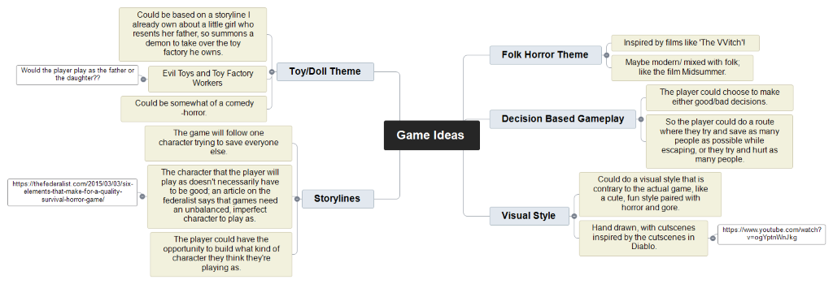
Week 2 – 7th October
This week we were given the task to make a GDD for our game idea and make a PowerPoint Presentation to pitch our games. After thinking over the past week, I’ve decided to go with the Folk Horror theme- based in a more modern setting (Like I mentioned last week- inspired by the film Midsommar). I want to do a summer-camp type game, where the player must try and escape a summer camp that’s trying to initiate them into a cult. The player must interact with other campers and distract the camp counsellors to get a phone to call the police. The player will have multiple options to choose from each time, and they’ll be able to decide if they want to do a more pacifistic route, or if they want to cause as much damage as possible (the game would have a few different endings). This week I’ve also tried to get some concept art done for what the characters might look like. I’ve included some of the initial concept art of characters within the game below.

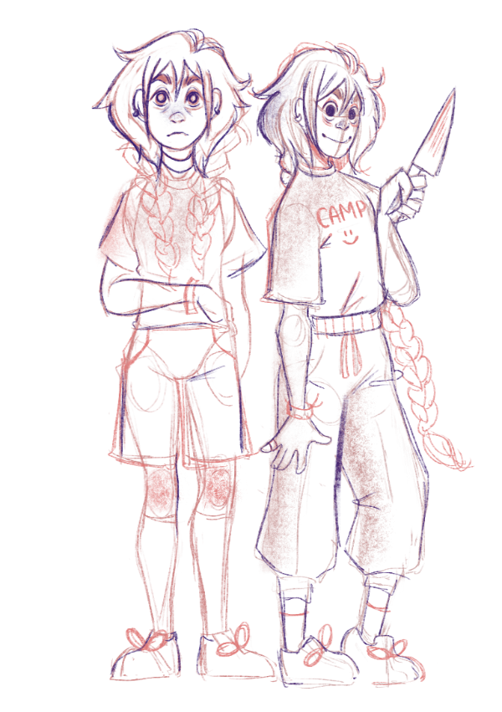

Week 3 – 14th October
This week we handed in the GDD, and we were supposed to pitch our game ideas, however Jess wasn’t in, so I think that’ll be delayed. I’ve been working on what I want the level to look like instead. I don’t want to make something to intricate with items I won’t be able to model, so I’m going to keep the room relatively plain; bunk beds, desks, simple furniture like that. I think the hardest part would be modelling characters so have within the room.
I’ve also been doing research on how to design a good level, so that I’m not just guessing what I’m doing. One article I’ve found particularly helpful was; https://www.gamasutra.com/blogs/TomPugh/20181022/329044/Level_Design_Tips_and_Tricks.php
While my level wont exactly be as big as the examples he’s included, I still think I could use his tips to better my ideas. Leading lines is one thing I know a lot of designers use, and I’d like to try and incorporate them into my design so the player can be encouraged to look at certain places. I’ve included a few sketches and reference images I’ve done today below.

INSERT IMAGE HERE

Week 4 – 21st October
This week we had a new teacher (Julian) who we pitched our ideas to. As Julian spent the lesson going around the class to listen to people’s ideas, I took the opportunity to finish the final bits of planning for my game, as I’m away for the next three weeks. Towards the end of the lesson, after talking with friends, we decided that we (Maddie, Beth, and Oscar) would join into one group, and instead work on Maddie’s idea. We felt this was the best course of action, as we were all a bit overwhelmed with what we were doing, and none of us knew anything about Maya or Unreal, so we thought as a group we could get more done and learn what we needed to more effectively. Maddie’s game is a steampunk style game, so I’m excited to do some concept art for the game over the next three weeks while I’m away. Then, when I’m back, I’ll be helping them with making the game in Unreal.

Week 5, 6, and 7 – 28th October – 18th November

I’ve been out of class for the past 3 weeks, so I’ve not been able to help with the group. However, with any free time I’ve had, I’ve been trying to keep updated on what’s happening, and making concept art to help where I can.
As you can see below, I’ve included some concept I’ve done of the Clockwork dolls. I’ve done one page for some of the outfits that the dolls would be wearing, and a more detailed page to show how the dolls look and where the joints are so they’re easier to model (if we get around to modelling).
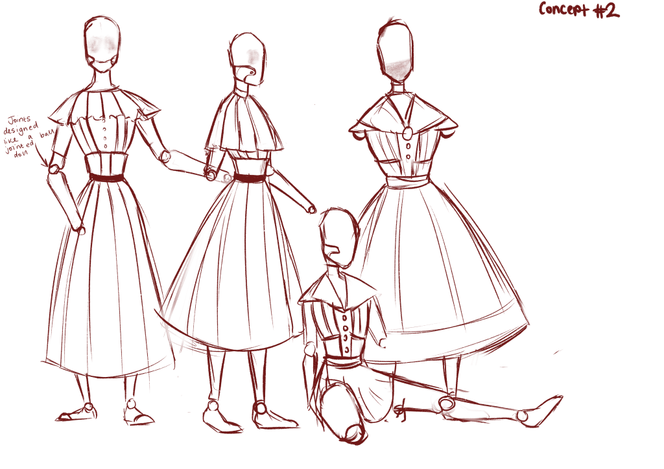

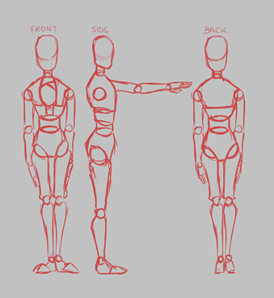
Week 9 – 18th November
This is my first week back after my holiday, and while I’ve missed some modelling lessons in Maya, I’ve tried to catch up as much as possible. We’re going to try and model furniture to put into our level. We’re all struggling a bit, so Beth’s been taking charge and trying to teach us how to model on Blender instead. Beth already has knowledge in Blender, so along with tutorials, Beth has been advising us on what to do.
We’ve tried to simplify the designs of the furniture we’re using for our inspiration by me making concept art of them; I’ve been taking the images of the furniture we all want to use in the game, and designing furniture based on them.

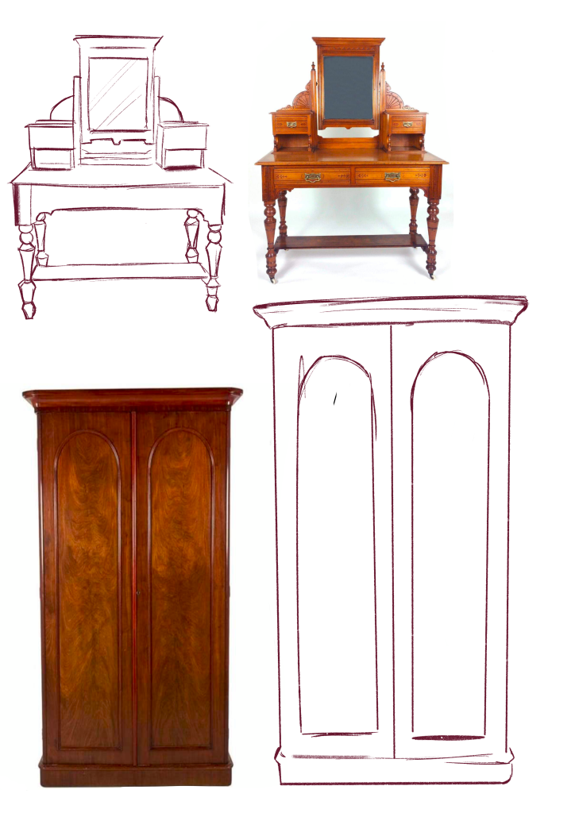
Week 10 – 25th November
We’re still trying to model the furniture for the room so we can move onto coding the game. Beth has still taken charge, and we’ve had to rewrite some of the plan of the game, as Maddie had written that when you fixed the Clockwork Dolls, they’d chase you through the next 2 rooms, which would make the game too hard to play. I suggested that the player would fix the dolls in rooms 1, 2, and 3, meaning when you fixed doll 1, it’d give you the key for room 2, when you fixed doll 2, it’d give you the key for 3, and when you fixed doll 3, you’d have to find the key while the dolls from all of the rooms. Then, when you entered the final corridor, the dolls wont chase, but they will spawn and attack and certain points throughout the corridor; however, even if you escape, the player does die.
We’ve also decided it’s unlikely we’d be able to do all 4 rooms; so, we’re just doing room one (we’re going to explain that the first 3 rooms are the same, and the last room is just a long corridor.

Week 11 – 2nd December
This is our last week to work on the project, so we’re trying to get everything done now as quickly as possible. Time management has not been our strong point during this, especially considering me and Oscar joined the group so late. While we have a solid plan and know what we want to do, we’re struggling to fully execute it. We’ve decided we’re going to have a title screen, so I’ve been looking as some



