
Component two: written assignment
name: Shahnaz Kausar Student number: 1714217
module name: changemakers building your personal brand for sustainable employment
module code: BMHP5015 module lecturer: Tsiwani Khumalo

Contents
Introduction
Job advertisement
Job role employability skills
Evaluating my own skills
Action plan and timeline
Building my personal brand
Promoting professional identity
Building a network for successful employment
Conclusion
References

Community support worker

Introduction
A Community Support Worker plays a vital role in promoting independence, wellbeing, and social inclusion for individuals who require support in their daily lives. This report explores the responsibilities of the role and its importance within health and social care, particularly in enabling people to live safely and confidently within their communities. Community Support Workers provide practical assistance, emotional support, and person-centred care tailored to individual needs. I am interested in this role because it aligns with my values of empowerment, dignity, and compassionate practice, and it offers the opportunity to make a meaningful difference in people’s everyday lives.
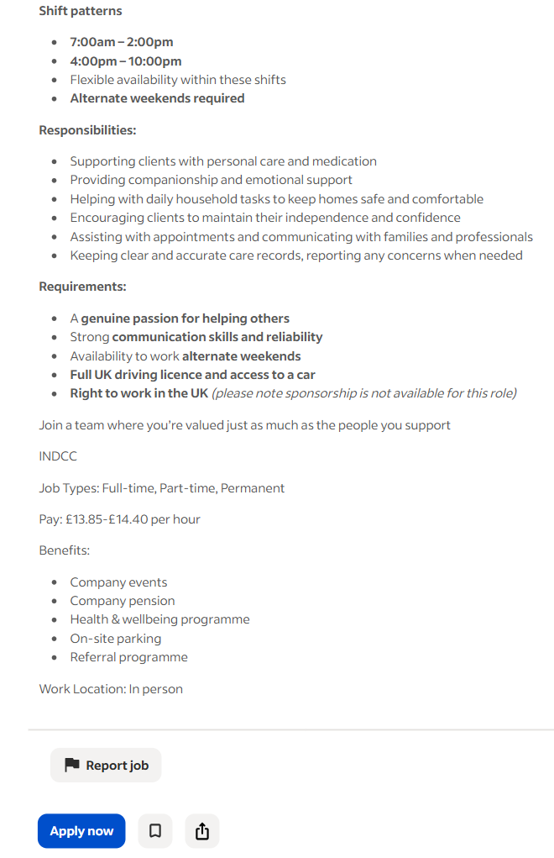
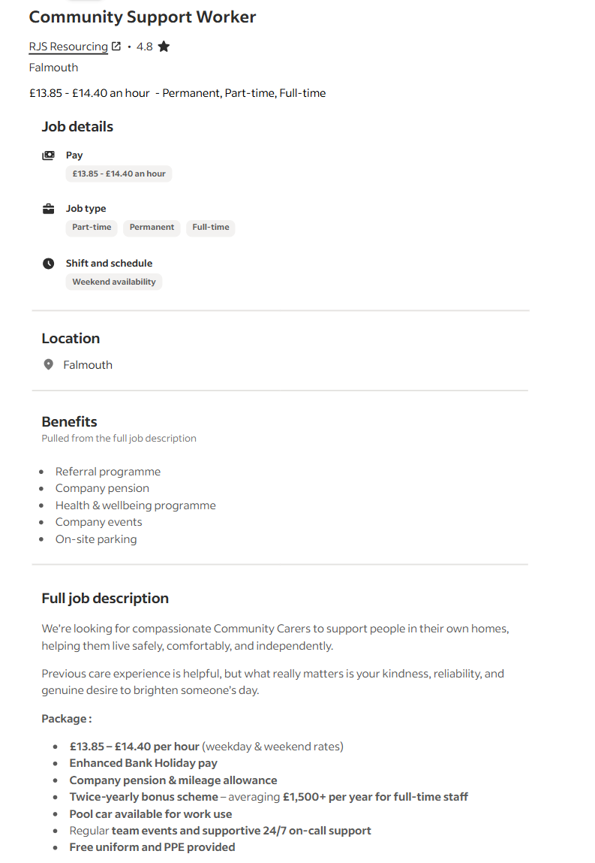
Job description

I felt inspired when I came across the Community Support Worker job advertisement on Indeed, as it highlighted the importance of compassion, independence, and supporting people within their own homes. Seeing how the role focuses on practical help, emotional support, and promoting confidence made me realise how strongly it aligns with my own values and career goals. This advert encouraged me to explore the role further and consider how I could make a positive difference in similar settings (Indeed, 2026).
Job role employability skills
The Community Support Worker job advertisement highlights several key employability skills that are essential for delivering high-quality care in people’s homes. One of the most important skills is communication, as the role involves offering companionship, providing emotional support, and liaising with families and professionals. Clear communication ensures that clients feel understood and safe, and it helps workers report concerns accurately to maintain wellbeing and safeguarding.
Another essential skill is reliability, which the advert emphasises through expectations such as consistent attendance, alternate weekend availability, and punctuality. Reliability is crucial in community care because clients depend on support workers for daily routines, medication, and personal care. Being dependable helps build trust and continuity, which are central to person-centred practice.
The advert also highlights compassion and empathy, describing the need for a “genuine passion for helping others.” These qualities enable workers to provide sensitive, respectful care that promotes dignity and emotional wellbeing. Compassionate practice helps clients feel valued and supported, especially when they may be vulnerable or isolated.
Time management is another key employability skill, as the role involves working within set shift patterns (7am–2pm and 4pm–10pm) and managing multiple tasks such as personal care, household duties, and supporting appointments. Effective time management ensures that all care tasks are completed safely and efficiently.
The job description also requires problem-solving skills, particularly when supporting clients to maintain independence, adapt routines, or overcome daily challenges. This skill contributes to promoting autonomy and confidence, which are core aims of community-based care.
Finally, the advert stresses the importance of record-keeping and attention to detail, as workers must keep accurate care notes and report any concerns. This ensures accountability, continuity of care, and compliance with safeguarding procedures.
Together, these employability skills enable Community Support Workers to deliver safe, compassionate, and person-centred support within the community.
Evaluating my own skills
Through reflecting on my current skills, experiences, and personal qualities, I can identify several strengths that align well with the requirements of the Community Support Worker role. Although I am still developing professionally, I have already gained valuable knowledge through my health and social care studies, including safeguarding, communication, equality and diversity, and person-centred practice. These areas provide a strong foundation for supporting individuals in the community. I have also completed practical learning activities, coursework, and independent study that have strengthened my understanding of professional values such as dignity, respect, and confidentiality.
One of my key strengths is my compassionate and empathetic nature, which the job advert highlights as essential. I naturally enjoy helping others and creating a positive, supportive environment. This aligns with the advert’s emphasis on kindness, emotional support, and building confidence in clients. I also consider myself reliable and committed, which is important for a role that requires consistent attendance, alternate weekend availability, and supporting people with daily routines. My ability to stay organised and manage my time effectively would help me work within set shift patterns and complete tasks safely and efficiently.
Another strength is my communication skills, developed through academic work, group tasks, and personal experiences. I am able to listen actively, explain information clearly, and adapt my communication style depending on the situation. This is vital for supporting clients, liaising with families, and keeping accurate care records, as required in the job description.
However, I also recognise areas for improvement. I would benefit from gaining more hands-on experience in a care setting to build confidence with tasks such as personal care, medication support, and record-keeping. I also want to strengthen my problem-solving skills in real-life scenarios, particularly when supporting clients to maintain independence or manage daily challenges. Additionally, I need to work on developing my resilience, as community care can sometimes be emotionally demanding.
There are several people who can support my development. Tutors and assessors can provide feedback on my coursework and guide me towards relevant training opportunities. Employers offering work placements or volunteering roles can help me gain practical experience. Experienced support workers or supervisors could also mentor me, helping me build confidence and learn best practice in real settings.
Overall, I believe I have a strong foundation of values and transferable skills, and with further experience and support, I can continue developing into an effective and compassionate Community Support Worker.
Action plan and timeline
In the short term, I will continue engaging fully with my current Health and Social Care course, focusing on units related to safeguarding, communication, equality and diversity, and person-centred practice. These units are essential because they form the foundation of safe and ethical care. For example, safeguarding knowledge will help me recognise signs of abuse or neglect and understand how to report concerns appropriately. Developing strong communication skills will support me in building trusting relationships with service users, families, and professionals. Equality and diversity learning will ensure I provide inclusive, non-judgemental support to people from different backgrounds. Person-centred practice is especially important for a Community Support Worker, as the job advert emphasises promoting independence and tailoring support to individual needs. By fully engaging with these units, completing all assignments to a high standard, and seeking feedback from tutors, I will strengthen my theoretical understanding and prepare myself for practical responsibilities.
Alongside my studies, I will look for volunteering opportunities within local care homes, community centres, or charities supporting vulnerable adults. Volunteering will give me hands-on experience with personal care, companionship, and supporting daily living tasks such as meal preparation, mobility, and household routines. It will also help me develop confidence when working with different service users, including older adults, people with disabilities, and individuals experiencing loneliness or mental health challenges. This experience will allow me to apply classroom knowledge in real situations, improve my communication skills, and learn how to respond calmly and professionally to unexpected challenges.
To further develop my employability, I plan to complete additional short training courses such as the Care Certificate, First Aid, Medication Awareness, and Moving and Handling. These qualifications are commonly required in community care roles and will help me feel more prepared for tasks like assisting with medication, supporting mobility safely, and responding to emergencies. Completing these courses will also show employers that I am committed to professional development.
In the medium term, I aim to apply for part-time or bank support worker roles, allowing me to gain paid experience while continuing my studies. This will help me develop resilience, problem-solving skills, and the ability to work independently in people’s homes. Paid experience will also help me understand the realities of shift work, lone working, and maintaining accurate care records.
Longer term, I plan to work towards a Level 3 Diploma in Health and Social Care, which will support career progression and open opportunities for more specialised roles, such as Senior Support Worker or Key Worker. This qualification will deepen my knowledge of legislation, complex needs, and leadership within care settings, helping me build a long-term career in community support.

Building my personal brand
Building a strong personal brand is an important part of developing my career in health and social care, especially as I work towards becoming a Community Support Worker. My personal brand will focus on qualities that are essential in this field, such as compassion, reliability, professionalism, and a commitment to person-centred care. By consistently demonstrating these values, I can create a clear and positive professional identity that reflects who I am and the type of practitioner I aim to become.
To build this brand, I will use professional platforms such as LinkedIn to showcase my qualifications, training, and experience. Creating a well-structured profile will allow me to connect with employers, support workers, and organisations within the sector. I can also share relevant content, such as reflections on my learning, articles about best practice, or insights from volunteering, to show my ongoing commitment to development.
In the future, I may create a simple professional portfolio or website to display certificates, coursework, and examples of my skills. Attending networking events, careers fairs, and training workshops will also help me build relationships and increase my visibility within the sector.
By presenting myself consistently and professionally across these platforms, I can develop a personal brand that supports my long-term career goals in community care.
Promoting professional identity
Promoting my professional identity is an important part of preparing for a career as a Community Support Worker. One of the key strategies I will use is communicating my skills and experiences clearly and confidently to potential employers. This includes highlighting my strengths in communication, empathy, reliability, and person-centred practice, as well as demonstrating my commitment to ongoing learning and development. When speaking to employers, attending interviews, or networking, I will focus on giving real examples from my coursework, volunteering, and training to show how I apply these skills in practice.
Another important strategy is tailoring my CV and cover letter for each job I apply for. I will ensure that my CV clearly presents my qualifications, relevant units from my Health and Social Care course, and any practical experience I gain through volunteering or placements. My cover letter will be personalised to each employer, showing that I understand their values and explaining how my skills match the role. This helps me stand out and shows professionalism.
Maintaining a strong online presence is also essential. I will keep my LinkedIn profile updated with my training, certificates, and achievements, and use it to connect with professionals in the sector. In the future, I may also create a simple online portfolio to showcase my development and reflect my personal brand.
Building a network for successful employment
Networking is an essential part of developing a successful career in the health and social care sector. Building strong professional connections can help me access new opportunities, gain practical insights, and learn from people with experience in community-based roles. Networking also allows me to stay updated on best practice, training opportunities, and changes within the sector, which is important for delivering safe and effective care. By connecting with others, I can develop my confidence, expand my knowledge, and build a support system that will guide me throughout my career.
There are several people and organisations that can support my development. Potential mentors include experienced Community Support Workers, supervisors from volunteering placements, and tutors from my Health and Social Care course. These individuals can offer advice, share their experiences, and help me understand what employers look for in new staff.
I can also connect with professional associations, such as Skills for Care, the British Association of Social Workers (BASW), and local care networks. These organisations provide training, events, and resources that support career progression.
Attending networking events, careers fairs, workshops, and employer talks will help me meet professionals from different areas of care. Using platforms like LinkedIn will also allow me to build an online network, follow organisations, and engage with content relevant to community support work.
Conclusion
In conclusion, this report has helped me develop a clear understanding of the Community Support Worker role and the skills required to succeed within the health and social care sector. By analysing the job advertisement, I identified key employability skills such as communication, compassion, reliability, and the ability to promote independence. My self-evaluation showed that I already have a strong foundation in these areas through my studies and personal qualities, while also recognising the importance of gaining more hands-on experience and further training to strengthen my confidence and practical abilities.
My action plan outlines the steps I will take to develop these skills, including completing relevant coursework, engaging in volunteering, undertaking short professional courses, and working towards a Level 3 qualification. I also explored how building a personal brand and promoting my professional identity through platforms like LinkedIn, tailored CVs, and networking opportunities will support my long-term career goals. Establishing a strong professional network will help me access guidance, mentorship, and future employment opportunities.
Overall, this process has reinforced my motivation and commitment to pursuing a career as a Community Support Worker. I am determined to continue developing my skills, gaining experience, and building a professional identity that reflects my passion for supporting others in the community.

References:
- Indeed (2026) Community Support Worker – Falmouth.
- Skills for Care (2024) What do care workers do?
- NHS Health Careers (2024) Support Worker Roles.
- Gov.uk (2024) Care Certificate Standards.
- Social Care Institute for Excellence (SCIE) (2024) Person-centred care.
- Care Quality Commission (CQC) (2024) Fundamental Standards.
- British Association of Social Workers (BASW) (2024) Professional Capabilities Framework.
- Mind (2024) Communication and Empathy in Support Work.
- NHS England (2024) Safeguarding Adults: Roles and Responsibilities.
- Health and Safety Executive (HSE) (2024) Moving and Handling in Health and Social Care.
- LinkedIn (2025) Building a Professional Profile in Health and Social Care.
- UCAS (2024) Health and Social Care Skills and Careers Guide.
- College of Social Work (2024) Importance of Reflective Practice.

Thank you


